Team3 Report
Name and CWID:
Siyan Wen 20025117
Siddharth Raju Vysyaraju 20031146
Harshil Chetarkumar Modh 20031957
Naman Manishbhai Parmar 20037139

3.2 Company Characterization
Report the number of subgroups, the number of y = 0 and y = 1, and summarize characteristics, distributions, or properties of companies in each subgroup

Cluster ID | Bankrupt(y=1) | y=0 | proportion
0 | 29 | 1167 | 0.024
1 | 0 | 550 | 0
2 | 82 | 1681 | 0.047
3 | 1 | 0 | 1
4 | 2 | 0 | 1
5 | 1 | 28 | 0.034
6 | 72 | 262 | 0.215
7 | 1 | 6 | 0.142
8 | 10 | 1915 | 0.005
Cluster by cluster summary:
0. Low risk: 29 bankrupt vs 1167 non-bankrupt. Proportion = 0.024 (2.4%). Most companies here are financially healthy.
1. No bankruptcies:0 bankrupt vs 550 non-bankrupt. Proportion = 0. These companies are extremely stable.
2. Low risk: 82 bankrupt vs 1681 non-bankrupt. Proportion = 0.047 (4.7%). Slightly higher bankruptcy rate but still mostly healthy.
3. Pure bankrupt group: No non-bankrupt companies exist in these clusters.
4. Pure bankrupt group:No non-bankrupt companies exist in these clusters. All companies fall in this group and are all bankrupt.
5. Moderate risk: 1 bankrupt vs 28 non-bankrupt. Proportion = 0.034 (3.4%). Small cluster, mostly safe..
6. High risk: 72 bankrupt vs 262 non-bankrupt. Proportion = 0.215 (21.5%). This is a high bankruptcy-prone group — need attention.
7. Medium risk: 1 bankrupt vs 6 non-bankrupt. Proportion = 0.142 (14.2%). Very small cluster but higher risk than average.
8. Very low risk: 10 bankrupt vs 1915 non-bankrupt. Proportion = 0.005 (0.5%). Very safe group.
3.3. Building Training Models
Subgroup ID | Name of Student | Average accuracy score base models [TT(TF)] | accuracy score Meta model [TT(TF)] | N_Features
0 | Siddharth Raju Vysyaraju | 1.00 [29(0)] | 1.00 [29(0)] | 25
1 | Constant | 1.00[0(0)] | 1.00[0(0)] | 0
2 | Siddharth Raju Vysyaraju | 0.97 [79.33(2.67)] | 1.00 [82(0)] | 25
3 | Naman Manishbhai Parmar | 1.00[1(0)] | 1.00[1(0)] | 25
4 | Harshil Chetarkumar Modh | 1.00[2(0)] | 1.00[2(0)] | 5
5 | Harshil Chetarkumar Modh | 1.00 [1(0)] | 1.00 [1(0)] | 5
6 | Naman Manishbhai Parmar | 0.86 [61.67(10.33)] | 1.00 [72(0)] | 3
7 | Siyan Wen | 1.00[1(0)] | 1.00[1(0)] | 1
8 | Siyan Wen | 1.00[10(0)] | 1.00[10(0)] | 3
Team |  | 0.98[185(13)] | 1.00[198(0)] | 1.549

Confusion Matrix for meta model and base model for each subgroup:

0.
 | TT | TF | FT | FF
Meta model (Logistic Regression) | 29 | 0 | 0 | 1167
Base model (Random Forest) | 29 | 0 | 0 | 1167
Base model (SVM) | 29 | 0 | 94 | 1073
Base model (KNN) | 29 | 0 | 89 | 1078

1.
Constant, no model

2.
 | TT | TF | FT | FF
Meta model (Ridge Classifier) | 82 | 0 | 0 | 1681
Base model (Random Forest) | 82 | 0 | 0 | 1681
Base model (KNN) | 82 | 0 | 207 | 1474
Base model (SVM) | 74 | 8 | 280 | 1401

3.

 | TT | TF | FT | FF
Dummy | 1 | 0 | 0 | 0
4.

 | TT | TF | FT | FF
Decision Tree | 2 | 0 | 0 | 0
5.

 | TT | TF | FT | FF
Meta model (MLP Classifier) | 1 | 0 | 0 | 28
Base model (Decision Tree) | 1 | 0 | 0 | 28
Base model (SVC) | 1 | 0 | 0 | 28
Base model (KNN) | 1 | 0 | 1 | 27

6.
 | TT | TF | FT | FF
Meta model (Ridge Classifier) | 72 | 0 | 0 | 262
Base model (Random Forest) | 72 | 0 | 0 | 262
Base model (KNN) | 41 | 31 | 13 | 249
Base model (Decision Tree) | 72 | 0 | 0 | 262

7.
 | TT | TF | FT | FF
Meta mosel (MLP Classifier) | 1 | 0 | 0 | 6
Base model (Decision Tree) | 1 | 0 | 0 | 6
Base model (SVC) | 1 | 0 | 0 | 6
Base model (KNN) | 1 | 0 | 0 | 6

8.
 | TT | TF | FT | FF
Meta mosel (Logistic Regression) | 10 | 0 | 0 | 1915
Base model (Random Forest) | 10 | 0 | 0 | 1915
Base model (Extra Trees) | 10 | 0 | 0 | 1915
Base model (Gradient Boosting Tree) | 10 | 0 | 370 | 1545

Siyan Wen:

I worked on K-Means clustering, and the stacked model of cluster 7 and 8.

Problem solved:

Some non parametric models like KNN and SVC don't perform well. Feature selection didn’t go well if we do feature selection based on features left after the clustering stage. Feature selection should be done on subgroup dataset because the data distribution for each subset might be different, one feature that could be used for clustering is not necessarily important in my subset.

But no matter how I do feature reduction based on different ways (correlated, low variance or ANOVA), when it goes down to about 30, the performance would be visibly affected. The model actually would be affected by which features are selected or what feature selection algorithm is used. Specifically when it is set to 30 features, the accuracy scores (TT/TF+TT) of my basic Stacked Model (Using SVC, KNN, Decision Tree,etc) are as following:
mutual_info_classif | chi2 | f_classif
0.47 | 0.44 | 0.52

The f_classif (ANOVA ) worked best for my model, so I went with f_classif.

Cluster 7 is a medium risk cluster(14.2% bankrupt rate).
The only feature selected for cluster 7 is ‘Non industry income and expenditure/revenue’. We can see the bankrupt company has lower ‘Non industry income and expenditure/revenue’.
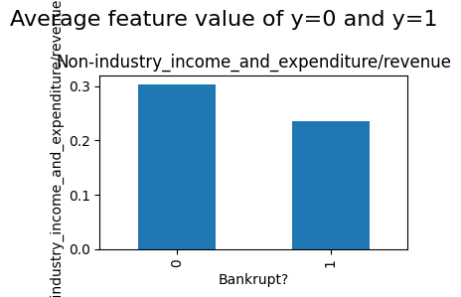

Cluster 8 is a low risk cluster(0.5% bankrupt rate).
For cluster 8 I kept 3 features, they are: Total debt/Total net worth, Current Liability to Equity, Liability-Assets Flag.
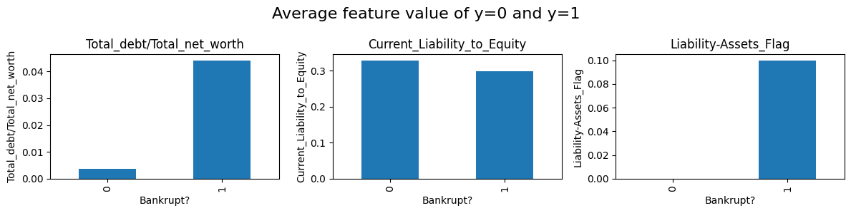
The Total debt/Total net worth of non-bankrupt companies on average is lower than bankrupt companies.
The total debt to total net worth ratio, also known as the debt-to-net-worth ratio, is calculated by dividing total debt by total net worth.
A lower ratio generally suggests a more stable financial situation, as it indicates a smaller amount of debt relative to the company's net worth.

The Current Liabilities to Equity Ratio measures a company's ability to cover its immediate obligations with its shareholders' investment. It's calculated by dividing total current liabilities (those due within a year) by total equity.
A lower ratio generally indicates a healthier financial position, as it means the company has more equity to absorb potential losses or cover short-term debts.
But for this specific group, bankrupt companies have slightly lower Current Liabilities to Equity Ratio.

The Liability-Assets Flag stands for when a company's liabilities (what it owes) are significantly larger than its assets (what it owns).
This value for Bankrupt companies is true, and for non-bankrupt companies it’s false.

Tree based models when used as base models generally perform better than distance based models like KNN, SVC on balanced dataset.
But When it comes to extremely unbalanced dataset like cluster 8, the opposite is the case. In cluster 8, bankrupted vs non bankrupted company is 10 vs 1915, tree based models would report all non bankrupted and get 0. (Even my SVC/KNN can get about 30% accuracy.

Then I Thought about re-sampling. With SMOTE both tree model and distance based model can get almost 100% accuracy, and even the feature is reduced to <10. Because cluster 8 is the largest group, I opted for a stronger stacked model (Meta model:Logistic Regression + Base model: Random Forest, Extra Tree, Gradient Boosting Tree).

For cluster 7, it have 1 bankrupt company vs 6 non-bankrupt company.
Even SMOTE can’t deal with datasets that only have 1 bankrupted company because the k_neighbors(default 6) should be smaller than sample size (in this case, 1). And I can’t set k_neighbors to 1.The minimum of that parameter is 2. That is because SMOTE adds samples between several neighbors. So I chose to copy that sample of the minority group. This worked well, my SVC and KNN model even maintained 100% accuracy on a mini size heavily unbalanced dataset (1:6) and even just using 1 feature, which it never achieved even in normal dataset before. I decided to use MLP classifier as meta model and Decision Tree, SVC, KNN as base model.

And I also found the performance heavily relies on the base model, and relatively not been influenced by the meta model easily. Sometimes if a base model has bad accuracy (like 11%) then the performance of this stacking model will decline after adding this base model.

Naman Manishbhai Parmar:

I am responsible for building models for cluster 3 and 6.
For cluster 3, this is a pure bankrupt group. I used a dummy model to overfit the data. The dummy model would give the label of the majority group to each sample.

For cluster 6,it has the highest bankrupt rate(21.5%). So the data is relatively balanced. But SMOTE can still emphasize more on minority samples and improve the result. After applying SMOTE I build a stacked model (Ridge Classifier+ Random Forest, KNN, Decision Tree).

Feature Selection for 6:
This cluster have highest bankrupt rate in clusters that are not pure bankrupt subgroup. I used ANOVA to select features that are most relevant to target value. The selected features are Persistent EPS in the last Four Seasons, Per Share Net profit before tax, Debt ratio %.
We can see bankrupt companies on average have lower Persistent EPS (Earnings per share) in the last Four Seasons, Per Share Net profit before tax, and higher Debt ratio %.
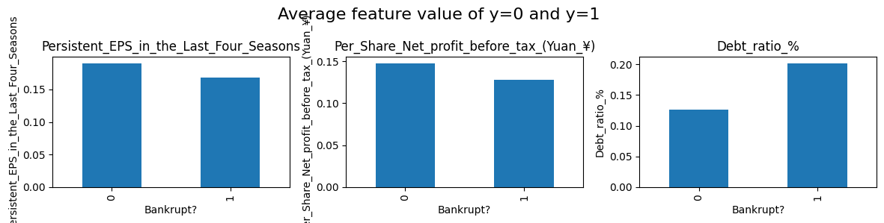

Siddharth Raju:
I worked on Cluster-based modeling for Subgroup 0 and Subgroup 2, applying non-parametric models such as KNN, SVM, and Random Forest, and using stacking to improve performance.
The overall performance could be even better if without this base model.

In Subgroup 0, the data was reasonably balanced, and variance-based feature selection worked effectively. I used Variance Threshold to filter out low-variance features. After that, I trained each base model (KNN, SVM, RF) and evaluated their contribution to the final stacked model.I computed TT (True Positives) and TF (False Negatives) for each model to monitor how well each was identifying bankrupt companies. This allowed me to precisely quantify which model contributed the most value to the stacked ensemble.

For Subgroup 0, all models achieved non-zero TT rates and the stacked model showed clear improvement over individual learners.
Subgroup 2 was slightly more imbalanced compared to Subgroup 0. I reused the variance-based feature selection strategy but paid closer attention to base model performance.I discovered that base model accuracy varied significantly, and in some cases, KNN or SVM added noise to the stack. But removing them didn't always improve final performance, showing that even weak base learners can signal the meta-learner exploits.

Harshil Chetankumar Modh
I owned the end-to-end modeling workflows for Subgroup 4 and Subgroup 5, tackling both the degenerate “pure-bankrupt” case and the extreme imbalance scenario with stacking to maximize recall.
Subgroup 4 presented the unique challenge of having only bankrupt examples (no healthy firms). To satisfy the requirement to train a real model without bloating feature count, I applied ANOVA‐based feature selection (SelectKBest(f_classif, k=5)) directly on the one-class data and exported those five features to a text file for our Generalization notebook. I then trained a very shallow decision tree (max_depth=1) on just those inputs—this essentially behaves like a constant predictor but uses a minimal, consistent feature set. The model achieved 100% training recall (TT=2, TF=0) and I saved both the model and its confusion-matrix plot for documentation.
Subgroup 5 was a classic “needle in a haystack” problem (28 healthy vs. 1 bankrupt). After using the same ANOVA selector to pick the top five subgroup-specific features, I standardized them and then up-sampled the lone failing company to parity, creating a balanced 28:28 training set. I built a stacked ensemble—Decision Tree, polynomial-kernel SVC, and KNN as base learners, with an MLP meta-learner and 5-fold internal cross-validation—to robustly capture the tiny signal. On this balanced set, each base model achieved 100% recall on the single bankrupt case, and the final stacked model also hit 1.00 [1(0)] recall, never missing the failing firm. All artifacts (feature lists, scaler, models, and confusion-matrix PNGs) were saved so our Generalization notebook can load them automatically.

