Contents

**Step 1: Login Screen** 2

**Test Cases** 2

**Step 2: Country Screen** 3

**Test Cases** 3

**Step 3: State Screen** 4

**Test cases** 4

**Step 3: City Screen** 5

**Test cases** 5

# **Step 1: Login Screen**

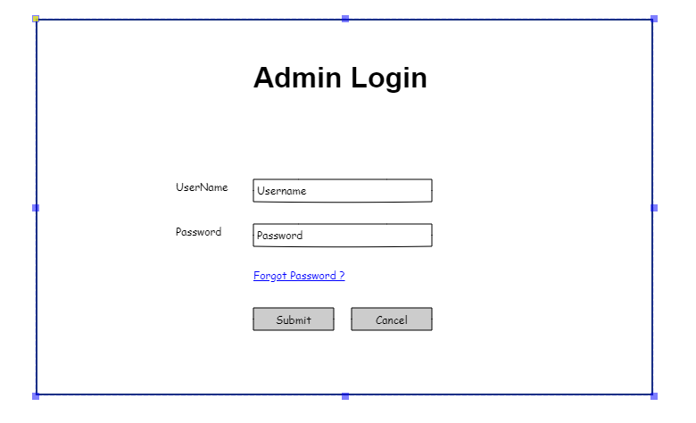

## **Test Cases**

* + username should not be blank
  + password should not be blank
  + provide proper validation message in toaster
  + check max length for both field it should not be more than 50
  + check if username and/or password is not correct
  + Redirect to dashboard screen only if username and password is correct
  + create SQL query for entering admin user entry in database
  + If user is successfully logged in then store user object in local storage

# **Step 2: Country Screen**

## **Test Cases**

1. Popup : Country name, Code and Phone code should not be blank
2. Popup: Country name should not be duplicated. If its duplicated then provide proper message like “Country Already Added”
3. Popup: On Save if data saved then success toaster message should be displayed.
4. Popup: On Save refresh country list. Page should not be reloaded. Use Two way data binding. On Click on Save button **No Get Api** call should be executed.
5. Popup: On Cancel Country name textbox should be cleared but popup should not be closed.
6. Popup: Your textbox max length and Nullable value should be equal to database table field value.
7. Popup: Country Code should be of 2 character only and mandatory
8. Popup: Phone code should of maximum 4 characters and mandatory
9. Popup: Any of field should not already exists in database.
10. Popup: On click of **X** popup should be closed.
11. Popup: Provide proper validation message
12. Popup: Max length Test : Should be same as database field value length
    * Country name max 50 characters it should be same in database
    * Country code max characters allowed should 2
    * Phone code max character length 4. Only numbers allowed
13. On Click of Add Button Popup Title should be “Add Country”.
14. Grid: On click of Edit Button Popup Title should be “Edit Country”.
15. Grid: On click of View Button Popup title should be “View Country”. In View all the controls in popup should be disabled.
16. Grid: On click of edit, popup should open with prefilled country name.
17. Grid: on Click of delete confirmation popup should be there. If confirmation yes then only record should be deleted.
18. Grid: Provide Server side paging
19. Grid: Provide Server side sorting
20. Grid: Number of records to display select and change listing of number of records in grid

# **Step 3: State Screen**

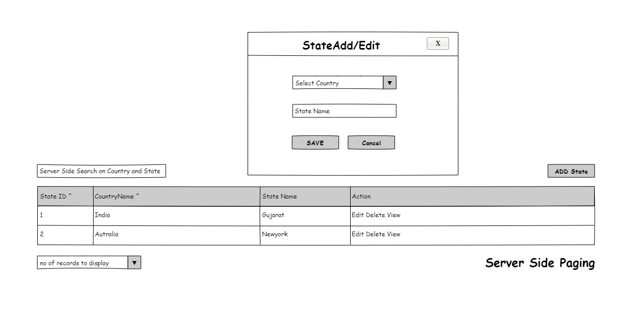

## **Test cases**

1. Popup : State name should be blank
2. Popup : State name should not already be added
3. Popup: On Save if data saved then success toaster message should be displayed.
4. Popup: On Save if data is not saved or State is already there then relevant message should be displayed. State data should be distinct related to country. Add records in below sequence and test your page.
   * Test Step 1: Select Country India and Add Hyderabad – Allowed
   * Test Step 2: Select Country India and Add Hyderabad – Not Allowed
   * Test Step 3: Select Country Pakistan and Add Hyderabad - Allowed
5. Popup: On Save refresh state list. Page should not be reloaded
6. Popup: On Cancel state name textbox should be cleared and Country dropdown default value should be “Select Country” but popup should not be closed.
7. Popup: On click of **X** popup should be closed.
8. Popup: Provide proper validation message
9. Popup: Your textbox max length and Nullable value should be equal to database table field value.
10. Popup: Check max length for state field it should not be more than 50
11. On Click of Add Button Popup Title should be “Add State”.
12. Grid: On click of Edit Button Popup Title should be “Edit State”.
13. Grid: On click of View Button Popup title should be “View State”. In View all the controls in popup should be disabled.
14. Grid: On click of edit, popup should open with pre-filled country name in dropdown and StateName in textbox.
15. Grid: on Click of delete confirmation popup should be there. If confirmation yes then only record should be deleted.
16. Grid: Provide Server side paging
17. Grid: Provide Server side sorting
18. Grid: Number of records to display select and change listing of number of records in grid

# **Step 3: City Screen**

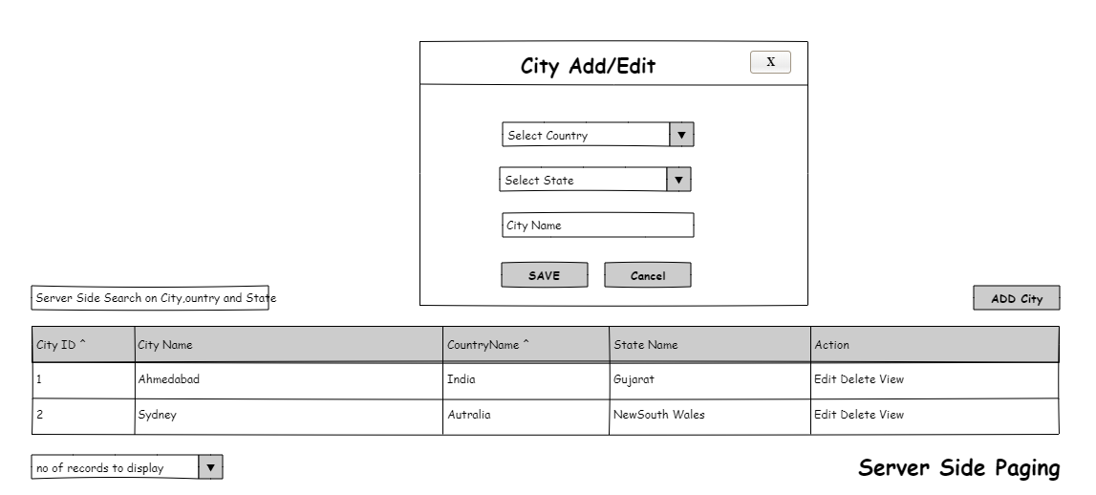

## **Test cases**

1. Popup : City name should be blank
2. Popup: City name should not already be added for specific country.
3. Popup: On Save if data saved then success toaster message should be displayed.
4. Popup: On Save if data is not saved or City is already there then relevant message should be displayed. State data should be distinct related to country. Add records in below sequence and test your page.
5. Popup: On Save refresh city list. Page should not be reloaded
6. Popup: On Cancel city name textbox should be cleared and Country and State dropdown default value should be “Select Country and Select State” but popup should not be closed.
7. Popup: On click of **X** popup should be closed.
8. Popup: Provide proper validation message
9. Popup: Textbox max length and Nullable value should be equal to database table field value.
10. Popup: Check max length for city field it should not be more than 50
11. On Click of Add Button Popup Title should be “Add City”.
12. Grid: On click of Edit Button Popup Title should be “Edit City”.
13. Grid: On click of View Button Popup title should be “View City”. In View all the controls in popup should be disabled.
14. Grid: On click of edit, popup should open with pre-filled country name in dropdown and CityName in textbox.
15. Grid: on Click of delete confirmation popup should be there. If confirmation yes then only record should be deleted.
16. Grid: Provide Server side paging
17. Grid: Provide Server side sorting
18. Grid: Number of records to display select and change listing of number of records in grid