**Course Table**

**Student Table**

**Enrollment Table**

**Insert**

**Data insert of S000000002 and C000003**

**After** **Data** **Insertion**

**Modify data from C000003 to C000004**

**After** **Modified**

**Manage** **Final Grade**

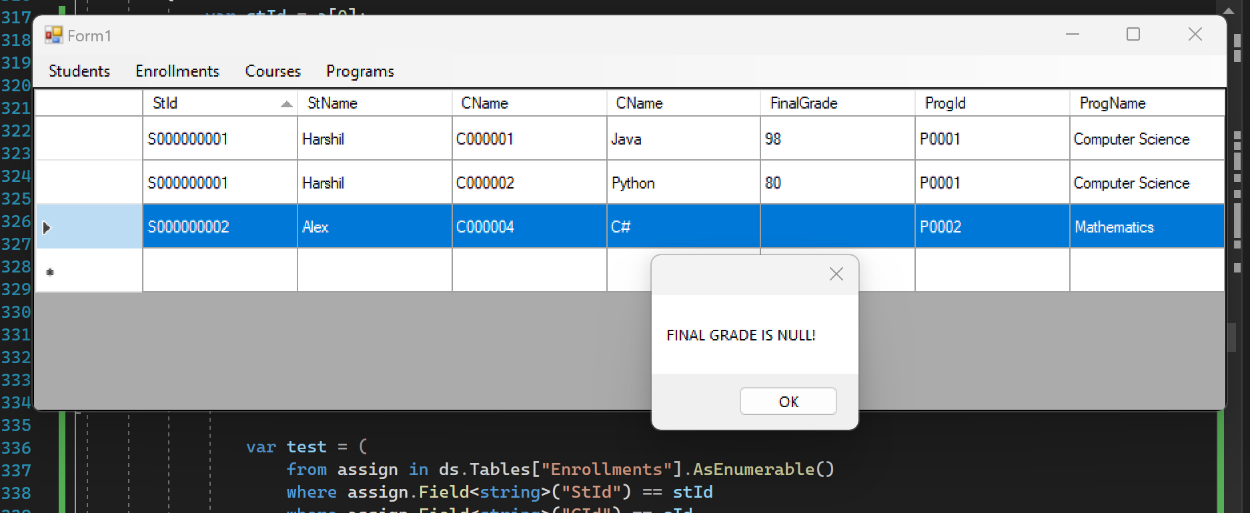

**S000000001 grades updated from 98 to 90**

**Delete**

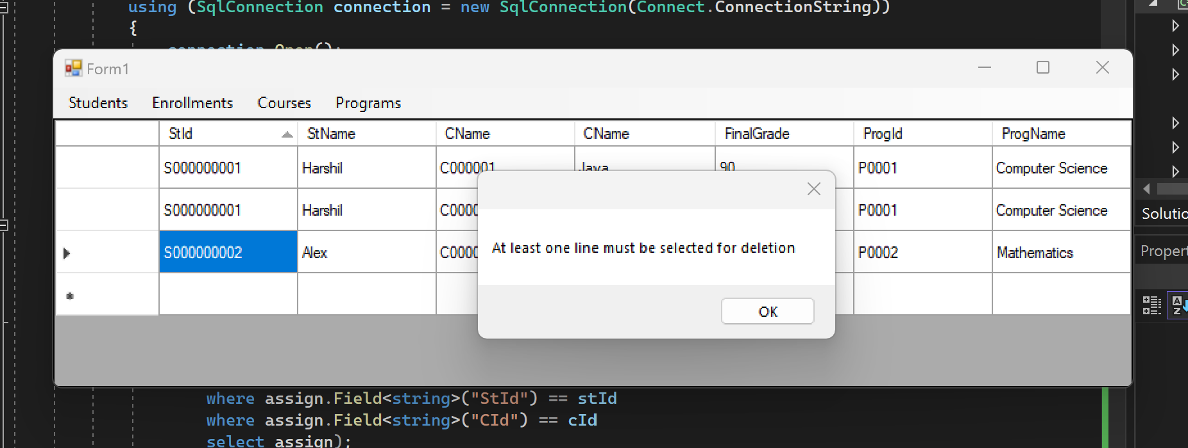

**After Deleted**

