**Vendor Management System API Documentation**

***By Harshil Gupta***

This document provides details about the API endpoints available in the Vendor Management System.

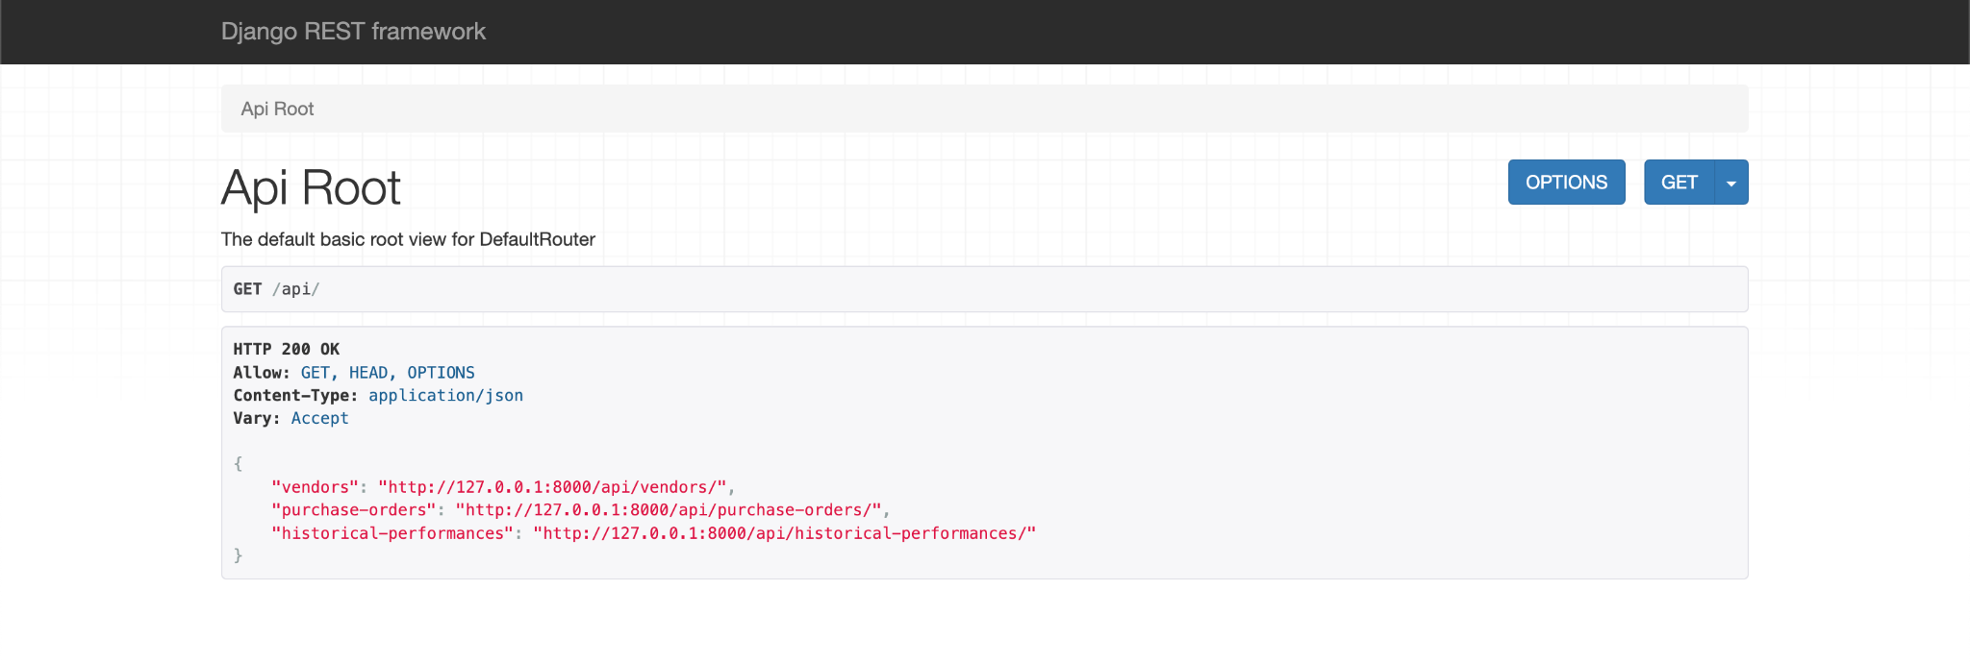

**Vendor Profile Management**

**Create a New Vendor**

Endpoint: POST http://127.0.0.1:8000/api/vendors/

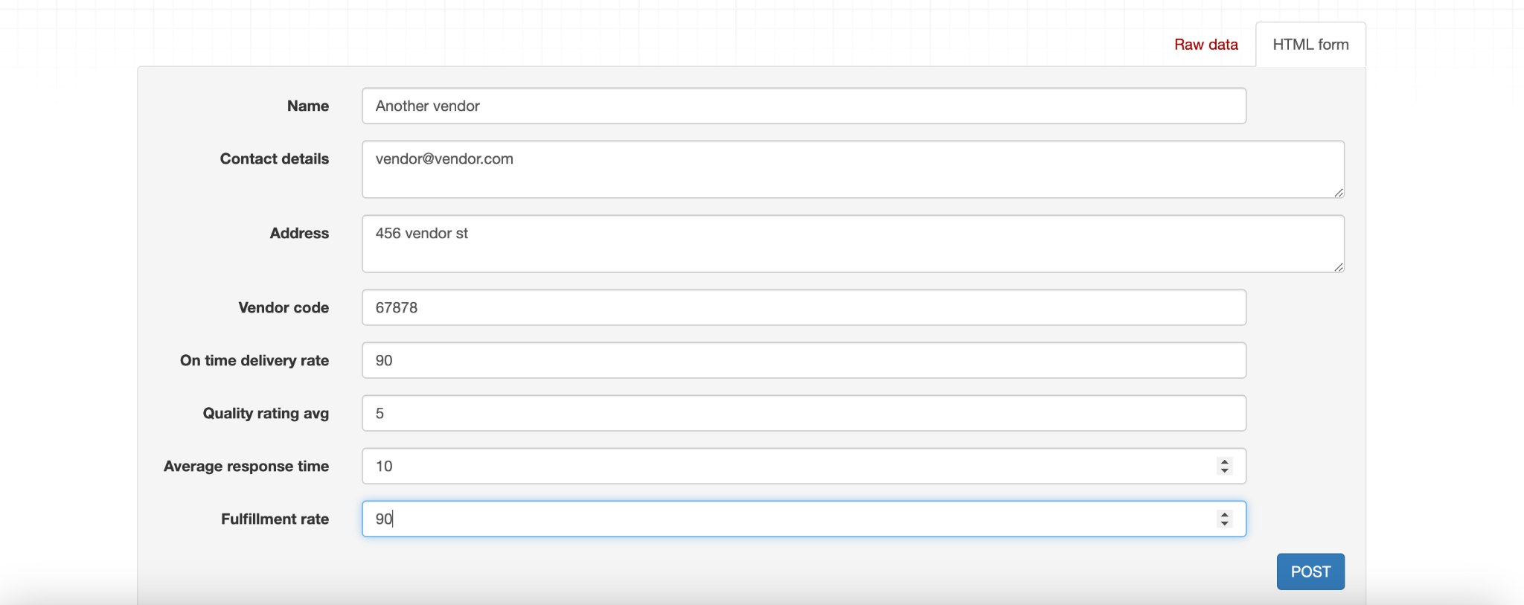

* Response: Returns the newly created vendor profile.

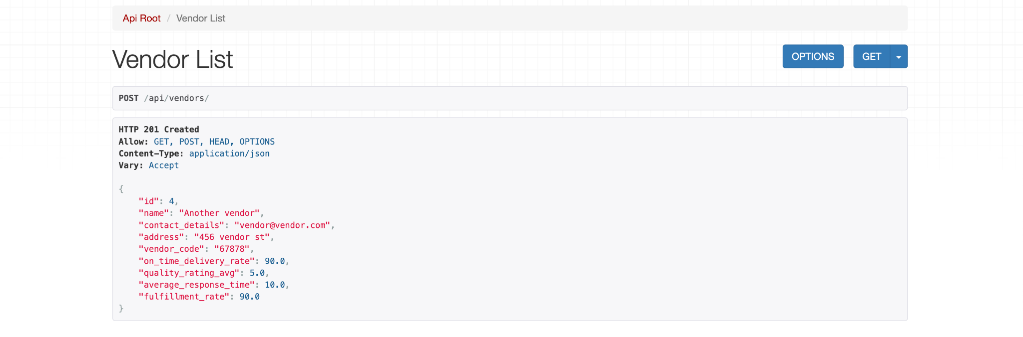

**List all vendors**

Endpoint: GET api/vendors/

Description: Retrieves a list of all vendors.

Response: Returns a list of vendor profiles.

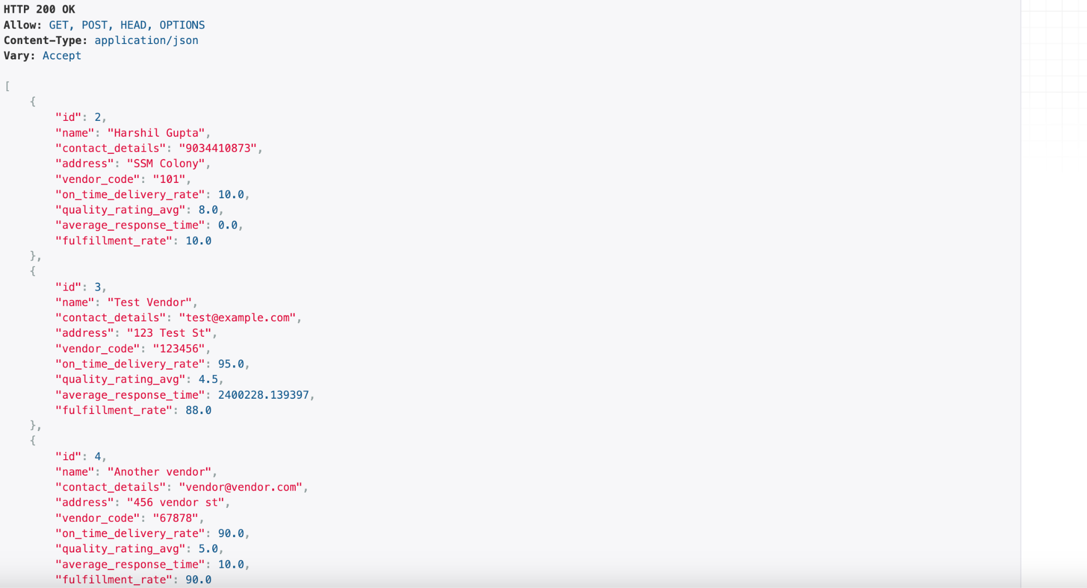

**Retrieve a specific Vendor**

Endpoint: GET /api/vendors/{vendor_id}/

Description: Retrieves details of a specific vendor identified by {vendor_id}.

Response: Returns the details of the specified vendor.

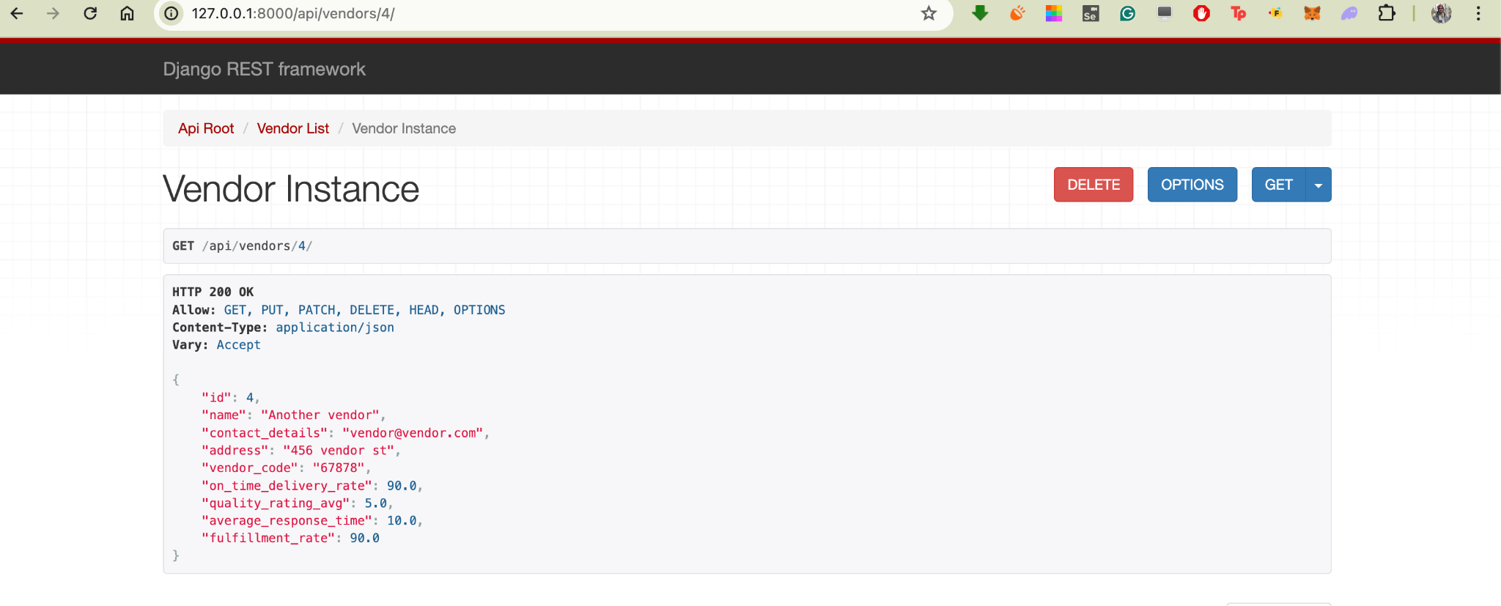

**Update a Vendor's Details**

Endpoint: PUT /api/vendors/{vendor_id}/

Description: Updates the details of a specific vendor identified by {vendor_id}.

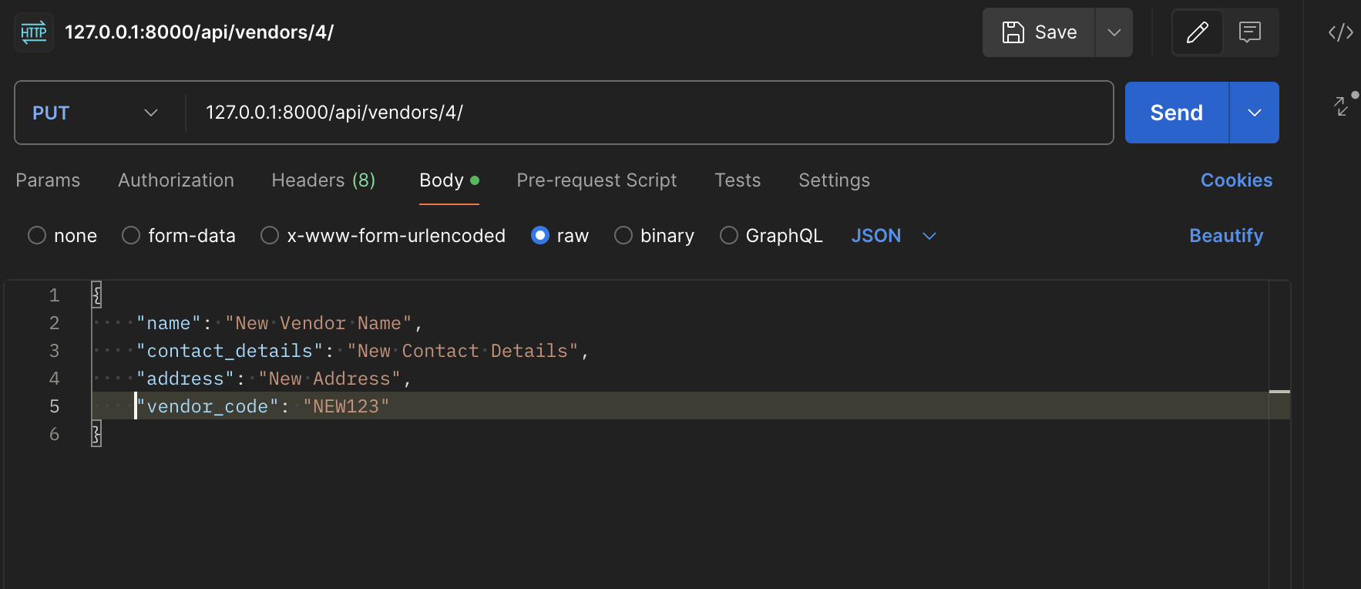

Response:

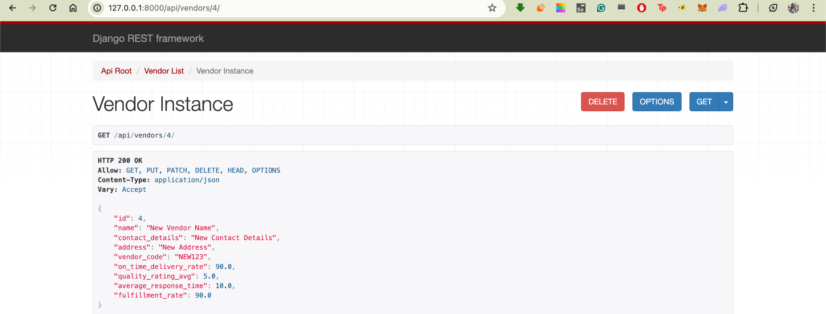

**Delete a Vendor**

Endpoint: DELETE /api/vendors/{vendor_id}/

Description: Deletes a specific vendor identified by {vendor_id}.

Response: Returns a success message upon successful deletion.

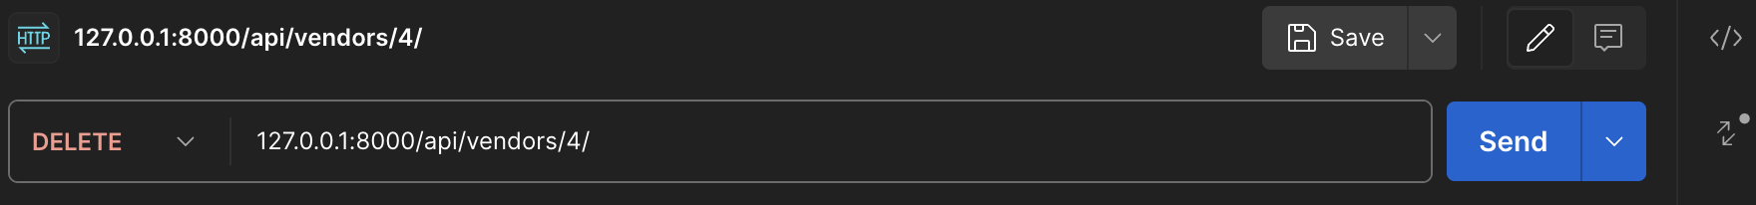

Response:

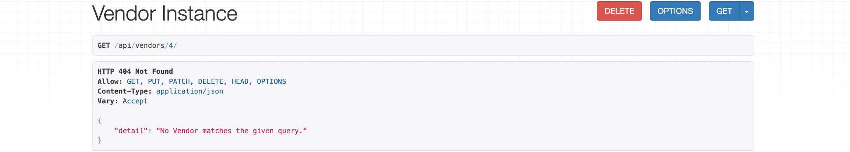

**Purchase Order Tracking**

**Create a Purchase Order**

Endpoint: POST /api/purchase_orders/

Description: Creates a new purchase order.

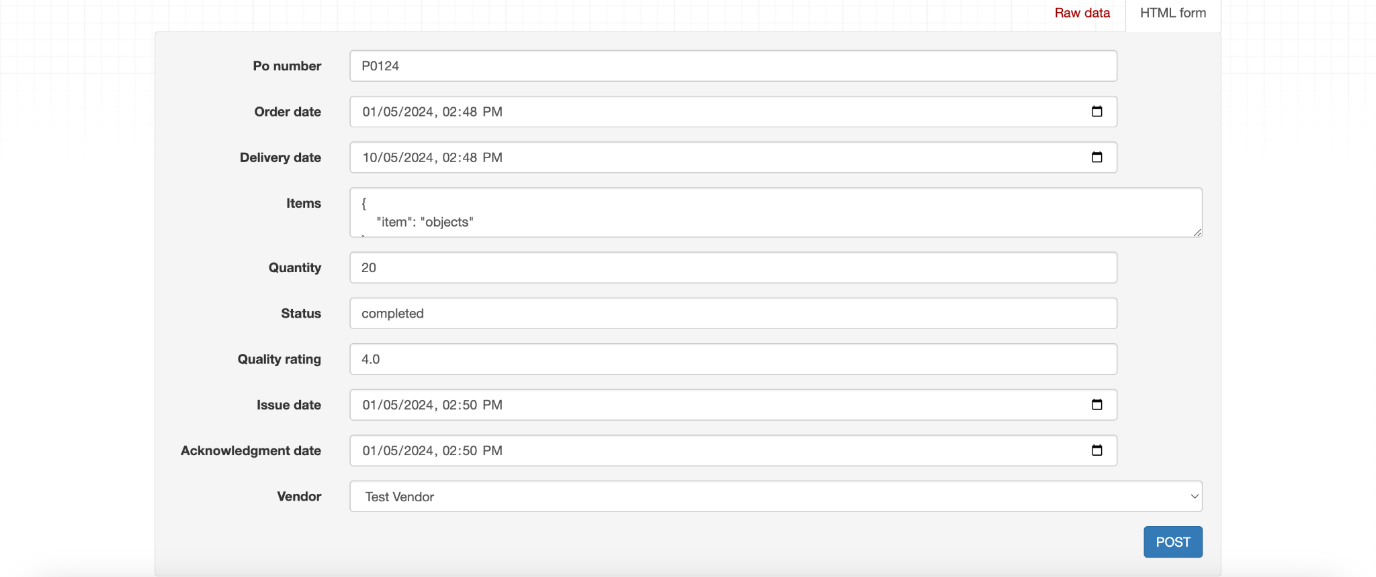

Response:

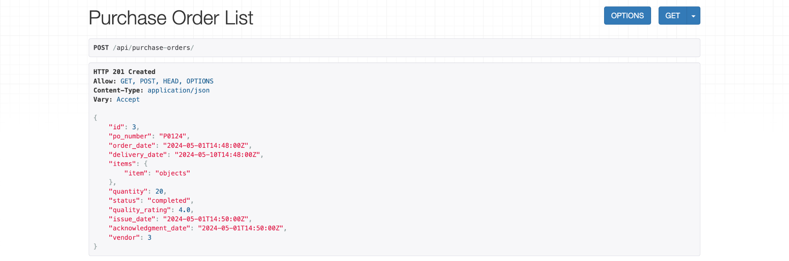

**List All Purchase Orders**

Endpoint: GET /api/purchase_orders/

Description: Retrieves a list of all purchase orders.

Response: Returns a list of purchase orders.

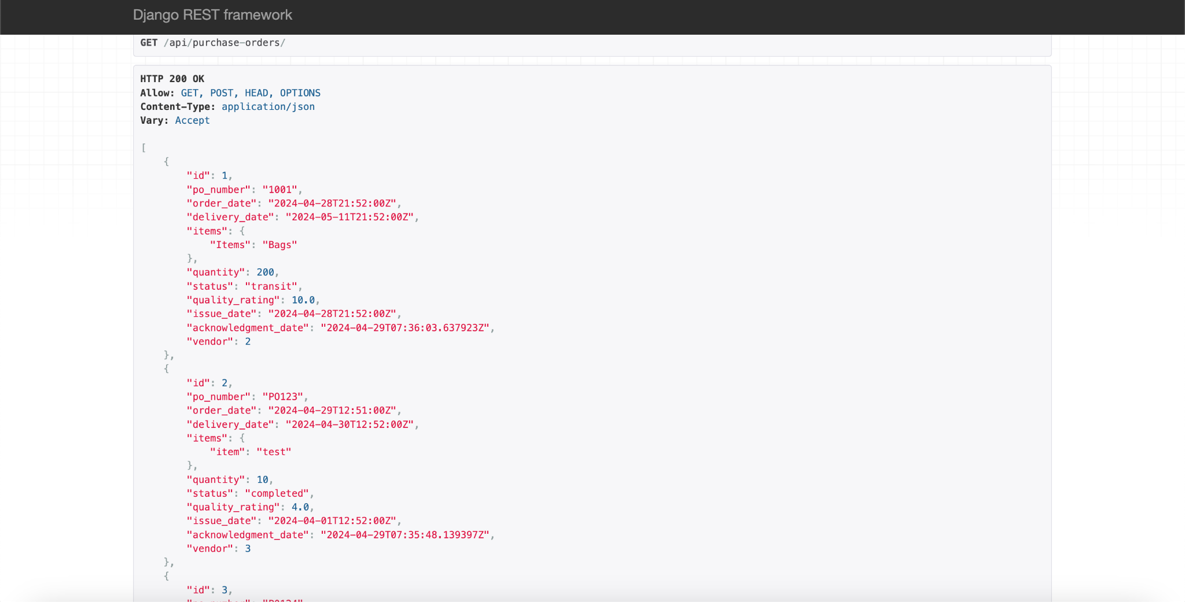

**Retrieve Details of a Specific Purchase Order**

Endpoint: GET /api/purchase_orders/{po_id}/

Description: Retrieves details of a specific purchase order identified by {po_id}.

Response: Returns the details of the specified purchase order.

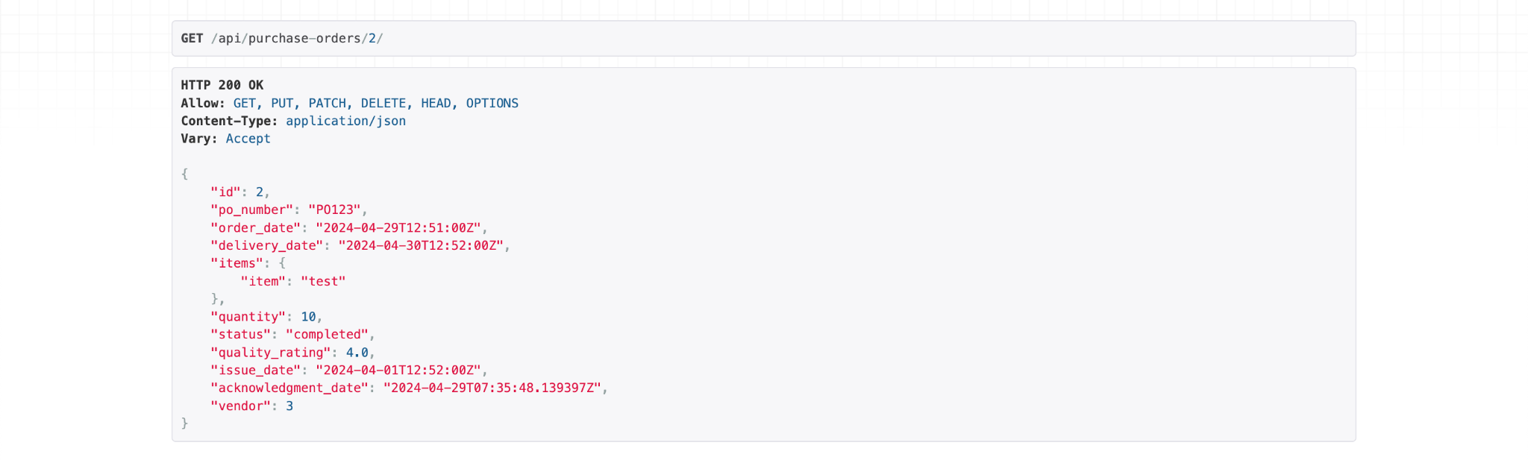

**Update a Purchase Order**

Endpoint: PUT /api/purchase_orders/{po_id}/

Description: Updates the details of a specific purchase order identified by {po_id}.

Before:

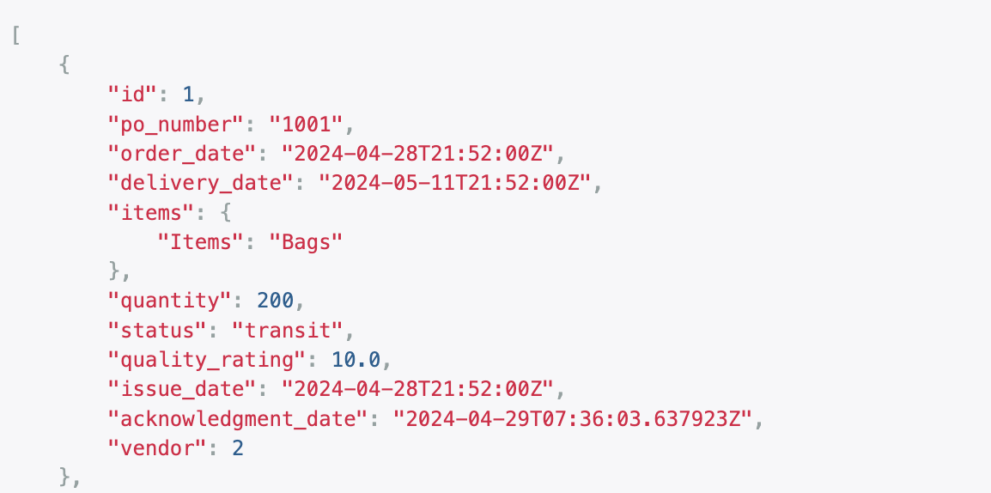

After:

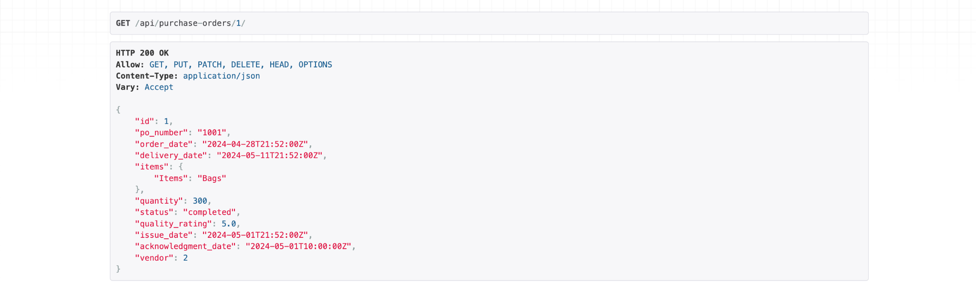

**Delete a Purchase Order**

Endpoint: DELETE /api/purchase_orders/{po_id}/

Description: Deletes a specific purchase order identified by {po_id}.

Response: Returns a success message upon successful deletion.

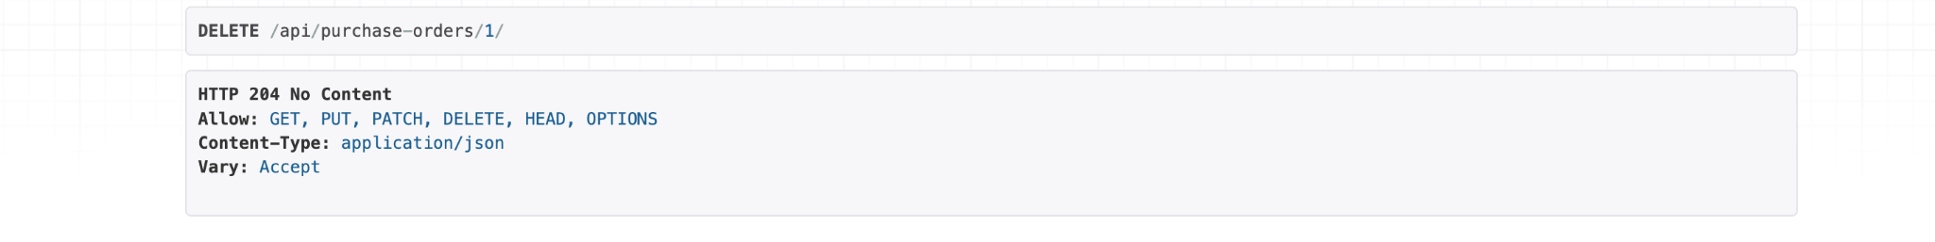

**Vendor Performance Evaluation**

**Retrieve a Vendor's Performance Metrics**

Endpoint: GET /api/vendors/{vendor_id}/performance/

Description: Retrieves the performance metrics of a specific vendor identified by {vendor_id}.

Response: Returns the performance metrics including on_time_delivery_rate, quality_rating_avg, average_response_time, and fulfillment_rate.

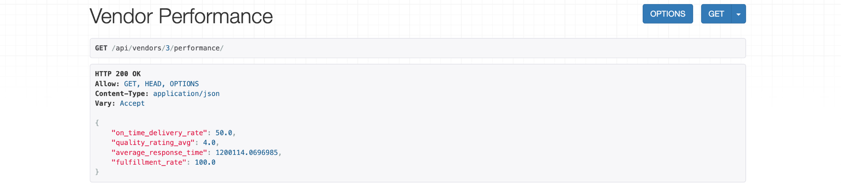

**Acknowledgment Endpoint**

Endpoint: PUT /purchase-orders/<int:po_id>/acknowledge/

Description: vendors to acknowledge PO’s

Response: It will update acknowledgment_date and trigger the recalculation

of average_response_time.

**Before Acknowledgement**

PO ID = 4 Data

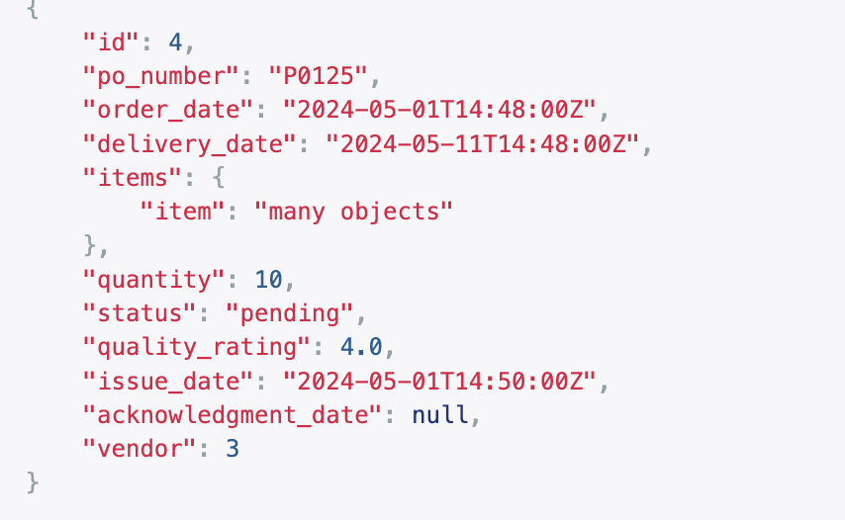

**Vendor Performance data for vendor ID=3**

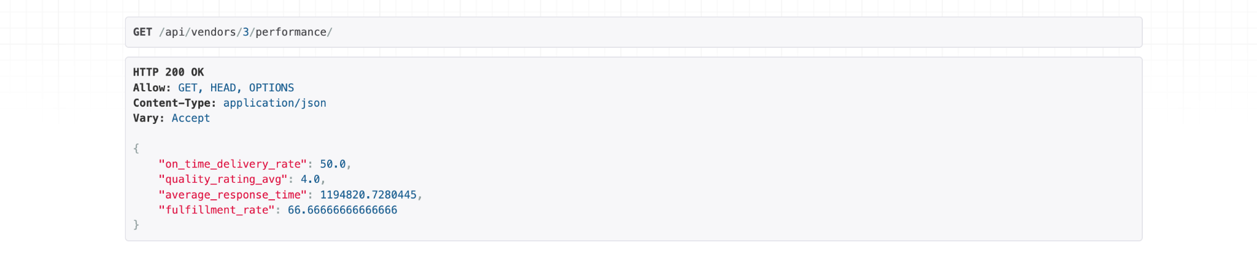

**After Acknowledgement**

PO ID = 4 Data

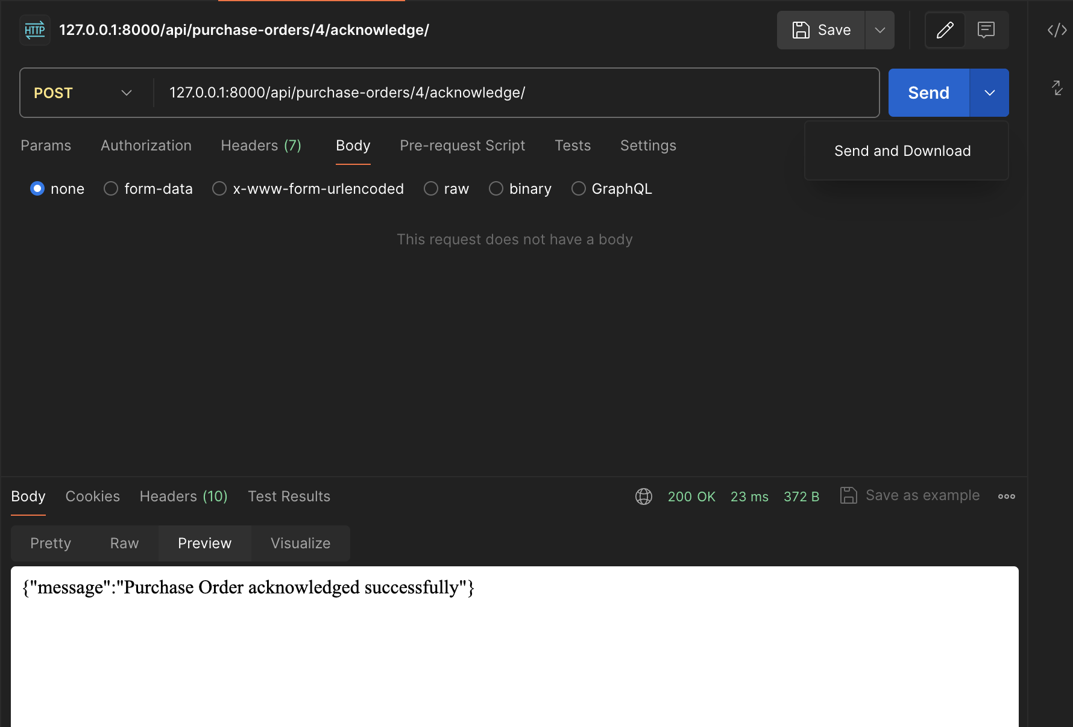

Acknowledgment Date change to current time stamp and status to ‘Completed’

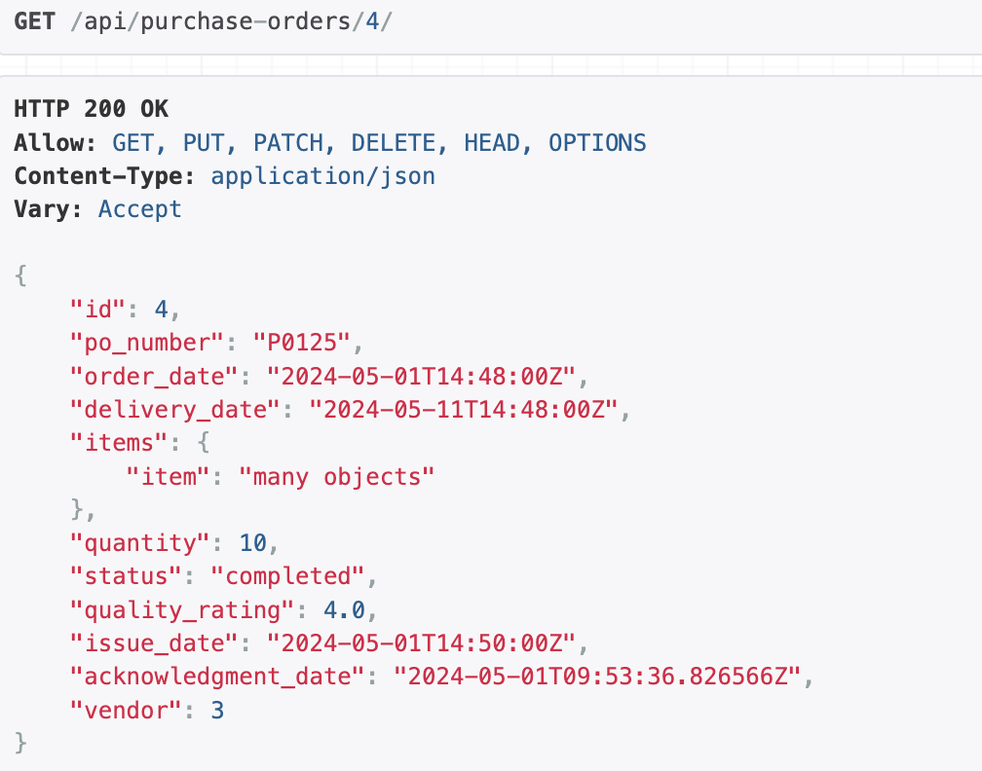

**Vendor Performance data for vendor ID=3**

All the recalculations done

