**INTERNET AND WEB PROGRAMMING**

Harshil Gupta

17BCE1112

**NEWSPAPER HTML CODE:**

<html>

<head>

<link rel="stylesheet" href="newspaper.css">

<title>Newspaper Style Design Experiment</title>

<meta name="viewport" content="width=device-width">

</head>

<body>

<div class="head">

<div class="headerobjectswrapper">

<div class="weatherforcastbox"><span style="font-style: italic;">Weatherforcast: Plenty of Sunshine</span><br><span>Wind: 8km/h SSE; Ther: 21°C; Hum: 82%</span></div>

<header>THE NEWSPOST</header>

</div>

<div class="subhead">INDIA, DELHI - Thursday DECEMBER 13, 2018 - Seven Pages</div>

</div>

<div class="content">

<div class="collumns">

<div class="collumn">

<div class="head"><span class="headline hl3">Can Twitter Predict the Future? Pentagon Says Maybe</span><p><span class="headline hl4">by JOHANN WOLFGANG VON GOETHE</span></p></div>

The Defense Department wants new computer tools to analyze mounds of unstructured text, blogs and tweets as part of a coordinated push to help military analysts predict the future and make decisions faster.<p>The search is part of the Office of Naval Research's "Data to Decisions" program, a series of three-to-10-year initiatives that will address the volume of information that threatens to overwhelm planners in the digital age, contract databases indicate. The goal is to build an open source system that can unite various tools that collect, manage and draw relationships between data sets.In a program announcement, ONR is calling for computer algorithms to predict events, fuse different forms of information and offer context on unfolding events. The office expects to spend $500,000 each year in funding. “The Department of Defense recognizes the potential for text analytics to play a vital role in future capabilities that inform timely and accurate situational awareness in time-constrained, uncertain, and complex environments,” the tender reads.</p></div>

<div class="collumn">

<div class="head"><span class="headline hl5">Give people courage</span><p><span class="headline hl6">The crowd seemed to grow</span></p></div>

The sunset faded to twilight before anything further happened. The crowd far away on the left, towards Woking, seemed to grow, and I heard now a faint murmur from it. The little knot of people towards Chobham dispersed. There was scarcely an intimation of movement from the pit.</p>

<figure class="figure">

<img class="media" src="r2.jpg" alt="">

<figcaption class="figcaption">Hermine hoping for courage.</figcaption>

</figure>

<p>It was this, as much as anything, that gave people courage, and I suppose the new arrivals from Woking also helped to restore confidence. At any rate, as the dusk came on a slow, intermittent movement upon the sand pits began, a movement that seemed to gather force as the stillness of the evening about the cylinder remained unbroken. Vertical black figures in twos and threes would advance, stop, watch, and advance again, spreading out as they did so in a thin irregular crescent that promised to enclose the pit in its attenuated horns. I, too, on my side began to move towards the pit.</p>

<p>Then I saw some cabmen and others had walked boldly into the sand pits, and heard the clatter of hoofs and the gride of wheels. I saw a lad trundling off the barrow of apples. And then, within thirty yards of the pit, advancing from the direction of Horsell, I noted a little black knot of men, the foremost of whom was waving a white flag.</p>

</div>

<div class="collumn"><div class="head"><span class="headline hl1">May the Force be with you</span><p><span class="headline hl2">Let go your conscious self and act on instinct</span></p></div>Partially, but it also obeys your commands. Hey, Luke! May the Force be with you. I have traced the Rebel spies to her. Now she is my only link to finding their secret base.</p>

<figure class="figure">

<img class="media" src="http://i.giphy.com/4fDWVPMoSyhgc.gif" alt="">

<figcaption class="figcaption">"This time, let go your conscious self and act on instinct."</figcaption>

</figure>

<p>Leave that to me. Send a distress signal, and inform the Senate that all on board were killed. <span class="citation">"Don't under estimate the Force. I suggest you try it again, Luke."</span> This time, let go your conscious self and act on instinct. In my experience, there is no such thing as luck. You're all clear, kid. Let's blow this thing and go home!</p>

<p>You don't believe in the Force, do you? Partially, but it also obeys your commands. The plans you refer to will soon be back in our hands. As you wish.</p></div>

<div class="collumn"><div class="head"><span class="headline hl3">How to Win Friends and Influence People </span><p><span class="headline hl4">A brief, no fluff, summary of Dale Carnegie’s</span></p></div><p>When dealing with people, let us remember we are not dealing with creatures of logic. We are dealing with creatures of emotion, creatures bristling with prejudices and motivated by pride and vanity.The only way on earth to influence other people is to talk about what they want and show them how to get it.If there is any one secret of success, it lies in the ability to get the other person’s point of view and see things from that person’s angle as well as from your own.Criticism is futile because it puts a person on the defensive and usually makes him strive to justify himself. Criticism is dangerous, because it wounds a person’s precious pride, hurts his sense of importance, and arouses resentment. …. Any fool can criticize, condemn and complain—and most fools do. But it takes character and self-control to be understanding and forgiving.</p></div>

<div class="collumn"><div class="head"><span class="headline hl1">It wasn't a dream </span><p><span class="headline hl4">by FRANZ KAFKA</span></p></div><p>One morning, when Gregor Samsa woke from troubled dreams, he found himself transformed in his bed into a horrible vermin. He lay on his armour-like back, and if he lifted his head a little he could see his brown belly, slightly domed and divided by arches into stiff sections. The bedding was hardly able to cover it and seemed ready to slide off any moment. </p>

<p>His many legs, pitifully thin compared with the size of the rest of him, waved about helplessly as he looked. "What's happened to me?" he thought. It wasn't a dream. His room, a proper human room although a little too small, lay peacefully between its four familiar walls. A collection of textile samples lay spread out on the table - Samsa was a travelling salesman - and above it there hung a picture that he had recently cut out of an illustrated magazine and housed in a nice, gilded frame. It showed a lady fitted out with a fur hat and fur boa who sat upright, raising a heavy fur muff that covered the whole of her lower arm towards the viewer. Gregor then turned to look out the window at the dull weather. </p></div>

</div>

</div>

</body>

</html>

**NEWSPAPER CSS CODE:**

body{

font-family: 'Droid Serif', serif;

font-size: 14px;

color: #2f2f2f;

background-color: #f9f7f1;

}

header{

font-family: 'Playfair Display', serif;

font-weight: 900;

font-size: 80px;

text-transform: uppercase;

display: inline-block;

line-height: 72px;

margin-bottom: 20px;

}

p{

margin-top: 0;

margin-bottom: 20px;

}

.head{

text-align: center;

position: relative;

}

.headerobjectswrapper{

}

.subhead{

text-transform: uppercase;

border-bottom: 2px solid #2f2f2f;

border-top: 2px solid #2f2f2f;

padding: 12px 0 12px 0;

}

.weatherforcastbox{

position: relative;

width: 12%;

left: 10px;

border: 3px double #2f2f2f;

padding: 10px 15px 10px 15px;

line-height: 20px;

display: inline-block;

margin: 0 50px 20px -360px;

}

.content{

font-size: 0;

line-height: 0;

word-spacing: -.31em;

display: inline-block;

margin: 30px 2% 0 2%;

}

.collumns{

}

.collumn{

font-size: 14px;

line-height: 20px;

width: 17.5%;

display: inline-block;

padding: 0 1% 0 1%;

vertical-align: top;

margin-bottom: 50px;

transition: all .7s;

}

.collumn + .collumn {

border-left: 1px solid #2f2f2f;

}

.collumn .headline{

text-align: center;

line-height: normal;

font-family: 'Playfair Display', serif;

display: block;

margin: 0 auto;

}

.collumn .headline.hl1{

font-weight: 700;

font-size: 30px;

text-transform: uppercase;

padding: 10px 0 10px 0;

}

.collumn .headline.hl2{

font-weight: 400;

font-style: italic;

font-size: 24px;

box-sizing: border-box;

padding: 10px 0 10px 0;

}

.collumn .headline.hl2:before{

border-top: 1px solid #2f2f2f;

content: '';

width: 100px;

height: 7px;

display: block;

margin: 0 auto;

}

.collumn .headline.hl2:after{

border-bottom: 1px solid #2f2f2f;

content: '';

width: 100px;

height: 13px;

display: block;

margin: 0 auto;

}

.collumn .headline.hl3{

font-weight: 400;

font-style: italic;

font-size: 36px;

box-sizing: border-box;

padding: 10px 0 10px 0;

}

.collumn .headline.hl4{

font-weight: 700;

font-size: 12px;

box-sizing: border-box;

padding: 10px 0 10px 0;

}

.collumn .headline.hl4:before{

border-top: 1px solid #2f2f2f;

content: '';

width: 100px;

height: 7px;

display: block;

margin: 0 auto;

}

.collumn .headline.hl4:after{

border-bottom: 1px solid #2f2f2f;

content: '';

width: 100px;

height: 10px;

display: block;

margin: 0 auto;

}

.collumn .headline.hl5{

font-weight: 400;

font-size: 42px;

text-transform: uppercase;

font-style: italic;

box-sizing: border-box;

padding: 10px 0 10px 0;

}

.collumn .headline.hl6{

font-weight: 400;

font-size: 18px;

box-sizing: border-box;

padding: 10px 0 10px 0;

}

.collumn .headline.hl6:before{

border-top: 1px solid #2f2f2f;

content: '';

width: 100px;

height: 7px;

display: block;

margin: 0 auto;

}

.collumn .headline.hl6:after{

border-bottom: 1px solid #2f2f2f;

content: '';

width: 100px;

height: 10px;

display: block;

margin: 0 auto;

}

.collumn .headline.hl7{

font-weight: 700;

font-size: 12px;

box-sizing: border-box;

display: block;

padding: 10px 0 10px 0;

}

.collumn .headline.hl8{

font-weight: 700;

font-size: 12px;

box-sizing: border-box;

padding: 10px 0 10px 0;

}

.collumn .headline.hl9{

font-weight: 700;

font-size: 12px;

box-sizing: border-box;

padding: 10px 0 10px 0;

}

.collumn .headline.hl10{

font-weight: 700;

font-size: 12px;

box-sizing: border-box;

padding: 10px 0 10px 0;

}

.collumn .citation{

font-family: 'Playfair Display', serif;

font-size: 36px;

line-height: 44px;

/*font-style: italic;*/

text-align: center;

font-weight: 400;

display: block;

margin: 40px 0 40px 0;

font-feature-settings: "liga", "dlig";

}

.collumn .citation:before{

border-top: 1px solid #2f2f2f;

content: '';

width: 100px;

height: 16px;

display: block;

margin: 0 auto;

}

.collumn .citation:after{

border-bottom: 1px solid #2f2f2f;

content: '';

width: 100px;

height: 16px;

display: block;

margin: 0 auto;

}

.collumn .figure {

margin: 0 0 20px;

}

.collumn .figcaption{

font-style: italic;

font-size: 12px;

}

.media {

-webkit-filter: sepia(80%) contrast(1) opacity(0.8);

filter: sepia(80%) grayscale(1) contrast(1) opacity(0.8);

mix-blend-mode: multiply;

width: 100%;

}

/*MEDIAQUERIES*/

@media only all and (max-width: 1300px) {

.weatherforcastbox{

display: none;

}

}

@media only all and (max-width: 1200px) {

.collumn{

width: 31%;

}

}

@media only all and (max-width: 900px) {

.collumn{

width: 47%;

}

}

@media only all and (max-width: 600px) {

.collumn{

width: 100%;

}

.collumn + .collumn {

border-left: none;

border-bottom: 1px solid #2f2f2f;

}

header{

max-width: 320px;

font-size: 60px;

line-height: 54px;

overflow: hidden;

}

}

**SCREENSHOTS:**

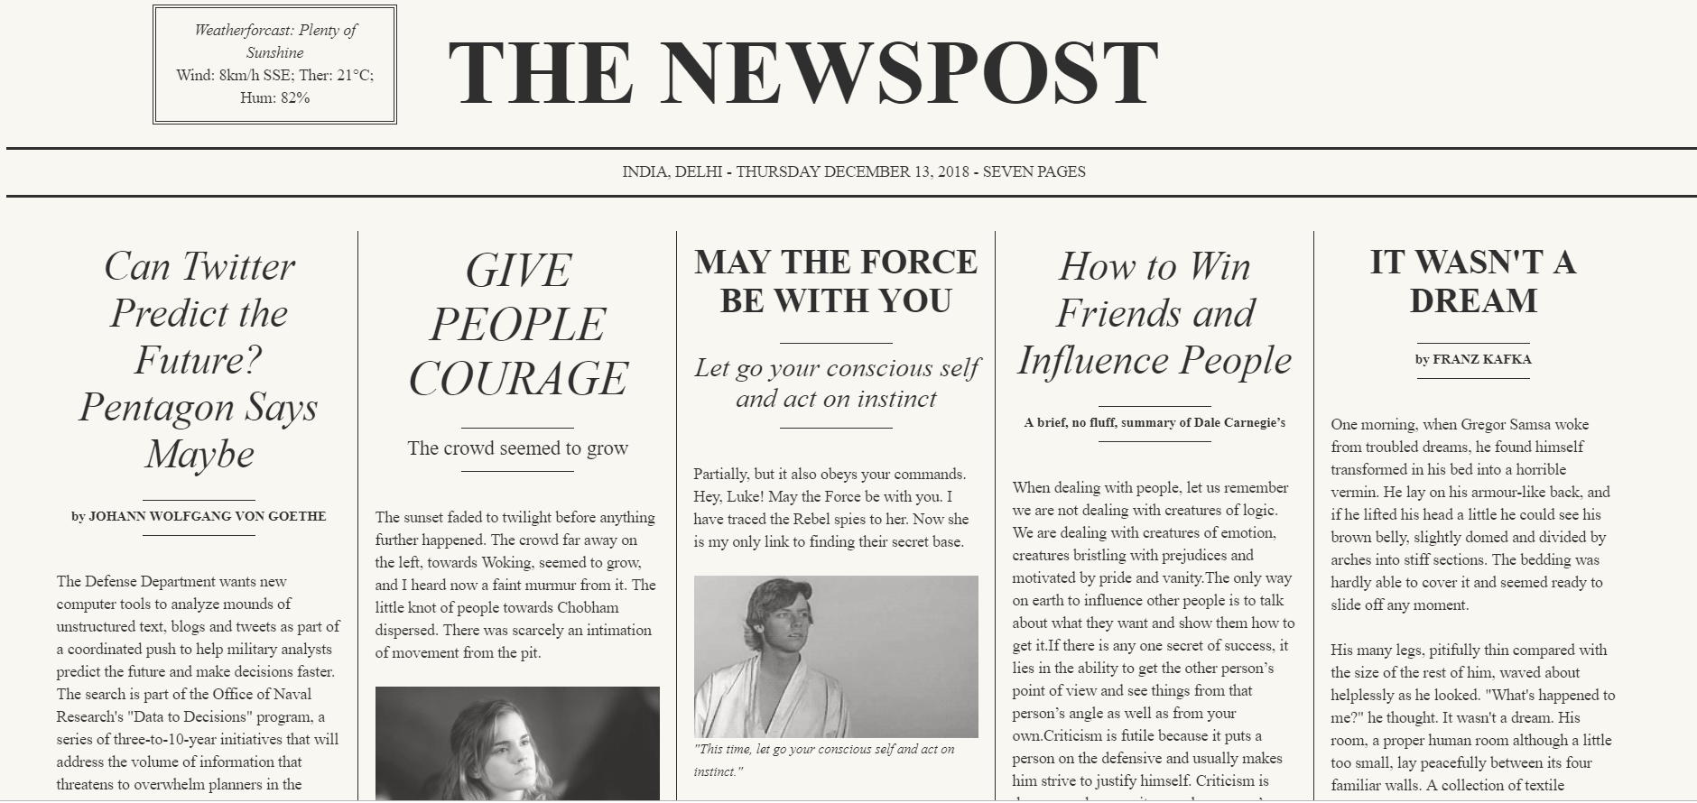

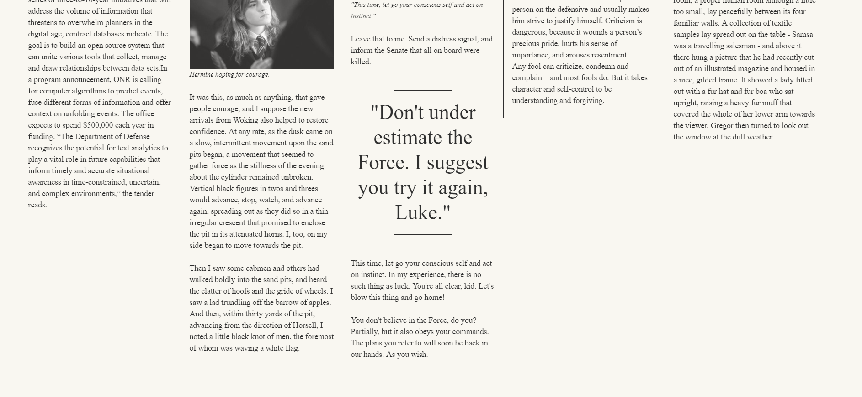

**ANIMATION HTML CODE:**

<!DOCTYPE html>

<html>

<head>

<meta name="viewport" content="width=device-width, initial-scale=1">

<style>

* {box-sizing: border-box}

body {font-family: Verdana, sans-serif; margin:0}

.mySlides {display: none}

img {vertical-align: middle;}

.slideshow-container {

max-width: 1000px;

position: relative;

margin: auto;

}

.prev, .next {

cursor: pointer;

position: absolute;

top: 50%;

width: auto;

padding: 16px;

margin-top: -22px;

color: white;

font-weight: bold;

font-size: 18px;

transition: 0.6s ease;

border-radius: 0 3px 3px 0;

user-select: none;

}

.next {

right: 0;

border-radius: 3px 0 0 3px;

}

.prev:hover, .next:hover {

background-color: rgba(0,0,0,0.8);

}

.text {

color: #f2f2f2;

font-size: 15px;

padding: 8px 12px;

position: absolute;

bottom: 8px;

width: 100%;

text-align: center;

}

.numbertext {

color: #f2f2f2;

font-size: 12px;

padding: 8px 12px;

position: absolute;

top: 0;

}

.dot {

cursor: pointer;

height: 15px;

width: 15px;

margin: 0 2px;

background-color: #bbb;

border-radius: 50%;

display: inline-block;

transition: background-color 0.6s ease;

}

.active, .dot:hover {

background-color: #717171;

}

.fade {

-webkit-animation-name: fade;

-webkit-animation-duration: 1.5s;

animation-name: fade;

animation-duration: 1.5s;

}

@-webkit-keyframes fade {

from {opacity: .4}

to {opacity: 1}

}

@keyframes fade {

from {opacity: .4}

to {opacity: 1}

}

@media only screen and (max-width: 300px) {

.prev, .next,.text {font-size: 11px}

}

</style>

</head>

<body>

<div class="slideshow-container">

<div class="mySlides fade">

<div class="numbertext">1 / 3</div>

<img src="n1.jpg" style="width:100%">

<div class="text">THE </div>

</div>

<div class="mySlides fade">

<div class="numbertext">2 / 3</div>

<img src="n4.jpg" style="width:100%">

<div class="text">BEAUTIFUL</div>

</div>

<div class="mySlides fade">

<div class="numbertext">3 / 3</div>

<img src="n2.jpg" style="width:100%">

<div class="text">NATURE!</div>

</div>

<a class="prev" onclick="plusSlides(-1)">&#10094;</a>

<a class="next" onclick="plusSlides(1)">&#10095;</a>

</div>

<br>

<div style="text-align:center">

<span class="dot" onclick="currentSlide(1)"></span>

<span class="dot" onclick="currentSlide(2)"></span>

<span class="dot" onclick="currentSlide(3)"></span>

</div>

<script>

var slideIndex = 1;

showSlides(slideIndex);

function plusSlides(n) {

showSlides(slideIndex += n);

}

function currentSlide(n) {

showSlides(slideIndex = n);

}

function showSlides(n) {

var i;

var slides = document.getElementsByClassName("mySlides");

var dots = document.getElementsByClassName("dot");

if (n > slides.length) {slideIndex = 1}

if (n < 1) {slideIndex = slides.length}

for (i = 0; i < slides.length; i++) {

slides[i].style.display = "none";

}

for (i = 0; i < dots.length; i++) {

dots[i].className = dots[i].className.replace(" active", "");

}

slides[slideIndex-1].style.display = "block";

dots[slideIndex-1].className += " active";

}

</script>

</body>

</html>

**SCREENSHOTS:**



