IWP LAB

NAME : Harshil Gupta

REG. NO. : 17BCE1112

1. Calculate the number of days left out for FAT exam using Sliders for getting date and month :

**CODE :**

<html>

<head>

<meta name="viewport" content="width=device-width, initial-scale=1">

<style>

.slidecontainer {

width: 100%;

}

.slider {

-webkit-appearance: none;

width: 100%;

height: 25px;

background: #d3d3d3;

outline: none;

opacity: 0.7;

-webkit-transition: .2s;

transition: opacity .2s;

}

.slider:hover {

opacity: 1;

}

.slider::-webkit-slider-thumb {

-webkit-appearance: none;

appearance: none;

width: 25px;

height: 25px;

background: #4CAF50;

cursor: pointer;

}

.slider::-moz-range-thumb {

width: 25px;

height: 25px;

background: #4CAF50;

cursor: pointer;

}

</style>

</head>

<body>

<div class="slidecontainer">

<form method="Post">

Month:<input type="range" name="month" min="1" max="12" value="1" class="slider" id="myRange">

<p>Value: <span id="demo"></span></p>

Day:<input type="range" name="date" min="1" max="31" value="1" class="slider" id="myRange1">

<p>Value: <span id="demo1"></span></p>

<p>Year:<input type="integer" value="2019"></p>

<p>

<input type="BUTTON" value="SUBMIT" OnClick="form.d2.value=myfunc(form.month.value,form.date.value)"><p>

Days left for FAT: <input type="integer" name="d2">

<form>

</div>

<script>

function myfunc(month,day)

{

month= month.toString();

day= day.toString();

var date1= month.concat('/');

date1= date1.concat(day);

date1= date1.concat('/2019');

var date2= '04/12/2019';

dt1=new Date(date1);

dt2 = new Date(date2);

var diff=Math.floor((Date.UTC(dt2.getFullYear(), dt2.getMonth(), dt2.getDate()) - Date.UTC(dt1.getFullYear(), dt1.getMonth(), dt1.getDate()) ) /(1000 * 60 * 60 * 24));

if(diff<0)

alert("Date exceeds");

return diff;

}

var slider = document.getElementById("myRange");

var output = document.getElementById("demo");

output.innerHTML = slider.value;

slider.oninput = function()

{

output.innerHTML = this.value;

if (this.value==2)

var x = document.getElementById("myRange1").max = "29";

else if(this.value== 1 || this.value== 3 || this.value== 5 || this.value== 7 || this.value== 8 || this.value== 10 || this.value== 12)

var x = document.getElementById("myRange1").max = "31";

else

var x = document.getElementById("myRange1").max = "30";

}

var slider1 = document.getElementById("myRange1");

var output1 = document.getElementById("demo1");

output1.innerHTML = slider1.value;

slider1.oninput = function()

{

output1.innerHTML = this.value;

}

</script>

</body>

</html>

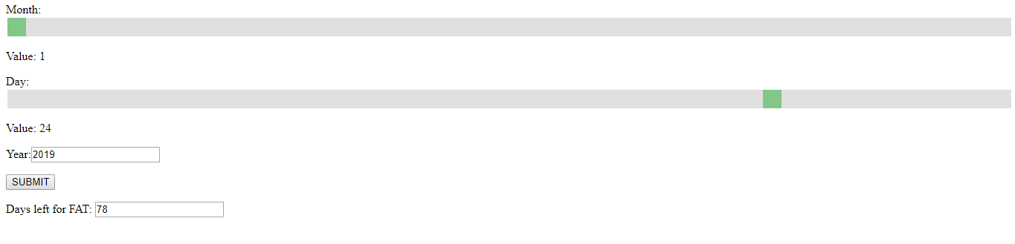

**OUTPUT :**

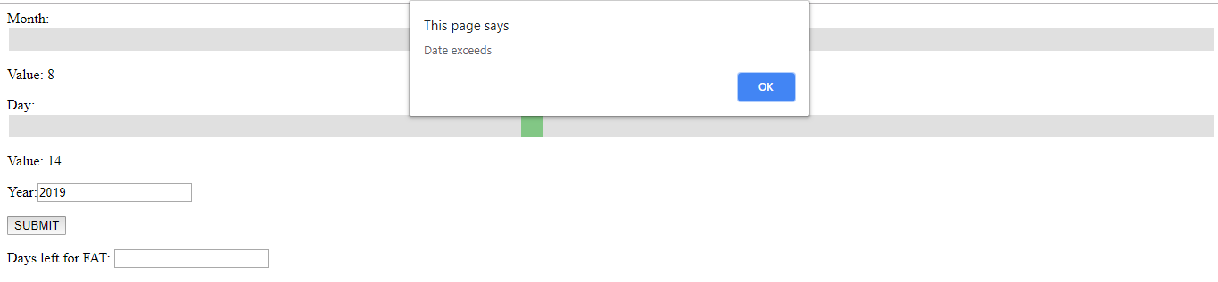

1. Pig Latin conversion for a given text

**CODE :**

<html>

<head>

<title>Pig Latin Converter</title>

<script>

function Convert() {

var Input = document.getElementById("Input").value;

var Inp = Input.toLowerCase().split("");

var PigLatinWord = document.getElementById("PigLatinWord");

var FirstLetter = Inp[0].toLowerCase();

Inp[0] = Inp[0].toLowerCase();

var Output;

var Goutput;

if(FirstLetter != "a" && FirstLetter != "e" && FirstLetter != "i" && FirstLetter != "o" && FirstLetter != "u") {

Inp.splice(0, 1);

Inp.push(FirstLetter);

Output = Inp.join("") + "ay";

Goutput = Output.toLowerCase();

PigLatinWord.innerHTML = Goutput;

} else {

Output = Inp.join("") + "way"

Goutput = Output.toLowerCase();

PigLatinWord.innerHTML = Output;

}

}</script>

</head>

<body bgcolor="#00FFFF">

<p id="title">PIG LATIN CONVERTER</p>

<input id="Input" placeholder="Input English Word Here">

<button id="Convert" onclick="Convert()">Convert</button>

<p id="PigLatinWord"></p>

</body>

</html>

**OUTPUT :**

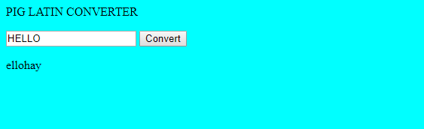

1. Create an editor with minimum of three tabs as it appears in a text editor

**CODE :**

<html>

<head>

<meta http-equiv="Content-Type" content="text/html; charset=utf-8">

<title>Text editor</title>

<link rel="stylesheet" type="text/css" href="style.css" />

<script type="text/javascript">

function view_text () {

var textArea = document.getElementById('my_text');

var div = document.getElementById('view_text');

var text = textArea.value;

text = text.replace(/\</gi, "<");

text = text.replace(/\>/gi, ">");

text = text.replace(/\n/gi, "<br />");

text = text.replace(/\[b\]/gi, "<b>");

text = text.replace(/\[\/b\]/gi, "</b>");

text = text.replace(/\[i\]/gi, "<i>");

text = text.replace(/\[\/i\]/gi, "</i>");

text = text.replace(/\[u\]/gi, "<u>");

text = text.replace(/\[\/u\]/gi, "</u>");

div.innerHTML = text;

}

function mod_selection (val1,val2) {

var textArea = document.getElementById('my_text');

if( -1 != navigator.userAgent.indexOf ("MSIE") ) {

var range = document.selection.createRange();

var stored_range = range.duplicate();

if(stored_range.length > 0) {

stored_range.moveToElementText(textArea);

stored_range.setEndPoint('EndToEnd', range);

textArea.selectionstart = stored_range.text.length - range.text.length;

textArea.selectionend = textArea.selectionstart + range.text.length;

}

}

if (typeof(textArea.selectionstart) != "undefined") {

.

var begin = textArea.value.substr(0, textArea.selectionstart);

var selection = textArea.value.substr(textArea.selectionstart, textArea.selectionend - textArea.selectionstart);

var end = textArea.value.substr(textArea.selectionend);

textArea.value = begin + val1 + selection + val2 + end;

}

}

</script>

</head>

<body>

<input type="button" value="B" onclick="mod_selection('[b]','[/b]')" />

<input type="button" value="I" onclick="mod_selection('[i]','[/i]')" />

<input type="button" value="U" onclick="mod_selection('[u]','[/u]')" />

<br/>

<textarea class="text_edit" id="my_text"></textarea>

<br />

<input type="button" value="Show text" onclick="view_text()" />

<div id="view_text">

</div>

</body>

</html>

