**IWP LAB**

HARSHIL GUPTA

17BCE1112

**DATE:**7/02/2019

**Q1)** Create a class named BankAccount with the necessary detail and do the following:

* Write an instance method transfer that moves money from this bank account to another account. The method takes two parameters: a BankAccount to accept money, and a real number for the amount to transfer. There is a $5.00 fee for transferring, to be deducted from the current account's balance.
* The method should modify the two objects such that "this" has its balance decreased by the given amount plus $5 fee, and the other's balance is increased by the given amount. A transfer also counts as a transaction on both accounts. If this account object does not have enough money to make the full transfer, transfer whatever money is left after the $5 fee is deducted. If this account has under $5 or the amount is 0 or less, no transfer should occur and neither account's state should be modified.

**CODE**

<html>

<head>

<title> Bank transfer</title>

<style>

body

{ background-color:#E8E3E3;

font-family:Arial;

font-size:20px;

}

p{

text-align: center;

margin-top: 100px;

}

input[type=text]

{ padding:12px 20px;

font-size:20px;

}

h1

{ color:#B03838;

}

</style>

</head>

<body>

<h1><center>BANK TRANSFER</center></h1>

<hr>

<p>

From: <input type="text" id="from"></input><br><br>

To: <input type="text" id="to"></input><br><br>

Amount: <input type="text" id="amount"></input><br><br>

<button type="button" onClick="transfer()"> Transfer! </button><br>

Account: <span id="output"></span><br><br>

Initial balance: 1000$ <br><br>

Final Balance: <span id="output1" ></span>

</p>

<script>

function transfer()

{

var x=document.getElementById("from").value;

var y=document.getElementById("to").value;

var z=document.getElementById("amount").value;

document.getElementById("output").innerHTML=x

if(parseInt(c)<996)

{

var d=1000 - (parseInt(z)+5);

document.getElementById("output1").innerHTML=d

}

else

{

document.getElementById("output1").innerHTML="Can't transfer";

}

}

</script>

</body>

</html>

**OUTPUT**

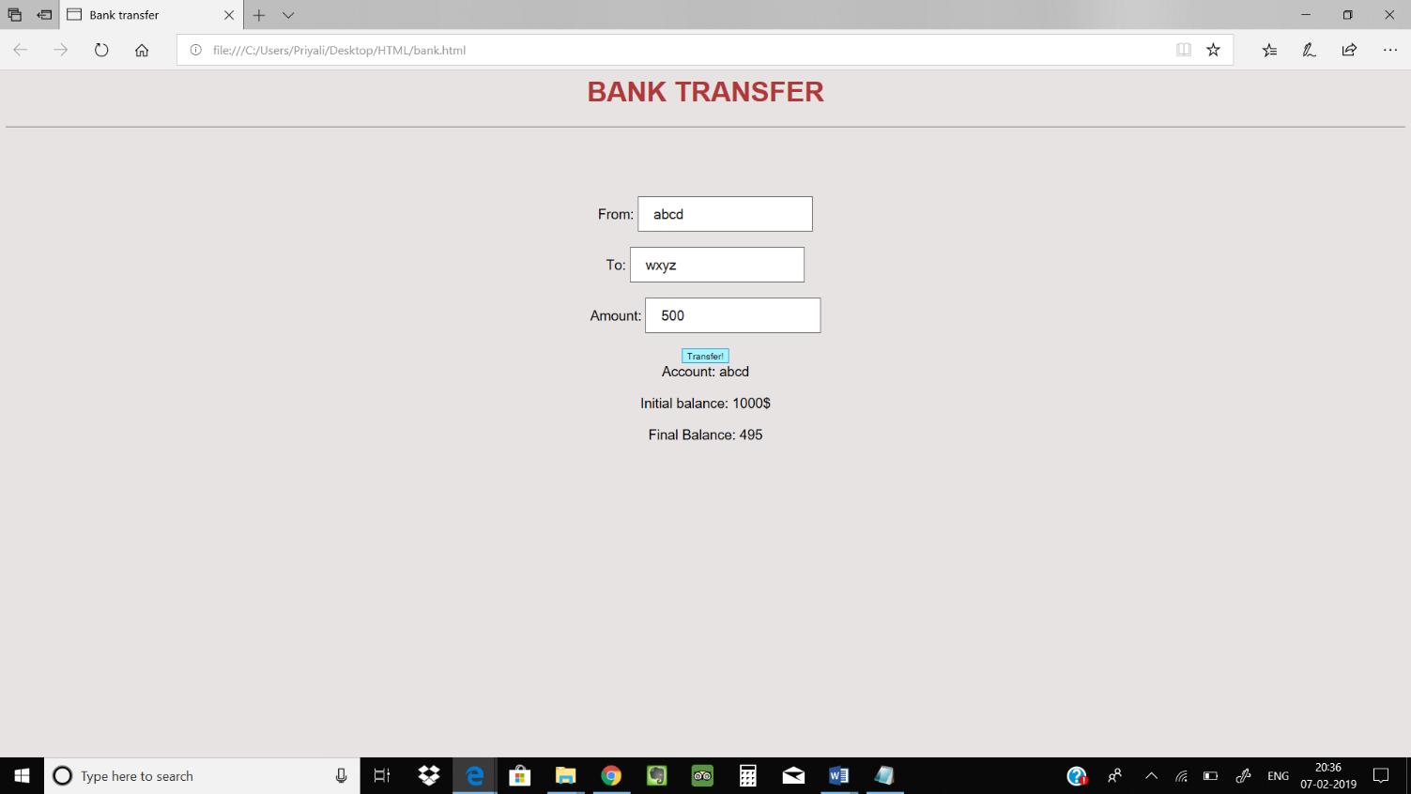

**Q2)** Create a very simple form that executes some JavaScript.

1. Create [a basic page in html](http://www.webhammer.com/javascript/exercises/blank_html_page.html) that consists of a form input button. Do not use a submit button, because this button will not submit anywhere that needs to be processed.
2. When the user clicks on the input button, change the background to "blue" using the document.bgColor property and the onClick Event Handler...

**CODE**

<html>

<head>

<title>Background</title>

<style>

body

{ background-color:#E8E3E3;

font-family:Arial;

font-size:20px;

}

p{

text-align: center;

margin-top: 100px;

}

input[type=text], input[type=date], input[type=integer]

{ padding:12px 20px;

font-size:20px;

}

h1

{ color:#DC80AE;

}

</style>

</head>

<body>

<h1>Hello World!</h1>

<hr>

<form method="Post">

Name:<input type="text" name="name" value=""><br><br>

DOB:<input type="date" name="dob" value=""><br><br>

Age:<input type="integer" name="age" value=""><br><br>

<button type="button" onclick="myFunction()">CLICK</button>

</form>

<script>

function myFunction() {

document.body.style.backgroundColor = "#72B5D7";

}

</script>

</body>

</html>

**OUTPUT**

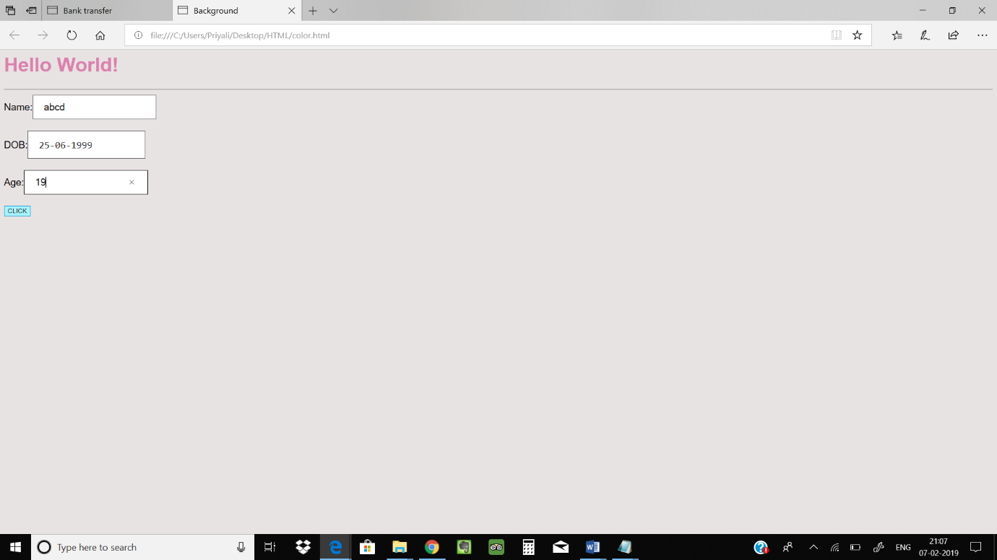

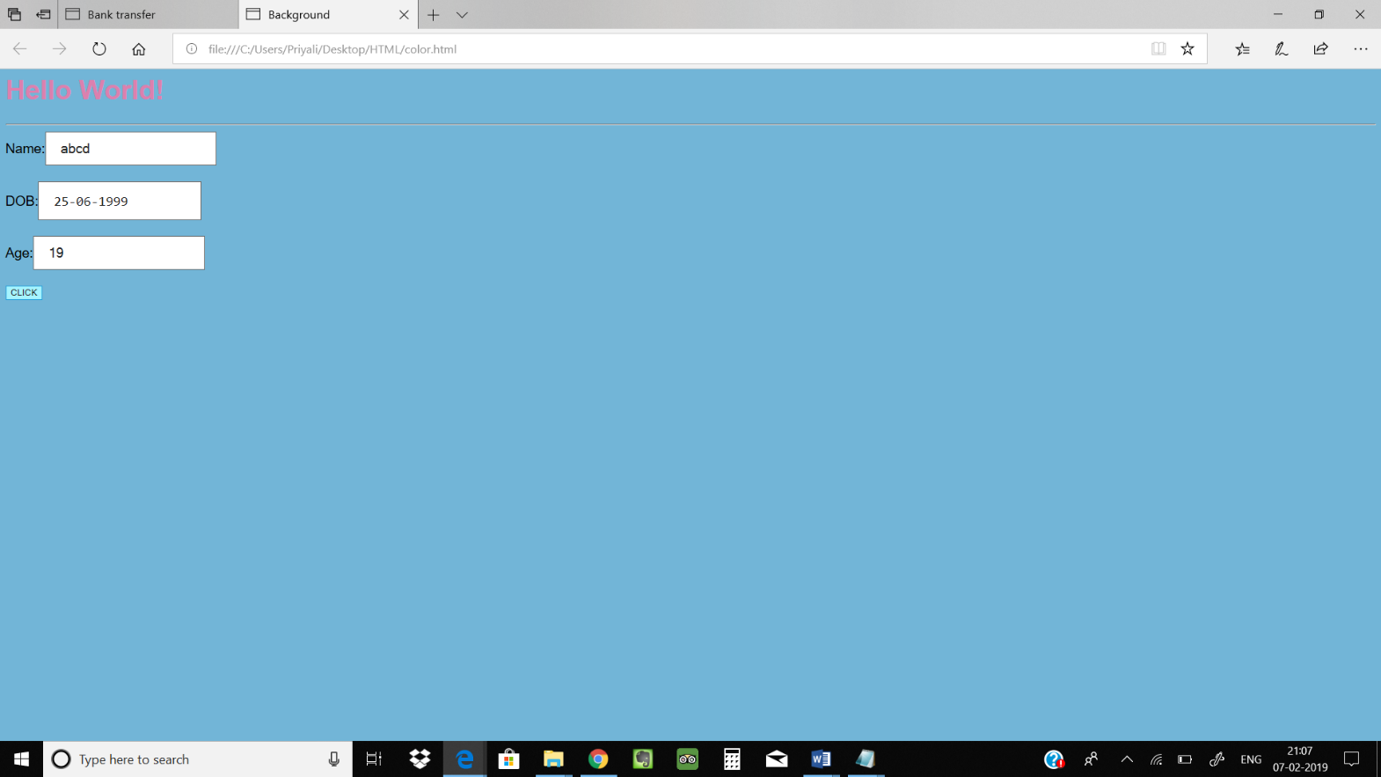

**Q3)** Your web page will have two frames. It will consist of two rows, a top frame and a bottom frame. The top frame will consist of a web page that is an interactive practice quiz for the first two weeks material in 810:088. It will have a total of 8 questions. There will be three true/false questions. Use the checkbox control to represent answering FALSE when it is unchecked and answering TRUE when it is checked. There will be two multiple choice questions. Use Radio Buttons to implement the 4 or 5 multiple choice answers for each question. There will be three fill in the blank questions. They should be one or two word short answer. If the answer to a question was Panthers, it should not matter whether the user typed panthers, PANTHERS, pANTHERS, or Panthers when your JavaScript code grades their quiz.

When the user clicks the Grade Quiz (or Grade Em) button, the results of their quiz will be posted or written to the bottom frame. Just tell the user how many answers they got correct. You do not need to tell them which questions they got right and which ones they got wrong. Obviously, their goal is to get 8 out of 8 correct.

When the quiz is graded, greet the user by their name. Examples:

Way to go, XXXX.  You got 7 out of 8 correct.

Keep trying XXXXX.  You answered 4 out of 8 correctly.

Do not give up.  You can DO it, Carlos.  You got 2 of 8 okay.

**CODE**

**quizf.html**

<html>

<head>

<title>810:080 JavaScript practice questions (12/14/2001)</title>

</head>

<frameset rows="84%,16%">

<frame src="quiz1.html" name="topFrame">

<frame src="quiz2.html" name="message">

</frameset>

</html>

**quiz1.html**

<html>

<head>

<title>Selection menus in Frame</title>

<script language="JavaScript" type="TEXT/JAVASCRIPT" src="mylibrary.js">

</script>

<script language="JavaScript" type="TEXT/JAVASCRIPT">

<!-- Hide script from old historical browsers

var windowER;

var windowUNI;

var partitionWindow;

function checkAnswers() {

var score = 0;

for (i=1; i<4; i++) {

ans = getSelectValue("quiz","q" + i);

if (ans == answers[i]) {

score++;

}

}

if ( equivalenceRelationsOK() )

{

score++;

}

if ( posetsOK() )

{

score++;

}

if (document.quiz.partitionsOf4.value == question6answer) {

score++;

}

score = score + questions7to14Points();

parent.message.scorefield.value = score;

}

function newWindow()

{

partitionWindow = window.open("../080/partitions.gif",

"partitionsWindow",

"width=600,height=600");

}

function newWindowER()

{

windowER = window.open("../080/partitionsToER.gif",

"windowER",

"width=600,height=600");

}

function closeExtraWindows()

{

if (windowER != null)

{

windowER.close();

}

if (windowUNI != null)

{

windowUNI.close();

}

if (partitionWindow != null)

{

partitionWindow.close();

}

}

function newWindowUNI()

{

windowUNI = window.open("animationBinaryRelationsVer2.html",

"windowUNI",

"width=500,height=450");

}

//-->

</script>

</head>

<body bgcolor="#DC80AE" onUnload="closeExtraWindows();">

<form name="quiz">

<OL>

<LI>How many different <A HREF="javascript:newWindow()">partitions</A>

exist for a set with cardinality 3?

<BR>

<SELECT NAME="q1">

<OPTION SELECTED>Choose

<OPTION VALUE="3">3

<OPTION VALUE="4">4

<OPTION VALUE="5">5

<OPTION VALUE="6">6

<OPTION VALUE="7">7

</SELECT>

<P>

<LI>What is the product of the floor(3.14159) * ceiling(-5.6)?

<BR>

<SELECT NAME="q2">

<OPTION SELECTED>Choose

<OPTION VALUE="-15">-15

<OPTION VALUE="-18">-18

<OPTION VALUE="-20">-20

<OPTION VALUE="-24">-24

</SELECT>

<P>

<LI>There are 12 presents under the tree. Gollum is told he can

pick any 1 or any 2 or any 3 presents? How many different

possibilities exist for what Gollum can have under these

circumstances?

<BR>

<SELECT NAME="q3">

<OPTION SELECTED>Choose

<OPTION VALUE="66">66

<OPTION VALUE="128">128

<OPTION VALUE="220">220

<OPTION VALUE="298">298

<OPTION VALUE="310">310

<OPTION VALUE="440">440

</SELECT>

<P>

<LI>What properties does an

<A HREF="javascript:newWindowER()">Equivalence Relation</A>

have?<BR>

<INPUT TYPE="checkbox" name="er1">Reflexive

<INPUT TYPE="checkbox" name="er2">Symmetric

<INPUT TYPE="checkbox" name="er3">Transitive

<INPUT TYPE="checkbox" name="er4">Antisymmetric

<P>

<LI>What properties does a POSET have?<BR>

<INPUT TYPE="checkbox" name="po1">Reflexive

<INPUT TYPE="checkbox" name="po2">Symmetric

<INPUT TYPE="checkbox" name="po3">Transitive

<INPUT TYPE="checkbox" name="po4">Antisymmetric

<P>

<LI>How many partitions of a 4 element set are possible?

<INPUT TYPE="text" name="partitionsOf4" size="6">

<HR NOSHADE>

Questions 7-14: <A HREF="javascript:newWindowUNI()">See the

animation</A> that questions 7 to 14 refer to.

<P>

<LI>Check all properties that the slide a. Binary Relation has?<BR>

<INPUT TYPE="checkbox" name="a1">Reflexive

<INPUT TYPE="checkbox" name="a2">Symmetric

<INPUT TYPE="checkbox" name="a3">Transitive

<INPUT TYPE="checkbox" name="a4">Antisymmetric

<P>

<LI>Check all properties that the slide b. Binary Relation has?<BR>

<INPUT TYPE="checkbox" name="b1">Reflexive

<INPUT TYPE="checkbox" name="b2">Symmetric

<INPUT TYPE="checkbox" name="b3">Transitive

<INPUT TYPE="checkbox" name="b4">Antisymmetric

<P>

<LI>Check all properties that the slide c. Binary Relation has?<BR>

<INPUT TYPE="checkbox" name="c1" CHECKED>Reflexive

<INPUT TYPE="checkbox" name="c2" CHECKED>Symmetric

<INPUT TYPE="checkbox" name="c3" CHECKED>Transitive

<INPUT TYPE="checkbox" name="c4" CHECKED>Antisymmetric

<P>

<LI>Check all properties that the slide d. Binary Relation has?<BR>

<INPUT TYPE="checkbox" name="d1">Reflexive

<INPUT TYPE="checkbox" name="d2">Symmetric

<INPUT TYPE="checkbox" name="d3">Transitive

<INPUT TYPE="checkbox" name="d4">Antisymmetric

<P>

<LI>Check all the slide e. properties?<BR>

<INPUT TYPE="checkbox" name="e1">Reflexive

<INPUT TYPE="checkbox" name="e2">Symmetric

<INPUT TYPE="checkbox" name="e3">Transitive

<INPUT TYPE="checkbox" name="e4">Antisymmetric

<P>

<LI>Check all properties that the slide f. Binary Relation has?<BR>

<INPUT TYPE="checkbox" name="f1">Reflexive

<INPUT TYPE="checkbox" name="f2">Symmetric

<INPUT TYPE="checkbox" name="f3">Transitive

<INPUT TYPE="checkbox" name="f4">Antisymmetric

<P>

<LI>Check all the slide g. properties?<BR>

<INPUT TYPE="checkbox" name="g1">Reflexive

<INPUT TYPE="checkbox" name="g2">Symmetric

<INPUT TYPE="checkbox" name="g3">Transitive

<INPUT TYPE="checkbox" name="g4">Antisymmetric

<P>

<LI>Check all the slide h. properties? <A

HREF="../080/transitiveConfusion.txt">Help on this question - useful

perhaps for MANY of the other Slides</A> too.<BR>

<INPUT TYPE="checkbox" name="h1">Reflexive

<INPUT TYPE="checkbox" name="h2">Symmetric

<INPUT TYPE="checkbox" name="h3">Transitive

<INPUT TYPE="checkbox" name="h4">Antisymmetric

</OL>

<P>

<H3>

<I>Check your task bar. Each link above opens up a NEW browser window.

If you click too soon on your maximized main browser window, the 2nd

window will be hidden behind it, if you have a maximized main

browser window. Use the task bar icon to get the link spawned window

to show up again.</I></H3>

</form>

</body>

</html>

**quiz2.html**

<html>

<head>

<title>JavaScript Frames (rows)</title>

</head>

<body bgcolor="#CEB57B">

<h3>

<INPUT TYPE="button" VALUE="Grade Quiz"

onclick="parent.topFrame.checkAnswers();">

&nbsp;

Your quiz score: <INPUT TYPE="text" name="scorefield" value="" size="10">

out of 14 possible.

</h3>

</body>

</html>

**OUTPUT**

