**IWP LAB SUBMISSION**

HARSHIL GUPTA

17BCE1112

QUE->Member Table : First name, Last name, Age, MovieId

Movie Table : MovieId, Title, Category

- Using PHP and MySQL retrieve the details of members who viewed a particular movieId

- Display the movie title most watched by

                        a) Members above 40 years of age

                        b) Between 18 yeas and 25 years

                        c) Below 18 years of age

CODE:

1)TABLE CREATION CODE:

<?php

$servername = "localhost";

$username = "root";

$password = "";

$dbname = "newDB";

// checking connection

$conn = new mysqli($servername, $username, $password, $dbname);

// Check connection

if ($conn->connect_error) {

die("Connection failed: " . $conn->connect_error);

}

// sql code to create table

$sql = "CREATE TABLE Member(

firstname VARCHAR(30) NOT NULL,

lastname VARCHAR(30) NOT NULL,

AGE INT(2),

MovieID INT(2)

)";

if ($conn->query($sql) === TRUE) {

echo "Table created successfully";

} else {

echo "Error creating table: " . $conn->error;

}

$conn->close();

?>

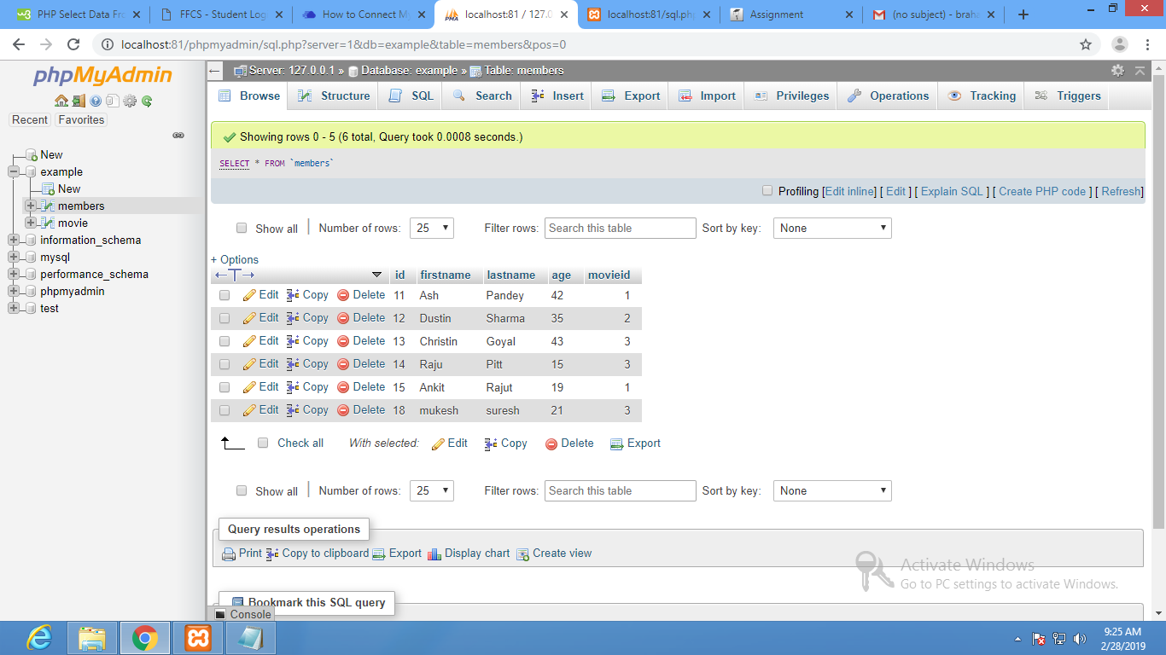

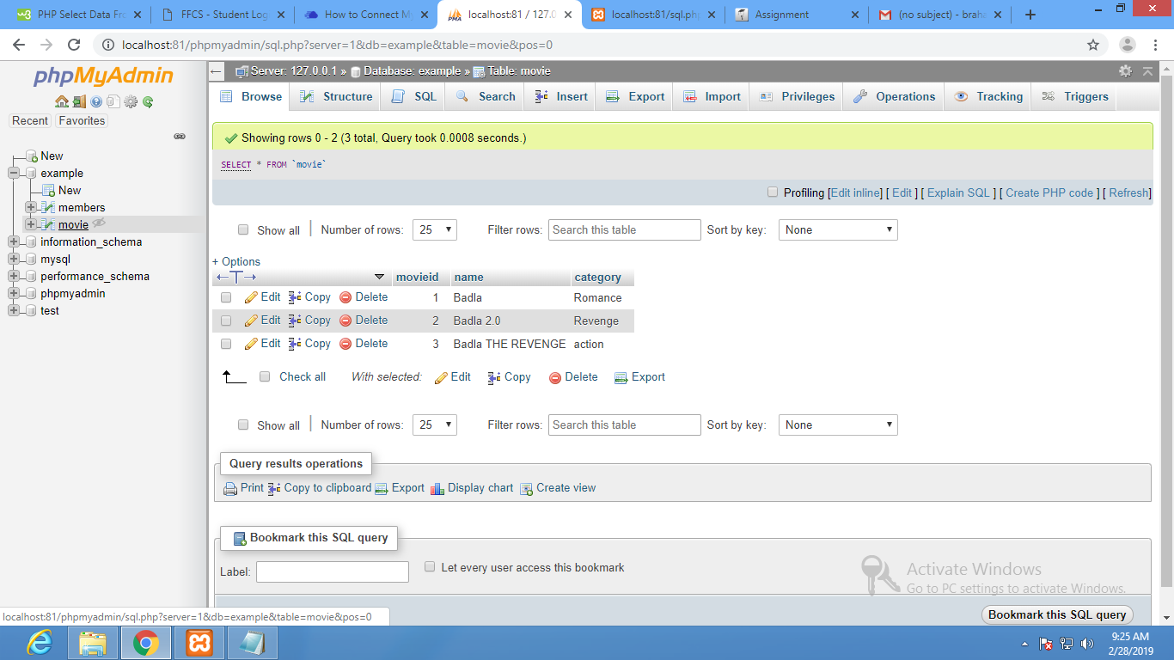

PART 1)

<?php

$servername = "localhost";

$username = "root";

$password = "";

$dbname = "example";

// checking connection

$conn = new mysqli($servername, $username, $password, $dbname);

// Check connection

if ($conn->connect_error) {

die("Connection failed: " . $conn->connect_error);

}

// sql code to create table

$sql = "select distinct*from movie left join members on movie.movieid=members.movieid where members.age >40;

$result = $conn->query($sql);

if ($result->num_rows > 0) {

// output data of each row

while($row = $result->fetch_assoc()) {

echo "MovieID: " . $row["movieid"]. "<br>Name: " . $row["name"]. "<br>Category " . $row["category"]. "<br>";

}

} else {

echo "0 results";

}

$conn->close();

?>

OUTPUT:

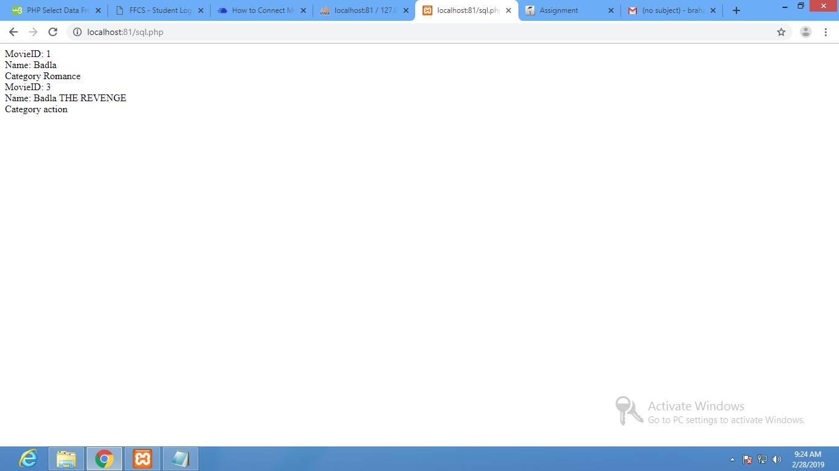

**PART 2)**

<?php

$servername = "localhost";

$username = "root";

$password = "";

$dbname = "example";

// checking connection

$conn = new mysqli($servername, $username, $password, $dbname);

// Check connection

if ($conn->connect_error) {

die("Connection failed: " . $conn->connect_error);

}

// sql code to create table

$sql = "select distinct*from movie left join members on movie.movieid=members.movieid where members.age < 18";

$result = $conn->query($sql);

if ($result->num_rows > 0) {

// output data of each row

while($row = $result->fetch_assoc()) {

echo "MovieID: " . $row["movieid"]. "<br>Name: " . $row["name"]. "<br>Category " . $row["category"]. "<br>";

}

} else {

echo "0 results";

}

$conn->close();

?>

OUTPUT:

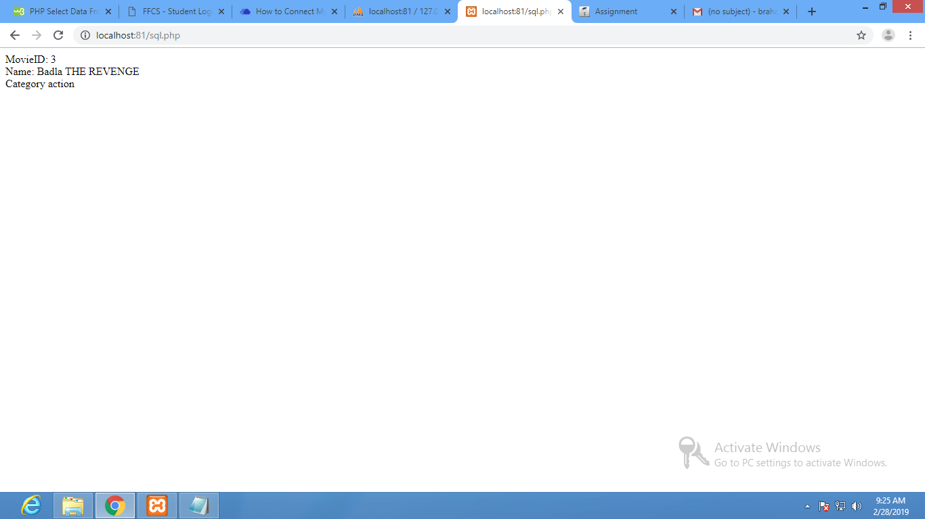

**PART 3)**

<?php

$servername = "localhost";

$username = "root";

$password = "";

$dbname = "example";

// checking connection

$conn = new mysqli($servername, $username, $password, $dbname);

// Check connection

if ($conn->connect_error) {

die("Connection failed: " . $conn->connect_error);

}

// sql code to create table

$sql = "select distinct*from movie left join members on movie.movieid=members.movieid where members.age between 18 and 25";

$result = $conn->query($sql);

if ($result->num_rows > 0) {

// output data of each row

while($row = $result->fetch_assoc()) {

echo "MovieID: " . $row["movieid"]. "<br>Name: " . $row["name"]. "<br>Category " . $row["category"]. "<br>";

}

} else {

echo "0 results";

}

$conn->close();

?>

**OUTPUT:**

