LAB Logbook

Lab 1

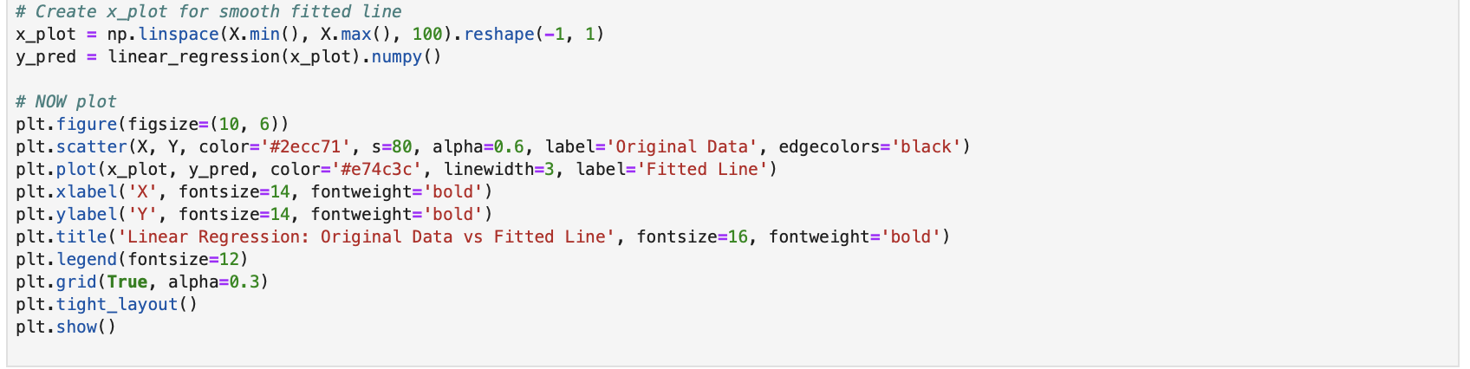
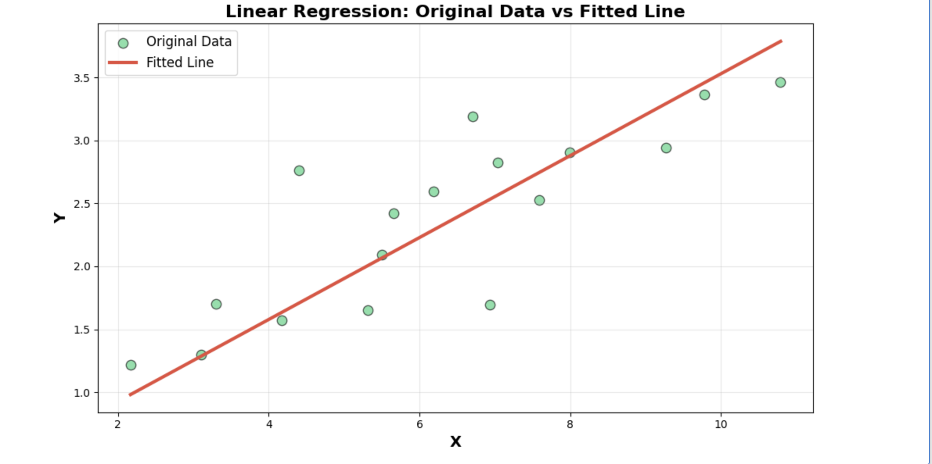

Lab 2
Test Accuracy: 0.95%.
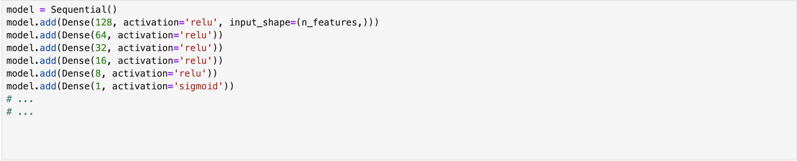
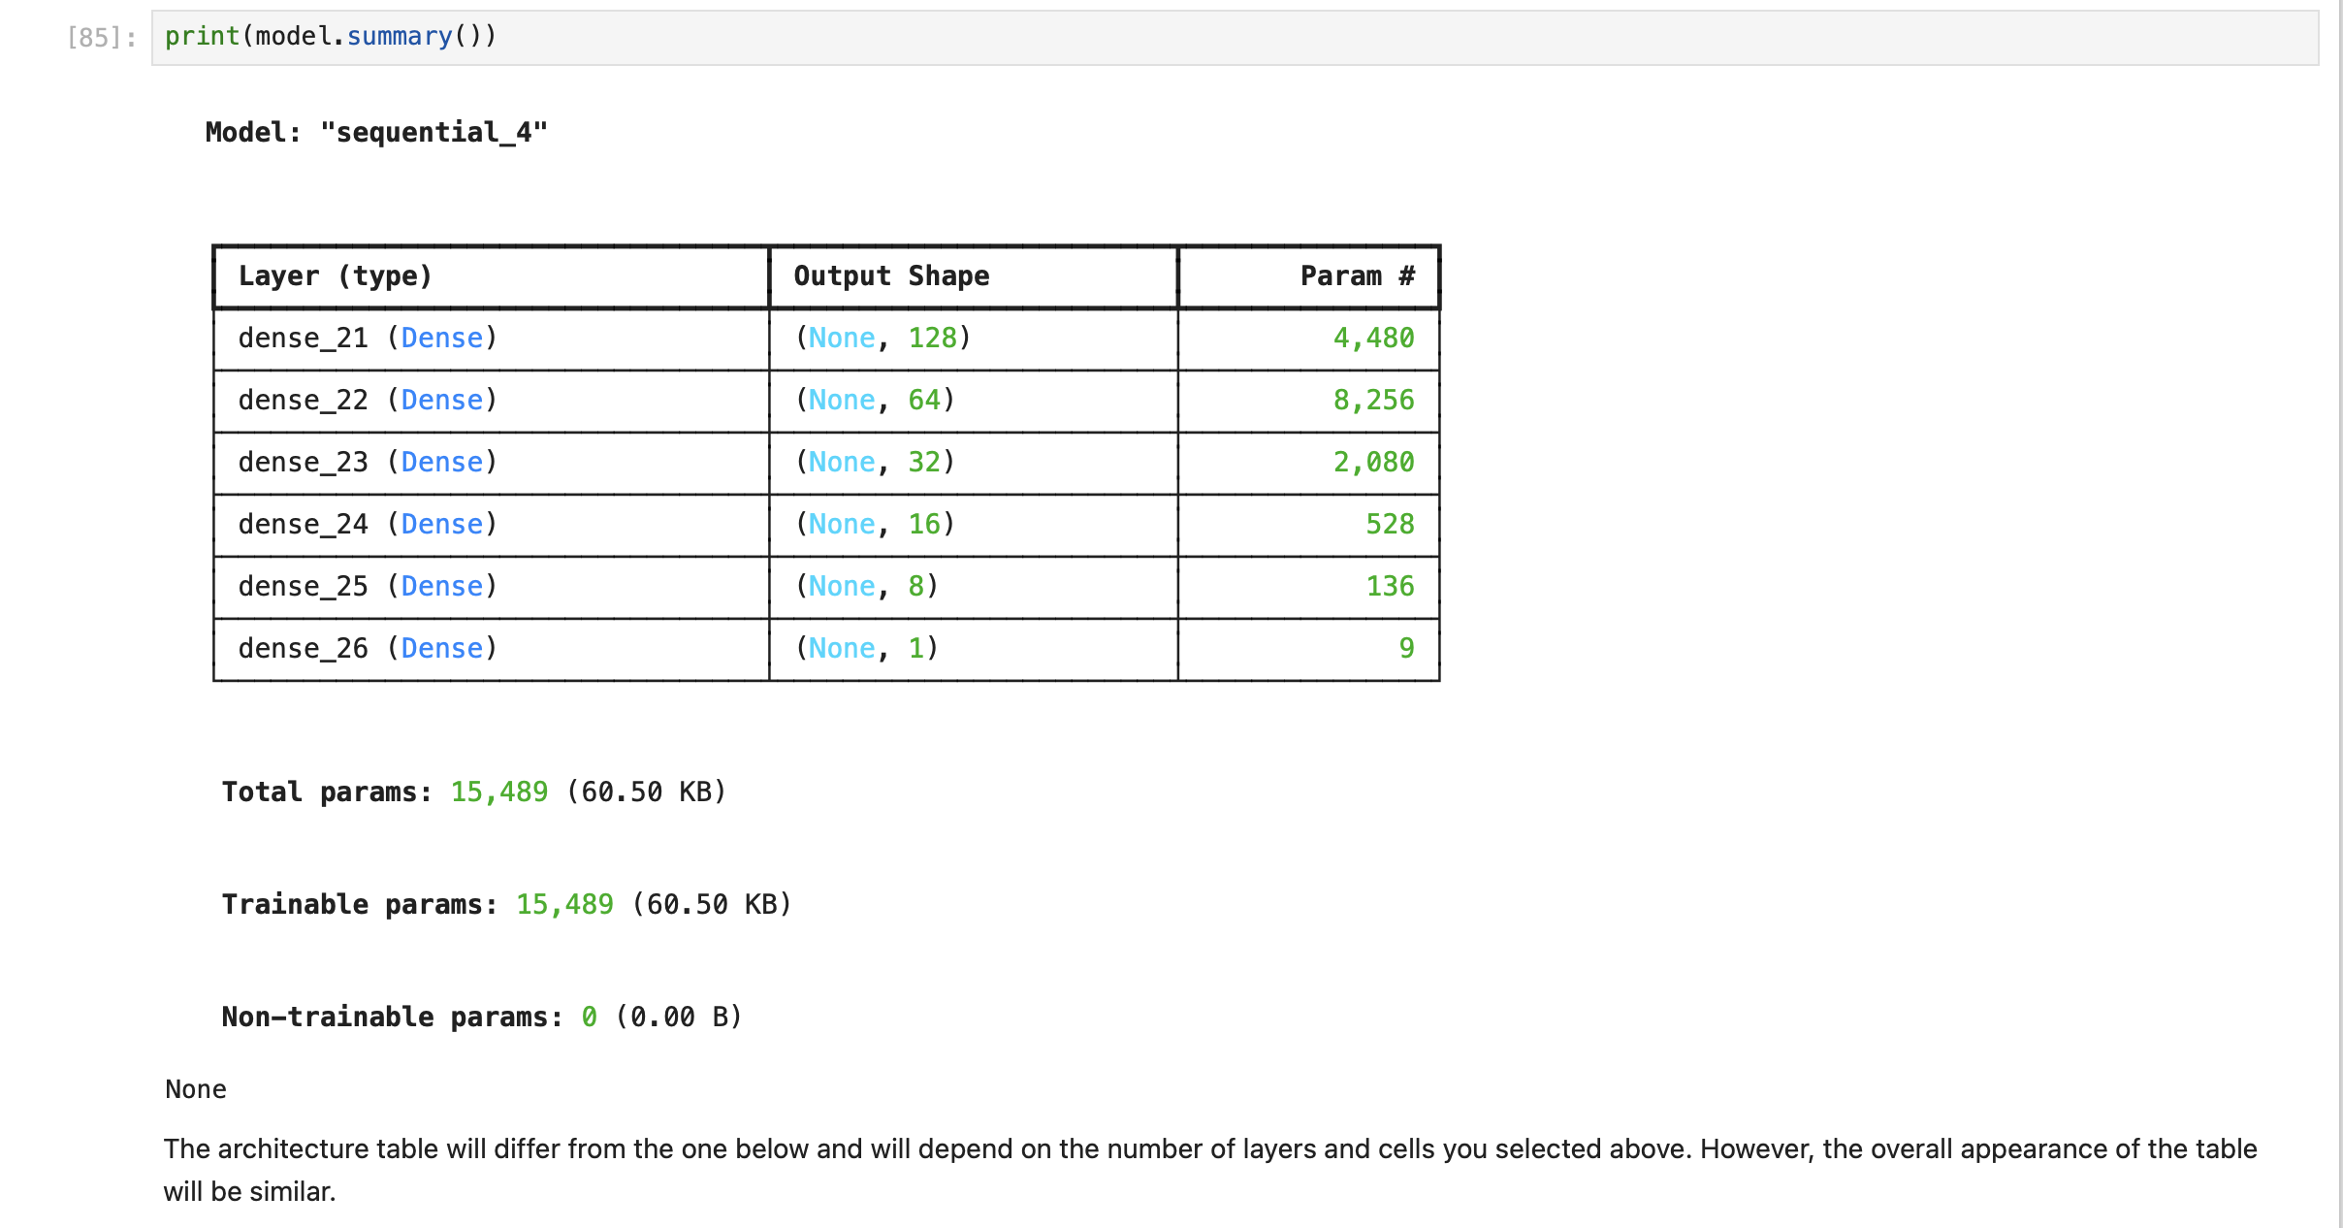

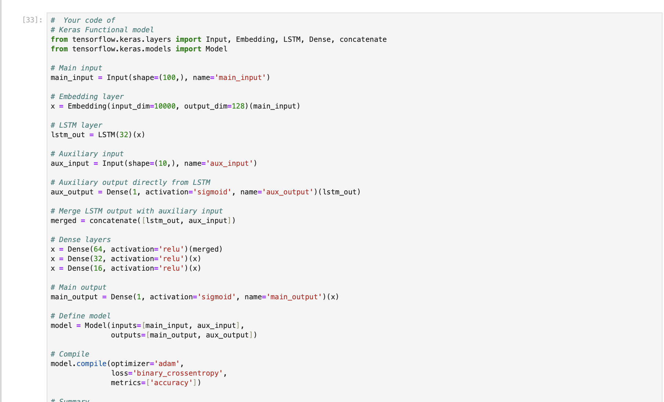
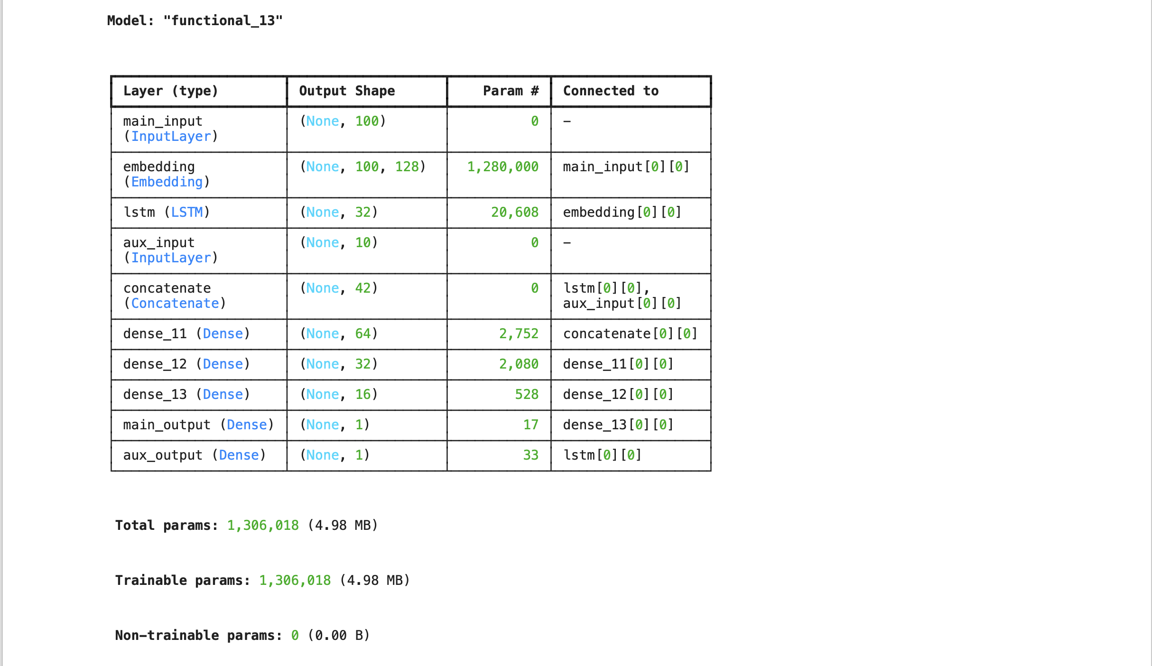

Lab 3
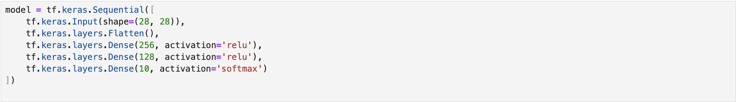
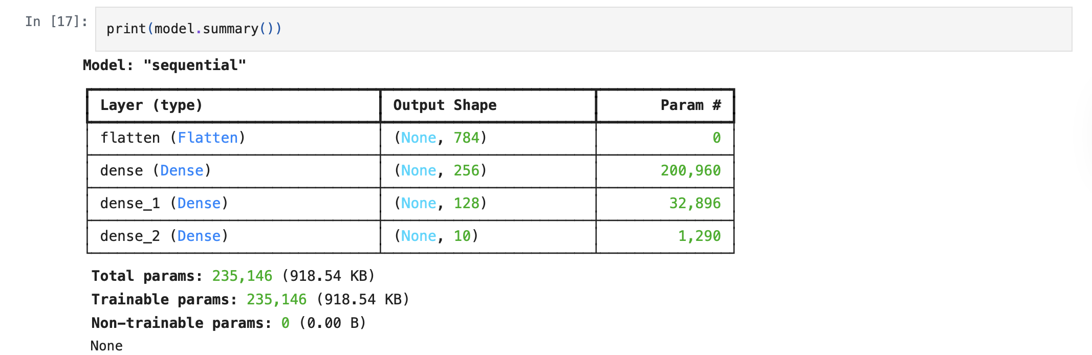
The test accuracy is 0.89%

Lab 4
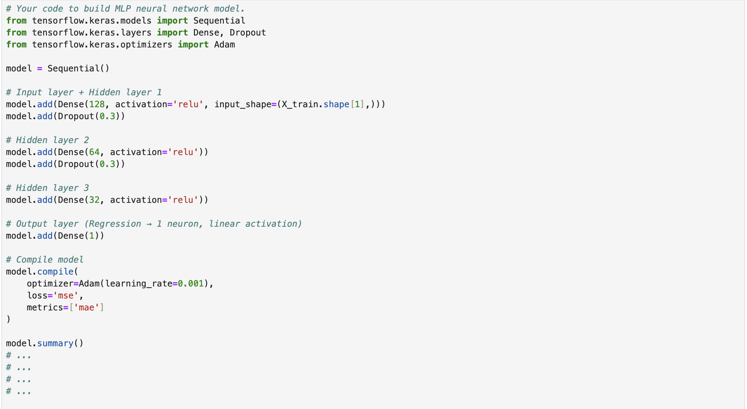
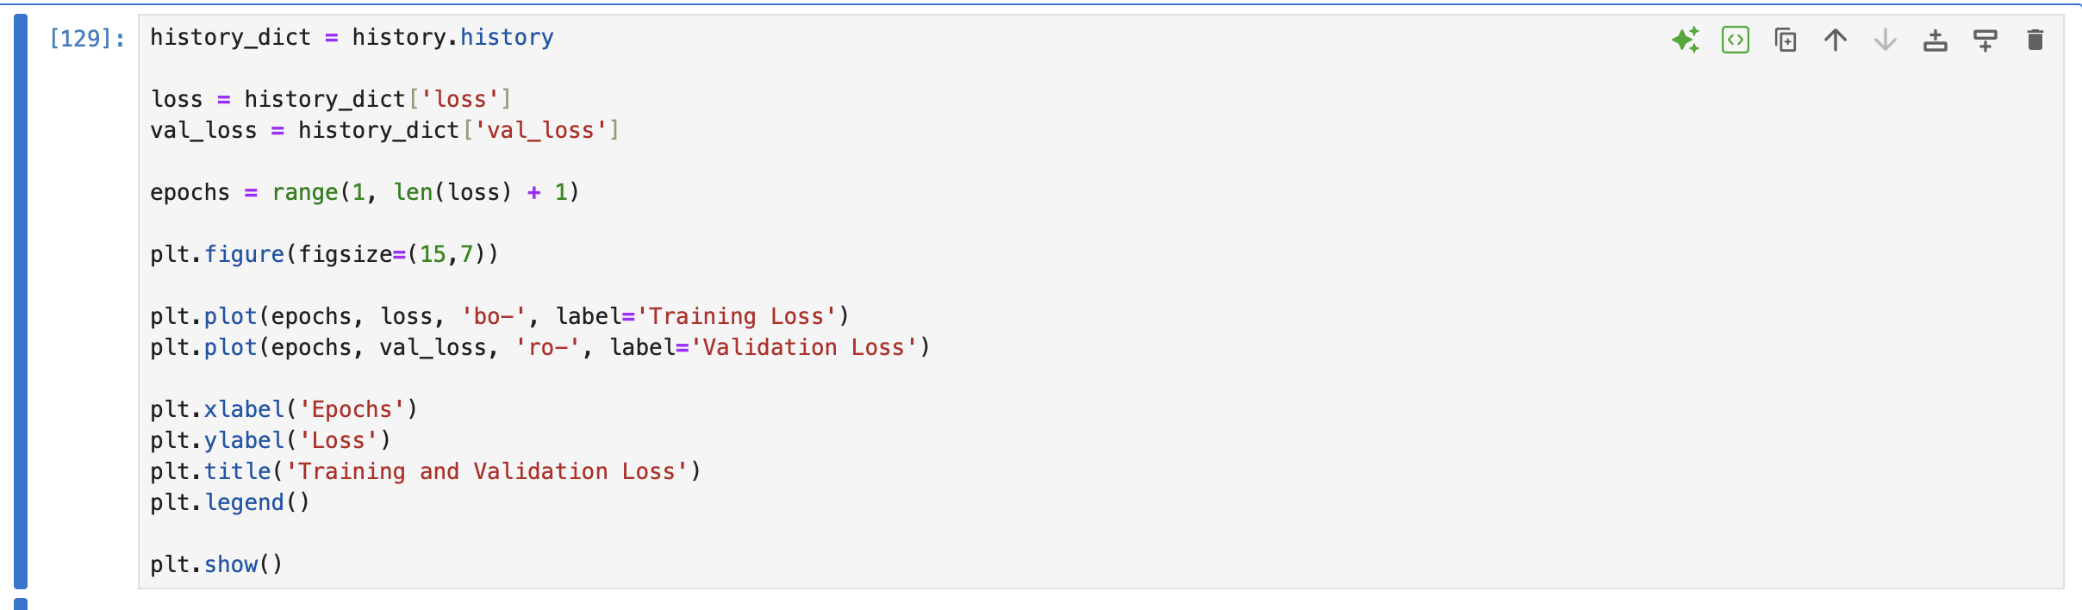
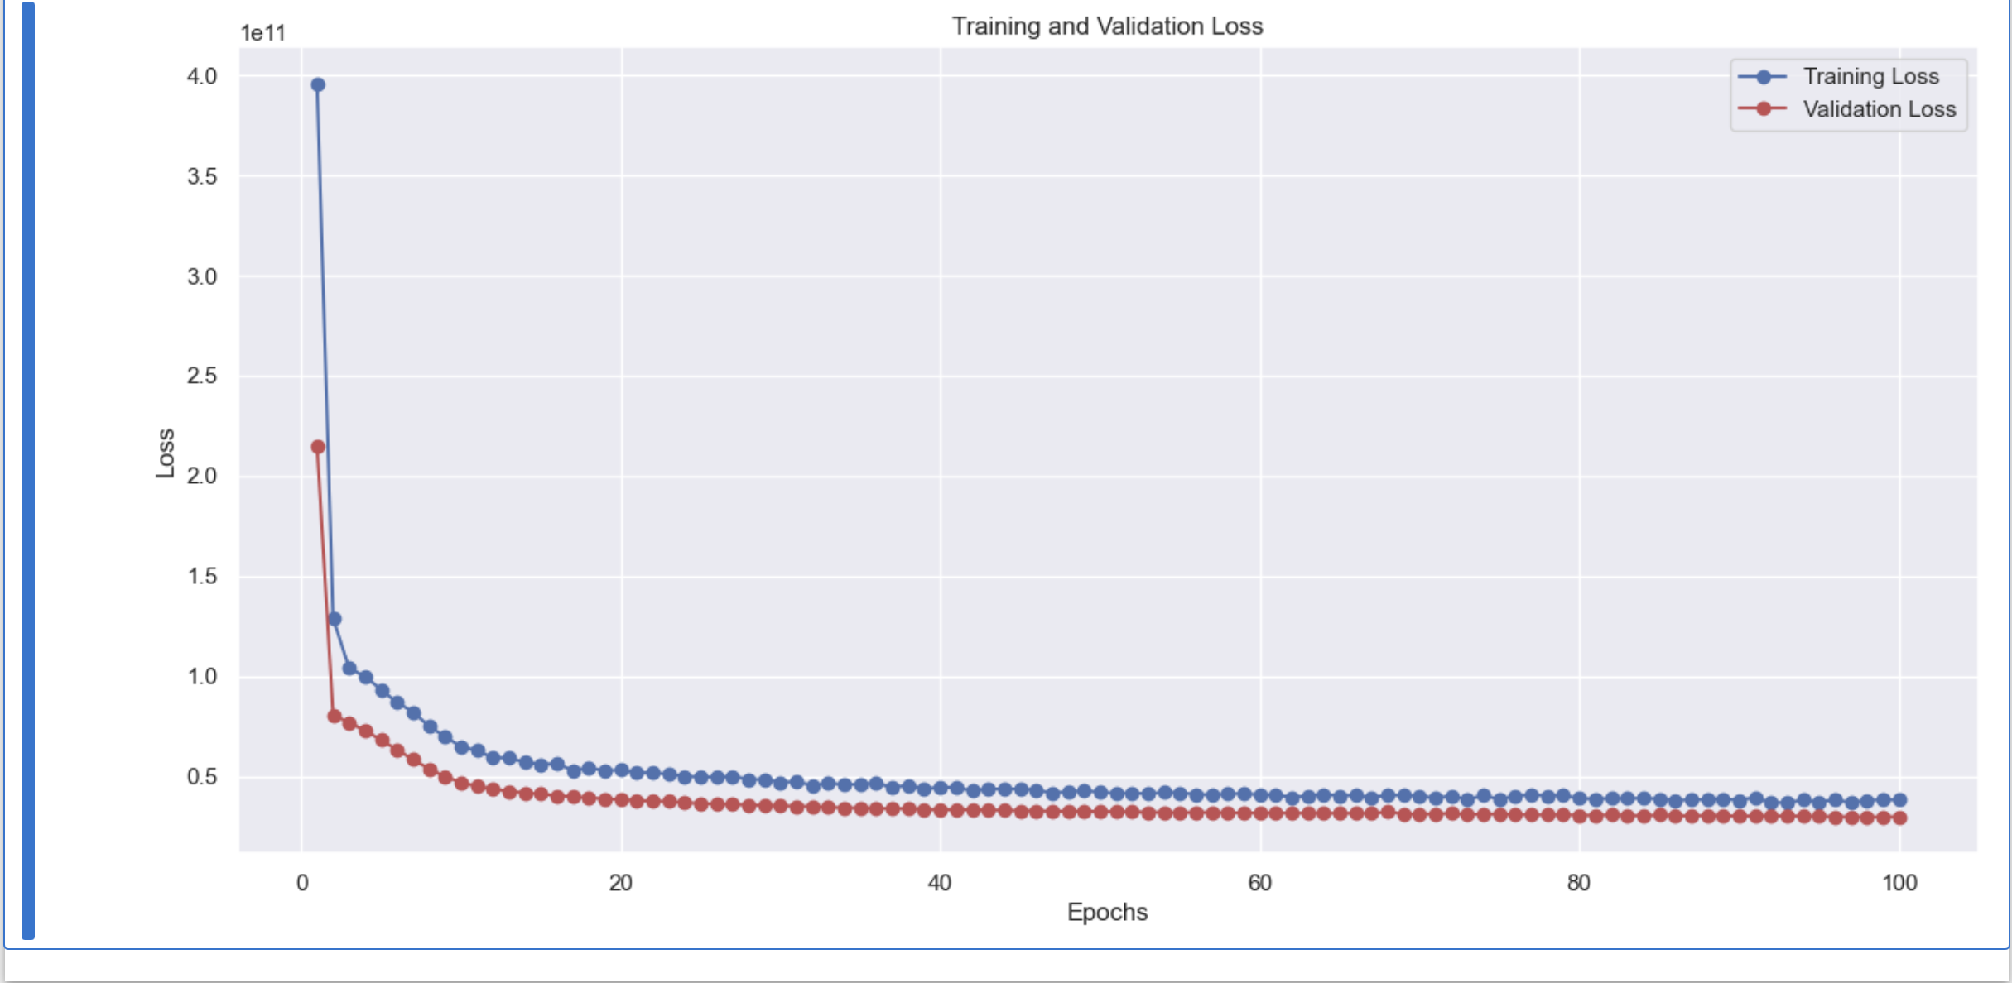
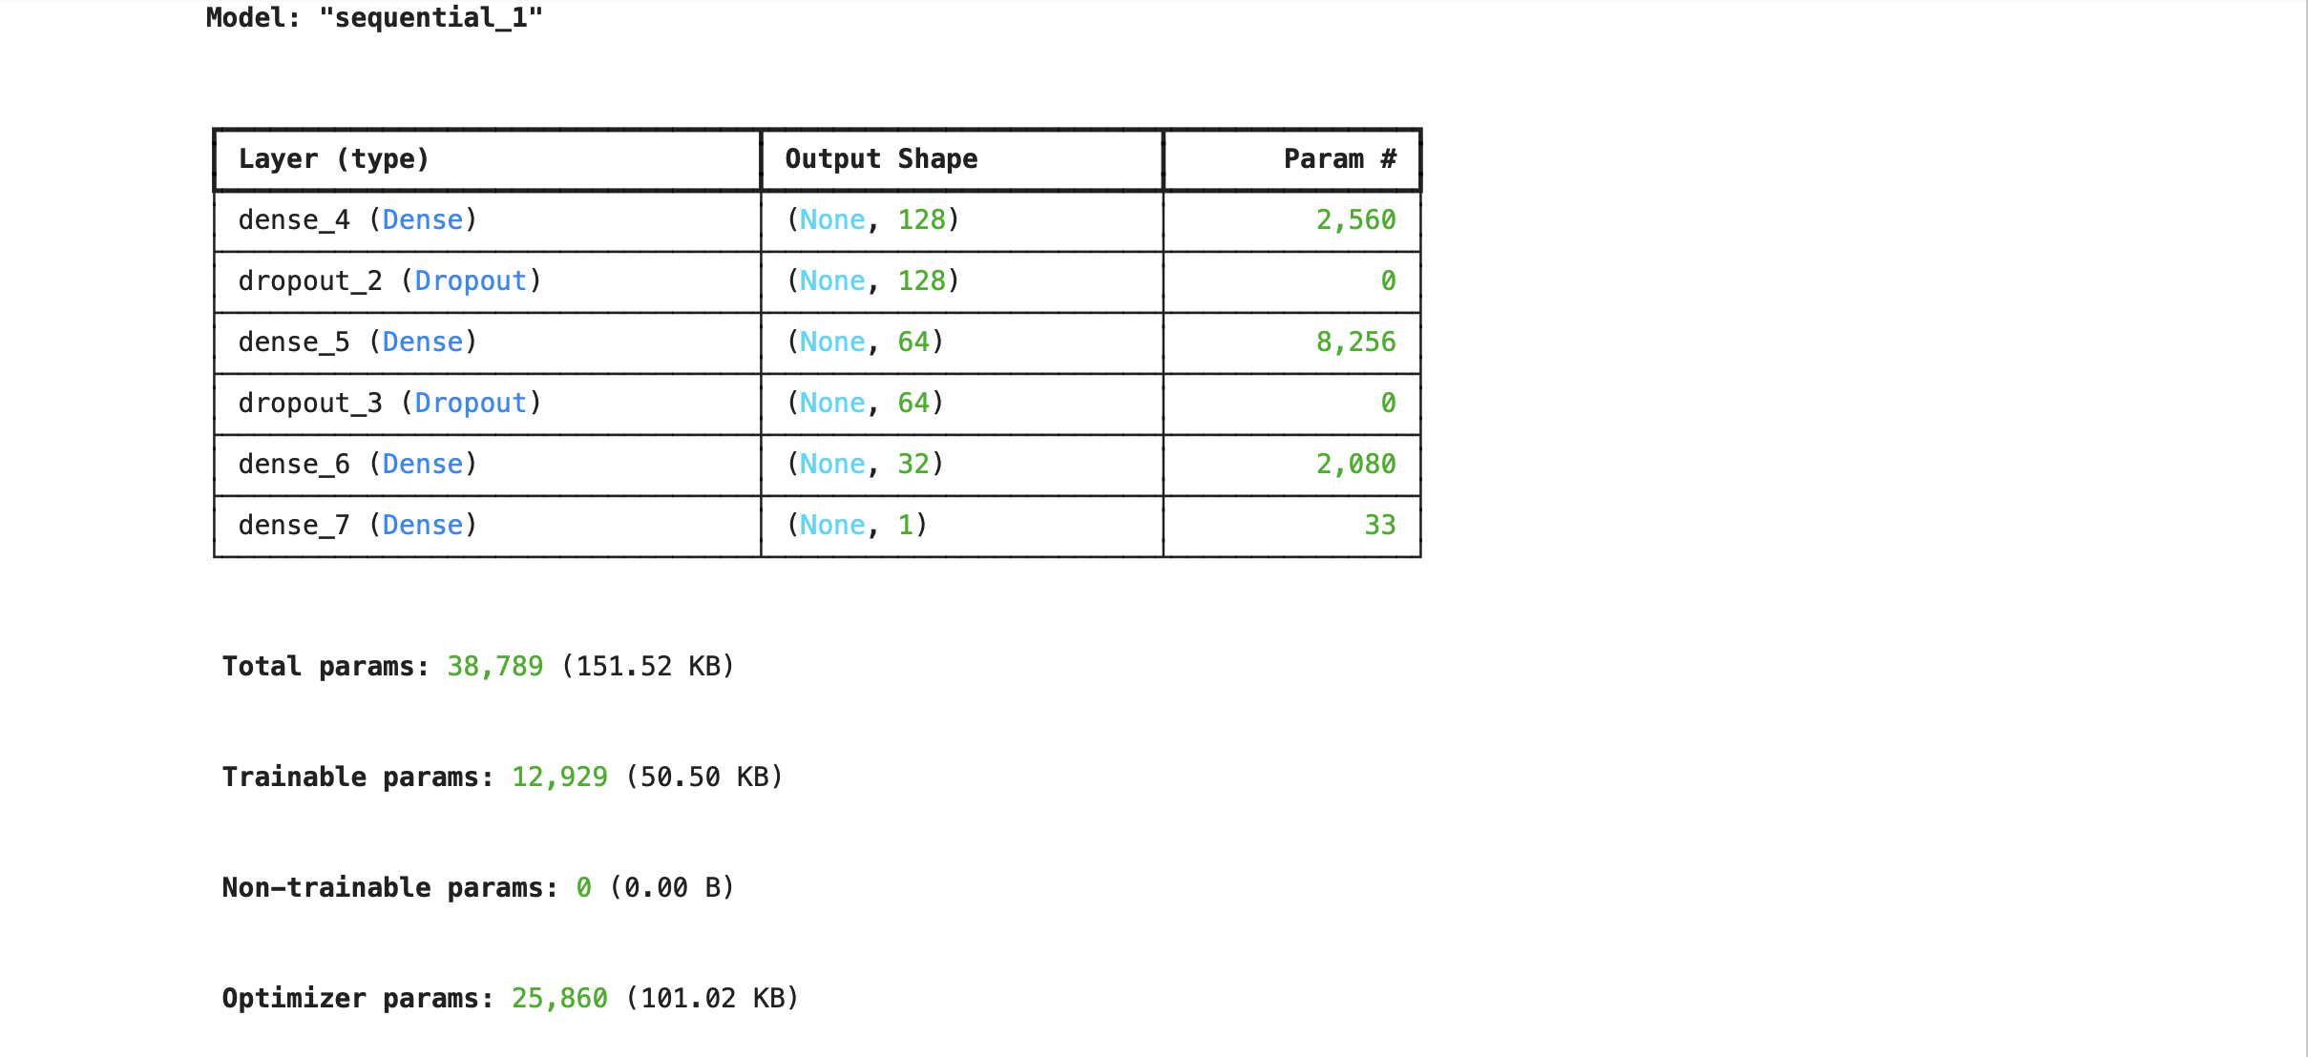
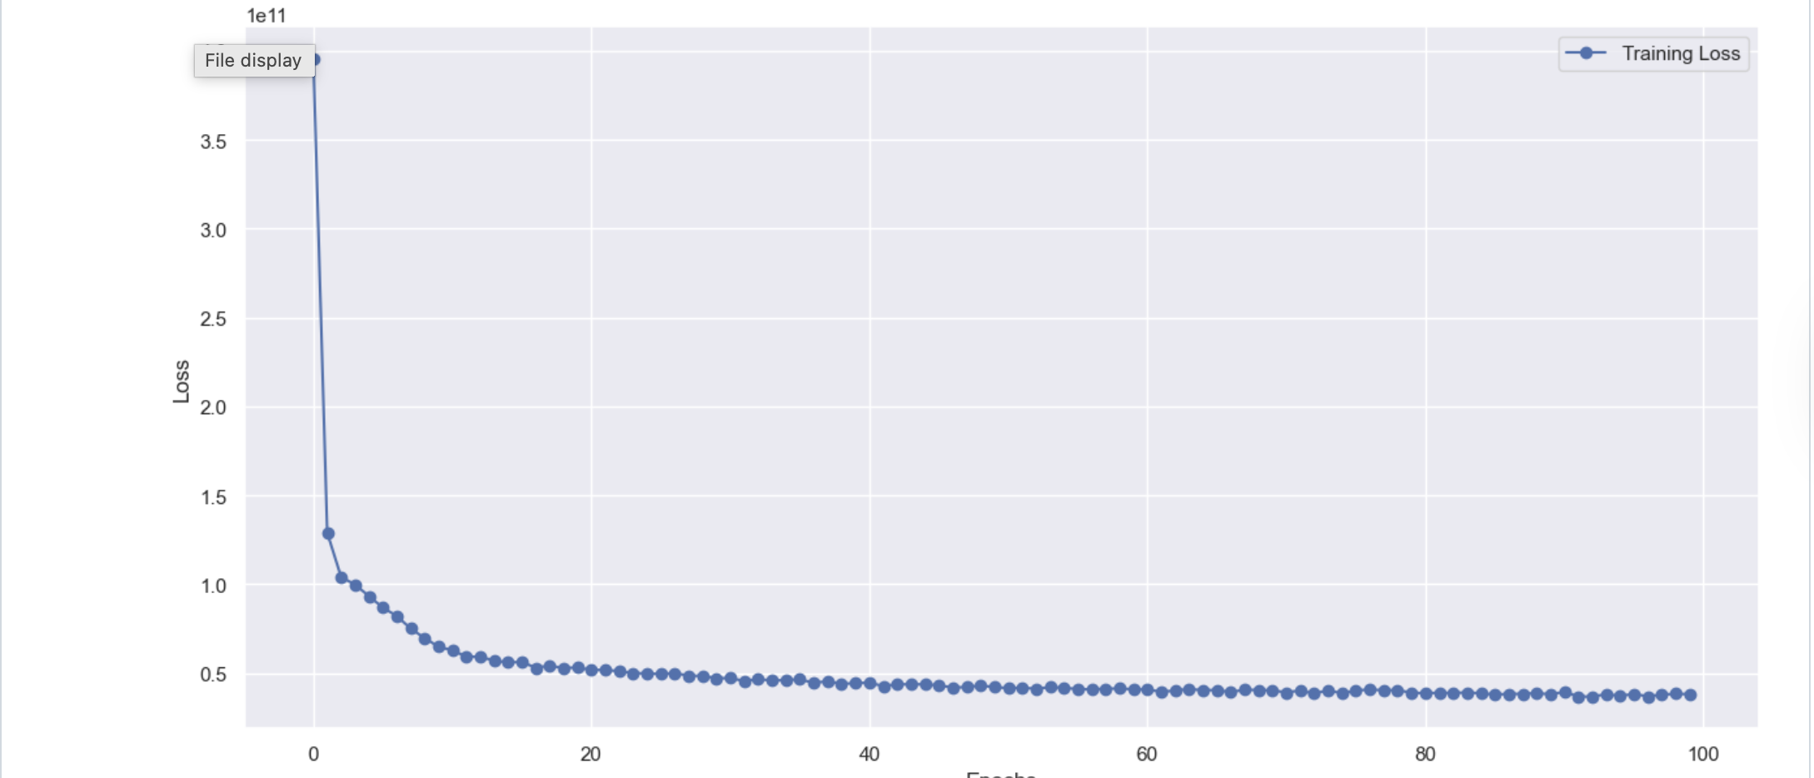

Lab 5

1. Plot of the model building code and model's summary
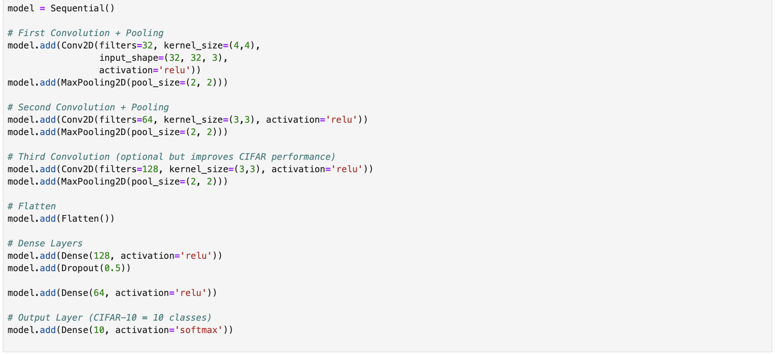
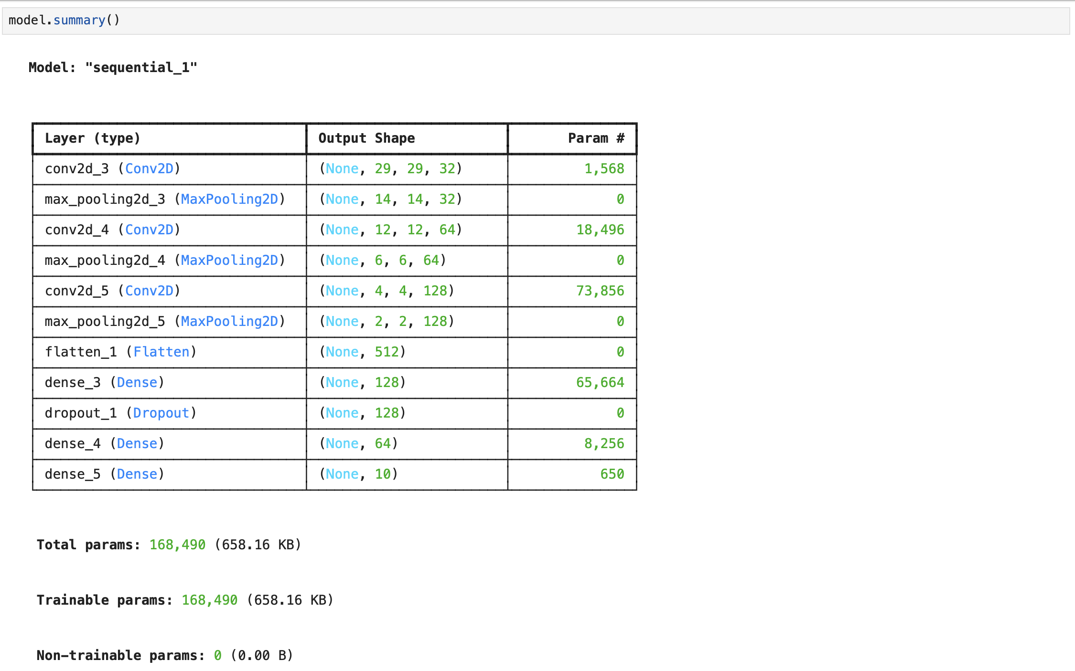

2. Please ensure to document in your laboratory logbook a graphical representation depicting the train loss and validation loss trends (4 graphs)

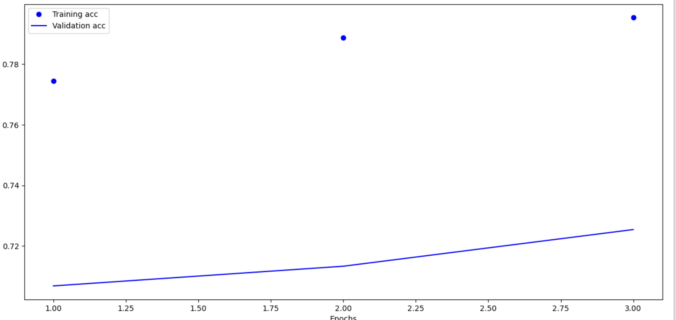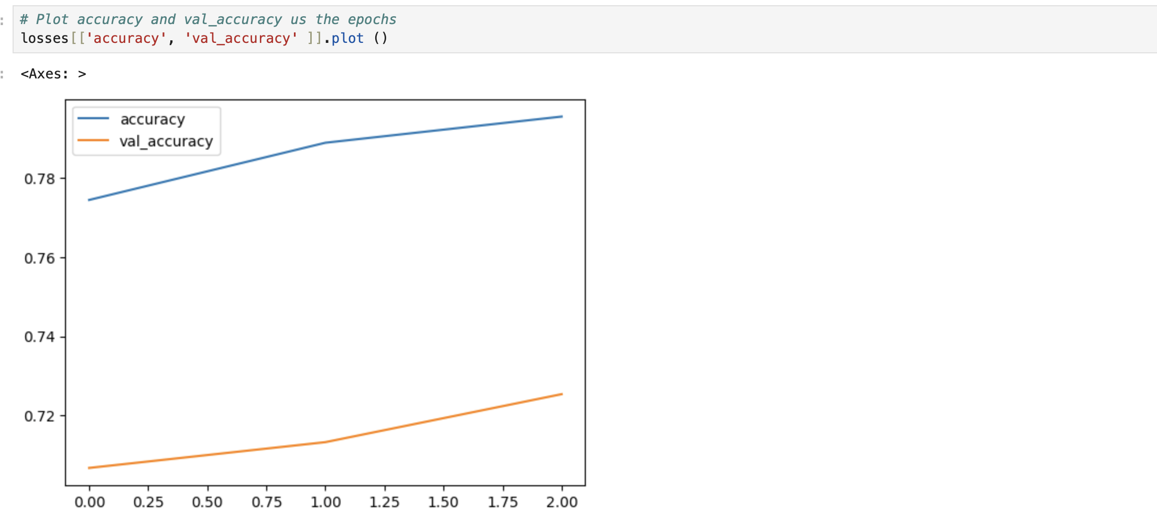
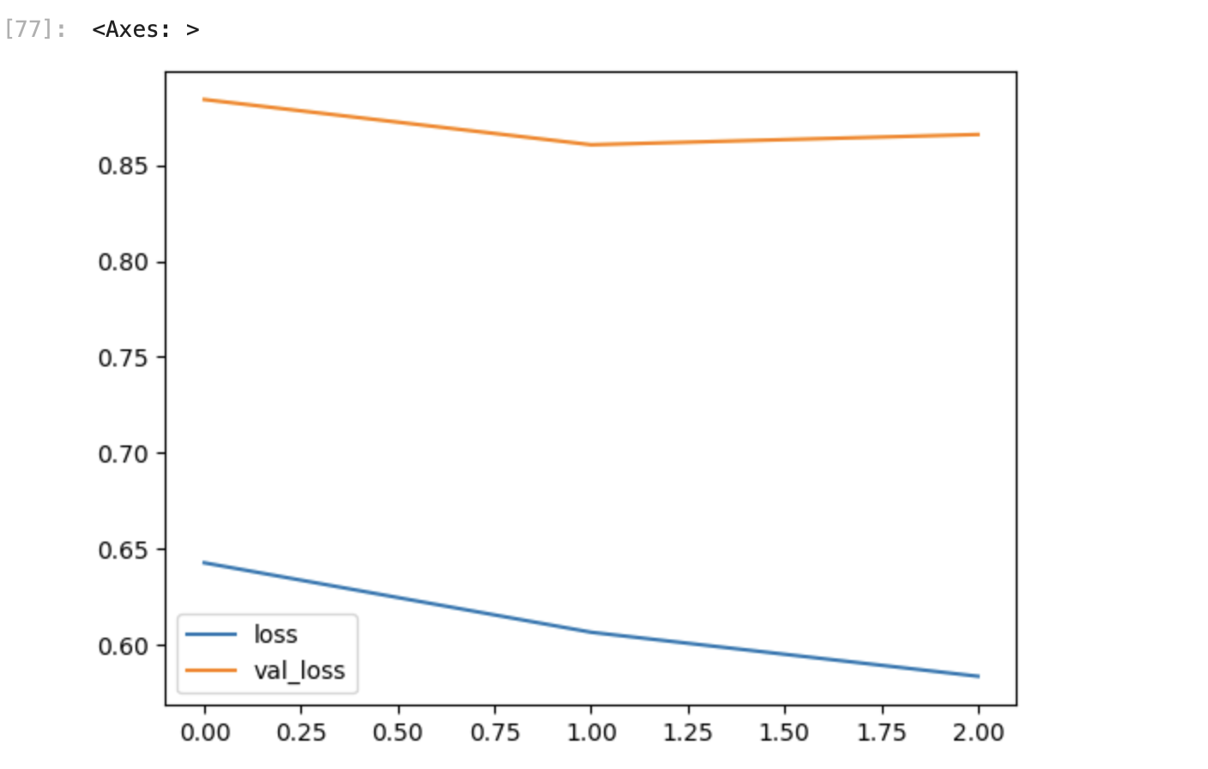
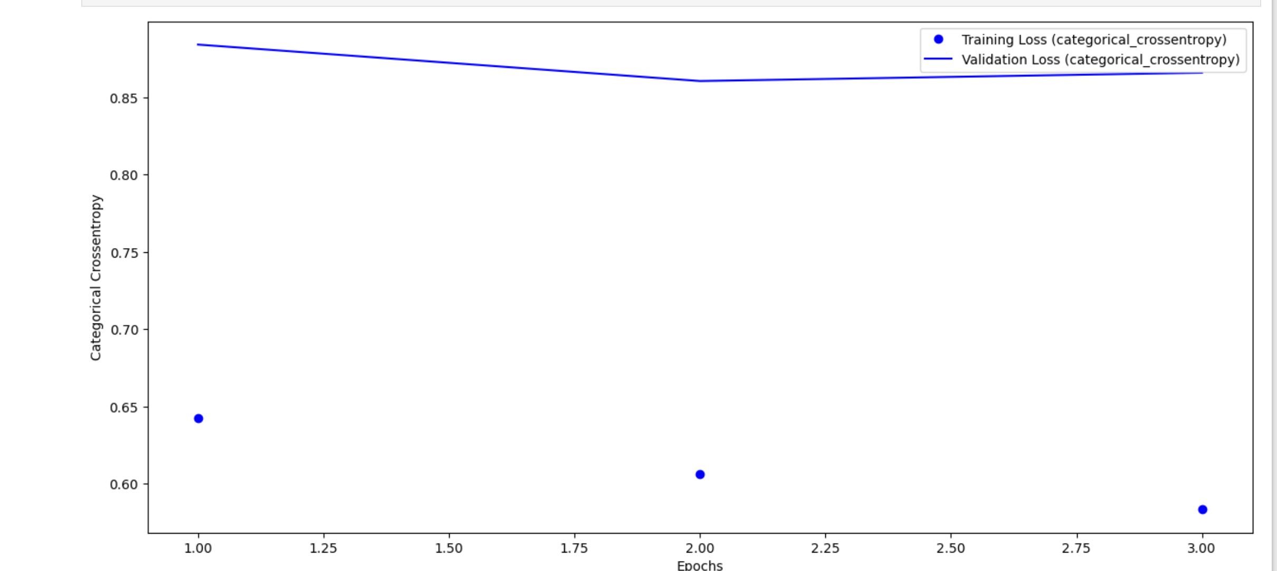

3. Based on this analysis, determine the optimal number of epochs for training your model.

Ans: So based on my analysis the optimal number of epochs will be 3.

Optional Task 2
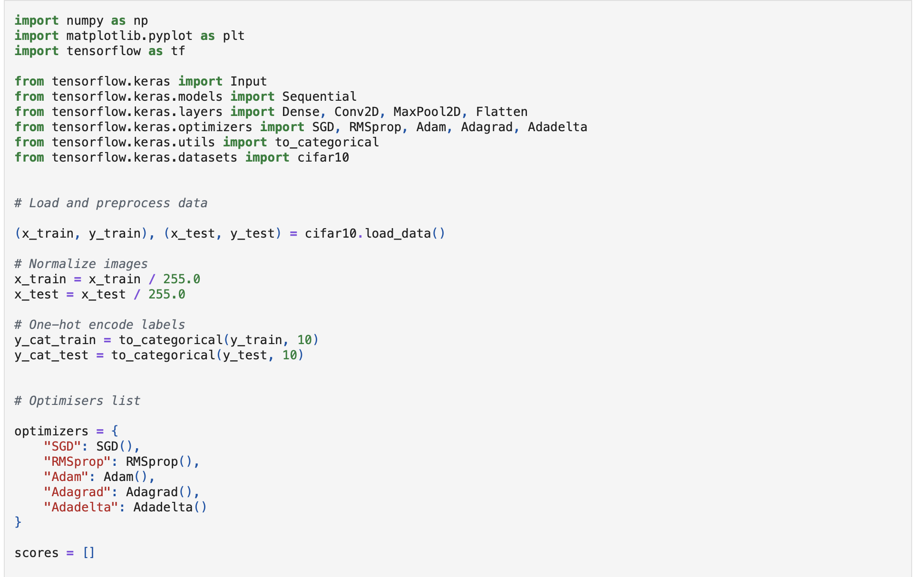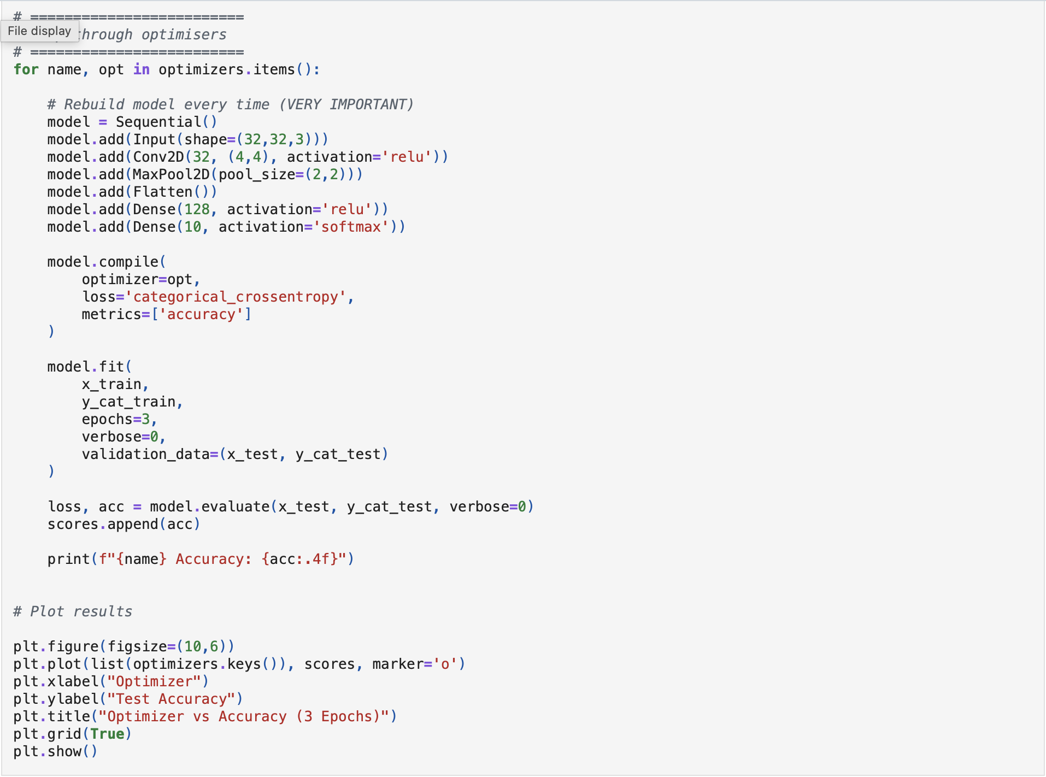
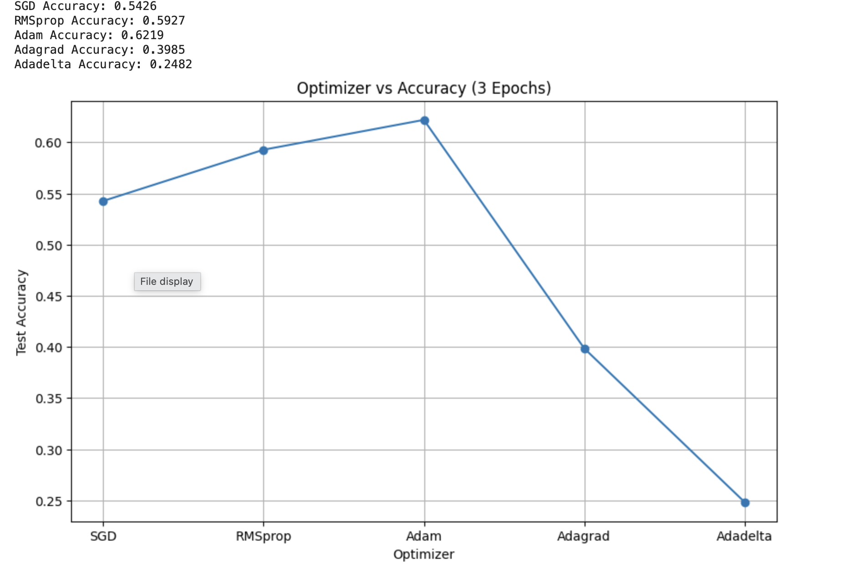

Lab 6
- Record the 2nd model's code & plot the summary()

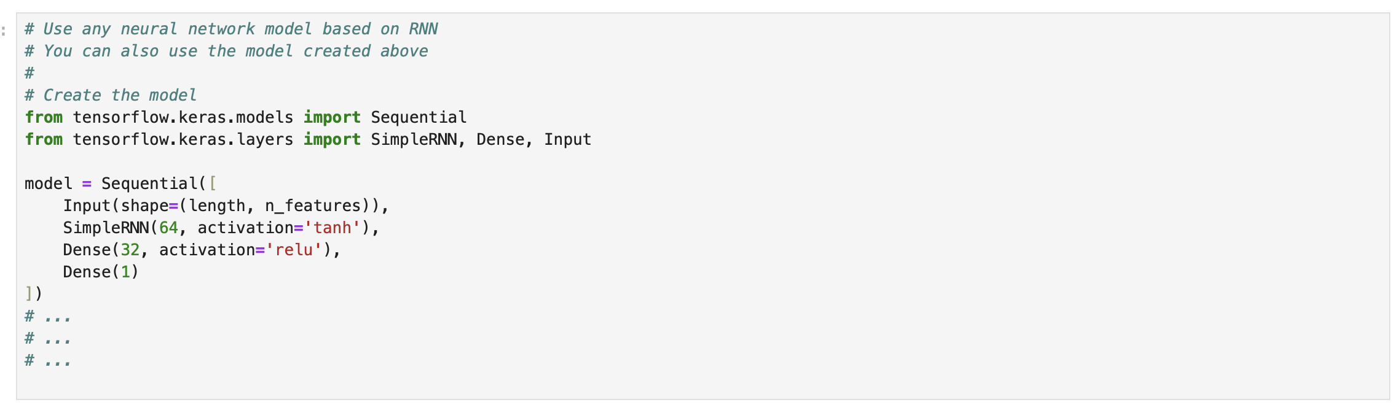

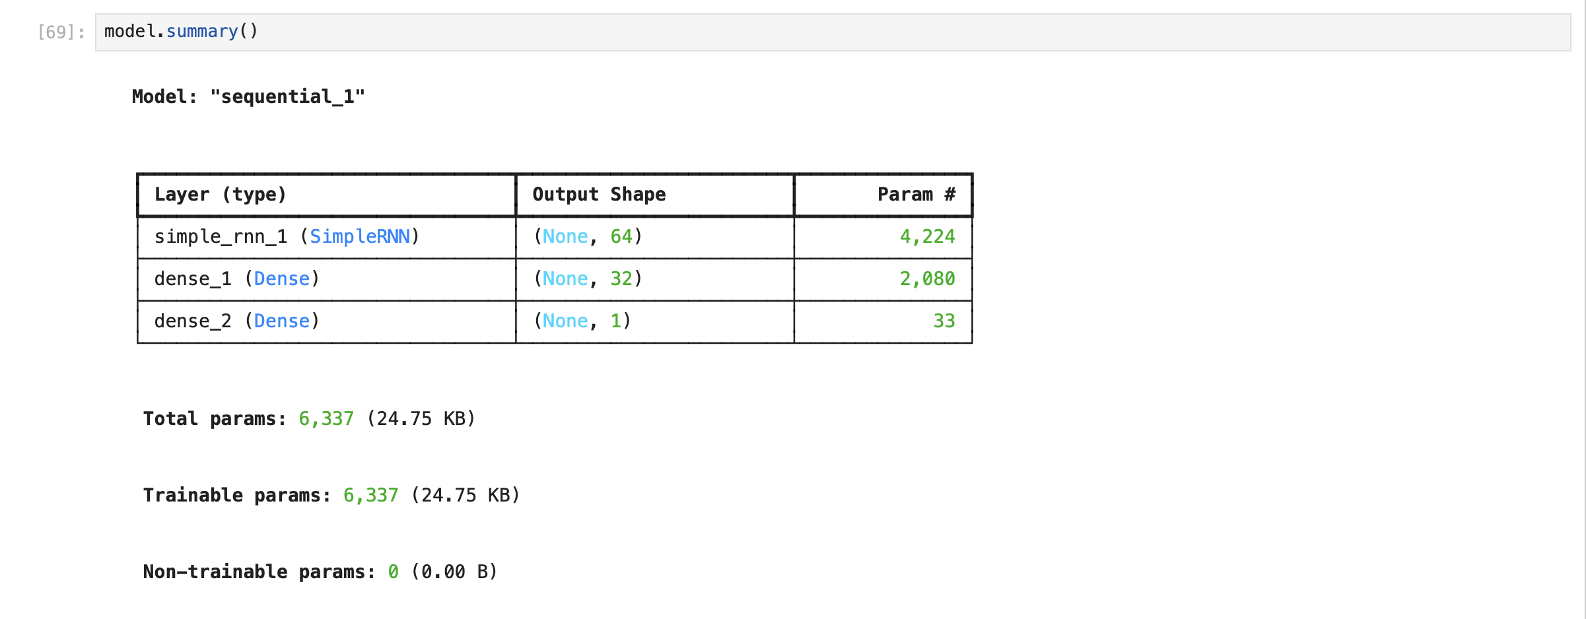
- Copy your early-stop code and history_2 fit-training-process

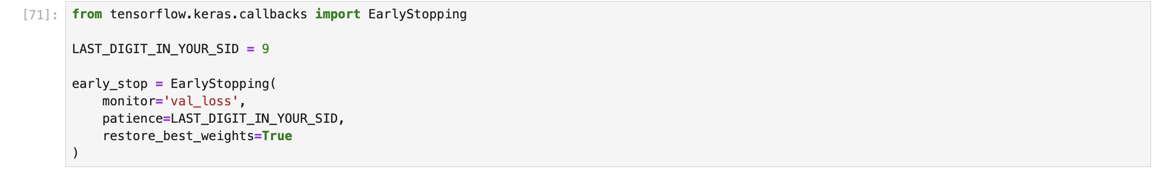

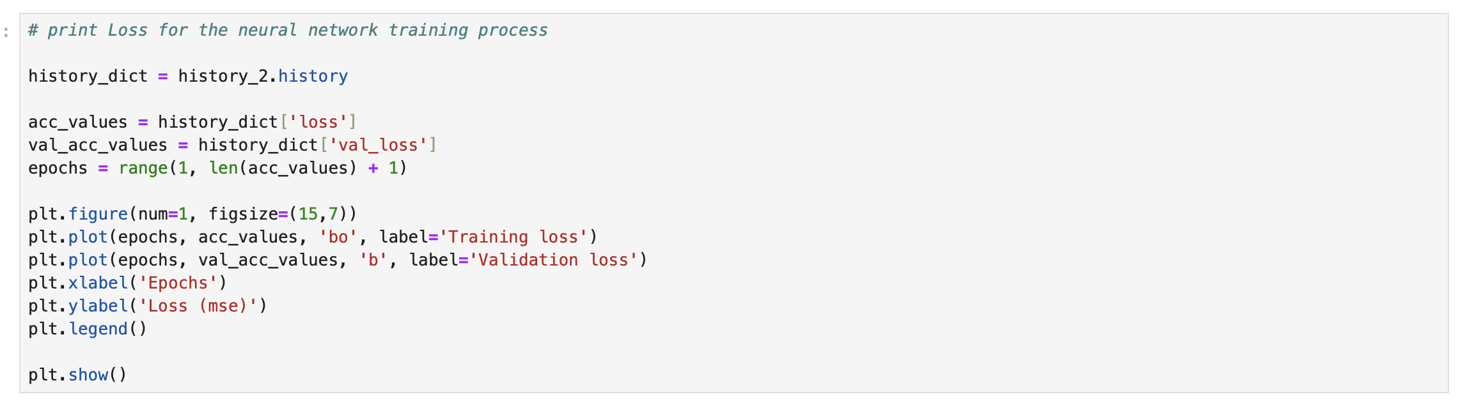

- Record the plot of validation and test loss of history_2.

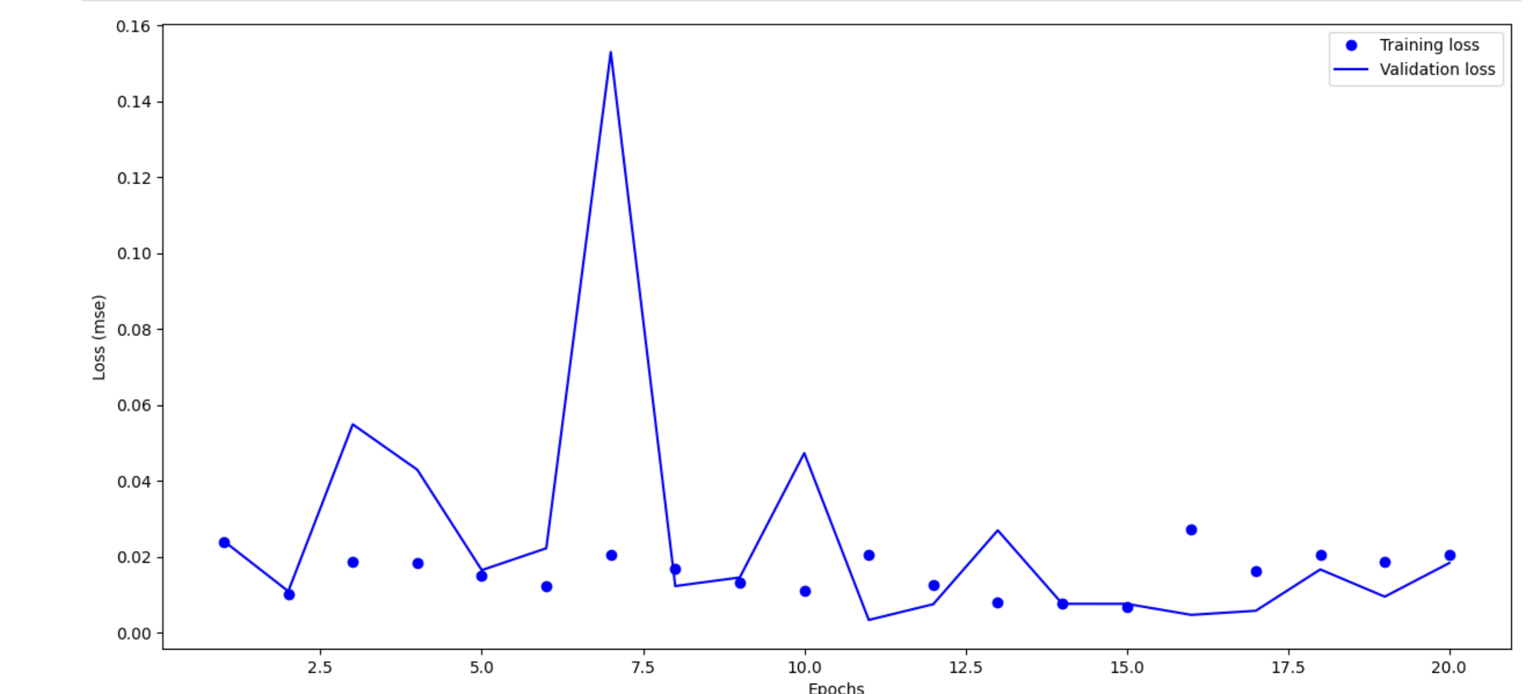

- Based on this analysis, determine the optimal number of epochs for training your model.

Ans: 8 epochs

5. Record the plot of the Checking Forecast for the last 12 months (last graph).
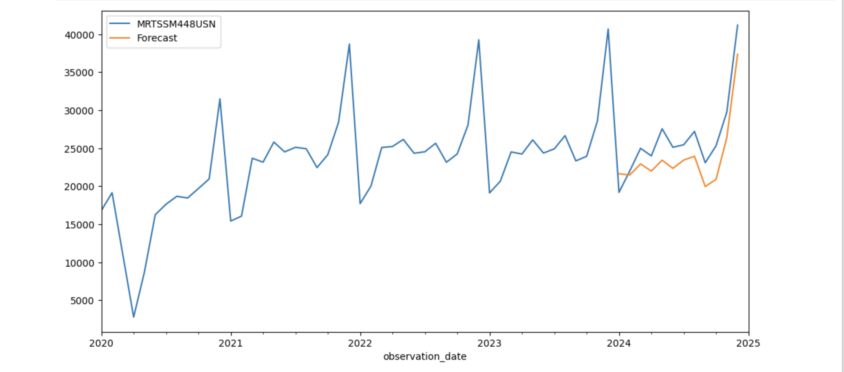

Lab 7

Plot graphs for Accuracy and Loss Function for VGG16 and VGG19 (4 graphs in total).

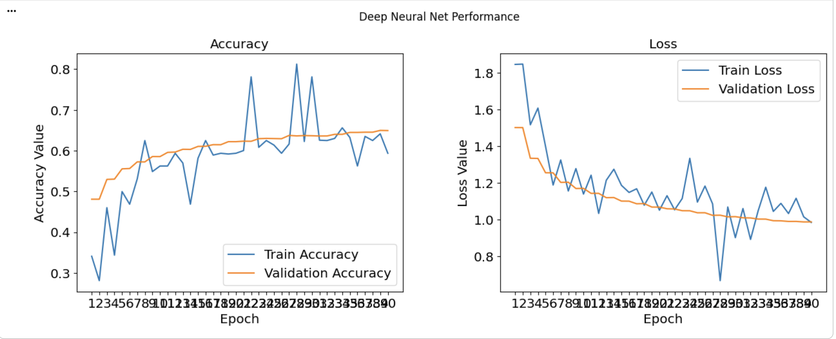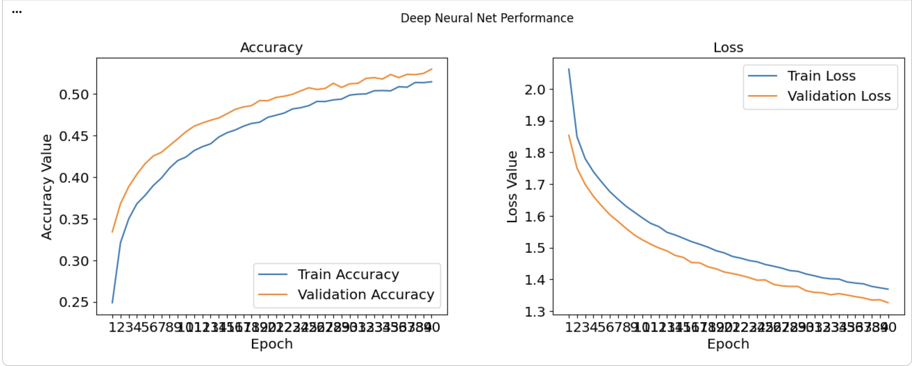

Based on this analysis, determine the optimal number of epochs for training your VGG16 and VGG19 models.

Ans: The optimal number of epochs for training our VGG16 and VGG19 models is 39.

Copy your early-stop code

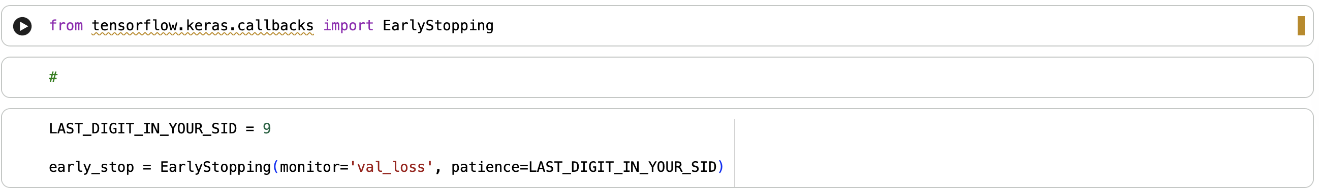

Add the final Performance Table

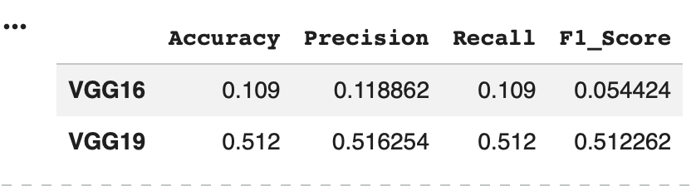

5. Plot the performance comparing histogram of VGG16 and VGG19
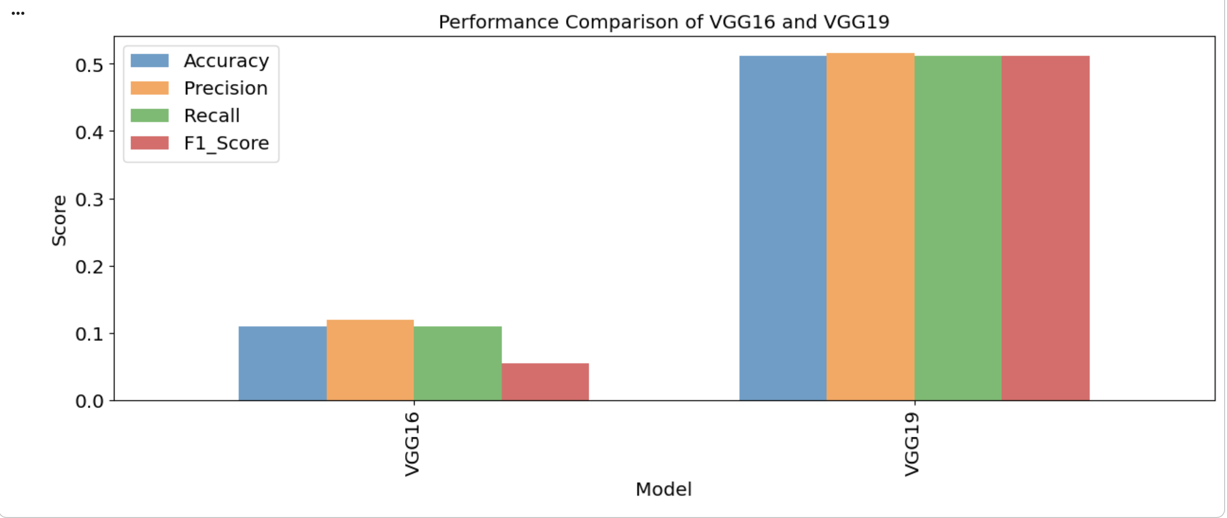
Task 2 optional
Summary of table of the 3 models
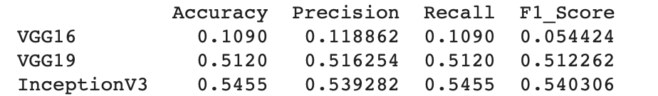

Histogram Comparison between 3 models
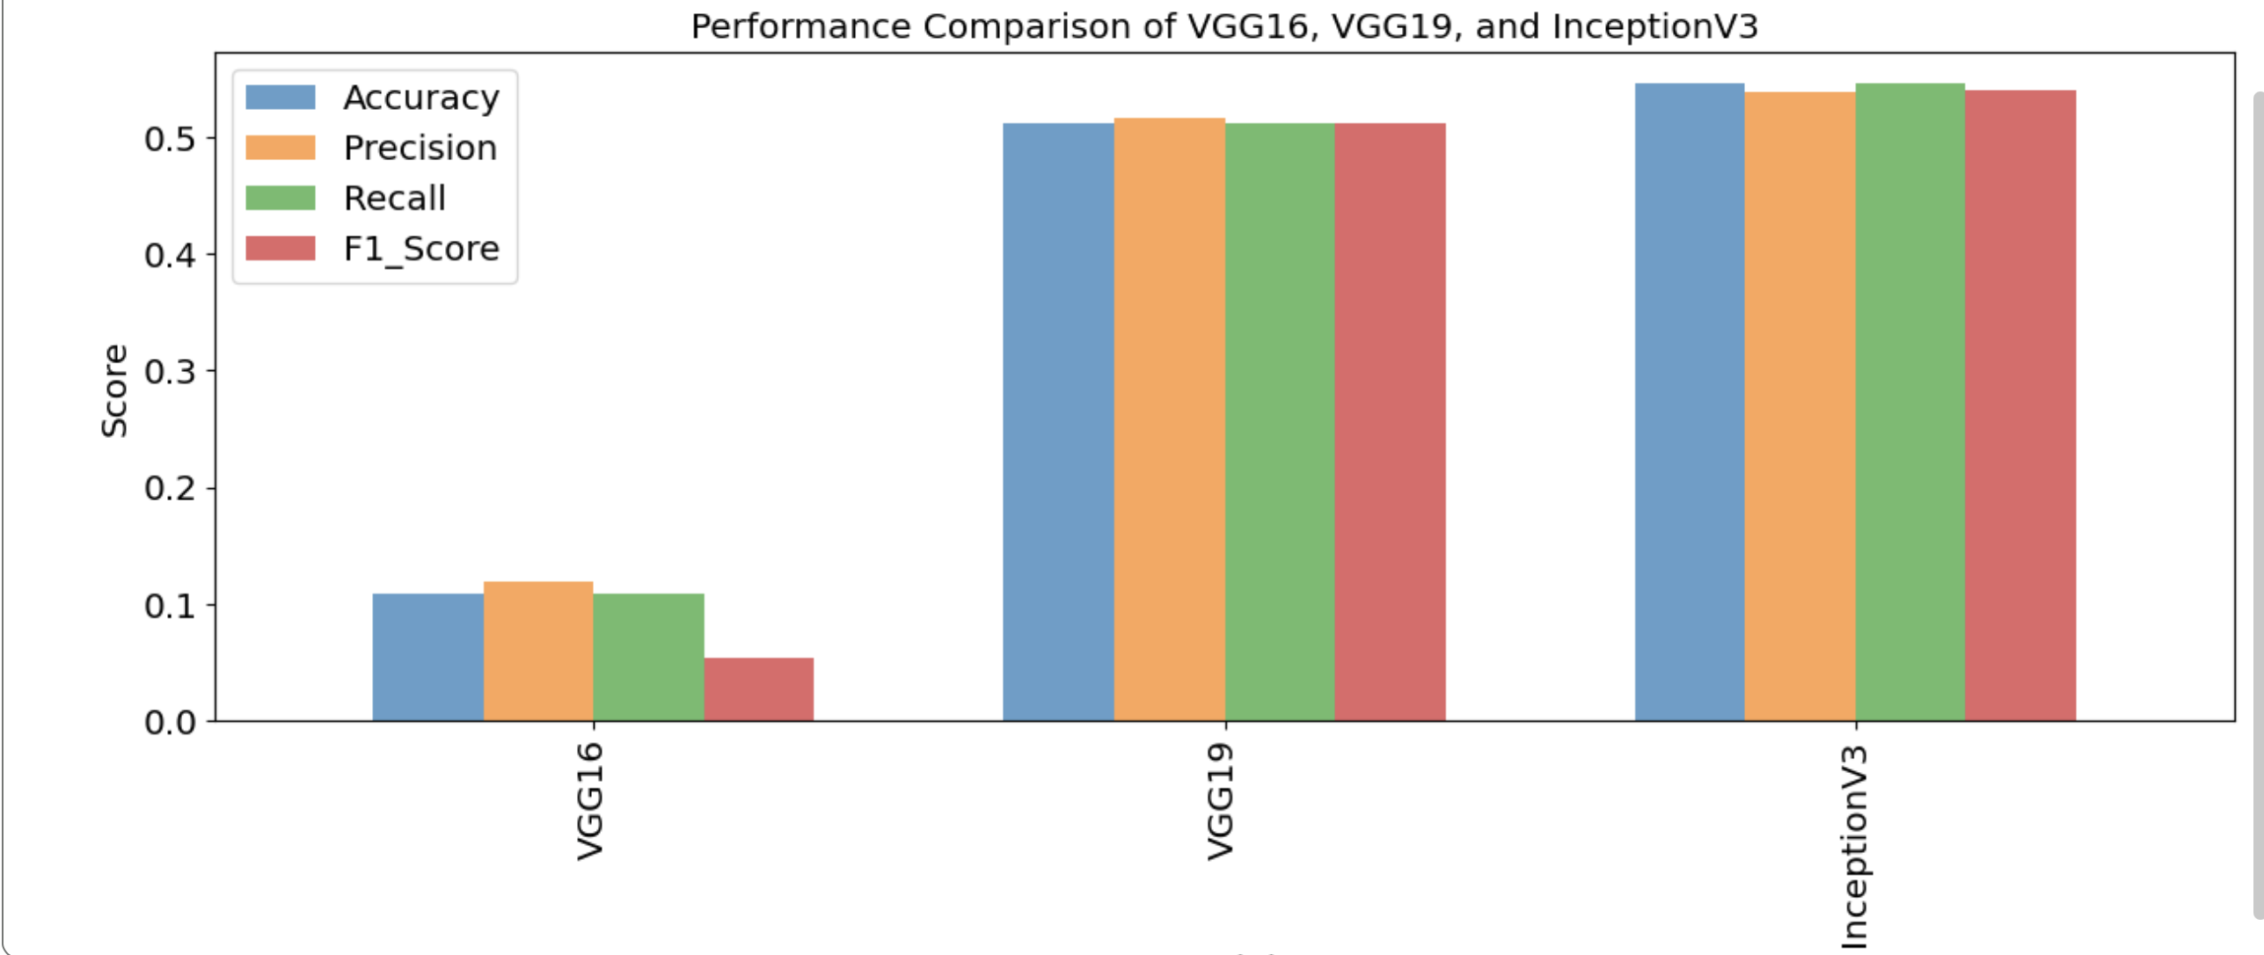

Lab 8

1. LSTM Architecture (model.summary())
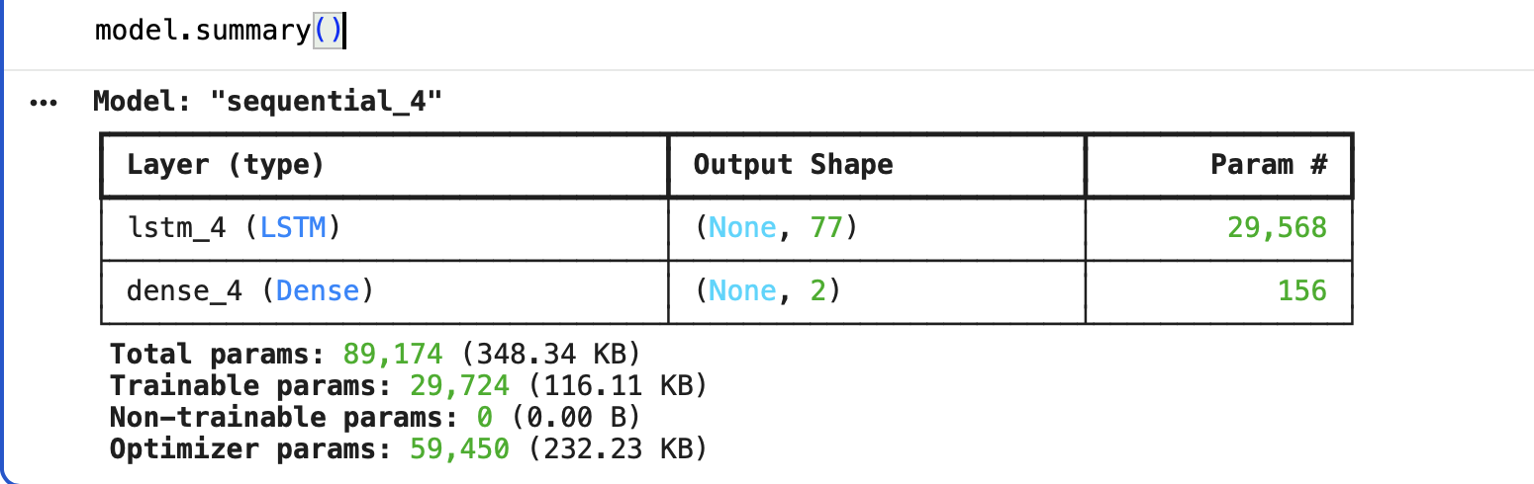

2. Model Training (model.fit())
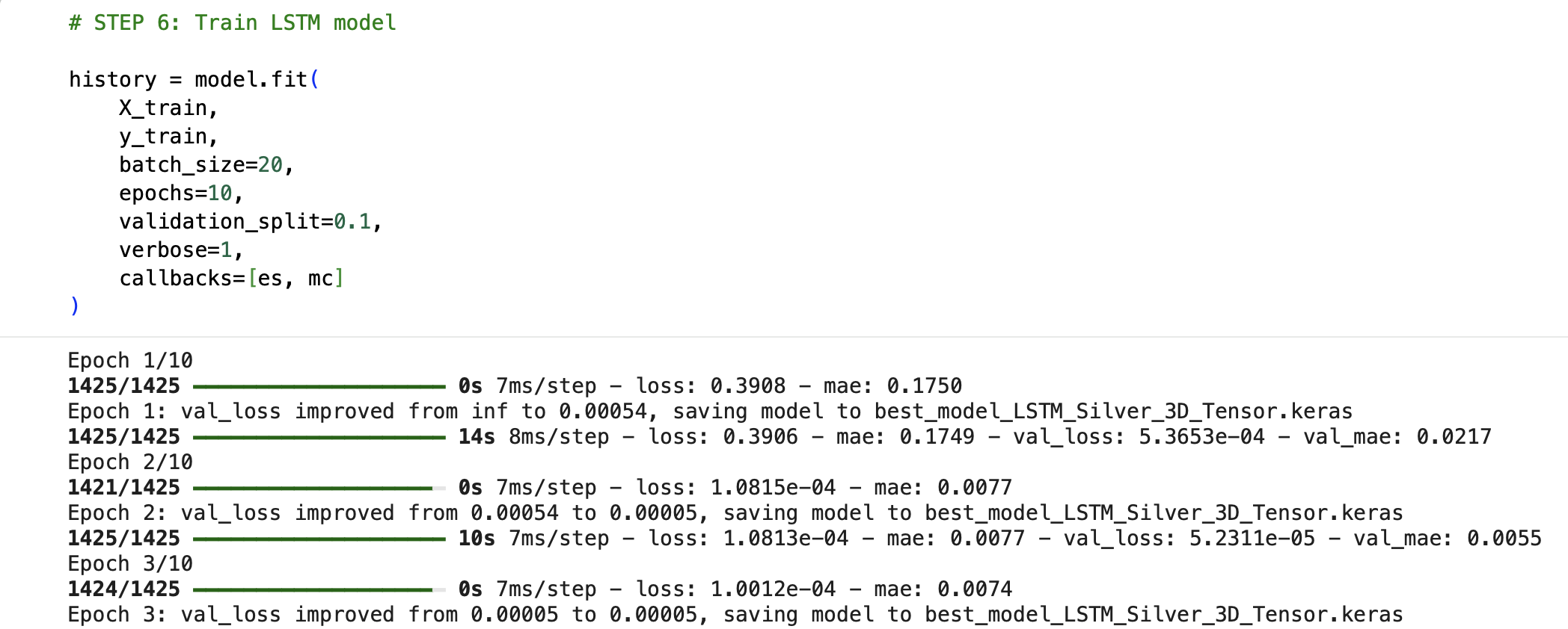

3. Test MSE & MAE
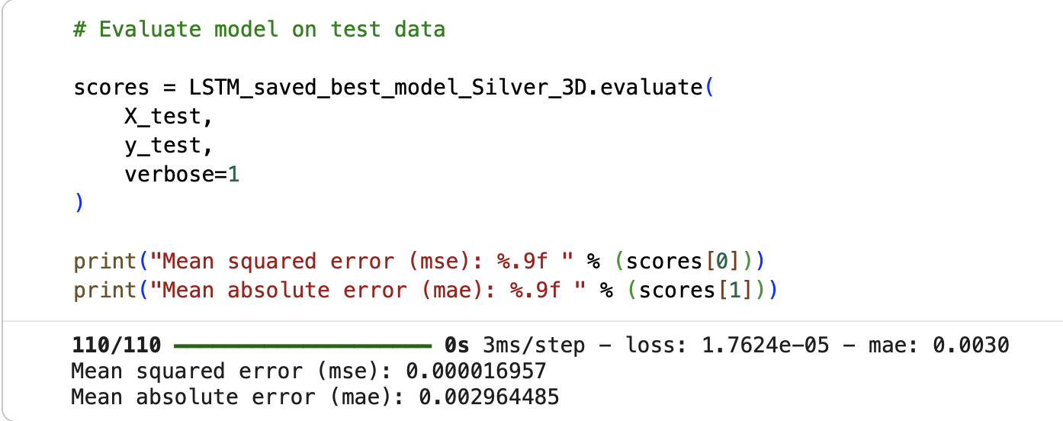

4. MAE Detailed Graph

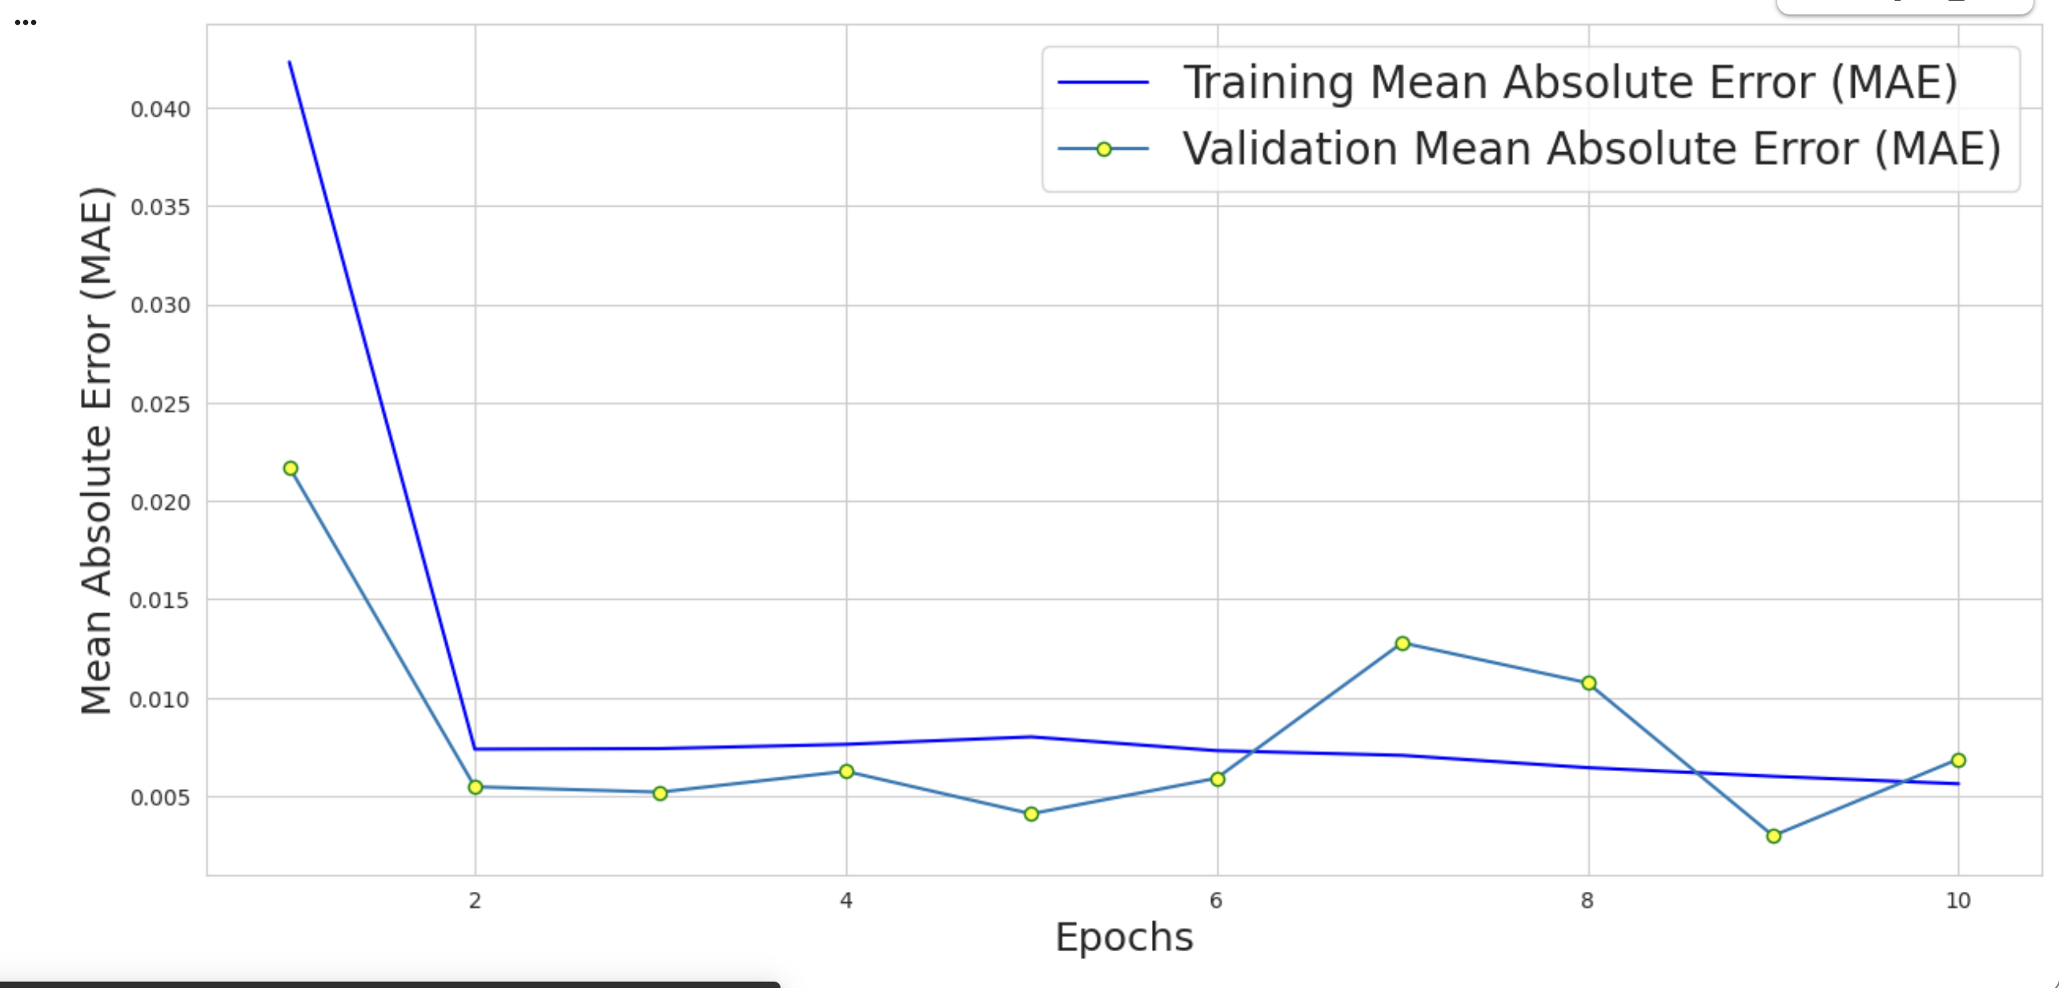

Lab 9
- Code your Use EarlyStopping() and ModelCheckpoint() functions
- Code and training result using model.fit()
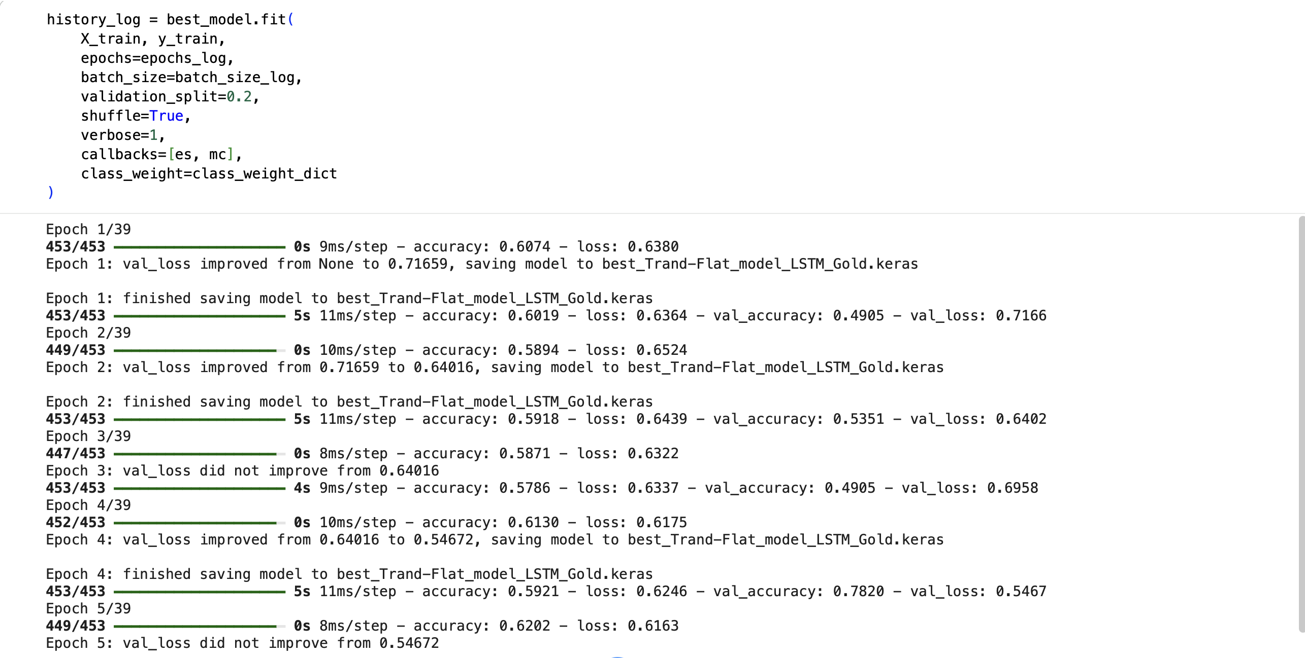
- The resulting test Accuracy and other error metrics for the classification task using classification_report().
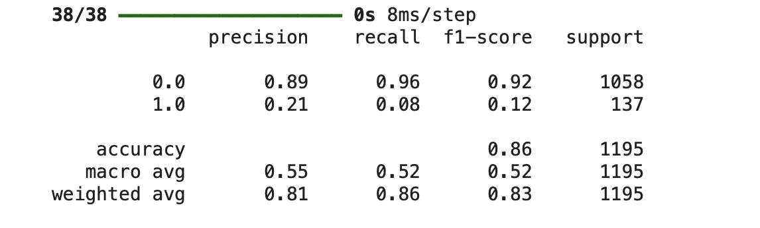

- Accuracy detailed graph
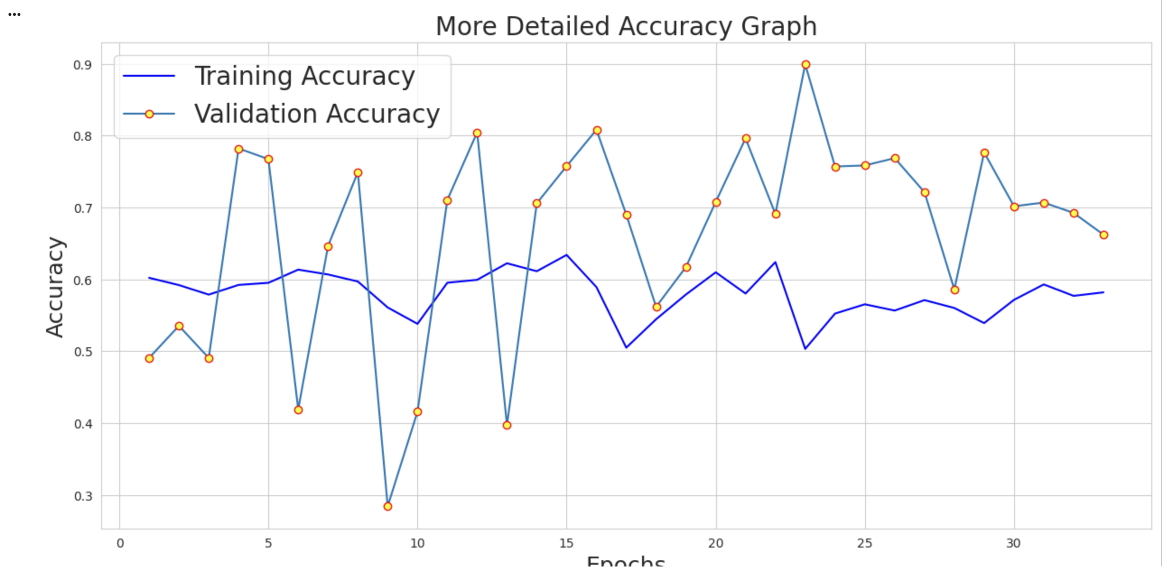

Lab 10
Task 1:
Encoder
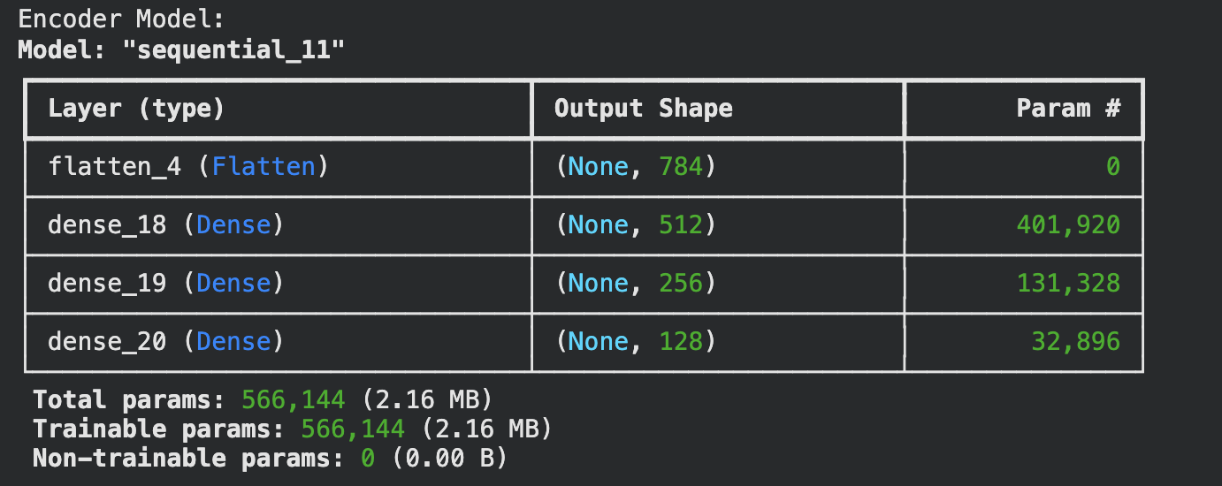
Decoder
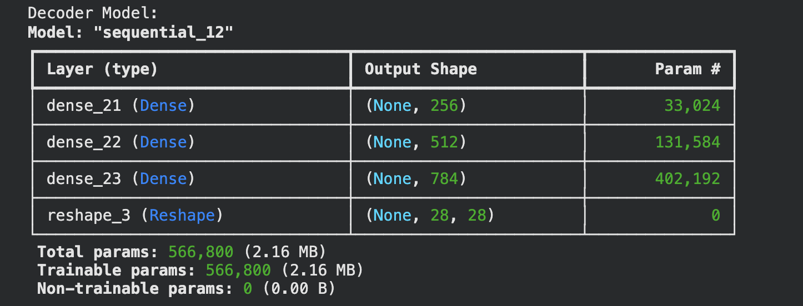
Autoencoder Model
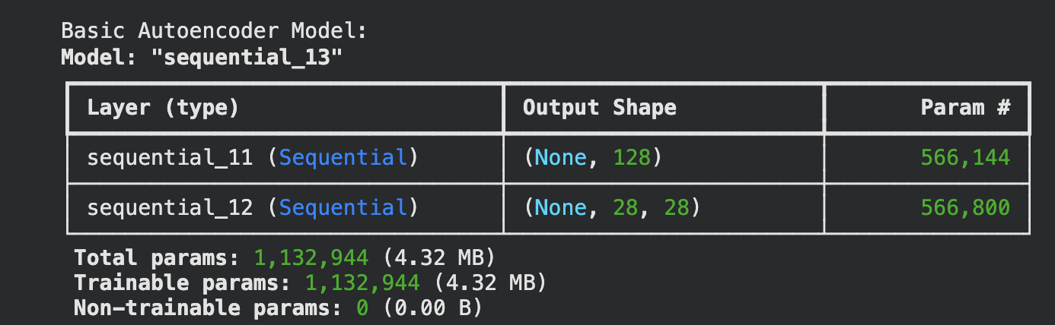

TASK 2:
- Table of your model autoencoder. Summary()
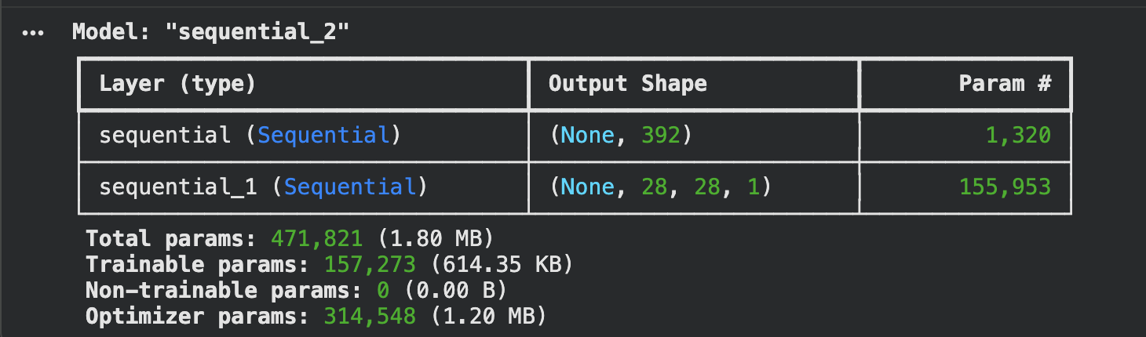
2. Code of your autoencoder.fit() (SID- 2173839)
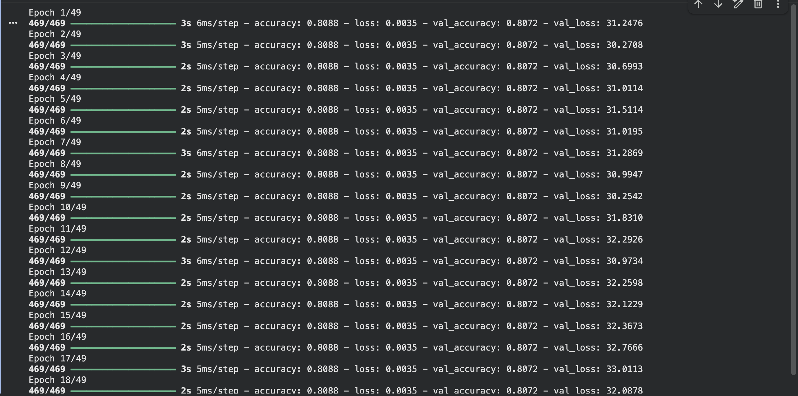

3.The Accuracy graph (Training vs Validation Accuracy)
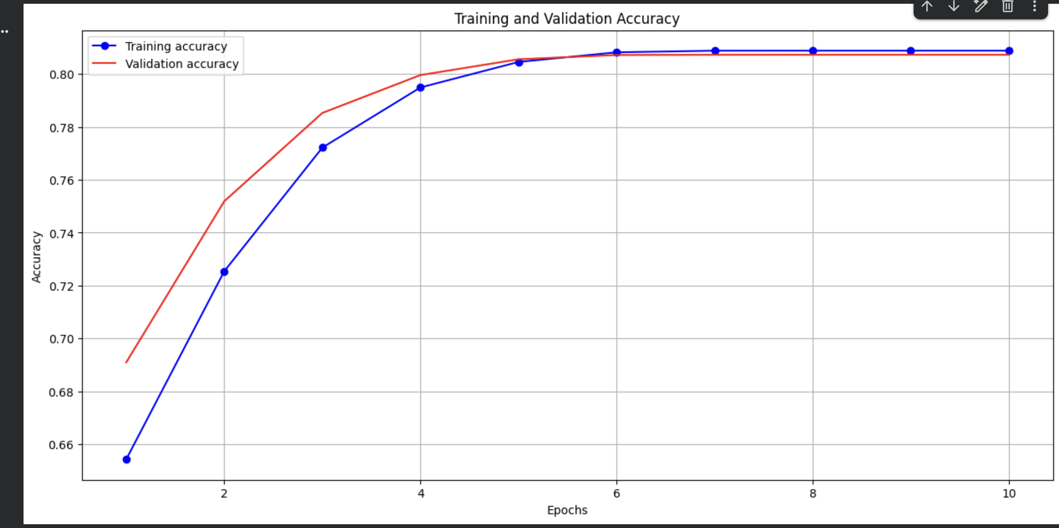
4. The Decoded Images plot (Original vs Reconstructed)
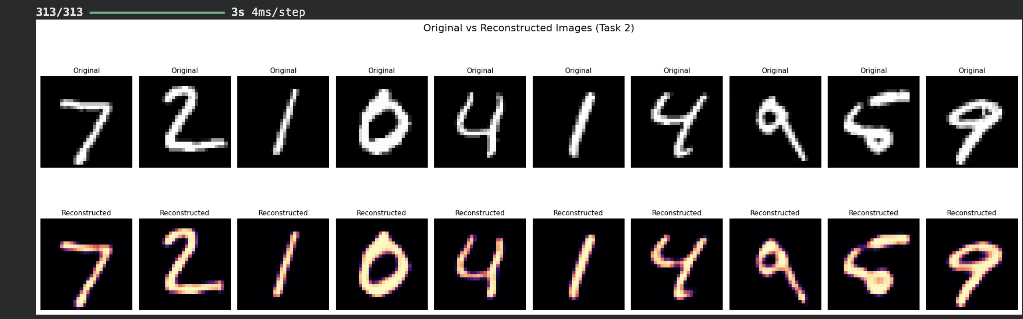

Lab 11
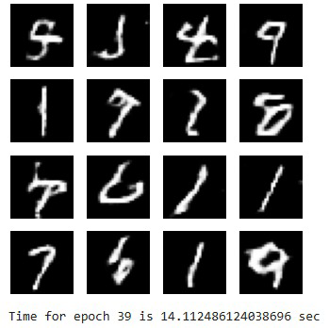
Task 2(Optional):
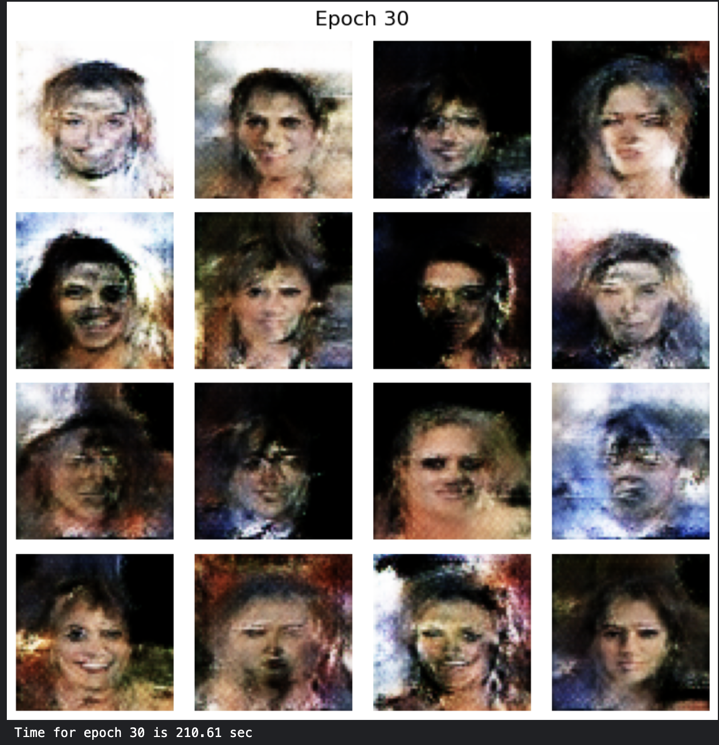

Lab 12
- Modify the training parameter of the RNN with an attention layer model
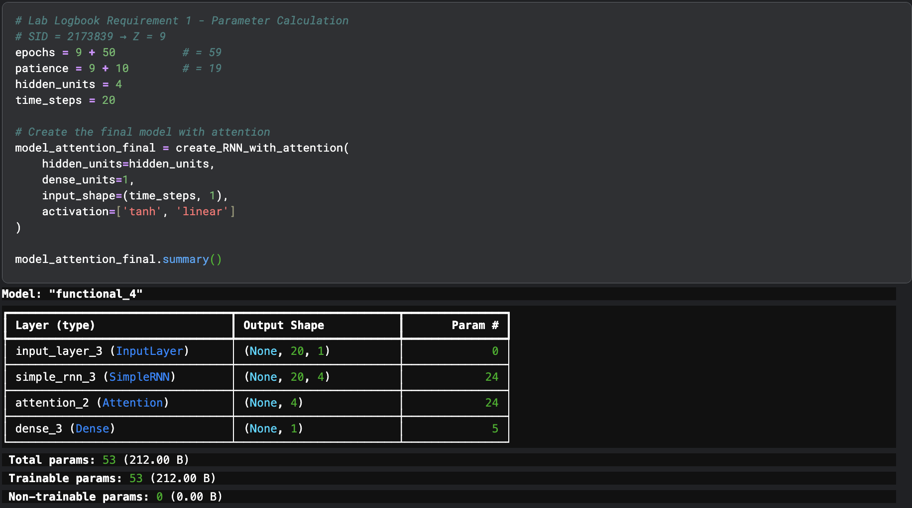
- Modify time_steps = 20 and hidden_units = 4
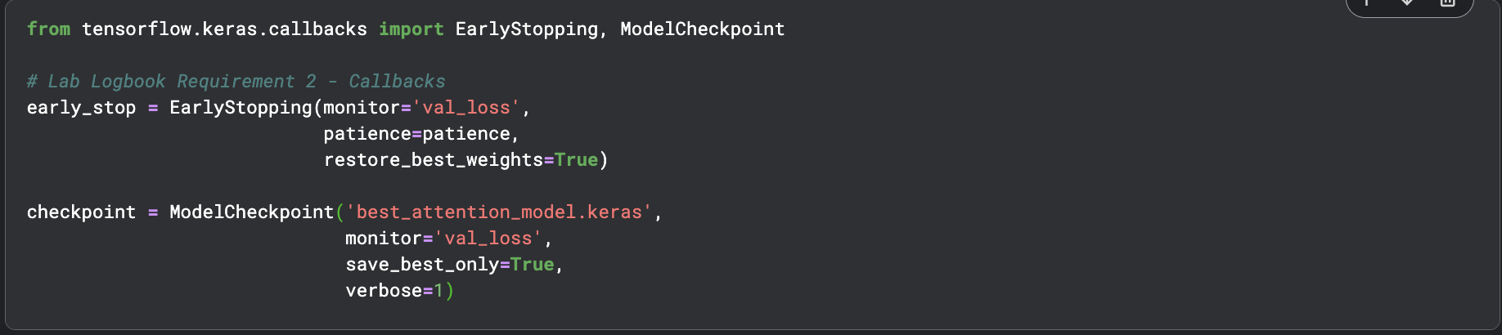

3. Leave other parameters the same as in the practical session
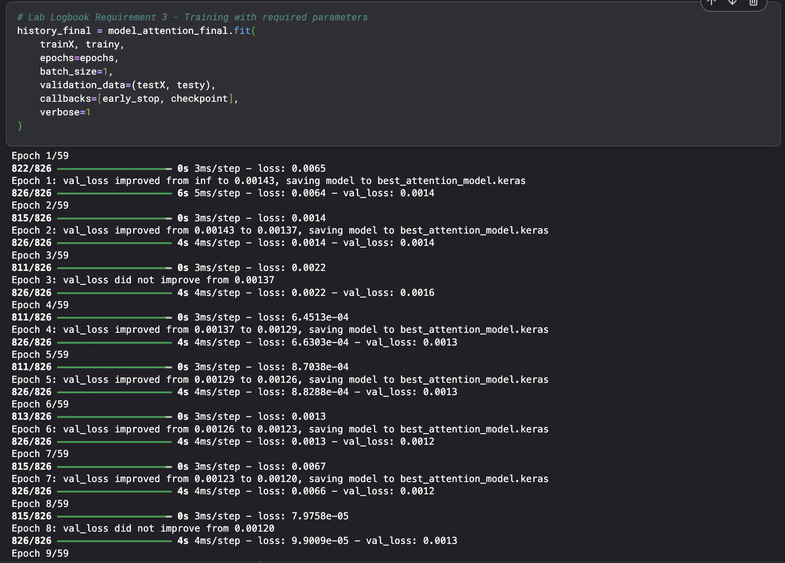
4. Calculate and demonstrate the received loss for train and test datasets
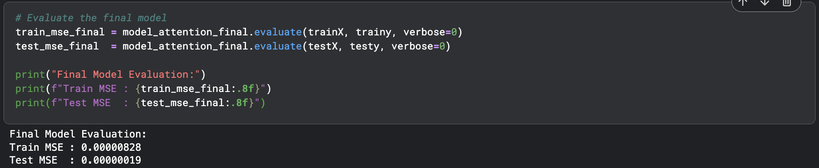

5. Plot the Loss function (MSE) graph during the training process for the 3 models together
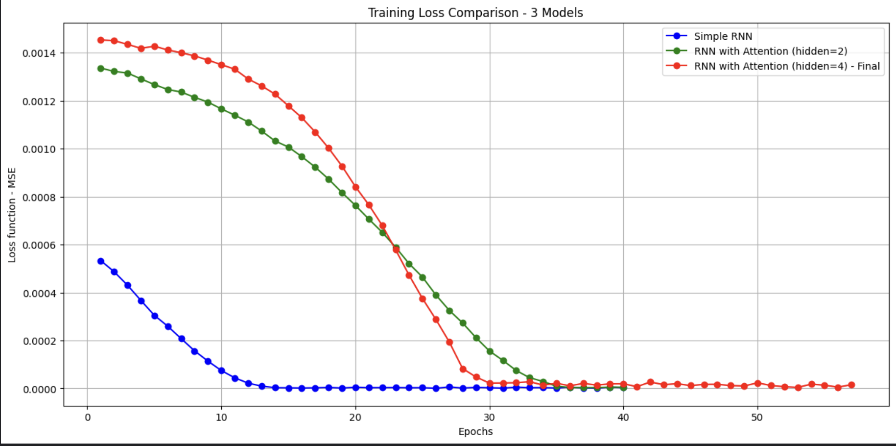
6. Histogram of 3 Models
