C++ Data Types
A data type specifies the type of data that a variable can store such as integer, floating, character etc.
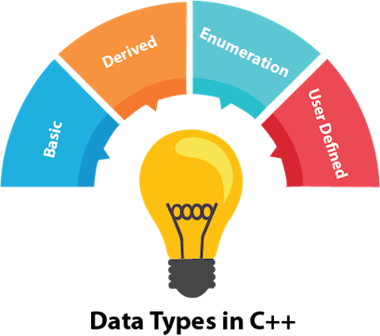
There are 4 types of data types in C++ language.
Types | Data Types
Basic Data Type | int, char, float, double, etc
Derived Data Type | array, pointer, etc
Enumeration Data Type | enum
User Defined Data Type | structure

C++ Operators
An operator is simply a symbol that is used to perform operations. There can be many types of operations like arithmetic, logical, bitwise etc.
There are following types of operators to perform different types of operations in C language.
- Arithmetic Operators
- Relational Operators
- Logical Operators
- Bitwise Operators
- Assignment Operator
- Unary operator
- Ternary or Conditional Operator

C++ Identifiers
C++ identifiers in a program are used to refer to the name of the variables, functions, arrays, or other user-defined data types created by the programmer. They are the basic requirement of any language. Every language has its own rules for naming the identifiers.
In short, we can say that the C++ identifiers represent the essential elements in a program which are given below:
- Constants
- Variables
- Functions
- Labels
- Defined data types

C++ Expression:

An expression can be of following types:
- Constant expressions
- Integral expressions
- Float expressions
- Pointer expressions
- Relational expressions
- Logical expressions
- Bitwise expressions
- Special assignment expressions
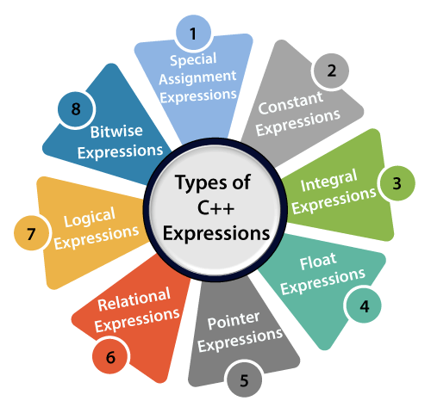
If the expression is a combination of the above expressions, such expressions are known as compound expressions.

C++ if-else
In C++ programming, if statement is used to test the condition. There are various types of if statements in C++.
- if statement
- if-else statement
- nested if statement
- if-else-if ladder

