Map Reduce Psuedo Code:

1. Consider two matrices A and B with dimension MxN

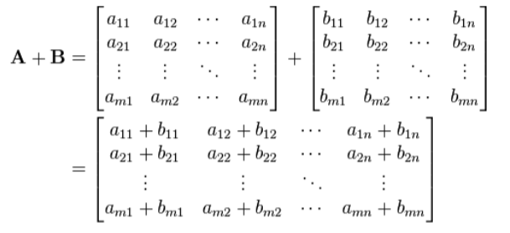

The map reduce pseudo code will appear as below:

The map will emit key value pairs:

1. For every element (i,j) of A, emit ((i,j), A[i,j])
2. For every element (i,j) of B, emit ((i,j), B[i,j])

Where i,j signifies the row and column number of the matrix element.

Coming to Reduce phase, it emits :

Key = (I,j)

Value = sum (A[i,j],B[I,j])

This results in matrix addition.

Here the same elements with same key value are being added.