**UMKC HACKATHON 2015**

**AdKnowledge UseCase1 - Enhanced Weather Reporting**

The main aim of this our application is to enable user to get an idea of how the weather along his route is going to be.

In this application, users have to first first log in to the application in order to use it. In case o a new user, he has to first register for the app by the providing his details and then login again. To login user should provide username and password. User has the option to de activate his account, in case he wants to discontinue using the app. He can also update his password, if he forgets it. All this authentication and data storage is done using **MongoLab API.**

After he logs in, user can find his route, using the map displayed on the screen. He should first enter source and destination and click on "Get Directions" button to find the route. We have used **Google Maps API** to get routes for locations.

By clicking on "Get Coordinates" button, he will be able to get weather conditions and temperatures of source and destination. We have also displayed, the city names, weather conditions and temperatures of 3 of the intermediate cities that come along his route. For this purpose we have made use of **OpenWeather API and WunderGround API.**

After using the app and getting required results, users can log out of the system.

**Technologies Used:**

**Languages:** AngularJS

**Framework:** Ionic

**Database:** Mongo DB

**API's:**

http://api.wunderground.com/api/36b799dc821d5836/geolookup/q/38.8061467,-90.8421592999.json

http://api.openweathermap.org/data/2.5/weather?lat=38&lon=-122&APPID=cd5851c27736df9057e4da4b9062ad00

http://maps.googleapis.com/maps/api/geocode/json?latlng=' values'&sensor=true'

MockUps:

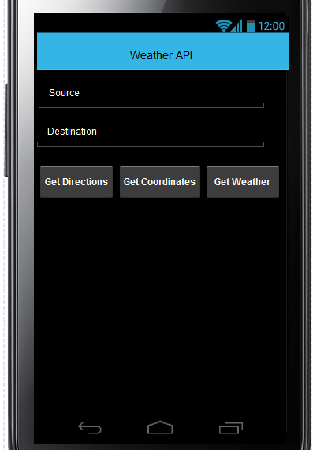

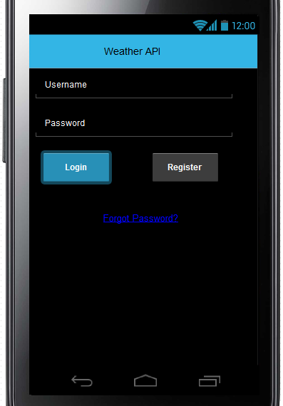

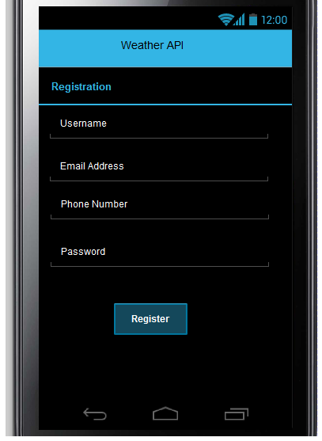

Wireframes:

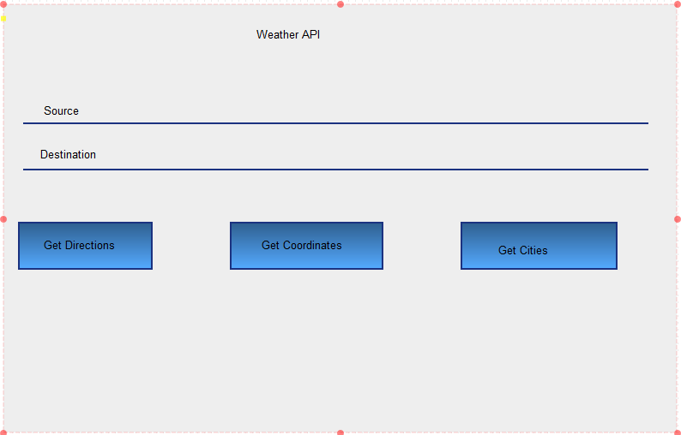

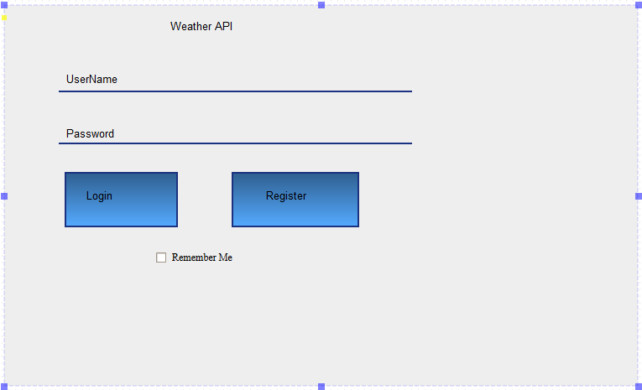

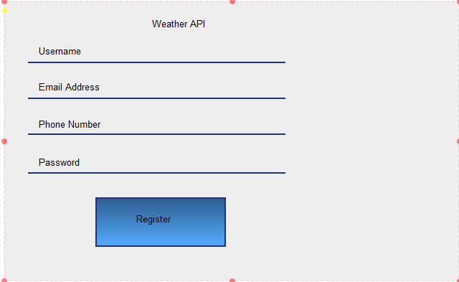

Github Link:

**https://github.com/Harshin1/Project2/tree/master/Hackathon/Billwayapp**

Youtube Link:

https://www.youtube.com/watch?v=5qvEaU_xhhw