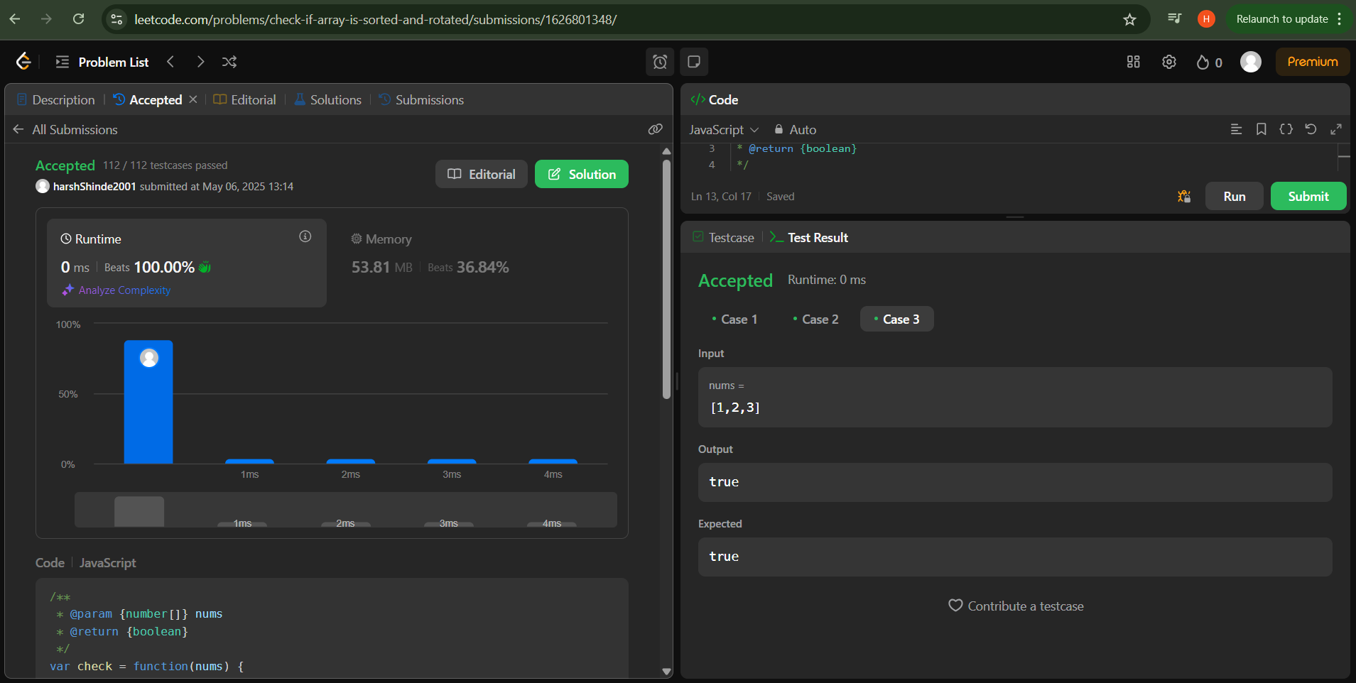

Problem no: 1752 “is array sorted”