[**560. Subarray Sum Equals K**](https://leetcode.com/problems/subarray-sum-equals-k/)

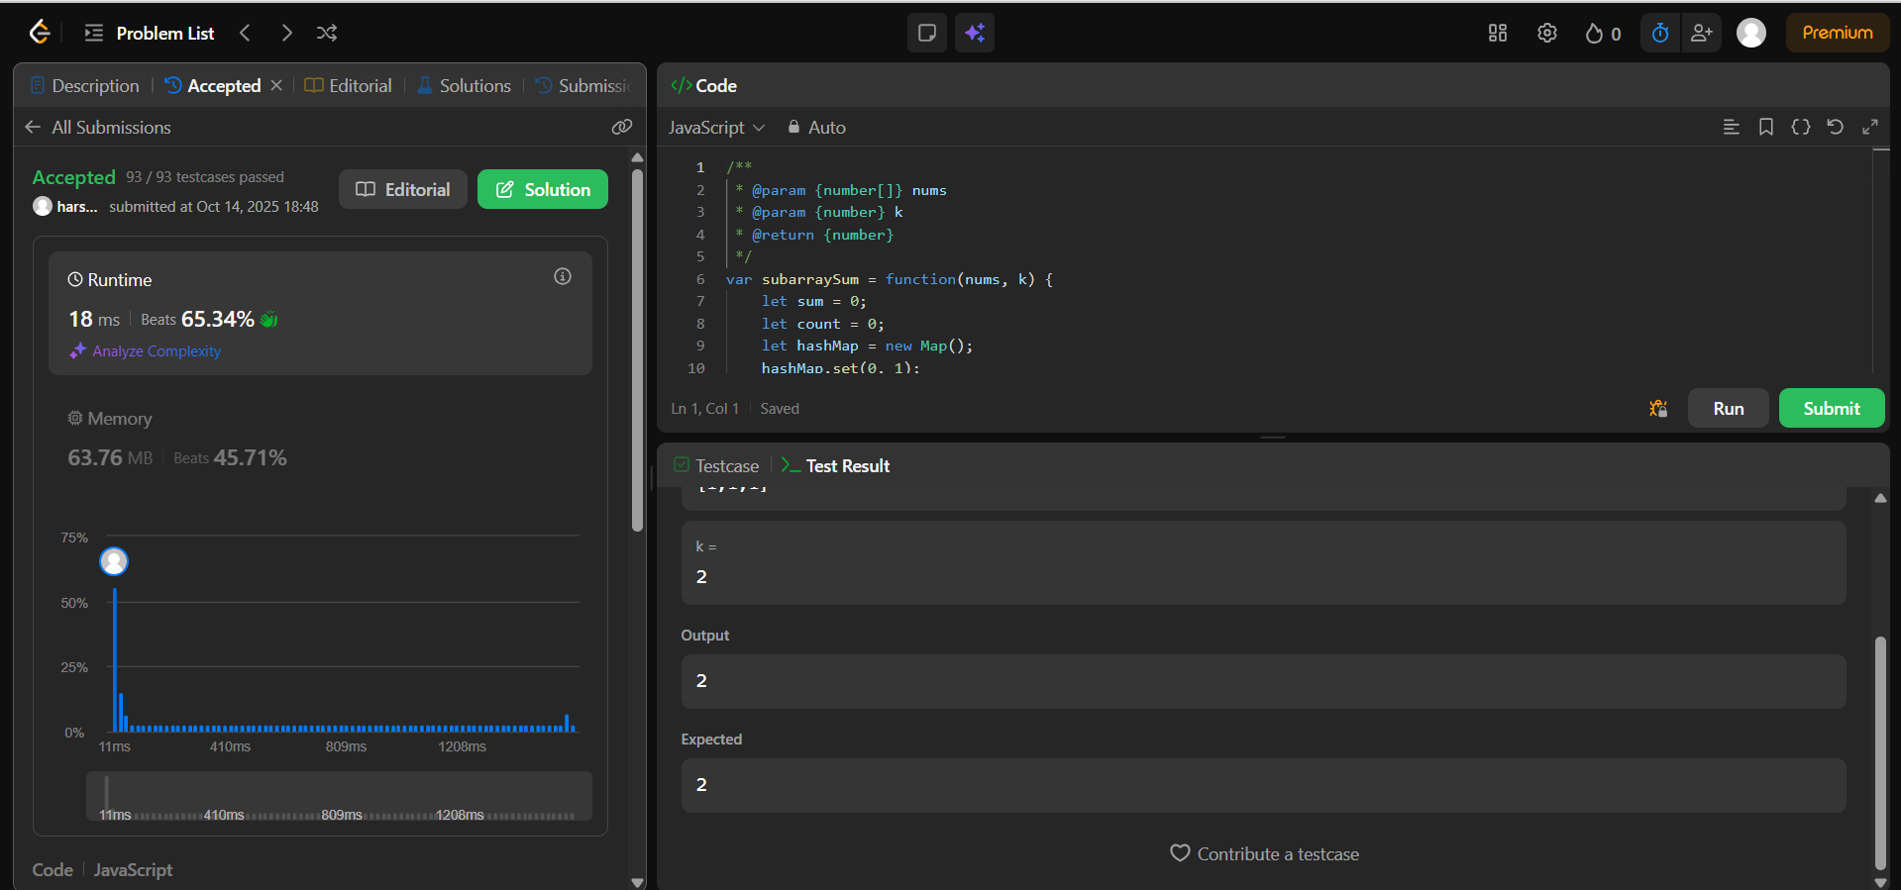

[**118. Pascal's Triangle**](https://leetcode.com/problems/pascals-triangle/)

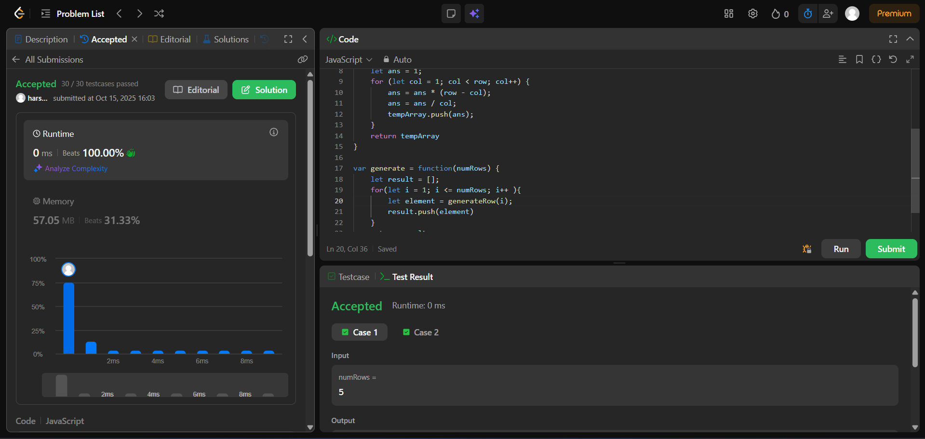

[**229. Majority Element II**](https://leetcode.com/problems/majority-element-ii/)

