Problem no: 2965, find missing and repeated values

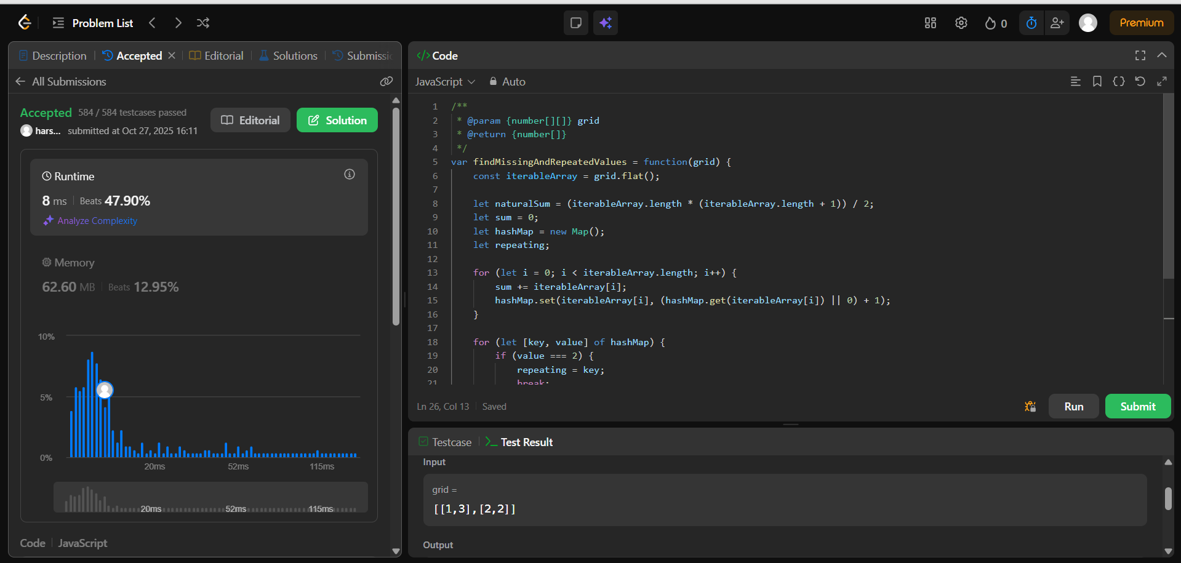

[**152. Maximum Product Subarray**](https://leetcode.com/problems/maximum-product-subarray/)

