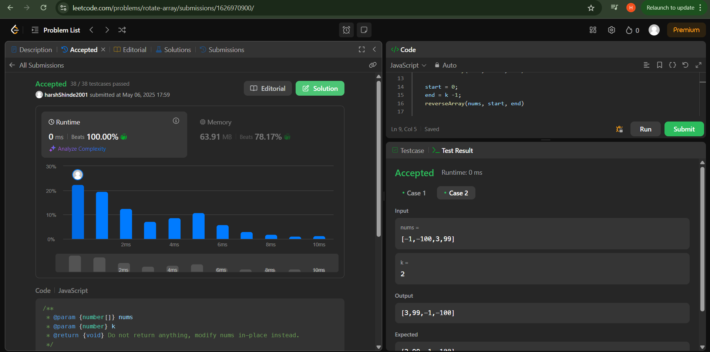

Problem no : 189: rotate elements at from k position

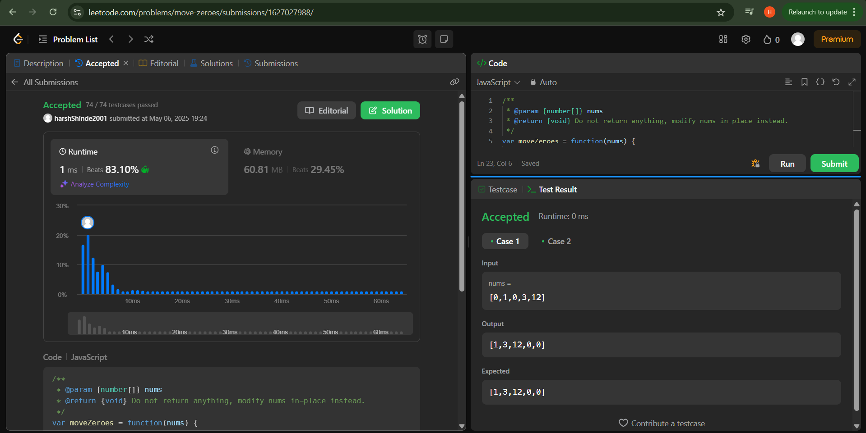

Problem no: 283 : moves zeros

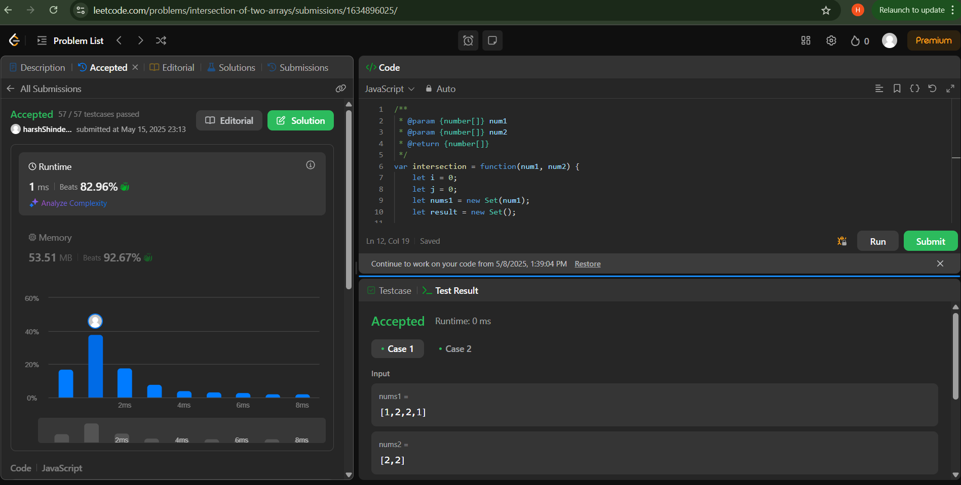

Problem no: 349 insertion of two arrays