FindMissing Number, problem No: 268

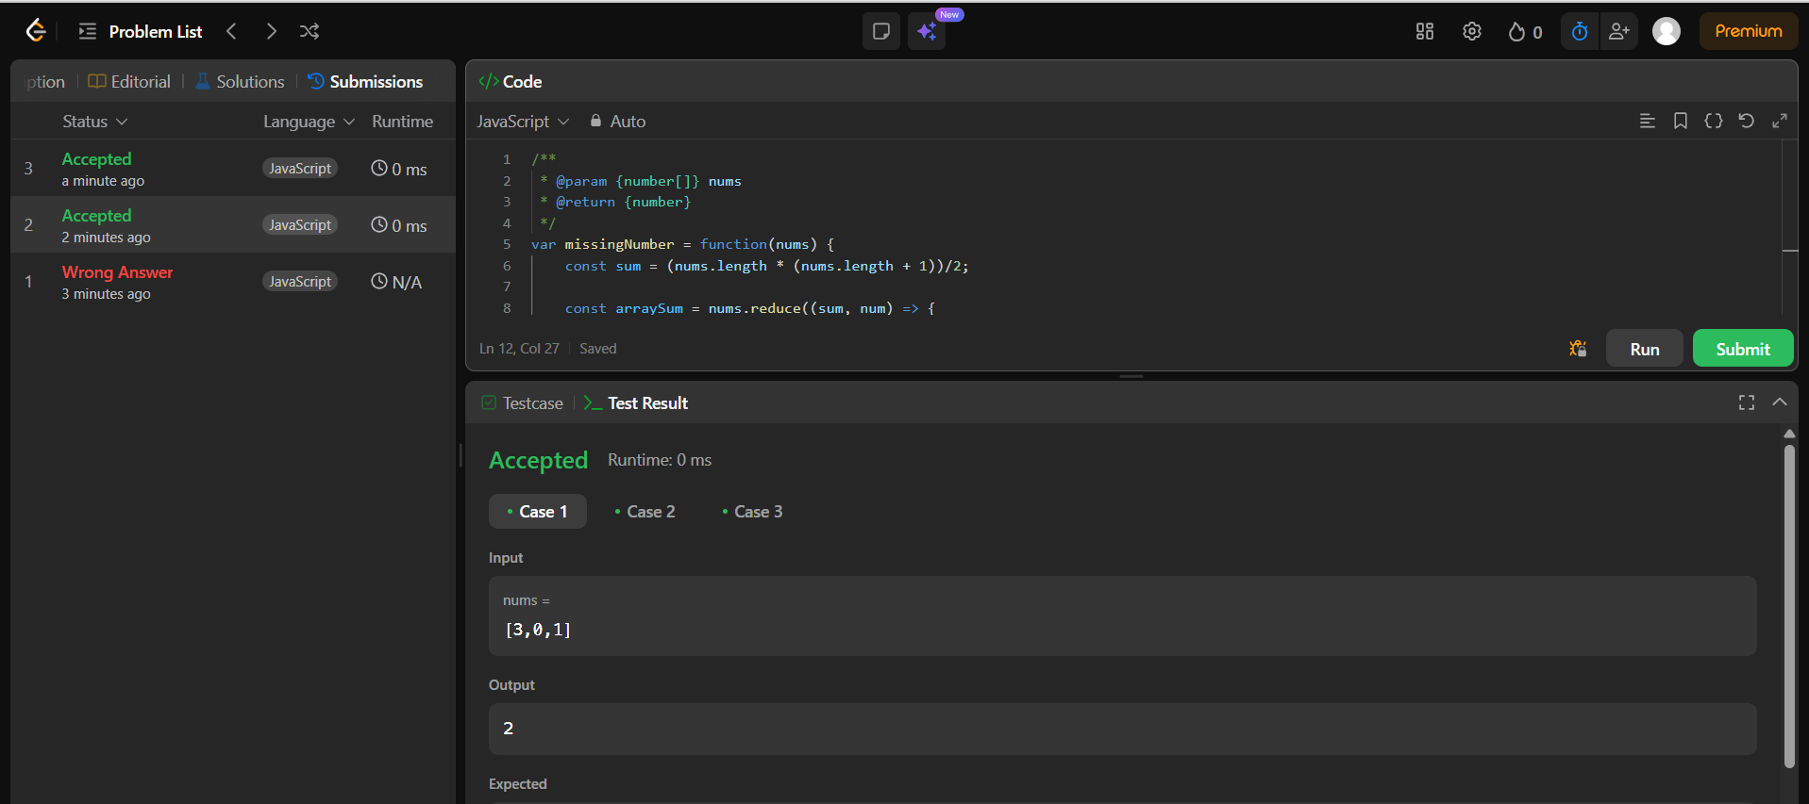

Problem No: 485 , find maximum consecutive ones from array

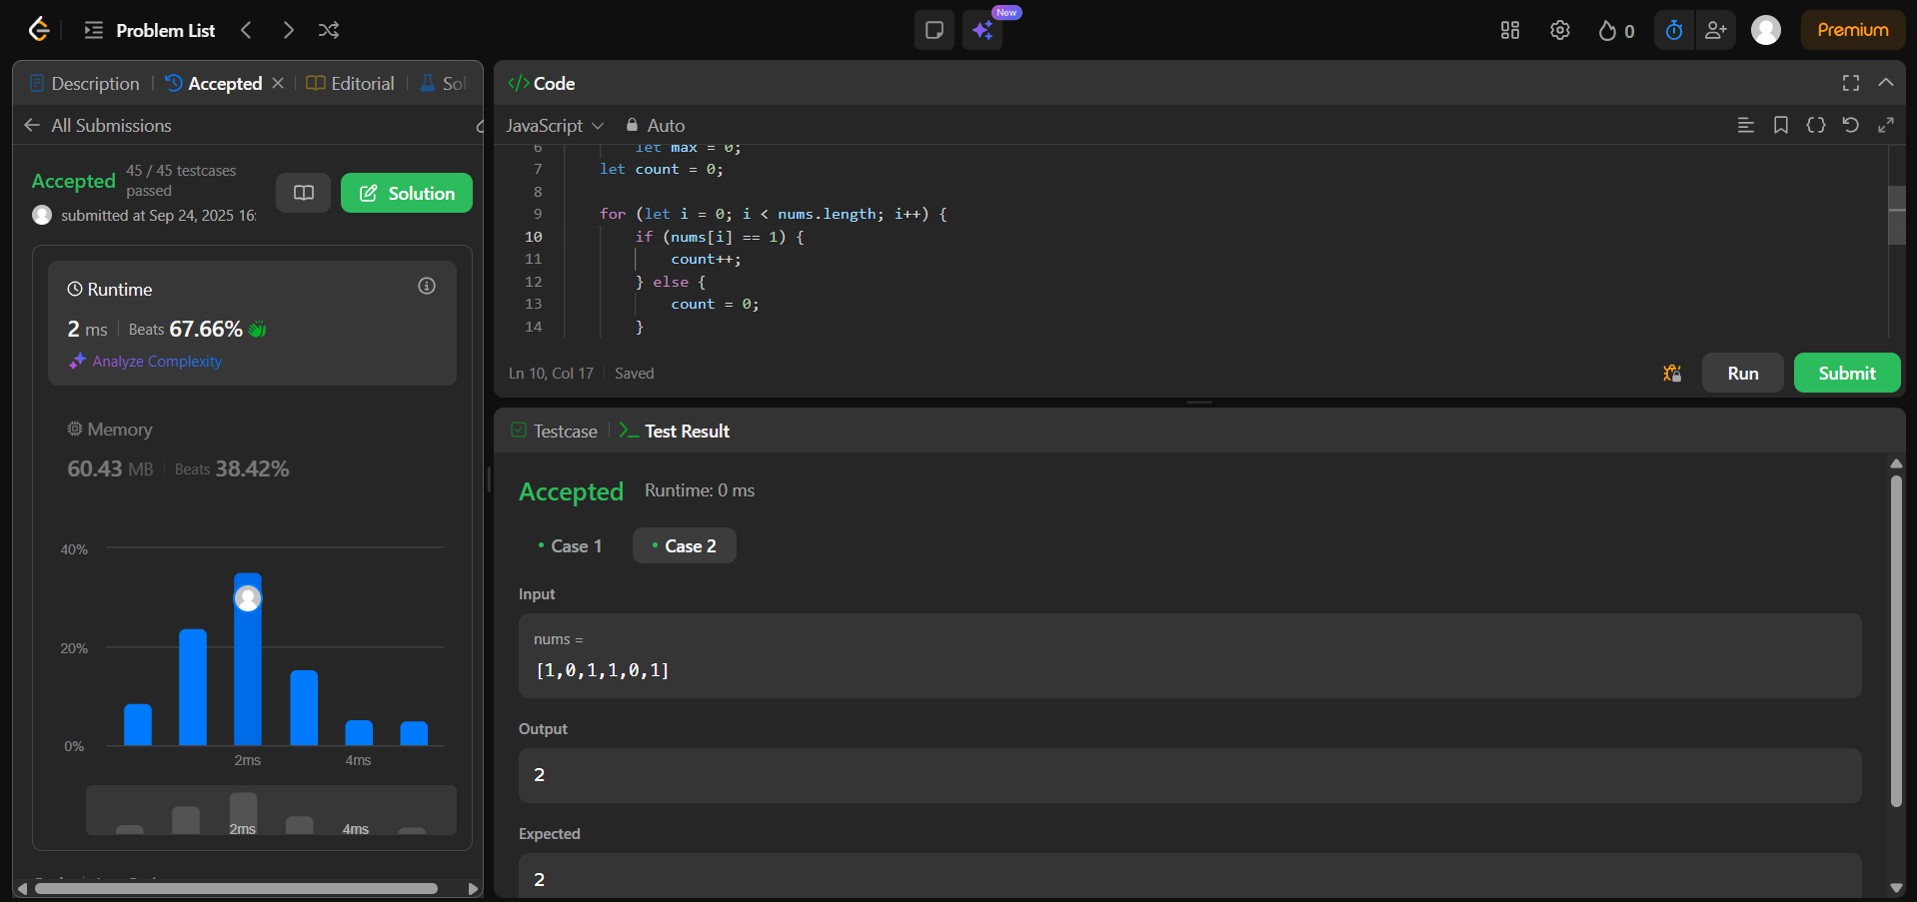

Problem No: 540 , find number which occurs once while others occurs twice

