Problem no: 1, Two Sum  
  
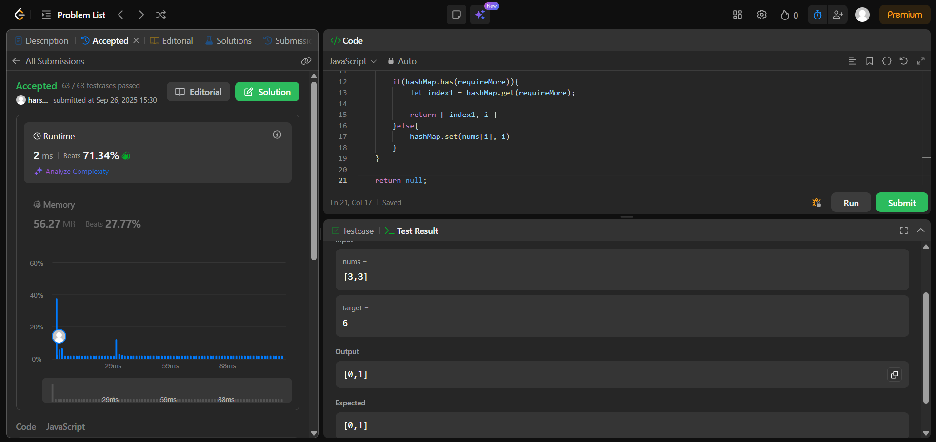

Problem No: 72, sort 0s 1s 2s  
