**[53. Maximum Subarray](https://leetcode.com/problems/maximum-subarray/)**(Kadanes algo)

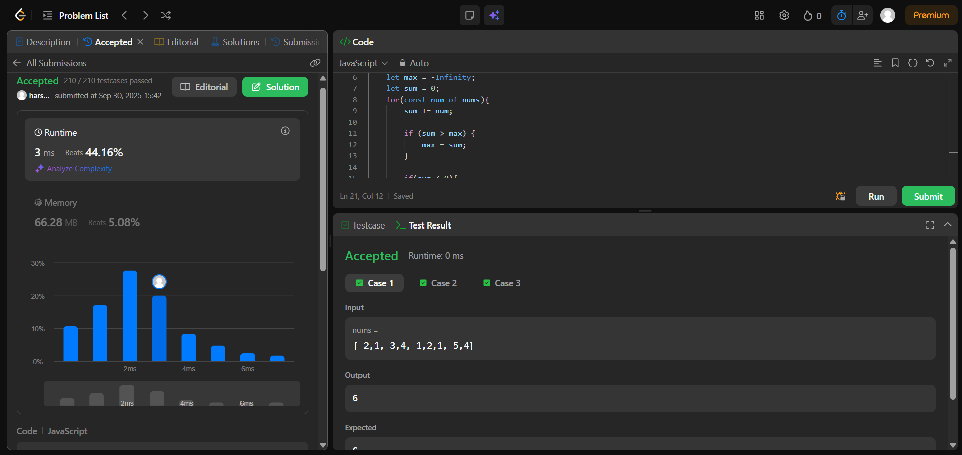

2149: Rearrange array by sign

