Problem No: 121 Best time to sell and buy

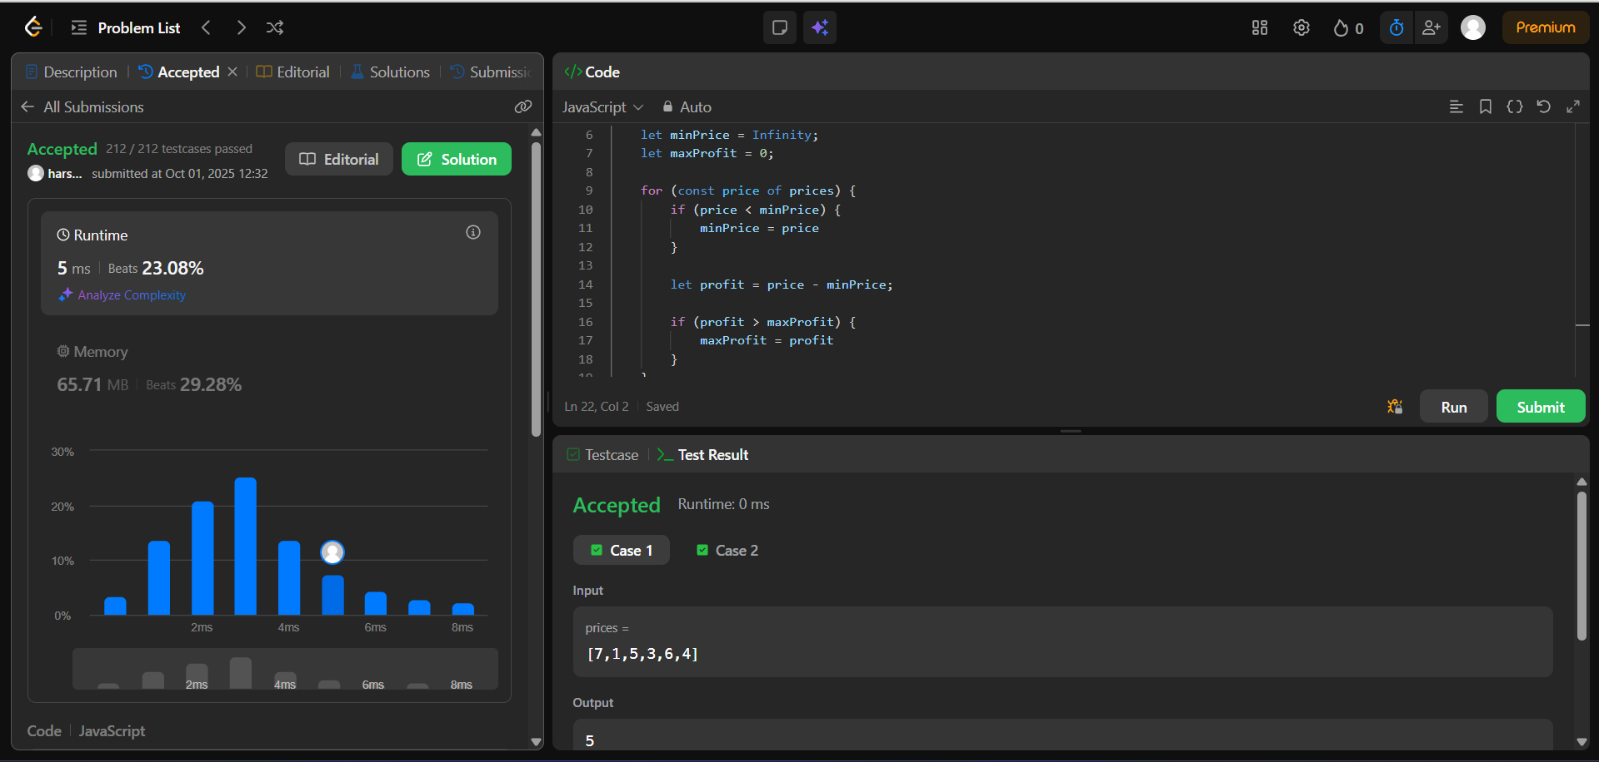

Problem No: 31, next Permutation

