Problem no: 704 binary search
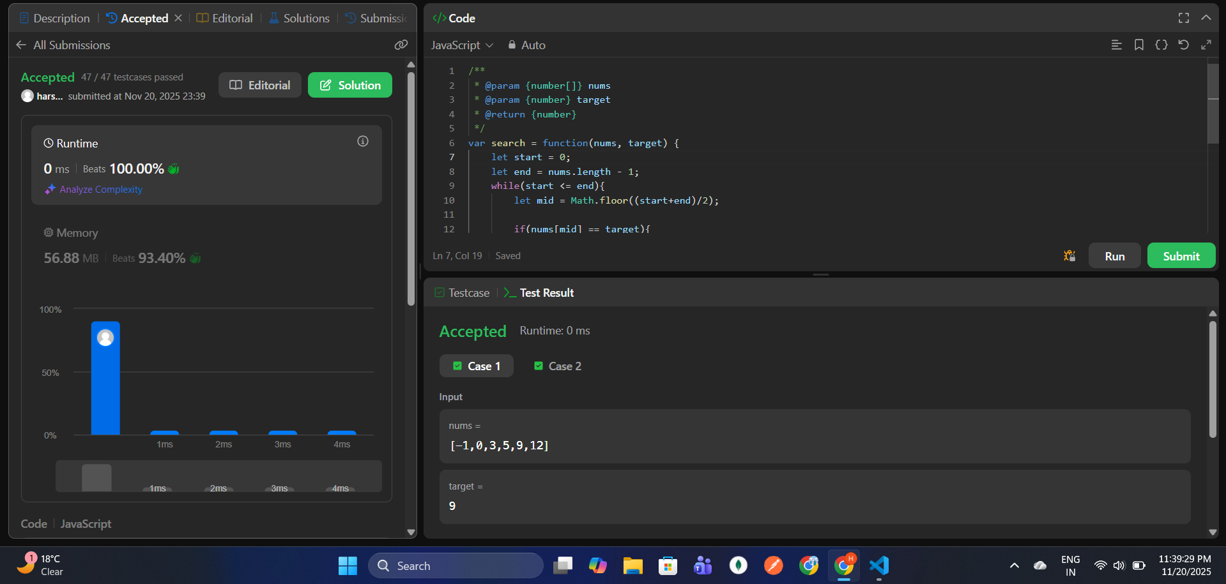

34. Find First and Last Position of Element in Sorted Array
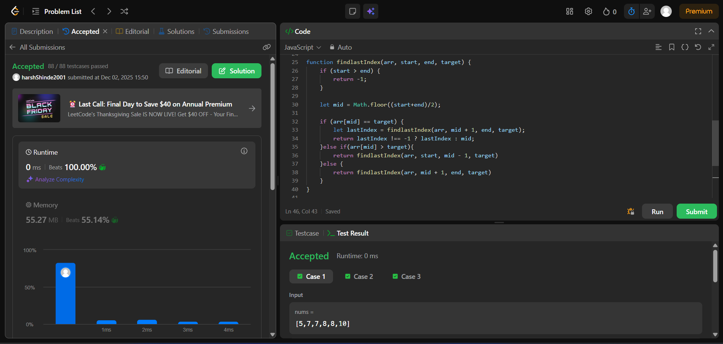

35. Search Insert Position
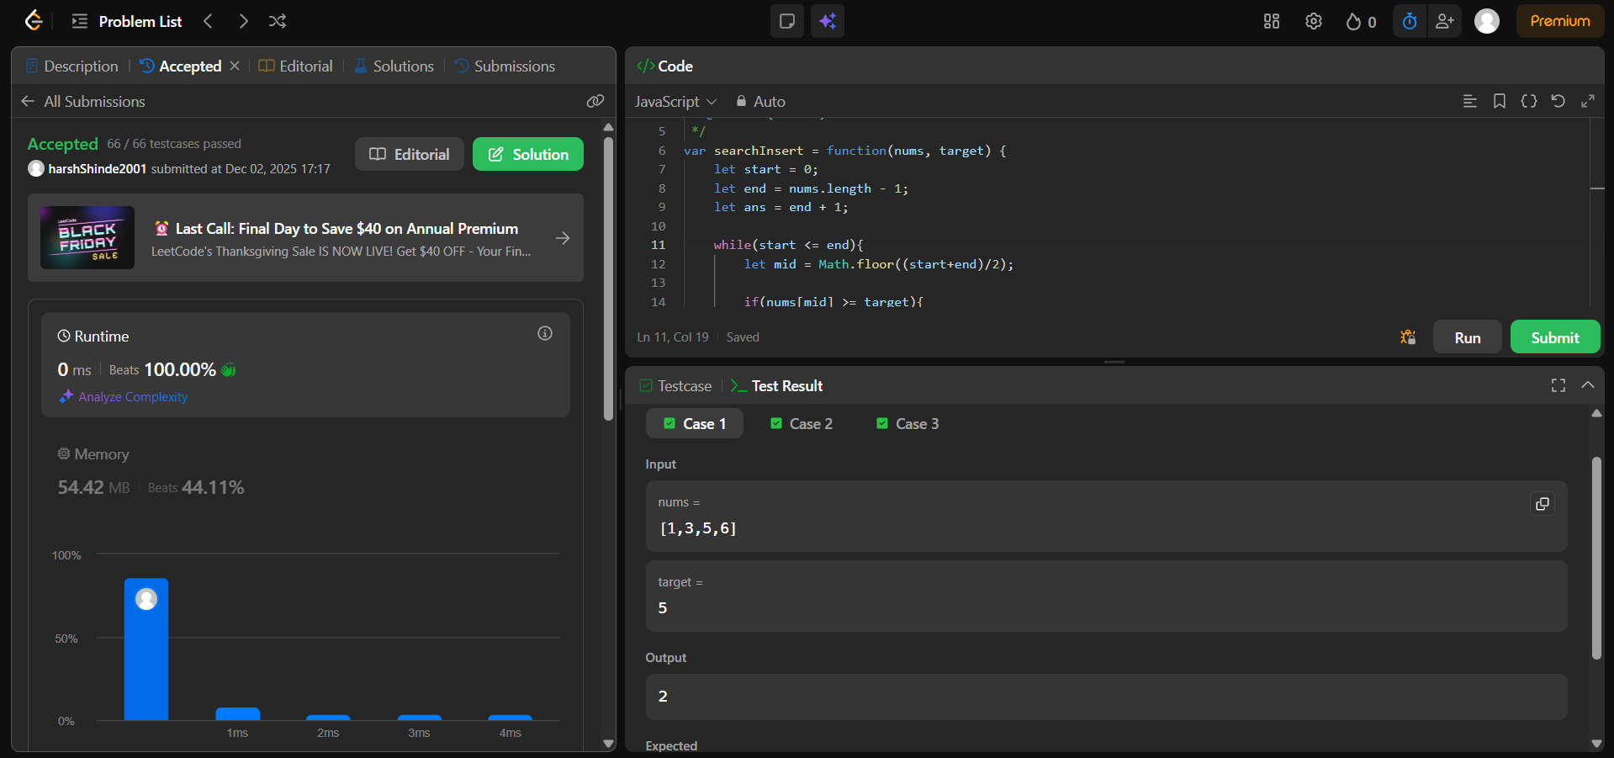

153. Find Minimum in Rotated Sorted Array
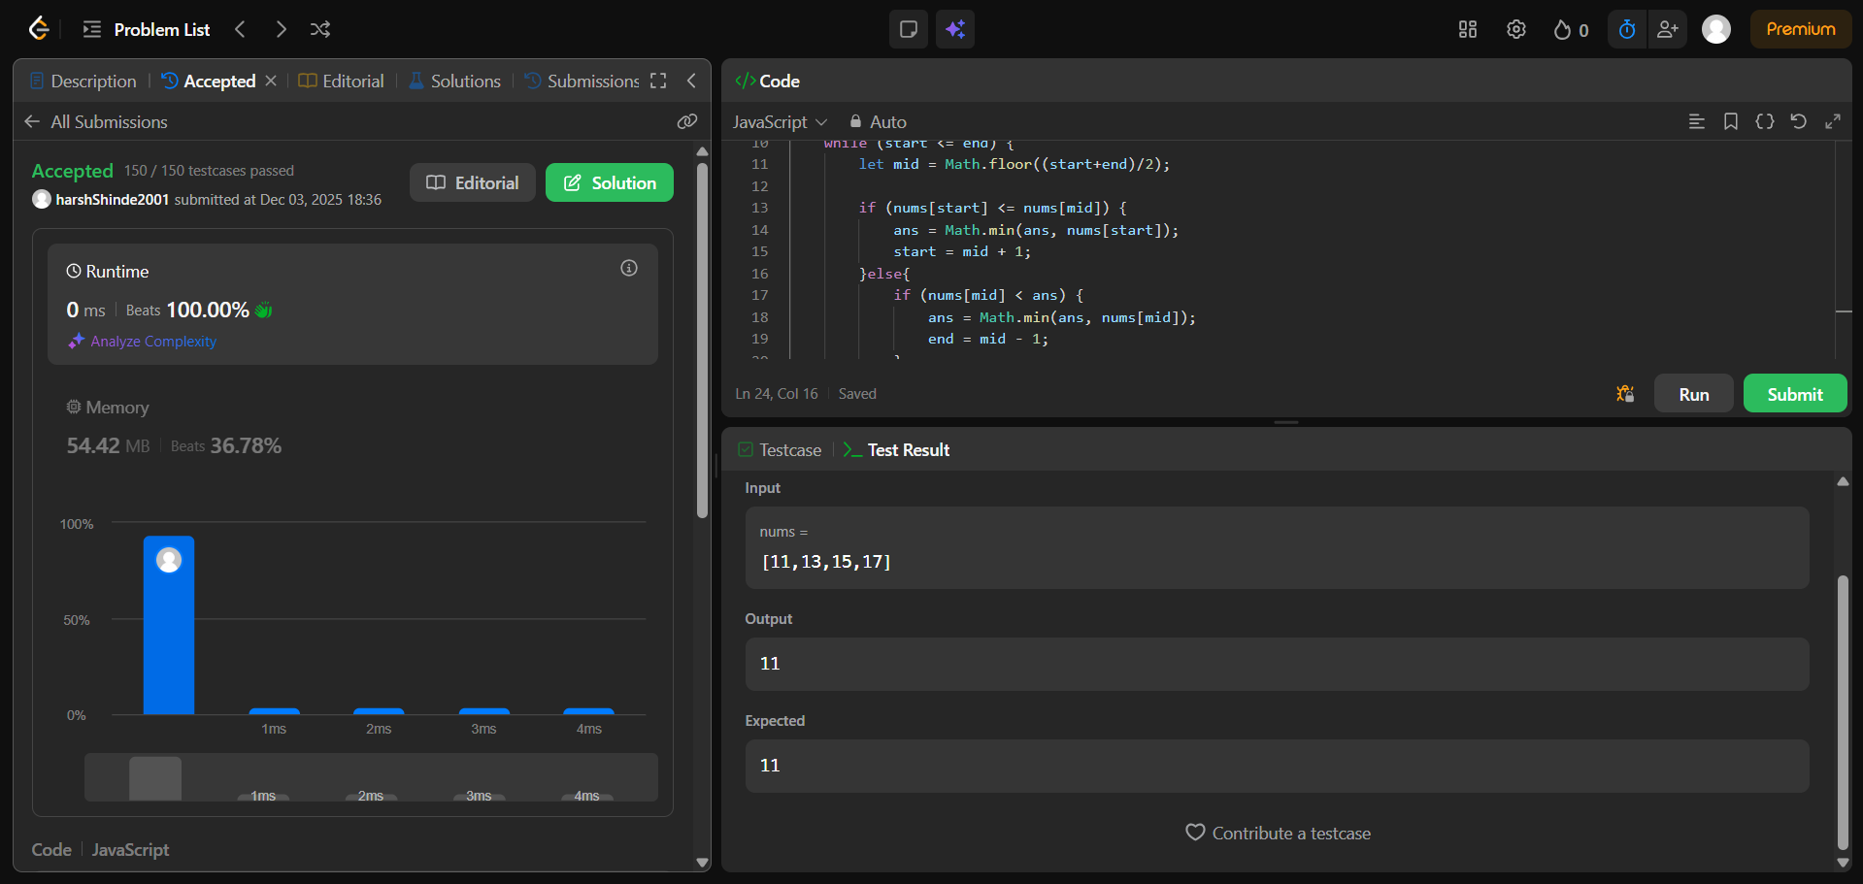
33. Search in Rotated Sorted Array
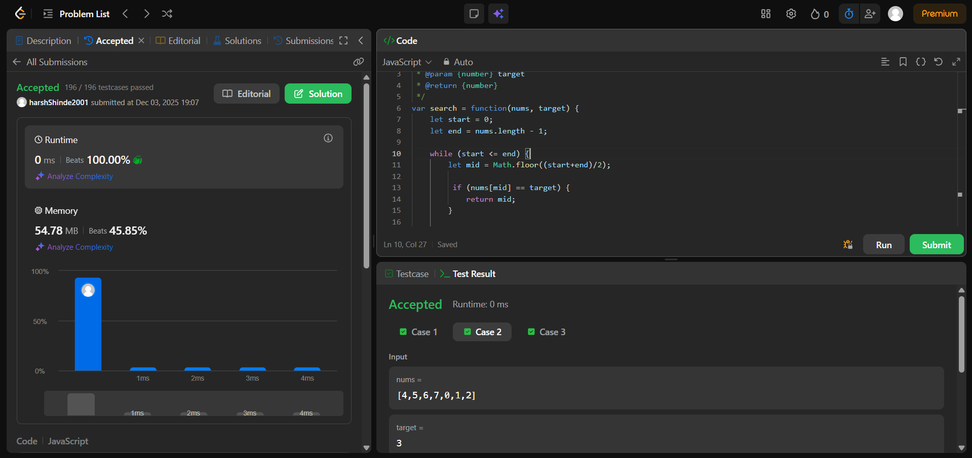

540. Single Element in a Sorted Array
