1482. Minimum Number of Days to Make m Bouquets
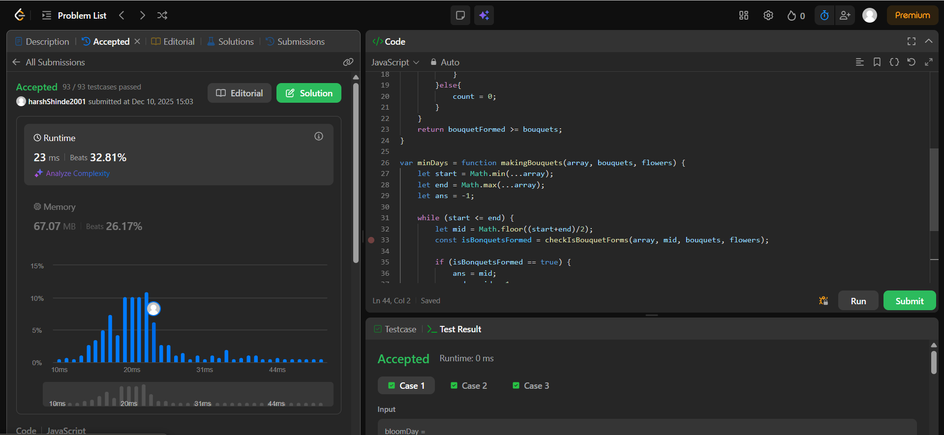

1011. Capacity To Ship Packages Within D Days
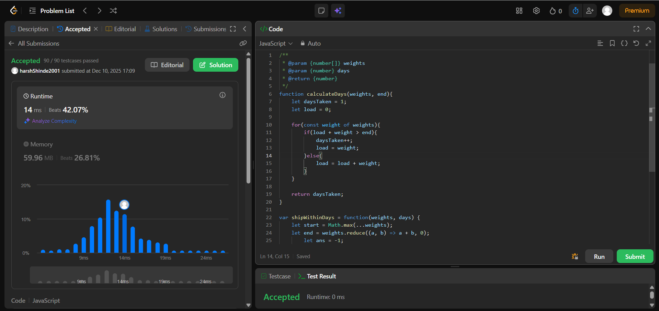

4. Median of Two Sorted Arrays
