**Problem Statement**: This is a simple challenge to help you practice printing to stdout. We're starting out by printing the most famous computing phrase of all time! In the editor below, use either printf or cout to print the string Hello, World! to stdout.

**Input Format**: You do not need to read any input in this challenge.

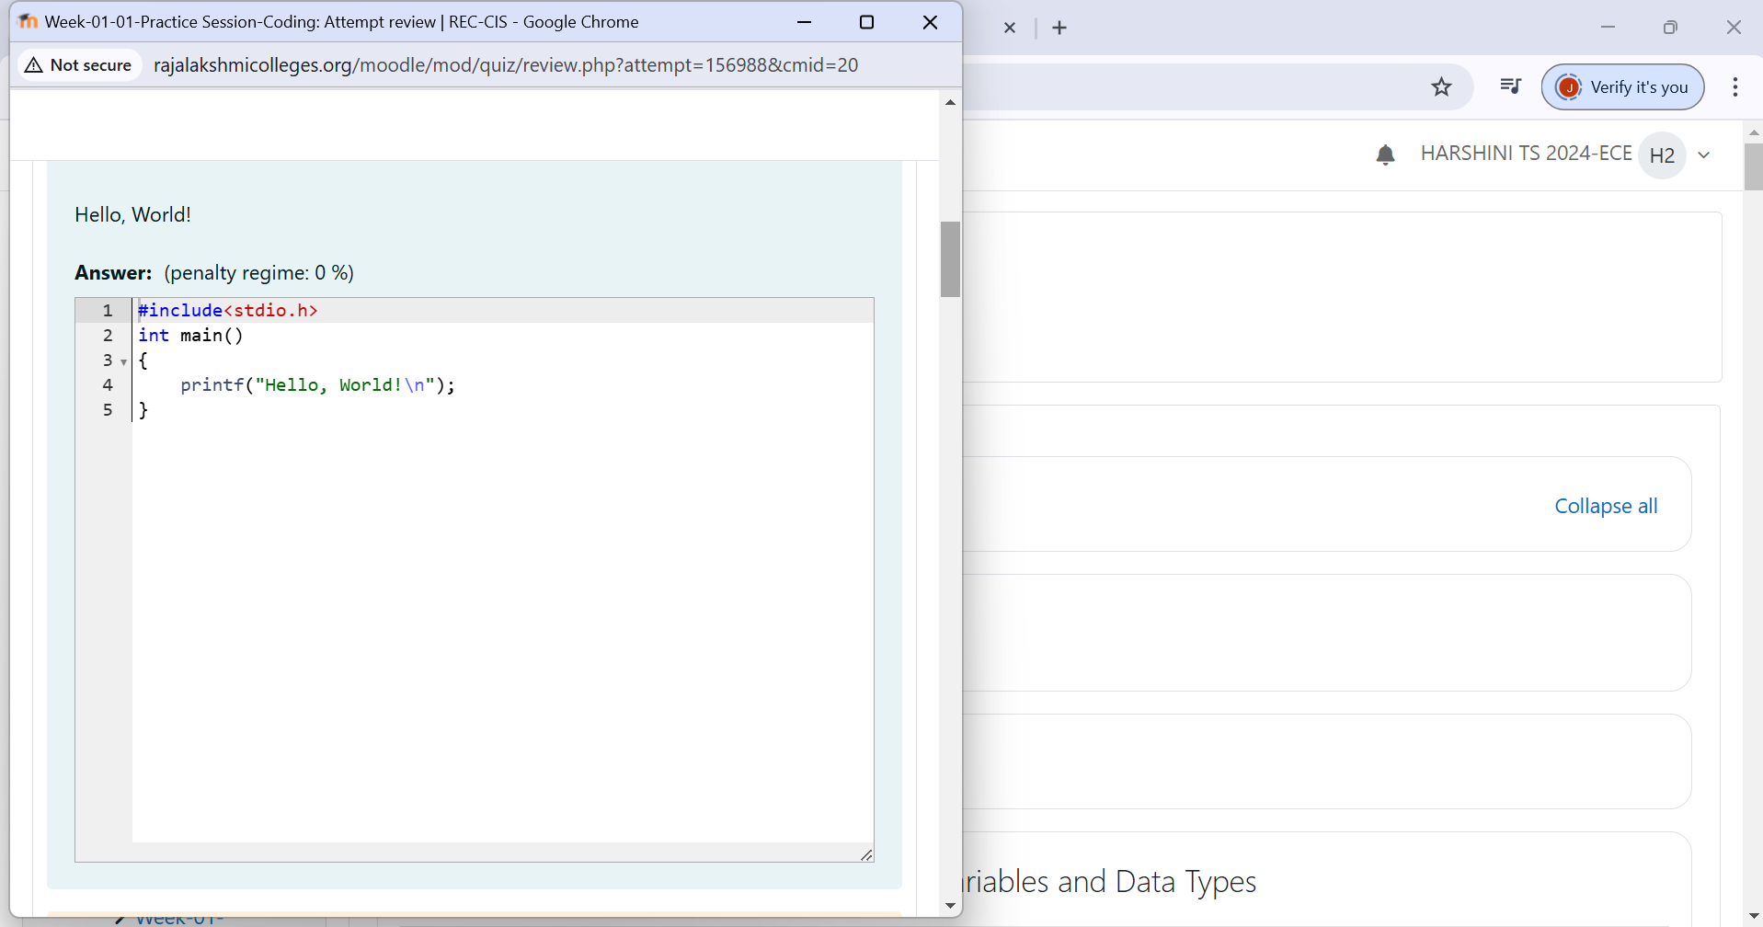 **Output Format:** Print Hello, World! to stdout.

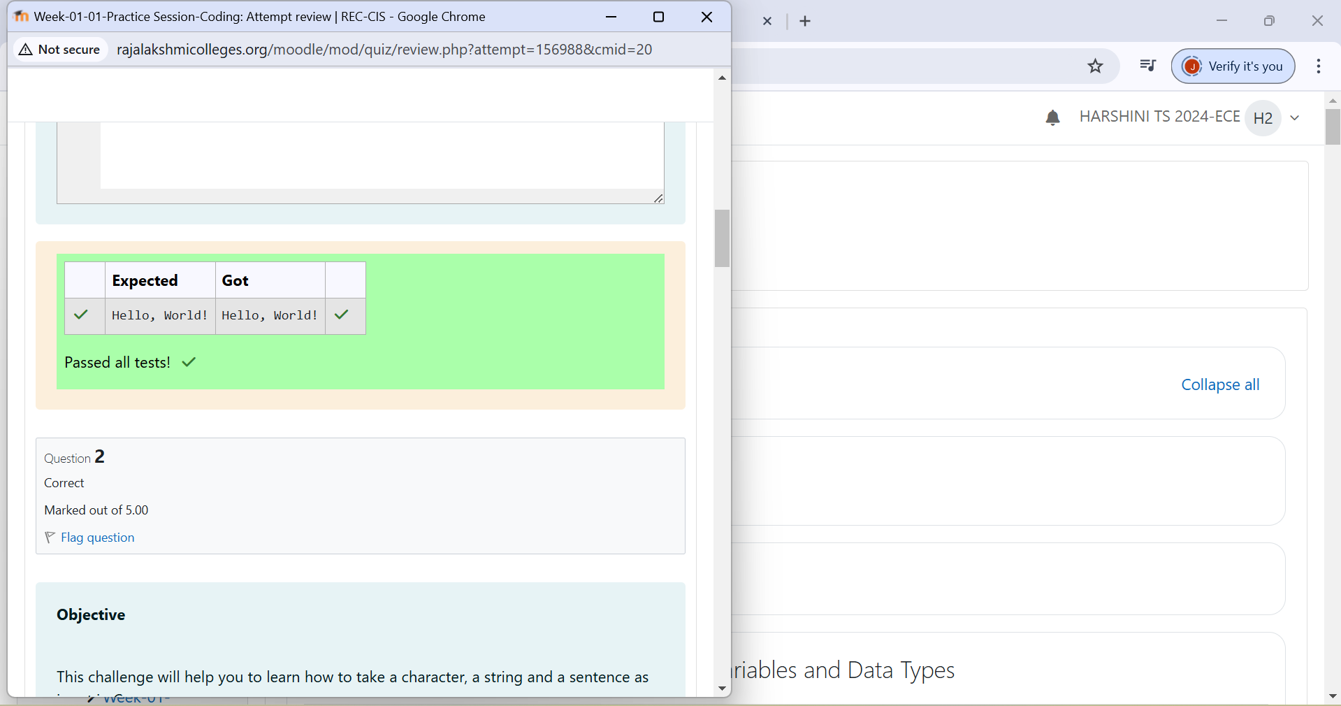

**Problem Statement**: This challenge will help you to learn how to take a character, a string and a sentence as input in C.

**Input Format**: First, take a character, ch as input. Then take the string, s as input. Lastly, take the sentence sen as input

**Output Format**: Print three lines of output. The first line prints the character, ch. The second line prints the string, s. The third line prints the sentence, sen.

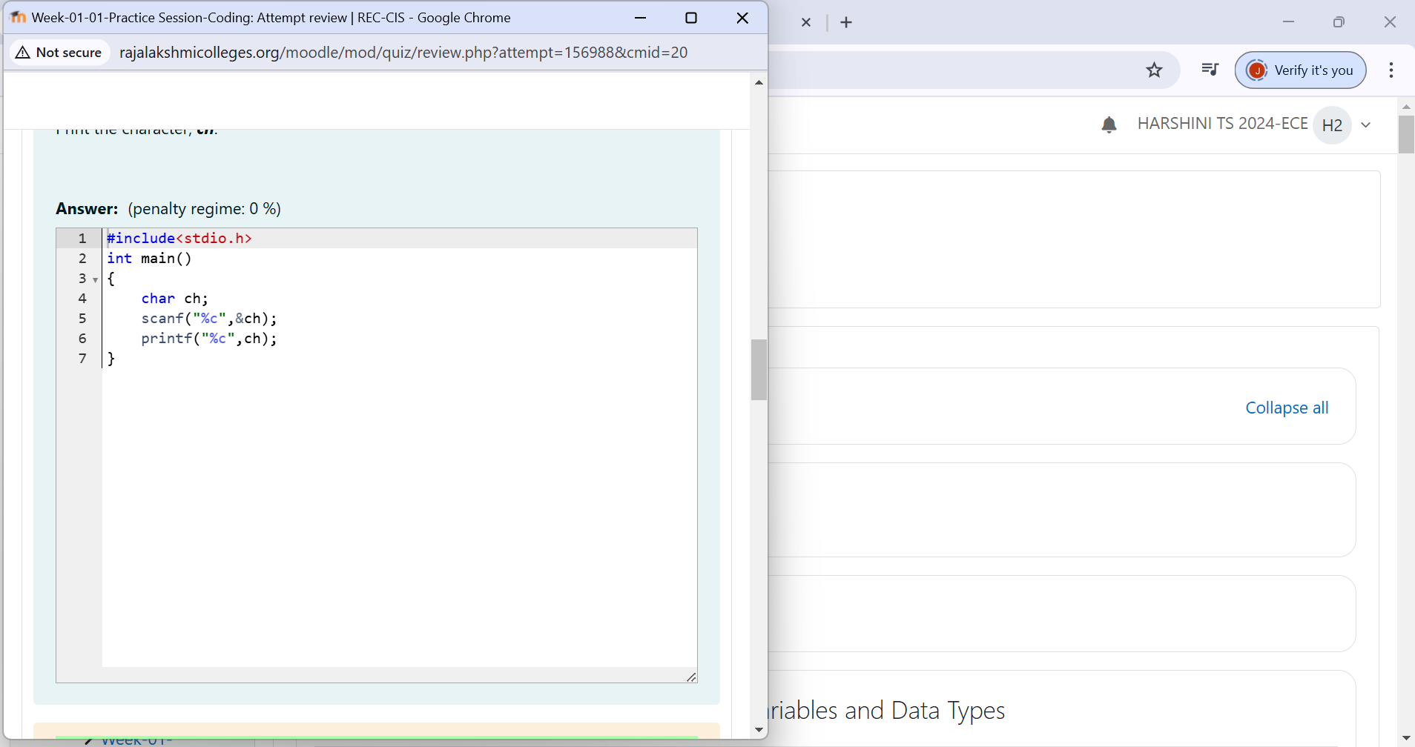

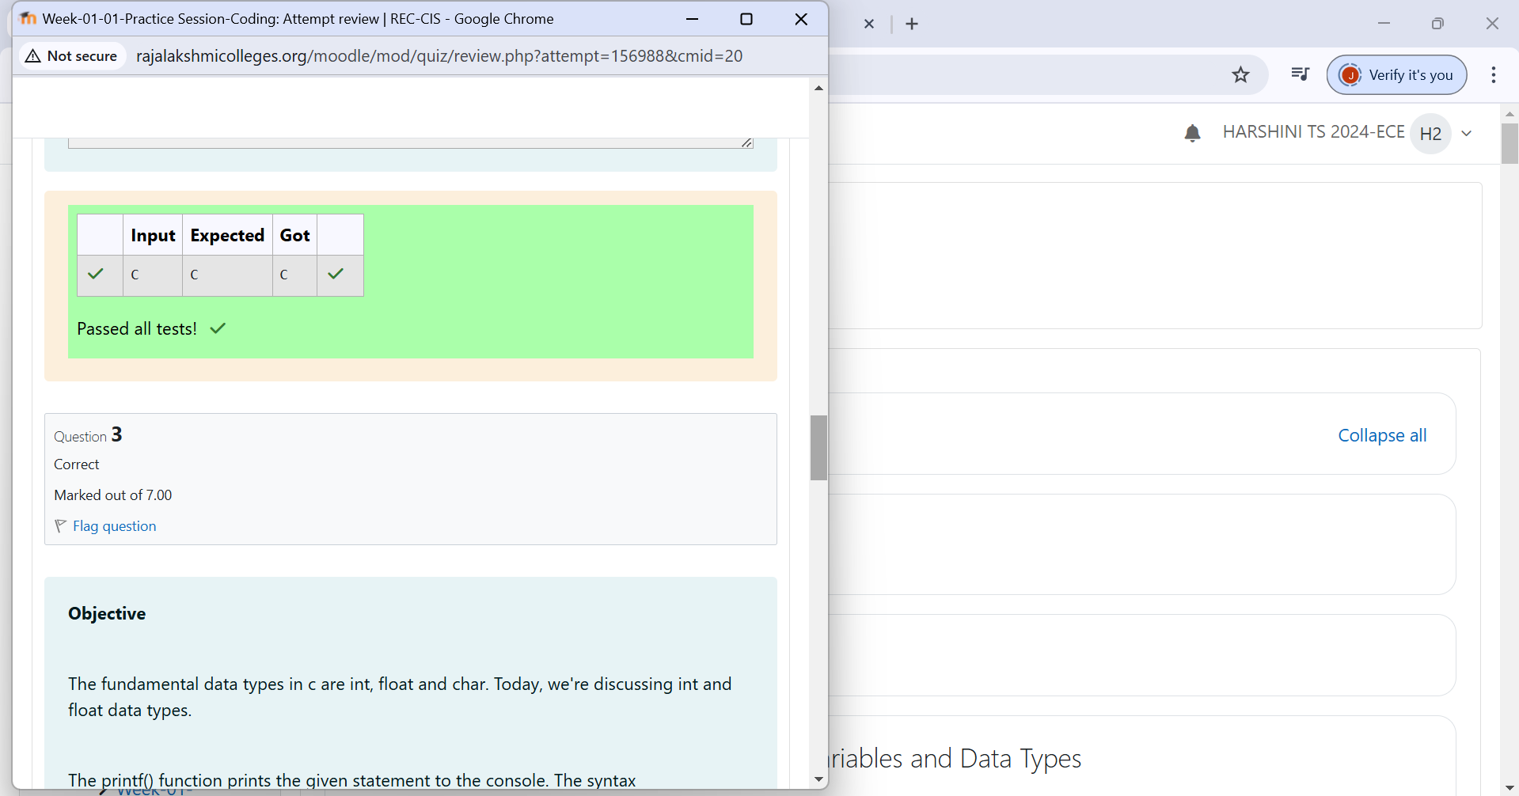

**Problem Statement**: The fundamental data types in c are int, float and char. Today, we're discussing int and float data types. The printf() function prints the given statement to the console. The syntax is printf("format string",argument_list);. In the function, if we are using an integer, character, string or float as argument, then in the format string we have to write %d (integer), %c (character), %s (string), %f (float) respectively.

