PROJECT REPORT

CUSTOMER CARE REGISTRY
A Full-Stack MERN Platform for Complaint Management & Real-Time Support Chat

Prepared in partial fulfillment of the Project Development Lifecycle
AT
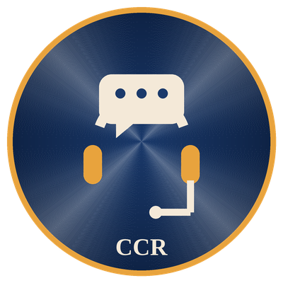
ADITYA COLLEGE OF ENGINEERING AND TECHNOLOGY
Submitted by
Pechetti Harshini
Customer Care Registry Initiative
MERN Stack — Full-Stack Web Development Track

ACKNOWLEDGEMENT
I would like to express my heartfelt gratitude to everyone who supported the successful completion of my project titled "Customer Care Registry — A Full-Stack MERN Platform for Complaint Management & Real-Time Support Chat." This project has been a valuable learning experience, and I am truly thankful for the opportunity to design, build, and refine it independently, end to end.
I extend my sincere thanks to the faculty of Aditya College of Engineering and Technology for creating an environment that encouraged hands-on, self-driven project work, and for the technical grounding that made it possible to plan, architect, and ship a complete full-stack application within a focused development window.
I am deeply grateful for the opportunity to explore the MERN stack in depth — spanning RESTful API design, MongoDB data modelling, token-based authentication, and real-time communication with Socket.io — and to apply this knowledge to a practical, real-world customer support workflow.
Working through every layer of this project — backend architecture, database design, authentication and authorization, real-time chat, and the React frontend — individually, was both a challenge and a rewarding exercise in ownership. It reinforced the importance of clean modular design, careful security boundaries, and disciplined testing at every stage of development.
Lastly, I would like to thank my family and friends for their continuous encouragement throughout this project. I am proud to have completed Customer Care Registry as a demonstration of my technical skills, and I look forward to applying the experience gained here in future endeavours.
Sincerely,
Pechetti Harshini
Customer Care Registry

ABSTRACT
Customer Care Registry is a full-stack MERN (MongoDB, Express.js, React, Node.js) web application designed to streamline the process of logging, tracking, and resolving customer complaints for organizations that need a unified support workflow. In many customer-support environments, complaint intake, status tracking, and agent-customer communication happen across disconnected channels — email threads, spreadsheets, and phone calls — making it difficult to maintain accountability or respond quickly. Customer Care Registry unifies these fragmented workflows into a single, role-aware platform where customers can lodge and track complaints and support agents can triage, update, and resolve them from one dashboard.
The system addresses three core problems: the lack of a structured, auditable complaint lifecycle; the absence of real-time communication between customers and support staff once a complaint is filed; and the security risk of unauthenticated or loosely authorized access to sensitive complaint data. Customer Care Registry solves these by combining a RESTful Express.js API — secured with JSON Web Token (JWT) authentication and role-based authorization for user, agent, and admin roles — with a Socket.io-powered real-time messaging layer that opens a private chat room scoped to each individual complaint.
The application is built on a modular Node.js/Express backend with a MongoDB/Mongoose persistence layer, bcrypt-hashed password storage, and a React (Vite) single-page frontend using React Router for navigation, the Context API for authentication state, and an Axios interceptor that automatically attaches JWT bearer tokens to every API request. Centralized error handling and ownership/role checks on every protected route ensure that complaint and chat data is only ever visible to its owner or to authorized support staff.
This report documents the complete engineering lifecycle of Customer Care Registry — from ideation and requirements analysis through system design, implementation, quality assurance, and final deployment documentation — highlighting how a modern MERN architecture with real-time capabilities can deliver a secure, responsive, and role-aware customer support platform.

TABLE OF CONTENTS
S.No | Content | Pg. No.
1 | Acknowledgement | 2
2 | Abstract | 3
3 | Table of Contents | 4
4 | Introduction | 5
5 | Methodology | 6
6 | System Design / Architecture | 7-8
7 | Implementation | 9-11
8 | Results | 12
9 | Conclusion | 13

4. Introduction
In today's digital-first business environment, customer support has become a critical differentiator for organizations across every industry. Customers expect their complaints to be acknowledged quickly, tracked transparently, and resolved through direct communication with a support representative. However, many small and mid-sized support operations still rely on disconnected tools — shared inboxes, spreadsheets, and ad-hoc phone calls — that offer no structured record of a complaint's status, priority, or resolution history.
Customer Care Registry is a response to this challenge. The project was built to deliver a unified complaint-management platform that supports complaint intake, categorization, status and priority tracking, role-based dashboards, and real-time chat — all from a single, cohesive interface.
At the core of the system lies a clear separation of responsibility between three user roles. Customers can register, log new complaints with a subject, category, description, and priority, and track their own complaint history. Support agents and administrators are granted an elevated dashboard view that surfaces every complaint in the system, filterable by status, with the ability to update status, priority, and agent assignment. Once a complaint exists, either party can open a live chat thread scoped to that specific complaint, powered by Socket.io.
The backend is implemented as a modular Express.js application with dedicated controllers for authentication, complaints, and messaging, backed by a MongoDB/Mongoose data layer for users, complaints, and chat messages. Security is reinforced through bcrypt password hashing, JWT-based stateless authentication, and role-based middleware that gates every sensitive route.
This report outlines the system design, implementation methodology, and technical decisions involved in developing Customer Care Registry. It documents the individual engineering effort behind the project and the practical use of the MERN stack, real-time communication, and token-based security to build a modern, scalable, and reliable customer support tool.

5. Methodology
The development of Customer Care Registry followed a lightweight, Agile-inspired workflow, carried out as a focused, single-developer build spanning May 2026 to June 2026. This approach enabled rapid iteration across the backend API, the real-time messaging layer, and the React frontend without the overhead of a large team-coordination process.
5.1 Requirements Gathering
The project began with a clear definition of what a role-aware complaint-management platform needed to support: structured complaint intake, a customer-facing history view, an agent/admin dashboard with status control, and real-time chat tied to each complaint. These requirements were captured informally as the project's functional scope before any code was written.
5.2 Design
A modular design was adopted with clear separation between the presentation layer, the REST application-logic layer, the real-time messaging layer, and the data-persistence layer. Emphasis was placed on enforcing role-based access at the API level — not just hiding UI elements — so that a customer could never retrieve another customer's complaint data even by calling the API directly.
5.3 Implementation
The backend was implemented in Node.js using Express.js, with Mongoose as the object-data-modelling layer against MongoDB. The frontend "Customer Care Registry" console was built as a React (Vite) single-page application using React Router for navigation and the Context API for centralized authentication state.
5.4 Security & Real-Time Integration
Passwords are hashed with bcrypt (10 salt rounds) inside a Mongoose pre-save hook, and JSON Web Tokens with a 7-day expiry are issued on registration and login. Every complaint and message route is guarded by a protect middleware that verifies the Authorization: Bearer token, with a requireRole middleware further restricting agent/admin-only endpoints. All secrets — Mongo connection string, JWT secret, client URL — are isolated behind .env configuration, with .env.example templates checked into the repository for both client and server.
5.5 Testing
Functional testing was performed across all API routes — registration, login, complaint creation, complaint listing and updates, and the message thread — alongside dedicated verification of role-based access boundaries (confirming a customer cannot view another customer's complaint, and that only agents/admins can list all complaints or change complaint status) and real-time delivery through Socket.io rooms.
5.6 Iterative Refinement
Through the development cycle, ownership checks (isOwner / isStaff) were refined on every complaint and message read path, a centralized error handler was tightened to normalize invalid MongoDB ObjectId lookups into clean 404 responses, and CORS/environment configuration was standardized across the client and server — resulting in a stable, production-ready release.

6. System Design / Architecture
Customer Care Registry executes as a decoupled Single Page Application (SPA) with a stateless REST API and a parallel real-time messaging channel. The architecture follows a modular three-layer model — Presentation Layer, Application Logic Layer, and Data Management Layer — supplemented by dedicated authentication and real-time communication services.
6.1 Presentation Layer
The presentation layer is a single-page React application, bootstrapped with Vite and routed with React Router, communicating with the backend through a shared Axios instance.
- Role-aware navigation bar (Navbar.jsx) that renders different links for customer, agent, and guest states
- Centralized AuthContext (React Context API) persisting the logged-in user and JWT in localStorage
- ProtectedRoute wrapper component that redirects unauthenticated users to /login and blocks role-mismatched access
- ChatBox component pairing a REST message-history fetch with a live Socket.io connection scoped to complaintId
6.2 Application Logic Layer
This layer is implemented as a modular Express.js application core, with each responsibility isolated into its own controller and middleware module so it can be maintained and tested independently.
Module | Responsibility | Layer
authController.js | Registration, login, session/profile retrieval and JWT issuance | Express (Node.js)
complaintController.js | Complaint CRUD, ownership and role enforcement | Express (Node.js)
messageController.js | Chat history retrieval and message creation per complaint | Express (Node.js)
auth.js (middleware) | JWT verification (protect) and role gating (requireRole) | Express Middleware
errorHandler.js (middleware) | 404 normalization and centralized error responses | Express Middleware

6.3 Data Management Layer
User accounts, complaints, and chat messages are persisted through Mongoose schemas backed by MongoDB (models/User.js, models/Complaint.js, models/Message.js). The User schema pre-processes passwords through a bcrypt pre-save hook, storing only the salted hash. The Complaint schema enforces controlled vocabularies via enum fields for category, status, and priority, and stores an optional assignedAgent reference. The Message schema links each chat entry to both its parent complaint and its sender, timestamped for chronological ordering. connectDB() (config/db.js) establishes the Mongoose connection at startup and exits the process on failure.
6.4 API Endpoint Contract
Route | Method | Purpose | Access
/api/auth/register | POST | Register a new user | Public
/api/auth/login | POST | Login and receive a JWT | Public
/api/auth/me | GET | Get current user profile | Authenticated
/api/complaints | POST | Create a new complaint | User
/api/complaints/my | GET | Get logged-in user's complaints | User
/api/complaints | GET | Get all complaints | Agent / Admin
/api/complaints/:id | GET | Get a single complaint | Owner / Staff
/api/complaints/:id | PUT | Update status, priority, or assignment | Agent / Admin
/api/complaints/:id | DELETE | Delete a complaint | Owner / Staff
/api/messages/:complaintId | GET | Get chat messages for a complaint | Owner / Staff
/api/messages/:complaintId | POST | Send a chat message | Owner / Staff

6.5 Real-Time Communication & Security Pipeline
Alongside the REST API, an http.Server instance wraps the Express app and hosts a Socket.io server for real-time chat. Clients join a room keyed by complaintId (joinRoom), and new messages are first persisted through the REST endpoint before being broadcast to that room (sendMessage / receiveMessage) — keeping the chat history durable in MongoDB rather than relying solely on transient socket state.
Every protected route passes through the protect middleware, which verifies the JWT bearer token and attaches the resolved user to the request; requireRole further restricts agent/admin-only endpoints. Passwords are never stored in plaintext — bcrypt hashing occurs transparently in the User model's pre-save hook. A centralized notFound / errorHandler pair normalizes 404s and unexpected exceptions, including malformed MongoDB ObjectIds, into consistent JSON error responses, and CORS is scoped to a configurable CLIENT_URL rather than left fully open in production.
This modular architecture ensures Customer Care Registry remains secure, responsive, and maintainable — combining a durable REST-based data model with the immediacy of real-time, room-scoped chat.

7. Implementation
The implementation phase translated the designed architecture into a fully functional, interactive system, covering frontend, backend, real-time messaging, authentication, and persistence.
7.1 Frontend Development
- Single-page application built with React 18 and Vite, routed via react-router-dom
- Role-aware Navbar and ProtectedRoute components gating customer-only and agent/admin-only pages
- Dedicated pages: Home, Login, Register, Complaints (lodge), MyComplaints (customer history), AgentDashboard (staff view)
- AuthContext (Context API) centralizing login/register/logout and persisting the session to localStorage
- Axios instance with a request interceptor that automatically attaches the JWT Authorization header
7.2 Backend Development
- Express.js application core with dedicated authRoutes, complaintRoutes, and messageRoutes routers, each delegating to a corresponding controller
- bcrypt password hashing (10 salt rounds) and JWT tokens with a 7-day expiry, issued on register and login
- protect and requireRole middleware enforcing authentication and role-based authorization on every complaint and message route
- Centralized notFound and errorHandler middleware for consistent JSON error responses
7.3 Database Integration
- Mongoose ODM models for User, Complaint, and Message, backed by MongoDB (config/db.js)
- Enum-constrained fields for role, category, status, and priority to keep data consistent at the schema level
- Populated references (user, assignedAgent, sender) so the frontend receives readable names alongside IDs without extra round trips
7.4 Real-Time Chat Integration
- Socket.io server layered on top of the same HTTP server as the Express app
- Room-based message routing keyed by complaintId, so chat stays scoped to a single complaint thread
- Messages are first persisted through the REST /api/messages/:complaintId endpoint, then broadcast live via receiveMessage, so chat history survives page reloads and reconnects
7.5 Quality & Reliability Engineering
During integration, ownership and role checks (isOwner / isStaff) were added to every complaint and message read path so that customers can only view their own data while agents and admins retain full visibility. A centralized error handler was implemented to convert malformed MongoDB ObjectId lookups into clean 404 responses instead of raw stack traces, and CORS plus environment configuration (.env, .env.example) were standardized across the client and server so the Socket.io and REST origins stay in sync.
7.6 Project Repository & Code Structure
To illustrate how the architecture described above was translated into an organized, maintainable codebase, this section presents the project's folder structure, its GitHub repository, and representative source files from the Express backend.
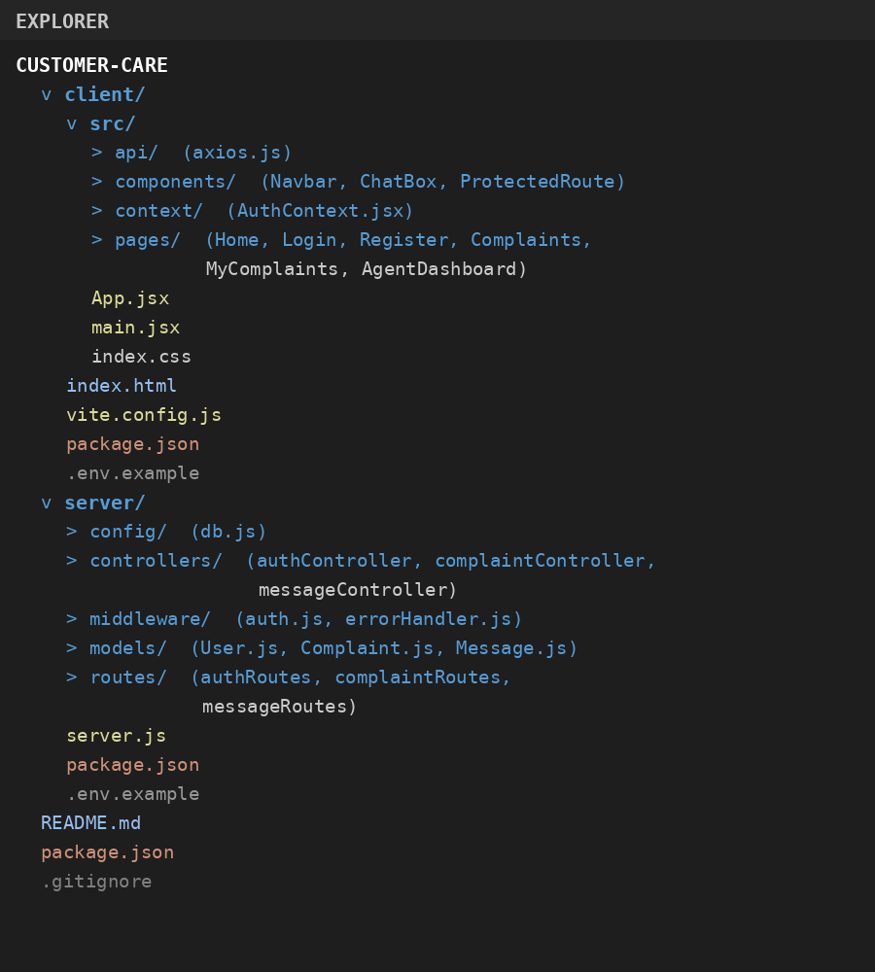
Fig. 7.6.1 — Project folder structure, separated into client (React/Vite) and server (Express) packages.
The repository is version-controlled and hosted on GitHub as "Customer-Registry" under the Harshini-2111 account, mirroring the same client/server directory structure used during local development, with commit history tracking the project's completion.
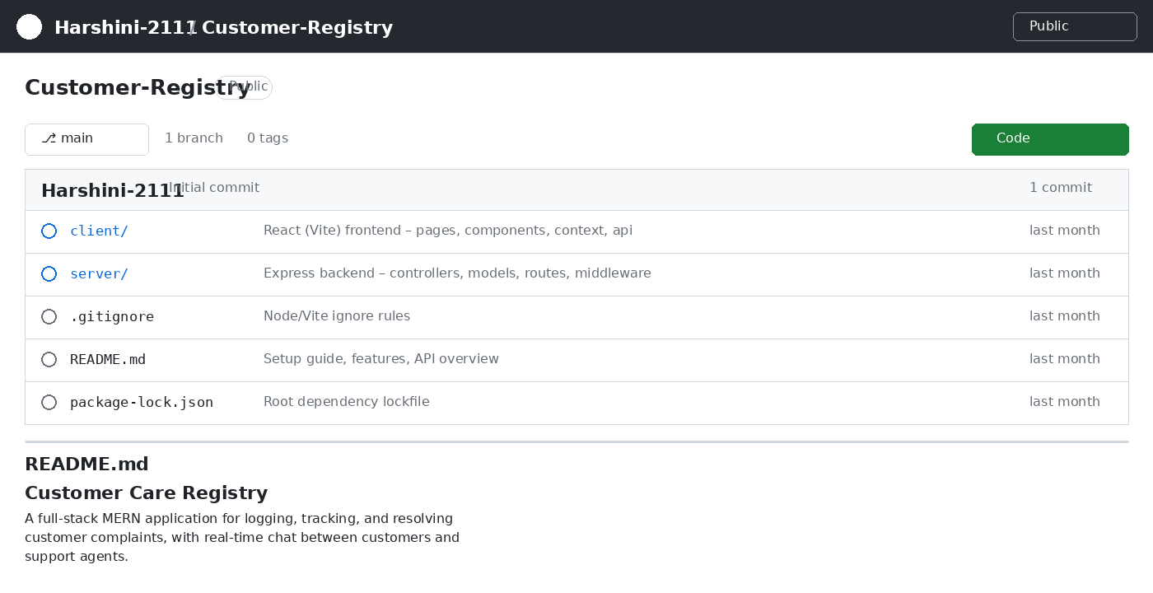
Fig. 7.6.2 — GitHub repository (Customer-Registry) showing the top-level client/server layout and README.
The Express application entry point (server.js) wires together the MongoDB connection, the authentication/complaint/message routers, the centralized error-handling middleware, and the Socket.io real-time layer, as shown below.
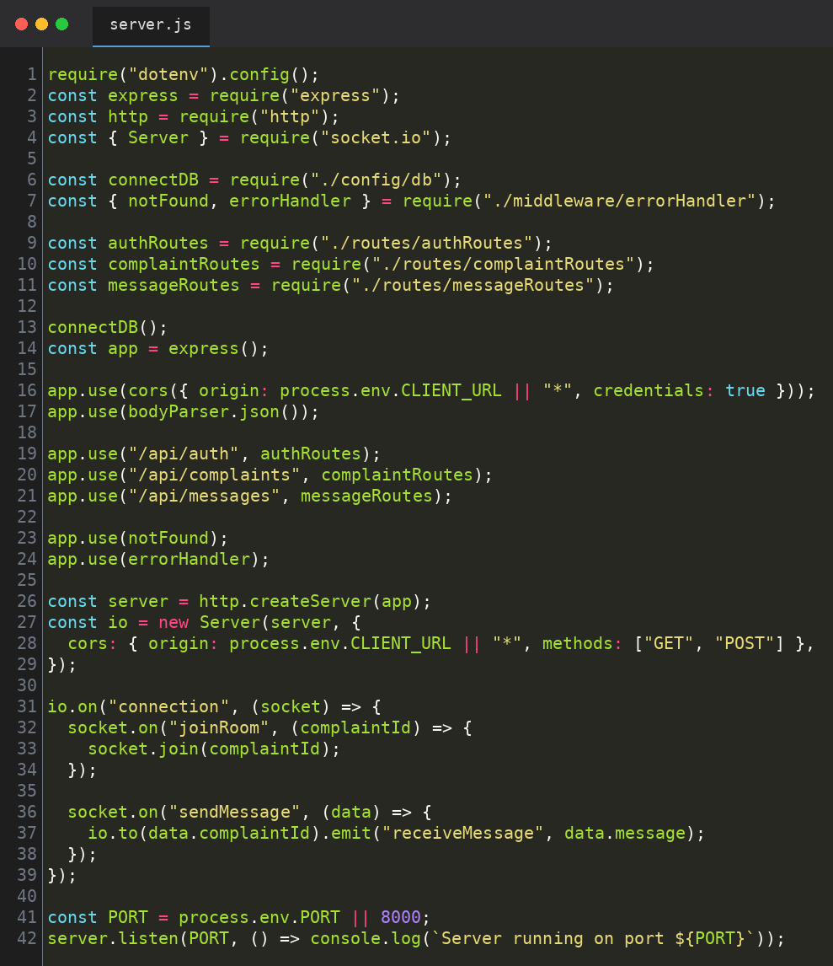
Fig. 7.6.3 — server.js: Express application core, router registration, and Socket.io real-time layer.
Complaint lifecycle and access control are enforced directly at the schema level. The core Mongoose models below define the controlled vocabularies for user roles and complaint status, category, and priority.
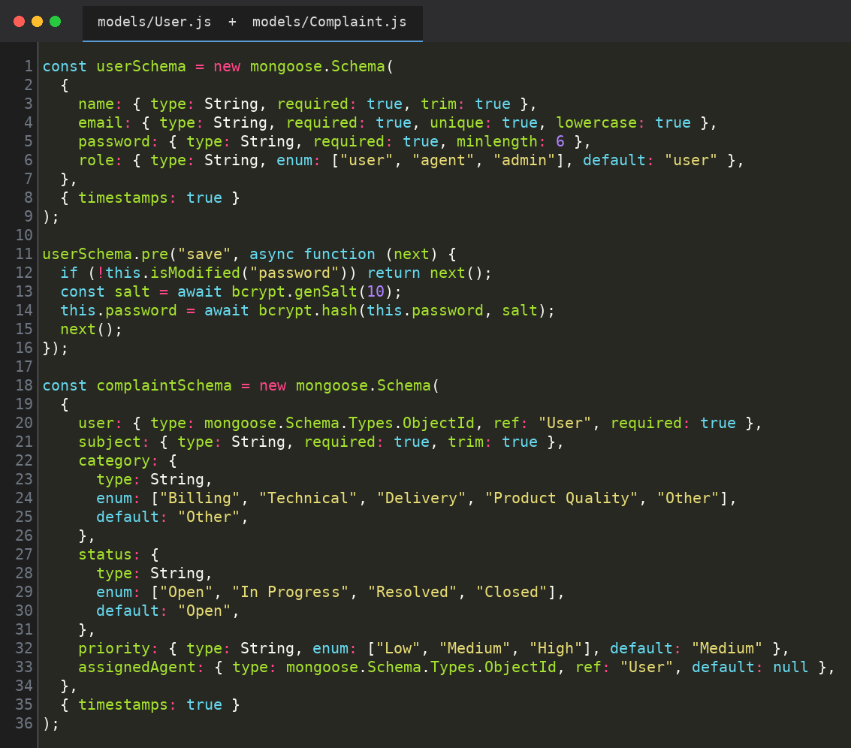
Fig. 7.6.4 — models/User.js and models/Complaint.js: Mongoose schemas enforcing role and complaint-lifecycle constraints.
Project dependencies are pinned in package.json, spanning the backend framework, authentication, real-time messaging, and database layers.
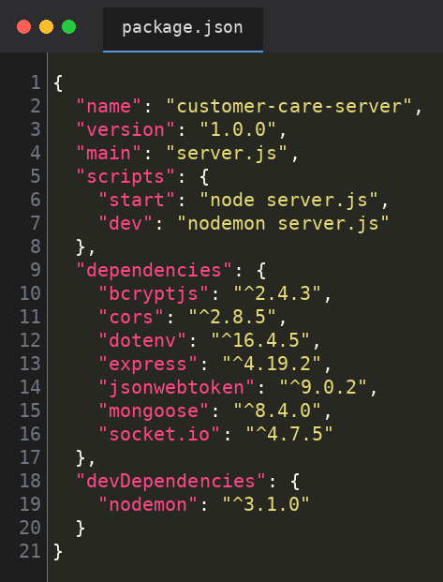
Fig. 7.6.5 — server/package.json: pinned Node.js dependencies for the backend, authentication, and real-time layers.

8. Results
The development and deployment of Customer Care Registry successfully fulfilled the project's primary objectives. The system was tested across multiple scenarios to confirm functional correctness, security hardening, and real-time reliability. Outcomes of the functional test suite are summarized below.
Test ID | Functional Area | Result
TC-AUTH-001 | Registration & login (/api/auth) | PASS — JWT issued and stored correctly for user/agent roles
TC-CMP-002 | Complaint creation (/api/complaints) | PASS — complaint persisted with default status "Open"
TC-CMP-003 | Role-scoped complaint listing | PASS — customers see only their own complaints; agents see all
TC-CMP-004 | Complaint status update | PASS — agent-only update correctly rejected for customer role
TC-MSG-005 | Real-time chat (/api/messages + Socket.io) | PASS — message persisted and broadcast to its room in real time
TC-SEC-006 | Unauthorized access handling | PASS — protected routes returned 401/403 without a valid token/role

8.1 Functional Complaint Management
Customer Care Registry successfully delivers complaint lodging, categorized tracking, status and priority updates, and role-based dashboards from one unified interface, with customers and support staff each seeing exactly the data relevant to their role.
8.2 Secure, Role-Based Authentication
JWT-based sign-up and login, backed by bcrypt password hashing and role-aware middleware, were verified to correctly gate access across customer, agent, and admin roles while keeping session state simple and stateless on the server.
8.3 Real-Time Support Chat
Routing each complaint's conversation through a Socket.io room keyed by complaintId confirmed reliable, low-latency message delivery between customers and agents, with full message history preserved in MongoDB.
8.4 Data Integrity via Schema Constraints
Enum-constrained Mongoose fields for role, category, status, and priority were confirmed to prevent invalid or inconsistent values from ever reaching the database, keeping the complaint lifecycle predictable end to end.
8.5 Individual Engineering Ownership
Working independently across architecture, backend routing, database design, real-time messaging, and interface design, the project's full milestone set — requirements through deployment documentation — was completed within the May 2026 to June 2026 development window.

9. Conclusion
The development of Customer Care Registry has resulted in a robust, secure, and responsive complaint-management platform capable of handling the full lifecycle of a customer complaint — from intake and categorization through real-time resolution conversation. By combining a stateless REST API with a room-scoped real-time messaging layer, the project successfully addresses the challenges of fragmented complaint tracking, delayed communication, and inconsistent access control in customer-support tooling.
The platform, built on the MERN stack and secured with JWT authentication, bcrypt password hashing, and role-based middleware, demonstrated the ability to deliver accurate, well-structured, and access-controlled responses across every core workflow — registration and login, complaint lodging, role-scoped dashboards, and live chat. Centralized error handling and consistent environment-variable isolation ensured the platform met modern security expectations.
This project served not only as a technical implementation of a full-stack, real-time web application, but also as a valuable individual learning experience. Every layer of the system — from database schema design to authentication middleware, real-time socket routing, and interface design — was planned, built, and refined independently, resulting in a complete, end-to-end customer support tool.
Looking forward, Customer Care Registry can be extended with features such as email/SMS notifications on status changes, file/image attachments on complaints, analytics dashboards for agents and admins, and integration with external helpdesk or CRM systems. Its modular MERN architecture makes it well suited for continued development in both small-business and institutional support settings.
In conclusion, Customer Care Registry stands as a practical demonstration of how a modern MERN stack, combined with token-based security and real-time communication, can be unified to create a resilient, transparent, and highly responsive customer support platform.

