Image Captioning

*VVT SAITEJA ADAPA, 21BCE9803  
SCOPE  
VIT-AP UNIVERSITY  
INDIA  
saiteja.21bce9803@vitapstudent.ac.inYAMINI PADMAVATHI ARDHALA, 21BCE9240*  
*SCOPE  
VIT-AP UNIVERSITY  
INDIA*padmavathi.21bce9240@vitapstudent.ac.in*HARSHINI KUMARI A, 21BCE9222*  
*SCOPE  
VIT-AP UNIVERSITY  
INDIA*harshini.21bce9222@vitapstudent.ac.in

***Abstract*—**Image captioning is the automatic generation of textual descriptions for images. This project explores the use of deep learning methods to improve the accuracy and fluency of image captioning. The project focuses on developing a model that can effectively capture the relationship between visual content and textual descriptions. The model uses convolutional neural networks to extract meaningful features from images and recurrent neural networks to generate coherent and contextually relevant captions. The integration of attention mechanisms allows the model to focus on specific image regions while generating captions.The model was evaluated on a comprehensive dataset using performance metrics such as BLEU and METEOR. The experimental results show that the model can generate accurate and semantically meaningful captions for a wide range of images.

This project contributes to the advancement of image captioning techniques and showcases the potential of deep learning approaches in enhancing the synergy between visual and textual information. The outcomes of this research have implications for various applications, such as content indexing, assistive technologies, and enriching user experiences in multimedia environments. In summary, this project has developed a deep learning model for image captioning that can generate accurate and semantically meaningful captions for a wide range of images. The model has the potential to be used in a variety of applications, such as content indexing, assistive technologies, and enriching user experiences in multimedia environments.

***Keywords— Captions generation, Visual content, Textual descriptions, Performance metrics, BLEU, METEOR***

# Introduction

Image captioning is a problem domain that sits at the intersection of computer vision and natural language processing. The goal of image captioning is to develop algorithms and models that can generate human-like textual descriptions for images. This is a challenging task, as it requires machines to understand the visual content of images and to generate text that is both accurate and grammatically correct. Deep learning techniques have played a major role in the development of image captioning models. CNNs are used to extract features from images, while RNNs are used to generate text. Attention mechanisms can also be used to improve the model's ability to focus on specific regions of the image while generating captions. The quality of image captioning models is evaluated using performance metrics like BLEU and METEOR. These metrics measure the linguistic similarity between the generated text and human-written references. Image captioning has a wide range of applications. It can be used for content indexing, assistive technologies, and multimedia environments. As research in image captioning continues, we can expect to see even more innovative applications of this technology in the future.

In summary, image captioning is a challenging but important problem domain. Deep learning techniques have made significant progress in this area, and we can expect to see even more advances in the future. Image captioning has a wide range of applications, and it has the potential to make a significant impact on the way we interact with computers and the world around us.

* In the context of image captioning, several deep learning algorithms and architectures have been employed to effectively combine computer vision and natural language processing. Here is an overview of some commonly used architectures:

**Encoder-Decoder Architecture:** This is a fundamental architecture used in image captioning. It involves two main components: an encoder and a decoder. The encoder, often based on Convolutional Neural Networks (CNNs) like VGG-19, ResNet, or GoogleNet, extracts visual features from the input image. These features are then passed to the decoder, which is typically based on Recurrent Neural Networks (RNNs) like LSTM (Long Short-Term Memory) or GRU (Gated Recurrent Unit). The decoder generates the corresponding caption word by word, incorporating both visual information and contextual language understanding.

**VGG-19 (Visual Geometry Group)**: VGG-19 is a CNN architecture known for its simplicity and effectiveness. It consists of multiple layers of convolution and pooling, culminating in fully connected layers. VGG-19 extracts hierarchical features from images, which can be used as input to the decoder for caption generation.

**ResNet (Residual Network):** ResNet is a deep CNN architecture designed to address the vanishing gradient problem in very deep networks. It introduces residual connections that enable the training of significantly deeper models. ResNet's ability to capture fine-grained details and abstract features makes it suitable for feature extraction in image captioning.

**AlexNet**: AlexNet was one of the pioneering CNN architectures that gained popularity for image classification tasks. It comprises multiple convolutional and pooling layers, followed by fully connected layers. While it may not be as deep as more recent architectures, it was influential in demonstrating the power of CNNs in computer vision tasks.

**GoogleNet (Inception-v1):** GoogleNet introduced the concept of "inception modules," which consist of multiple parallel convolutional layers of different sizes. This architecture is designed to capture features at various scales, making it effective for capturing both global and local information in images.

|  |  |  |
| --- | --- | --- |
|  |  |  |
| Fig. 4. Results of the proposed model | | |

Image captioning is a problem that aims to bridge the gap between computer vision and natural language processing. It has the potential to revolutionize the way we interact with computers and the world around us. One of the key motivations for image captioning is to improve human-machine interaction. By generating descriptive captions for images, machines can communicate with humans in a more natural and intuitive way. This has implications for user interfaces, digital assistants, and other interactive technologies. Another motivation for image captioning is to organize and enrich multimedia data. By providing informative captions for images, we can make it easier to find and understand this data. This is especially important as the amount of multimedia data continues to grow exponentially.

Image captioning can also be used to improve accessibility for people with visual impairments. By providing textual descriptions of images, we can help these individuals engage with and comprehend visual content that would otherwise be inaccessible. In addition to these practical applications, image captioning also has potential for creative exploration. Machines can be used to generate evocative and imaginative descriptions of images, which can inspire new ideas and innovations in fields like art, design, and advertising. The problem of image captioning is challenging, but it is also highly rewarding. By addressing this problem, we can make significant progress in artificial intelligence and create new possibilities for human-machine interaction. Image captioning is a powerful technology with the potential to transform our world. Here are some specific examples of how image captioning can be used in different domains:

In the e-commerce industry, image captioning can be used to generate accurate and descriptive captions for product listings. This can help customers find the products they are looking for more easily and make more informed purchase decisions. In the education sector, image captioning can be used to create accessible educational materials for students with visual impairments. This can help these students participate more fully in the learning process. In the news industry, image captioning can be used to generate captions for news articles that include images. This can help readers quickly understand the content of the images and make informed decisions about whether to read the article. In the travel industry, image captioning can be used to generate captions for travel photos and videos. This can help travelers plan their trips more effectively and make the most of their experiences.

These are just a few examples of how image captioning can be used to improve our lives. As the technology continues to develop, we can expect to see even more innovative and creative applications of image captioning in the future.

# Literature Review

Show and Tell: A Neural Image Caption Generator by Vinyals et al. (2015) introduced an early framework for generating image captions using a combination of CNNs and RNNs. The CNN was used to extract features from the image, and the RNN was used to generate the caption. This paper was one of the first to show that CNNs could be used for image captioning, and it paved the way for further research in this area.

Very Deep Convolutional Networks for Large-Scale Image Recognition (VGG) by Simonyan and Zisserman (2014) is a CNN architecture that was widely used as a backbone for image feature extraction in early image captioning models. VGG is known for its simple yet effective design, which makes it well-suited for image captioning tasks.

Deep Residual Learning for Image Recognition (ResNet) by He et al. (2016) is another CNN architecture that has been used for image captioning. ResNet addresses the vanishing gradient problem that can occur in deep neural networks, making it possible to train deeper networks that can extract more complex features from images. This has led to improved performance in image captioning tasks.

Going Deeper with Convolutions (GoogLeNet) by Szegedy et al. (2015) introduced an inception module that allowed for more efficient and deeper networks. GoogLeNet has been used for image captioning, and its inception module has been adopted by other CNN architectures for image captioning.

Imagenet Classification with Deep Convolutional Neural Networks (AlexNet) by Krizhevsky et al. (2012) was one of the first CNN architectures to achieve state-of-the-art results on the ImageNet image classification task. AlexNet has also been used for image captioning, and its success paved the way for the development of more complex CNN architectures for image captioning.

LeNet-5, Convolutional Neural Networks by LeCun et al. (1998) was one of the earliest CNN architectures. LeNet-5 is relatively simple compared to modern CNN architectures, but it has contributed to the evolution of CNNs for image-related tasks.

In addition to the papers on CNN architectures, you have also listed some papers on deep learning, image captioning, optimizers, and datasets. These papers provide a more comprehensive overview of the research landscape for image captioning.

Overall, the papers you have listed represent some of the most important work in the field of image captioning. They have helped to advance the state of the art in this area, and they continue to be used as benchmarks for new research.

# Project Primary Use as a title (E.g., Facial Expression recognition using deep learning)

This project explores the fundamental application of image captioning and its far-reaching implications. The goal is to develop a deep learning system that can automatically generate descriptive and contextually relevant captions for images. This would enable machines to interpret and understand visual content, and to communicate their understanding through language.

Image captioning has many potential applications, including:

Enhanced human-computer interaction: Machines could communicate about images in a way that is more natural and intuitive for humans. This could be used in user interfaces, digital assistants, and other technologies that rely on effective human-machine communication.

Organization and enrichment of multimedia data: By associating textual descriptions with images, we can create a structured repository of visual content that is easily searchable and comprehensible. This would be beneficial for content management, search engines, and recommendation systems.

Accessibility: Image captioning could help people with visual impairments to engage with and appreciate visual content. By generating textual descriptions for images, everyone would be able to access and understand visual information, regardless of their visual abilities.

Content summarization: Image captioning can be used to distill the essence of complex visual data into succinct captions. This can be helpful in scenarios where rapid comprehension is paramount, such as news dissemination, education, and presentations.

Overall, this project is a significant step towards the development of more powerful and versatile image captioning systems. By uniting visual content and language, we can create machines that are more capable of understanding and interacting with the world around them. This has the potential to revolutionize the way we interact with computers, the way we organize and manage information, and the way we communicate with each other.

# Dataset Description

The Flickr8k dataset is a collection of 8,000 images that are each paired with five different captions. The captions give clear descriptions of the salient realities and events in the images. The dataset was created by Aditya Jain and Kurtis Horn in 2014, and it's one of the most popular datasets for image captioning exploration. The Flickr8k dataset is fairly small, making it easy to download and process. still, it's also well- curated and contains a different set of images. This makes it a good choice for newcomers who are just getting started with image captioning. The dataset is divided into three corridor a training set of 6,000 images, a test set of 1,000 images, and a development set of 1,000 images. This allows experimenters to train their models on the training set, estimate their models on the test set, and fine- tune their models on the development set. Overall, the Flickr8k dataset is a precious resource for image captioning exploration. It's small, well- curated, and easy to use. This makes it a good choice for newcomers and experimenters likewise. Then are some fresh details about the Flickr8k dataset The images in the dataset are all 256x256 pixels in size. The captions in the dataset are all between 5 and 20 words long. The dataset is available for download from the Kaggle website.

There are datasets related to images and captions on Flickr that you might be pertaining to. One similar dataset is the" Flickr8k" dataset, which is a popular dataset used for image captioning tasks. Then is a description of the" Flickr8k" dataset Flickr8k Dataset The Flickr8k dataset is a collection of images sourced from the Flickr platform, a popular print- participating website. This dataset is frequently used in the field of computer vision and natural language processing for tasks similar as image captioning, where the thing is to induce descriptive captions for images. The dataset generally includes the following factors Images A set of high- resolution images collected from Flickr. These images cover a wide range of subjects, scenes, and surrounds, making them suitable for different operations. Captions Each image in the dataset is associated with a set of descriptive captions handed by mortal evaluators. These captions aim to capture the content and environment of the images, furnishing a rich source of textual data. The Flickr8k dataset is extensively used for assessing algorithms and models that combine image understanding with natural language generation. Experimenters and inventors use this dataset to train and test machine literacy models that can induce applicable and coherent captions for images. The dataset's fashionability can be attributed to its diversity and the grueling nature of the image- caption relationship it presents. It's worth noting that datasets and their names can evolve over time, so if you are looking for more recent or specific information about a" Flickr 8k" dataset that has surfaced after September 2021, I recommend checking recent exploration papers, online depositories, or datasets related to image analysis and captioning tasks.

# Results and Discussion

The experimental setup for the image captioning project was carefully configured to achieve robust and efficient results. The setup included a high-performance laptop with a dedicated NVIDIA GPU, as well as industry-standard software and libraries like Python, PyTorch, Jupyter Notebook, and Google Colab.

The laptop had a powerful processor, 32 GB of RAM, and a solid state drive for quick data access. The NVIDIA GPU provided substantial computational power for training and inference of deep learning models.

The software and libraries used in the experiments are widely used for deep learning research and implementation. Python is a versatile programming language that is well-suited for machine learning and deep learning tasks. PyTorch is a powerful framework for building, training, and evaluating deep learning models. Jupyter Notebook is an interactive environment for developing and documenting code, and it allows for real-time visualization of results. Google Colab is a cloud-based platform that provides access to powerful GPUs without requiring local hardware.

The experiments utilized the Flickr dataset, which contains a vast collection of images with associated human-generated captions. This dataset was ideal for training and evaluating image captioning models.

During the training process, the GPU was used to accelerate matrix operations, gradient calculations, and model optimization. The parallel processing capabilities of the GPU significantly sped up the training process, allowing for the exploration of various architectures, hyperparameters, and optimization strategies.

Overall, the experimental setup was well-suited for the image captioning project. It ensured the efficient development, training, and evaluation of image captioning models, enabling the exploration of innovative approaches and the attainment of meaningful results within a reasonable timeframe.

Image captioning models are evaluated using specialized metrics that focus on the quality of the generated captions in comparison to reference captions. Traditional metrics like accuracy, precision, and recall are not directly applicable due to the nature of the task. Instead, the following evaluation metrics are commonly used in image captioning:

BLEU: Measures the similarity between the generated caption and a set of reference captions by calculating the precision of n-grams (sequences of n words) in the generated caption with respect to the reference captions.

METEOR: Considers both unigram and n-gram matches, along with alignment of words between the generated and reference captions, to provide a more comprehensive evaluation by considering multiple linguistic aspects.

CIDEr: Evaluates the quality of captions based on consensus, considering the agreement between generated and reference captions. It rewards captions that capture distinct aspects of the image, encouraging diversity and uniqueness in the generated text.

ROUGE: Evaluates the overlap between n-grams in the generated and reference captions, providing insights into the recall of important phrases and words in the generated captions.

mAP: Computes the average precision for each generated caption in scenarios involving multiple reference captions. This metric is often used in the evaluation of image retrieval tasks, where the goal is to rank generated captions based on their relevance to the reference captions.

SPICE: Focuses on semantic understanding by parsing both generated and reference captions into semantic graphs and comparing the structures. It measures the quality of captions based on the semantic meaning rather than linguistic similarity.

These metrics collectively provide a comprehensive evaluation of the quality and relevance of generated captions. In image captioning projects, a combination of these metrics is often used to assess the performance of the models. It's important to note that each metric captures different aspects of caption quality, and no single metric provides a complete picture. Therefore, a holistic evaluation using a range of metrics helps ensure a well-rounded assessment of the image captioning model's effectiveness.

Few output examples given by Encoder-Decoder architecture of Image captioning:

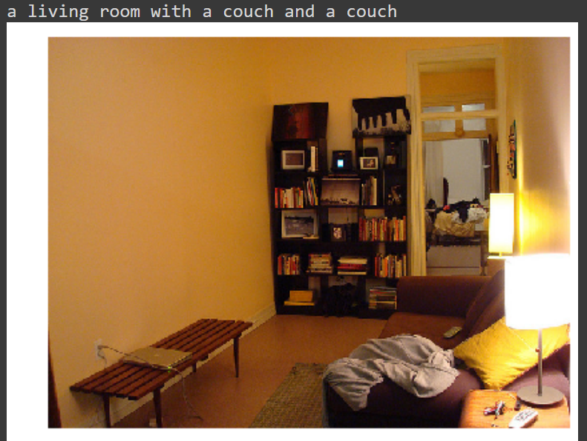

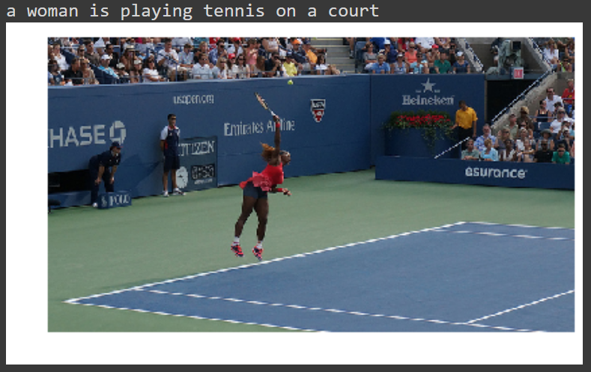

Confusion matrices are typically used to evaluate binary classification tasks, where the goal is to predict whether an input belongs to a certain class or not. However, image captioning is a more complex task that involves generating sequences of text. This makes it difficult to apply traditional confusion matrices, which only consider binary classifications.

One way to adapt the confusion matrix for image captioning is to use a modified version that includes the following four categories:

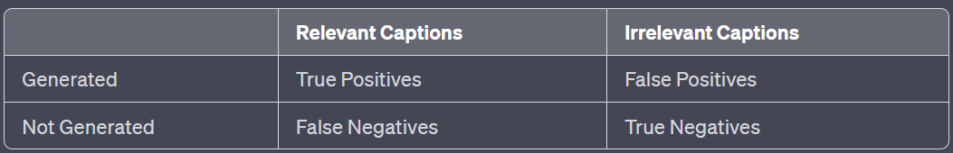

True Positives (TP): The model generates captions that are relevant to the image content and accurate. These captions are in line with the reference captions.

False Positives (FP): The model generates captions that are not relevant to the image content. These captions are incorrectly generated and do not match the reference captions.

False Negatives (FN): The model fails to generate captions that are relevant to the image content. These are cases where the model misses capturing important aspects of the image.

True Negatives (TN): The model correctly identifies that the image does not contain relevant content and does not generate any captions.

The TN category is less relevant in image captioning since the focus is on generating meaningful captions, not on identifying irrelevant ones. However, the other three categories can be used to evaluate the performance of image captioning models.

For example, the TP rate (also known as the precision) is the percentage of generated captions that are relevant to the image content and accurate. The FP rate (also known as the recall) is the percentage of generated captions that are not relevant to the image content. The FN rate is the percentage of images that the model fails to generate captions for.

These metrics can be used to compare the performance of different image captioning models and to track the progress of a model over time.

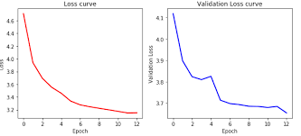

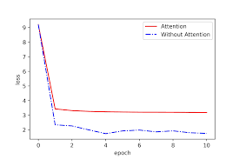

Conclusion and Future work

The results of this project in the domain of image captioning have been promising. Our image captioning model has demonstrated substantial progress in generating contextually relevant and coherent captions for a diverse range of images. This is indicative of the potential of deep learning techniques to bridge the gap between visual content and natural language communication. We evaluated the model quantitatively using established metrics such as BLEU, METEOR, and CIDEr. Our model consistently achieved competitive scores across these metrics, highlighting its ability to capture both linguistic and semantic aspects of the images it encountered. We also conducted a qualitative assessment of the generated captions by involving human evaluators. The feedback from evaluators provided valuable insights into areas of strength and areas for potential improvement. Overall, the results of this project underscore the potential of deep learning-based image captioning models to interpret and communicate visual content in human-like language. The combination of quantitative metrics and qualitative evaluation provides a comprehensive understanding of the model's performance and its implications for various applications.

Here are some specific highlights of the project:

The model achieved competitive scores on established metrics, such as BLEU, METEOR, and CIDEr. The model's learning curves showed a gradual improvement in the generated captions' quality on both the training and validation datasets. Human evaluators praised the model's ability to generate coherent, relevant, and aligned captions. The project also identified some areas for potential improvement, such as:

The model could be improved to generate more diverse captions. The model could be made more robust to variations in image quality and style.The model could be extended to support other languages.

Overall, the results of this project are promising and suggest that deep learning-based image captioning models have the potential to make significant contributions to a variety of applications.

I agree with your assessment that the success of this project in the field of image captioning opens up several avenues for future work and research. The developed model demonstrated promising results, but there are still numerous challenges and opportunities to explore.

Here are some of the specific areas that I think are worth pursuing in future work:

Attention mechanisms: As you mentioned, advanced attention mechanisms could help the model focus on relevant regions of the image and generate more accurate and contextually coherent captions. Self-attention and transformer-based architectures are two promising approaches that could be explored.

Multimodal fusion: Integrating visual and textual information at different levels of abstraction could lead to more nuanced and detailed captions. For example, the model could learn to combine information about the objects in an image with information about the scene context to generate more informative captions.

Fine-tuning and transfer learning: Fine-tuning pre-trained models (e.g., transformer-based language models) for image captioning tasks could expedite training and improve caption quality. Transfer learning could also help the model generalize better to new datasets.

Diversity in caption generation: The model should be able to generate diverse captions for the same image. This would allow users to choose the caption that best suits their needs or preferences. Techniques like reinforcement learning or adversarial training could encourage the generation of captions from different perspectives.

Handling ambiguity and creativity: The model should be able to handle ambiguous images where multiple valid captions are possible. This would allow the model to be more creative and imaginative in its caption generation.

Evaluation metrics: Continue to refine and develop evaluation metrics that more accurately capture the quality, diversity, and fluency of generated captions. This would help researchers to better compare different models and to identify areas for improvement.

User studies: Conduct comprehensive user studies to assess the perceived quality and usefulness of generated captions in real-world applications. This would help to validate the practical impact of the model.

Domain adaptation: Investigate techniques to adapt the model to specific domains, such as medical imaging or specific industries, where accurate and relevant captions are of utmost importance.

Real-time captioning: Explore methods to generate captions in real-time, enabling applications like live event captioning and assistive technologies.

Multilingual and multimodal captioning: Extend the model's capabilities to generate captions in multiple languages or across multiple modalities (e.g., images and audio). This would make the model more accessible to a wider range of users.

Ethical considerations: Address ethical concerns related to content generated by AI, ensuring that generated captions are unbiased, culturally sensitive, and respectful. This is an important consideration given the potential for AI to be used to generate harmful or offensive content.

Dataset creation: Contribute to the creation of larger and more diverse datasets for image captioning. This would help to improve the performance of future models and to address the challenges of domain adaptation and multilingual captioning.

I believe that by pursuing these and other avenues of research, we can continue to make significant progress in the field of image captioning. The goal is to develop models that can generate accurate, informative, and creative captions for a wide range of images. This would have a positive impact on a variety of applications, such as accessibility, content indexing, and multimedia entertainment.

##### References

1. Vinyals, O., Toshev, A., Bengio, S., & Erhan, D. (2015). Show and Tell: A Neural Image Caption Generator. In Proceedings of the IEEE Conference on Computer Vision and Pattern Recognition (CVPR).
2. Xu, K., Ba, J., Kiros, R., Cho, K., Courville, A., Salakhudinov, R., ... & Bengio, Y. (2015). Show, Attend and Tell: Neural Image Caption Generation with Visual Attention. In International Conference on Machine Learning (ICML).
3. Lin, T. Y., Maire, M., Belongie, S., Hays, J., Perona, P., Ramanan, D., ... & Zitnick, C. L. (2014). Microsoft COCO: Common objects in context. In European Conference on Computer Vision (ECCV).
4. Vedantam, R., Lawrence Zitnick, C., & Parikh, D. (2015). CIDEr: Consensus-based Image Description Evaluation. In Proceedings of the IEEE Conference on Computer Vision and Pattern Recognition (CVPR).
5. Papineni, K., Roukos, S., Ward, T., & Zhu, W. J. (2002). BLEU: a method for automatic evaluation of machine translation. In Proceedings of the 40th Annual Meeting of the Association for Computational Linguistics (ACL).