RESUME 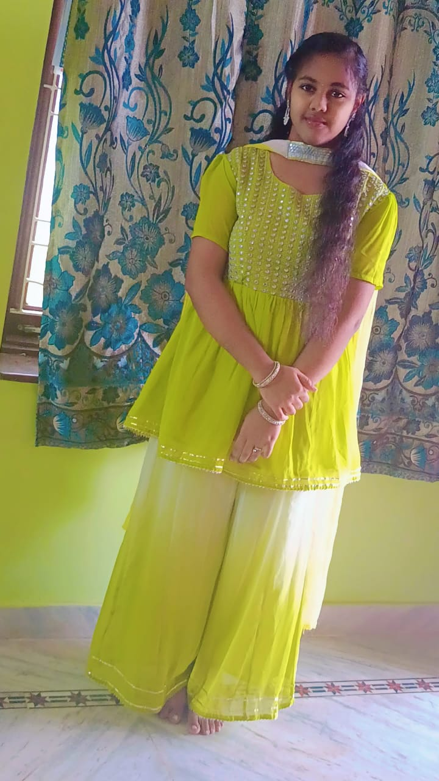
PEPAKAYALA HARSHINI
📧 pepakayalaharshini@gmail.com
🐙 GitHub: Harshini-888
💼 LinkedIn: Pepakayala Harshini
📍 Andhra Pradesh, India

CAREER OBJECTIVE
Motivated and enthusiastic B.Tech student specializing in Artificial Intelligence and Machine Learning, seeking opportunities to apply and enhance my technical skills in software development, web development, and open-source contributions. Passionate about continuous learning, innovation, and building impactful technology solutions.

EDUCATION
B.Tech – Artificial Intelligence & Machine Learning
Velagapudi Ramakrishna Siddhartha Engineering College
2025 –2029

TECHNICAL SKILLS
Programming Languages
- C Programming
- Python
Core Concepts
- Data Structures
- Problem Solving
Web Technologies
- HTML (Basics)
- MySQL (Basics)
Other Skills
- Video Editing
- Team Collaboration
- Communication Skills
- Open Source Contribution

INTERNSHIPS
Cognifyz Technologies
Frontend Development Intern
CodSoft
Web Development Intern
CodeAlpha
Web Development Intern
Social Summer Camp 5
Student Intern

CERTIFICATIONS
- C Essentials – Cisco Networking Academy
- Python Essentials – Cisco Networking Academy

LEADERSHIP & ACHIEVEMENTS
- GSSoC 2026 Ambassador
- Nexus Spring of Code 2026 Contributor
- Active Open Source Learner
- LinkedIn Community with 164+ Followers

PROJECTS
Personal Portfolio Website
Designed and developed a responsive portfolio website using HTML and CSS to showcase skills, certifications, internships, and achievements.
Python Mini Projects
Developed beginner-level Python projects to strengthen programming fundamentals and logical thinking.
1.hangman game
2.mini chatbots
3.website for my fathers medical store
4. design thinking :student work details.

STRENGTHS
- Quick Learner
- Self-Motivated
- Adaptability
- Leadership
- Time Management
- Positive Attitude

DECLARATION
I hereby declare that the information provided above is true and correct to the best of my knowledge and belief.
Pepakayala Harshini

