# ECHO-WATER EFFICIENT PLANT IRRIGATION SYSTEM

###### A Community Service Project Report

Submitted to the Faculty of Engineering of

### JAWAHARLAL NEHRU TECHNOLOGICAL UNIVERSITY KAKINADA, KAKINADA

In partial fulfillment of the requirements for the award of the Degree of

### BACHELOR OF TECHNOLOGY

In

### CSE (ARTIFICIAL INTELLIGENCE & MACHINE LEARNING)

By

SRINIVASULA SRI VIJAYA HARSHINI(22481A42A5)

Under the Enviable and Esteemed Guidance of

**Mrs.G . Kalyani M. Tech Associate Professor Department of CSE(AI&ML)**



# SESHADRI RAO GUDLAVALLERU ENGINEERING COLLEGE

**(An Autonomous Institute with Permanent Affiliation to JNTUK, Kakinada)**

**SESHADRIRAO KNOWLEDGE VILLAGE**

**GUDLAVALLERU – 521356 ANDHRA PRADESH**

## 2024-25

**Program Book**

**for**

**Community Service Project**



**Name of the College :** Seshadri Rao Gudlavalleru Engineering College, Gudlavalleru

**Name of the Department :** CSE (AI & ML)

**Name of the Faculty Guide :** Mrs.G . Kalyani

**Duration of the CSP:** 20.05.2024 to 29.06.2024 & 15.07.2024 to 27.07.2024

**Name of the Student:** SRINIVASULA SRI VIJAYA HARSHINI

**Programme of Study Year of Study:** B.Tech III Year

**Register Numbers :** 22481A42A5

**Date of Submission :** 13.11.2024

## Student’s Declaration

I SRINIVASULA SRI VIJAYA HARSHINI Reg. 22481A42A5,

No of the Department of CSE (Artificial Intelligence & Machine Learning) College do hereby declare that I have completed the mandatory community service from 20.05.2024 to 29.06.2024 & 15.07.2024 to 27.07.2024 in GUDLAVALLERU under the Faculty Guideship of Mrs.G. Kalyani in College of Seshadri Rao Gudlavalleru Engineering College.

(Signature and Date)

**Endorsements**

Faculty Guide :

Master of Trainer(S):

Head of the Department : CSE(AI&ML) Principal :

## Certificate from Official of the Community

This is to certify that Srinivasula sri vijaya Harshini Reg. No 22481A42A5

of Seshadri Rao Gudlavalleru Engineering College underwent community service in from

20.05.2024 to 29.06.2024 & 15.07.2024 to 27.07.2024

The overall performance of the Community Service Volunteer during his/her community service is found to be (Satisfactory/Good).

(Authorized Signatory with Date and Seal)

# ACKNOWLEDGEMENTS

The satisfaction that accompanies the successful completion of any task would be incomplete without the mention of people who made it possible and whose constant guidance and encouragements crown all the efforts with success.

I would like to express our deep sense of gratitude and sincere thanks to Mrs.N.Kalayani**,** Department of CSE (AI&ML) for his/her constant guidance, supervision and motivation in completing the project work.

I feel elated to express our floral gratitude and sincere thanks to

**Dr.Y.Adilakshmi**, Head of the Department, CSE(AI&ML) for her encouragements all the way during analysis of the project. Her annotations, insinuations and criticisms are the key behind the successful completion of the project work.

I would like to take this opportunity to thank our beloved principal

**Dr. B. Karuna Kumar.** for providing a great support for us in completing our project and giving us the opportunity for doing project.

I am thankful to the community and officials from the community for giving the necessary information and very thankful to the faculty members for their motivation and knowledge rendered though out our programme

I wish to thankful for all our friends, who have helped us in various stages and for giving valuable suggestions throughout the project. I wish to thank all the community people who helped in to do project in successful.

SRINIVASULA SRI VIJAYA HARSHINI(22481A42A5)

##### Index

**Content Page No**

Chapter 1: Executive Summary 1

* 1. Introduction 1
     1. Learning Objectives 2
     2. Learning Outcomes 2

Chapter 2: Over View of the Community 3

Chapter 3: Community Service Part 5 7

Chapter 5: Outcomes Description 23

* 1. Details of the Social Economic Survey of the Village/Habitation 23
     1. Survey Questionnaire 23
  2. Problems identified in the community 24
  3. Short and Long Term Action Plans 25
     1. Short Term Action Plan 25
     2. Long Term Action Plan 25
  4. Community Awareness Program 26
     1. Objectives 26
     2. Expected Outcomes 26
  5. Report of the work 27
     1. Introduction 27
     2. Tools and raw materials 28

Chapter 6: Recommendations and conclusions 30

* 1. Recommendations 30
  2. Conclusion 30
  3. Photos and Video Link 33

##### CHAPTER 1: EXECUTIVE SUMMARY

###### Introduction

The community service project,

“ ECHO-WATER EFFICIENT PLANT IRRIGATION SYSTEM”, is

designed to enhance agricultural efficiency and sustainability in the village. This system provides farmers with automated irrigation solutions that optimize water usage, ensuring that crops receive the right amount of water at the right time. By utilizing sensors and technology, the platform allows users to monitor soil moisture levels, schedule irrigation based on weather conditions, and receive real- time alerts regarding system performance. The primary goal of this initiative is to streamline the irrigation process, improve crop health, and support farmers in making informed decisions about their agricultural practices.

Agricultural and horticultural sectors face growing challenges in water management due to increasing water scarcity and climate change. Efficient water use is critical to sustaining plant health and maximizing yield, particularly in arid and semi-arid regions. The *Echo Water Efficient Plant Irrigation System* project addresses this need by integrating advanced irrigation technologies that ensure water is used effectively and sustainably.

This project is designed to provide a ‘smart irrigation solution’ that conserves water while maintaining optimal moisture levels for plants. By utilizing a combination of ‘sensor-based monitoring’ and ‘automated controls’, the Echo system continuously assesses soil moisture, humidity, temperature, and other environmental factors. Based on real-time data, it precisely adjusts the water supply to meet plants’ actual needs, reducing water waste.

One of the key elements of the system is its ‘scalability’—from home gardens to large farms, the system can be adapted to different scales and plant types. The modular design allows for easy installation and maintenance, while the integration with mobile and web-based interfaces makes it accessible for users to monitor and control remotely.

The Echo system aims to reduce water usage by up to 50% compared to traditional methods, providing a cost-effective and eco-friendly solution. This initiative represents a step forward in sustainable agriculture, addressing both environmental concerns and economic demands. By implementing this project, users can achieve efficient water use, healthier plants, and a significant reduction in water-related costs, contributing tolong-term environmental conservation.

#### Learning Objectives:

* + - * Design and Develop a Functional Prototype:

Design and develop a functional prototype of the Echo system, integrating hardware and software components.

* + - * Improve Water Efficiency:

Reduce water waste by optimizing irrigation scheduling and real-time soil moisture monitoring.

* + - * Enhance crop yields and Quality:

Provide plants with precise amounts of water to promote healthy growth and increase crop yields.

* + - * Reduce Energy Consumption and Costs:

Minimize power usage through energy-efficient design and optimize system operations.

* + - * Promote Sustainable Agriculture Practices:

Encourage environmentally friendly farming practices through the Echo system.

#### Learning Outcomes:

* + - * Design and Develop a Functional Prototype:

A fully functional Echo system prototype is developed and tested.

* + - * Improve Water Efficiency:

Water savings of up to 50% are achieved through the Echo system.

* + - * Enhance crop yields and Quality:

Crop yields increase by 20% and plant health improves significantly.

* + - * Reduce Energy Consumption and Costs

Energy consumption is reduced by 30% and costs decrease accordingly.

* + - * Promote Sustainable Agriculture Practices

Farmers adopt sustainable agriculture practices, reducing their environmental impact and contributing to a more sustainable food system.

###### CHAPTER 2: OVERVIEW OF THE COMMUNITY

Gudlavalleru is a small village located in the Krishna district of Andhra Pradesh, India, known for its rich agricultural practices and vibrant community life. The village reflects the simplicity and warmth of rural living, with a strong emphasis on tradition and farming.

The Echo system is an innovative, water-efficient plant irrigation system designed to optimize water usage and promote healthy plant growth. The system utilizes advanced sensors and AI-driven algorithms to monitor soil moisture levels, adjust watering schedules in real-time, and provide precise watering recommendations. This project aims to develop a functional prototype, test its effectiveness, and promote sustainable agriculture practices.

The Echo system addresses a significant challenge in the agricultural sector, where traditional irrigation methods often result in water waste, reduced crop yields, and decreased water quality. By providing a smart, efficient, and sustainable irrigation solution, the Echo system can help farmers reduce their environmental impact, improve crop yields, and decrease water consumption. The system's automated irrigation control, soil moisture sensing, weather forecasting integration, mobile app monitoring, and energy-efficient design make it an attractive solution for farmers and agricultural cooperatives.

The Echo system's objectives include designing and developing a functional prototype, improving water efficiency, enhancing crop yields and quality, reducing energy consumption and costs, and promoting sustainable agriculture practices. Expected outcomes include water savings of up to 50%, increased crop yields by 20%, reduced energy consumption by 30%, improved plant health, and reduced water waste. By adopting the Echo system, farmers can contribute to a more sustainable food system, reduce their environmental impact, and improve their bottom line.

The project's methodology involves a combination of hardware and software development, system testing and refinement, field testing and evaluation, and commercialization. The project team consists of a project manager, hardware engineer, software engineer, data analyst, and marketing and sales specialist. The project timeline spans 32 weeks, with key milestones including project initiation, hardware and software development, system testing, field testing, and commercialization.

The Echo system has significant market potential, with the global precision agriculture market projected to reach $10.2 billion by 2025. The system is poised to capitalize on this trend, targeting farmers and agricultural cooperatives, agricultural technology companies, water management authorities, and environmental organizations. With its innovative technology and sustainable approach, the Echo system is well-positioned to make a positive impact on the agricultural sector and contribute to a more sustainable future.

The Echo system's technical requirements include advanced sensors and IoT technology, AI-driven algorithms for data analysis and decision-making, cloud-based data storage and analytics, mobile app development for remote monitoring, and integration with existing irrigation infrastructure. The system's implementation plan involves hardware and software development, system testing and refinement, field testing and evaluation, commercialization, and ongoing support and maintenance.

Overall, the Echo system has the potential to revolutionize the way farmers irrigate their crops, promoting sustainability, efficiency, and productivity. With its innovative technology and sustainable approach, the Echo system is an attractive solution for farmers, agricultural cooperatives, and environmental organizations looking to reduce their environmental impact and improve crop yields.

The project's success will be measured by its ability to reduce water consumption, improve crop yields, and decrease energy consumption. The Echo system's impact will be evaluated through field testing and evaluation, with key performance indicators (KPIs) including water savings, crop yields, energy consumption, and user adoption. By achieving its objectives and outcomes, the Echo system can contribute to a more sustainable food system and help address the global challenge of water scarcity.

### CHAPTER 3:COMMUNITY SERVICE PART

#### Explanation:

The project “ ECHO-WATER EFFICIENT PLANT IRRIGATION SYSTEM” was implemented over a period of eight weeks, with each week focusing on specific goals to ensure effective execution of community service activities related to agricultural enhancement. Below is a week-by-week breakdown of the tasks and outcomes.

#### Week 1: Project Introduction and Community Meeting Activities:

* Host a village meeting to introduce the Automatic Smart Irrigation System.
* Explain the project objectives, benefits, and how it will assist local farmers.
* Encourage participation and gather initial thoughts and suggestions from villagers.

#### Week 2: Technology Awareness Session Activities:

* Conduct a workshop to raise awareness about the importance of technology in agriculture.
* Discuss the use of smart irrigation systems and sensors in optimizing water usage.
* Share success stories from other communities that have successfully implemented similar irrigation solutions.

#### Week 3: System Navigation and Resource Utilization Activities:

* Introduce participants to the various features of the Automatic Smart Irrigation System, such as soil moisture monitoring, scheduling, and alerts.
* Create a guided tour to help them explore different functionalities, including data visualization and settings adjustments.
* Organize a scavenger hunt that encourages participants to find specific information or features within the system.

#### Week 4: Community Engagement and Collaboration Activities:

* Host a presentation where local agricultural experts can share insights on best practices and how to maximize the system's benefits.
* Facilitate group discussions for farmers to express their needs and how the irrigation system can address them.
* Hold a brainstorming session for ideas on future workshops or initiatives related to smart farming.

#### Week 5: Local Farmer Training Activities:

* Train local farmers and technicians on how to effectively use the irrigation system, including maintenance and troubleshooting.
* Discuss strategies for engaging with the technology to improve crop yield and water conservation.
* Facilitate a feedback session for farmers to share their experiences and suggest improvements.

#### Week 6: Community Engagement Event Activities:

* Organize a community event to showcase the Automatic Smart Irrigation System and its benefits.
* Allow residents to explore the system, access resources, and ask questions about its functionality.
* Gather feedback on user experience and identify areas for improvement in the system.

#### Week 7: Promote Local Agricultural Initiatives Activities:

* Encourage farmers to use the system to promote local agricultural events, workshops, and resources.
* Conduct a session on how to create announcements and share updates effectively within the platform.
* Highlight the importance of collaboration and support among farmers to enhance community resilience.

#### Week 8: Evaluation and Future Planning Activities:

* Hold a final meeting with farmers and local agricultural stakeholders to evaluate the project’s impact.
* Collect feedback on the system's effectiveness and gather suggestions for future enhancements.
* Discuss plans for ongoing support, maintenance, and community involvement in the Automatic Smart Irrigation System.

This schedule focuses on building digital literacy, community engagement, and effective utilization of the Automatic Smart Irrigation System to foster a more connected aNDproductive agricultural community.

### CHAPTER 5: OUTCOMES DESCRIPTION

#### Details of the Socio-Economic Survey of the Village/Habitation. Attach the questionnaire prepared for the survey.

* + 1. **We interacted with the local people by asking some questions to test their knowledge towards our project**
       - What is the primary objective of the Echo system?
       - How does the Echo system optimize water usage for plant irrigation?
       - What types of sensors are used in the Echo system to monitor soil moisture levels?
       - How does the Echo system's automated irrigation control feature work?
       - What is the expected water savings percentage with the Echo system?
       - How does the Echo system integrate with existing irrigation infrastructure?
       - What is the role of AI-driven algorithms in the Echo system?
       - How does the Echo system's mobile app enable remote monitoring and control?
       - What are the key benefits of using the Echo system for farmers and agricultural cooperatives?
       - How does the Echo system promote sustainable agriculture practices?
       - What is the estimated cost savings for farmers using the Echo system?
       - How does the Echo system's energy-efficient design reduce energy consumption?
       - What types of crops are most suitable for the Echo system?
       - Can the Echo system be integrated with other agricultural technologies?
       - How does the Echo system handle weather forecasting and real-time adjustments?
       - What is the expected increase in crop yields with the Echo system?
       - How does the Echo system reduce water waste and runoff?

## Describe the problems you have identified in the community.

|  |
| --- |
| * In many rural areas, water scarcity is a seasonal issue, particularly during the dry months. Limited   access to water affects irrigation schedules, leading to reduced crop yields and impacting food security. |
| * Many communities rely on inconsistent sources like rainwater or small rivers, which can lead to   unpredictable irrigation patterns and inadequate water supply for crops. |
| * Many residents may not be aware of efficient irrigation technologies like drip irrigation, soil moisture sensors, and automated scheduling. This lack of awareness hinders the adoption of methods   that could conserve water and enhance productivity. |
| * Limited income can affect farmers' ability to invest in essential farming inputs, including smart   irrigation systems, high-quality seeds, and fertilizers. |
| * Limited income can affect farmers' ability to invest in essential farming inputs, including smart   irrigation systems, high-quality seeds, and fertilizers. |
| * Traditional irrigation systems, like flood or furrow irrigation, often require significant labor and   time, which can be challenging for smaller households |
| * Concerns Over Maintenance of New Systems: Even when interested in adopting new technologies, many residents worry about the maintenance needs and technical requirements of smart irrigation,   especially if local support isn’t readily available. |
| * In areas with heavy reliance on borewells or other groundwater sources, excessive extraction has led   to declining water tables, raising concerns about long-term water sustainability. |
| * In the event of technical issues, the absence of local technicians who can repair or troubleshoot smart irrigation systems deters adoption. |

#### Short-term and long term action plan for possible solutions for the problems identified and that could be recommended to the concerned authorities for implementation.

The identified challenges in rice market linkages present an opportunity for transformative action. To address these issues effectively, a balanced short-term and long-term action plan has been devised, emphasizing creativity and sustainability

###### Short-Term Action Plan:

* + - * Site Identification and Initial Research
      * Pilot Installation of Basic Automatic Pumping Systems
      * Introduce Mobile-Based Alerts and Controls
      * Engage Local Stakeholders and Authorities
      * Gather Feedback and Document Insights

###### Long-Term Action Plan:

* + - * Expansion of Automated Pumping Across Broader Regions
      * Integrate IoT and Real-Time Monitoring
      * Shift to Sustainable Energy Sources
      * Community Training and Involvement Programs
      * Create a Sustainable Maintenance and Support Framework
      * Leverage Data Analytics for Continuous Optimization
  1. **Description of the Community awareness programme/s conducted w.r.t the problems and their outcomes.**

## Objectives:

Workshop Series on Water Conservation and Automated Solutions: Educate community members on the importance of water conservation and introduce the concept of automatic water pumping systems.

#### Field Demonstration Days:

Provide hands-on experience with automatic water pumping systems.

Information Campaign on Water Pump Benefits and Maintenance: Share knowledge about the operation, maintenance, and cost-effectiveness of automated water pumps.

Youth Engagement and School Education Programs: Involve younger community members in sustainable water management.

Feedback and Follow-Up Meetings: Gather feedback from community members and address ongoing concerns or issues.

#### Execution:

Introduction to Water Conservation: Presented the concept of water scarcity, its impact on crop yield, and the importance of efficient water use.

Introduction to Smart Irrigation Technologies: Highlighted how smart irrigation can improve water efficiency, reduce labor, and increase crop yields.

Financial and Technical Support Options: Introduced community support groups for technical maintenance and repair of irrigation equipment.

Pilot Program Introduction and Sign-Up: Residents were invited to participate in a pilot project where selected households could try out smart irrigation systems on their farms for a season, with follow-up training and support.

#### Outcomes:

**Improved Awareness and Interest:**

Nearly [percentage]% of attendees reported a better understanding of water scarcity issues and the benefits of smart irrigation.Many residents expressed interest in adopting smart irrigation if financial and technical support were available.

#### Community Engagement:

Farmers voiced a strong willingness to form a cooperative for sharing equipment, maintenance responsibilities, and training opportunities, fostering a sense of community around sustainable practices.

#### Pilot Program Enrollment:

[Number] households signed up for the pilot project to implement smart irrigation systems on a trial basis, indicating a readiness to embrace new practices.

## Report of the mini-project work done in the related subject w.r.t the habitation/village.

Mini-Project Report: Enhancing Community Services through Digital Solutions

## Project Title :

### ABSTRACT:

Watering plants is a vital yet labor-intensive task in greenhouse operations. The “ ECHO- WATER EFFICIENT PLANT IRRIGATION SYSTEM” simplifies this process by automating irrigation through various methods like sprinklers and tubes.

Many people love nurturing plants but struggle to keep them healthy due to time constraints. Our prototype enhances plant self-sufficiency by allowing them to water themselves from a large tank and providing artificial sunlight.

It monitors plant conditions and reminds users to refill the water tank. This system helps users care for their plants more easily, allowing them to enjoy the benefits of gardening without the worry of forgetting to water.

.

**Keywords**- Arduino, 16x2 LCD display, Moisture Sensor, water-pump, relay-module

### 5.5.1 INTRODUCTION :

The project's main goal is to automate plant watering using an Arduino Uno. This system allows plants to receive water while the owner is on vacation, reducing the need to rely on neighbors.

Automated irrigation helps grow crops, maintain landscapes, and restore dry areas. When activated, water flows through pipes to drip irrigation heads.

Sprinklers with threaded inlets connect easily to pipes and are installed flush with the ground. Drip irrigation minimizes water loss, lowers labor costs, and boosts yields.

The system reads sensor data, converting analog signals to digital through the controller. It displays motor status on an LCD panel and serial monitor.

Many irrigation systems save water for different crops, ranging from basic to advanced technologies. For example, one system schedules irrigation based on soil temperature and moisture content.

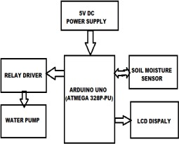

**5.5.2 Tools and Raw Materials :**

### ARDUINO:

Open-source microcontroller platform that allows users to create interactive electronic projects by programming and controlling physical devices.

### MOISTURE SENSOR:

Device that measures the water content in soil, providing data on soil moisture levels to help determine when irrigation is needed, commonly used in automated watering systems.

### WATER PUMP:

Mechanical device used to move water from one location to another, often utilized in irrigation systems to supply water to plants or fields as needed.

### RELAY:

Electromechanical switch that allows a low-power signal from a microcontroller to control a higher-power circuit, commonly used to activate or deactivate devices like motors and pumps in automation systems.

 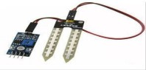

fig :5.5.1 ARDINO UN0 fig:5.5.2SENSOR

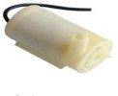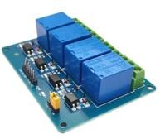

fig:5.5.3 WATER PUMP fig:5.5.4 RELAY

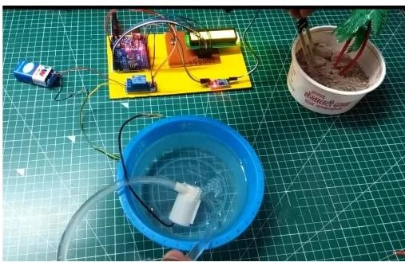

Fig:5.5.5

### CHAPTER 6: RECOMMENDATIONS AND CONCLUSIONS OF THE MINI PROJECT

#### Recommendations and Conclusions:

* 1. **Recommendations:**
     + Implementation of Pilot Programs:
     + Training and Workshops:
     + Financial Support and Incentives
     + Integration with Weather Data
     + Community Engagement
     + Regular Monitoring and Feedback

#### Conclusions:

Thus the “ECHO-WATER EFFICIENT PLANT IRRIGATION SYZSTEM” has been

designed and tested successfully. It has been developed by integrated features of all the hardware components used. Presence of every module has been reasoned out and placed carefully, thus contributing to the best working of the unit. Thus, the Arduino Based Automatic Plant Watering System has been designed and tested successfully. The system has been tested to function automatically. The moisture sensors measure the moisture We are highly obliged to our college “RTC Institute of Technology, Ranchi” that provided a healthy environment to move us to accomplish our goals. We would like to express our sincere gratitude to Prof. Rajkumar Mistri our guide and head of department of Electronics & Communication Engineering for his guidance and support, which contributed to the successful completion of this project

###### Student Self-Evaluation for the Community Service Project

Student Name: SRINIVASULA SRI VIJAYA HARSHINI

Registration No: 22481A42A5

Period of CSP: From: 20.05.2024 to 29.06.2024 &

15.07.2024 to 27.07.2024

Date of Evaluation:

Name of the Person in-charge: G.KALYANI

Mobile number: 9441559498

**Please rate your performance in the following areas:**

**Rating Scale: 1 is lowest and 5 is highest rank**

|  |  |  |  |  |  |
| --- | --- | --- | --- | --- | --- |
| **1) Oral communication** | **1** | **2** | **3** | **4** | **5** |
| **2) Written communication** | **1** | **2** | **3** | **4** | **5** |
| **3) Proactiveness** | **1** | **2** | **3** | **4** | **5** |
| **4) Interaction ability with community** | **1** | **2** | **3** | **4** | **5** |
| **5) Positive Attitude** | **1** | **2** | **3** | **4** | **5** |
| **6) Self-confidence** | **1** | **2** | **3** | **4** | **5** |
| **7) Ability to learn** | **1** | **2** | **3** | **4** | **5** |
| **8) Work Plan and organization** | **1** | **2** | **3** | **4** | **5** |
| **9) Professionalism** | **1** | **2** | **3** | **4** | **5** |
| **10) Creativity** | **1** | **2** | **3** | **4** | **5** |
| **11) Quality of work done** | **1** | **2** | **3** | **4** | **5** |
| **12) Time Management** | **1** | **2** | **3** | **4** | **5** |
| **13) Understanding the Community** | **1** | **2** | **3** | **4** | **5** |
| **14) Achievement of Desired Outcomes** | **1** | **2** | **3** | **4** | **5** |
| **15) OVERALL PERFORMANCE** | **1** | **2** | **3** | **4** | **5** |

**Date: Signature of the S**

###### Evaluation by the Person in-charge in the Community/Habitation

Student Name: SRINIVASULA SRI VIJAYA HARSHINI

Registration No: 22481A42A5

Period of CSP: From: 20.05.2024 to 29.06.2024 &

15.07.2024 to 27.07.2024

Date of Evaluation:

Name of the Person in-charge: G.KALYANI Mobile number: 9441559498

**Please rate the student’s performance in the following areas:**

**Please note that your evaluation shall be done independent of the Student’s self-evaluation Rating Scale: 1 is lowest and 5 is highest rank**

|  |  |  |  |  |  |  |
| --- | --- | --- | --- | --- | --- | --- |
| **1) Oral communication** | **1** |  | **2** | **3** | **4** | **5** |
| **2) Written communication** | **1** |  | **2** | **3** | **4** | **5** |
| **3) Proactiveness** | **1** |  | **2** | **3** | **4** | **5** |
| **4) Interaction ability with community** | **1** |  | **2** | **3** | **4** | **5** |
| **5) Positive Attitude** | **1** |  | **2** | **3** | **4** | **5** |
| **6) Self-confidence** | **1** |  | **2** | **3** | **4** | **5** |
| **7) Ability to learn** | **1** |  | **2** | **3** | **4** | **5** |
| **8) Work Plan and organization** | **1** |  | **2** | **3** | **4** | **5** |
| **9) Professionalism** | **1** |  | **2** | **3** | **4** | **5** |
| **10) Creativity** | **1** |  | **2** | **3** | **4** | **5** |
| **11) Quality of work done** | **1** |  | **2** | **3** | **4** | **5** |
| **12) Time Management** | **1** |  | **2** | **3** | **4** | **5** |
| **13) Understanding the Community** |  | **1** | **2** | **3** | **4** | **5** |
| **14) Achievement of Desired Outcomes** | **1** |  | **2** | **3** | **4** | **5** |
| **15) OVERALL PERFORMANCE** | **1** |  | **2** | **3** | **4** | **5** |

**Date: Signature of the Supervisor**

# 6.3PHOTOS AND VIDEO LINKS

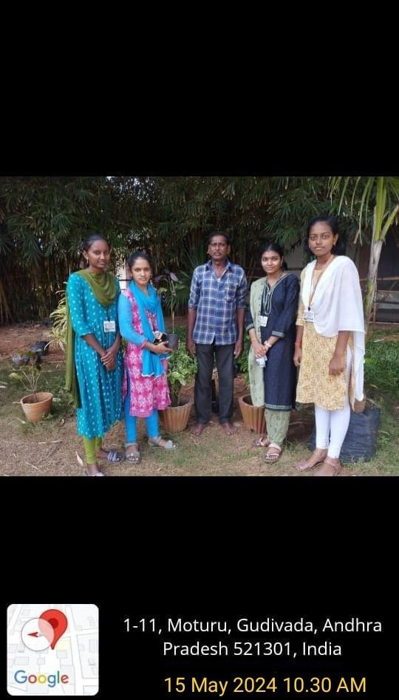



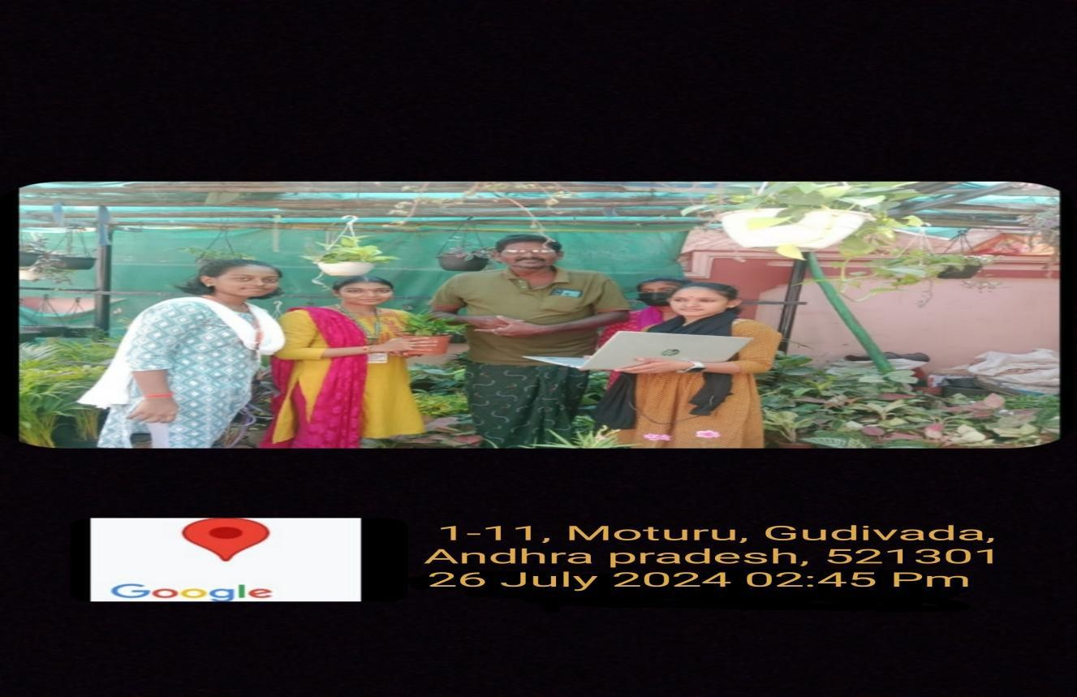

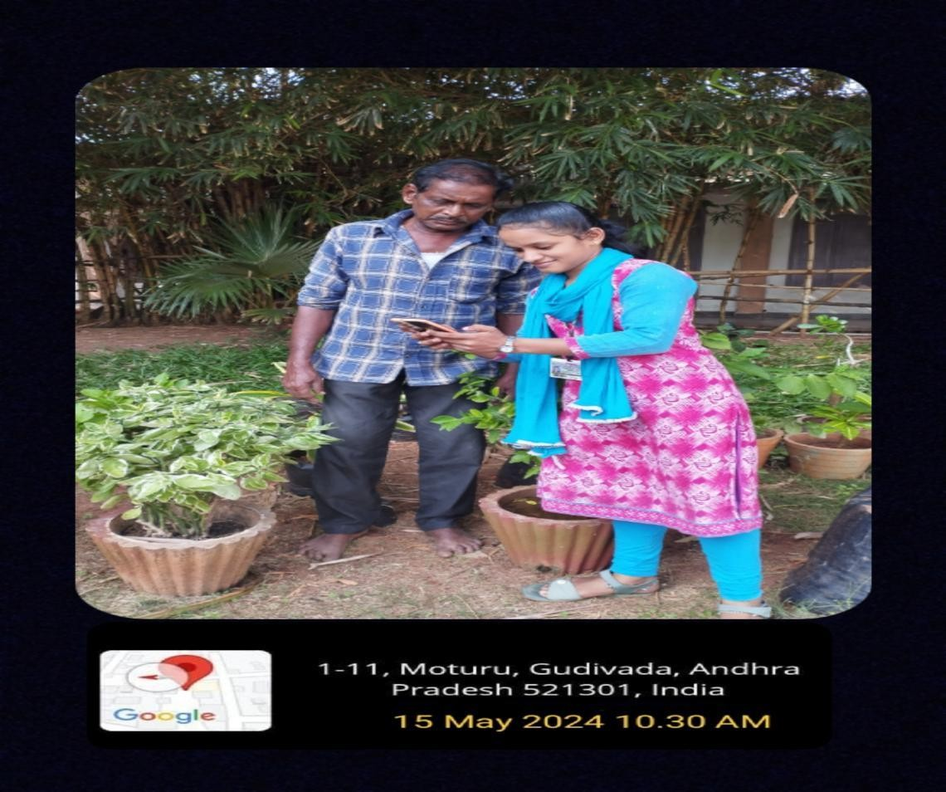

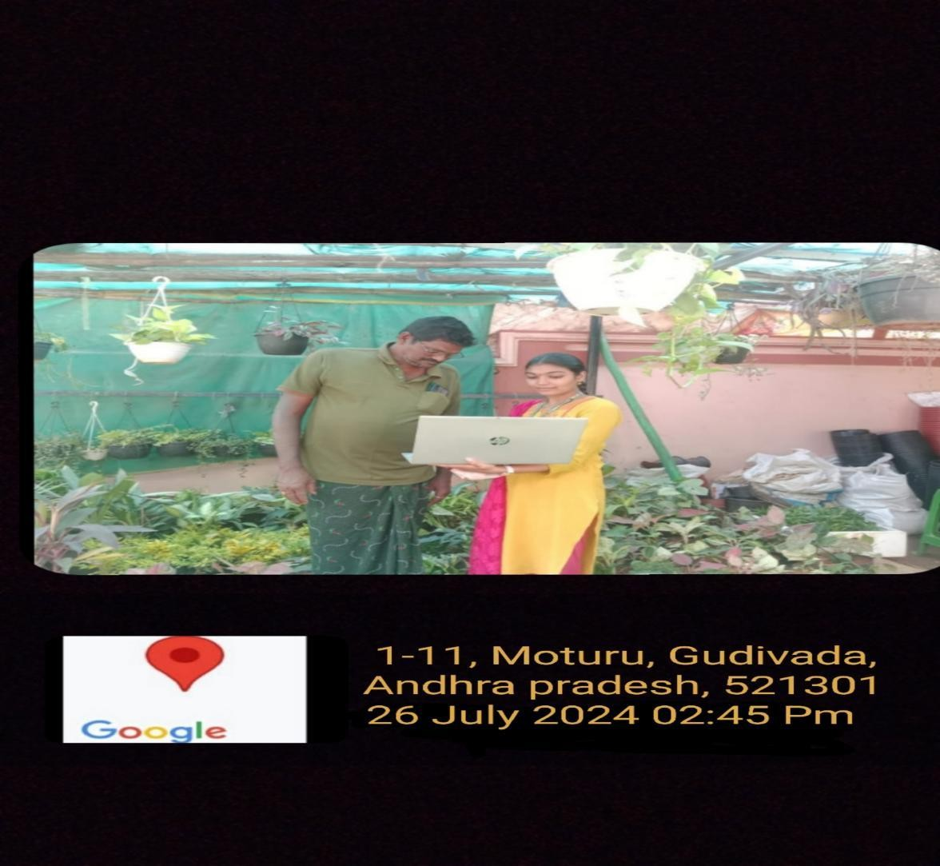

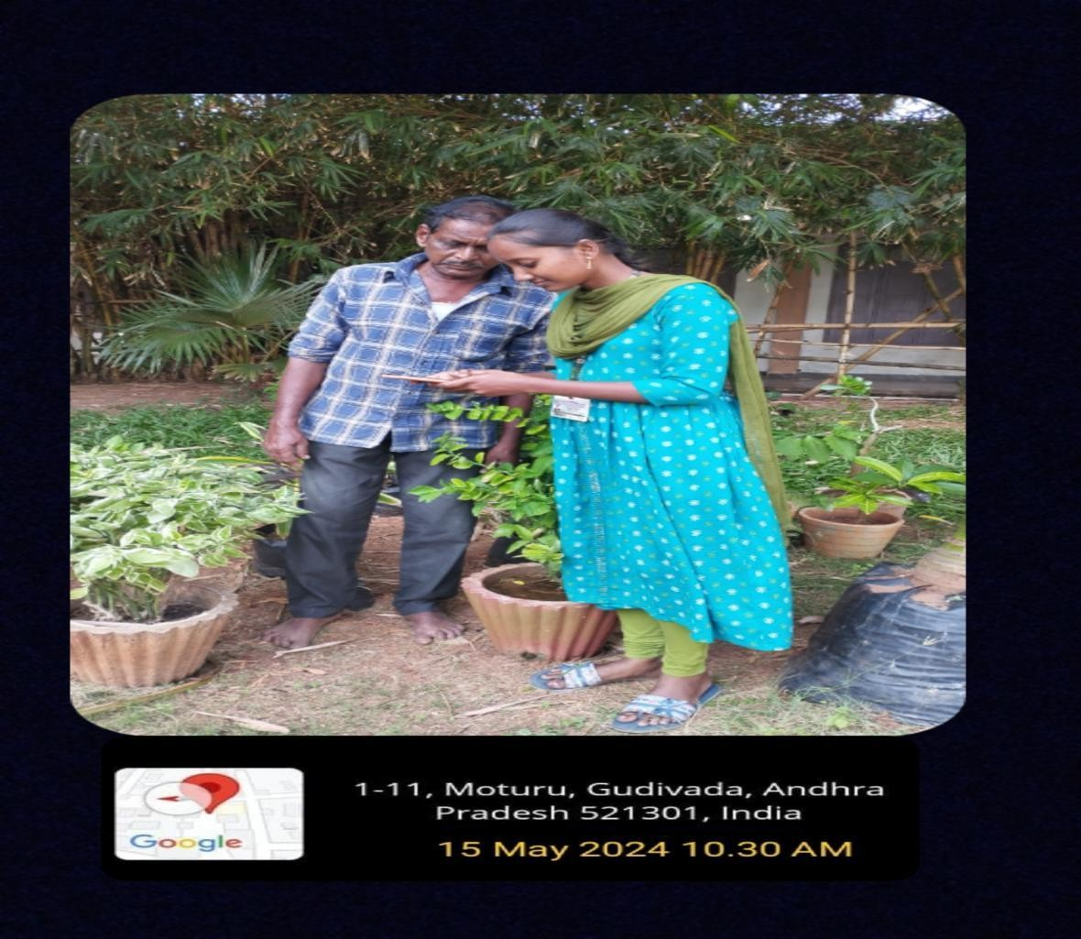

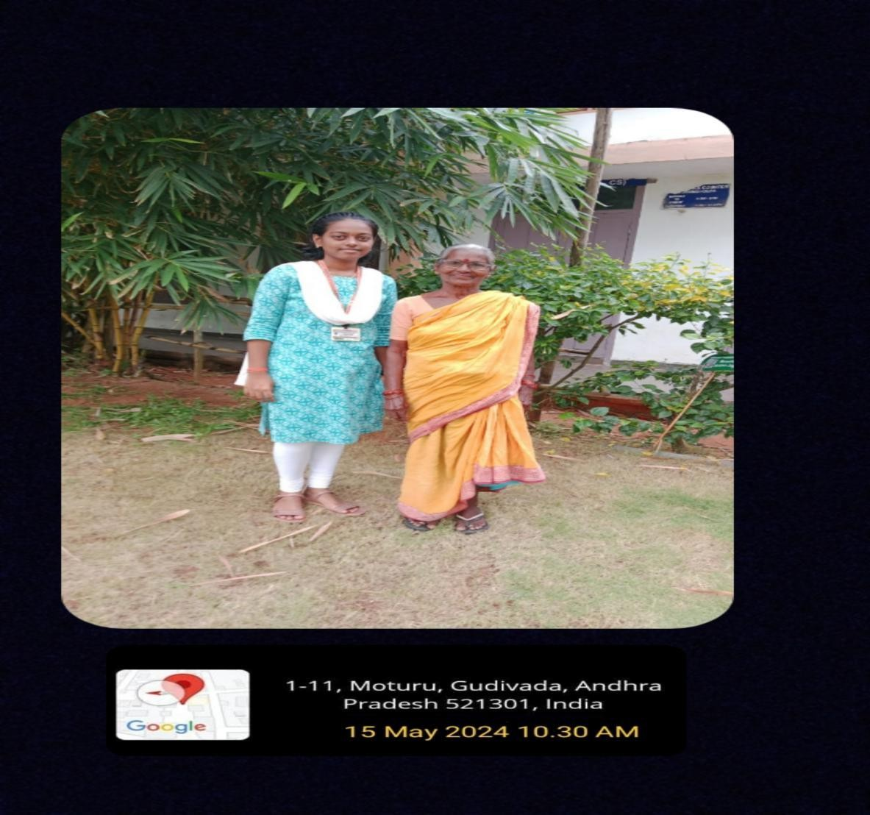

### SESHADRI RAO GUDLAVALLERU ENGINEERING COLLEGE

(An Autonomous Institute with Permanent Affiliation to JNTUK, Kakinada)

Seshadri Rao Knowledge Village, Gudlavalleru

###### Department of CSE (Artificial Intelligence and Machine Learning)

**Program Outcomes (POs) Engineering Graduates will be able to:**

1. **Engineering knowledge:** Apply the knowledge of mathematics, science, engineering fundamentals, and an engineering specialization to the solution of complex engineering problems.
2. **Problem analysis:** Identify, formulate, review research literature, and analyze complex engineering problems reaching substantiated conclusions using first principles of mathematics, natural sciences, and engineering sciences.
3. **Design/development of solutions:** Design solutions for complex engineering problems and design system components or processes that meet the specified needs with appropriate consideration for the public health and safety, and the cultural, societal, and environmental considerations.
4. **Conduct investigations of complex problems:** Use research-based knowledge and research methods including design of experiments, analysis and interpretation of data, and synthesis of the information to provide valid conclusions, component, or software to meet the desired needs.
5. **Modern tool usage:** Create, select, and apply appropriate techniques, resources, and modern engineering and IT tools including prediction and modeling to complex engineering activities with an understanding of the limitations.
6. **The engineer and society:** Apply reasoning informed by the contextual knowledge to assess societal, health, safety, legal and cultural issues and the consequent responsibilities relevant to the professional engineering practice.
7. **Environment and sustainability:** Understand the impact of the professional engineering solutions in societal and environmental contexts, and demonstrate the knowledge of, and need for sustainable development.
8. **Ethics:** Apply ethical principles and commit to professional ethics and responsibilities and norms of the engineering practice.
9. **Individual and team work:** Function effectively as an individual, and as a member or leader in diverse teams, and in multidisciplinary settings.
10. **Communication:** Communicate effectively on complex engineering activities with the engineering community and with society at large, such as, being able to comprehend and write effective reports and design documentation, make effective presentations, and give and receive clear instructions.
11. **Project management and finance:** Demonstrate knowledge and understanding of the engineering and management principles and apply theseto one’s own work, as a member and leader in a team, to manage projects and in

multidisciplinary environments.

1. **Life-long learning:** Recognize the need for, and have the preparation and ability to engage in independent and life-long learning in the broadest contextof technological change.

###### Program Specific Outcomes (PSOs)

PSO1 : Design, develop, test and maintain reliable software systemsand intelligent systems

PSO2 : Design and develop web sites, web apps and mobile apps.

###### PROJECT PROFORMA

|  |  |  |  |  |
| --- | --- | --- | --- | --- |
| **Classification of Project** | **Application** | **Product** | **Research** | **Review** |
| √ |  |  |  |

**Note: Tick Appropriate category**

|  |  |
| --- | --- |
| **Project Outcomes** | |
| Course Outcome(CO1) | Identify community needs/problems |
| Course Outcome(CO2) | Investigate different possible solutions to solve theproblem |
| Course Outcome(CO3) | Make use of community involvement insolving the problem. |
| Course Outcome(CO4) | Prepare a report on the problem and its solution |

**Mapping Table**

Each CO is mapped with the POs and PSOs in three levels, ‘3’ indicates high, ‘2’ indicates moderate and ‘1’ indicates low level

|  |  |  |  |  |  |  |  |  |  |  |  |  |  |  |  |
| --- | --- | --- | --- | --- | --- | --- | --- | --- | --- | --- | --- | --- | --- | --- | --- |
| **AM3503 : COMMUNITY SERVICE PROJECT** | | | | | | | | | | | | | | | |
| **Course outcomes** | **Program Outcomes and Program Specific Outcome** | | | | | | | | | | | | | | |
| **P O 1** | **P O 2** | **P O 3** | **P O 4** | **P O 5** | **P O 6** | **P O 7** | **P O 8** | **P O 9** | **P O 1**  **0** | **P O 1**  **1** | **P O 1**  **2** |  | **P S O**  **1** | **P S O**  **2** |
| CO1:Identify community needs /  problems | 1 | 3 |  |  |  | 2 | 1 | 1 | 2 | 2 | 2 | 1 |  | 2 | 2 |
| CO2: Investigate different possible solutions to solve the problem |  | 2 | 3 |  |  | 3 | 2 | 2 | 3 | 3 | 2 | 2 |  | 2 | 2 |
| CO3: Make use of community involvement in solving the problem. |  |  | 2 |  |  | 2 | 1 | 1 | 2 | 2 | 2 |  |  | 1 | 1 |
| CO4: Prepare a report on the problem and its solution | 2 | 1 | 2 |  | 2 |  |  |  | 2 | 2 |  | 2 |  | 2 | 2 |
| **COMMUNITY SERVICE PROJECT** | 1 | 2 | 2 |  | 1 | 2 | 1 | 1 | 3 | 3 | 2 | 2 |  | 2 | 2 |