Inclusivity and Accessibility Focused News Website
Done by: Harshini J (21BCE1243)
Gerina Mary C (21BCE5566)
Supervised by: Dr. Deepika Roselind K

Table of Contents

1. Introduction
2. Literature Review
3. Project Objectives
4. Methodology
5. System Design / Architecture
6. Implementation
7. Results and Analysis and Discussion
8. Conclusion and Future Work
9. References
10. Appendices [Code]

Introduction
The proposed project will develop an inclusivity and accessibility-driven news website to help people with various needs, especially people with disabilities, enjoy an enhanced user experience. It will include features meant to let users change the colour contrast of themes, provide translations into a language they know, and an option for text-to-speech to make the content available to users with low vision, language barriers, or other challenges. The absence of functionality is a major gap in today's web accessibility and truly juxtaposes against global standards such as WCAG 2.1. This work investigates how human-computer interaction and accessibility come together to implement user-centred design principles on a platform that epitomizes functionality and inclusivity. The paper thus strives to provide a model of accessible news delivery, iterative testing, and feedback from users that may be applied across several digital platforms. These expected results can be enumerated to include a functional prototype, the studies of satisfaction from users, and feasibility guidelines for the implementation of similar features in other web-based environments.

Literature Review
[1] The development of the prosody modelling of the text-to-speech system has attracted attention over recent years, with the promise to improve human-computer interaction. Prosody, including duration, intonation, and intensity patterns in speech, will enhance naturalness and intelligibility in the case of synthesized speech. Traditional systems such as those implemented in the Festival TTS system commonly made use of Classification and Regression Trees (CART) to model prosodic features. These techniques, with phone-based features, do not often lead to models yielding high prediction accuracy, and they are especially poor for systems using syllable-based units. In recent years, some researchers have tried to alleviate these limitations through the application of neural networks, specifically feedforward neural networks (FFNN), in the modelling of prosody. For instance, the considerable strength of neural networks lies in capturing complex and not necessarily linear dynamics between linguistic and production constraints and prosodic patterns required for making correct predictions. Average comparative evaluations have usually evidenced that models based on FFNN offer many more accurate predictions of the prosodic features than models based on CART and, for this, the synthesized speech sounds better. These findings are important because the emerging neural network is already affording a super-strong potential for the actual enhancement of TTS systems, desired, and important in assistive technologies, telecommunications, and other technologies.
[2] This paper deals with the integration of inclusive computational applications into the treatment of ASD, mainly for improving the social and emotional skills of autistic children. The paper surveys current literature about emotional intelligence, autism, and HCI to define the most pertinent functional and non-functional features for software applications in treating ASD. Previous research has shown that traditional therapies often focus on behavioural and communication skills, but little research has gone into the utilisation of inclusive technologies that can enhance these skills in a non-invasive and natural way. The paper thus fills this gap by providing a systematic review of software applications using pictograms and other visual elements, which turn out to be quite effective with children suffering from ASD. This study uses heuristic evaluation to identify key usability criteria, such as ease of use, aesthetic quality, and accessibility, in selected apps. The results are further used to build a conceptual framework for designing an inclusive computational tool that may enhance the improvement of emotional and social intelligence in children with ASD. The literature identifies the significance of HCI models in the development of efficient therapeutic tools but points out that more studies are required in the integration of these technologies into clinical settings.
[3] Literature on assistive technology designed for the visually impaired obviously supports the need for inclusive and user-centred design approaches to improve accessibility and usability within daily living environments. Most of the recent developments have been centered on general and assistive technologies targeted at improving ADLs and IADLs. While screen readers, braille devices, and haptic feedback systems have gone a long way to making things equitable, there remains a gulf in attending to the specific challenges that exist for the visually impaired in interacting with home appliances. Tactile and haptic feedback systems in appliance design are developed, but they often give rise to superficial applications that ignore the markedly diverse needs of these different users with regard to both price and customization. A single direction that clearly holds quite some promise in the realm is user-centred design, as evidenced by the design for modified home appliances like smart refrigerators. This approach is hinged upon iterative design inputs from users, designed with such aspects in place as automatic door operations and tray actuation systems, which end up not only being accessible but also cost-effective. The suggestion, therefore, is that although the extant solutions have made headway, there will continue to be a need for affordable, inclusive, and adaptable technologies toward the amelioration of quality of life for the visually impaired and elderly populations. The focus of future research should be further refinement of those technologies through the inclusion of advanced control strategies and extension of their applicability through inclusive design frameworks.
[4] The paper presents a novel approach to the improvement of machine translation systems by human-computer interaction algorithms. In the respect of machine translation and interactive systems, several contributions have been presented in the literature. Some of the related contributions that can be mentioned include those of Souza et al., which underline educational integration for HCI with an emphasis on theoretical improvement; and those of Ohri et al., who proposed to enhance the accuracy of the system's translation by an integration of hierarchical models with phrase-based translation memory. The present study particularly criticizes the limitations of current machine translation systems in semantic accuracy and emotional nuance. It proposes HCIA as a solution to such problems. This paper looks at Interactive Machine Translation that is going to integrate Machine Translation with users' input in refining the result of translations to address traditional method failures. HCIA provides a more flexible and user-friendly interface to reduce the cognitive load of the translator in order to improve efficiency. Experimental results indicated that systems with HCIA-based approaches significantly improve translation efficiency in comparison with the traditional method. However, refinement in filtering the phrase table and overall translation quality is still admitted.
[5] Interest in the development of intelligent automated translation systems has heightened due to growing interest in seeking fast, convenient language translation solutions. Traditionally, language translation relied on manual means, which are time-consuming and resource-intensive. Machine translation progressively adopts advanced algorithms and language modelling to ensure a more accurate and efficient translation process. According to Mahata et al., the need for real-time translation has become a must as the traditional systems are failing to deliver instant results, particularly on mobile platforms. The authors further pointed out that neural machine translation models have impressive progress on the benchmark tests, which prove their capability of translation into different families of languages. However, even with this rapid progress, reaching translation quality comparable with professional human translators is still hard to reach. This paper proposes a new approach that addresses these deficiencies based on a human-computer interaction enhancement algorithm. It assimilates a series of technical innovations, including augmented reality and interactive interfaces, to improve both the quality of translation and user experience. Results from the proposed system are comparatively better than traditional MT systems, more so on BLEU scores for fields such as news, finance, medicine, education, etc. The improved algorithm performs far better when it involves short and medium-length sentences, but with very long ones, it faces difficulties, which can be noted in the study's evaluation metrics. This literature review also pointed out that translation technologies are in continuous evolution and that innovative work is needed to fill the gap between machine capabilities and human competence in translation.
[6] Literature on the accessibility of the web highly emphasizes that there was a critical need for this paper in order to secure an inclusive digital experience for people with disabilities. In this regard, it has opened both opportunities and challenges for making the content of the web more accessible, moving from static text-based pages to dynamic multimedia-rich platforms. Precisely, it is expected that while the advancement in Web technologies increased access, they also introduced new barriers—specifically those for visually impaired end-users. Studies show that advertisements, especially pop-ups and auto-playing videos, further exaggerate the problems in the accessibility area by covering screen readers and thus making navigation difficult. WCAG offers a framework to meet these challenges through its principles related to perceivability, operability, understandability, and robustness. To this end, compliance has often been checked using tools like AChecker and WAVE, which usually turn up the same types of mistakes: inadequate text alternatives for non-text content and poor navigational structures. Earlier studies also put a priority on including accessibility principles in web design in order to make interfaces easier to use. Since assistive technologies are already being created, browser extensions summarizing content would only be one in the greater trends aiming to improve the web for all users, especially users with impairments. While this has seen improvement, the literature advises that it will require continuous evaluation and adaptation to move at par with the changing web technologies and user needs.
[7] The paper "Evaluation of a university website's usability for visually impaired students" by Menzi-Çetin et al. discusses the junction between human-computer interaction and accessibility, putting special emphasis on the usability of university websites for visually impaired students. It addresses key issues in human–computer interaction to enhance web accessibility for people with disabilities: the need for user-centered design and universal design principles. The methodology that was used in conducting the study involved usability testing with five blind students and questionnaires about satisfaction. Major problems were detected: the difficulty in accessing the dates for final exams and course schedules, structured inappropriate for the pages, and lack of assistive technology integration. The results highlighted how much more intuitive navigation is required, a text version for all the pages, and reorganization of sequences of web links for serving visually impaired users. It contributes to HCI by demonstrating how involving users with visual impairment in the design and evaluation cycle of website development can provide insight into usability problems that may not be otherwise found, and it promotes more usable web interfaces through the following universal design standards.
[8] In the paper "Accessibility of Digital Systems in Information Retrieval by Users with Visual Impairment," Gatwiri Kiambati and colleagues dig into a very vital area of accessibility for digital information systems by users with visual impairments (VI). It is founded on a broader history of human-computer interaction, largely basing on the way in which accessibility issues lower usability in digital libraries for the visually impaired. In this, it is specifically highlighted that assistive technologies highly require compatibility with digital systems, from assumptions concerning the use of alternative formats for the content to general interface accessibility and usability. In relation to the principles of HCI, this points to user-centred design, giving ideas to design digital systems natively accessible and able to adapt to the various needs of visually impaired users. Experiences with digital libraries do change significantly with prior training in the use of assistive technology and the frequency of use of such libraries, suggesting that accessibility issues are not merely technical in nature but are also a function of user skills and interface design. It adds to the HCI field empirical work on how much digital systems should be designed to be inclusive and usable for people with visual impairments so as to achieve inclusivity in digital environments.
[9] Xie et al. paper discusses the design of help features that improve the usability of DLs for blind and visually impaired users. In such a research setting, the study follows human-computer interaction and bases its juncture of the vulnerabilities BVI have on the inadequacies of the designs in most DLs. That is, through a sound experimental design that involved questionnaires, think-aloud protocols, and interviews, the authors compared two versions of the DL, where the participants of this group faced a DL with variously implemented help facilities and one that did not. The results showed that the tailored help features in the DL significantly reduced the number of help situations experienced by BVI users, improved their perceived usefulness of the DL, and enhanced overall satisfaction. It contributes to HCI by situating these issues within the social model of disability, emphasizing that design creates a barrier. Therefore, it has more to do with design than focusing on the disability of a person. This study affirms the need, therefore, for DL designers to make provisions for distinctive situations that characterize help-seeking among the BVI users and to include features that will facilitate their interaction to ensure that the digital space is more indiscriminately friendly.
[10] The paper by Bhardwaj and Kumar presents the problems that visually impaired students currently face in accessing digital resources and therefore needs the development of DigitVaran to bridge this gap. Previous research has stressed that there are considerable barriers to digital environments via poorly designed web content and a lack of assistive technologies for the visually impaired. The literature strongly shows a call for good interface design that will allow accessibility standards to allow smoother interactions for visually impaired users. By responding to the voices of its users, this research is aligned with principles in HCI that stress user-centred design, emphasizing the inclusion of user experiences in the development of assistive technologies and digital systems. In the development of DigitVaran, the authors are adding to some gaps that previous studies had pointed out with respect to the availability of digital infrastructure and poorly constructed training in using assistive devices, hence contributing significantly to the bettering of the practice of Inclusive HCI.
[11] HCI in this reference is also focussed on providing web accessibility to colorblind users. In the paper "A Novel Heuristic Method for Quantitative Assessment of Web Accessibility for Colorblind," S. Meenakshi and Anshu Singla contribute to this area by proposing a heuristic evaluation method of assessing conformance with WCAG. This approach allows incorporation of automated tools with manual observations, thus all improvements in the aspects indicated as weaknesses from previous works published in the HCI literature on accessibility assessment. In providing a structured approach to quantifying and validating web accessibility specifically for colourblind users, this work is relevant to HCI's quest for designing inclusive, user-friendly interfaces, and it manages to provide constructive insight into best practices in designing against common visual disabilities.
[12] In the paper "Mapping 20 Years of Accessibility Research in HCI: A Co-word Analysis," Sarsenbayeva et al. provide a comprehensive review of accessibility research in Human–Computer Interaction, using co-word analysis to trace its intellectual evolution over two decades. The authors analyze 1,535 papers from major HCI venues with strategic diagrams, hierarchical clustering, and network core-periphery analysis drawn from ASSETS, TACCESS, IJHCS, and CHI. This paper identifies core, rising, and declining themes in accessibility research over the period from 2001 to 2021, noticing huge thematic shifts and growth. Especially relevant here are trends such as motor impairments and visual impairments, whose importance has changed across both decades. This paper brings out trends such as adaptive interfaces and affective computing as future directions and also presents a roadmap for researchers and practitioners working in this field. It is an outstanding work in quantitatively mapping accessibility research, which provides a view into the changing landscape within HCI.
[13] The paper from Abascal and Nicolle traces the evolution of Human-Computer Interaction concerning accessibility for users with disabilities. First, HCI has been developed with respect to adaptations to already existing technologies; therefore, fragmented and often obsolete solutions are the result. Universal design is one where application functionality is independent of the user interface, hence enabling more adaptable and inclusive interaction. They mention all the benefits of sophisticated approaches, such as adaptive interfaces and affective computing. The paper places an emphasis on Universal Design—that is, on creating inherently accessible systems—while recognizing that some users may still need assistive technologies. It is an appeal to ethical and socially aware design practices, and collaboration across disciplines for the sake of engendering inclusivity and tackling digital divides.
[14] The paper "Digital Literacy Skills of University Students with Visual Impairment: A Mixed-Methods Analysis" contributes to HCI research on how digitally challenged university students use digital technologies. In particular, it extends previous work of HCI on accessibility by showing that while students with visual impairments excel in basic technical and cognitive skills, they face challenges related to social aspects, like the creation of content and collaboration. It supports HCI literature advocating for inclusive design and user-centred technology solutions. The research further points to the fact that high exposure to the internet and being exposed to technology from an early age significantly improves DL skills, suggesting that HCI-targeted solutions could improve digital experiences for the visually impaired. This emphasizes the continued HCI research needed to develop tools and strategies that will help students in higher education with visual impairments.
[15] This paper critically assesses the usability and effectiveness of Microsoft's Accessibility Insights for Web, a browser extension that supports the evaluation of web accessibility against WCAG. In the research, huge deficiencies of current automated accessibility tools are exposed: very often, they could not even pass half of the WCAG criteria and need human judgment in order to be evaluated properly. The authors identified some of the usability issues of Accessibility Insights through a combination of user interviews, heuristic evaluations, and co-design sessions with developers and accessibility experts. Their research provides input into the general topic of web accessibility, pointing out a lack of tools that integrate both automated and manual testing and are themselves user-friendly and accessible. These findings underscore the importance of iterative design and user feedback in developing effective accessibility tools. Equally, a tool such as this should be more intuitive in future incarnations and accommodate a diverse range of users, including those with disabilities.

Project Objectives
Primary Objectives:
The primary objectives of this project focus on enhancing accessibility, promoting inclusivity, and facilitating easy navigation for users. Accessibility has been provided through features that include text-to-speech, adjustable text sizes, high-contrast modes, and shortcut buttons that enable full-scale support to users with visual, auditory, or motor impairments by removing all barriers that might limit accessibility for all individuals concerned to use the platform both independently and effectively.
A further main aim is inclusiveness, which is achieved by making a system accessible to people from different linguistic and cultural backgrounds. Therefore, by providing multi-lingual support, it is able to make news available in several languages, hence making the user feel engaged and included in case they are not fluent in the primary language of the platform. The system also values usability through its development of an intuitive and user-friendly interface. With accessibility-friendly shortcuts and clear navigation paths, the website ensures that users, regardless of their technical expertise, can easily discover and engage with content.

Secondary Objectives:
The secondary goals supplement the objectives of user engagement and still keep the site equitable and adaptive. At the heart of this is the customizable user experience, including features such as volume controls, display preference options, and plentiful personalization choices that will allow users to customize their interaction with the system according to their specific needs. Such customization would ensure that users are comfortable and enjoy the immersion on the site, which makes them much more satisfied and retained.
Furthermore, the project would cross digital divides because it would ensure interoperability with accessible technologies and access across devices. The project meets underserved populations-mostly those with resources or access to sophisticated tools and fair access to high-quality news content. Of course, evaluation and enhancement of features on inclusivity and accessibility are constant needs. Regular user testing and feedback analyses enable the team to evaluate the platform’s impact and implement necessary adjustments, thereby ensuring that it evolves effectively to meet the dynamic needs of its diverse audience.

Methodology
Feature Engineering:
The news website was inclusively accessible, and feature engineering addressed their users' varied needs. It included a suite of features such as colour themes, text resizing, and shortcuts enabling ability advancement for people with visual impairments, cognitive challenges, or physical disabilities. For translation, the MyMemory API was utilized to enable multilingual content delivery.

Model Selection:
Appropriate models and APIs were chosen that balanced accuracy with accessibility and computational efficiency. Speech Synthesis API was used to generate natural-sounding speech. It made it possible to support various voices and languages in order to address a variety of user requirements. This API was quick to integrate and robust with functionality that adapted for just-in-time text-to-speech conversion. The MyMemory API has one of the most extensive translation memory capabilities: it works with machine and human-related translations to provide contextually appropriate multilingual material. These APIs were selected for use based on their performance metrics, capability to scale to various languages and low latency.

System Design / Architecture
System Architecture Diagram:

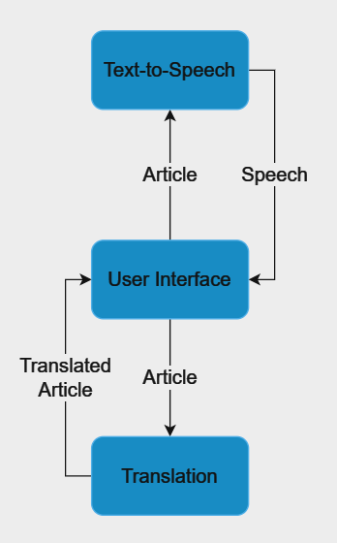

Module Description:
1. User Interface (UI) Module
The UI module provides an easy and customizable interface designed to meet a wide variety of user needs. These features include:
- Colour Themes: There are various colour themes to enable users with visual impairments, including colour blindness and light sensitivity.
- Text Resizing: changeable font size to best suit readability for visually impaired users.
- Keyboard Shortcuts: Shortcuts to make navigation easier for the motor-impaired population or users of assistive devices.
- Responsive Design: Compatibility with various devices, ensuring an optimized experience across desktops, tablets, and smartphones.

2. Text-to-Speech Module
This module converts text on screen into natural-sounding clear speech, using the Speech Synthesis API. Below are its capabilities:
- Support for multiple languages and voices to cater for varied demographics of users.
- Variable speech volume for tailored listening.
- The on-demand audio playback for an article.

3. Translation Module
The translation module uses the MyMemory API to enable multi-linguality, thereby making the same content accessible to a wider audience worldwide. Key functionalities include:
- News articles are translated in real-time into many languages.
- Context-aware translation to ensure accuracy and cultural relevance.
User-friendly interface selection for choosing languages.

Implementation
Tools and Technologies:
The development of the news portal, which accommodates users with its vast features, uses the following technologies and resources:
HyperText Markup Language (HTML):
The page content and layout have been structured using semantic HTML tags, thus enhancing accessibility and ensuring compatibility with assistive technologies such as screen readers.
Cascading Style Sheets (CSS):
CSS was used to make the user interfaces responsive and aesthetically more presentable. The custom colour themes were included using CSS variables.
JavaScript (JS):
JavaScript was used to make the pages interactive and dynamic in their functionalities. This includes keyboard shortcut integration, API integration and real-time text-to-speech and translation functionality.
Speech Synthesis API:
The text-to-speech function enables reading in audio format and has voice settings that can be set to improve accessibility.
MyMemory API:
Used to deliver multilingual translation capabilities, ensuring that users could access content in a preferred language.
Version Control (Git):
Git was used to manage code changes and collaborate during the development lifecycle.

Development Process:
Requirement Analysis:
The project started with identifying the key requirements of accessibility and inclusivity, considering the aspects of personalization, text-to-speech support, and the presence of multiple languages. Accessibility guidelines such as WCAG were analyzed for compliance.
Design and Prototyping:
Wireframes and prototypes were created to achieve a friendly layout. Colour themes, typography, and responsive elements to cater to diverse users' needs were planned during this phase.

Frontend Development:
HTML was used to structure the website with semantic elements to improve navigation for assistive tools. CSS styles were used in creating nice and accessible themes as well as in the offering of text resizing and responsive design capabilities. Interactivity could be achieved using JavaScript by manipulating API requests for text-to-speech and translation and keyboard shortcuts.
API Integration:
The Speech Synthesis API was integrated for real-time text-to-speech conversion with adjustable voice parameters.
The MyMemory API was integrated in order to allow for dynamic translation of content using several languages.
Testing and Refining:
The test was also done comprehensively to provide complete usability and accessibility, from various devices, browsers, and user scenarios. All concerns regarding responsiveness, compatibility, and performance were taken care of during this phase.
Deployment: The last website developed was deployed as a static website via GitHub.

Code Snippets:
Text-to-Speech function:
function TTS() {
const newsContent = $('#headline').text()+". "+document.querySelector('#news-topic .news-content').innerText;
if (newsContent.trim()) {
if (window.speechSynthesis.speaking && currentUtterance) {
// If speech is already playing, cancel it
window.speechSynthesis.cancel();
volumeSlider.disabled = false;
currentUtterance = null;
}
else if (!currentUtterance) {
// Create a new SpeechSynthesisUtterance instance if it doesn't exist
currentUtterance = new SpeechSynthesisUtterance(newsContent);
currentUtterance.volume = volumeSlider.value;
currentUtterance.lang = tlang; // Adjust the language if needed
window.speechSynthesis.speak(currentUtterance);
volumeSlider.disabled = true;
currentUtterance.onend = () => {
// Reset currentUtterance when speaking ends
currentUtterance = null;
volumeSlider.disabled = false;
};
} else {
// Reset the text if currentUtterance exists
currentUtterance.text = newsContent;
}
// Speak the utterance

} else {
console.error('No content to read');
}
};

Translation function:
function TTT() {
if (window.speechSynthesis.speaking && currentUtterance) {
// If speech is already playing, cancel it
window.speechSynthesis.cancel();
volumeSlider.disabled = false;
currentUtterance = null;
}
var curlang = $('#language-dropdown').val();
tlang = curlang;
if (curlang == "en"){
$('#headline').text(hcontent);
$('#content').text(content);
}
else{
var languagePair = "en|"+curlang; // Get the selected language pair

// Send a GET request to MyMemory API
$.ajax({
url: 'https://api.mymemory.translated.net/get',
type: 'GET',
data: {
q: hcontent,
langpair: languagePair
},
success: function(response) {
// Update the content with the translated text
$('#headline').text(response.responseData.translatedText);
},
error: function() {
alert('Error while translating');
}
});
$.ajax({
url: 'https://api.mymemory.translated.net/get',
type: 'GET',
data: {
q: content,
langpair: languagePair
},
success: function(response) {
// Update the content with the translated text
$('#content').text(response.responseData.translatedText);
},
error: function() {
alert('Error while translating');
}
});
}
};

Results and Analysis
GUI Screenshots:
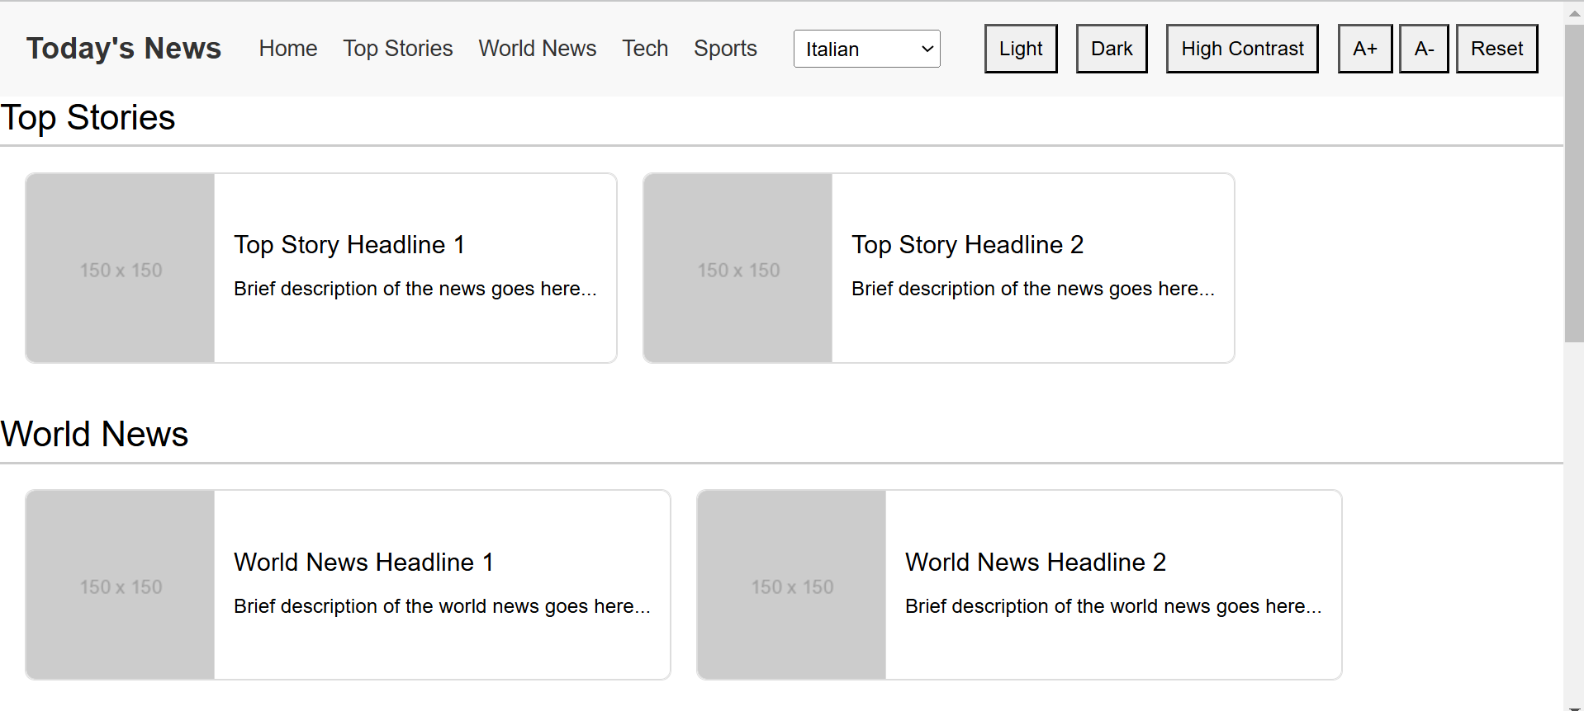
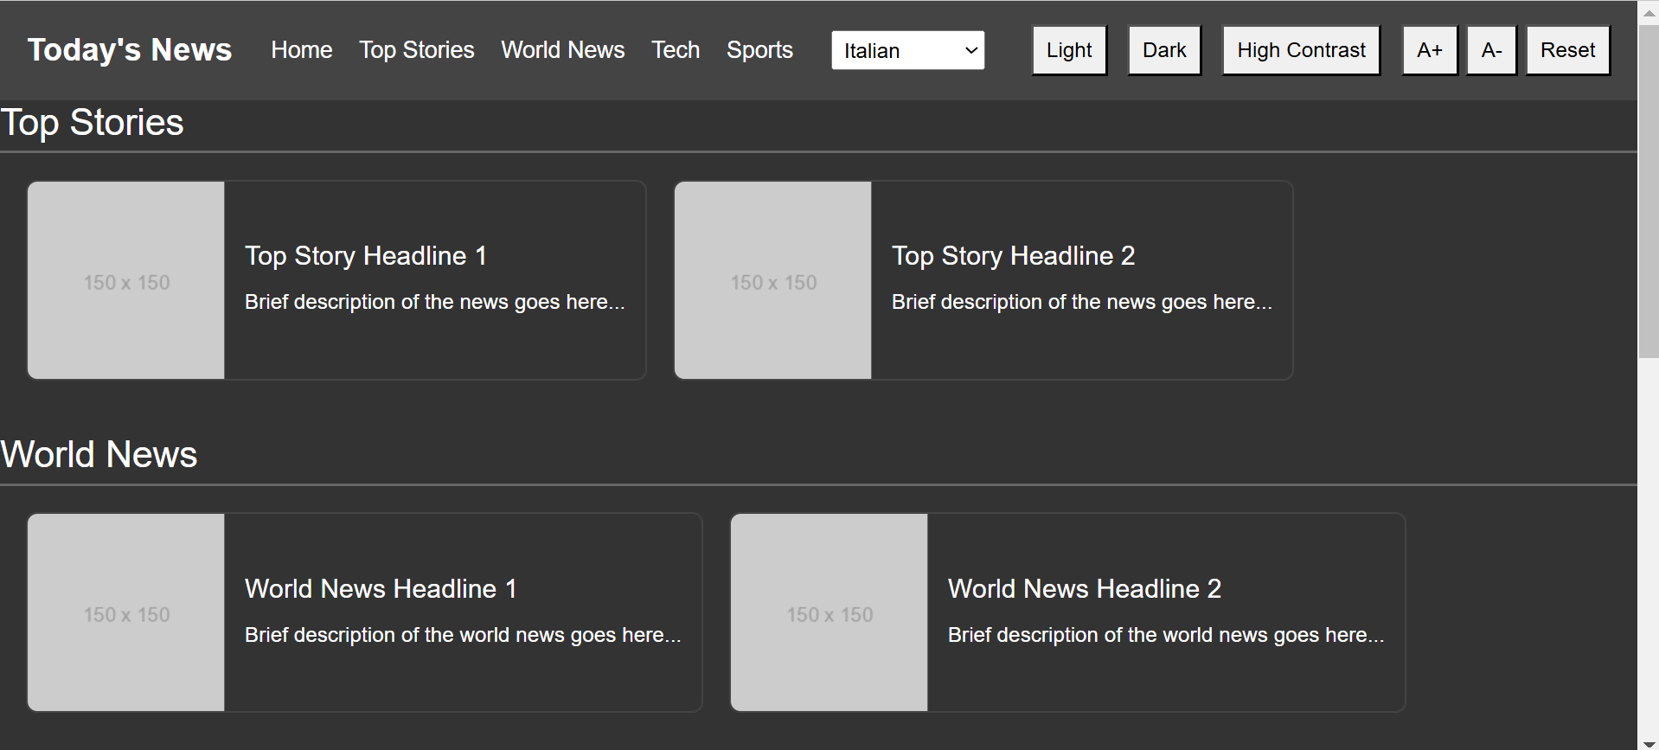
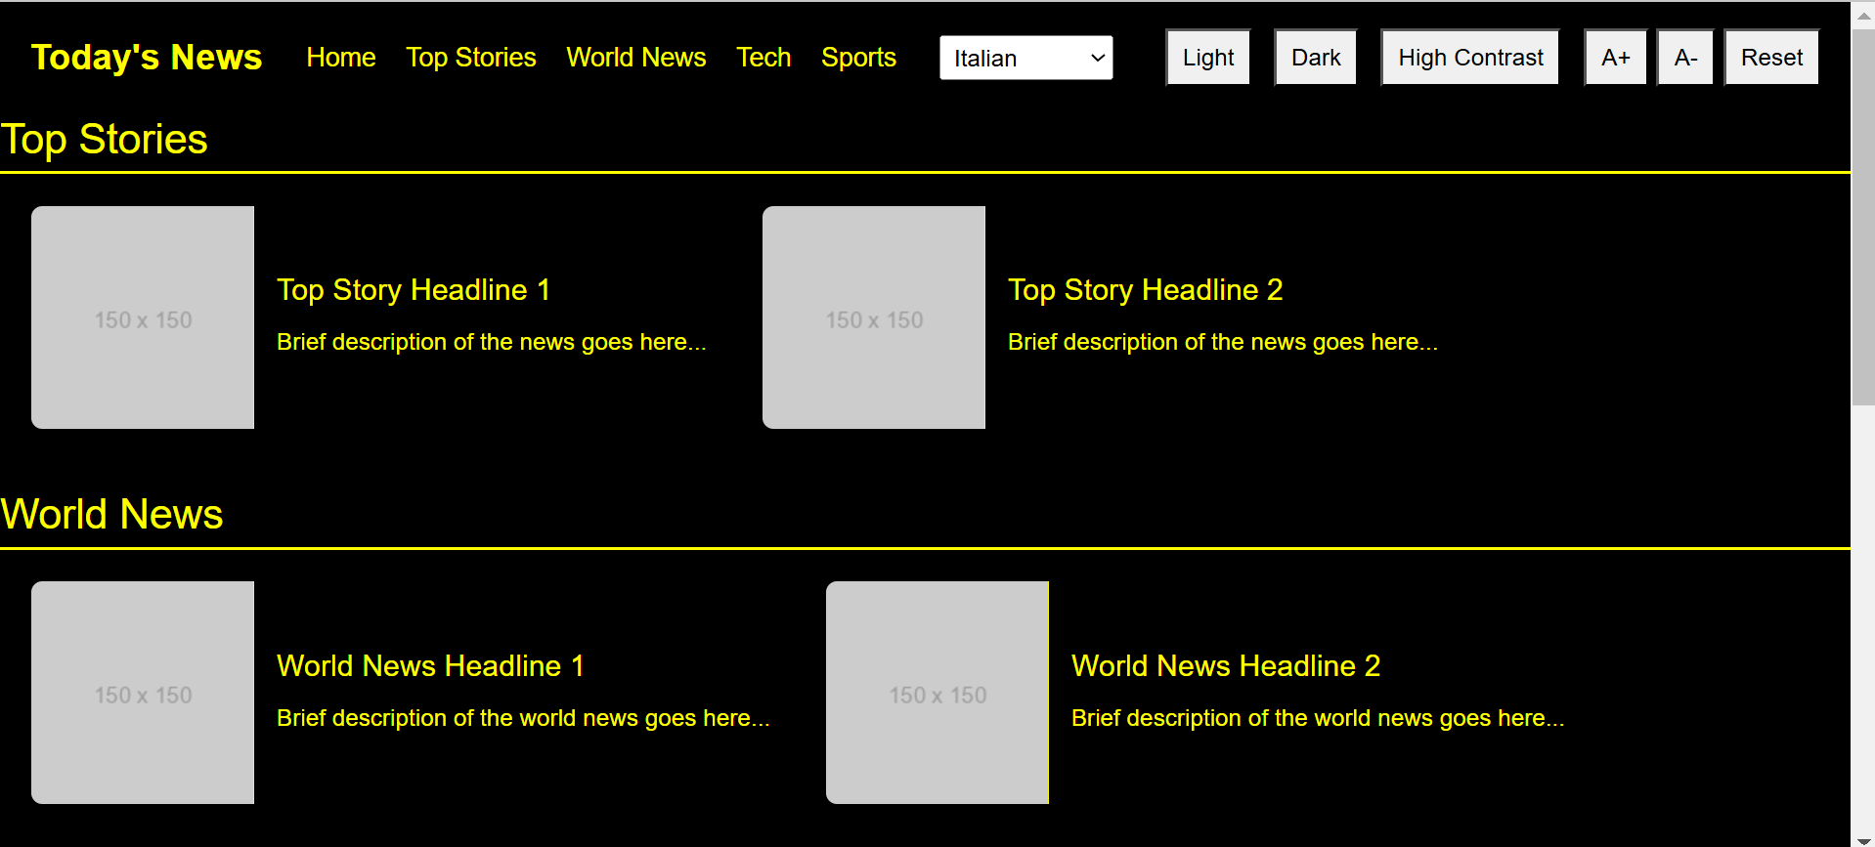
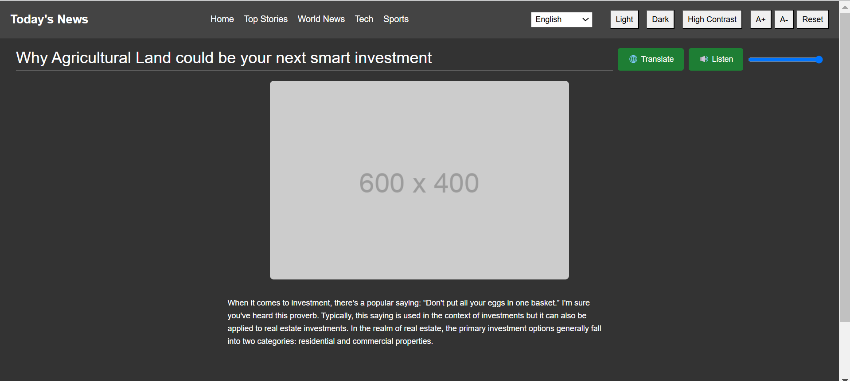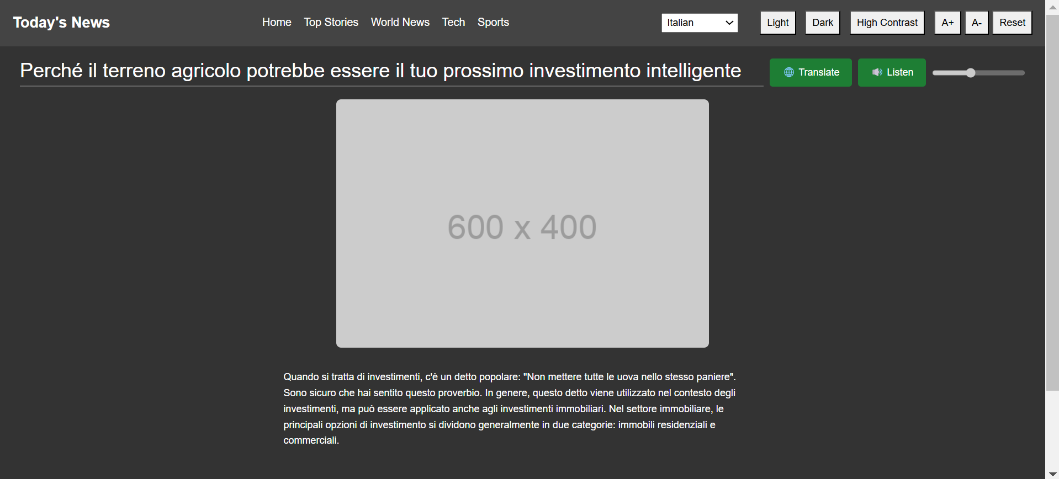

Discussion
Limitations:
Despite the success of the project, there were several limitations and challenges. One of the major issues faced was the response time of the API, which at times caused delays- mainly for resource-consuming operations such as real-time language translation or text-to-speech processing. These delays impacted the smoothness of the user experience in specific scenarios, highlighting the need for optimizing backend processes and exploring more efficient API solutions.
Another area that was limited was multilingual support, where the application supported a predefined set of languages. The scope would be further amplified by providing support for regional dialects and less spoken languages, thus even further increasing inclusivity. Although all basic accessibility standards were met, the platform did not adhere to advanced Web Content Accessibility Guidelines (WCAG) owing to issues of time. Such limitations provide avenues for improvement in later versions of the project.
Conclusion and Future Work
Summary of Findings:
This project actually shows the way technology can be developed to construct an inclusive and accessible news portal. It responds to different groups of users through features such as language translation, adjustment of text size, or high-contrast modes, and user-friendly navigation tools, thereby providing equal access to features for the visually disabled, hearing-impaired, and motor-impaired users. Additionally, multilingual support helps enhance inclusivity by breaking down language barriers, allowing users with different linguistic backgrounds to better engage with the system. In conclusion, the project highlights how usability, inclusivity, and accessibility are fundamental elements that should be used in developing a digital space where all individuals can feel valued and supported.

Future Scope:
Although the project meets its key objectives, there is much room for further enhancements and growth. Future initiatives may look into integrating high-end AI-based resources such as real-time speech input and output for real-time news programming and content recommendation based on personal interests. Further increasing the multilingual functionality to support greater numbers of languages and dialects may help to enhance inclusiveness and expand audience reach.
Further, integration of tools such as gestural navigation and voice commands can open the way to better accessibility for people with severe motor impairments. In addition, WCAG standard compliance can be examined and reviewed from time to time to ensure that the platform remains up-to-date with evolving needs.
Another promising direction is falling under community-driven features-translation crowdsourcing and content contributions from less represented regions. User feedback loops, coupled with analytics insights, can help inform iterative improvements, but such improvements should ensure the relevance and effectiveness of the platform. Improvements can help make sure the platform maintains current achievements but continues evolving as a benchmark for equitable and accessible digital news services.

References
[1] Reddy, V. R., & Rao, K. S. (2012, December). Better human computer interaction by enhancing the quality of text-to-speech synthesis. In 2012 4th International Conference on Intelligent Human Computer Interaction (IHCI) (pp. 1-6). IEEE.
[2] Moreno, G., Moreira, F., Collazos, C. A., & Fardoun, H. M. (2020, June). Recommendations for the design of inclusive apps for the treatment of autism: An approach to design focused on inclusive users. In 2020 15th Iberian Conference on Information Systems and Technologies (CISTI) (pp. 1-6). IEEE.
[3] Nayak, S. K., Chavan, N. S., & Srinath, N. (2016, December). User centered inclusive design for assistive technology. In 2016 IEEE Annual India Conference (INDICON) (pp. 1-6). IEEE.
[4] Fu, X. (2022, December). English Machine Translation System based on Human-Computer Interaction Algorithm. In 2022 IEEE 2nd International Conference on Mobile Networks and Wireless Communications (ICMNWC) (pp. 1-4). IEEE.
[5] Guo, S. (2023, April). Intelligent English Automatic Translation System Based on Human-Computer Interaction Enhancement Algorithm. In 2023 Asia-Europe Conference on Electronics, Data Processing and Informatics (ACEDPI) (pp. 465-469). IEEE.
[6] Rajyalakshmi, T., & Kuppusamy, K. S. (2023, September). Accessible e-News Summary Browser Extension for Visually Challenged Users. In 2023 3rd International Conference on Innovative Sustainable Computational Technologies (CISCT) (pp. 1-6). IEEE.
[7] Menzi-Çetin, N., Alemdağ, E., Tüzün, H., & Yıldız, M. (2017). Evaluation of a university website’s usability for visually impaired students. Universal Access in the Information Society, 16, 151-160.
[8] Kiambati, F. G., Juma, S. W., & Wawire, B. A. (2024). Accessibility of digital systems in information retrieval by users with visual impairment. Quality Assurance in Education.
[9] Xie, I., Babu, R., Lee, T. H., Castillo, M. D., You, S., & Hanlon, A. M. (2020). Enhancing usability of digital libraries: Designing help features to support blind and visually impaired users. Information Processing & Management, 57(3), 102110.
[10] Bhardwaj, R. K., & Kumar, S. (2017). A comprehensive digital environment for visually impaired students: user’s perspectives. Library Hi Tech, 35(4), 542-557.
[11] Meenakshi, S., & Singla, A. (2023). A novel heuristic method for quantitative assessment of web accessibility for colorblind. Universal Access in the Information Society, 1-21.
[12] Sarsenbayeva, Z., van Berkel, N., Hettiachchi, D., Tag, B., Velloso, E., Goncalves, J., & Kostakos, V. (2023). Mapping 20 years of accessibility research in HCI: A co-word analysis. International Journal of Human-Computer Studies, 175, 103018.
[13] Abascal, J., & Nicolle, C. (2005). Moving towards inclusive design guidelines for socially and ethically aware HCI. Interacting with computers, 17(5), 484-505.
[14] Arslantas, T. K., & Gul, A. (2022). Digital literacy skills of university students with visual impairment: A mixed-methods analysis. Education and Information Technologies, 27(4), 5605-5625.
[15] Shah, K., Garg, A., & Bruce, C. (2023, July). Improving Web Accessibility Testing with Microsoft’s Accessibility Insights for Web. In International Conference on Human-Computer Interaction (pp. 358-365). Cham: Springer Nature Switzerland.

Appendix
Index.html:
<!DOCTYPE html>
<html lang="en">
<head>
<meta charset="UTF-8">
<meta name="viewport" content="width=device-width, initial-scale=1.0">
<link href="https://cdn.jsdelivr.net/npm/bootstrap@5.2.3/dist/css/bootstrap.min.css" rel="stylesheet" crossorigin="anonymous">
<script src="https://code.jquery.com/jquery-3.6.0.min.js"></script>
<title>Accessible News Website</title>
<link rel="stylesheet" href="style.css">
</head>
<body>
<script src="https://cdn.jsdelivr.net/npm/bootstrap@5.2.3/dist/js/bootstrap.bundle.min.js" crossorigin="anonymous"></script>
<header>
<div class="navbar">
<h1 class="site-title">Today's News</h1>
<nav>
<ul>
<li><a href="#">Home</a></li>
<li><a href="#top-stories">Top Stories</a></li>
<li><a href="#world-news">World News</a></li>
<li><a href="#tech">Tech</a></li>
<li><a href="#sports">Sports</a></li>
</ul>
</nav>
<div id="navbar-right">
<select id="language-dropdown" aria-label="Select audio language">
<option value="en">English</option>
<option value="es">Spanish</option>
<option value="fr">French</option>
<option value="de">German</option>
<option value="it">Italian</option>
<option value="pt">Portuguese</option>
<option value="hi">Hindi</option>
</select>
<div id="theme-switcher">
<button data-theme="light">Light</button>
<button data-theme="dark">Dark</button>
<button data-theme="high-contrast">High Contrast</button>
</div>
<div id="zoom-controls">
<button id="zoom-in" aria-label="Zoom In">A+</button>
<button id="zoom-out" aria-label="Zoom Out">A-</button>
<button id="reset-zoom" aria-label="Reset Zoom">Reset</button>
</div>
</div>
</div>
</header>

<main>
<!-- Top Stories Section -->
<section id="top-stories">
<h2>Top Stories</h2>
<div class="news-cards">
<article class="news-card">
<a href="news_topic1.html" class="news-card">
<img src="https://via.placeholder.com/150" alt="News Image 1">
<div class="news-content">
<h3>Top Story Headline 1</h3>
<p>Brief description of the news goes here...</p>
</div>
</a>
</article>

<article class="news-card">
<a href="news_topic1.html" class="news-card">
<img src="https://via.placeholder.com/150" alt="News Image 2">
<div class="news-content">
<h3>Top Story Headline 2</h3>
<p>Brief description of the news goes here...</p>
</div>
</a>
</article>
</div>
</section>

<!-- World News Section -->
<section id="world-news">
<h2>World News</h2>
<div class="news-cards">
<article class="news-card">
<a href="news_topic1.html" class="news-card">
<img src="https://via.placeholder.com/150" alt="World News Image 1">
<div class="news-content">
<h3>World News Headline 1</h3>
<p>Brief description of the world news goes here...</p>
</div>
</a>
</article>

<article class="news-card">
<a href="news_topic1.html" class="news-card">
<img src="https://via.placeholder.com/150" alt="World News Image 2">
<div class="news-content">
<h3>World News Headline 2</h3>
<p>Brief description of the world news goes here...</p>
</div>
</a>
</article>
</div>
</section>

<!-- Tech News Section -->
<section id="tech">
<h2>Tech News</h2>
<div class="news-cards">
<article class="news-card">
<a href="news_topic1.html" class="news-card">
<img src="https://via.placeholder.com/150" alt="Tech News Image 1">
<div class="news-content">
<h3>Tech News Headline 1</h3>
<p>Brief description of the tech news goes here...</p>
</div>
</a>
</article>

<article class="news-card">
<a href="news_topic1.html" class="news-card">
<img src="https://via.placeholder.com/150" alt="Tech News Image 2">
<div class="news-content">
<h3>Tech News Headline 2</h3>
<p>Brief description of the tech news goes here...</p>
</div>
</a>
</article>
</div>
</section>

<!-- Sports News Section -->
<section id="sports">
<h2>Sports News</h2>
<div class="news-cards">
<article class="news-card">
<a href="news_topic1.html" class="news-card">
<img src="https://via.placeholder.com/150" alt="Sports News Image 1">
<div class="news-content">
<h3>Sports News Headline 1</h3>
<p>Brief description of the sports news goes here...</p>
</div>
</a>
</article>

<article class="news-card">
<a href="news_topic1.html" class="news-card">
<img src="https://via.placeholder.com/150" alt="Sports News Image 2">
<div class="news-content">
<h3>Sports News Headline 2</h3>
<p>Brief description of the sports news goes here...</p>
</div>
</a>
</article>
</div>
</section>
</main>

<footer>
<p>&copy; 2024 Today's News. All rights reserved.</p>
<p>Email: <a href="mailto:info@newswebsite.com">info@todaysnews.com</a></p>
<p>Mobile: <a href="tel:+1234567890">+91 1234567890</a></p>
<button id="scrollTopBtn" title="Go to top">&#8679;</button>
</footer>

<script src="script.js"></script>
</body>
</html>

News_topic.html:
<!DOCTYPE html>
<html lang="en">
<head>
<meta charset="UTF-8">
<meta name="viewport" content="width=device-width, initial-scale=1.0">
<script src="https://code.jquery.com/jquery-3.6.0.min.js"></script>
<title>News Topic - Today's News</title>
<link href="https://cdn.jsdelivr.net/npm/bootstrap@5.2.3/dist/css/bootstrap.min.css" rel="stylesheet" crossorigin="anonymous">
<link rel="stylesheet" href="style.css">
</head>
<body>
<script src="https://cdn.jsdelivr.net/npm/bootstrap@5.2.3/dist/js/bootstrap.bundle.min.js" crossorigin="anonymous"></script>
<header>
<div class="navbar">
<h1 class="site-title">Today's News</h1>
<nav>
<ul>
<li><a href="index.html">Home</a></li>
<li><a href="index.html#top-stories">Top Stories</a></li>
<li><a href="index.html#world-news">World News</a></li>
<li><a href="index.html#tech">Tech</a></li>
<li><a href="index.html#sports">Sports</a></li>
</ul>
</nav>
<div id="navbar-right">
<select id="language-dropdown" aria-label="Select audio language">
<option value="en">English</option>
<option value="es">Spanish</option>
<option value="fr">French</option>
<option value="de">German</option>
<option value="it">Italian</option>
<option value="pt">Portuguese</option>
<option value="hi">Hindi</option>
</select>
<div id="theme-switcher">
<button data-theme="light">Light</button>
<button data-theme="dark">Dark</button>
<button data-theme="high-contrast">High Contrast</button>
</div>
<div id="zoom-controls">
<button id="zoom-in" aria-label="Zoom In">A+</button>
<button id="zoom-out" aria-label="Zoom Out">A-</button>
<button id="reset-zoom" aria-label="Reset Zoom">Reset</button>
</div>
</div>
</div>
</header>

<main>
<section id="news-topic">
<div class="headline-container container-fluid">
<h2 class="news-headline" id="headline">Why Agricultural Land could be your next smart investment</h2>
<button id="translate" aria-label="Translate this news">🌐 Translate</button>
<button id="text-to-speech" aria-label="Listen to this news">🔊 Listen</button>
<label for="volume-slider" id="volume-label" style="display: none;">Volume:</label>
<input type="range" id="volume-slider" min="0" max="1" step="0.1" value="1" style="display: inline;">
</div>
<article class="news-detail">
<img src="https://via.placeholder.com/600x400" alt="News Topic Image">
<div class="news-content">
<div id="content">
<p>When it comes to investment, there's a popular saying: “Don't put all your eggs in one basket.” I'm sure you've heard this proverb. Typically, this saying is used in the context of investments but it can also be applied to real estate investments. In the realm of real estate, the primary investment options generally fall into two categories: residential and commercial properties.</p>
</div>
</div>
</article>
</section>
</main>

<footer>
<p>&copy; 2024 Today's News. All rights reserved.</p>
<p>Email: <a href="mailto:info@newswebsite.com">info@todaysnews.com</a></p>
<p>Mobile: <a href="tel:+1234567890">+91 1234567890</a></p>
<button id="scrollTopBtn" title="Go to top">&#8679;</button>
</footer>

<script src="script.js"></script>
</body>
</html>

Style.css:
/* General styles */
body {
font-family: Arial, sans-serif;
margin: 0;
padding: 0;
line-height: 1.6;
background-color: var(--background-color);
color: var(--text-color);
}

/* Header styles */
header {
background-color: var(--header-background);
color: var(--header-text-color);
padding: 10px 20px;
}

.navbar {
display: flex;
align-items: center;
justify-content: space-between;
}

.site-title {
margin: 0;
font-size: 1.5em;
font-weight: bold;
}

nav ul {
list-style-type: none;
margin: 0;
padding: 0;
display: flex;
justify-content: center;
flex-grow: 1;
}

nav ul li {
margin-right: 20px;
}

nav ul li:last-child {
margin-right: 0;
}

nav ul li a {
color: var(--header-text-color);
text-decoration: none;
font-size: 1.1em;
}

nav ul li a:hover {
text-decoration: underline;
}

/* Navbar right-side container */
#navbar-right {
display: flex;
align-items: center;
}

/* Language dropdown styles */
#language-dropdown {
margin-right: 20px;
padding: 5px;
font-size: 1rem;
cursor: pointer;
}

/* Theme switcher styles */
#theme-switcher {
margin-left: 10px;
}

#theme-switcher button {
margin: 0 5px;
padding: 5px 10px;
font-size: 1rem;
cursor: pointer;
}

/* Section styles */
section {
margin-bottom: 40px;
}

section h2 {
margin-bottom: 20px;
font-size: 1.75em;
border-bottom: 2px solid var(--section-border-color);
padding-bottom: 5px;
}

/* News cards styles */
.news-cards {
display: flex;
flex-wrap: nowrap; /* Ensure cards are in a single line */
gap: 20px;
padding: 0 20px;
overflow-x: auto; /* Allow horizontal scrolling if needed */
}

.news-card {
display: flex;
align-items: center;
text-decoration: none;
color: inherit;
background-color: var(--card-background);
border: 1px solid var(--card-border);
border-radius: 8px;
overflow: hidden; /* Hide overflow */
transition: transform 0.3s ease, box-shadow 0.3s ease;
flex-shrink: 0; /* Prevent shrinking of cards */
}

.light .news-card {
border-color: #ddd; /* Light border color */
background-color: #fff;
color: #000; /* White background for light theme */
}

.light .news-card:hover,
.light .news-card:focus {
box-shadow: 0 4px 8px rgba(0, 0, 0, 0.1); /* Lighter shadow for light theme */
}

/* Dark Theme */
.dark .news-card {
border-color: #444; /* Darker border color */
background-color: #333; /* Dark background for dark theme */
color: #fff; /* Light text color for readability */
}

.dark .news-card:hover,
.dark .news-card:focus {
box-shadow: 0 4px 8px rgba(255, 255, 255, 0.3); /* Lighter shadow for dark theme */
}

/* High Contrast Theme */
.high-contrast .news-card {
border-color: #000; /* Black border for high contrast */
background-color: #000; /* Yellow background for high contrast */
color: #ffff00; /* Black text color for high contrast */
}

.high-contrast .news-card:hover,
.high-contrast .news-card:focus {
box-shadow: 0 4px 8px rgb(255, 242, 0); /* Strong shadow for high contrast */
}

.news-card img {
width: 150px;
height: 150px;
object-fit: cover;
border-right: 1px solid var(--card-border);
}

.news-content {
padding: 15px;
flex-grow: 1;
}

.news-content h3 {
margin: 0 0 10px;
font-size: 1.25em;
}

.news-content p {
margin: 0;
font-size: 1em;
color: var(--text-color);
}

/* Footer styles */
footer {
background-color: #f1f1f1; /* Light background for the footer */
padding: 20px;
text-align: center;
border-top: 1px solid #ddd;
}

footer p {
margin: 5px 0;
color: #333; /* Dark text color for readability */
}

footer a {
color: #007bff; /* Link color */
text-decoration: none; /* Remove underline from links */
}

footer a:hover,
footer a:focus {
text-decoration: underline; /* Underline on hover/focus for better visibility */
}

/* Light Theme Footer */
.light footer {
background-color: #fff; /* White background for light theme */
color: #333; /* Dark text color for light theme */
}

.light footer a {
color: #007bff; /* Blue link color for light theme */
}

/* Dark Theme Footer */
.dark footer {
background-color: #333; /* Dark background for dark theme */
color: #ffffff; /* Light text color for dark theme */
}

.dark footer a {
color: #4a90e2; /* Light blue link color for dark theme */
}

.dark footer p {
color: #fff; /* Light blue link color for dark theme */
}

/* High Contrast Theme Footer */
.high-contrast footer {
background-color: #ffff00; /* Yellow background for high contrast */
color: #000; /* Black text color for high contrast */
}

.high-contrast footer a {
color: #000; /* Black link color for high contrast */
}

/* Light Theme */
body.light {
--background-color: #ffffff;
--text-color: #000000;
--header-background: #f8f8f8;
--header-text-color: #333333;
--card-background: #ffffff;
--card-border: #dddddd;
--footer-background: #f8f8f8;
--footer-text-color: #333333;
--section-border-color: #cccccc;
}

/* Dark Theme */
body.dark {
--background-color: #333333;
--text-color: #ffffff;
--header-background: #444444;
--header-text-color: #ffffff;
--card-background: #555555;
--card-border: #666666;
--footer-background: #444444;
--footer-text-color: #ffffff;
--section-border-color: #666666;
}

/* High Contrast Theme */
body.high-contrast {
--background-color: #000000;
--text-color: #ffff00; /* Yellow text for high contrast */
--header-background: #000000;
--header-text-color: #ffff00; /* Yellow text for high contrast */
--card-background: #000000;
--card-border: #ffff00; /* Yellow border for high contrast */
--footer-background: #000000;
--footer-text-color: #ffff00; /* Yellow text for high contrast */
--section-border-color: #ffff00; /* Yellow section border */
}

/* News Topic Page Styles */
#news-topic {
padding: 20px;
}

.headline-container {
display: flex;
align-items: center;
gap: 10px;
margin-bottom: 20px;
}

.news-headline {
margin: 0;
font-size: 2em;
flex-grow: 1;
}

#text-to-speech {
padding: 10px 20px;
font-size: 1rem;
background-color: var(--button-background);
color: var(--button-text-color);
border: none;
border-radius: 5px;
cursor: pointer;
transition: background-color 0.3s ease;
}

#text-to-speech:hover {
background-color: var(--button-hover-background);
}

/* Light Theme Button Colors */
body.light #text-to-speech {
--button-background: #007bff;
--button-text-color: #ffffff;
--button-hover-background: #0056b3;
}

/* Dark Theme Button Colors */
body.dark #text-to-speech {
--button-background: #1e7e34;
--button-text-color: #ffffff;
--button-hover-background: #155724;
}

/* High Contrast Theme Button Colors */
body.high-contrast #text-to-speech {
--button-background: #ffff00;
--button-text-color: #000000;
--button-hover-background: #ffcc00;
}

#translate {
padding: 10px 20px;
font-size: 1rem;
background-color: var(--button-background);
color: var(--button-text-color);
border: none;
border-radius: 5px;
cursor: pointer;
transition: background-color 0.3s ease;
}

#translate:hover {
background-color: var(--button-hover-background);
}

/* Light Theme Button Colors */
body.light #translate {
--button-background: #007bff;
--button-text-color: #ffffff;
--button-hover-background: #0056b3;
}

/* Dark Theme Button Colors */
body.dark #translate {
--button-background: #1e7e34;
--button-text-color: #ffffff;
--button-hover-background: #155724;
}

/* High Contrast Theme Button Colors */
body.high-contrast #translate {
--button-background: #ffff00;
--button-text-color: #000000;
--button-hover-background: #ffcc00;
}

.news-detail {
display: flex;
flex-direction: column;
align-items: center;
gap: 20px;
text-align: center;
}

.news-detail img {
width: 100%;
max-width: 600px;
height: auto;
border-radius: 8px;
}

.news-detail .news-content {
text-align: left;
max-width: 800px;
}

.news-detail .news-content p {
margin: 0 0 20px;
}

#scrollTopBtn {
display: none; /* Hidden by default */
position: fixed;
bottom: 30px; /* Position it 30px from the bottom */
right: 30px; /* Position it 30px from the right */
font-size: 36px; /* Bigger font size for a larger button */
background-color: #007bff; /* Blue background */
color: white;
border: none;
padding: 20px 25px; /* Increased padding for a larger button */
border-radius: 50%; /* Circle shape */
cursor: pointer;
box-shadow: 0px 4px 8px rgba(0, 0, 0, 0.3); /* Shadow effect */
transition: opacity 0.3s ease; /* Smooth transition */
z-index: 1000; /* Ensure it stays on top */
}

#scrollTopBtn:hover {
background-color: #0056b3; /* Darker blue on hover */
}

#volume-slider {
width: 150px;
}

#zoom-controls {
display: flex;
gap: 5px;
margin-left: 10px;
}

#zoom-controls button {
padding: 5px 10px;
font-size: 1rem;
cursor: pointer;
}

Script.js:
//making changes
document.addEventListener("DOMContentLoaded", function() {
const themeSwitcher = document.getElementById('theme-switcher');
const languageDropdown = document.getElementById('language-dropdown');
const textToSpeechButton = document.getElementById('text-to-speech');

let fontSize = 16; // Default font size in pixels

// Function to update the font size
function updateFontSize() {
document.body.style.fontSize = fontSize + 'px';
}

// Zoom In Button
document.getElementById('zoom-in').addEventListener('click', function () {
fontSize += 2;
updateFontSize();
});

// Zoom Out Button
document.getElementById('zoom-out').addEventListener('click', function () {
if (fontSize > 10) { // Minimum font size limit
fontSize -= 2;
updateFontSize();
}
});

// Reset Zoom Button
document.getElementById('reset-zoom').addEventListener('click', function () {
fontSize = 16; // Reset to default font size
updateFontSize();
});

// Keyboard Shortcuts
document.addEventListener('keydown', function (e) {
if (e.ctrlKey && e.key === '+') { // Ctrl + Plus
e.preventDefault();
fontSize += 2;
updateFontSize();
}
if (e.ctrlKey && e.key === '-') { // Ctrl + Minus
e.preventDefault();
if (fontSize > 10) {
fontSize -= 2;
updateFontSize();
}
}
if (e.ctrlKey && e.key === '0') { // Ctrl + 0
e.preventDefault();
fontSize = 16;
updateFontSize();
}
});

let currentUtterance = null;
const volumeSlider = document.getElementById('volume-slider');
window.onscroll = function () {
const scrollTopBtn = document.getElementById('scrollTopBtn');
if (document.body.scrollTop > 100 || document.documentElement.scrollTop > 100) {
scrollTopBtn.style.display = "block";
} else {
scrollTopBtn.style.display = "none";
}
};

// Scroll to the top when button clicked
document.getElementById('scrollTopBtn').onclick = function () {
window.scrollTo({ top: 0, behavior: 'smooth' });
};

// Load saved theme from localStorage if it exists
const savedTheme = localStorage.getItem('theme');
if (savedTheme) {
document.body.className = savedTheme;
}
else {
document.body.className = "light";
localStorage.setItem('theme', "light");
}

// Load saved language from localStorage if it exists
const savedLanguage = localStorage.getItem('language');
if (savedLanguage) {
languageDropdown.value = savedLanguage;
}

// Set theme on button click and save to localStorage
themeSwitcher.querySelectorAll('button').forEach(button => {
button.addEventListener('click', function() {
const theme = this.getAttribute('data-theme');
document.body.className = theme;
localStorage.setItem('theme', theme);
});
});

var content = $('#content').text(); // Get the content to translate
var hcontent = $('#headline').text();
var tlang = "en";

// Set language on dropdown change and save to localStorage
languageDropdown.addEventListener('change', function() {
const language = this.value;
localStorage.setItem('language', language);
// Update URL with the selected language
const url = new URL(window.location.href);
url.searchParams.set('lang', language);
window.history.replaceState({}, '', url);
if (window.speechSynthesis.speaking && currentUtterance) {
// If speech is already playing, cancel it
window.speechSynthesis.cancel();
currentUtterance = null;
}
});

// Apply language from URL if present
const urlLanguage = new URLSearchParams(window.location.search).get('lang');
if (urlLanguage) {
languageDropdown.value = urlLanguage;
localStorage.setItem('language', urlLanguage);
}

//textToSpeechButton.addEventListener('click', () =>
function TTS() {
const newsContent = $('#headline').text()+". "+document.querySelector('#news-topic .news-content').innerText;
if (newsContent.trim()) {
if (window.speechSynthesis.speaking && currentUtterance) {
// If speech is already playing, cancel it
window.speechSynthesis.cancel();
volumeSlider.disabled = false;
currentUtterance = null;
}
else if (!currentUtterance) {
// Create a new SpeechSynthesisUtterance instance if it doesn't exist
currentUtterance = new SpeechSynthesisUtterance(newsContent);
currentUtterance.volume = volumeSlider.value;
currentUtterance.lang = tlang; // Adjust the language if needed
window.speechSynthesis.speak(currentUtterance);
volumeSlider.disabled = true;
currentUtterance.onend = () => {
// Reset currentUtterance when speaking ends
currentUtterance = null;
volumeSlider.disabled = false;
};
} else {
// Reset the text if currentUtterance exists
currentUtterance.text = newsContent;
}
// Speak the utterance

} else {
console.error('No content to read');
}
};

textToSpeechButton.addEventListener('click', () => {
TTS();
});

document.addEventListener('keydown', function (e) {
if (e.ctrlKey && e.key === '2') { // Ctrl + 2
TTS();
}
});

window.addEventListener('beforeunload', () => {
window.speechSynthesis.cancel();
volumeSlider.disabled = false;
});

function TTT() {
if (window.speechSynthesis.speaking && currentUtterance) {
// If speech is already playing, cancel it
window.speechSynthesis.cancel();
volumeSlider.disabled = false;
currentUtterance = null;
}
var curlang = $('#language-dropdown').val();
tlang = curlang;
if (curlang == "en"){
$('#headline').text(hcontent);
$('#content').text(content);
}
else{
var languagePair = "en|"+curlang; // Get the selected language pair

// Send a GET request to MyMemory API
$.ajax({
url: 'https://api.mymemory.translated.net/get',
type: 'GET',
data: {
q: hcontent,
langpair: languagePair
},
success: function(response) {
// Update the content with the translated text
$('#headline').text(response.responseData.translatedText);
},
error: function() {
alert('Error while translating');
}
});
$.ajax({
url: 'https://api.mymemory.translated.net/get',
type: 'GET',
data: {
q: content,
langpair: languagePair
},
success: function(response) {
// Update the content with the translated text
$('#content').text(response.responseData.translatedText);
},
error: function() {
alert('Error while translating');
}
});
}
};

$('#translate').on('click', function () {
TTT();
});

document.addEventListener('keydown', function (e) {
if (e.ctrlKey && e.key === '1') { // Ctrl + 1
TTT();
}
});
});

