select * from tb1
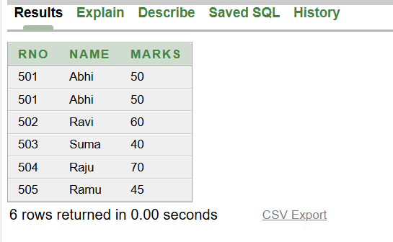

select * from tb2
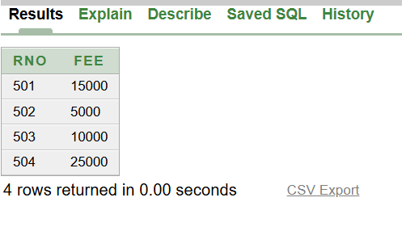

select * from tb1,tb2;
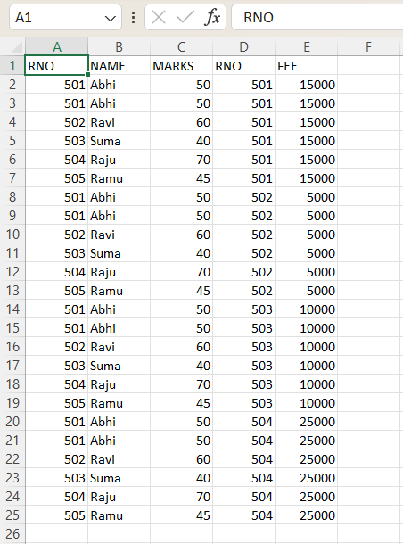

select * from tb1,tb2 where tb1.rno=tb2.rno;
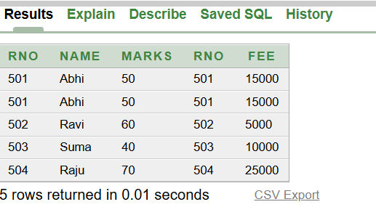

select * from tb1 inner join tb2 on tb1.rno=tb2.rno;
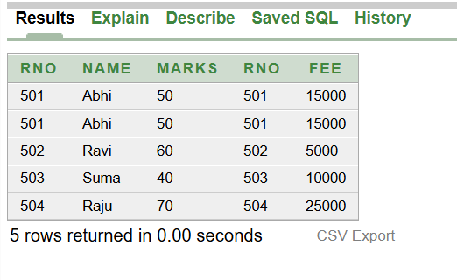
select * from tb1 natural join tb2;
