ASO Platform — Complete ML Observations & Experimental Results
Generated: 2026-08-06 15:21
This document contains every recorded observation, metric, and configuration from the ASO efficacy prediction ML pipeline.

1. Overview & Experimental Setup
Dataset: OligoFormer/data/Hu.csv (2,361 ASO-mRNA pairs)
Embedding cache: backend/data/hu_embeddings.pt (precomputed RNA-FM)
Seed: 42 | 5-fold cross-validation (KFold, shuffle=True)
Base hyperparameters (from HPO): lr=1e-3, dropout=0.2, weight_decay=1e-5, batch=32
Training: Adam optimizer, MSE loss, early stopping (patience=10), max 100 epochs

2. Model Architectures

FusionNet
Plain concatenation + MLP. All feature families are concatenated into a single 1300-dim vector (640-dim siRNA RNA-FM + 640-dim mRNA RNA-FM + 11 accessibility + 9 handcrafted features) and passed through a stack of linear layers: 1300 → 512 → 256 → 128 → 64 → 1. Each block is Linear + BatchNorm1d + GELU + Dropout.

GatedFusionNet
Replaces concatenation with learned per-family gating. Each family is projected to 128 dims, a sigmoid gate weight is learned per sample per family, gated features are concatenated (4×128) and fed through the same MLP (512→256→128→64→1). Family dims: [640 siRNA, 640 mRNA, 11 accessibility, 9 handcrafted].

3. Hyperparameter Search (HPO)
Grid search over 243 configurations (lr ∈ {1e-3, 5e-4, 1e-4}, dropout ∈ {0.2, 0.3, 0.4}, hidden ∈ {[256,128,64], [512,256,128,64], [768,512,256]}, weight_decay ∈ {0, 1e-5, 1e-4}, batch ∈ {16, 32, 64}), evaluated with 3-fold CV, 30 epochs/fold, patience 10.
Run | LR | Dropout | Hidden | WD | Batch | Pearson | SD | R² | SD | Time(s)
1 | 0.001 | 0.2 | [256, 128, 64] | 0 | 16 | 0.5307 | 0.0216 | 0.2563 | 0.0222 | 16.6
2 | 0.001 | 0.2 | [256, 128, 64] | 0 | 32 | 0.5600 | 0.0126 | 0.2775 | 0.0100 | 8.5
3 | 0.001 | 0.2 | [256, 128, 64] | 0 | 64 | 0.5080 | 0.0426 | 0.2039 | 0.0489 | 4.6
4 | 0.001 | 0.2 | [256, 128, 64] | 1e-05 | 16 | 0.5420 | 0.0318 | 0.2782 | 0.0331 | 16.2
5 | 0.001 | 0.2 | [256, 128, 64] | 1e-05 | 32 | 0.5486 | 0.0242 | 0.2810 | 0.0316 | 9.0
6 | 0.001 | 0.2 | [256, 128, 64] | 1e-05 | 64 | 0.5062 | 0.0241 | 0.2394 | 0.0342 | 4.8
7 | 0.001 | 0.2 | [256, 128, 64] | 0.0001 | 16 | 0.5359 | 0.0213 | 0.2765 | 0.0151 | 16.8
8 | 0.001 | 0.2 | [256, 128, 64] | 0.0001 | 32 | 0.5346 | 0.0268 | 0.2686 | 0.0383 | 9.0
9 | 0.001 | 0.2 | [256, 128, 64] | 0.0001 | 64 | 0.4631 | 0.0623 | 0.1974 | 0.0524 | 4.5
10 | 0.001 | 0.2 | [512, 256, 128, 64] | 0 | 16 | 0.5354 | 0.0142 | 0.2739 | 0.0143 | 25.4
11 | 0.001 | 0.2 | [512, 256, 128, 64] | 0 | 32 | 0.5390 | 0.0190 | 0.2786 | 0.0227 | 13.6
12 | 0.001 | 0.2 | [512, 256, 128, 64] | 0 | 64 | 0.4994 | 0.0075 | 0.2151 | 0.0204 | 8.0
13 | 0.001 | 0.2 | [512, 256, 128, 64] | 1e-05 | 16 | 0.5601 | 0.0253 | 0.2955 | 0.0331 | 31.7
14 | 0.001 | 0.2 | [512, 256, 128, 64] | 1e-05 | 32 | 0.4974 | 0.0745 | 0.2298 | 0.0629 | 15.7
15 | 0.001 | 0.2 | [512, 256, 128, 64] | 1e-05 | 64 | 0.5142 | 0.0254 | 0.2258 | 0.0398 | 9.5
16 | 0.001 | 0.2 | [512, 256, 128, 64] | 0.0001 | 16 | 0.5053 | 0.0220 | 0.2461 | 0.0148 | 32.7
17 | 0.001 | 0.2 | [512, 256, 128, 64] | 0.0001 | 32 | 0.5087 | 0.0454 | 0.2427 | 0.0482 | 17.0
18 | 0.001 | 0.2 | [512, 256, 128, 64] | 0.0001 | 64 | 0.4737 | 0.0415 | 0.2117 | 0.0469 | 8.5
19 | 0.001 | 0.2 | [768, 512, 256] | 0 | 16 | 0.5287 | 0.0191 | 0.2252 | 0.0289 | 33.7
20 | 0.001 | 0.2 | [768, 512, 256] | 0 | 32 | 0.5126 | 0.0394 | 0.2455 | 0.0414 | 16.2
21 | 0.001 | 0.2 | [768, 512, 256] | 0 | 64 | 0.4927 | 0.0480 | 0.2221 | 0.0445 | 9.5
22 | 0.001 | 0.2 | [768, 512, 256] | 1e-05 | 16 | 0.5413 | 0.0218 | 0.2454 | 0.0039 | 35.6
23 | 0.001 | 0.2 | [768, 512, 256] | 1e-05 | 32 | 0.5304 | 0.0365 | 0.2391 | 0.0389 | 22.2
24 | 0.001 | 0.2 | [768, 512, 256] | 1e-05 | 64 | 0.4604 | 0.0365 | 0.1816 | 0.0382 | 10.2
25 | 0.001 | 0.2 | [768, 512, 256] | 0.0001 | 16 | 0.4745 | 0.0253 | 0.1730 | 0.0049 | 45.9
26 | 0.001 | 0.2 | [768, 512, 256] | 0.0001 | 32 | 0.4889 | 0.0170 | 0.1854 | 0.0126 | 20.3
27 | 0.001 | 0.2 | [768, 512, 256] | 0.0001 | 64 | 0.5163 | 0.0139 | 0.2368 | 0.0224 | 14.0
28 | 0.001 | 0.3 | [256, 128, 64] | 0 | 16 | 0.5510 | 0.0145 | 0.2945 | 0.0156 | 17.1
29 | 0.001 | 0.3 | [256, 128, 64] | 0 | 32 | 0.5144 | 0.0019 | 0.2408 | 0.0049 | 9.1
30 | 0.001 | 0.3 | [256, 128, 64] | 0 | 64 | 0.4714 | 0.0071 | 0.1815 | 0.0155 | 5.4
31 | 0.001 | 0.3 | [256, 128, 64] | 1e-05 | 16 | 0.5538 | 0.0238 | 0.2881 | 0.0227 | 18.1
32 | 0.001 | 0.3 | [256, 128, 64] | 1e-05 | 32 | 0.5419 | 0.0076 | 0.2697 | 0.0140 | 9.4
33 | 0.001 | 0.3 | [256, 128, 64] | 1e-05 | 64 | 0.4652 | 0.0121 | 0.1789 | 0.0382 | 5.0
34 | 0.001 | 0.3 | [256, 128, 64] | 0.0001 | 16 | 0.5266 | 0.0112 | 0.2742 | 0.0143 | 17.8
35 | 0.001 | 0.3 | [256, 128, 64] | 0.0001 | 32 | 0.5192 | 0.0225 | 0.2452 | 0.0217 | 9.5
36 | 0.001 | 0.3 | [256, 128, 64] | 0.0001 | 64 | 0.4902 | 0.0196 | 0.2140 | 0.0285 | 5.0
37 | 0.001 | 0.3 | [512, 256, 128, 64] | 0 | 16 | 0.5543 | 0.0268 | 0.2989 | 0.0279 | 29.2
38 | 0.001 | 0.3 | [512, 256, 128, 64] | 0 | 32 | 0.5439 | 0.0183 | 0.2834 | 0.0165 | 15.5
39 | 0.001 | 0.3 | [512, 256, 128, 64] | 0 | 64 | 0.4284 | 0.1014 | 0.1564 | 0.0690 | 7.0
40 | 0.001 | 0.3 | [512, 256, 128, 64] | 1e-05 | 16 | 0.5344 | 0.0153 | 0.2779 | 0.0207 | 32.9
41 | 0.001 | 0.3 | [512, 256, 128, 64] | 1e-05 | 32 | 0.5393 | 0.0177 | 0.2801 | 0.0132 | 17.7
42 | 0.001 | 0.3 | [512, 256, 128, 64] | 1e-05 | 64 | 0.4993 | 0.0308 | 0.2207 | 0.0230 | 9.1
43 | 0.001 | 0.3 | [512, 256, 128, 64] | 0.0001 | 16 | 0.4910 | 0.0588 | 0.2390 | 0.0570 | 29.3
44 | 0.001 | 0.3 | [512, 256, 128, 64] | 0.0001 | 32 | 0.5208 | 0.0151 | 0.2551 | 0.0263 | 16.6
45 | 0.001 | 0.3 | [512, 256, 128, 64] | 0.0001 | 64 | 0.4851 | 0.0429 | 0.2188 | 0.0470 | 9.8
46 | 0.001 | 0.3 | [768, 512, 256] | 0 | 16 | 0.5246 | 0.0151 | 0.2475 | 0.0421 | 37.0
47 | 0.001 | 0.3 | [768, 512, 256] | 0 | 32 | 0.5103 | 0.0249 | 0.2395 | 0.0237 | 18.0
48 | 0.001 | 0.3 | [768, 512, 256] | 0 | 64 | 0.4818 | 0.0304 | 0.2155 | 0.0399 | 10.7
49 | 0.001 | 0.3 | [768, 512, 256] | 1e-05 | 16 | 0.5323 | 0.0130 | 0.2567 | 0.0204 | 45.4
50 | 0.001 | 0.3 | [768, 512, 256] | 1e-05 | 32 | 0.5192 | 0.0327 | 0.2295 | 0.0225 | 23.2
51 | 0.001 | 0.3 | [768, 512, 256] | 1e-05 | 64 | 0.5018 | 0.0209 | 0.2401 | 0.0168 | 12.7
52 | 0.001 | 0.3 | [768, 512, 256] | 0.0001 | 16 | 0.5154 | 0.0204 | 0.2391 | 0.0286 | 39.4
53 | 0.001 | 0.3 | [768, 512, 256] | 0.0001 | 32 | 0.5024 | 0.0402 | 0.2368 | 0.0327 | 20.3
54 | 0.001 | 0.3 | [768, 512, 256] | 0.0001 | 64 | 0.5051 | 0.0308 | 0.2276 | 0.0508 | 11.4
55 | 0.001 | 0.4 | [256, 128, 64] | 0 | 16 | 0.5507 | 0.0061 | 0.2968 | 0.0070 | 16.9
56 | 0.001 | 0.4 | [256, 128, 64] | 0 | 32 | 0.5005 | 0.0286 | 0.2369 | 0.0388 | 7.8
57 | 0.001 | 0.4 | [256, 128, 64] | 0 | 64 | 0.3974 | 0.0284 | 0.0822 | 0.0298 | 4.3
58 | 0.001 | 0.4 | [256, 128, 64] | 1e-05 | 16 | 0.5420 | 0.0164 | 0.2916 | 0.0174 | 16.5
59 | 0.001 | 0.4 | [256, 128, 64] | 1e-05 | 32 | 0.5270 | 0.0069 | 0.2666 | 0.0075 | 8.3
60 | 0.001 | 0.4 | [256, 128, 64] | 1e-05 | 64 | 0.4441 | 0.0393 | 0.1494 | 0.0516 | 4.6
61 | 0.001 | 0.4 | [256, 128, 64] | 0.0001 | 16 | 0.5317 | 0.0424 | 0.2791 | 0.0443 | 17.8
62 | 0.001 | 0.4 | [256, 128, 64] | 0.0001 | 32 | 0.5029 | 0.0052 | 0.2388 | 0.0035 | 9.7
63 | 0.001 | 0.4 | [256, 128, 64] | 0.0001 | 64 | 0.4191 | 0.0352 | 0.1058 | 0.0108 | 5.0
64 | 0.001 | 0.4 | [512, 256, 128, 64] | 0 | 16 | 0.5129 | 0.0070 | 0.2600 | 0.0084 | 29.0
65 | 0.001 | 0.4 | [512, 256, 128, 64] | 0 | 32 | 0.4910 | 0.0496 | 0.2198 | 0.0538 | 15.4
66 | 0.001 | 0.4 | [512, 256, 128, 64] | 0 | 64 | 0.3912 | 0.0438 | 0.1117 | 0.0390 | 8.4
67 | 0.001 | 0.4 | [512, 256, 128, 64] | 1e-05 | 16 | 0.5343 | 0.0072 | 0.2770 | 0.0125 | 30.7
68 | 0.001 | 0.4 | [512, 256, 128, 64] | 1e-05 | 32 | 0.4331 | 0.0196 | 0.1719 | 0.0252 | 16.1
69 | 0.001 | 0.4 | [512, 256, 128, 64] | 1e-05 | 64 | 0.4222 | 0.0172 | 0.1403 | 0.0212 | 9.1
70 | 0.001 | 0.4 | [512, 256, 128, 64] | 0.0001 | 16 | 0.5367 | 0.0130 | 0.2711 | 0.0232 | 32.1
71 | 0.001 | 0.4 | [512, 256, 128, 64] | 0.0001 | 32 | 0.5011 | 0.0306 | 0.2469 | 0.0313 | 16.7
72 | 0.001 | 0.4 | [512, 256, 128, 64] | 0.0001 | 64 | 0.3685 | 0.0725 | 0.0684 | 0.0661 | 8.9
73 | 0.001 | 0.4 | [768, 512, 256] | 0 | 16 | 0.5475 | 0.0105 | 0.2772 | 0.0023 | 36.3
74 | 0.001 | 0.4 | [768, 512, 256] | 0 | 32 | 0.5127 | 0.0096 | 0.2404 | 0.0133 | 19.6
75 | 0.001 | 0.4 | [768, 512, 256] | 0 | 64 | 0.4886 | 0.0292 | 0.2309 | 0.0250 | 11.0
76 | 0.001 | 0.4 | [768, 512, 256] | 1e-05 | 16 | 0.5417 | 0.0126 | 0.2666 | 0.0079 | 38.4
77 | 0.001 | 0.4 | [768, 512, 256] | 1e-05 | 32 | 0.5253 | 0.0372 | 0.2529 | 0.0384 | 22.3
78 | 0.001 | 0.4 | [768, 512, 256] | 1e-05 | 64 | 0.5038 | 0.0154 | 0.2264 | 0.0262 | 12.6
79 | 0.001 | 0.4 | [768, 512, 256] | 0.0001 | 16 | 0.5222 | 0.0016 | 0.2566 | 0.0043 | 38.8
80 | 0.001 | 0.4 | [768, 512, 256] | 0.0001 | 32 | 0.5188 | 0.0228 | 0.2489 | 0.0291 | 21.8
81 | 0.001 | 0.4 | [768, 512, 256] | 0.0001 | 64 | 0.5154 | 0.0151 | 0.2373 | 0.0193 | 13.3
82 | 0.0005 | 0.2 | [256, 128, 64] | 0 | 16 | 0.5447 | 0.0158 | 0.2752 | 0.0284 | 16.1
83 | 0.0005 | 0.2 | [256, 128, 64] | 0 | 32 | 0.5116 | 0.0115 | 0.2473 | 0.0198 | 8.0
84 | 0.0005 | 0.2 | [256, 128, 64] | 0 | 64 | 0.4343 | 0.0051 | 0.1588 | 0.0143 | 4.1
85 | 0.0005 | 0.2 | [256, 128, 64] | 1e-05 | 16 | 0.5310 | 0.0145 | 0.2722 | 0.0146 | 16.4
86 | 0.0005 | 0.2 | [256, 128, 64] | 1e-05 | 32 | 0.4975 | 0.0203 | 0.2087 | 0.0377 | 9.4
87 | 0.0005 | 0.2 | [256, 128, 64] | 1e-05 | 64 | 0.4851 | 0.0070 | 0.1999 | 0.0128 | 4.9
88 | 0.0005 | 0.2 | [256, 128, 64] | 0.0001 | 16 | 0.5112 | 0.0135 | 0.2561 | 0.0106 | 16.9
89 | 0.0005 | 0.2 | [256, 128, 64] | 0.0001 | 32 | 0.4966 | 0.0411 | 0.2178 | 0.0513 | 8.9
90 | 0.0005 | 0.2 | [256, 128, 64] | 0.0001 | 64 | 0.4694 | 0.0267 | 0.1585 | 0.0334 | 4.9
91 | 0.0005 | 0.2 | [512, 256, 128, 64] | 0 | 16 | 0.5284 | 0.0277 | 0.2708 | 0.0298 | 27.8
92 | 0.0005 | 0.2 | [512, 256, 128, 64] | 0 | 32 | 0.4943 | 0.0048 | 0.2224 | 0.0052 | 15.2
93 | 0.0005 | 0.2 | [512, 256, 128, 64] | 0 | 64 | 0.4731 | 0.0328 | 0.2088 | 0.0343 | 7.9
94 | 0.0005 | 0.2 | [512, 256, 128, 64] | 1e-05 | 16 | 0.5041 | 0.0231 | 0.2401 | 0.0256 | 31.6
95 | 0.0005 | 0.2 | [512, 256, 128, 64] | 1e-05 | 32 | 0.4977 | 0.0426 | 0.2361 | 0.0531 | 15.7
96 | 0.0005 | 0.2 | [512, 256, 128, 64] | 1e-05 | 64 | 0.4710 | 0.0387 | 0.2078 | 0.0439 | 8.7
97 | 0.0005 | 0.2 | [512, 256, 128, 64] | 0.0001 | 16 | 0.5345 | 0.0178 | 0.2454 | 0.0226 | 29.4
98 | 0.0005 | 0.2 | [512, 256, 128, 64] | 0.0001 | 32 | 0.4873 | 0.0367 | 0.2295 | 0.0419 | 15.5
99 | 0.0005 | 0.2 | [512, 256, 128, 64] | 0.0001 | 64 | 0.4527 | 0.0260 | 0.1779 | 0.0298 | 8.8
100 | 0.0005 | 0.2 | [768, 512, 256] | 0 | 16 | 0.5076 | 0.0373 | 0.2295 | 0.0322 | 34.1
101 | 0.0005 | 0.2 | [768, 512, 256] | 0 | 32 | 0.5128 | 0.0348 | 0.2406 | 0.0339 | 18.7
102 | 0.0005 | 0.2 | [768, 512, 256] | 0 | 64 | 0.5085 | 0.0258 | 0.2211 | 0.0304 | 11.6
103 | 0.0005 | 0.2 | [768, 512, 256] | 1e-05 | 16 | 0.5006 | 0.0247 | 0.2408 | 0.0260 | 36.1
104 | 0.0005 | 0.2 | [768, 512, 256] | 1e-05 | 32 | 0.5323 | 0.0404 | 0.2644 | 0.0408 | 22.0
105 | 0.0005 | 0.2 | [768, 512, 256] | 1e-05 | 64 | 0.4925 | 0.0260 | 0.2261 | 0.0184 | 12.4
106 | 0.0005 | 0.2 | [768, 512, 256] | 0.0001 | 16 | 0.4902 | 0.0417 | 0.2326 | 0.0333 | 38.7
107 | 0.0005 | 0.2 | [768, 512, 256] | 0.0001 | 32 | 0.5150 | 0.0234 | 0.2386 | 0.0362 | 24.0
108 | 0.0005 | 0.2 | [768, 512, 256] | 0.0001 | 64 | 0.4892 | 0.0180 | 0.2132 | 0.0249 | 13.6
109 | 0.0005 | 0.3 | [256, 128, 64] | 0 | 16 | 0.5186 | 0.0176 | 0.2589 | 0.0227 | 18.9
110 | 0.0005 | 0.3 | [256, 128, 64] | 0 | 32 | 0.4777 | 0.0228 | 0.2091 | 0.0223 | 10.0
111 | 0.0005 | 0.3 | [256, 128, 64] | 0 | 64 | 0.4264 | 0.0359 | 0.0970 | 0.0589 | 5.6
112 | 0.0005 | 0.3 | [256, 128, 64] | 1e-05 | 16 | 0.5333 | 0.0057 | 0.2724 | 0.0107 | 21.5
113 | 0.0005 | 0.3 | [256, 128, 64] | 1e-05 | 32 | 0.4391 | 0.0600 | 0.1527 | 0.0519 | 10.9
114 | 0.0005 | 0.3 | [256, 128, 64] | 1e-05 | 64 | 0.3502 | 0.0556 | 0.0370 | 0.0584 | 5.9
115 | 0.0005 | 0.3 | [256, 128, 64] | 0.0001 | 16 | 0.5209 | 0.0235 | 0.2551 | 0.0249 | 21.5
116 | 0.0005 | 0.3 | [256, 128, 64] | 0.0001 | 32 | 0.4425 | 0.0282 | 0.1517 | 0.0276 | 10.7
117 | 0.0005 | 0.3 | [256, 128, 64] | 0.0001 | 64 | 0.4547 | 0.0154 | 0.1272 | 0.0518 | 5.4
118 | 0.0005 | 0.3 | [512, 256, 128, 64] | 0 | 16 | 0.3944 | 0.1287 | 0.1557 | 0.0989 | 24.9
119 | 0.0005 | 0.3 | [512, 256, 128, 64] | 0 | 32 | 0.4215 | 0.0467 | 0.1512 | 0.0406 | 16.9
120 | 0.0005 | 0.3 | [512, 256, 128, 64] | 0 | 64 | 0.3295 | 0.0286 | 0.0379 | 0.0385 | 8.2
121 | 0.0005 | 0.3 | [512, 256, 128, 64] | 1e-05 | 16 | 0.5281 | 0.0159 | 0.2541 | 0.0224 | 35.4
122 | 0.0005 | 0.3 | [512, 256, 128, 64] | 1e-05 | 32 | 0.4606 | 0.0425 | 0.1809 | 0.0689 | 18.4
123 | 0.0005 | 0.3 | [512, 256, 128, 64] | 1e-05 | 64 | 0.3308 | 0.0499 | 0.0435 | 0.0455 | 9.1
124 | 0.0005 | 0.3 | [512, 256, 128, 64] | 0.0001 | 16 | 0.5289 | 0.0092 | 0.2611 | 0.0134 | 33.2
125 | 0.0005 | 0.3 | [512, 256, 128, 64] | 0.0001 | 32 | 0.4495 | 0.0713 | 0.1856 | 0.0696 | 17.4
126 | 0.0005 | 0.3 | [512, 256, 128, 64] | 0.0001 | 64 | 0.3573 | 0.0628 | 0.0837 | 0.0595 | 9.9
127 | 0.0005 | 0.3 | [768, 512, 256] | 0 | 16 | 0.5303 | 0.0149 | 0.2514 | 0.0282 | 42.5
128 | 0.0005 | 0.3 | [768, 512, 256] | 0 | 32 | 0.4931 | 0.0290 | 0.2184 | 0.0218 | 20.1
129 | 0.0005 | 0.3 | [768, 512, 256] | 0 | 64 | 0.4576 | 0.0668 | 0.1818 | 0.0537 | 12.1
130 | 0.0005 | 0.3 | [768, 512, 256] | 1e-05 | 16 | 0.5062 | 0.0381 | 0.2362 | 0.0249 | 45.4
131 | 0.0005 | 0.3 | [768, 512, 256] | 1e-05 | 32 | 0.5206 | 0.0192 | 0.2612 | 0.0144 | 24.1
132 | 0.0005 | 0.3 | [768, 512, 256] | 1e-05 | 64 | 0.5005 | 0.0296 | 0.2052 | 0.0584 | 13.2
133 | 0.0005 | 0.3 | [768, 512, 256] | 0.0001 | 16 | 0.4959 | 0.0407 | 0.2224 | 0.0318 | 44.2
134 | 0.0005 | 0.3 | [768, 512, 256] | 0.0001 | 32 | 0.5055 | 0.0322 | 0.2397 | 0.0315 | 23.7
135 | 0.0005 | 0.3 | [768, 512, 256] | 0.0001 | 64 | 0.4957 | 0.0432 | 0.2184 | 0.0299 | 15.7
136 | 0.0005 | 0.4 | [256, 128, 64] | 0 | 16 | 0.4942 | 0.0288 | 0.2119 | 0.0505 | 18.6
137 | 0.0005 | 0.4 | [256, 128, 64] | 0 | 32 | 0.3540 | 0.0180 | 0.0027 | 0.0594 | 10.0
138 | 0.0005 | 0.4 | [256, 128, 64] | 0 | 64 | 0.3195 | 0.0135 | -0.0425 | 0.0787 | 5.4
139 | 0.0005 | 0.4 | [256, 128, 64] | 1e-05 | 16 | 0.5018 | 0.0315 | 0.2074 | 0.0631 | 21.6
140 | 0.0005 | 0.4 | [256, 128, 64] | 1e-05 | 32 | 0.4081 | 0.0421 | 0.0726 | 0.0735 | 10.9
141 | 0.0005 | 0.4 | [256, 128, 64] | 1e-05 | 64 | 0.3098 | 0.0092 | -0.1394 | 0.0737 | 7.3
142 | 0.0005 | 0.4 | [256, 128, 64] | 0.0001 | 16 | 0.5090 | 0.0184 | 0.2358 | 0.0122 | 21.9
143 | 0.0005 | 0.4 | [256, 128, 64] | 0.0001 | 32 | 0.4099 | 0.0380 | 0.1014 | 0.0504 | 11.5
144 | 0.0005 | 0.4 | [256, 128, 64] | 0.0001 | 64 | 0.3123 | 0.0376 | -0.1756 | 0.1082 | 6.0
145 | 0.0005 | 0.4 | [512, 256, 128, 64] | 0 | 16 | 0.4278 | 0.0804 | 0.1588 | 0.0767 | 29.6
146 | 0.0005 | 0.4 | [512, 256, 128, 64] | 0 | 32 | 0.3533 | 0.0582 | 0.0959 | 0.0480 | 15.8
147 | 0.0005 | 0.4 | [512, 256, 128, 64] | 0 | 64 | 0.2787 | 0.0156 | -0.1141 | 0.0322 | 9.3
148 | 0.0005 | 0.4 | [512, 256, 128, 64] | 1e-05 | 16 | 0.4651 | 0.0490 | 0.1913 | 0.0385 | 35.0
149 | 0.0005 | 0.4 | [512, 256, 128, 64] | 1e-05 | 32 | 0.3134 | 0.0503 | 0.0004 | 0.0286 | 20.3
150 | 0.0005 | 0.4 | [512, 256, 128, 64] | 1e-05 | 64 | 0.2806 | 0.0513 | -0.0691 | 0.0202 | 11.8
151 | 0.0005 | 0.4 | [512, 256, 128, 64] | 0.0001 | 16 | 0.4537 | 0.0418 | 0.2029 | 0.0374 | 37.8
152 | 0.0005 | 0.4 | [512, 256, 128, 64] | 0.0001 | 32 | 0.3059 | 0.0163 | 0.0197 | 0.0361 | 17.7
153 | 0.0005 | 0.4 | [512, 256, 128, 64] | 0.0001 | 64 | 0.2866 | 0.0440 | -0.1045 | 0.1049 | 10.4
154 | 0.0005 | 0.4 | [768, 512, 256] | 0 | 16 | 0.5420 | 0.0150 | 0.2580 | 0.0419 | 44.9
155 | 0.0005 | 0.4 | [768, 512, 256] | 0 | 32 | 0.4048 | 0.1067 | 0.1448 | 0.0814 | 20.6
156 | 0.0005 | 0.4 | [768, 512, 256] | 0 | 64 | 0.3917 | 0.1086 | 0.0960 | 0.0627 | 11.8
157 | 0.0005 | 0.4 | [768, 512, 256] | 1e-05 | 16 | 0.5209 | 0.0116 | 0.2353 | 0.0216 | 50.2
158 | 0.0005 | 0.4 | [768, 512, 256] | 1e-05 | 32 | 0.5076 | 0.0316 | 0.2285 | 0.0342 | 28.0
159 | 0.0005 | 0.4 | [768, 512, 256] | 1e-05 | 64 | 0.4318 | 0.0097 | 0.1321 | 0.0266 | 15.1
160 | 0.0005 | 0.4 | [768, 512, 256] | 0.0001 | 16 | 0.5175 | 0.0226 | 0.2348 | 0.0128 | 50.3
161 | 0.0005 | 0.4 | [768, 512, 256] | 0.0001 | 32 | 0.4326 | 0.0607 | 0.1726 | 0.0596 | 23.1
162 | 0.0005 | 0.4 | [768, 512, 256] | 0.0001 | 64 | 0.3857 | 0.0614 | 0.1170 | 0.0517 | 11.6
163 | 0.0001 | 0.2 | [256, 128, 64] | 0 | 16 | 0.3925 | 0.0313 | 0.0902 | 0.0441 | 21.9
164 | 0.0001 | 0.2 | [256, 128, 64] | 0 | 32 | 0.3308 | 0.0614 | 0.0056 | 0.1051 | 11.4
165 | 0.0001 | 0.2 | [256, 128, 64] | 0 | 64 | 0.3427 | 0.0159 | -0.0899 | 0.0371 | 6.0
166 | 0.0001 | 0.2 | [256, 128, 64] | 1e-05 | 16 | 0.3759 | 0.0508 | 0.0412 | 0.0252 | 23.4
167 | 0.0001 | 0.2 | [256, 128, 64] | 1e-05 | 32 | 0.3779 | 0.0350 | 0.0676 | 0.0456 | 12.2
168 | 0.0001 | 0.2 | [256, 128, 64] | 1e-05 | 64 | 0.3474 | 0.0232 | -0.0402 | 0.0508 | 6.5
169 | 0.0001 | 0.2 | [256, 128, 64] | 0.0001 | 16 | 0.4005 | 0.0328 | 0.0711 | 0.0224 | 23.1
170 | 0.0001 | 0.2 | [256, 128, 64] | 0.0001 | 32 | 0.3659 | 0.0280 | 0.0330 | 0.0164 | 12.7
171 | 0.0001 | 0.2 | [256, 128, 64] | 0.0001 | 64 | 0.3410 | 0.0377 | -0.0605 | 0.0521 | 6.4
172 | 0.0001 | 0.2 | [512, 256, 128, 64] | 0 | 16 | 0.3666 | 0.0537 | 0.0806 | 0.0599 | 36.8
173 | 0.0001 | 0.2 | [512, 256, 128, 64] | 0 | 32 | 0.3332 | 0.0204 | 0.0033 | 0.0324 | 18.0
174 | 0.0001 | 0.2 | [512, 256, 128, 64] | 0 | 64 | 0.3190 | 0.0342 | -0.0692 | 0.0470 | 10.4
175 | 0.0001 | 0.2 | [512, 256, 128, 64] | 1e-05 | 16 | 0.3411 | 0.0479 | 0.0803 | 0.0413 | 39.1
176 | 0.0001 | 0.2 | [512, 256, 128, 64] | 1e-05 | 32 | 0.3422 | 0.0494 | 0.0268 | 0.0284 | 20.8
177 | 0.0001 | 0.2 | [512, 256, 128, 64] | 1e-05 | 64 | 0.3369 | 0.0259 | -0.0509 | 0.0550 | 11.3
178 | 0.0001 | 0.2 | [512, 256, 128, 64] | 0.0001 | 16 | 0.3428 | 0.0221 | 0.0614 | 0.0295 | 40.4
179 | 0.0001 | 0.2 | [512, 256, 128, 64] | 0.0001 | 32 | 0.3305 | 0.0390 | 0.0421 | 0.0099 | 21.4
180 | 0.0001 | 0.2 | [512, 256, 128, 64] | 0.0001 | 64 | 0.3351 | 0.0367 | -0.1564 | 0.1035 | 12.4
181 | 0.0001 | 0.2 | [768, 512, 256] | 0 | 16 | 0.4499 | 0.0433 | 0.1737 | 0.0399 | 45.3
182 | 0.0001 | 0.2 | [768, 512, 256] | 0 | 32 | 0.4262 | 0.0610 | 0.1714 | 0.0539 | 27.0
183 | 0.0001 | 0.2 | [768, 512, 256] | 0 | 64 | 0.4227 | 0.0331 | 0.1539 | 0.0271 | 14.9
184 | 0.0001 | 0.2 | [768, 512, 256] | 1e-05 | 16 | 0.4758 | 0.0251 | 0.2045 | 0.0258 | 52.8
185 | 0.0001 | 0.2 | [768, 512, 256] | 1e-05 | 32 | 0.4168 | 0.0256 | 0.1466 | 0.0319 | 25.9
186 | 0.0001 | 0.2 | [768, 512, 256] | 1e-05 | 64 | 0.4062 | 0.0477 | 0.1217 | 0.0208 | 16.2
187 | 0.0001 | 0.2 | [768, 512, 256] | 0.0001 | 16 | 0.4315 | 0.0036 | 0.1750 | 0.0059 | 55.3
188 | 0.0001 | 0.2 | [768, 512, 256] | 0.0001 | 32 | 0.4224 | 0.0149 | 0.1596 | 0.0254 | 28.4
189 | 0.0001 | 0.2 | [768, 512, 256] | 0.0001 | 64 | 0.4160 | 0.0467 | 0.1339 | 0.0329 | 16.2
190 | 0.0001 | 0.3 | [256, 128, 64] | 0 | 16 | 0.3331 | 0.0426 | -0.0266 | 0.0260 | 26.0
191 | 0.0001 | 0.3 | [256, 128, 64] | 0 | 32 | 0.3058 | 0.0238 | -0.1053 | 0.0971 | 14.1
192 | 0.0001 | 0.3 | [256, 128, 64] | 0 | 64 | 0.2905 | 0.0216 | -0.4091 | 0.0913 | 8.2
193 | 0.0001 | 0.3 | [256, 128, 64] | 1e-05 | 16 | 0.3233 | 0.0506 | -0.1146 | 0.0221 | 33.1
194 | 0.0001 | 0.3 | [256, 128, 64] | 1e-05 | 32 | 0.2978 | 0.0338 | -0.0549 | 0.0660 | 15.7
195 | 0.0001 | 0.3 | [256, 128, 64] | 1e-05 | 64 | 0.3114 | 0.0427 | -0.1910 | 0.0406 | 9.3
196 | 0.0001 | 0.3 | [256, 128, 64] | 0.0001 | 16 | 0.3280 | 0.0427 | -0.1439 | 0.0171 | 31.3
197 | 0.0001 | 0.3 | [256, 128, 64] | 0.0001 | 32 | 0.3044 | 0.0385 | -0.0369 | 0.0471 | 17.1
198 | 0.0001 | 0.3 | [256, 128, 64] | 0.0001 | 64 | 0.2750 | 0.0369 | -0.5033 | 0.3426 | 9.3
199 | 0.0001 | 0.3 | [512, 256, 128, 64] | 0 | 16 | 0.2699 | 0.0098 | -0.0868 | 0.0151 | 44.0
200 | 0.0001 | 0.3 | [512, 256, 128, 64] | 0 | 32 | 0.2801 | 0.0231 | -0.1363 | 0.0665 | 23.9
201 | 0.0001 | 0.3 | [512, 256, 128, 64] | 0 | 64 | 0.2401 | 0.0302 | -0.4201 | 0.2750 | 14.1
202 | 0.0001 | 0.3 | [512, 256, 128, 64] | 1e-05 | 16 | 0.3044 | 0.0371 | -0.0766 | 0.0867 | 50.0
203 | 0.0001 | 0.3 | [512, 256, 128, 64] | 1e-05 | 32 | 0.2636 | 0.0437 | -0.1502 | 0.1409 | 23.8
204 | 0.0001 | 0.3 | [512, 256, 128, 64] | 1e-05 | 64 | 0.2453 | 0.0250 | -0.4176 | 0.0365 | 9.9
205 | 0.0001 | 0.3 | [512, 256, 128, 64] | 0.0001 | 16 | 0.2916 | 0.0246 | -0.0546 | 0.0229 | 37.9
206 | 0.0001 | 0.3 | [512, 256, 128, 64] | 0.0001 | 32 | 0.2540 | 0.0205 | -0.1722 | 0.0786 | 20.3
207 | 0.0001 | 0.3 | [512, 256, 128, 64] | 0.0001 | 64 | 0.2258 | 0.0113 | -0.5401 | 0.2684 | 11.3
208 | 0.0001 | 0.3 | [768, 512, 256] | 0 | 16 | 0.4002 | 0.0285 | 0.1205 | 0.0342 | 41.6
209 | 0.0001 | 0.3 | [768, 512, 256] | 0 | 32 | 0.3792 | 0.0329 | 0.1336 | 0.0145 | 22.8
210 | 0.0001 | 0.3 | [768, 512, 256] | 0 | 64 | 0.3678 | 0.0467 | 0.0672 | 0.0603 | 13.4
211 | 0.0001 | 0.3 | [768, 512, 256] | 1e-05 | 16 | 0.3962 | 0.0269 | 0.1029 | 0.0427 | 49.9
212 | 0.0001 | 0.3 | [768, 512, 256] | 1e-05 | 32 | 0.3505 | 0.0604 | 0.0810 | 0.0418 | 24.6
213 | 0.0001 | 0.3 | [768, 512, 256] | 1e-05 | 64 | 0.3507 | 0.0527 | 0.0749 | 0.0383 | 14.6
214 | 0.0001 | 0.3 | [768, 512, 256] | 0.0001 | 16 | 0.4157 | 0.0428 | 0.1197 | 0.0471 | 48.4
215 | 0.0001 | 0.3 | [768, 512, 256] | 0.0001 | 32 | 0.3600 | 0.0315 | 0.0801 | 0.0177 | 24.5
216 | 0.0001 | 0.3 | [768, 512, 256] | 0.0001 | 64 | 0.3375 | 0.0236 | 0.0096 | 0.0717 | 14.1
217 | 0.0001 | 0.4 | [256, 128, 64] | 0 | 16 | 0.2771 | 0.0437 | -0.3122 | 0.0320 | 20.6
218 | 0.0001 | 0.4 | [256, 128, 64] | 0 | 32 | 0.2604 | 0.0256 | -0.5876 | 0.2998 | 11.8
219 | 0.0001 | 0.4 | [256, 128, 64] | 0 | 64 | 0.2531 | 0.0262 | -0.9622 | 0.3886 | 5.7
220 | 0.0001 | 0.4 | [256, 128, 64] | 1e-05 | 16 | 0.2902 | 0.0434 | -0.3553 | 0.1193 | 22.1
221 | 0.0001 | 0.4 | [256, 128, 64] | 1e-05 | 32 | 0.2172 | 0.0092 | -0.5975 | 0.1954 | 12.6
222 | 0.0001 | 0.4 | [256, 128, 64] | 1e-05 | 64 | 0.2622 | 0.0288 | -1.1340 | 0.1795 | 6.4
223 | 0.0001 | 0.4 | [256, 128, 64] | 0.0001 | 16 | 0.2984 | 0.0430 | -0.1442 | 0.0340 | 21.5
224 | 0.0001 | 0.4 | [256, 128, 64] | 0.0001 | 32 | 0.2608 | 0.0163 | -0.7655 | 0.1817 | 11.8
225 | 0.0001 | 0.4 | [256, 128, 64] | 0.0001 | 64 | 0.2392 | 0.0262 | -0.8989 | 0.2171 | 6.4
226 | 0.0001 | 0.4 | [512, 256, 128, 64] | 0 | 16 | 0.2741 | 0.0376 | -0.2253 | 0.0456 | 35.8
227 | 0.0001 | 0.4 | [512, 256, 128, 64] | 0 | 32 | 0.2140 | 0.0318 | -0.5600 | 0.3127 | 17.8
228 | 0.0001 | 0.4 | [512, 256, 128, 64] | 0 | 64 | 0.2293 | 0.0354 | -0.9526 | 0.1091 | 9.5
229 | 0.0001 | 0.4 | [512, 256, 128, 64] | 1e-05 | 16 | 0.2415 | 0.0140 | -0.2131 | 0.0596 | 39.0
230 | 0.0001 | 0.4 | [512, 256, 128, 64] | 1e-05 | 32 | 0.2233 | 0.0522 | -0.3633 | 0.0577 | 19.3
231 | 0.0001 | 0.4 | [512, 256, 128, 64] | 1e-05 | 64 | 0.1477 | 0.0421 | -1.4299 | 0.2662 | 11.4
232 | 0.0001 | 0.4 | [512, 256, 128, 64] | 0.0001 | 16 | 0.2517 | 0.0255 | -0.2563 | 0.1073 | 39.8
233 | 0.0001 | 0.4 | [512, 256, 128, 64] | 0.0001 | 32 | 0.2479 | 0.0234 | -0.4627 | 0.0763 | 19.3
234 | 0.0001 | 0.4 | [512, 256, 128, 64] | 0.0001 | 64 | 0.2088 | 0.0291 | -0.8051 | 0.2599 | 11.6
235 | 0.0001 | 0.4 | [768, 512, 256] | 0 | 16 | 0.3229 | 0.0467 | -0.1207 | 0.0195 | 46.7
236 | 0.0001 | 0.4 | [768, 512, 256] | 0 | 32 | 0.2645 | 0.0696 | -0.1495 | 0.1469 | 21.6
237 | 0.0001 | 0.4 | [768, 512, 256] | 0 | 64 | 0.2600 | 0.0434 | -0.2098 | 0.0186 | 12.5
238 | 0.0001 | 0.4 | [768, 512, 256] | 1e-05 | 16 | 0.3095 | 0.0170 | -0.0183 | 0.0186 | 46.9
239 | 0.0001 | 0.4 | [768, 512, 256] | 1e-05 | 32 | 0.3089 | 0.0323 | -0.1202 | 0.0608 | 25.4
240 | 0.0001 | 0.4 | [768, 512, 256] | 1e-05 | 64 | 0.2943 | 0.0353 | -0.1957 | 0.0890 | 14.6
241 | 0.0001 | 0.4 | [768, 512, 256] | 0.0001 | 16 | 0.3320 | 0.0247 | -0.0610 | 0.0376 | 50.6
242 | 0.0001 | 0.4 | [768, 512, 256] | 0.0001 | 32 | 0.3004 | 0.0322 | -0.0321 | 0.0557 | 26.0
243 | 0.0001 | 0.4 | [768, 512, 256] | 0.0001 | 64 | 0.2804 | 0.0302 | -0.1874 | 0.0405 | 13.4
Best HPO config (run 13): lr=0.001, dropout=0.2, hidden=[512, 256, 128, 64], weight_decay=1e-05, batch=16 → Pearson = 0.5601 ± 0.0253, R² = 0.2955 ± 0.0331.
Observation: the best config found was lr=0.001, dropout=0.2, hidden=[512, 256, 128, 64], weight_decay=1e-05, batch=16. batch=64 consistently underperformed across all configurations; larger hidden widths were not better.

4. Final FusionNet Cross-Validation (backend/results)
Model: FusionNet | Dataset: Huesken (2361 samples) | 5 folds
Pearson = 0.5494 ± 0.0148 | R² = 0.2879 ± 0.0233 | MSE = 0.016 | MAE = 0.099 | epochs = 44
Best fold: 3 (Pearson 0.5782) | OOF: Pearson 0.5433, R² 0.2894, MSE 0.016, MAE 0.099
Fold | Pearson | R2 | MSE | MAE | Epochs
1 | 0.5436 | 0.292 | 0.0162 | 0.0973 | 34
2 | 0.5395 | 0.2628 | 0.0161 | 0.1019 | 32
3 | 0.5747 | 0.3168 | 0.015 | 0.0959 | 44
4 | 0.5329 | 0.2593 | 0.0166 | 0.1004 | 23
5 | 0.5565 | 0.3084 | 0.0159 | 0.0998 | 34
Mean | 0.5494 | 0.2879 | 0.016 | 0.099
SD | 0.0148 | 0.0233 | 0.0005 | 0.0022

Training log (final model)
Epoch | TrainLoss | ValLoss | TrainPearson | ValPearson
1 | 0.1313 | 0.0361 | 0.0164 | 0.0445
2 | 0.0527 | 0.0427 | 0.1168 | 0.1672
3 | 0.0419 | 0.0233 | 0.1202 | 0.2142
4 | 0.0354 | 0.0235 | 0.1647 | 0.2452
5 | 0.0311 | 0.0218 | 0.1672 | 0.2614
6 | 0.0280 | 0.0221 | 0.2306 | 0.2566
7 | 0.0272 | 0.0199 | 0.2382 | 0.3152
8 | 0.0251 | 0.0204 | 0.2689 | 0.3115
9 | 0.0234 | 0.0208 | 0.3121 | 0.2585
10 | 0.0218 | 0.0201 | 0.3778 | 0.3093
11 | 0.0201 | 0.0196 | 0.4311 | 0.4282
12 | 0.0190 | 0.0198 | 0.4833 | 0.3740
13 | 0.0170 | 0.0211 | 0.5442 | 0.3684
14 | 0.0158 | 0.0196 | 0.5821 | 0.4400
15 | 0.0149 | 0.0182 | 0.6131 | 0.4370
16 | 0.0132 | 0.0174 | 0.6636 | 0.4821
17 | 0.0124 | 0.0223 | 0.6842 | 0.4578
18 | 0.0116 | 0.0189 | 0.7096 | 0.4926
19 | 0.0110 | 0.0203 | 0.7246 | 0.5019
20 | 0.0110 | 0.0208 | 0.7239 | 0.4558
21 | 0.0106 | 0.0171 | 0.7382 | 0.4962
22 | 0.0099 | 0.0227 | 0.7563 | 0.4636
23 | 0.0096 | 0.0171 | 0.7641 | 0.5103
24 | 0.0086 | 0.0186 | 0.7901 | 0.5063
25 | 0.0084 | 0.0179 | 0.7976 | 0.4949
26 | 0.0083 | 0.0221 | 0.7976 | 0.4988
27 | 0.0083 | 0.0159 | 0.7993 | 0.5438
28 | 0.0080 | 0.0329 | 0.8054 | 0.4753
29 | 0.0070 | 0.0269 | 0.8323 | 0.5371
30 | 0.0075 | 0.0163 | 0.8182 | 0.5439
31 | 0.0065 | 0.0329 | 0.8450 | 0.4762
32 | 0.0067 | 0.0156 | 0.8401 | 0.5782
33 | 0.0064 | 0.0200 | 0.8465 | 0.5190
34 | 0.0068 | 0.0151 | 0.8369 | 0.5747
35 | 0.0059 | 0.0198 | 0.8592 | 0.5674
36 | 0.0058 | 0.0495 | 0.8628 | 0.4622
37 | 0.0060 | 0.0179 | 0.8589 | 0.5466
38 | 0.0057 | 0.0379 | 0.8653 | 0.5052
39 | 0.0056 | 0.0167 | 0.8677 | 0.5429
40 | 0.0051 | 0.0185 | 0.8798 | 0.5581
41 | 0.0054 | 0.0174 | 0.8731 | 0.5653
42 | 0.0055 | 0.0593 | 0.8701 | 0.3787
43 | 0.0056 | 0.0172 | 0.8669 | 0.5469
44 | 0.0049 | 0.0215 | 0.8851 | 0.5332
Learning curve:
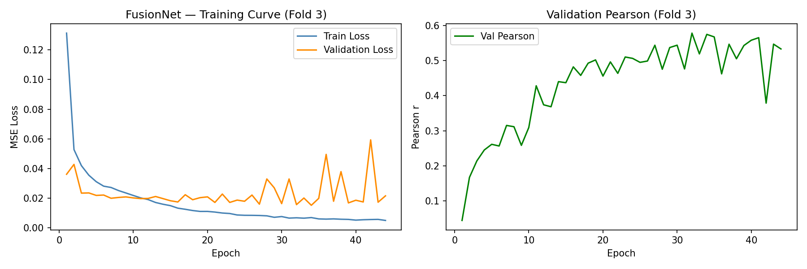
Predicted vs true (OOF) scatter:
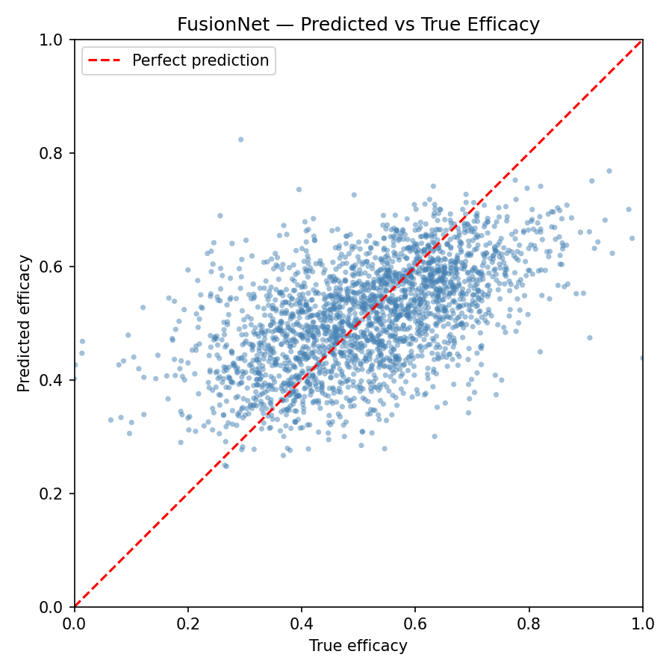

Binary classification evaluation (OOF, threshold 0.5)
FusionNet — Binary Classification Confusion (out-of-fold predictions)
Binary threshold on predicted efficacy: 0.5
Test samples: 2361
Accuracy: 0.7052
Confusion matrix (rows=true, cols=pred):
Pred Low(0) Pred High(1)
True Low(0) 766 421
True High(1) 275 899
Classification report:
precision recall f1-score support
Low efficacy (0) 0.74 0.65 0.69 1187
High efficacy (1) 0.68 0.77 0.72 1174
accuracy 0.71 2361
macro avg 0.71 0.71 0.70 2361
weighted avg 0.71 0.71 0.70 2361
Per-sample OOF predictions (Sample, True, Predicted) are stored in backend/results/Huesken/predictions.csv (2,361 rows).

5. CV Analysis & Training Improvements
# CV Analysis & Training Improvements
## Root Cause
The original CV used 10 hardcoded epochs (`range(10)` in `cv_fusion.py`), which was too short.
With proper training (100 epochs + early stopping), all 5 folds now reach Pearson 0.51–0.59.
## 5-Fold CV Results (after fix)
| Fold | Pearson | R² | MSE |
|------|---------|------|-------|
| 1 | 0.5887 | 0.33 | 0.0154|
| 2 | 0.5086 | 0.24 | 0.0167|
| 3 | 0.5483 | 0.28 | 0.0159|
| 4 | 0.5507 | 0.27 | 0.0164|
| 5 | 0.5592 | 0.29 | 0.0163|
| Mean | 0.5511 | 0.28 | - |
| SD | 0.0257 | 0.03 | - |
## Bug Check
- Model reinitialized each fold: OK
- Optimizer reinitialized each fold: OK
- Embedding/label alignment: OK
- No StandardScaler (no normalization leak): OK
- Early stopping saves best model: OK
- No CV implementation bugs found
## Changes Made
| File | Change |
|------|--------|
| backend/config/config.yaml | epochs: 50→100, added patience: 10 |
| backend/train.py | Early stopping + best checkpoint + Pearson in output |
| backend/experiments/cv_fusion.py | Per-epoch val loss, early stopping, best checkpoint, Pearson |
Raw CV results:
Fold Pearson R²
1 0.5887 0.3303
2 0.5086 0.2352
3 0.5483 0.2758
4 0.5507 0.2698
5 0.5592 0.2900
Mean 0.5511 0.2802
SD 0.0257 0.0309

6. Ablation Study
Feature Configuration | Pearson | R²
Handcrafted features only (9-dim) | 0.2967 ± 0.0512 | 0.0855 ± 0.0301
RNA-FM embeddings only (1280-dim) | 0.5641 ± 0.0097 | 0.2892 ± 0.0158
Accessibility features only (11-dim) | 0.1189 ± 0.0609 | 0.0098 ± 0.0150
RNA-FM + Accessibility (1291-dim) | 0.5370 ± 0.0388 | 0.2764 ± 0.0509
RNA-FM + Handcrafted (1289-dim) | 0.5507 ± 0.0248 | 0.2885 ± 0.0275
Full FusionNet (1300-dim) | 0.5520 ± 0.0183 | 0.2735 ± 0.0307
Key finding: RNA-FM embeddings alone (Pearson=0.564) outperform the full FusionNet (0.552). Handcrafted features contribute 0.297, accessibility only 0.119. Concatenation hurts: RNA-FM + anything ≤ RNA-FM alone.

Handcrafted features only (9-dim) (exp01_handcrafted)
Description: Handcrafted features only (9-dim) | Feature families: handcrafted | Input dim: 9 | Architecture: [64, 32]
Fold | Pearson | R² | MSE | MAE
1 | 0.3533 | 0.1172 | 0.0203 | 0.1139
2 | 0.2606 | 0.0559 | 0.0206 | 0.1164
3 | 0.2174 | 0.0451 | 0.0210 | 0.1171
4 | 0.3429 | 0.1164 | 0.0199 | 0.1139
5 | 0.3093 | 0.0932 | 0.0209 | 0.1161
Summary: Pearson = 0.2967 ± 0.0512 | R² = 0.0855 ± 0.0301 | MSE = 0.0205 ± 0.0004 | MAE = 0.1155 ± 0.0013
Training curve:
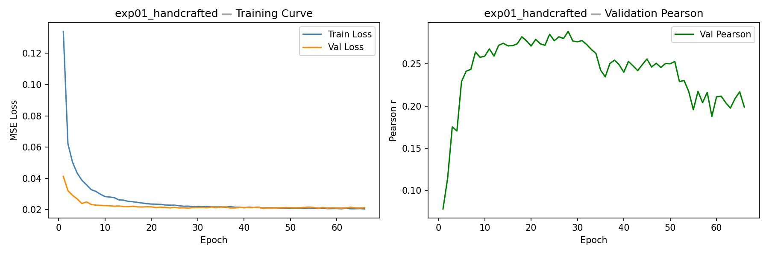
Configuration:
experiment: exp01_handcrafted
description: Handcrafted features only (9-dim)
feature_families:
- handcrafted
input_dim: 9
hyperparameters:
learning_rate: 0.001
dropout: 0.2
weight_decay: 1.0e-05
batch_size: 32
epochs: 100
patience: 10
n_folds: 5
seed: 42
architecture:
- 64
- 32
results:
pearson_mean: 0.296698126310019
pearson_sd: 0.051169142703072684
r2_mean: 0.085536527633667
r2_sd: 0.030089319167924403

RNA-FM embeddings only (1280-dim) (exp02_rnafm)
Description: RNA-FM embeddings only (1280-dim) | Feature families: rnafm | Input dim: 1280 | Architecture: [512, 256, 128, 64]
Fold | Pearson | R² | MSE | MAE
1 | 0.5785 | 0.2984 | 0.0161 | 0.0975
2 | 0.5595 | 0.2951 | 0.0154 | 0.0973
3 | 0.5588 | 0.3071 | 0.0152 | 0.0970
4 | 0.5719 | 0.2840 | 0.0161 | 0.0985
5 | 0.5519 | 0.2612 | 0.0170 | 0.1016
Summary: Pearson = 0.5641 ± 0.0097 | R² = 0.2892 ± 0.0158 | MSE = 0.0160 ± 0.0006 | MAE = 0.0984 ± 0.0017
Training curve:
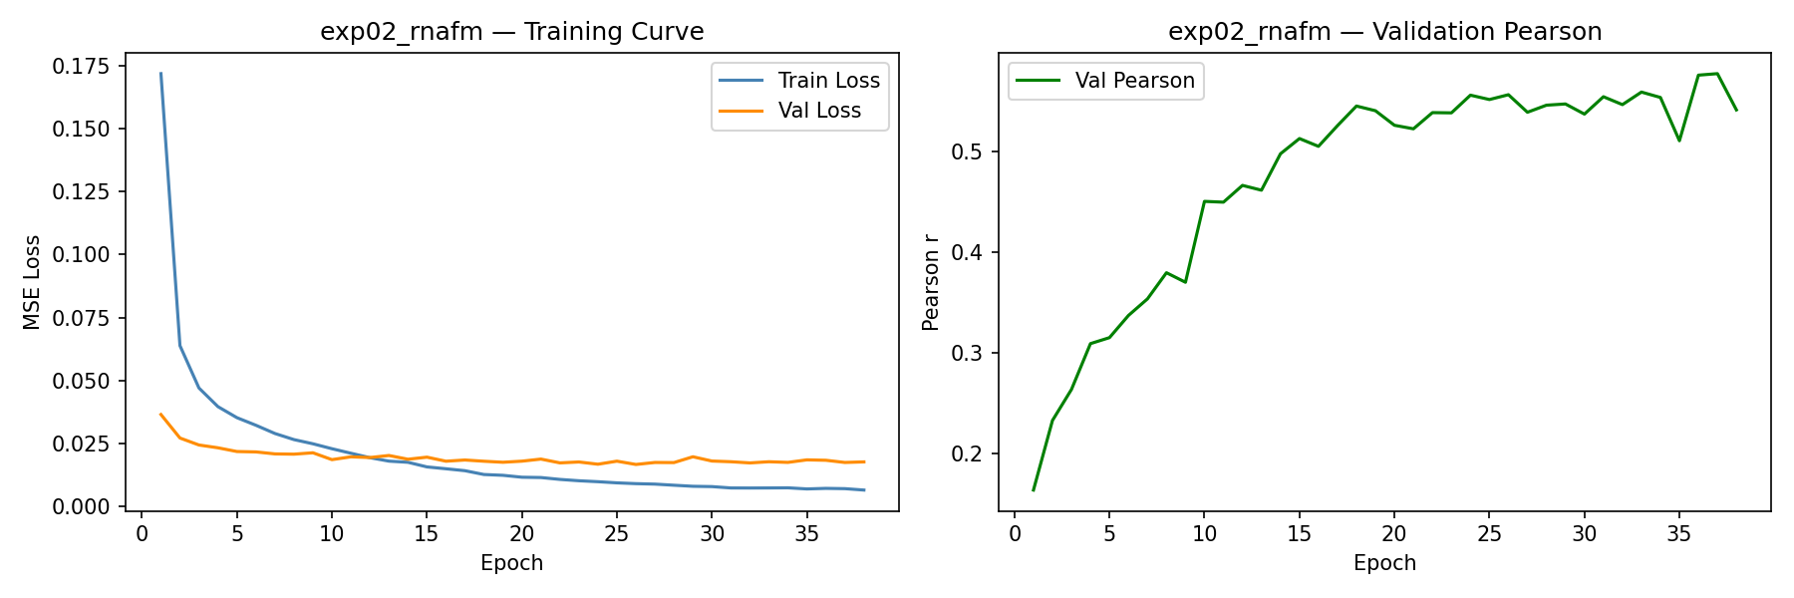
Configuration:
experiment: exp02_rnafm
description: RNA-FM embeddings only (1280-dim)
feature_families:
- rnafm
input_dim: 1280
hyperparameters:
learning_rate: 0.001
dropout: 0.2
weight_decay: 1.0e-05
batch_size: 32
epochs: 100
patience: 10
n_folds: 5
seed: 42
architecture:
- 512
- 256
- 128
- 64
results:
pearson_mean: 0.5641117807251168
pearson_sd: 0.009663070129723858
r2_mean: 0.2891587734222412
r2_sd: 0.015835167182691214

Accessibility features only (11-dim) (exp03_accessibility)
Description: Accessibility features only (11-dim) | Feature families: accessibility | Input dim: 11 | Architecture: [64, 32]
Fold | Pearson | R² | MSE | MAE
1 | 0.1727 | 0.0289 | 0.0223 | 0.1202
2 | 0.0612 | -0.0072 | 0.0220 | 0.1193
3 | 0.0329 | -0.0083 | 0.0222 | 0.1198
4 | 0.1849 | 0.0204 | 0.0220 | 0.1222
5 | 0.1431 | 0.0153 | 0.0227 | 0.1224
Summary: Pearson = 0.1189 ± 0.0609 | R² = 0.0098 ± 0.0150 | MSE = 0.0222 ± 0.0002 | MAE = 0.1208 ± 0.0013
Training curve:
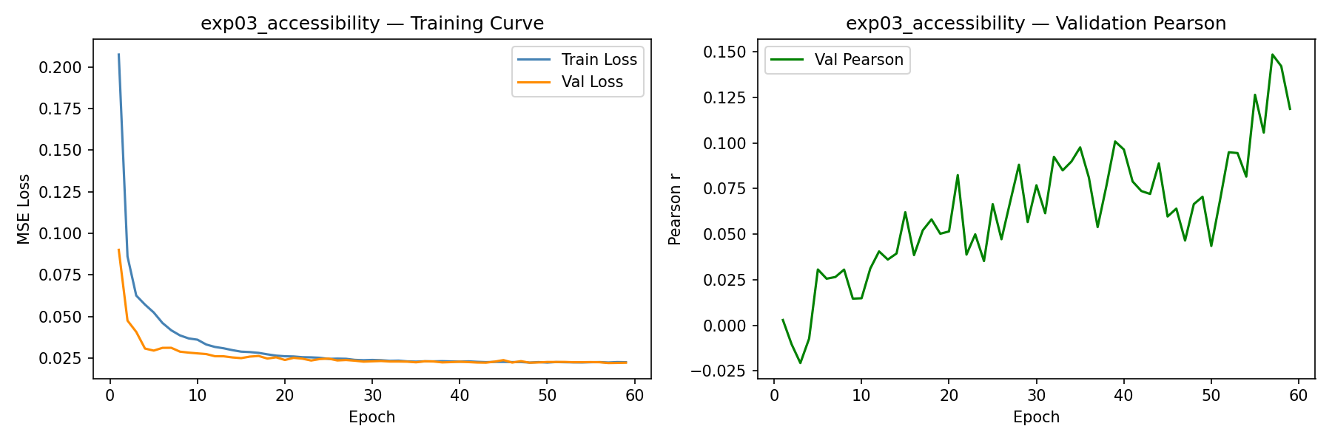
Configuration:
experiment: exp03_accessibility
description: Accessibility features only (11-dim)
feature_families:
- accessibility
input_dim: 11
hyperparameters:
learning_rate: 0.001
dropout: 0.2
weight_decay: 1.0e-05
batch_size: 32
epochs: 100
patience: 10
n_folds: 5
seed: 42
architecture:
- 64
- 32
results:
pearson_mean: 0.11893637858812176
pearson_sd: 0.060909571399345754
r2_mean: 0.00981278419494629
r2_sd: 0.014989841228903655

RNA-FM + Accessibility (1291-dim) (exp04_rnafm_accessibility)
Description: RNA-FM + Accessibility (1291-dim) | Feature families: rnafm, accessibility | Input dim: 1291 | Architecture: [512, 256, 128, 64]
Fold | Pearson | R² | MSE | MAE
1 | 0.5367 | 0.2732 | 0.0167 | 0.1002
2 | 0.5063 | 0.2285 | 0.0168 | 0.1018
3 | 0.5383 | 0.2825 | 0.0158 | 0.0993
4 | 0.4964 | 0.2295 | 0.0173 | 0.1021
5 | 0.6071 | 0.3682 | 0.0145 | 0.0941
Summary: Pearson = 0.5370 ± 0.0388 | R² = 0.2764 ± 0.0509 | MSE = 0.0162 ± 0.0010 | MAE = 0.0995 ± 0.0029
Training curve:
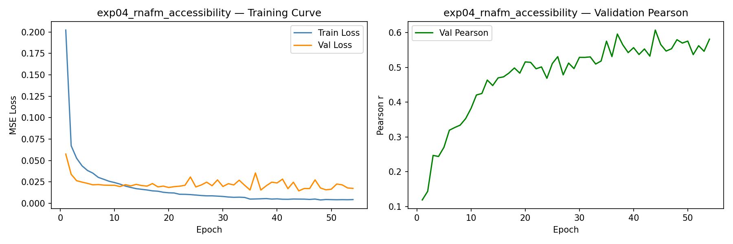
Configuration:
experiment: exp04_rnafm_accessibility
description: RNA-FM + Accessibility (1291-dim)
feature_families:
- rnafm
- accessibility
input_dim: 1291
hyperparameters:
learning_rate: 0.001
dropout: 0.2
weight_decay: 1.0e-05
batch_size: 32
epochs: 100
patience: 10
n_folds: 5
seed: 42
architecture:
- 512
- 256
- 128
- 64
results:
pearson_mean: 0.5369637183419916
pearson_sd: 0.03875543083505856
r2_mean: 0.2763623118400574
r2_sd: 0.05091699314978891

RNA-FM + Handcrafted (1289-dim) (exp05_rnafm_handcrafted)
Description: RNA-FM + Handcrafted (1289-dim) | Feature families: rnafm, handcrafted | Input dim: 1289 | Architecture: [512, 256, 128, 64]
Fold | Pearson | R² | MSE | MAE
1 | 0.5817 | 0.3344 | 0.0153 | 0.0946
2 | 0.5403 | 0.2707 | 0.0159 | 0.0971
3 | 0.5615 | 0.2852 | 0.0157 | 0.0993
4 | 0.5617 | 0.2990 | 0.0158 | 0.0970
5 | 0.5085 | 0.2534 | 0.0172 | 0.1021
Summary: Pearson = 0.5507 ± 0.0248 | R² = 0.2885 ± 0.0275 | MSE = 0.0160 ± 0.0006 | MAE = 0.0980 ± 0.0025
Training curve:
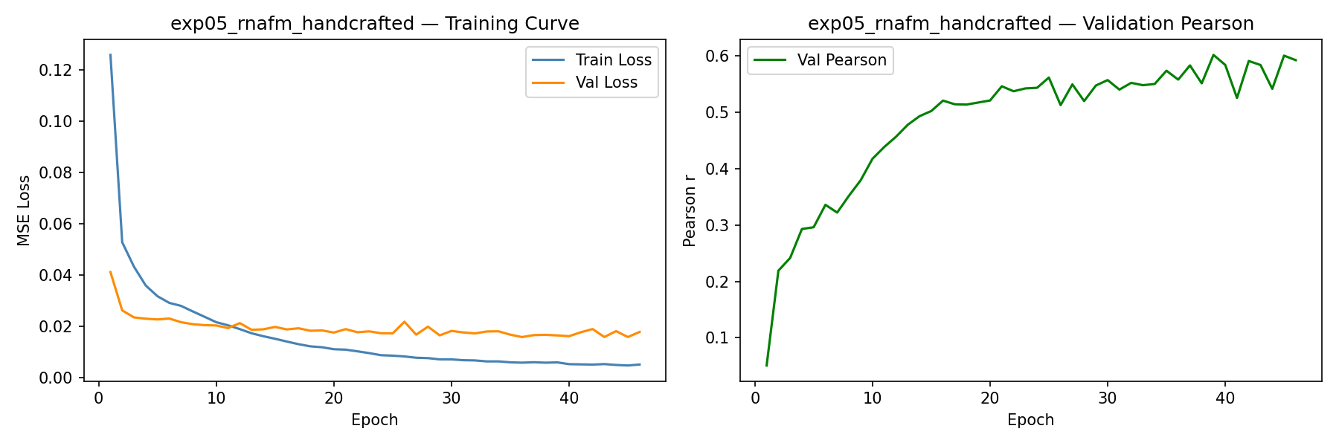
Configuration:
experiment: exp05_rnafm_handcrafted
description: RNA-FM + Handcrafted (1289-dim)
feature_families:
- rnafm
- handcrafted
input_dim: 1289
hyperparameters:
learning_rate: 0.001
dropout: 0.2
weight_decay: 1.0e-05
batch_size: 32
epochs: 100
patience: 10
n_folds: 5
seed: 42
architecture:
- 512
- 256
- 128
- 64
results:
pearson_mean: 0.5507368686756225
pearson_sd: 0.024826716205162205
r2_mean: 0.2885173439979553
r2_sd: 0.027482769403190915

Full FusionNet (1300-dim) (exp06_fusion)
Description: Full FusionNet (1300-dim) | Feature families: rnafm, accessibility, handcrafted | Input dim: 1300 | Architecture: [512, 256, 128, 64]
Fold | Pearson | R² | MSE | MAE
1 | 0.5665 | 0.2900 | 0.0163 | 0.0994
2 | 0.5190 | 0.2184 | 0.0171 | 0.1019
3 | 0.5550 | 0.2643 | 0.0162 | 0.0993
4 | 0.5706 | 0.3070 | 0.0156 | 0.0962
5 | 0.5488 | 0.2880 | 0.0164 | 0.1013
Summary: Pearson = 0.5520 ± 0.0183 | R² = 0.2735 ± 0.0307 | MSE = 0.0163 ± 0.0005 | MAE = 0.0996 ± 0.0020
Training curve:
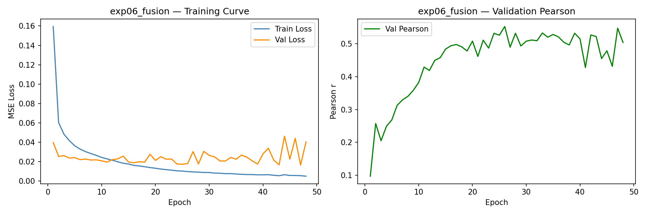
Configuration:
experiment: exp06_fusion
description: Full FusionNet (1300-dim)
feature_families:
- rnafm
- accessibility
- handcrafted
input_dim: 1300
hyperparameters:
learning_rate: 0.001
dropout: 0.2
weight_decay: 1.0e-05
batch_size: 32
epochs: 100
patience: 10
n_folds: 5
seed: 42
architecture:
- 512
- 256
- 128
- 64
results:
pearson_mean: 0.5519744573865244
pearson_sd: 0.018254607218829048
r2_mean: 0.2735456943511963
r2_sd: 0.030739187001816763

7. Baseline Comparison
Model | Pearson | R² | MSE | MAE
RandomForest | 0.4312 ± 0.0422 | 0.1663 ± 0.0266 | 0.0187 | 0.1100
XGBoost | 0.4709 ± 0.0490 | 0.2174 ± 0.0500 | 0.0176 | 0.1053
SVR_rbf | 0.5404 ± 0.0317 | 0.2841 ± 0.0329 | 0.0161 | 0.1002
FusionNet | 0.5520 ± 0.0183 | 0.2735 ± 0.0307 | 0.0163 | 0.0996
Key finding: FusionNet edges SVR on Pearson (0.552 vs 0.540) with much lower fold-to-fold variance (±0.018 vs ±0.032). RandomForest and XGBoost are clearly worse.

Per-fold details — RandomForest
Fold | Pearson | R² | MSE | MAE
1 | 0.4652 | 0.1806 | 0.0188 | 0.1101
2 | 0.3743 | 0.1285 | 0.0190 | 0.1117
3 | 0.3850 | 0.1408 | 0.0189 | 0.1101
4 | 0.4639 | 0.1950 | 0.0181 | 0.1083
5 | 0.4675 | 0.1869 | 0.0187 | 0.1098

Per-fold details — XGBoost
Fold | Pearson | R² | MSE | MAE
1 | 0.4948 | 0.2367 | 0.0175 | 0.1055
2 | 0.3765 | 0.1207 | 0.0192 | 0.1118
3 | 0.4735 | 0.2232 | 0.0171 | 0.1046
4 | 0.5153 | 0.2628 | 0.0166 | 0.1015
5 | 0.4943 | 0.2436 | 0.0174 | 0.1032

Per-fold details — SVR_rbf
Fold | Pearson | R² | MSE | MAE
1 | 0.5580 | 0.3015 | 0.0160 | 0.0998
2 | 0.4820 | 0.2212 | 0.0170 | 0.1036
3 | 0.5335 | 0.2820 | 0.0158 | 0.0996
4 | 0.5566 | 0.3058 | 0.0156 | 0.0976
5 | 0.5720 | 0.3102 | 0.0159 | 0.1005

Per-fold details — FusionNet
Fold | Pearson | R² | MSE | MAE
1 | 0.5665 | 0.2900 | 0.0163 | 0.0994
2 | 0.5190 | 0.2184 | 0.0171 | 0.1019
3 | 0.5550 | 0.2643 | 0.0162 | 0.0993
4 | 0.5706 | 0.3070 | 0.0156 | 0.0962
5 | 0.5488 | 0.2880 | 0.0164 | 0.1013

8. SHAP Explainability
Explainer: LinearExplainer | Surrogate: Ridge(alpha=1.0) (R²=0.9999) | Background samples: 50 | Explained samples: 80

Feature family importance
Feature Family | Importance (sum |SHAP|) | Normalized
rnafm_mRNA | 2.9038 | 50.46%
rnafm_siRNA | 2.8041 | 48.73%
handcrafted | 0.0278 | 0.48%
accessibility | 0.0192 | 0.33%
Key finding: RNA-FM embeddings account for ~99% of model explainability (mRNA 50.5% + siRNA 48.7%). Handcrafted (0.5%) and accessibility (0.3%) are effectively ignored by the plain MLP.

Top 20 individual features
Feature | Mean |SHAP|
rnafm_si_638 | 0.0220
rnafm_si_158 | 0.0211
rnafm_si_239 | 0.0202
rnafm_mrna_288 | 0.0196
rnafm_mrna_571 | 0.0190
rnafm_mrna_107 | 0.0190
rnafm_si_297 | 0.0183
rnafm_mrna_330 | 0.0167
rnafm_mrna_237 | 0.0165
rnafm_si_577 | 0.0161
rnafm_si_274 | 0.0159
rnafm_mrna_565 | 0.0159
rnafm_si_108 | 0.0154
rnafm_mrna_69 | 0.0154
rnafm_mrna_505 | 0.0153
rnafm_mrna_421 | 0.0151
rnafm_si_107 | 0.0150
rnafm_si_24 | 0.0148
rnafm_mrna_319 | 0.0144
rnafm_si_601 | 0.0143

Prediction statistics (explained sample)
 | Mean | Std
Predicted | 0.4957 | 0.1310
True | 0.4598 | 0.1378
SHAP plots:
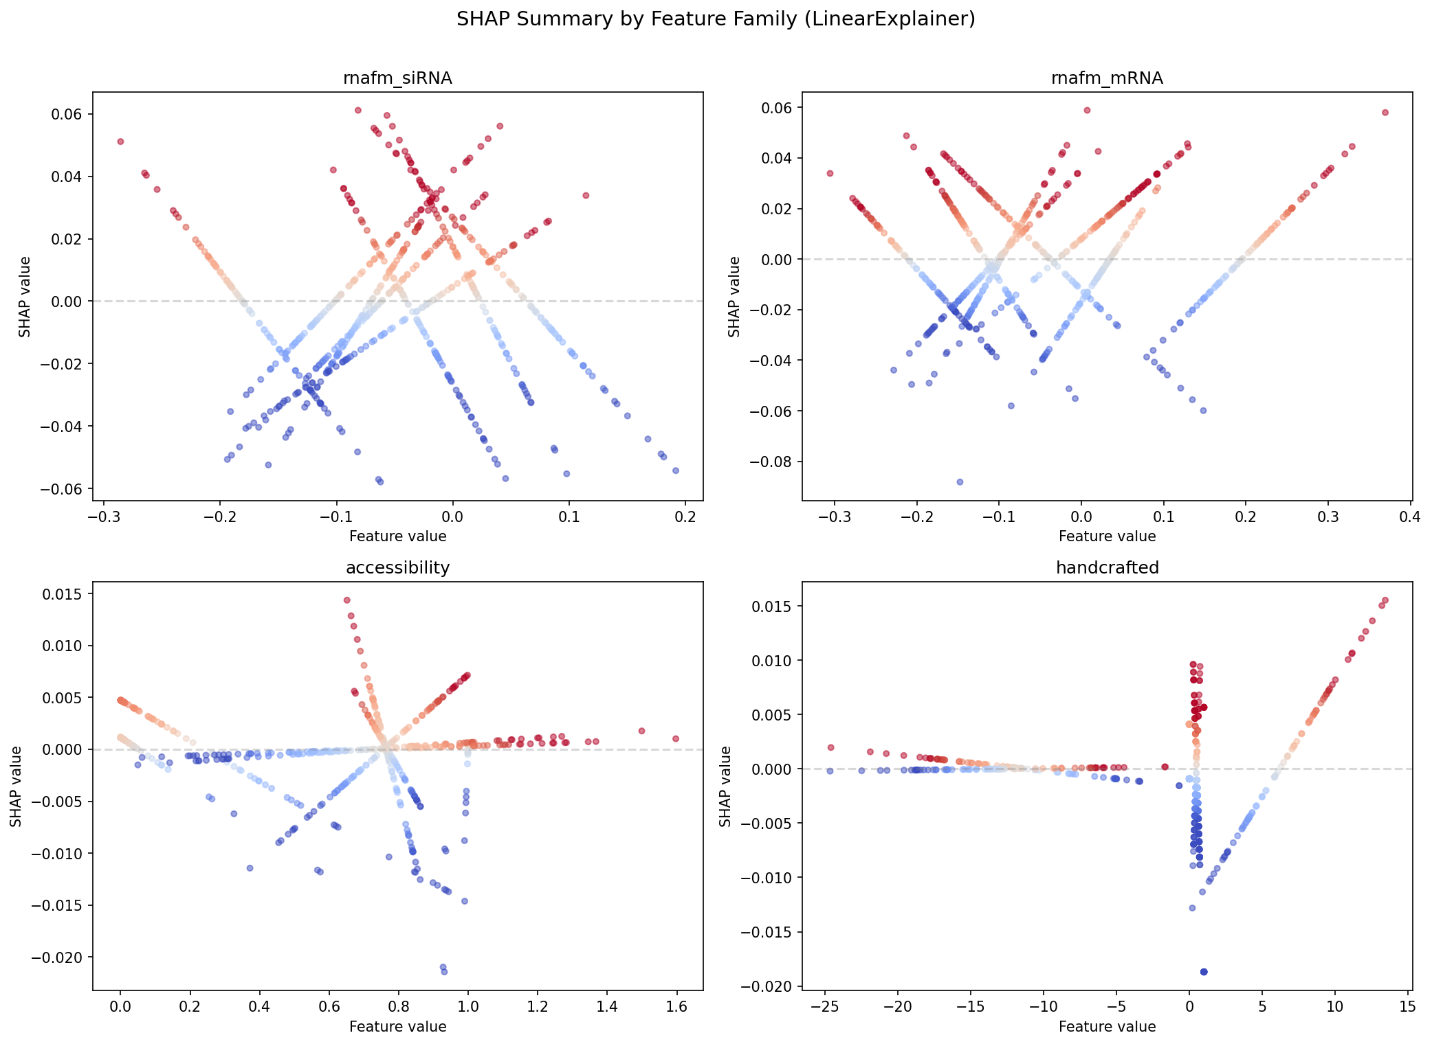
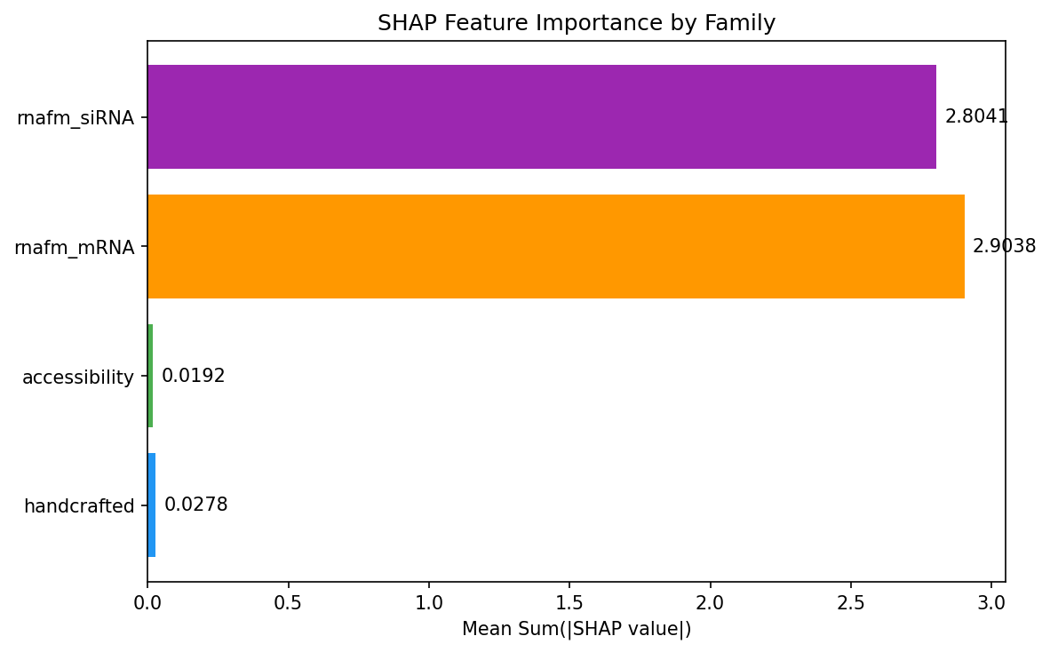
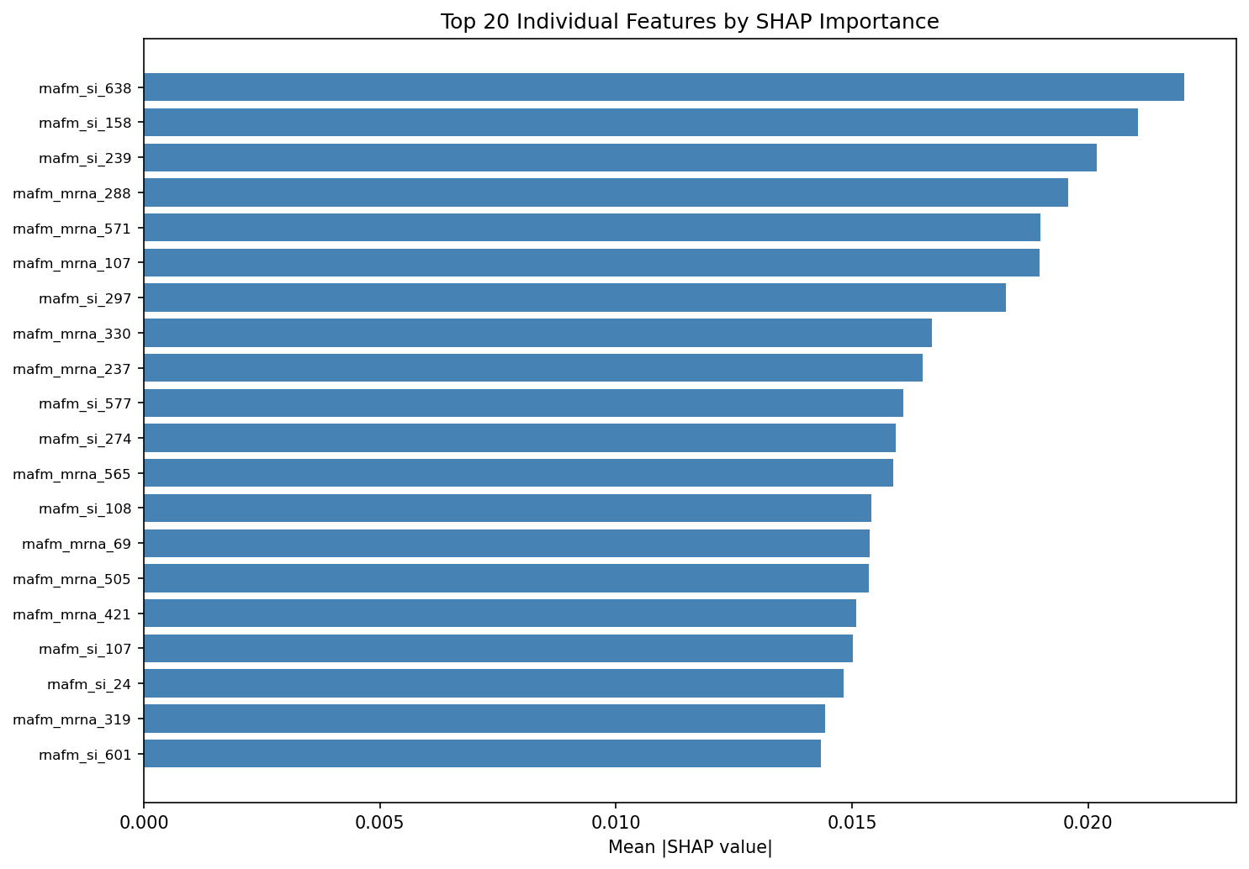

Force plots
force_family_highest_pred_125.png
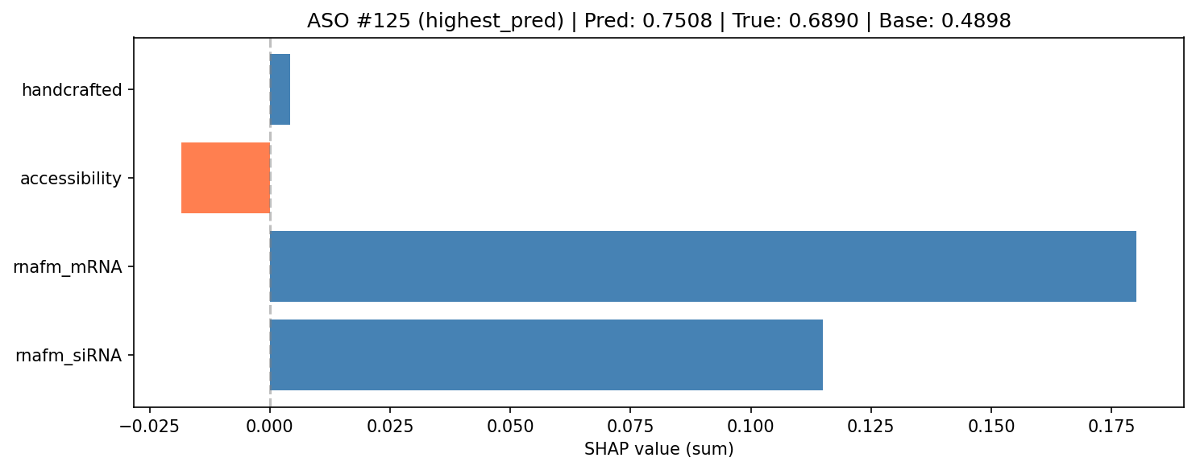
force_family_lowest_pred_107.png
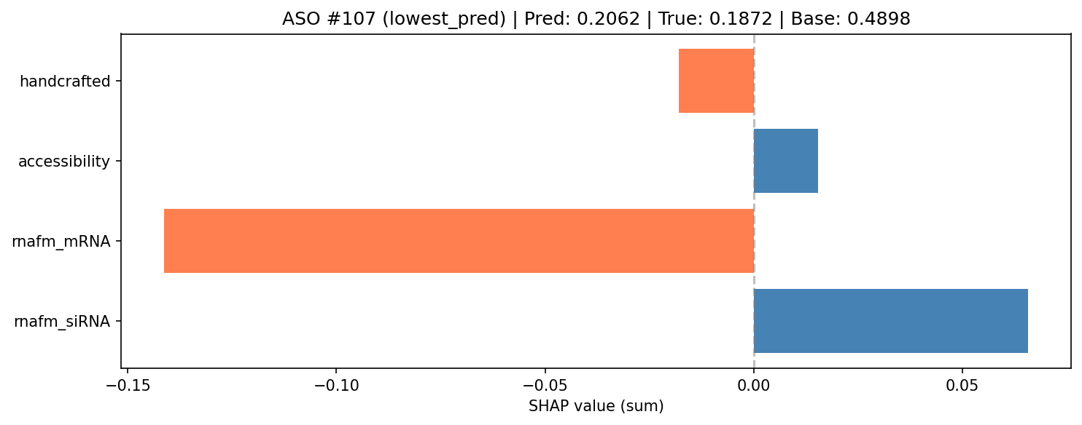
force_family_median_91.png
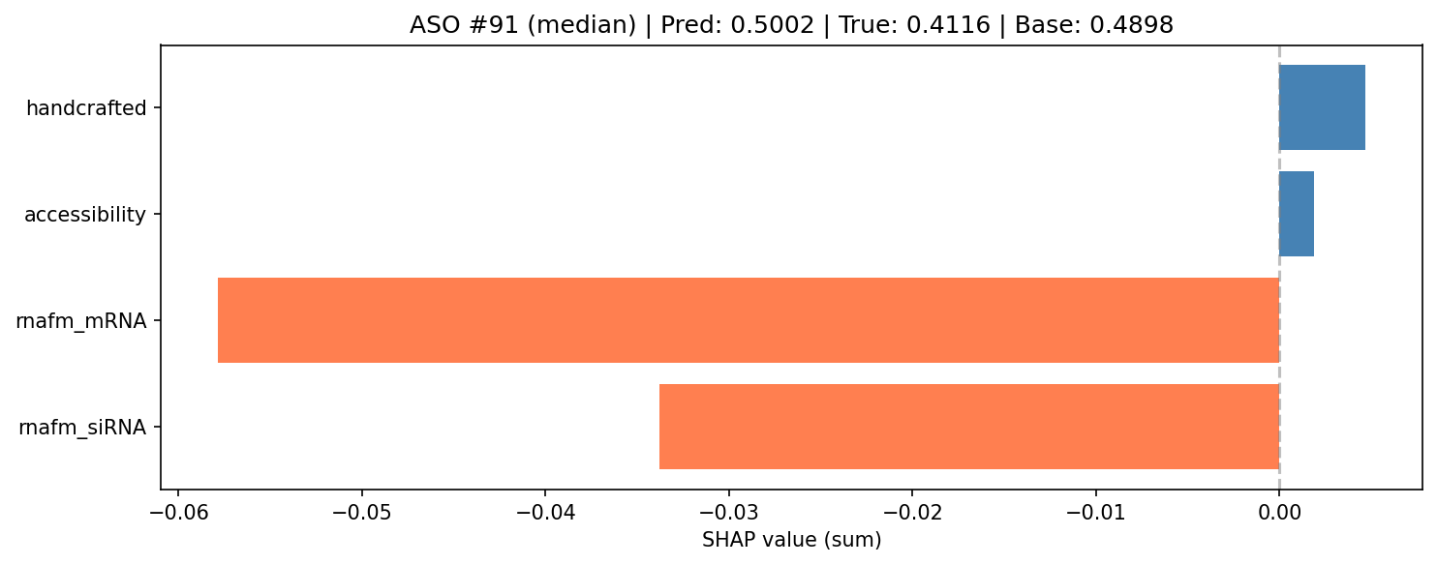
force_family_q25_93.png
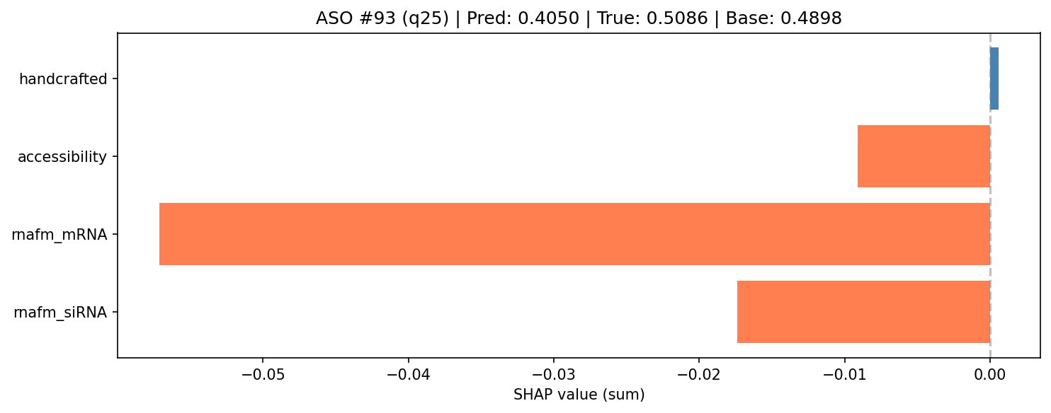
force_family_q75_57.png
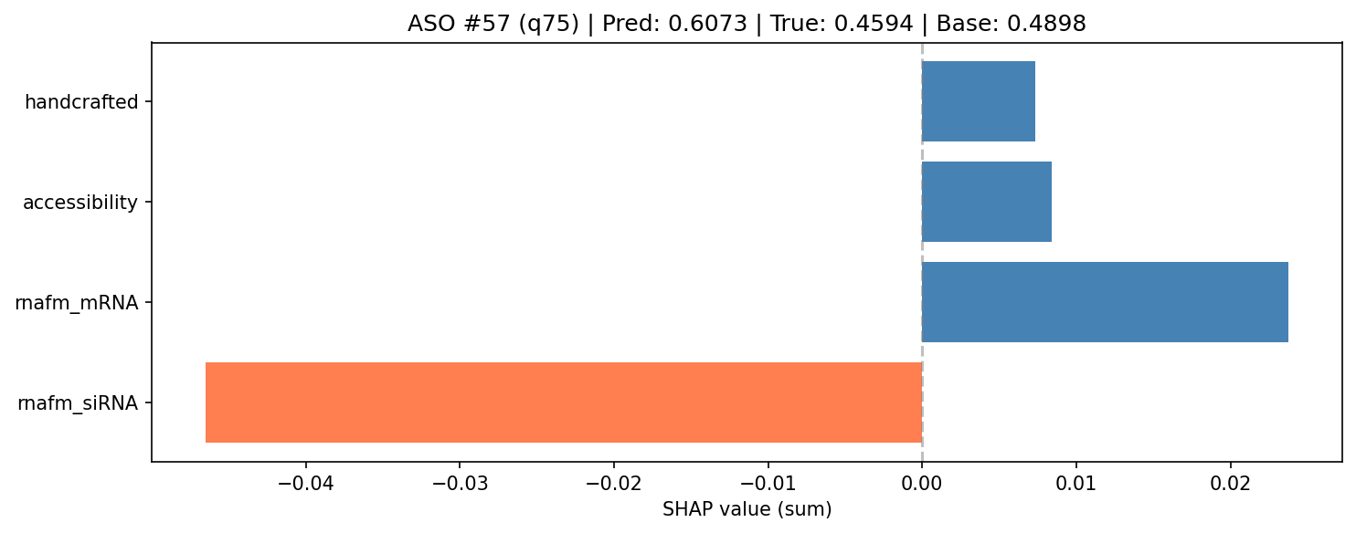

9. Feature Attention (Gated Fusion)
Model | Pearson | R² | ΔPearson | ΔR²
FusionNet | 0.5520 ± 0.0183 | 0.2735 ± 0.0307 | - | -
GatedFusionNet | 0.5848 ± 0.0223 | 0.3309 ± 0.0288 | +0.0329 | +0.0574
Key finding: GatedFusionNet improves Pearson by +0.0329 (0.552 → 0.585) and R² by +0.0574 (0.274 → 0.331). Learned gating lets the model utilize biological features that concatenation ignored.

Learned gate weights
Feature Family | Gate Weight | Normalized
rnafm_siRNA | 0.6140 | 31.07%
rnafm_mRNA | 0.5502 | 27.84%
accessibility | 0.4272 | 21.62%
handcrafted | 0.3850 | 19.48%
Key finding: gate weights now spread across all families — accessibility 21.6% and handcrafted 19.5% — vs <1% SHAP importance in the plain MLP. The biological features contain useful signal the plain architecture was failing to leverage.

Per-fold details — FusionNet
Fold | Pearson | R² | MSE | MAE
1 | 0.5665 | 0.2900 | 0.0163 | 0.0994
2 | 0.5190 | 0.2184 | 0.0171 | 0.1019
3 | 0.5550 | 0.2643 | 0.0162 | 0.0993
4 | 0.5706 | 0.3070 | 0.0156 | 0.0962
5 | 0.5488 | 0.2880 | 0.0164 | 0.1013
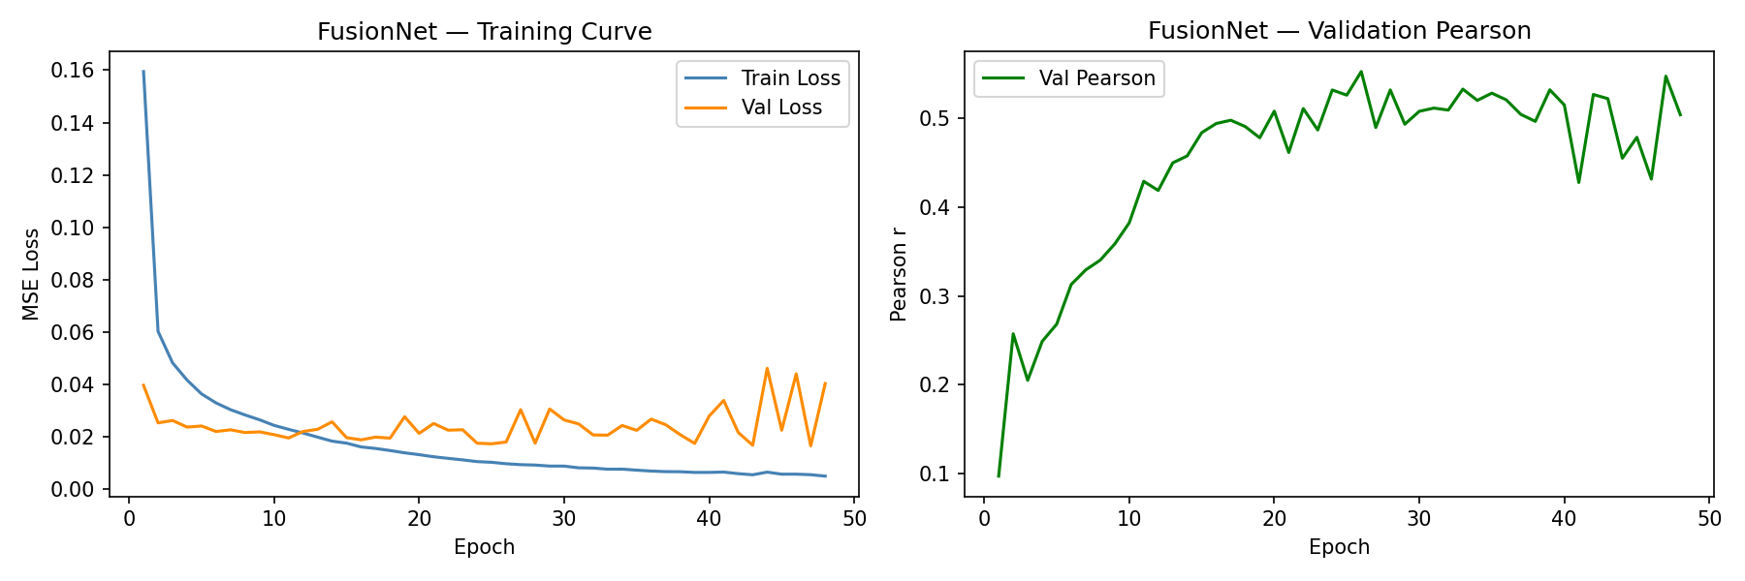

Per-fold details — GatedFusionNet
Fold | Pearson | R² | MSE | MAE
1 | 0.6049 | 0.3589 | 0.0147 | 0.0937
2 | 0.5507 | 0.3001 | 0.0153 | 0.0953
3 | 0.5824 | 0.3345 | 0.0146 | 0.0957
4 | 0.5734 | 0.2959 | 0.0158 | 0.0971
5 | 0.6127 | 0.3651 | 0.0146 | 0.0943
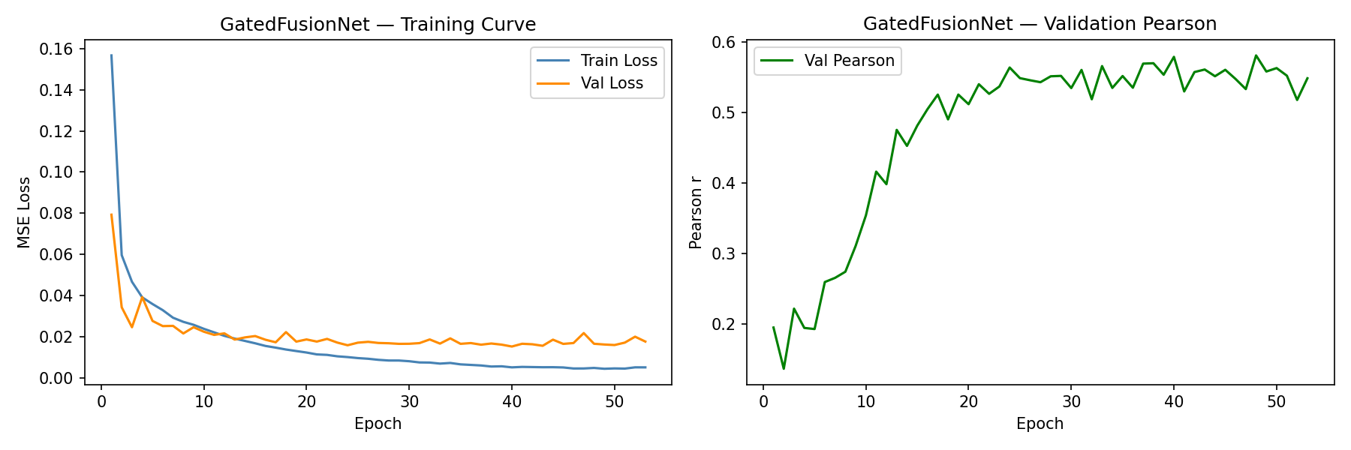

10. Cross-Feature Interaction (CrossAttentionFusion)
Research question: can we explicitly model the interaction between the ASO and its target RNA instead of treating them as independent embeddings?

Embedding check (design decision)
The RNA-FM embeddings used in this pipeline are MEAN-POOLED: backend/features/rnafm.py runs token_embeddings.mean(dim=1), producing one fixed 640-dim vector per sequence (stored in backend/data/hu_embeddings.pt as siRNA(640) + mRNA(640)). There are NO per-nucleotide token embeddings (L x 640).
Consequence: a true nucleotide-level cross-attention transformer is impossible with the cached features (nn.MultiheadAttention over a single token is a no-op). Per the prescribed fallback, we implemented a cross-feature interaction module instead: feature-level cross-attention (query = ASO, key/value = target) plus an elementwise bilinear interaction, plus gated accessibility/handcrafted features.
Model | Pearson | R²
RNA-FM only | 0.5641 ± 0.0097 | 0.2892 ± 0.0158
FusionNet | 0.5520 ± 0.0183 | 0.2735 ± 0.0307
GatedFusionNet | 0.5848 ± 0.0223 | 0.3309 ± 0.0288
CrossAttentionFusion | 0.5843 ± 0.0244 | 0.3261 ± 0.0283
Result: CrossAttentionFusion reaches Pearson 0.5843 ± 0.0244, statistically indistinguishable from GatedFusionNet (-0.0005 ΔPearson) and clearly above FusionNet and RNA-FM only. The interaction terms do not add signal beyond learned gating when embeddings are already pooled to a single vector per sequence — consistent with the hypothesis that nucleotide-level interaction is where the remaining signal would be.

Per-fold details
Fold | Pearson | R² | MSE | MAE
1 | 0.6100 | 0.3650 | 0.0146 | 0.0928
2 | 0.5478 | 0.2868 | 0.0156 | 0.0979
3 | 0.5632 | 0.3027 | 0.0153 | 0.0962
4 | 0.5967 | 0.3455 | 0.0147 | 0.0949
5 | 0.6038 | 0.3307 | 0.0154 | 0.0955
Architecture: rnafm_dim=640, proj_dim=256, gate_hidden=32, head=[512, 256, 128, 64]; input 1300-dim. Same hyperparameters as all prior experiments (lr=1e-3, dropout=0.2, wd=1e-5, batch=32, patience=10, max 100 epochs).
Training curve:
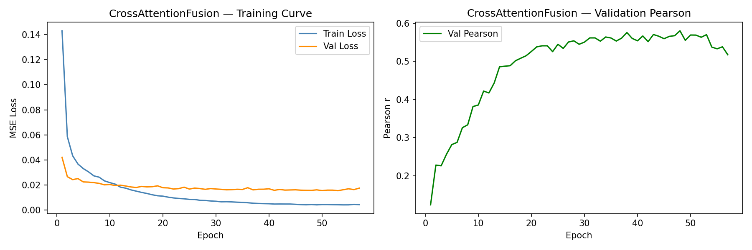
Learned cross-feature attention map (256x256, ASO features → target features):
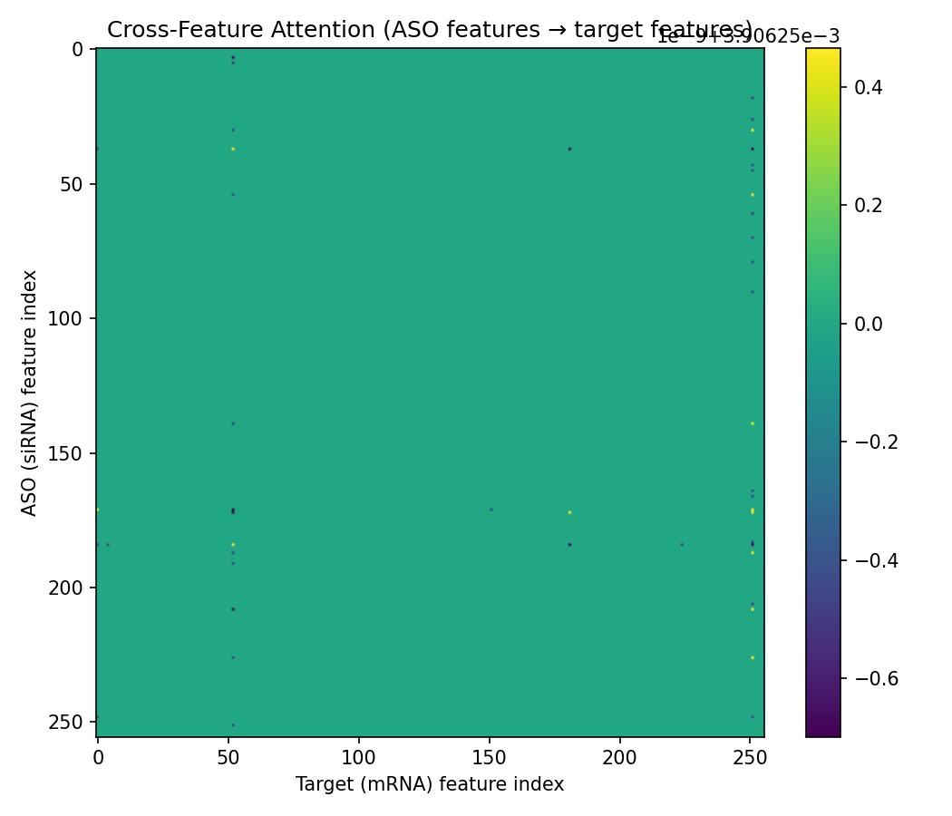
Limitation: this heatmap is feature-level (256 projected dims), not nucleotide-level. A biologically interpretable ASO-position × target-position map requires re-extracting token embeddings from RNA-FM (skip the mean pool) and feeding token sequences — left as the next phase.

11. Token-Level Cross-Attention Transformer (TokenCrossAttention)
Research question: does modeling the ASO-target interaction at the NUCLEOTIDE level (instead of the single-vector, feature-level attention of Phase 10) improve prediction?

Token representation (design decision)
RNA-FM was re-run without the mean pool (backend/features/rnafm.py now exposes embed_with_tokens / embed_batch_with_tokens). Per-nucleotide embeddings are cached in backend/data/hu_token_embeddings.pt: aso_tokens (2361, 19, 640), mrna_tokens (2361, 57, 640).
Target representation: Huesken mRNA targets are already pre-windowed — the binding site is exactly the central 19 nt (verified: starts at position 19 of 57 in every sample), i.e. 19 nt upstream + 19 nt binding site + 19 nt downstream. The full 57-nt window is used for training (fixed length -> no padding, no attention mask). For inference on full-length mRNAs (>1000 nt), a windowing step (e.g. ±40 nt around the predicted binding site) is applied at inference time only.
Architecture: per-token projection to d_model=128 + learnable positional encoding (required: RNA-FM token embeddings carry no position info) -> target self-attention (1 transformer block, 4 heads) -> ASO-position cross-attention over target positions -> mean-pool + elementwise bilinear + gated accessibility/handcrafted features -> MLP head [512, 256, 128, 64].
Model | Pearson | R²
RNA-FM only | 0.5641 ± 0.0097 | 0.2892 ± 0.0158
FusionNet | 0.5520 ± 0.0183 | 0.2735 ± 0.0307
GatedFusionNet | 0.5848 ± 0.0223 | 0.3309 ± 0.0288
CrossAttentionFusion (feat-level) | 0.5843 ± 0.0244 | 0.3261 ± 0.0283
TokenCrossAttention (nt-level) | 0.6195 ± 0.0264 | 0.3720 ± 0.0411
Result: TokenCrossAttention reaches Pearson 0.6195 ± 0.0264 and R² 0.3720 ± 0.0411 — the best result so far, +0.0347 ΔPearson over GatedFusionNet and +0.035 over CrossAttentionFusion. Per-fold paired t-test vs exp10: p=0.067 (trending, not significant at alpha=0.05 with 5 folds; direction consistent in 4 of 5 folds).

Per-fold details
Fold | Pearson | R² | MSE | MAE
1 | 0.6429 | 0.4086 | 0.0136 | 0.0899
2 | 0.6203 | 0.3734 | 0.0137 | 0.0905
3 | 0.5977 | 0.3366 | 0.0146 | 0.0964
4 | 0.5830 | 0.3168 | 0.0154 | 0.0944
5 | 0.6533 | 0.4249 | 0.0132 | 0.0912
Architecture: rnafm_dim=640, d_model=128, n_heads=4, aso_len=19, target_len=57, gate_hidden=32, head=[512, 256, 128, 64]. Same hyperparameters as all prior experiments (lr=1e-3, dropout=0.2, wd=1e-5, batch=32, patience=10, max 100 epochs).
Training curve:
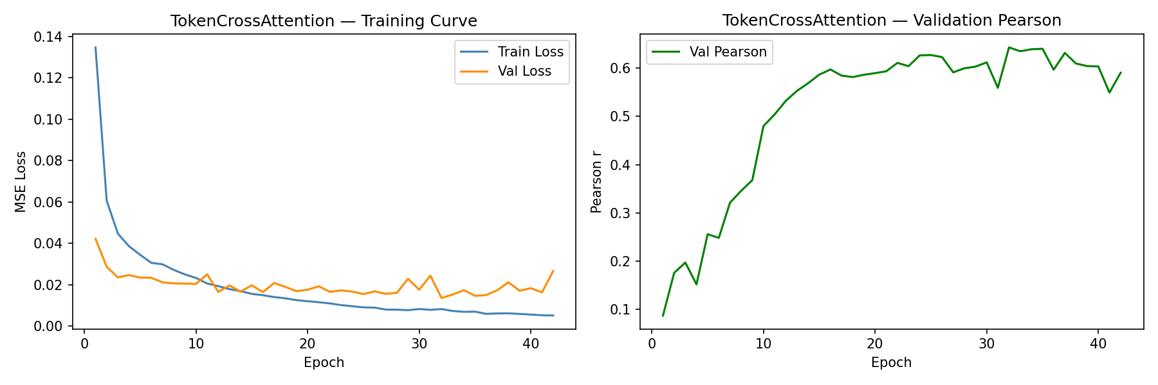
ASO-position x target-position cross-attention matrix (averaged over heads, batches, and the 5 folds; red box = binding site, target positions 19-37):
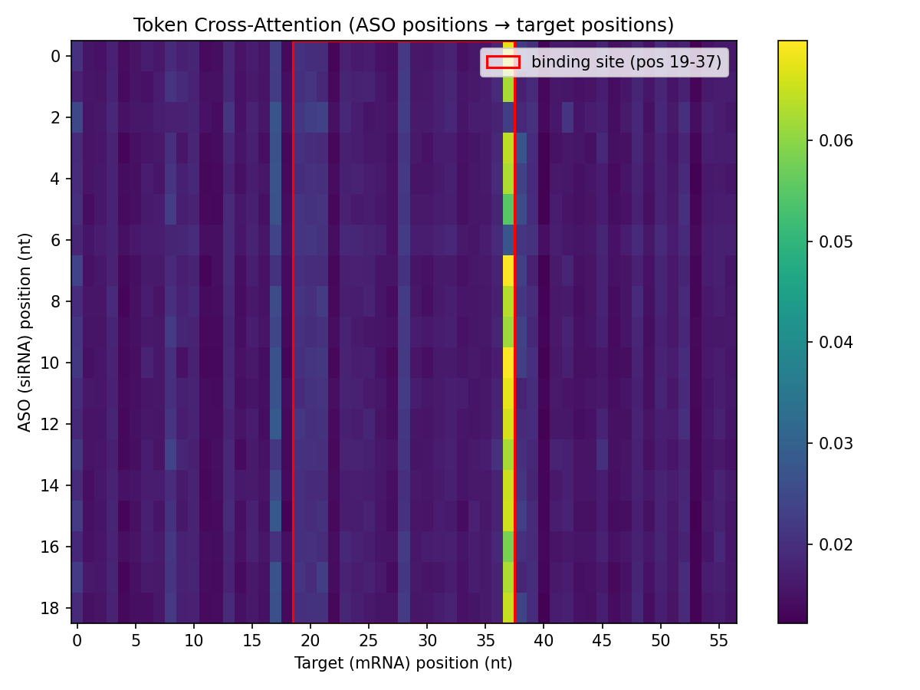
Interpretation: the binding-site region receives the highest mean attention (0.0195) vs upstream (0.0168) and downstream (0.0164) — the model learns to focus ASO positions on the complementary target region, a biologically sensible interaction map.

12. Unified Results (all models)
Model | Category | Pearson | R²
Handcrafted features only (9-dim) | Ablation | 0.2967 ± 0.0512 | 0.0855 ± 0.0301
RNA-FM embeddings only (1280-dim) | Ablation | 0.5641 ± 0.0097 | 0.2892 ± 0.0158
Accessibility features only (11-dim) | Ablation | 0.1189 ± 0.0609 | 0.0098 ± 0.0150
RNA-FM + Accessibility (1291-dim) | Ablation | 0.5370 ± 0.0388 | 0.2764 ± 0.0509
RNA-FM + Handcrafted (1289-dim) | Ablation | 0.5507 ± 0.0248 | 0.2885 ± 0.0275
Full FusionNet (1300-dim) | Ablation | 0.5520 ± 0.0183 | 0.2735 ± 0.0307
RandomForest | Baseline | 0.4312 ± 0.0422 | 0.1663 ± 0.0266
XGBoost | Baseline | 0.4709 ± 0.0490 | 0.2174 ± 0.0500
SVR_rbf | Baseline | 0.5404 ± 0.0317 | 0.2841 ± 0.0329
FusionNet | Baseline | 0.5520 ± 0.0183 | 0.2735 ± 0.0307
FusionNet (attention run) | FeatureAttention | 0.5520 ± 0.0183 | 0.2735 ± 0.0307
GatedFusionNet (BEST) | FeatureAttention | 0.5848 ± 0.0223 | 0.3309 ± 0.0288
CrossAttentionFusion | CrossFeature | 0.5843 ± 0.0244 | 0.3261 ± 0.0283
TokenCrossAttention (BEST) | TokenCross | 0.6195 ± 0.0264 | 0.3720 ± 0.0411
Current best result: Pearson = 0.6195 (TokenCrossAttention 0.6195 vs GatedFusionNet 0.5848 vs CrossAttentionFusion 0.5843)
Original benchmark: Pearson = 0.560 ± 0.026 (FusionNet, HPO)

13. Summary of Observations
• RNA-FM embeddings are the dominant predictive signal (Pearson 0.564 alone).
• Handcrafted features alone reach 0.297; accessibility alone only 0.119.
• Plain concatenation of RNA-FM with biological features does NOT help (0.552 ≤ 0.564).
• Classical ML: SVR approaches FusionNet (0.540 vs 0.552); RandomForest/XGBoost are far behind.
• SHAP shows biological features get <1% of plain-MLP importance.
• Gated attention recovers the biological signal: +0.033 Pearson, +0.057 R² over plain FusionNet.
• RNA-FM embeddings are mean-pooled to one 640-dim vector per sequence; no per-nucleotide tokens are cached.
• Feature-level cross-attention + bilinear interaction (CrossAttentionFusion) reaches 0.584 Pearson — statistically tied with GatedFusionNet, above FusionNet and RNA-FM-only.
• Interaction terms add no signal beyond gating when embeddings are pooled; remaining signal likely lives at nucleotide level.
• Token-level cross-attention (TokenCrossAttention) reaches Pearson 0.6195 ± 0.0264 — best result, +0.035 over GatedFusionNet and CrossAttentionFusion (paired t-test p=0.067, trending).
• Attention matrix shows the model focuses ASO positions on the binding-site region of the target (mean attention 0.0195 vs 0.0168/0.0164 up/downstream).
• batch=64 consistently underperforms; best HPO config uses batch=16/32.
• 10-epoch training was insufficient; 100 epochs + early stopping raised every fold into 0.51–0.59.
• Final OOF model: Pearson 0.543, R² 0.289; binary threshold 0.5 gives 70.5% accuracy.

14. Next Steps
1. Increase statistical power (nested CV / repeated folds / bootstrap) to confirm the exp11 gain over gating.
2. Integrate the token-level cross-attention model into the serving model in backend/models.
3. Add inference-time target windowing (±40 nt around predicted binding site) for full-length mRNAs.
4. Validate on an external dataset before deployment.

