EX:No.8 221501042

**Create an ARIMA model for time series forecasting.**

**Aim:**

Write a program to create an ARIMA model for time series forecasting.

**Algorithm:**

1. **Import necessary libraries**:  
Import numpy, pandas, matplotlib.pyplot, ARIMA from statsmodels.tsa.arima.model, and mean_squared_error from sklearn.metrics.

2. **Load the dataset**:  
Read the weather dataset using pandas.read_csv() and parse the 'Date' column as datetime. Set the 'Date' column as the index.

3. **Select the target column**:  
Extract the 'Temperature' column from the DataFrame for time series forecasting.

4. **Split the data**:  
Calculate the training size as 80% of the total data.  
Split the data into training and testing sets using this calculated size.

5. **Define and fit the ARIMA model**:  
Initialize the ARIMA model with training data and set parameters (p=5, d=1, q=0).  
Fit the model using .fit().

6. **Forecast future values**:  
Forecast the temperature values for the length of the test set using .forecast().

7.**Visualize the training data**:  
Create a line plot for the training data using matplotlib.

8.**Visualize the actual test data**:  
Create a line plot for the test (actual) data.

9.**Visualize the forecasted vs actual test data**:  
Plot the ARIMA forecast along with the actual test values on the same graph to compare performance.

10.**Evaluate the model**:  
Calculate the Root Mean Squared Error (RMSE) between the forecast and actual test values using mean_squared_error().

11.**Print the RMSE value**.

**Code:**

import numpy as np

import pandas as pd

import matplotlib.pyplot as plt

from statsmodels.tsa.arima.model import ARIMA

from sklearn.metrics import mean_squared_error

df = pd.read_csv(r"C:\Users\harsh\Downloads\cleaned_weather.csv", parse_dates=['date'], index_col='date')

time_series = df['T']

train_size = int(len(time_series) * 0.8)

train, test = time_series[:train_size], time_series[train_size:]

# Fit ARIMA model (p=5, d=1, q=0) - you can tune these parameters based on AIC/BIC or grid search

model = ARIMA(train, order=(5, 1, 0))

model_fit = model.fit()

forecast = model_fit.forecast(steps=len(test))

plt.figure(figsize=(10, 4))

plt.plot(train, label='Training Data', color='blue')

plt.title('Training Data')

plt.xlabel('Date')

plt.ylabel('Temperature')

plt.legend()

plt.grid(True)

plt.tight_layout()

plt.show()

plt.figure(figsize=(10, 4))

plt.plot(test, label='Actual Test Data', color='green')

plt.title('Actual Test Data')

plt.xlabel('Date')

plt.ylabel('Temperature')

plt.legend()

plt.grid(True)

plt.tight_layout()

plt.show()

plt.figure(figsize=(10, 4))

plt.plot(test.index, forecast, label='ARIMA Forecast', color='red')

plt.plot(test, label='Actual Test Data', color='green')

plt.title('ARIMA Forecast vs Actual')

plt.xlabel('Date')

plt.ylabel('Temperature')

plt.legend()

plt.grid(True)

plt.tight_layout()

plt.show()

rmse = np.sqrt(mean_squared_error(test, forecast))

print(f'RMSE: {rmse:.2f}')

**Output:**

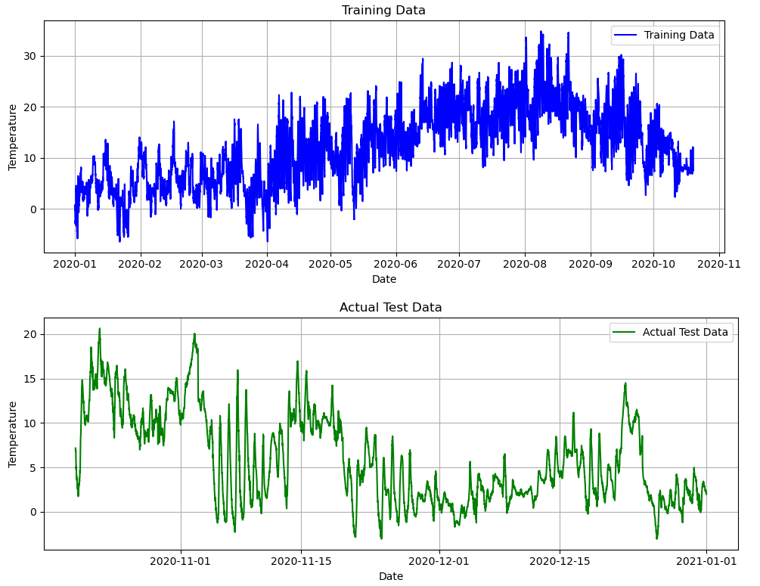

**Result:**

Thus, the program to create an ARIMA model for time series forecasting was created successfully.