**https://github.com/HarshiniNetha/ADS_Assignment-2**

**Methane Emission and Energy Usage**

Methane is a potent greenhouse gas that contributes to climate change, and energy production is a major source of methane emissions. The relationship between methane emission and energy used by countries is an important one. As countries continue to rely on fossil fuels for energy, they also contribute to the problem of methane emissions. According to the Intergovernmental Panel on Climate Change (IPCC), energy production is responsible for nearly two-thirds of global methane emissions. These emissions come from a variety of sources, including natural gas and coal production, as well as the transport and use of these fuels. The more energy a country consumes, the more it contributes to methane emissions and climate change. However, there are ways to reduce methane emissions from energy production. For example, natural gas leaks can be minimized through better maintenance and monitoring of infrastructure. Methane can also be captured and used as a fuel, reducing emissions and providing energy. In addition, renewable energy sources such as wind and solar power can help reduce reliance on fossil fuels and therefore lower methane emissions.

The emission of methane concerning energy production and usage is a common fact in the world and for which greenhouse effects can be seen. So, to analyze the effects of methane emission, the world bank data has been collected from 1960 to 2022 and the indicators such as Methane emissions (in kilo tonnes) and Energy use (kilogram) have been selected for nine countries which are Bangladesh, United Kingdom, Germany, Argentina, Brazil, India, Australia, Iraq and Bhutan. The outlook of the filtered data is shown below:

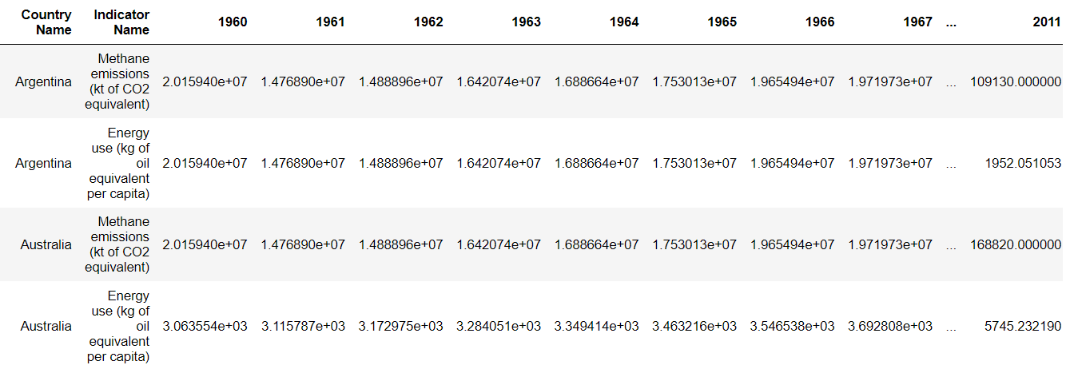

The statistics of the data have been inspected using describe method and the outcome is shown below year-wise (left) and country with indicators (right):

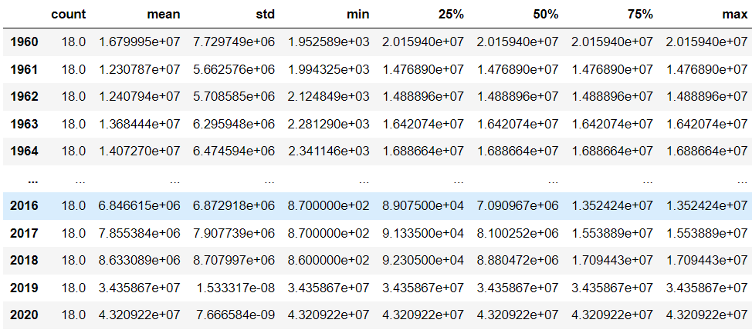 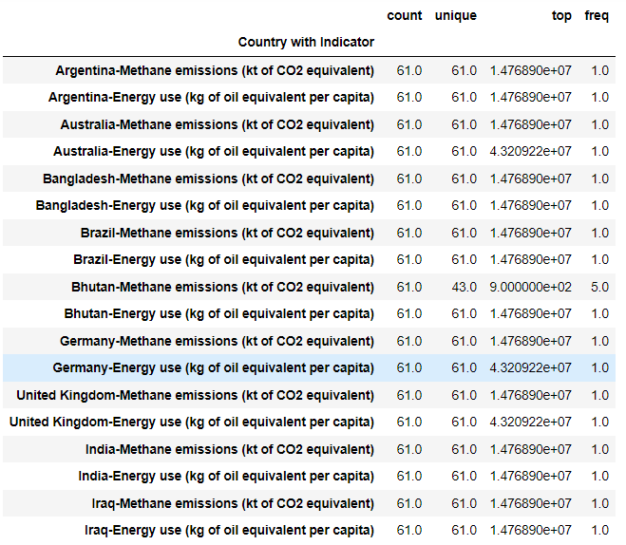

The time series analysis has been done on two indicators for all nine countries to visualize the growth of using methane and the usage of energy. The outcomes of the analyses are shown below:

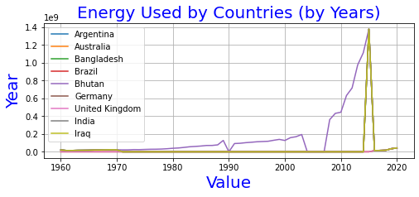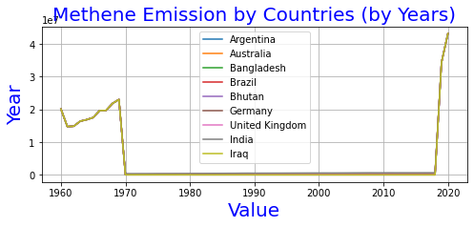

From the outcomes of the analyses, it can be observed that the usage of energy has got a peak in 2015 and the emission of methane increased from 2018 onwards. To identify the valuation of methane emission and energy usage by countries, bar charts have been prepared which are shown below with data:

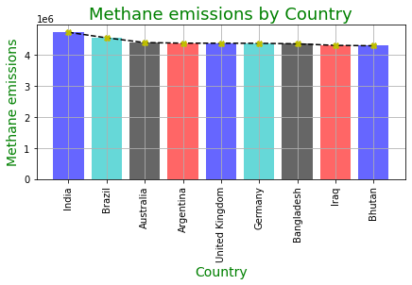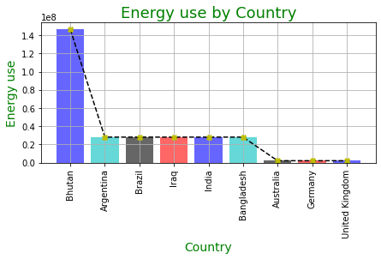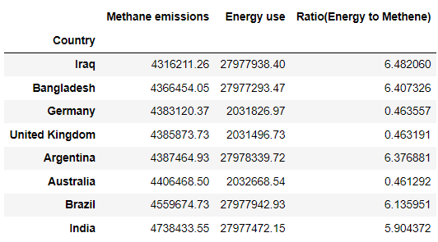

From the outcomes of analyses, it can be observed that the highest methane emission has been done by India whereas the higher energy usage can be seen for Bhutan followed by Argentina. So, to understand the fact concerning energy used by methane usage, the ratio has been calculated and the outcomes are shown below with data:

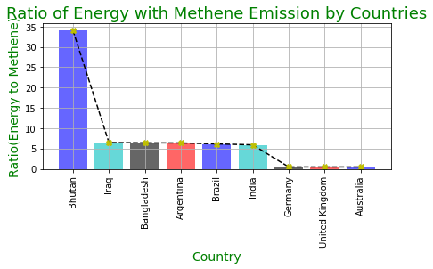 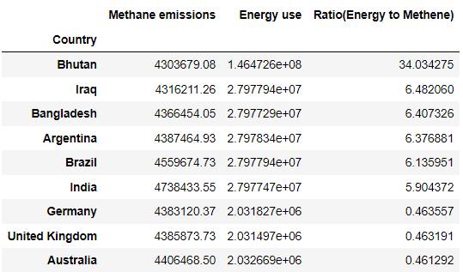

The outcomes are showing that the ratio is highest for Bhutan and lowest for Australia. It means Bhutan is one of the most pollution-concerned countries that emit less methane but consume energy as required. Next, the correlation between the chosen indicators for all countries has been done and the heatmap is shown below:

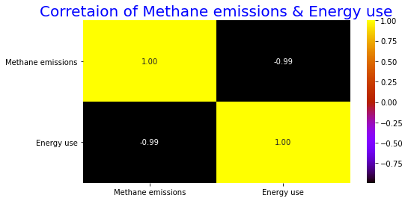

From the overall analysis, the relationship between the indicators along with the statistic of methane emission with energy usage has been evaluated for selected countries. In conclusion, it can be stated that the countries (which are prone to emit methane and use higher energy consumption) need to be careful in order to maintain the cleanliness of the atmosphere from methane emissions. As countries continue to rely on fossil fuels for energy, they also contribute to the problem of climate change through methane emissions. However, there are solutions, such as better maintenance and monitoring, capturing methane for energy, and transitioning to renewable energy sources, that can help reduce methane emissions and create a more sustainable future.