**ONLINE DISCUSSION FORUM**

# **MINI PROJECT REPORT**

Submitted by

SIVAHARSHINI S

(23MCA018)

Under the guidance of

**Dr. R. SURESH KUMAR**

**Assistant Professor,**

**Department of MCA**

In partial fulfilment of the requirements for the award of the degree of

# **MASTER OF COMPUTER APPLICATIONS**

**Bharathiar University, Coimbatore**



# **PG DEPARTMENT OF COMPUTER APPLICATIONS**

# **SREE SARASWATHI THYAGARAJA COLLEGE,**

# **POLLACHI**

**An Autonomous, NAAC Re-Accredited with “A+” Grade,**

**ISO 9001:2008 Certified Institution Affiliated to Bharathiar University, Coimbatore, Approved by AICTE for MBA/MCA & UGC for 2(f) & 12(B) status**

**Thippampatti Post, Palani Road, Pollachi – 642 107.**

**OCTOBER 2024**

**CERTIFICATE**

This is to certify that the Mini Project work entitled **“ONLINE DISCUSSION FORUM”** is a Bonafide record of work done by **SIVAHARSHINI S (23MCA018)** submitted in partial fulfilment of the requirement for the award of the degree **MASTER OF COMPUTER APPLICATIONS** of Bharathiar University, Coimbatore under my supervision.

**Date :**

**Place** : **Pollachi Signature of the Guide**

**Counter Signed**

## **H.O.D D.DIRECTOR PRINCIPAL**

**External Viva-voice Conducted on .**

**INTERNAL EXAMINER EXTERNAL EXAMINER**

# **DECLARATION**

I SIVAHARSHINI S dohereby declare that this Mini Project entitled **“ONLINE DISCUSSION FORUM”** submitted to the Bharathiar University, Coimbatore in partial fulfilment of the requirement for the award of the degree **MASTER OF COMPUTER APPLICATIONS**, is a record of original work done by me during the period of study at **SREE SARASWATHI THYAGARAJA COLLEGE (AUTONOMOUS), POLLACHI** Under the guidance of **Dr.R.SURESH KUMAR, MCA.,M.Sc (Maths).,PGDCA.,M.Phil,Ph.D** Assistant Professor, Department of MCA.

Date :

Place : **POLLACHI** **Signature of the Candidate**

# **ACKNOWLEDGEMENT**

The success of the project depends on the efforts invested. It's my duty to acknowledge and thank the individuals who has contributed in successful completion of the project.

I wish to express our deep sense of gratitude to the Management of Sree Saraswathi Thyagaraja College, Pollachi, for carrying out the task.

I would like to convey my sincere thanks to beloved Principal **Dr.M.R.VANITHAMANI MBA.,M.Phil.,PhD.,** for providing necessary facilities that enabled to the success of my project.

I would like to express my sincere thanks to the Deputy Director of School of Computing Science **Ms.D.GEETHA, M.Sc(C.S).,M.Phil.,SET.,** for her directions. I thank her for the interest and continuous support.

I would like to express my sincere thanks to the Head of the Department In charge**. Dr. V.THAHIRA BANU, MSc(It).,M.Phil,NET,Ph.D.** for her directions. I thank her for the interest and continuous support.

I would like to express my sincere thanks to my project guide **Dr.R.SURESH KUMAR, MCA.,M.Sc (Maths).,PGDCA.,M.Phil,Ph.D** Assistant Professorfor his directions. I thank his for the interest and continuous support.

I own my special gratitude to my parents and friends who helped me to make this project a memorable success.

# **ABSTRACT**

This project presents the development of an online discussion forum leveraging PHP and MySQL technologies. The forum aims to facilitate dynamic user interaction, enabling participants to share ideas, seek advice, and engage in topic-based discussions. Key features include user authentication, thread creation, commenting, and real-time notifications, ensuring a seamless user experience.

The architecture comprises a robust back-end powered by PHP, which handles server-side logic, and a MySQL database that manages user data, posts, and comments. Front-end interaction is designed with HTML, CSS, and JavaScript, ensuring a responsive and intuitive interface.

This forum also incorporates moderation tools, enabling administrators to manage content effectively and maintain community standards. Security measures, including input validation and encryption, are implemented to protect user data and enhance platform integrity.

The project demonstrates a practical application of web development skills and serves as a foundation for further enhancements, such as mobile responsiveness and integration of machine learning for personalized content recommendations. Ultimately, this online discussion forum promotes collaborative learning and knowledge sharing within a user-friendly environment.

# 

# **CONTENTS**

|  |  |  |
| --- | --- | --- |
| **S. No** | **Particulars** | **Page No** |
| **1** | **Introduction** |  |
|  | 1.1 Overview of Project | **1** |
|  | 1.2 Module Description | **2** |
|  | 1.3 System Specification | **3** |
| **2** | **System Study** |  |
|  | 2.1 Existing System | 4 |
|  | 2.2 Proposed System | **5** |
| **3** | **Software Features** |  |
|  | 3.1 PHP | **6** |
|  | 3.2 MySQL | **7** |
| **4** | **System Design** |  |
|  | 4.1 Database Design | **10** |
|  | 4.2 Table Design | **10** |
| **5** | **ER Diagram** | **13** |
| **6** | **Data Flow Diagram** | **14** |
| **7** | **Testing** | **16** |
| **8** | **Conclusion** | **18** |
| **9** | **Future Enhancement** | **19** |
| **10** | **Bibliography** | **20** |
| **11** | **Screenshots** | **21** |
| **12** | **Sample Coding** | **24** |

**1.INTRODUCTION**

* 1. **Overview of Project**

Online discussion forums play a pivotal role in fostering communication, collaboration, and knowledge sharing among diverse groups of individuals. This project aims to create a comprehensive online discussion forum using PHP and MySQL, two widely-used technologies that provide a powerful foundation for web development.

The forum will serve as a digital space where users can engage in meaningful conversations on various topics, share insights, and seek advice from peers. By providing an accessible platform for discussion, the forum encourages community building and enhances the exchange of ideas, making it a valuable resource for hobbyists, professionals, and learners alike.

PHP will handle the server-side functionality, allowing for dynamic content generation and user interactions, while MySQL will manage the data storage, ensuring efficient retrieval and organization of user-generated content. Together, these technologies enable the creation of a responsive, secure, and user-friendly environment.

This project emphasizes key features such as user authentication, thread creation, real-time notifications, and moderation tools to maintain a respectful atmosphere. By focusing on usability and security, the forum aims to create a welcoming space for all users, encouraging participation and fostering a sense of community.

Ultimately, this online discussion forum represents an opportunity to leverage technology for enhanced communication, facilitating discussions that can lead to personal growth, professional development, and collaborative problem-solving.

* 1. **Module Description**

**1.2.1 User-Side Module**

* Login and Registration
* Home Page
* Topic Categories Page
* Add Post
* My Post Page
* Comment Section
* Delete Posted Topics
* Delete Posted Comments
* Logout

**1.2.2 Admin-Side Module**

* Home Page
* Category Management
* Post Management
* User Management
* Login and Logout

**1.3 System Specification**

**1.3.1 Hardware Specification**

PROCESSOR : PENTIUM III 866 MHz

RAM : 128 MD SD RAM

MONITOR : 15” COLOR

HARD DISK : 20 GB

FLOPPY DRIVE : 1.44 MB

CD DRIVE : LG 52X

KEYBOARD : STANDARD 102 KEYS

MOUSE : 3 BUTTONS

**1.3.2 Software Specification**

FRONT END : HTML , CSS, JAVASCRIPT

BACKEND : My SQL ,PHP

WEB BROWSER : Mozilla, Google Chrome

SOFTWARE : XAMPP Server

**2. SYSTEM STUDY**

**2.1. Existing System**

In general people share their ideas, queries and answers from their colleagues or friends through the intercom or direct manner. They need to spend time for their work.

**Drawbacks**

* **Ongoing maintenance:** PHP and MySQL require regular updates and security patches to address vulnerabilities and improve performance.
* **Development costs:** Maintaining and updating a large-scale discussion forum can be expensive, especially if it requires specialized knowledge and skills.
* **Scalability limitations:** As the forum grows, it may become difficult to scale the system to meet increasing demands without significant architectural changes.
* **SQL injection vulnerabilities:** Improperly sanitized user input can lead to SQL injection attacks, allowing malicious users to execute arbitrary SQL commands.
* **Cross-site scripting (XSS) vulnerabilities:** If not properly handled, XSS attacks can inject malicious code into web pages, compromising user data and potentially taking control of their accounts.
* **Session hijacking:** Inadequate session management can expose users to session hijacking attacks, where unauthorized individuals can gain access to their accounts.

**2.2 Proposed System**

It is difficult to note down all the problems manually. Instead it is decided to develop an “ONLINE DISCUSS FORUM” to ease the operation.

A system is required which is being capable of elimination all the problems and become useful to users and thus the new system is derived. Here we get a different view from different users.

**Benefits**

* **Enhanced communication:** Easier interaction and knowledge sharing among users.
* **Increased accessibility:** Articles and discussions can be accessed from anywhere at any time.
* **Time-saving:** Efficient way to find information and connect with others.
* **Community building:** Fosters a sense of belonging and collaboration among users.
* **Problem-solving:** Helps users find solutions to their challenges through collective knowledge

**3. SOFTWARE FEATURES**

**3.1 About PHP**

PHP is a powerful server-side scripting language for creating dynamic and interactive websites. PHP widely used; free and efficient alternative to competitors such as Microsoft’s ASP.PHP is perfectly suited for Web development and can be embedded directly into the HTML code. The PHP syntax is similar to pearl and C.

PHP is open source that it is readily available and absolutely free. Stability, flexibility and speed are chief qualities that attract to choose PHP.PHP have multiple extensions and is extremely scalable.

**Server-side scripting**

This server-side scripting is the most traditional and main target field for PHP. Programmer needs three things to make this work. Programmer need to run the web server, with a connected PHP installation. Programmer can access the PHP program output with a web browser, viewing the PHP page through the server. All these can run on your home machine if programmers are just experimenting with PHP programming.

**Command line scripting**

Programmer can make a PHP script to run it without any server or browser. Programmers only need the PHP parser to use it this way. This type of usage is ideal for scripts regularly executed using croon (on Unix or Linux) or Task Scheduler (on Windows). These scripts can also be used for simple text processing tasks.

**Features of PHP**

* PHP runs on different platforms (Windows, Linux, UNIX, etc.)
* PHP is compatible with almost all servers used today.
* PHP is free to download from the official PHP resource: www.php.net.

**3.2 About MySQL**

MySQL is an open-source relational database management system (RDBMS) is developed, distributed and supported by MySQL AB. MySQL is a popular choice of database for use in web applications MySQL can be scaled by deploying it on more powerful hardware, such as a multi-processor server with gigabytes of memory. MySQL is easy to use, yet extremely powerful, secure, and scalable. And because of its small size and speed, it is the ideal database solution for Web sites.

**MySQL is a database management system**

A database is a structured collection of data. It may be anything from a simple shopping list to a picture gallery or the vast amount of information in a corporation network. To add, access and process data stored in a computer database we need a database management system such as MySQL server. Since computers are very good at handling large amount of data, database management system plays a central role in computing.

**MySQL is a relational database management system**

A relational database stores separate data in separate tables rather than putting all the data in one big storeroom. This adds speed and flexibility. The SQL part of “MySQL” stands for “Structured Query Language”. SQL is the most common standardize language used to access database and is defined by the ANSI/ISO SQL standard. The SQL standard has been evolving since 1986 and several versions exist.

**MySQL software is open source**

Open source means that it is possible for anyone to use modify the software. Anybody can download the MySQL software uses the GPL (GNU General Public License), to define what we may and may not use do with the software.

**MySQL Server works in Client/ Server or embedded systems**

The MySQL database software is a client/server system that consists of a multi-threaded SQL server that supports different backend, several different client programs and libraries, administrative tools and a wide range of Application Programming Interface(APIs). A large amount of contributed MySQL software is available:

Modern day websites seem to be relying more and more on compel the Structured Query Language is a very popular database language, and its standardization makes it easy to store, update and access data. One of the most powerful SQL servers out there is called MySQL and surprisingly enough, it’s free.

Some of the features of MySQL include: Handles large databases, in the area of 50,000,000+records. No memory leaks. Tested with a commercial memory leakage detector (purify). A privilege and password system which is very flexible and secure, and which allows host-based verification. Passwords are secure since all password traffic when connecting the server is encrypted.

**Features of MySQL**

**Client/server Architecture:** MySQL is a client/server system. There is a database server (MySQL) and arbitrarily many clients (application programs), which communicate with the server. The clients can run on the same computer as the server or on another computer.

**SQL Compatibility:** As before said SQL is a standardized language for querying and updating data and for the administration of a database. Through the configuration setting sol-mode we can make the MySQL server behave for the most part compatibly with various database systems.

**Stored procedures:** Stored procedures (SPs for short) are generally used to simplify steps such as inserting or deleting a data record.

**Triggers:** Triggers are SQL commands that are automatically executed by the server in certain database operations INSERT, UPDATE, and DELETE, MySQL has supported triggers.

**Replication:** Replication allows the contents of a database to be copied (replicated) onto a number of computers to increase protection against system and to improve the speed of database queries.

**Platform independence:** MySQL can be executed under a number of operating systems. The most important are Apple Macintosh OS X, Linux, Microsoft Windows.

**4. SYSTEM DESIGN**

**4.1 DATABASE DESIGN**

The database design involves creation of tables that are represented in physical database as stored files. They have their own existence. Each table constitute of rows and columns where each row can be viewed as record that consists of related information and column can be viewed as field of data of same type. The table is also designed with some position can have a null value

**4.2 TABLE DESIGN**

**Table name**: user_details table

**Description** : This table is to store the user login details.

**Primary key** : user_id

|  |  |  |
| --- | --- | --- |
| **Column Name** | **Data Type** | **Description** |
| user_id | Varchar | user_id |
| User Name | Varchar | Username |
| Password | Varchar | Password |
| E-mail | Varchar | Mail id |

**Table Name** : admin_details

**Description** : This table is to store the admin login details.

**Primary key** : a_id

|  |  |  |
| --- | --- | --- |
| **Column Name** | **Data Type** | **Description** |
| Admin id | Varchar | a_id |
| Admin Name | Varchar | Admin name |
| Password | Varchar | Password |

**Table name**: category table

**Description** : This table is to store the category details.

**Primary key** : c_id

|  |  |  |
| --- | --- | --- |
| **Column Name** | **Data Type** | **Description** |
| Category Name | Varchar | Category name |
| Category Id | Varchar | c_id |
| Description | Varchar | Description |

**Table name**: Topic table

**Description** : This table is to store the topic details.

**Primary key** : top_id

**Foreign key** : user_id ,cateogory id ,

|  |  |  |
| --- | --- | --- |
| **Column Name** | **Data Type** | **Description** |
| Title | Varchar | Topic |
| Category Id | Varchar | c_id |
| Topic Id | Varchar | top_id |
| User Id | Varchar | user_Id |
| Post Date | Timestamp | Time |

**Table name**: post table

**Description** : This table is to store the posting details.

**Primary key** : post_id

**Foreign key** : user_id ,topic id ,

|  |  |  |
| --- | --- | --- |
| **Column Name** | **Data Type** | **Description** |
| User Id | Varchar | user_id |
| Post Id | Varchar | post_d |
| Topic Id | Varchar | top_id |
| Content | Text | Post content |
| Creation Date | Timestamp | Time |

**5. ER DIAGRAM**

Online

Discussion

Forum

Admin

User

E-mail

user_id

E-mail

admin_id

Name

Password

Password

Name

Topic

Category

Post date

Title

Description

c_id

top_id

c_id

Name

user_id

Post Date

Post

user_id

Content

post_id

topic_id

**6. DATA FLOW DIAGRAM**

**LEVEL 0:**

Username

&

Password

Register

Online Discussion Forum

Admin

User

Login

**LEVEL 1:**

Login

Online Discussion Forum

Admin

Users

Category List

Odfs_db

Post

Report

**LEVEL 2:**

Login

Login /

Registration

User

View Article

Post Article

Odfs_db

View Comment

Post Comment

Report

**7. TESTING**

**7.1 SYSTEM TESTING**

**TESTING METHODOLOGY**

System testing is actually a series of different tests whose primary purpose is to fully exercise the computer-based system. System testing is the state of implementation that is aimed at assuring that the system works accurately and efficiently. Testing is the vital to the success of the system. System testing makes the logical assumption that if all the parts of the system are correct, the goal will be successfully achieved. The objective of testing is as follows:

➢ Testing is the process of executing a program with the intention of finding an error.

➢ A successful test is that one of the cover of undiscovered error.

**UNIT TESTING**

Unit resting focuses on the verification efforts on the smallest unit of software design, the module. This is also known as “Module Testing”. The modules are tested separately. This testing is carried out during programming stage itself. In this testing each module is found to be working satisfactory as regard to the expected output from the module.

**VALIDATION TESTING**

Here in the validation testing we want to check whether the given conditions to the text box are working correctly. Because in the name place we want to enter the characters and the special symbols only we should not enter the numbers in the name field. Here while on runtime we entered numeric values in the string specified columns of product inwards. It raises error. In this phase each module has been tested by wrong inputs, for example Employee Name should be a character as well as their age should be in numbers.

**INTEGRATION TESTING**

Integration testing is a systematic testing for constructing the programs structure, while at the same time conducting the tests to uncover errors associated with in the interface. The objective is to take unit tested modules and build a program structure. Modules are combines and tested as a whole. Here correction is difficult because the cast experience of the entire program complicate the isolation cases. In this phase testing is done by how the system would interact with users and its User Interface flexibility.

**WHITEBOX TESTING**

White box testing, sometimes called glass-box testing is a test case design method that uses the control structure of the procedural design to derive test cases. Using white box testing methods, the software engineer can derive test cases.

➢ Exercise all logical decisions on their true and false sides.

➢ Execute all loops at their boundaries and within their operational bounds.

➢ Exercise internal data structures to ensure their validity.

**BLACK BOX TESTING**

Black box testing, also called behavioral testing, focuses on the functional requirements of the software. That is, black box testing enables the software engineer to derive sets of input conditions that will fully exercise all functional requirements for a program. Black box testing is not an alternative to white box techniques. Rather it is a complementary approach that is likely to uncover a different class of errors than white box methods. Black box testing attempts to find errors in the following categories. After preparing the test data the system under study was tested using test data. While testing the system by using test data errors were found and corrected. A series of tests were performed for the proposed system before the system was ready for implementation

**8. CONCLUSION**

* + In conclusion, the online discussion forum developed using PHP and MySQL provides a robust and efficient platform for users to engage in meaningful discussions and share knowledge. The forum's user-friendly interface, coupled with its robust security features, ensures a seamless and secure experience for users. The use of PHP and MySQL enables efficient data management, scalability, and flexibility, making it an ideal choice for building a discussion forum.
  + The forum's features, such as user registration, login, and profile management, topic creation, posting, and commenting, provide a comprehensive platform for users to engage with each other. The search functionality and categorization of topics enable users to easily find and participate in relevant discussions.
  + The use of MySQL as the database management system ensures efficient data storage and retrieval, while PHP's server-side scripting capabilities enable dynamic content generation and user interaction. The forum's design and development adhere to best practices, ensuring a scalable and maintainable platform.
* Overall, the online discussion forum developed using PHP and MySQL is a reliable and efficient platform for fostering online discussions and knowledge sharing. Its user-friendly interface, robust security features, and efficient data management make it an ideal choice for individuals and organizations seeking to create a online community.

**9. FUTURE ENHANCEMENT**

* + An online discussion forum built using PHP and MySQL provides a platform for users to engage in conversations, share knowledge, and collaborate on topics of interest
  + Future enhancements can significantly improve the functionality, security, and user experience of such a system.
  + For security, implementing two-factor authentication (2FA), CAPTCHA, and stronger password encryption can help protect user data and prevent unauthorized access. Enhancing the user interface with features like a rich text editor, real-time notifications, and an upvote/downvote system can create a more interactive and engaging environment.
  + Additionally, mobile optimization or the development of a companion mobile app ensures accessibility on various devices, while gamification elements like points or rewards foster greater user engagement.
  + From a management perspective, introducing moderation tools, content reporting, and admin controls improves content quality and community safety. Scalability solutions such as database optimization, load balancing, and cloud hosting can handle increased traffic as the platform grows.
  + Furthermore, adding integrations like a REST API, social media sharing, multilingual support, and AI-driven features such as spam detection, content recommendation, and sentiment analysis makes the forum more powerful and adaptive. These enhancements will transform the forum into a comprehensive, modern, and efficient community platform.

**10. BIBLOGRAPHY**

**REFERENCE BOOKS**

1. Gunasekaran, K. & Sandhya, M. (2015), Implementation of a Discussion Forum Using PHP and MySQL, International Journal of Advanced Research in Computer and Communication Engineering, Vol. 4, Issue 5.

2. Palanisamy, B. & Singh, M. (2017), Web-Based Discussion Forum Using PHP and MySQL, International Journal of Computer Science and Engineering, Vol. 5, Issue 3

3. Lai, S. & Nguyen, D. (2020), Enhancing User Interaction on Discussion Platforms Using PHP and MySQL, Journal of Web Development Studies, Vol. 12, Issue 1.

**WEBSITES**

**<https://www.w3schools.com/>**

**[https://dev.MySQL.com/doc/](https://dev.mysql.com/doc/)**

**<https://www.php.net/manual/en/>**

**https://www.tutorialspoint.com/**

**11. SCREENSHOTS**



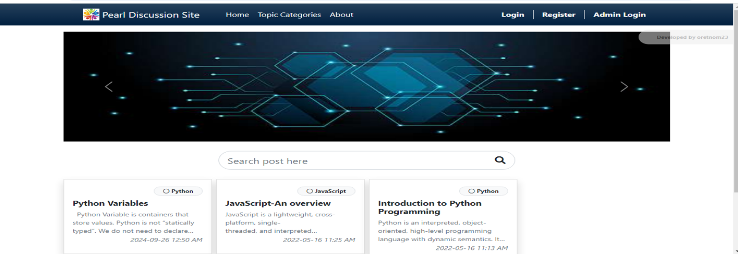

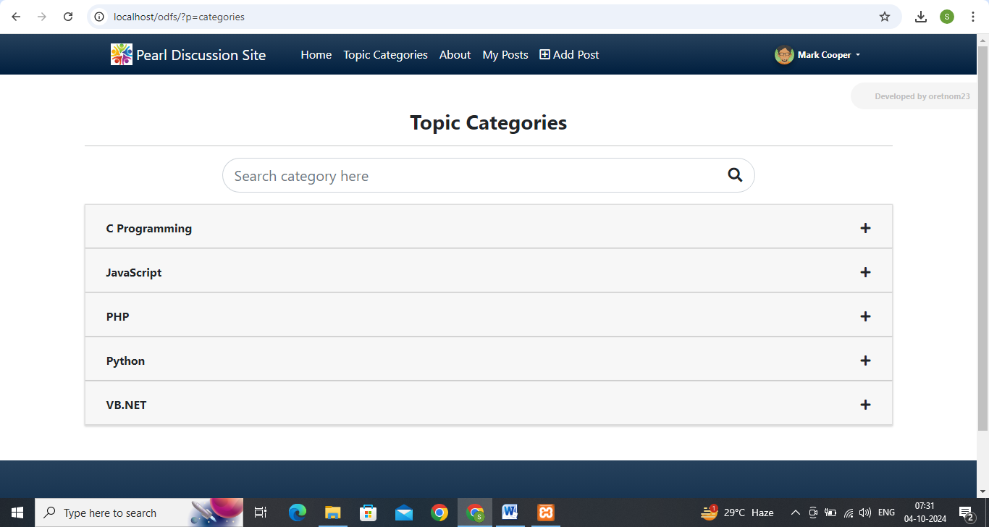

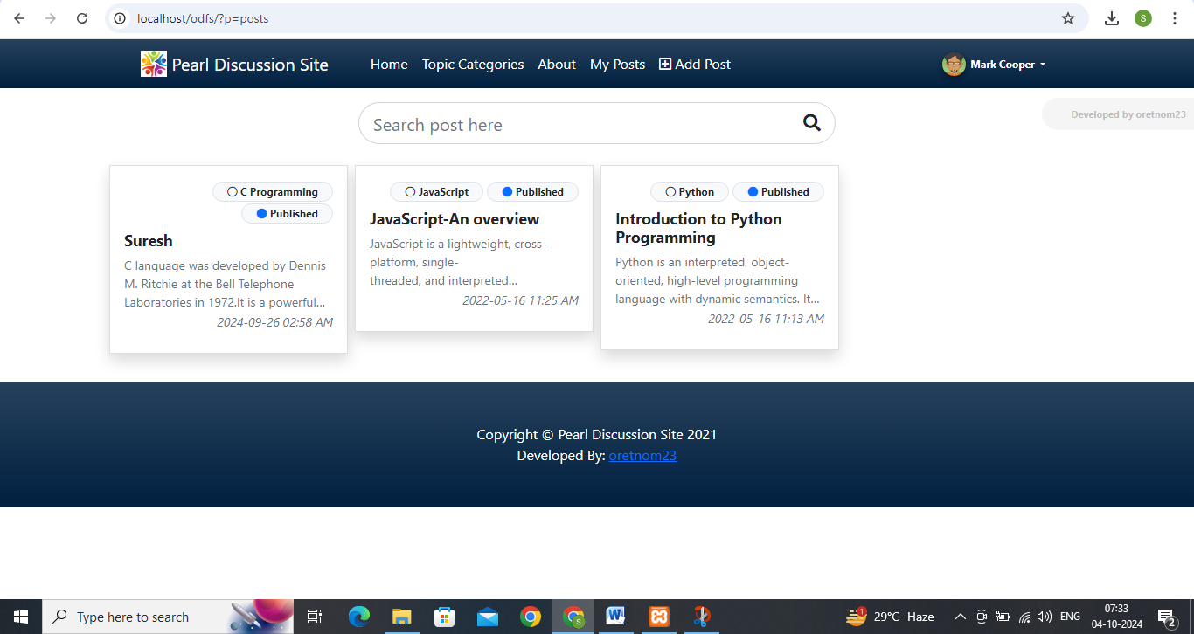



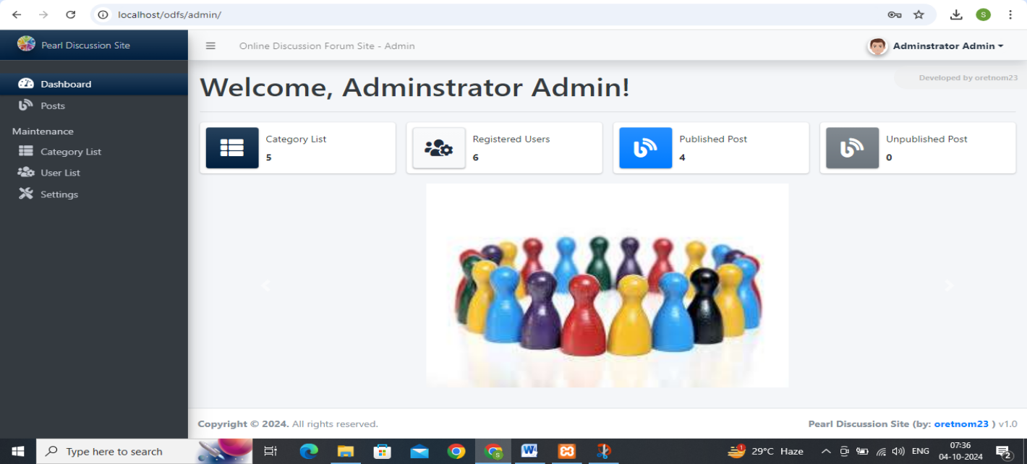

**12. SAMPLE CODING**

Index.php

<!DOCTYPE html>

<html lang="en">

<head>

<meta charset="utf-8" />

<meta name="viewport" content="width=device-width, initial-scale=1, shrink-to-fit=no" />

<meta name="description" content="" />

<meta name="author" content="" />

<title>Shop Homepage - Start Bootstrap Template</title>

<!-- Favicon-->

<link rel="icon" type="image/x-icon" href="assets/favicon.ico" />

<!-- Bootstrap icons-->

<link href="https://cdn.jsdelivr.net/npm/bootstrap-icons@1.5.0/font/bootstrap-icons.css" rel="stylesheet" />

<!-- Core theme CSS (includes Bootstrap)-->

<link href="css/styles.css" rel="stylesheet" />

</head>

<body>

<!-- Navigation-->

<nav class="navbar navbar-expand-lg navbar-light bg-light">

<div class="container px-4 px-lg-5">

<a class="navbar-brand" href="#!">Start Bootstrap</a>

<button class="navbar-toggler" type="button" data-bs-toggle="collapse" data-bs-target="#navbarSupportedContent" aria-controls="navbarSupportedContent" aria-expanded="false" aria-label="Toggle navigation"><span class="navbar-toggler-icon"></span></button>

<div class="collapse navbar-collapse" id="navbarSupportedContent">

<ul class="navbar-nav me-auto mb-2 mb-lg-0 ms-lg-4">

<li class="nav-item"><a class="nav-link active" aria-current="page" href="#!">Home</a></li>

<li class="nav-item"><a class="nav-link" href="#!">About</a></li>

<li class="nav-item dropdown">

<a class="nav-link dropdown-toggle" id="navbarDropdown" href="#" role="button" data-bs-toggle="dropdown" aria-expanded="false">Shop</a>

<ul class="dropdown-menu" aria-labelledby="navbarDropdown">

<li><a class="dropdown-item" href="#!">All Products</a></li>

<li><hr class="dropdown-divider" /></li>

<li><a class="dropdown-item" href="#!">Popular Items</a></li>

<li><a class="dropdown-item" href="#!">New Arrivals</a></li>

</ul>

</li>

</ul>

<form class="d-flex">

<button class="btn btn-outline-dark" type="submit">

<i class="bi-cart-fill me-1"></i>

Cart

<span class="badge bg-dark text-white ms-1 rounded-pill">0</span>

</button>

</form>

</div>

</div>

</nav>

<!-- Header-->

<header class="bg-dark py-5">

<div class="container px-4 px-lg-5 my-5">

<div class="text-center text-white">

<h1 class="display-4 fw-bolder">Shop in style</h1>

<p class="lead fw-normal text-white-50 mb-0">With this shop hompeage template</p>

</div>

</div>

</header>

<!-- Section-->

<section class="py-5">

<div class="container px-4 px-lg-5 mt-5">

<div class="row gx-4 gx-lg-5 row-cols-2 row-cols-md-3 row-cols-xl-4 justify-content-center">

<div class="col mb-5">

<div class="card h-100">

<!-- Product image-->

<img class="card-img-top" src="https://dummyimage.com/450x300/dee2e6/6c757d.jpg" alt="..." />

<!-- Product details-->

<div class="card-body p-4">

<div class="text-center">

<!-- Product name-->

<h5 class="fw-bolder">Fancy Product</h5>

<!-- Product price-->

$40.00 - $80.00

</div>

</div>

<!-- Product actions-->

<div class="card-footer p-4 pt-0 border-top-0 bg-transparent">

<div class="text-center"><a class="btn btn-outline-dark mt-auto" href="#">View options</a></div>

</div>

</div>

</div>

<div class="col mb-5">

<div class="card h-100">

<!-- Sale badge-->

<div class="badge bg-dark text-white position-absolute" style="top: 0.5rem; right: 0.5rem">Sale</div>

<!-- Product image-->

<img class="card-img-top" src="https://dummyimage.com/450x300/dee2e6/6c757d.jpg" alt="..." />

<!-- Product details-->

<div class="card-body p-4">

<div class="text-center">

<!-- Product name-->

<h5 class="fw-bolder">Special Item</h5>

<!-- Product reviews-->

<div class="d-flex justify-content-center small text-warning mb-2">

<div class="bi-star-fill"></div>

<div class="bi-star-fill"></div>

<div class="bi-star-fill"></div>

<div class="bi-star-fill"></div>

<div class="bi-star-fill"></div>

</div>

<!-- Product price-->

<span class="text-muted text-decoration-line-through">$20.00</span>

$18.00

</div>

</div>

<!-- Product actions-->

<div class="card-footer p-4 pt-0 border-top-0 bg-transparent">

<div class="text-center"><a class="btn btn-outline-dark mt-auto" href="#">Add to cart</a></div>

</div>

</div>

</div>

<div class="col mb-5">

<div class="card h-100">

<!-- Sale badge-->

<div class="badge bg-dark text-white position-absolute" style="top: 0.5rem; right: 0.5rem">Sale</div>

<!-- Product image-->

<img class="card-img-top" src="https://dummyimage.com/450x300/dee2e6/6c757d.jpg" alt="..." />

<!-- Product details-->

<div class="card-body p-4">

<div class="text-center">

<!-- Product name-->

<h5 class="fw-bolder">Sale Item</h5>

<!-- Product price-->

<span class="text-muted text-decoration-line-through">$50.00</span>

$25.00

</div>

</div>

<!-- Product actions-->

<div class="card-footer p-4 pt-0 border-top-0 bg-transparent">

<div class="text-center"><a class="btn btn-outline-dark mt-auto" href="#">Add to cart</a></div>

</div>

</div>

</div>

<div class="col mb-5">

<div class="card h-100">

<!-- Product image-->

<img class="card-img-top" src="https://dummyimage.com/450x300/dee2e6/6c757d.jpg" alt="..." />

<!-- Product details-->

<div class="card-body p-4">

<div class="text-center">

<!-- Product name-->

<h5 class="fw-bolder">Popular Item</h5>

<!-- Product reviews-->

<div class="d-flex justify-content-center small text-warning mb-2">

<div class="bi-star-fill"></div>

<div class="bi-star-fill"></div>

<div class="bi-star-fill"></div>

<div class="bi-star-fill"></div>

<div class="bi-star-fill"></div>

</div>

<!-- Product price-->

$40.00

</div>

</div>

<!-- Product actions-->

<div class="card-footer p-4 pt-0 border-top-0 bg-transparent">

<div class="text-center"><a class="btn btn-outline-dark mt-auto" href="#">Add to cart</a></div>

</div>

</div>

</div>

<div class="col mb-5">

<div class="card h-100">

<!-- Sale badge-->

<div class="badge bg-dark text-white position-absolute" style="top: 0.5rem; right: 0.5rem">Sale</div>

<!-- Product image-->

<img class="card-img-top" src="https://dummyimage.com/450x300/dee2e6/6c757d.jpg" alt="..." />

<!-- Product details-->

<div class="card-body p-4">

<div class="text-center">

<!-- Product name-->

<h5 class="fw-bolder">Sale Item</h5>

<!-- Product price-->

<span class="text-muted text-decoration-line-through">$50.00</span>

$25.00

</div>

</div>

<!-- Product actions-->

<div class="card-footer p-4 pt-0 border-top-0 bg-transparent">

<div class="text-center"><a class="btn btn-outline-dark mt-auto" href="#">Add to cart</a></div>

</div>

</div>

</div>

<div class="col mb-5">

<div class="card h-100">

<!-- Product image-->

<img class="card-img-top" src="https://dummyimage.com/450x300/dee2e6/6c757d.jpg" alt="..." />

<!-- Product details-->

<div class="card-body p-4">

<div class="text-center">

<!-- Product name-->

<h5 class="fw-bolder">Fancy Product</h5>

<!-- Product price-->

$120.00 - $280.00

</div>

</div>

<!-- Product actions-->

<div class="card-footer p-4 pt-0 border-top-0 bg-transparent">

<div class="text-center"><a class="btn btn-outline-dark mt-auto" href="#">View options</a></div>

</div>

</div>

</div>

<div class="col mb-5">

<div class="card h-100">

<!-- Sale badge-->

<div class="badge bg-dark text-white position-absolute" style="top: 0.5rem; right: 0.5rem">Sale</div>

<!-- Product image-->

<img class="card-img-top" src="https://dummyimage.com/450x300/dee2e6/6c757d.jpg" alt="..." />

<!-- Product details-->

<div class="card-body p-4">

<div class="text-center">

<!-- Product name-->

<h5 class="fw-bolder">Special Item</h5>

<!-- Product reviews-->

<div class="d-flex justify-content-center small text-warning mb-2">

<div class="bi-star-fill"></div>

<div class="bi-star-fill"></div>

<div class="bi-star-fill"></div>

<div class="bi-star-fill"></div>

<div class="bi-star-fill"></div>

</div>

<!-- Product price-->

<span class="text-muted text-decoration-line-through">$20.00</span>

$18.00

</div>

</div>

<!-- Product actions-->

<div class="card-footer p-4 pt-0 border-top-0 bg-transparent">

<div class="text-center"><a class="btn btn-outline-dark mt-auto" href="#">Add to cart</a></div>

</div>

</div>

</div>

<div class="col mb-5">

<div class="card h-100">

<!-- Product image-->

<img class="card-img-top" src="https://dummyimage.com/450x300/dee2e6/6c757d.jpg" alt="..." />

<!-- Product details-->

<div class="card-body p-4">

<div class="text-center">

<!-- Product name-->

<h5 class="fw-bolder">Popular Item</h5>

<!-- Product reviews-->

<div class="d-flex justify-content-center small text-warning mb-2">

<div class="bi-star-fill"></div>

<div class="bi-star-fill"></div>

<div class="bi-star-fill"></div>

<div class="bi-star-fill"></div>

<div class="bi-star-fill"></div>

</div>

<!-- Product price-->

$40.00

</div>

</div>

<!-- Product actions-->

<div class="card-footer p-4 pt-0 border-top-0 bg-transparent">

<div class="text-center"><a class="btn btn-outline-dark mt-auto" href="#">Add to cart</a></div>

</div>

</div>

</div>

</div>

</div>

</section>

<!-- Footer-->

<footer class="py-5 bg-dark">

<div class="container"><p class="m-0 text-center text-white">Copyright &copy; Your Website 2021</p></div>

</footer>

<!-- Bootstrap core JS-->

<script src="https://cdn.jsdelivr.net/npm/bootstrap@5.0.1/dist/js/bootstrap.bundle.min.js"></script>

<!-- Core theme JS-->

<script src="js/scripts.js"></script>

</body>

</html>