RAMANUJAN COLLEGE
UNIVERSITY OF DELHI

COMPUTER NETWORK PRACTICALS

SUBMITTED TO –
MS SHEETAL

SUBMITTED BY –
NAME – Harsh Tanwar
COURSE – B.S.C (HONS) COMPUTER SCIENCE
COLLEGE ROLL NO. – 24570024
UNIVERSITY ROLL NO. – 24020570036

Acknowledgement

I would like to express my sincere gratitude to my subject teacher for their continuous guidance, support, and
encouragement throughout the completion of this project on Computer Networks. Their valuable insights and constructive feedback helped me understand the concepts more clearly and complete this work effectively.
I am also thankful to my college, University of Delhi, for
providing the necessary resources and a conducive learning environment that made this project possible.
I extend my appreciation to my classmates and friends for their cooperation, suggestions, and discussions, which contributed to improving my understanding of the subject.
Lastly, I would like to thank my family for their constant support and motivation, which encouraged me to complete this project successfully.

PRACTICALS
Q1. To Study basic network command and Network configuration commands
ifconfig
ip addr
ip route
ping -c 4 8.8.8.8
traceroute google.com
nslookup google.com
ss -tuln
arp -a
hostname
hostname -I
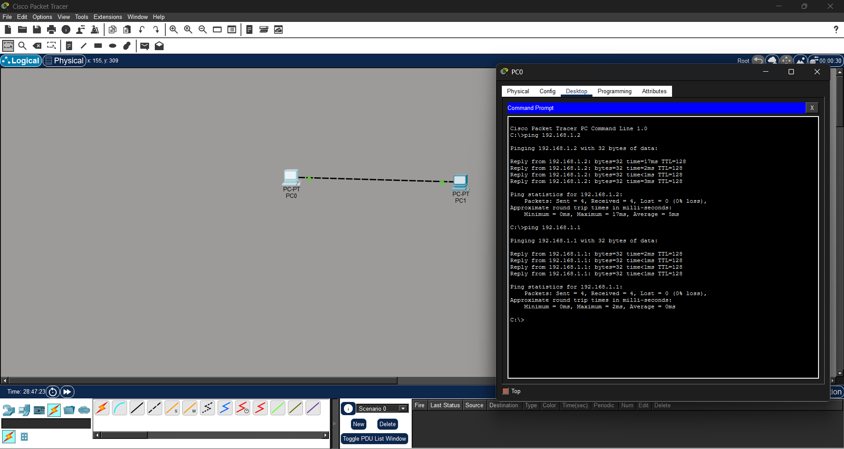

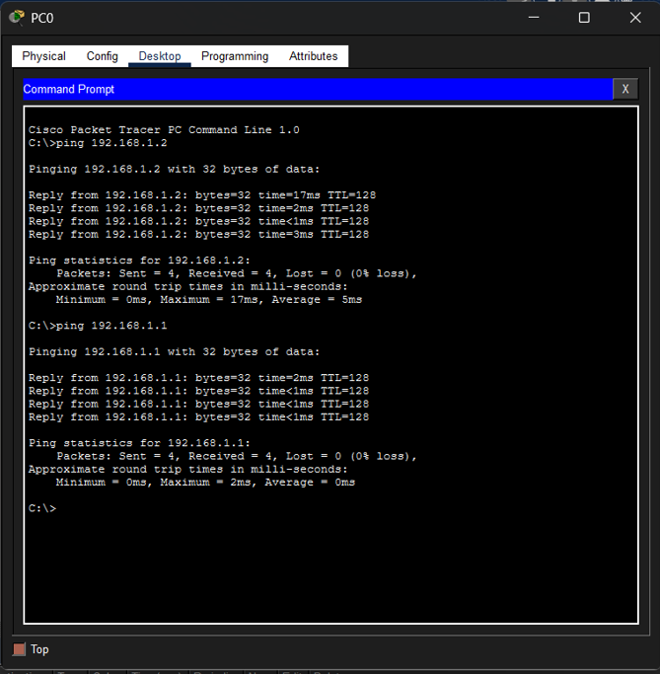

Q2. To study and perform PC to PC communication.
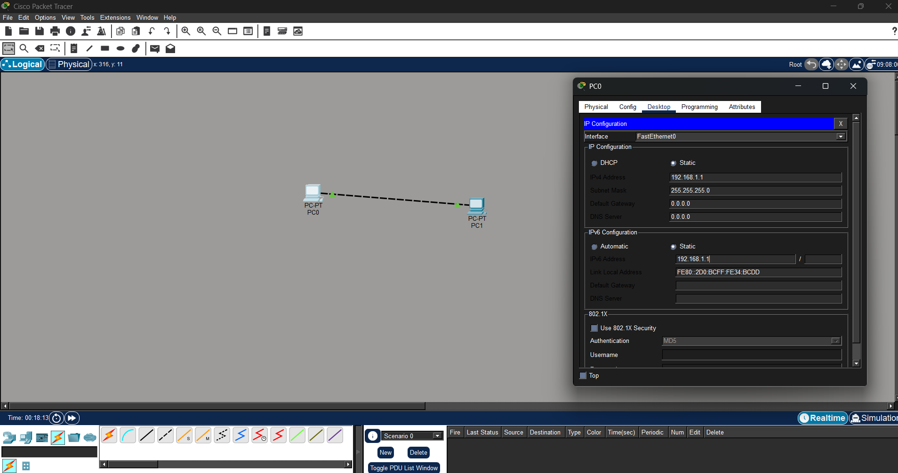
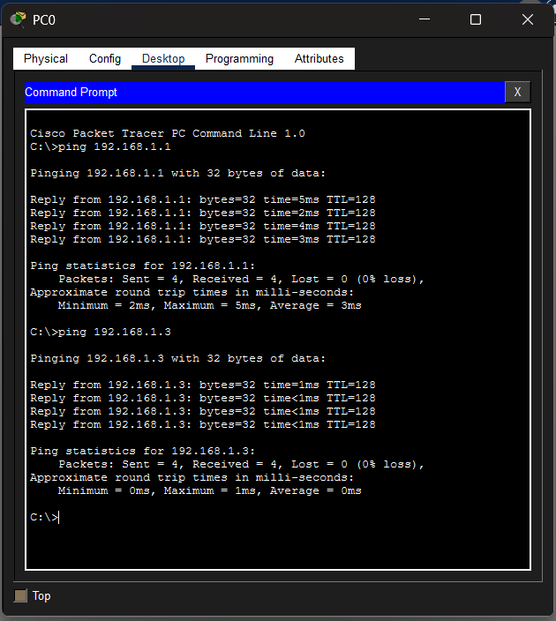

Q3. To create Star topology using Hub and Switch.
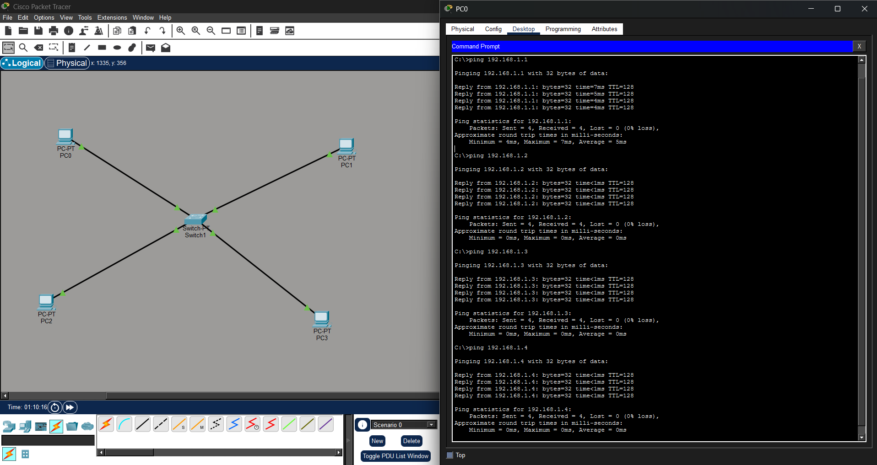
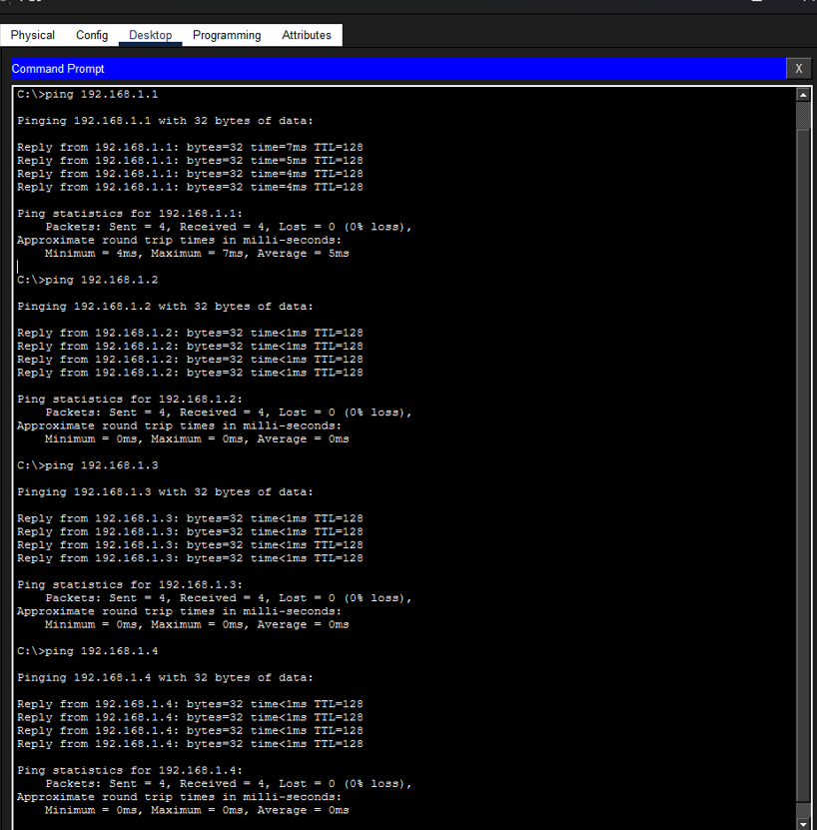

Q4. To create Bus, Ring, Tree, Hybrid, Mesh topologies.
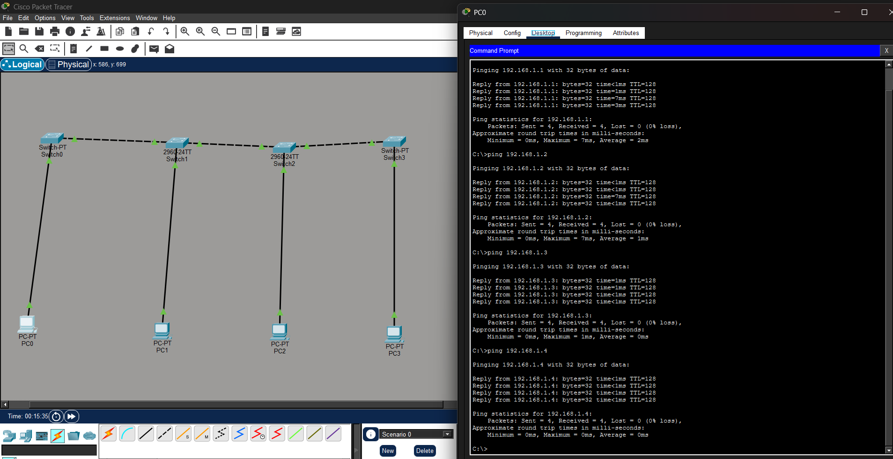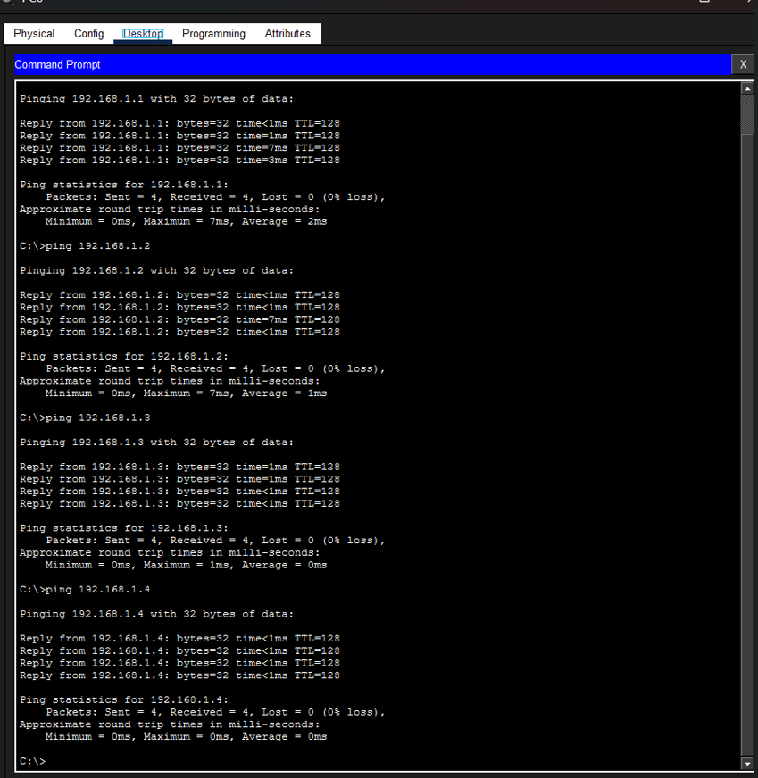

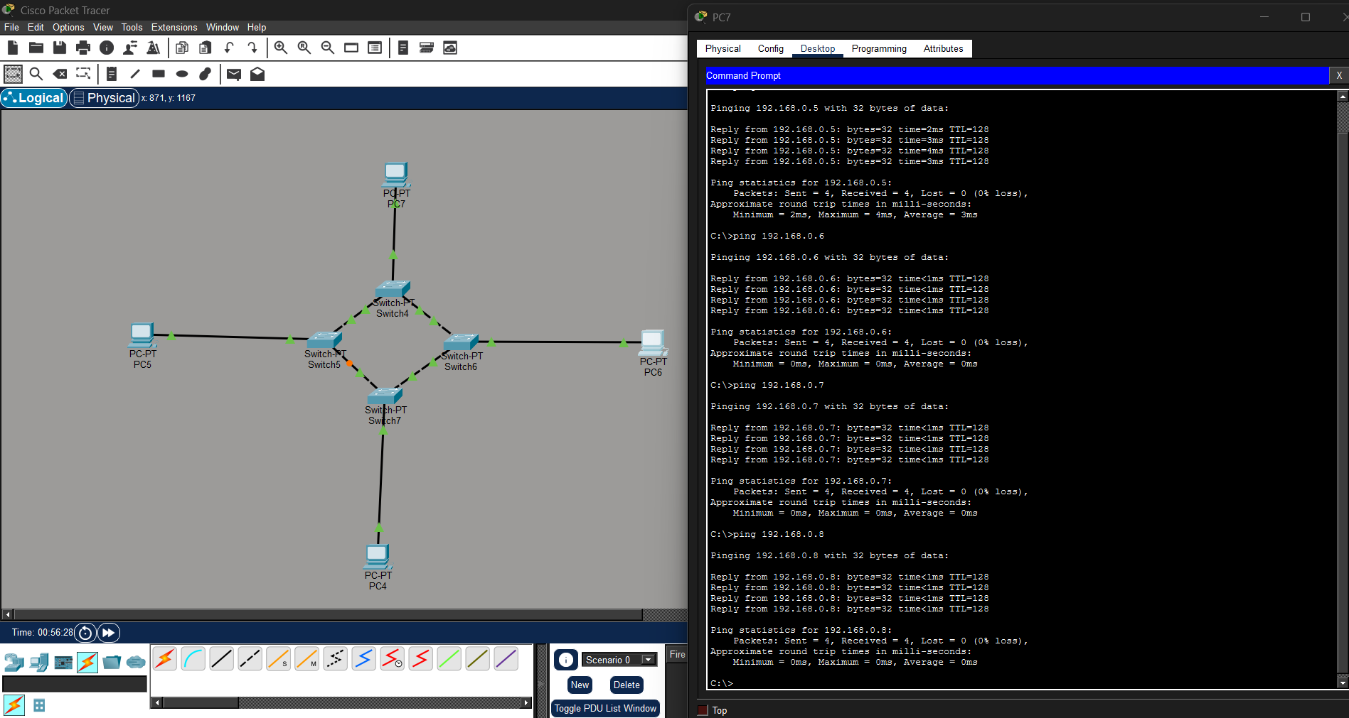
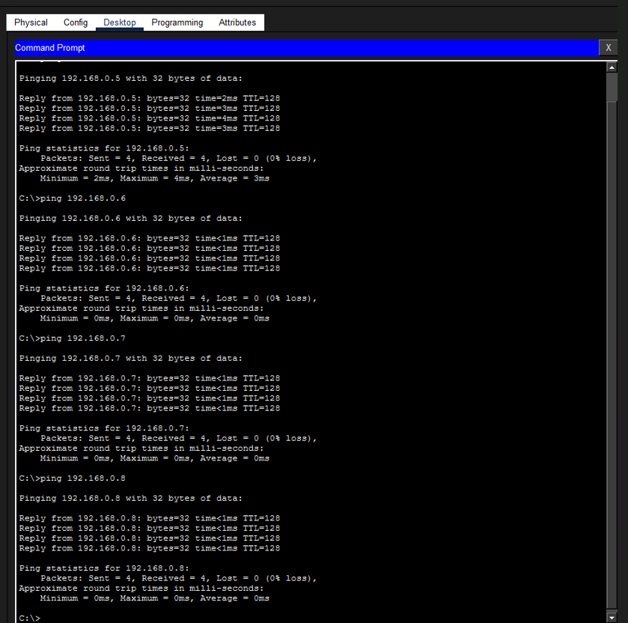

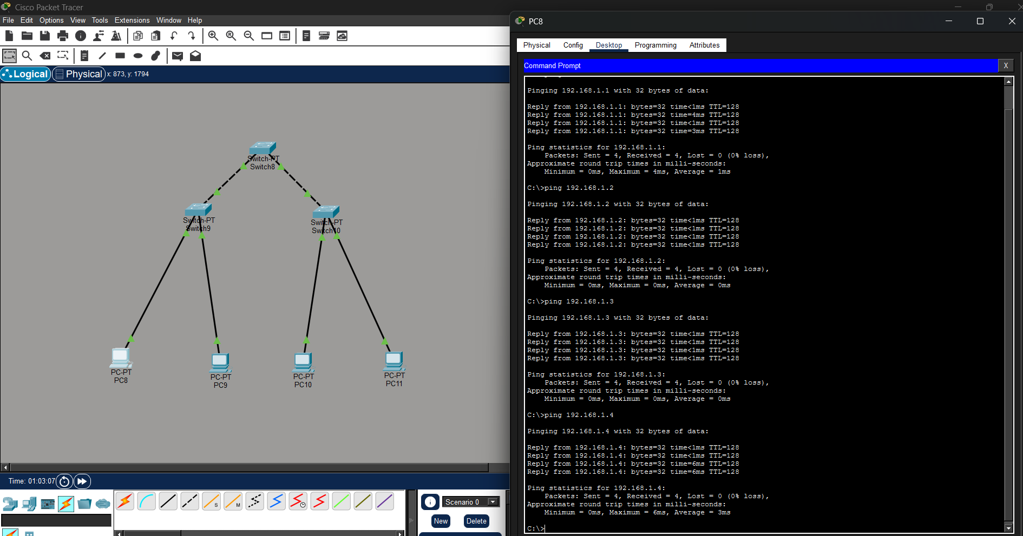
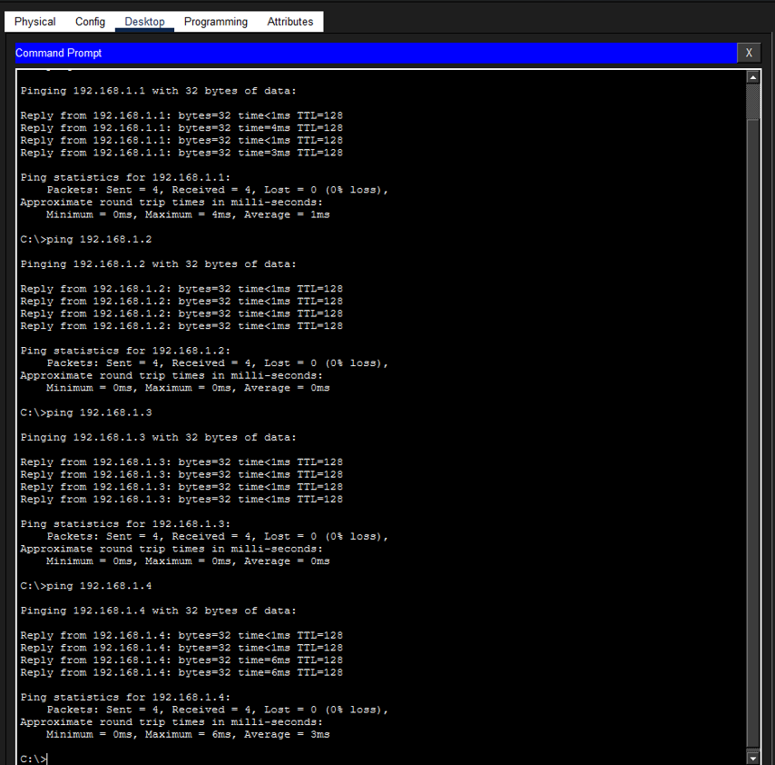

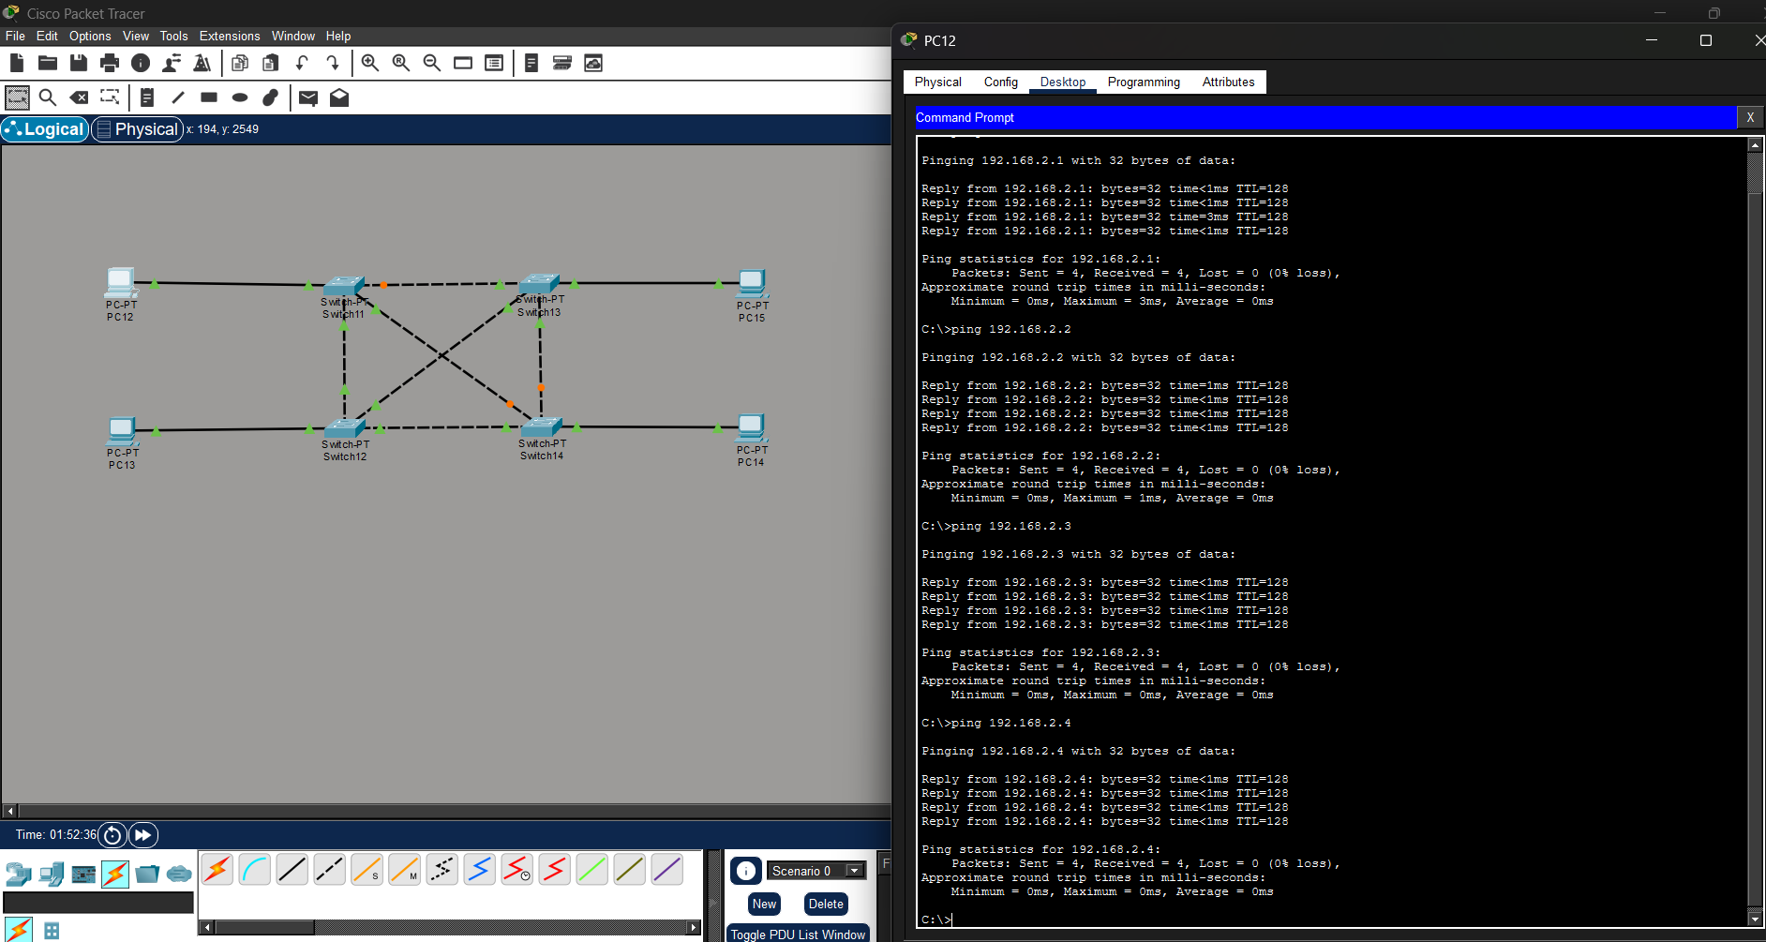
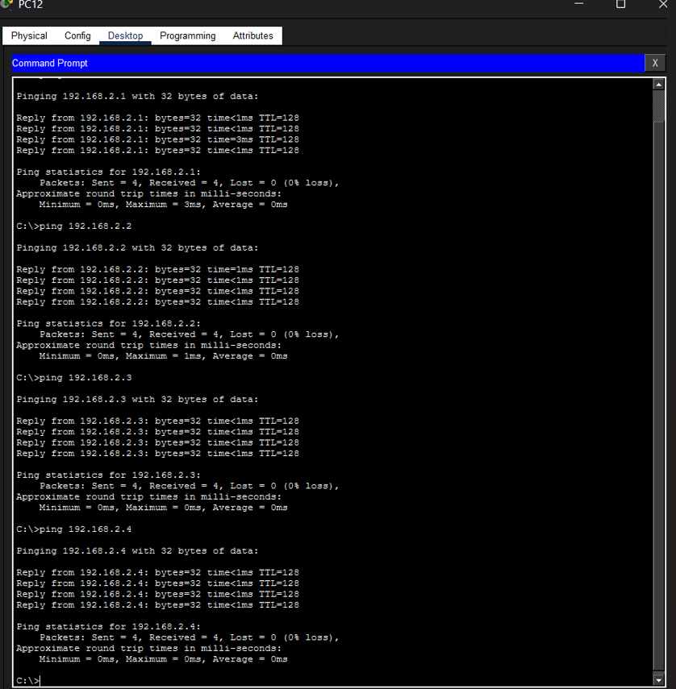

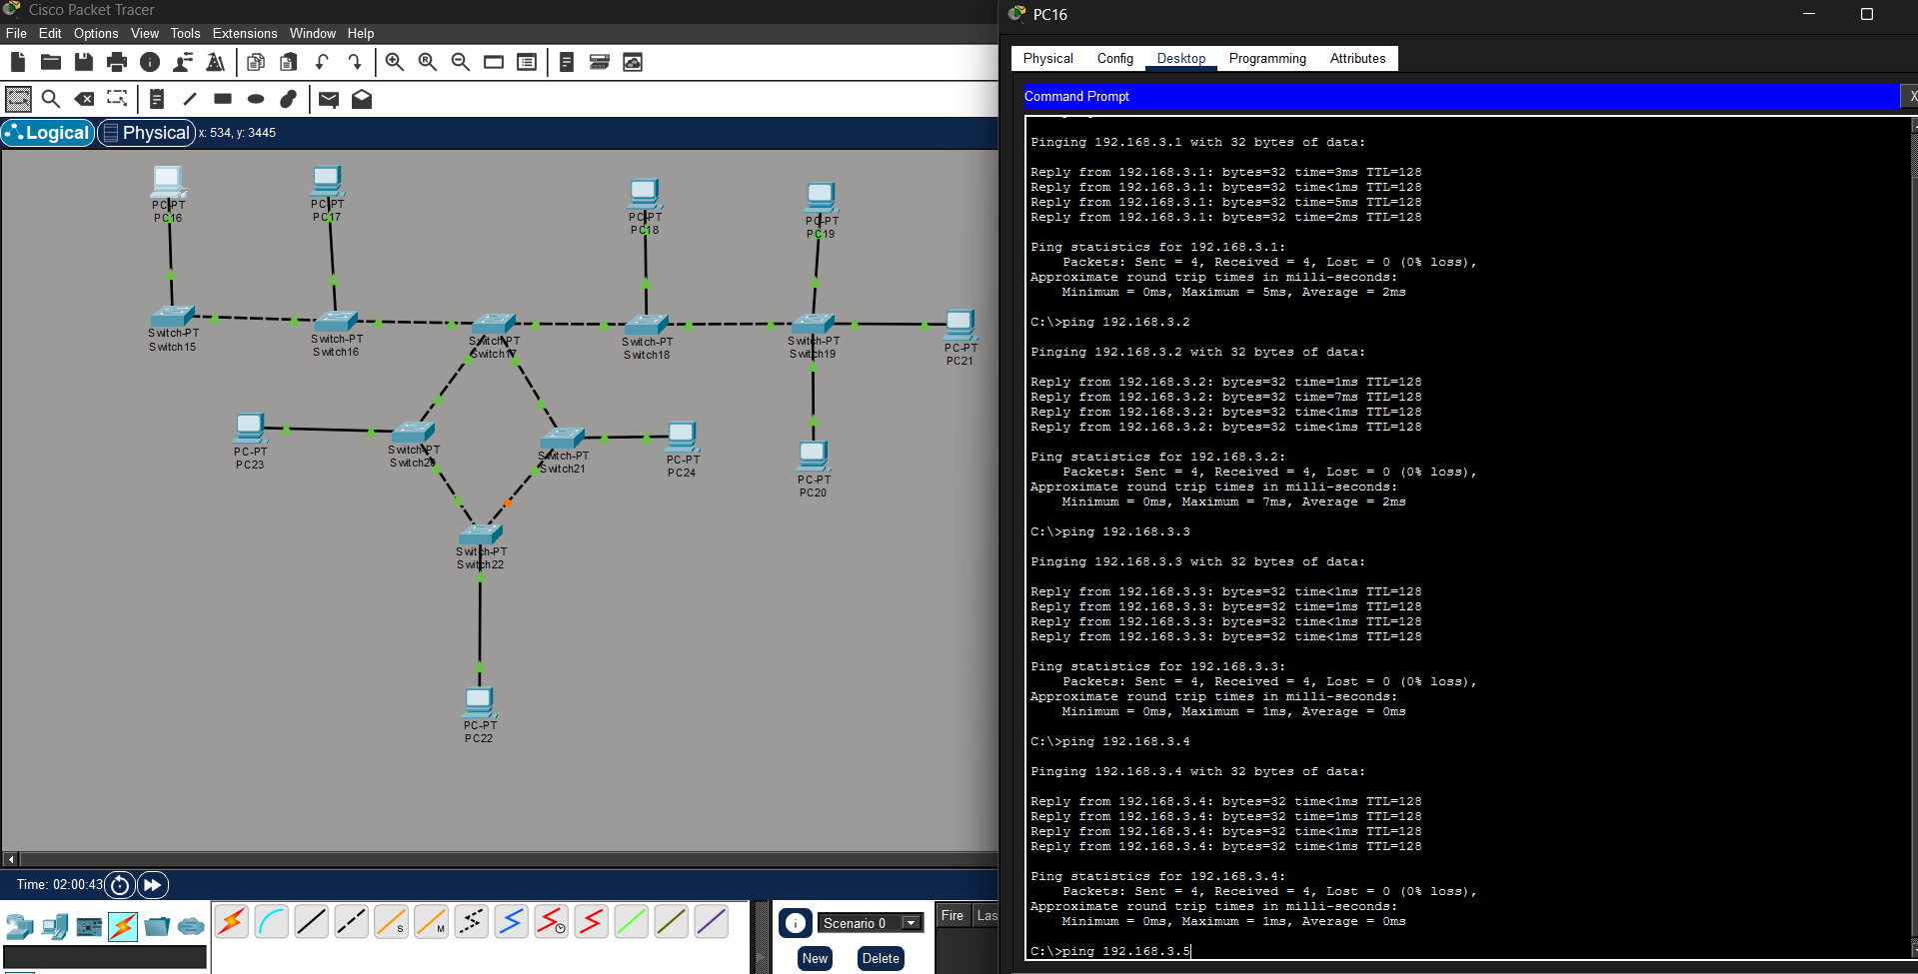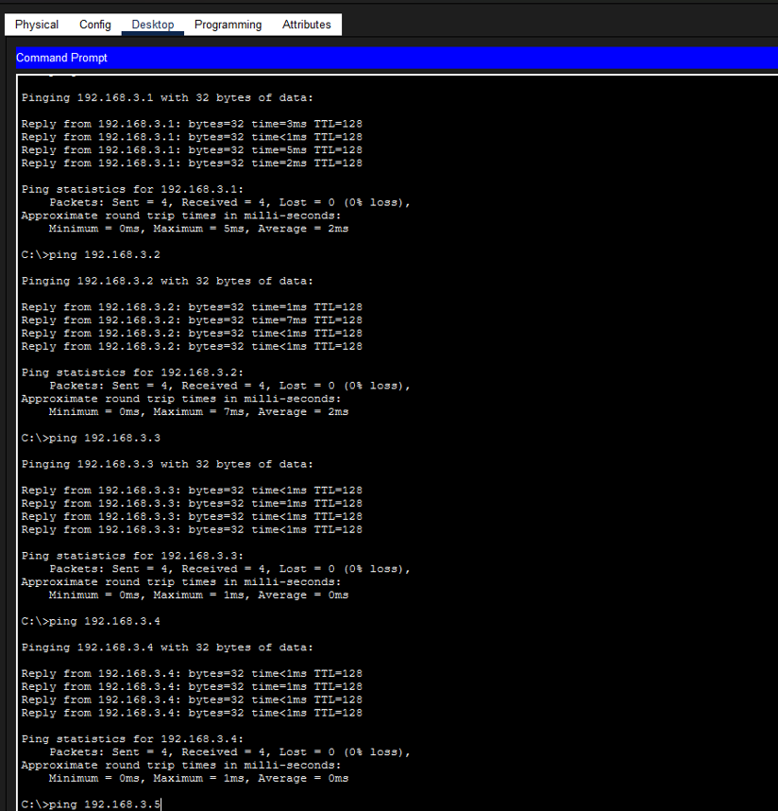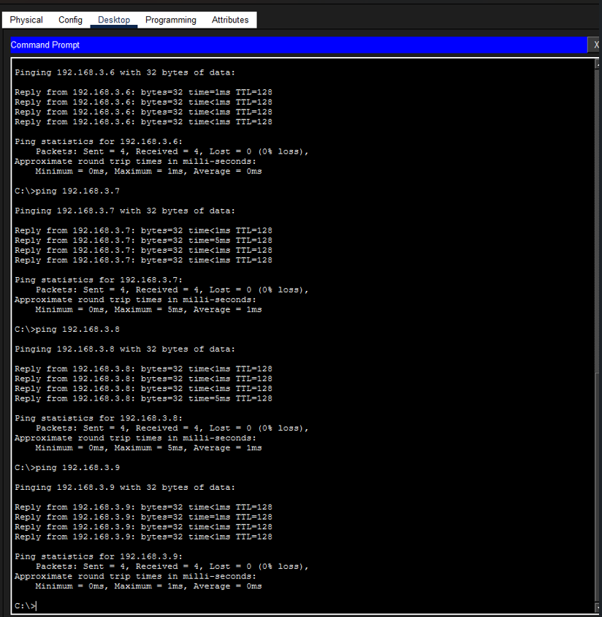
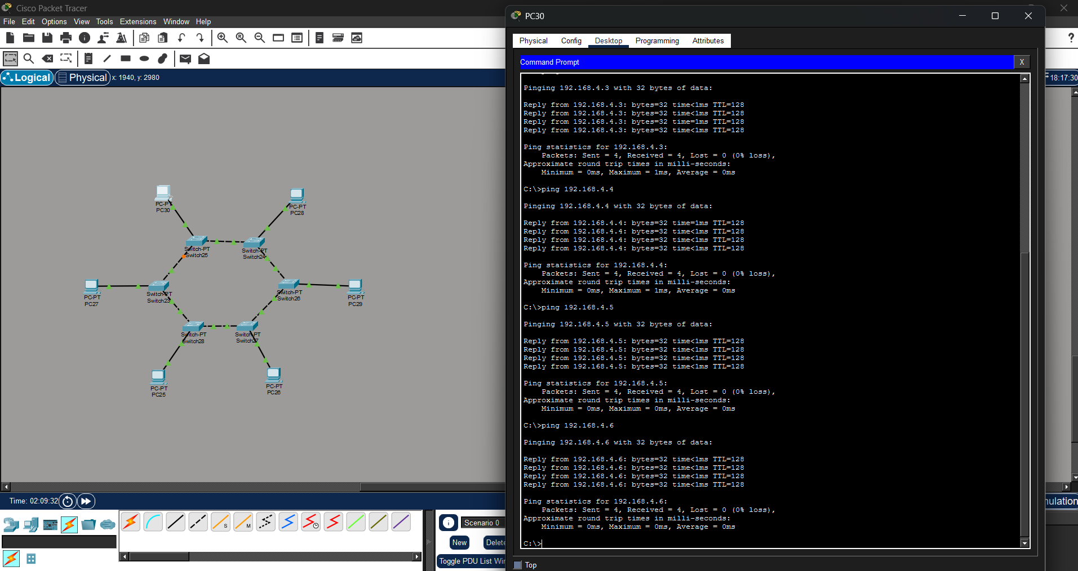
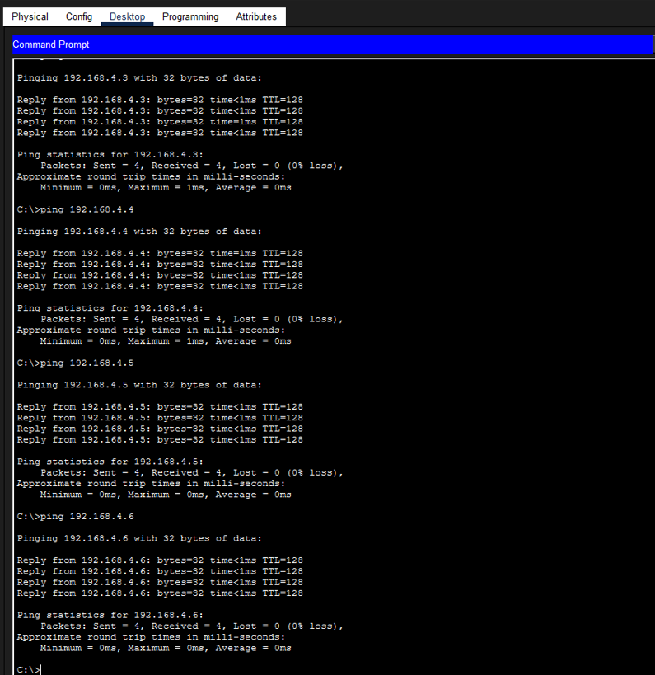
Q5. Perform an initial Switch configuration.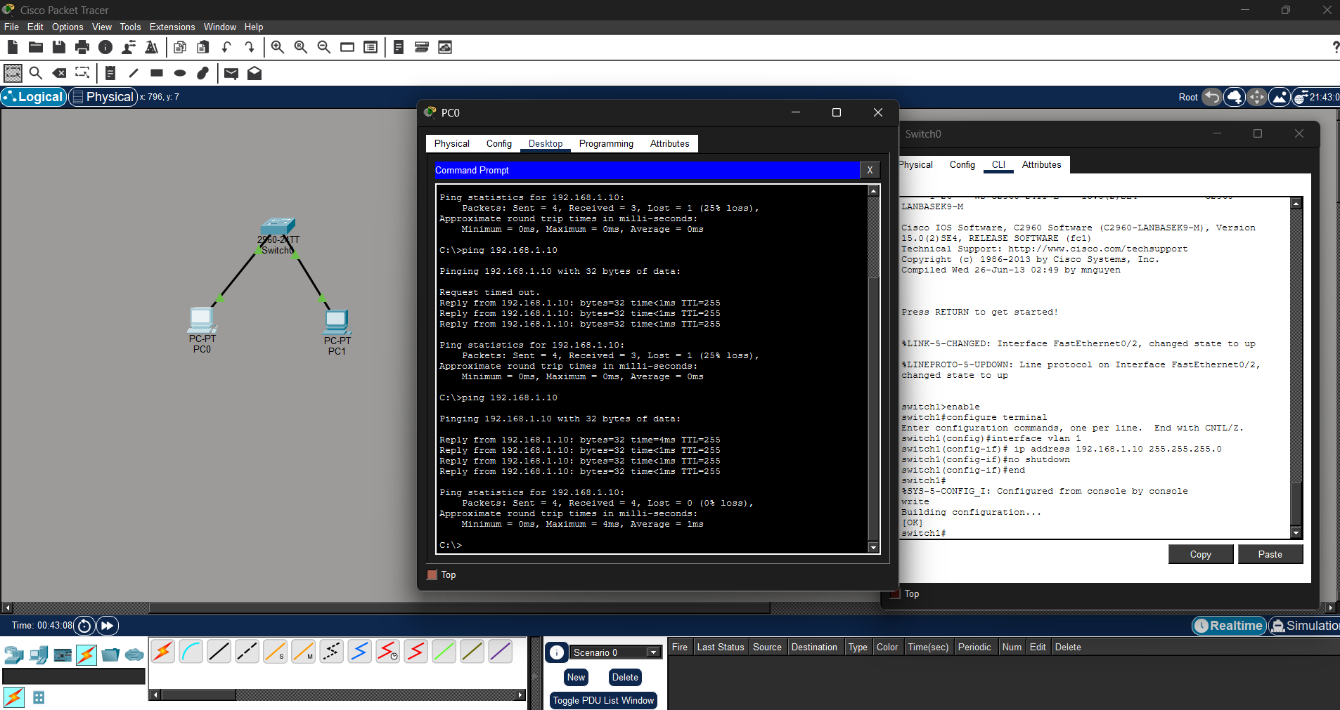 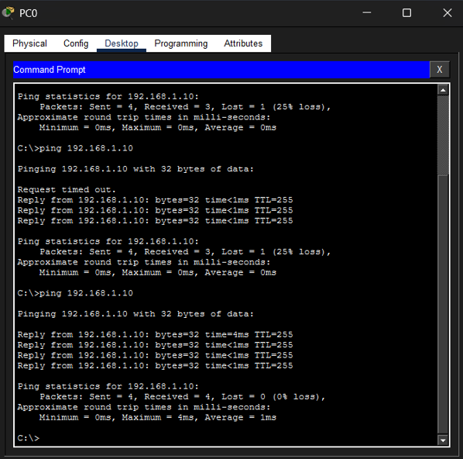 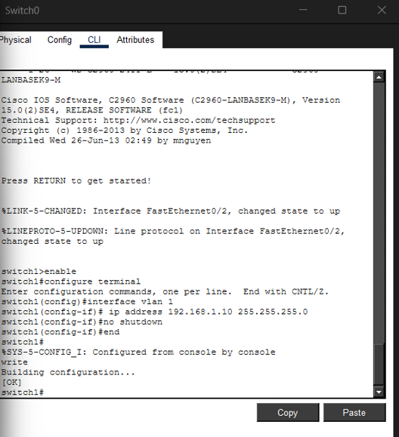

Q6. Perform an initial Router configuration.
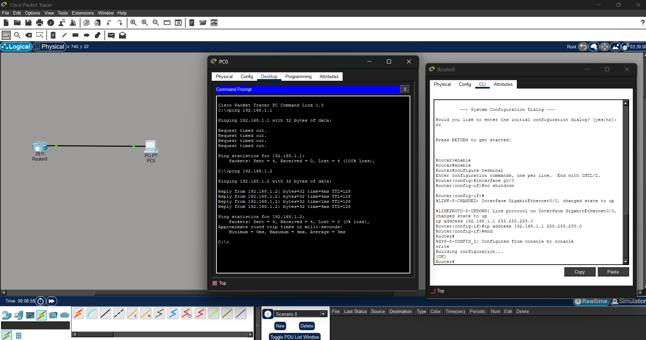
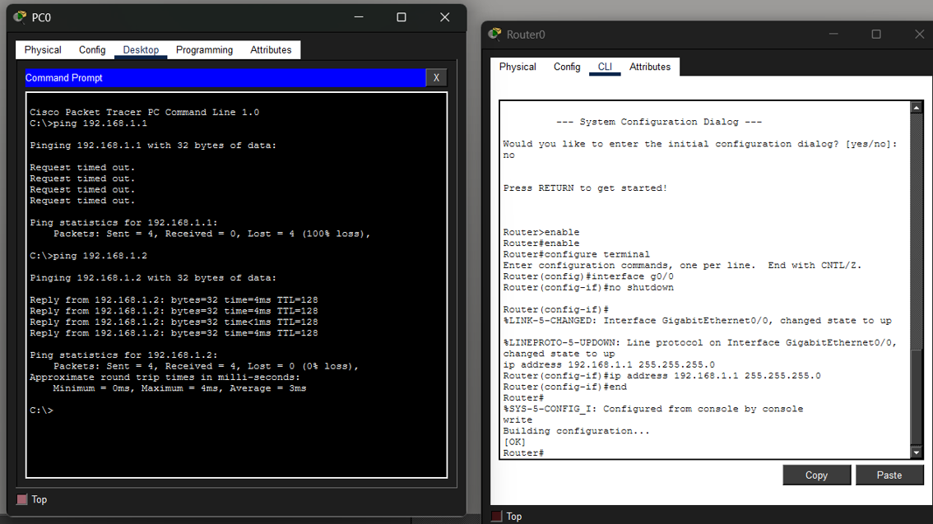

Q7. To implement Client Server Network.
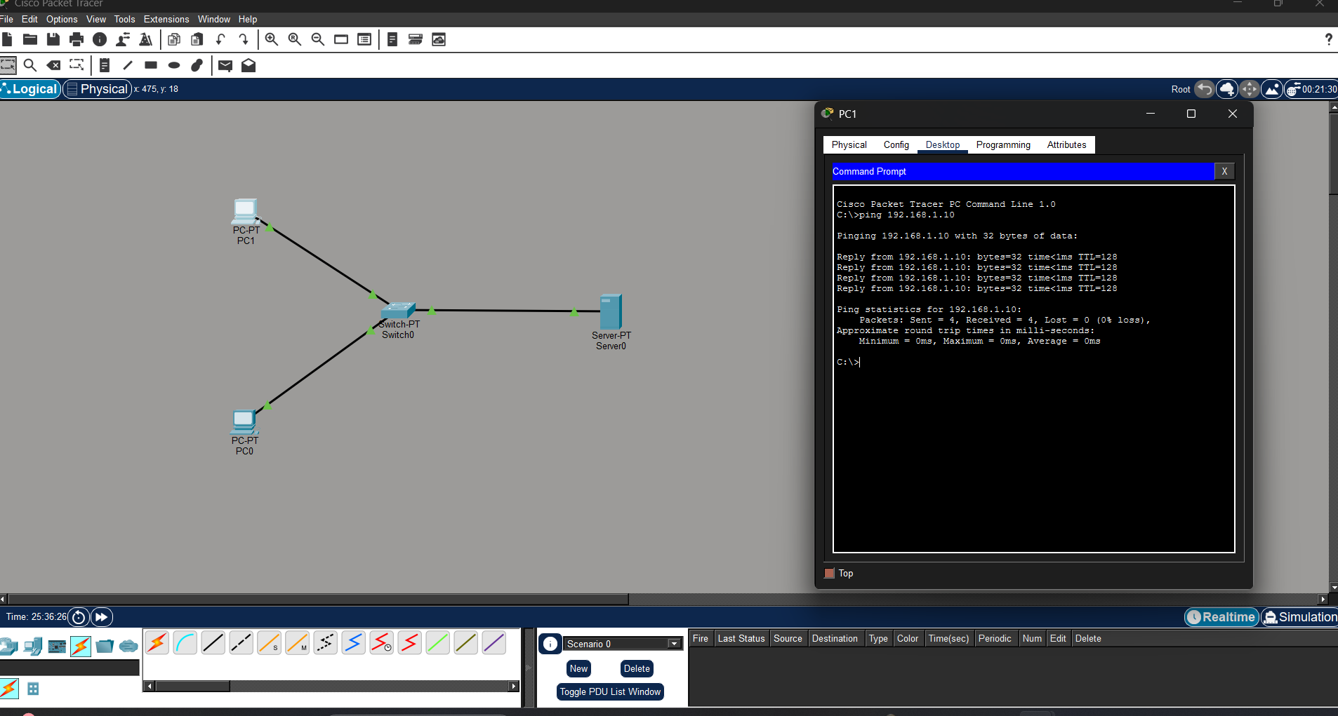
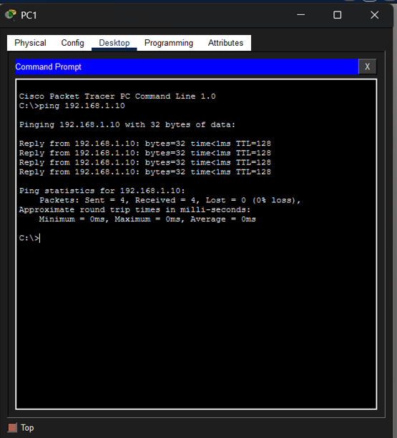
Q8. To implement connection between devices using a router.
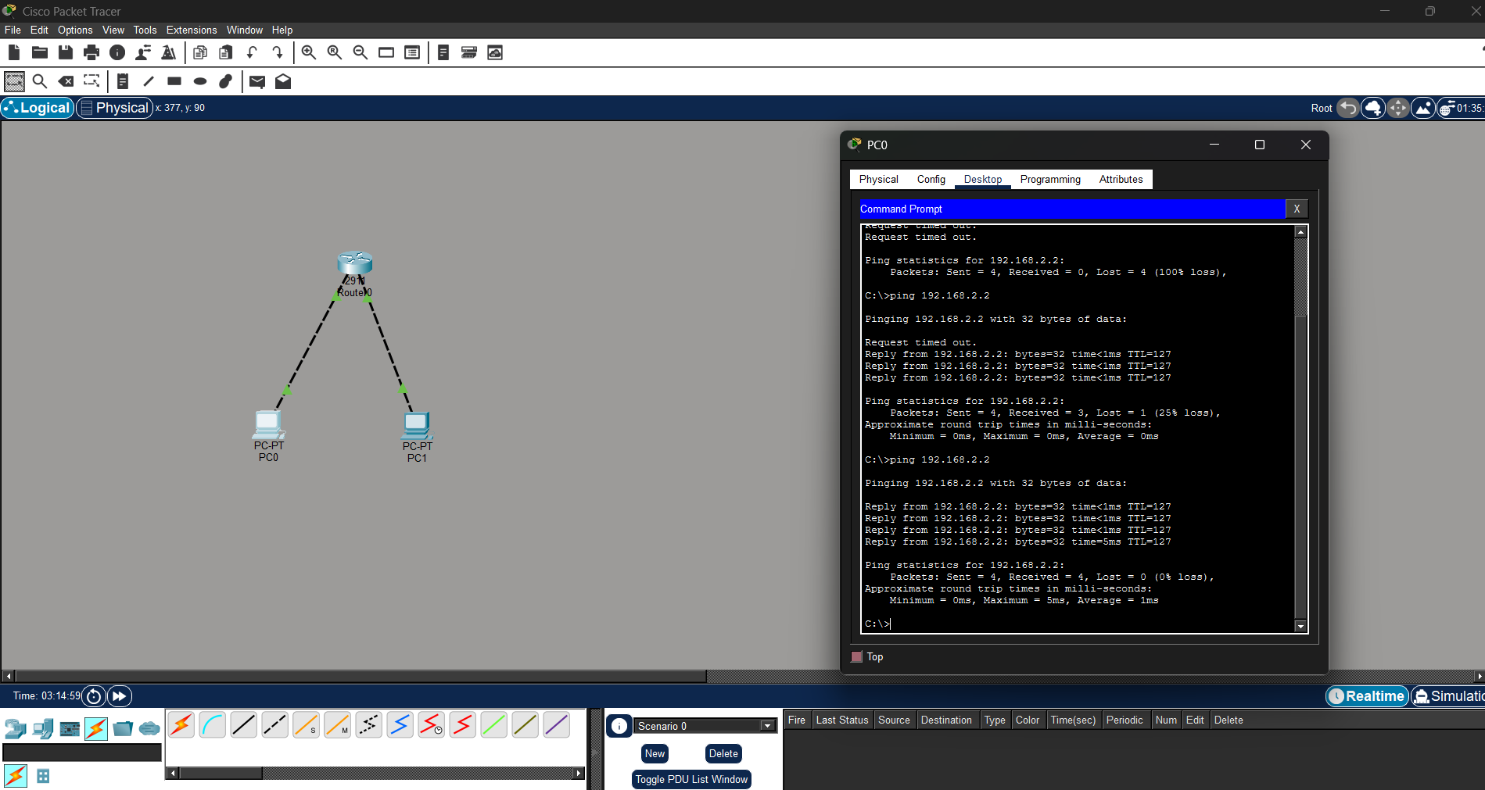
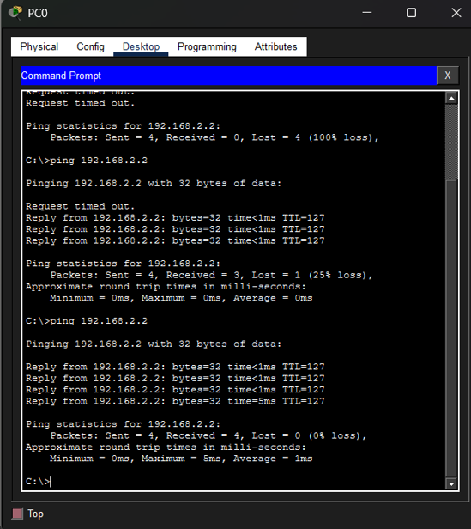
Q9. To perform remote desktop sharing within LAN connection.
