Campus Sports

Software Requirements Specification

Course Code: CSE494
Course Name: Intelligent NoSQL Databases

Student Names: Harshit Sharma
12313696

TABLE OF CONTENTS
- [1. INTRODUCTION]
- [1.1 Purpose]
- [1.2 Scope]
- [1.3 Definitions, Acronyms, and Abbreviations]
- [1.4 References]
- [1.5 Overview]
- [2. GENERAL DESCRIPTION]
- [2.1 Product Perspective]
- [2.2 Product Functions]
- [2.3 User Characteristics]
- [2.4 General Constraints]
- [2.5 Assumptions and Dependencies]
- [3. SPECIFIC REQUIREMENTS]
- [3.1 External Interface Requirements]
- [3.1.1 User Interfaces (UI Architecture & Screen Layouts)]
- [3.1.2 Hardware Interfaces]
- [3.1.3 Software Interfaces]
- [3.1.4 Communications Interfaces]
- [3.2 Functional Requirements]
- [3.2.1 User Authentication, Registration & Session Invalidation]
- [3.2.2 Real-time Slot Availability & Dynamic Grid Computation]
- [3.2.3 Atomic Conflict-Free Reservation Engine]
- [3.2.4 Policy-Aware Booking Cancellation System]
- [3.2.5 Sports Taxonomy & Dynamic Parametric Metadata Schema]
- [3.2.6 Facilities Operations & Parametric Catalog Management]
- [3.2.7 In-App Notification Dispatch & TTL Expiry]
- [3.2.8 Administrative Central Dispatch Operations & Schedule Matrix]
- [3.2.9 High-Density Administrative Bookings Roster Management]
- [3.2.10 Server-Side Analytical Intelligence & Aggregation Pipelines]
- [3.2.11 User Directory, Active State Governance & Session Invalidation]
- [3.3 Non-Functional Requirements]
- [3.3.1 Performance]
- [3.3.2 Reliability]
- [3.3.3 Availability]
- [3.3.4 Security]
- [3.3.5 Maintainability]
- [3.3.6 Portability]
- [3.4 Design Constraints]
- [3.5 Other Requirements]
- [4. ANALYSIS MODELS]
- [4.1 Data Flow Diagrams (DFD)]
- [Context Level (Level 0) DFD]
- [Level 1 DFD (Decomposed System Architecture)]
- [Level 2 DFD (Reservation & Concurrency Lock Subsystem)]
- [Entity-Relationship Diagram (ERD / Collection Relational Model)]
- [State Transition Diagram (Booking Lifecycle)]
- [5. GITHUB LINK]
- [A. APPENDICES]
- [A.1 Appendix 1: Database Collection Schemas, Indexes & REST API Specifications]
- [A.2 Appendix 2: Field & Court Design System Tokens & UI Specifications]

1. INTRODUCTION

1.1 Purpose
This Software Requirements Specification (SRS) establishes the complete functional, behavioral, performance, and architectural requirements for the Campus Sports Management & Facilities Booking Portal.
The intended audience for this document includes:
- Software Engineers & Developers: To guide implementation, verify system architecture, and enforce database concurrency invariants.
- Quality Assurance & Verification Teams: To construct test matrices, automated integration suites, and stress tests for race-condition prevention.
- University Athletics Administration & Facility Managers: To audit functional workflows, access control policies, turnstile entry mechanisms, and business rule enforcement.
- Academic Project Evaluators: To evaluate system compliance with software engineering rigors, architectural patterns, and IEEE 830-1998 standards for CA-3.

1.2 Scope
The software product produced is Campus Sports, a high-performance web platform designed to eradicate administrative friction in collegiate athletic infrastructure.

What the Software Product Will Do:
- Provide students with real-time, minute-precise slot availability across all campus sports venues (badminton courts, basketball arenas, outdoor football pitches, tennis hardcourts, and Olympic swimming pools).
- Enable students to complete a confirmed, collision-free court reservation in under 30 seconds.
- Enforce strict zero double-booking guarantees using atomic database-level partial unique constraints, preventing race conditions during peak registration windows.
- Automatically generate verifiable contactless turnstile QR gate passes and cryptographic tokens for authorized student venue admission.
- Provide athletic administrators with a live Central Dispatch Console featuring a multi-court 16-hour schedule matrix, real-time roster attendance monitoring, instant blockout overrides (for varsity practices/maintenance), user directory governance, and server-side aggregation analytics.
- Enforce fair-play collegiate usage quotas: maximum 5 active concurrent reservations per student, 14-day advance booking windows, and a 60-minute cancellation cutoff.

What the Software Product Will Not Do:
- The system will not process monetary transactions or fee collections, as university facilities are chartered under tuition-funded student activity privileges.
- The system will not directly manage physical turnstile motorized actuators; instead, it interfaces via secure RESTful gate-token verification endpoints that local turnstile IoT optical controllers query.
- The system will not act as a general social media messaging network; peer invitations generate sharable access passes rather than persistent unstructured chat channels.

Objectives and Measurable Goals:
- Deterministic Concurrency: 100% prevention of duplicate bookings for the identical facility and start time, even under sub-millisecond concurrent requests.
- Sub-second Response Times: 95% of API transactions processed in under 120 ms; availability matrix queries served in under 45 ms.
- High Operational Efficiency: Reduction of manual athletic desk overhead by over 90% via automated turnstile pass dispatch and instant cancellation reassignment.

1.3 Definitions, Acronyms, and Abbreviations
Term / Acronym | Definition
SRS | Software Requirements Specification
API | Application Programming Interface
REST | Representational State Transfer
JWT | JSON Web Token (RFC 7519)
Argon2id | Memory-hard password hashing algorithm (RFC 9106)
TTL | Time-To-Live (automated database index expiration)
DFD | Data Flow Diagram
ERD | Entity-Relationship Diagram
Partial Unique Index | A database index that enforces uniqueness exclusively on documents matching a specified filter predicate
Campus-Local Time | Wall-clock time of the physical university campus (standardized to Asia/Kolkata / UTC+05:30)

1.4 References
- IEEE Std 830-1998: IEEE Recommended Practice for Software Requirements Specifications.
- RFC 7519: JSON Web Token (JWT), Internet Engineering Task Force (IETF).
- RFC 9106: Argon2 Password Hashing Function.
- Next.js 15 & React 19 Architecture Manual, Vercel Documentation (2025).
- FastAPI Framework Documentation, Sebastián Ramírez (tiangolo), Linux Foundation.
- MongoDB Manual: Indexes, Partial Indexes, and Aggregation Pipeline Optimization.
- Field & Court Design Specification, Google Stitch Design Token Guidelines (2025).

1.5 Overview
The remainder of this document is organized into four main sections:
- Section 2 (General Description): Explores the high-level context, user personas, operational constraints, and technical assumptions governing the software.
- Section 3 (Specific Requirements): Detailed external interface requirements (complete with screen layout descriptions and screenshot headings), comprehensive functional requirement breakdowns, and measurable non-functional metrics.
- Section 4 (Analysis Models): Formal architectural models including Context (Level 0), Level 1, and Level 2 Data Flow Diagrams, Entity-Relationship Models, and State Lifecycle Diagrams.
- Sections 5–6 and Appendices: Repository and deployment references, database collection definitions, and design token specifications.

2. GENERAL DESCRIPTION

2.1 Product Perspective
Campus Sports is an autonomous, self-contained, cloud-native web platform operating within the university's digital ecosystem. It interfaces upstream with student single-sign-on credentials and downstream with physical venue turnstile gate scanners.
+-------------------------------------------------------------------------------+
| UNIVERSITY CAMPUS NETWORK |
| |
| +---------------------+ HTTPS / REST +--------------------------+ |
| | Student Smartphone /| <====================> | Next.js 15 Frontend | |
| | Laptop Browser | JSON Web Tokens | (Field & Court Design) | |
| +---------------------+ +--------------------------+ |
| || |
| Internal API Proxy |
| || |
| \/ |
| +---------------------+ HTTPS / REST +--------------------------+ |
| | Admin Dispatch | <====================> | FastAPI Backend | |
| | Laptop Console | | (Python 3.12, AsyncIO) | |
| +---------------------+ +--------------------------+ |
| || |
| Async PyMongo Client |
| || |
| \/ |
| +---------------------+ TCP / Auth TLS +--------------------------+ |
| | Turnstile Gate IoT | <====================> | MongoDB Database | |
| | Optical Scanners | | (Partial Unique Indexes) | |
| +---------------------+ +--------------------------+ |
+-------------------------------------------------------------------------------+
The system operates as a monorepo consisting of:
- Backend Application: FastAPI (Python 3.12) utilizing asynchronous I/O (AsyncMongoClient), strict schema validation via Pydantic v2, and server-side aggregation pipelines.
- Frontend Application: Next.js 15 (React 19, TypeScript) utilizing Tailwind CSS v4, TanStack Query v5 for asynchronous server-state synchronization, and the "Field & Court" design system.
- Database Store: MongoDB 6.0+ utilizing memory-optimized indexes, partial uniqueness filtering, and automated TTL cleanup.

2.2 Product Functions
The high-level capabilities of Campus Sports are categorized into student and administrative functions:

Student Capabilities:
- Instant Discovery & Filtering: Interactive visual browsing of 8 campus venues across 6 sporting disciplines, with real-time filtering by sport, court surface (wooden sprung, synthetic matting, hardcourt), lighting grade, and air conditioning.
- Dynamic Slot Timetable: Selection of booking dates across a 14-day rolling window, presenting 30-to-120 minute discrete time slots reflecting live operational availability.
- Conflict-Free Reservation: Single-tap slot booking with atomic conflict detection, confirming reservations in under 30 seconds.
- Contactless Turnstile Gate Passes: Procedural high-contrast vector QR pass generation with unique token identifiers (CSP-2025-...) for contactless gate turnstile admittance.
- Self-Service Booking Lifecycle: Real-time quota tracking (5 active reservations max), automated status progression (upcoming, active, completed, cancelled), and policy-compliant cancellation (penalty-free prior to 60-minute window).
- Proactive Notification Stream: Instant notification dispatch for booking confirmations, slot schedule updates, and administrative overrides.

Administrator Capabilities:
- Central Dispatch Operations Console: Master schedule matrix displaying all campus courts across 16 hourly windows (06:00 to 22:00) with real-time visual occupancy and current-hour indicators.
- Instant Blockout & Overrides: Modal-driven manual reservation overrides for varsity squad blockouts, inter-college tournaments, or unexpected facility maintenance.
- High-Density Attendance Roster: Live searchable turnstile roster detailing student attendance, roll numbers, gate entry timestamps, and walk-in reissuance for no-shows.
- Dynamic Sports & Facilities Catalog Management: Schema definition for sports categories, facility creation with parameterized operating hours and dynamic attributes.
- User Governance: Complete student directory management with role elevation, active state toggling, and emergency session invalidation with automatic slot freeing.
- Server-Side Analytical Intelligence: Multi-metric analytics dashboards reporting venue occupancy, peak utilization hours, cancellation ratios, and sport popularity metrics computed via MongoDB aggregation pipelines.

2.3 User Characteristics

Student User Persona:
- Educational Level / Background: Undergraduate and graduate university students across all academic disciplines.
- Technical Literacy: Moderate to high proficiency with modern mobile web applications.
- Behavioral Patterns: Heavy access during morning hours (07:00–09:00) and evening training windows (16:00–21:00); strong preference for handheld mobile devices; low tolerance for complex multi-step navigation.

Athletic Facility Administrator Persona:
- Professional Role: Campus athletic directors, facility supervisors, varsity head coaches, and equipment dispatch personnel.
- Technical Literacy: Basic to moderate familiarity with desktop administrative consoles and spreadsheet-style scheduling interfaces.
- Operational Priorities: Rapid conflict resolution, rapid inspection of venue turnstile rolls, facility safety compliance, and comprehensive monthly utilization reporting.

2.4 General Constraints
- Zero External Shadow Dependencies: The user interface relies strictly on clean 1px structural borders, SVG line iconography (lucide-react), and Sora/Inter typography, completely prohibiting heavy drop shadows or decorative gradients.
- Strict Accent Color Hierarchy: The vivid athletic orange accent color (#FF6B35 / #FE6A34) is strictly restricted to at most one primary conversion call-to-action per screen, preserving user focus.
- Database Concurrency Guarantee: Prevention of duplicate bookings must be enforced exclusively at the database layer via partial unique constraints, rather than relying on race-prone application-level "find-then-insert" logic.
- Timezone Invariance: All temporal data must be stored, computed, and compared internally in UTC ISO-8601 strings, while presenting local wall-clock times in Asia/Kolkata (+05:30) regardless of the client browser's local timezone.
- No Stock Photography: The user interface relies entirely on structured architectural line work, geometric court schematics, dynamic slot matrices, and real-time data badges rather than stock athletic photographs.

2.5 Assumptions and Dependencies
- Campus Network Infrastructure: University sports complexes are equipped with local Wi-Fi or cellular coverage allowing mobile devices to render turnstile passes.
- Continuous Clock Synchronization: The backend server host maintains accurate network time synchronization via NTP, ensuring the injectable clock accurately evaluates cancellation cutoffs and slot starts.3. SPECIFIC REQUIREMENTS

3.1 External Interface Requirements

3.1.1 User Interfaces
The Campus Sports user experience is architected upon the Field & Court design system (derived from Google Stitch). The system utilizes a dual-typeface hierarchy (Sora 600 for headings/stats, Inter 400/500/600 for interface copy and tables), a collegiate turf-inspired palette (Deep Court Green #14382B, Athletic Accent Orange #FF6B35, Sage Tint #DCE5DE, Canvas Canvas #F1FCF5), and 1px structural borders (#D7DFD9).
Below are the detailed interface specifications and screenshot allocations for all 10 core screens:

SCREEN 1: Public Landing & University Portal Gateway
- Route: /
- Purpose: Public-facing gateway communicating real-time campus facility status, athletic disciplines, three-step reservation workflow, and transactional conflict-prevention guarantees.
- Key UI Components:
- Deep Court Green header with university athletic seal and quick login/register links.
- Dark Hero panel with athletic badge pill, Sora display headline ("Book campus sports facilities without the guesswork"), real-time venue metrics strip (8 Venues, 24 Courts, &lt;30s Booking Time, 100% Turnstile Sync).
- Single Accent Orange CTA: Create an account with secondary Log in action.
- Live campus facility notice strip (rubber-sole rules and locker hours).
- Three-step workflow card progression (Choose Sport -> Pick Slot -> Scan & Play).
- Featured sports showcase grid (Badminton, Basketball, Tennis, Football, Swimming).
- Transactional zero-double-booking architectural guarantee banner.
- Institutional footer with student/admin navigation links.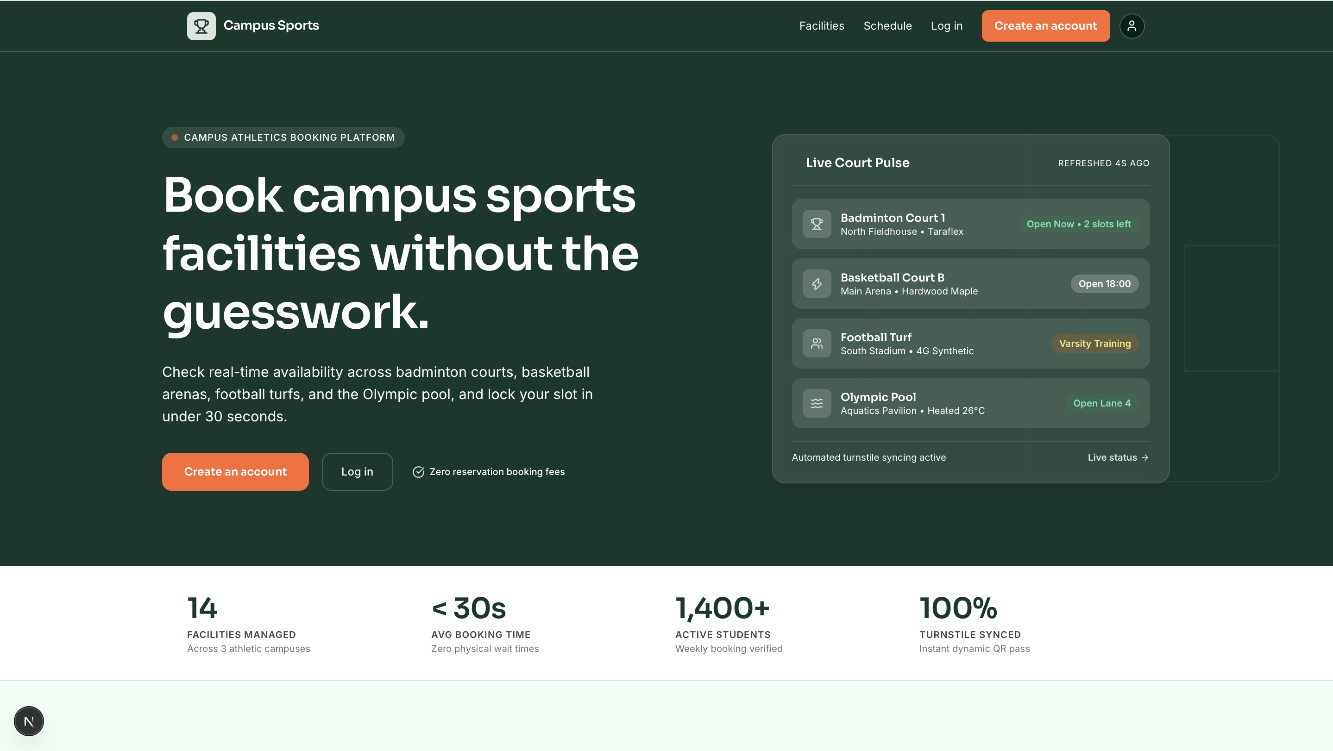

SCREEN 2: Student & Staff Authentication (Split Layout)
- Route: /login & /register
- Purpose: Secure authentication gateway supporting credential login and new student account creation with field validation.
- Key UI Components:
- Inputs: Floating focus rings in Accent Orange, email input, Argon2id password input with security criteria, optional student registration number field.
- Submit: Full-width Accent Orange button with animated pending spinner.
- Race-safe inline error callouts for invalid credentials or duplicate email registrations.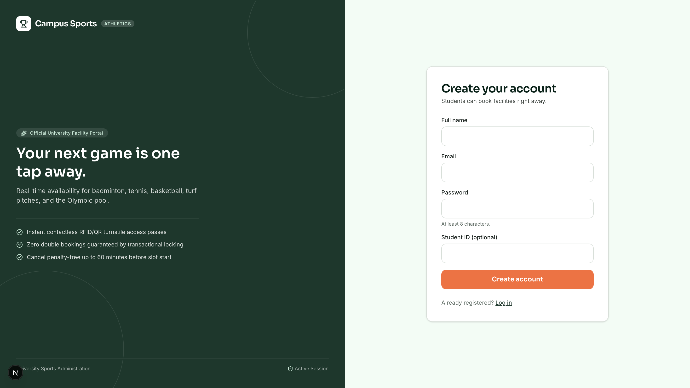

SCREEN 3: Student Operational Dashboard
- Route: /dashboard
- Purpose: Primary personalized hub for authenticated students, displaying active booking quotas, next scheduled match, contactless QR turnstile pass, and 1-tap quick booking.
- Key UI Components:
- Top Hero Welcome Panel: Student ID pill, Verified Student badge, Sora greeting ("Welcome back, Asha"), and 3 quick metrics pills (Active Bookings, Facilities Synchronized, Turnstile Active status).
- Single Accent Orange CTA: + Quick Book a Court with average completion time descriptor (24s).
- Live Campus Directive Strip: Rule reminders (non-marking shoes, physical ID), arena temperature (21°C), locker operational hours.
- Left Column — Next Booking & Gate Pass:
- Ticket Card Surface with sport badge, confirmed status pill, and time countdown ("Starts in 2h 15m").
- Schedule details box with clock icon, formatted time (17:00–18:00), and access hub designation.
- Peer invite card and recent notifications feed.
- Right Column — Quick Reservation Grid:
- Sport category explore cards with facility counts and open slot tallies.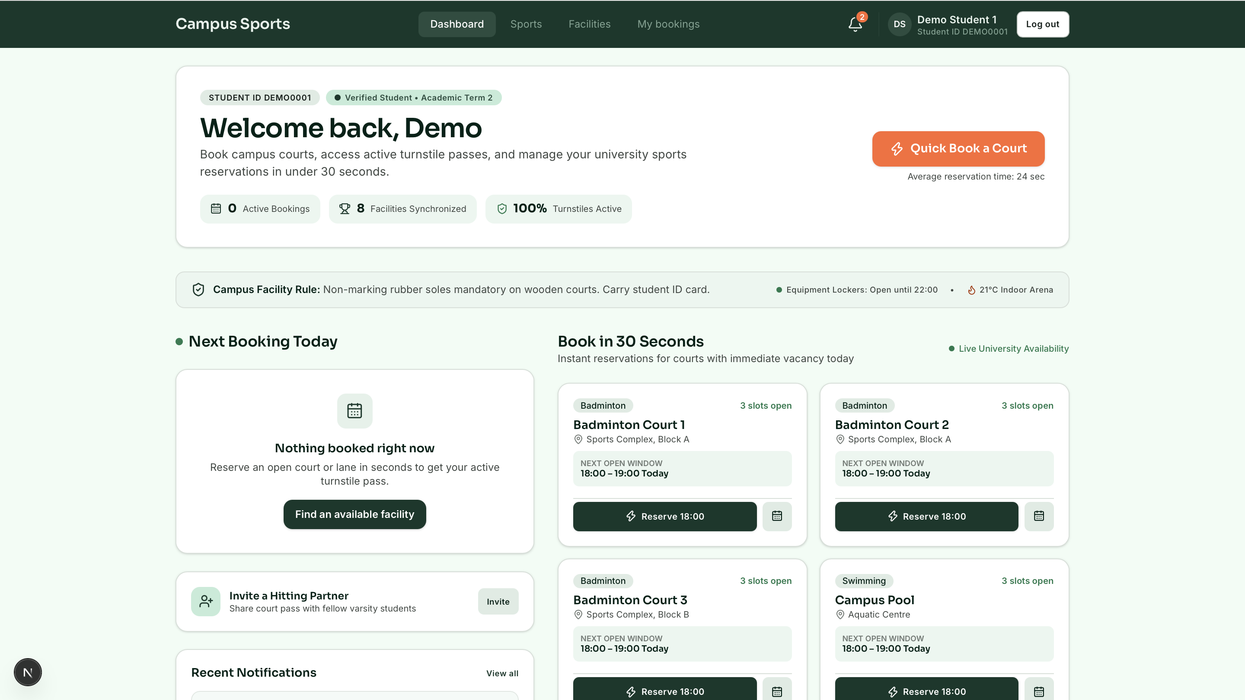

SCREEN 4: Campus Sports Directory & Disciplines Showcase
- Route: /sports
- Purpose: Categorical directory of athletic disciplines available on campus with facility counts and live open slot metrics.
- Key UI Components:
- Header with term badge pill, Sora title ("Sports Disciplines"), and explanatory subtitle.
- Responsive grid for sport disciplines (Badminton, Basketball, Tennis, Football, Swimming, Fitness).
- Cards: Category-specific athletic icons (racquet, team, aquatic, fitness, individual), semantic category color pills, technical facility descriptions.
- Metric divider: Facility counts and live open slot counters ("6 open slots today").
- Primary navigation button: View Facilities routing directly to parametric filtered lists.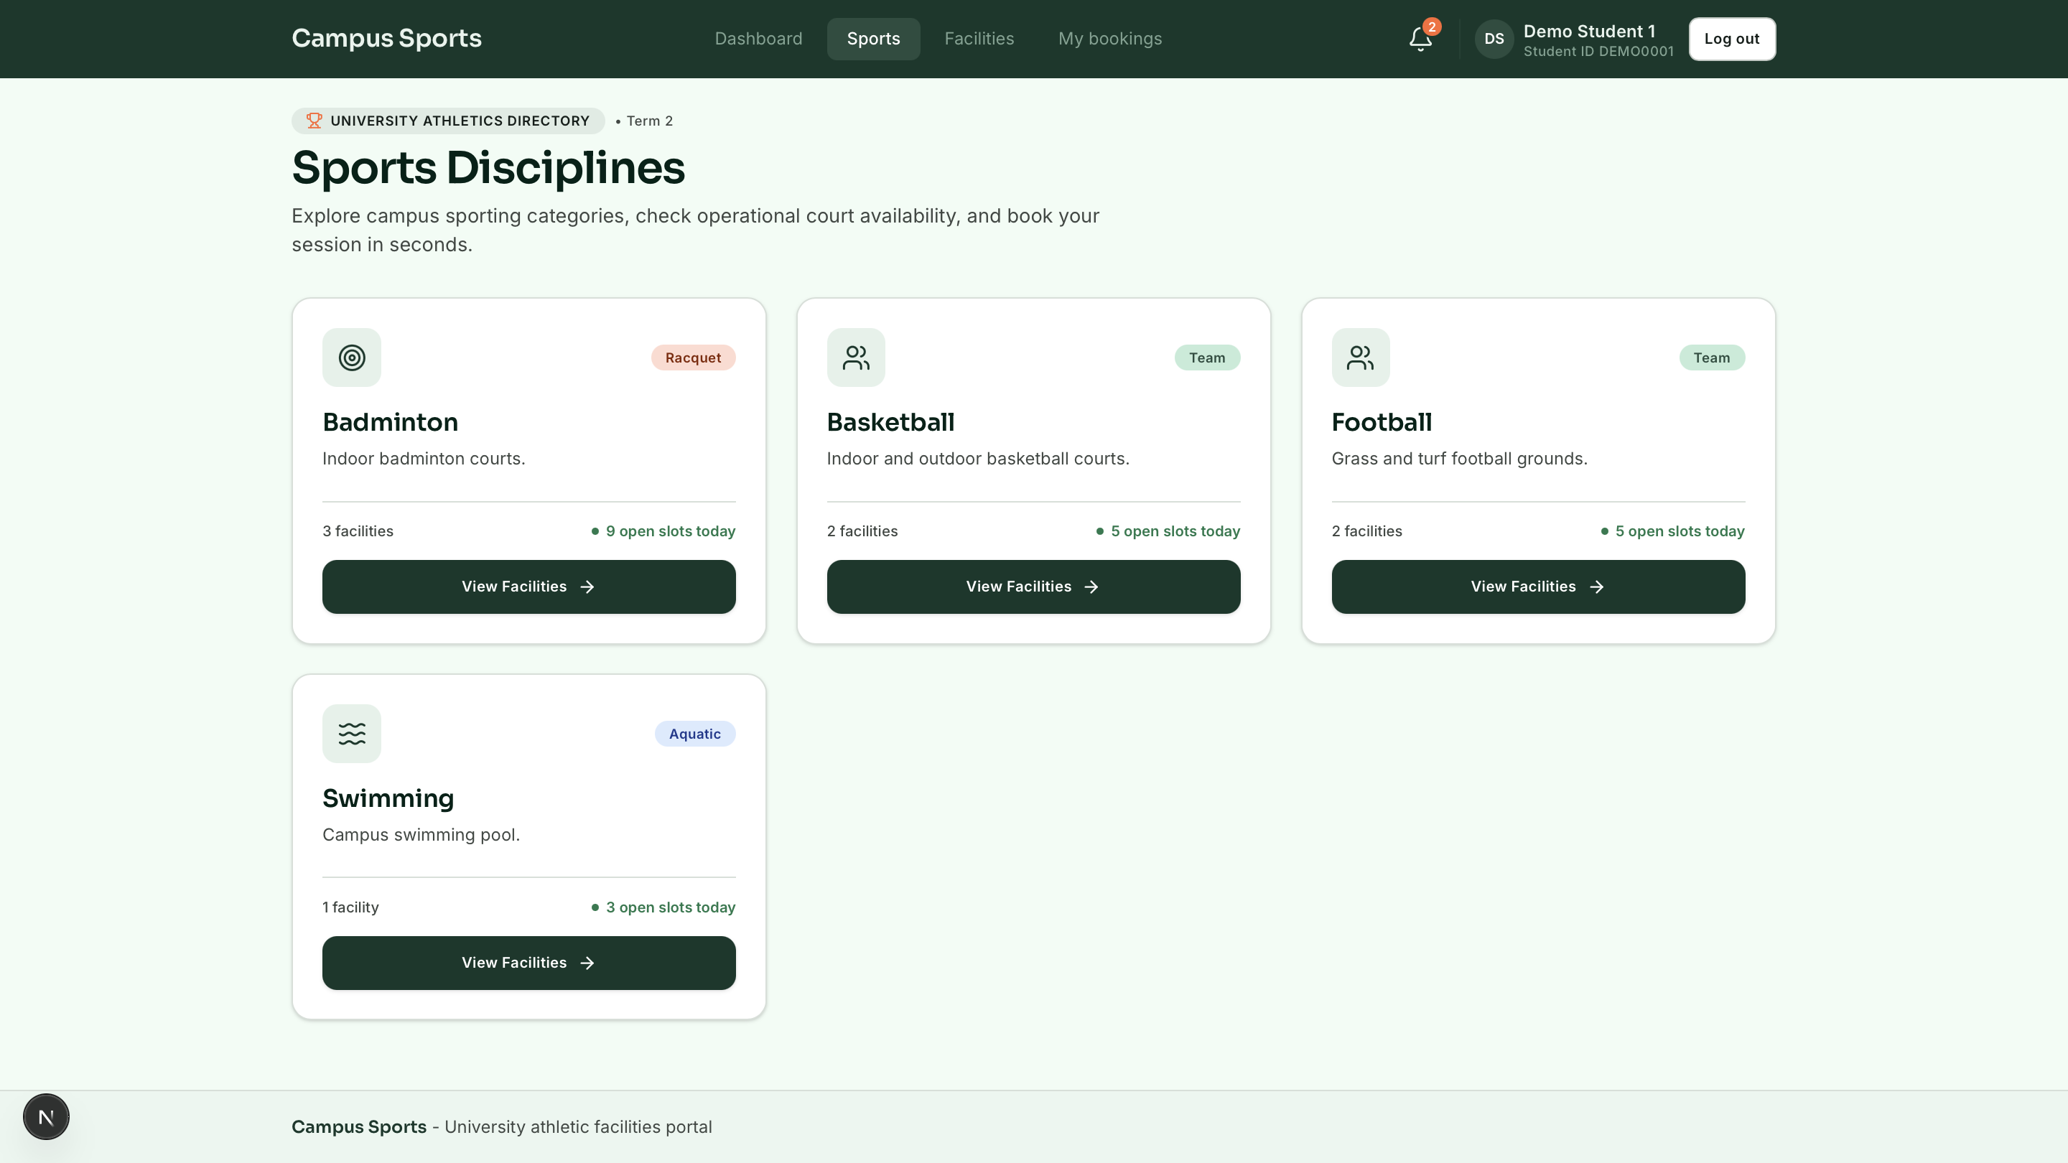

SCREEN 5: Facility Details, Interactive Slot Matrix & Reservation Summary
- Route: /facilities/[id]
- Purpose: High-precision booking workspace providing facility technical specifications, operating hours drawer, horizontal 14-day date strip, interactive slot grid, and sticky reservation summary.
- Key UI Components:
- Athletic breadcrumb trail (Sports > Badminton > Badminton Court 1).
- Facility Hero Card: Sport badge, operational status pill, slot length tag, building location, court specifications grid, and collapsible weekly operating hours drawer (Mon–Sun opening/closing windows).
- Operational Alerts: Dedicated alert containers for maintenance shutdowns, active quota caps, or slot conflict toasts.
- 14-Day Date Strip: Horizontally scrollable day selector with day number, 3-letter weekday, "Today" badge, active selection in Deep Green, and closed days disabled.
- Interactive Timetable Slot Grid: High-density responsive grid supporting all standardized Field & Court slot states:
- Booked by Me: Solid Success Green fill (#1F7A4D), white text, checkmark icon prefix.
- Past: Plain background, light grey strikethrough text, disabled.
- Maintenance: 45-degree repeating diagonal slate-gray stripes (slot-stripes).
- Sticky Right Summary Column (Desktop) / Bottom Sheet (Mobile):
- Live Holding indicator.
- Selected time window and formatted date highlight box.
- Metadata confirmation table.
- Cancellation policy notice (penalty-free up to 60m before slot).
- Single Accent Orange CTA: Confirm Booking — 17:00 – 18:00.
- Active Quota usage progress meter (e.g., 3 / 5 slots used).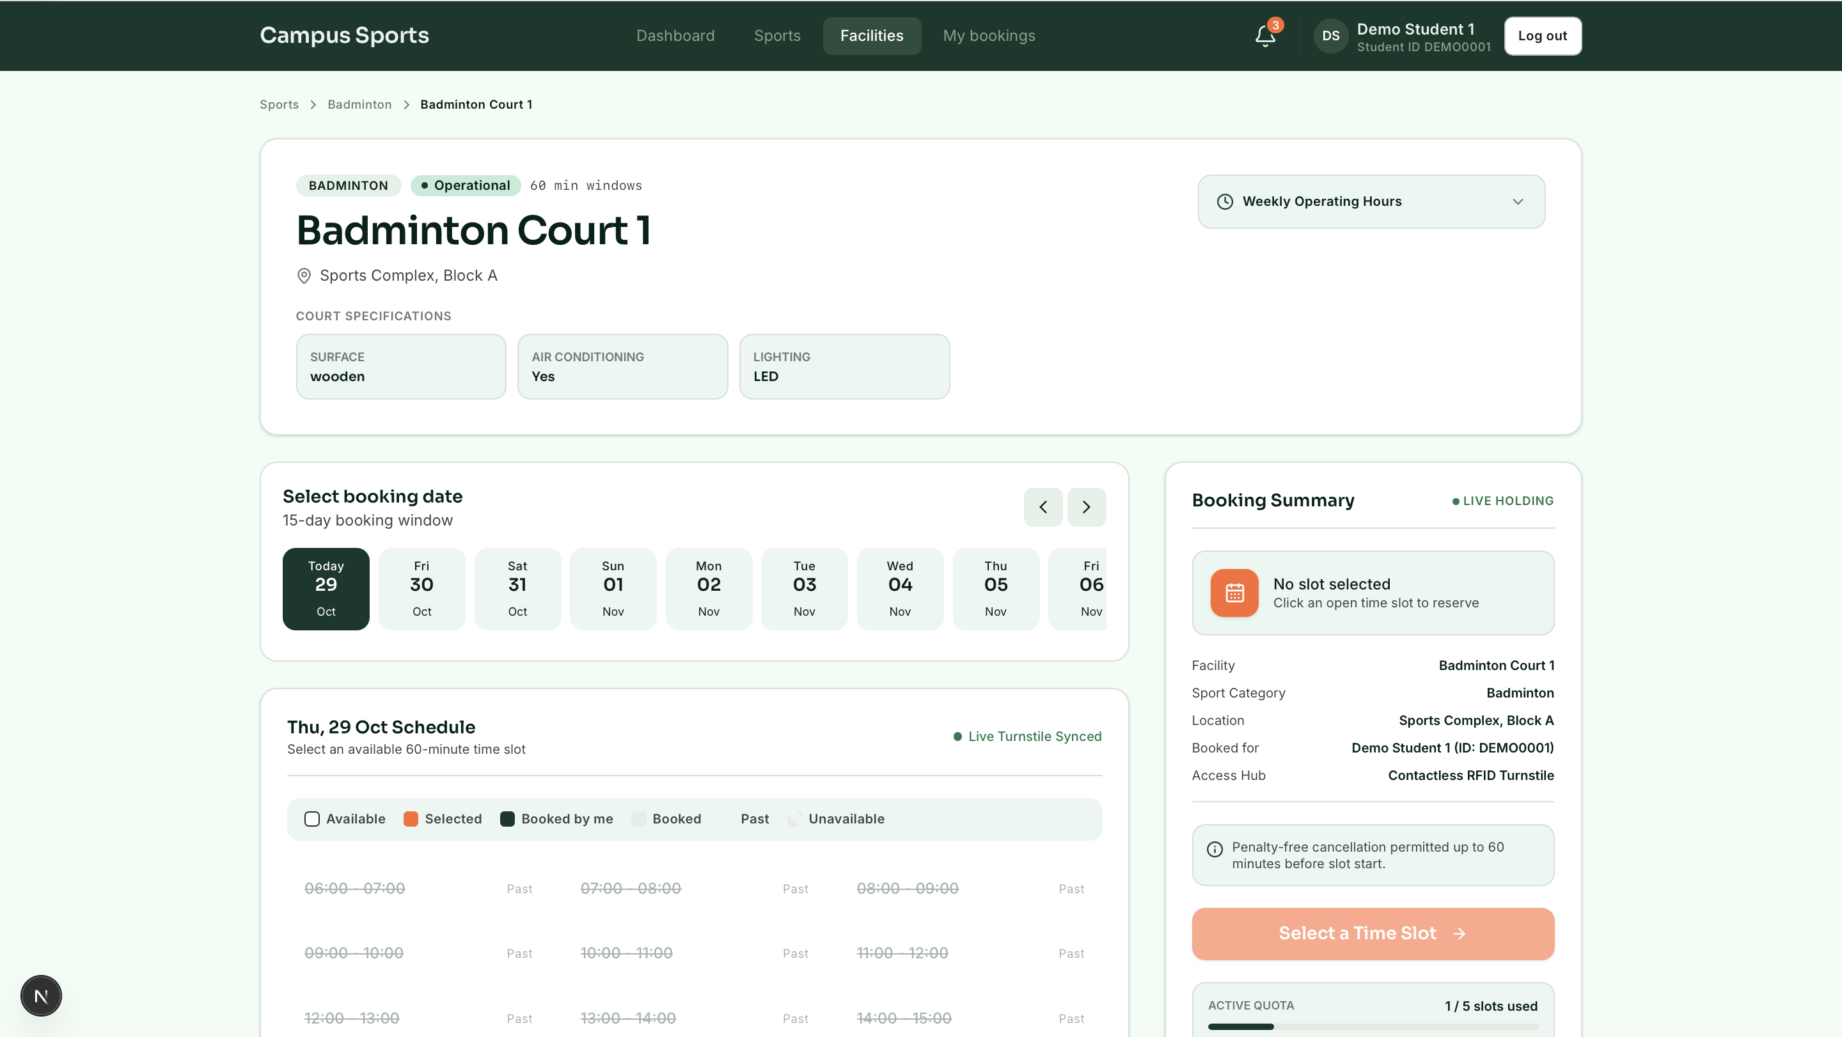

SCREEN 6: Student My Bookings Roster & Gate Pass Modal
- Route: /bookings
- Purpose: Personal reservation portfolio allowing students to review upcoming games, access turnstile passes, cancel reservations, and audit past attendance history.
- Key UI Components:
- Header: Member portal badge, Student ID tag, Sora title, and Active Slot Quota metric card (e.g., "3 / 5 slots used • 2 sessions free to reserve").
- Segmented Navigation: Tabbed pills for Upcoming Sessions (X) and Past History (Y) with turnstile synchronization indicator.
- Booking Cards:
- Athletic schematic badge (sport icon + court number).
- Sport category tracking label, confirmed status pill, real-time countdown badge ("Starts in 3h 15m").
- Venue name, formatted 24h time range, building location.
- Token badge (Token #TK-8842-A1).
- Action controls: Gate Pass button (opens QR pass modal) and Cancel Booking button (with policy enforcement: disabled with padlock icon if &le; 60m to start).
- Turnstile Access Gate Pass Modal: Full-screen modal with large procedural vector QR code, token code, optical scanner directions, and reservation summary.
- Cancellation Confirmation Modal: Dialogue prompting for optional cancellation reason with warning regarding immediate slot release to the public pool.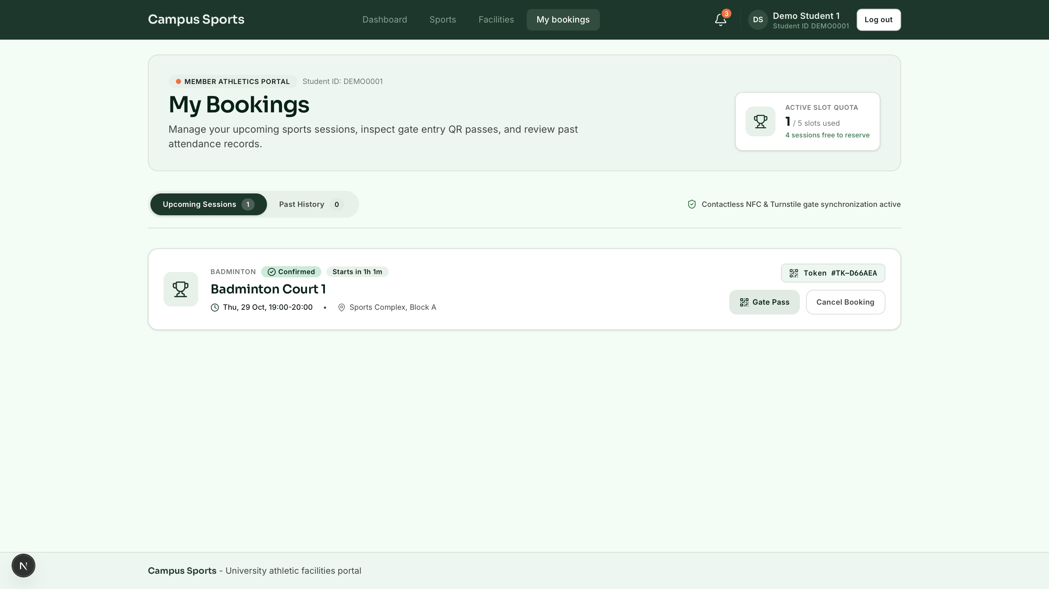

SCREEN 7: Administrator Central Dispatch Operations & Schedule Matrix
- Route: /admin
- Purpose: Central command dashboard providing facility directors with real-time multi-court schedule visualization, operational KPIs, and instant blockout overrides.
- Key UI Components:
- Central Dispatch Console header with term badge, Sora title, date navigation picker (Previous/Next day, Today), and single Accent Orange CTA: + Create Blockout / Reservation.
- Filter Pills Bar: Sport category filters (All Venues (8), Racquet (4), Hardwood (2), Turf (1), Aquatics (1)).
- 4 Operational KPI Cards:
- Total Bookings Today: Count vs capacity (e.g., 142 / 160 slots), visual progress bar, occupancy percentage.
- Active Players On-Court: Real-time head count, turnstile synchronization status.
- Pending Check-Ins: Slots starting in next 60 minutes with auto-release threshold alert.
- Maintenance Offline: Offline court counter with zero-unplanned-closure metric.
- Timetable Slot Legend Bar.
- Master Facilities Schedule Matrix (Horizontal Timeline):
- Horizontally scrolling multi-court grid spanning 16 hourly windows (06:00 to 22:00).
- Sticky left venue column with operational status dot, facility name, and building/surface descriptor.
- Current Hour column prominently highlighted with Deep Green header indicator ("13:00 NOW").
- Discrete slot cells color-coded by state: Past, Student Booking (with student name and booking ID), Booked & Verified (with check icon), Varsity Blockout (multi-column spanning), Maintenance Polish (diagonal stripes), and Available Free slots with 1-click override triggers.
- Manual Blockout / Override Dialogue: Modal form supporting Varsity Blockout, Facility Maintenance, or VIP Match reservations with start time, duration, and cancellation alert triggers.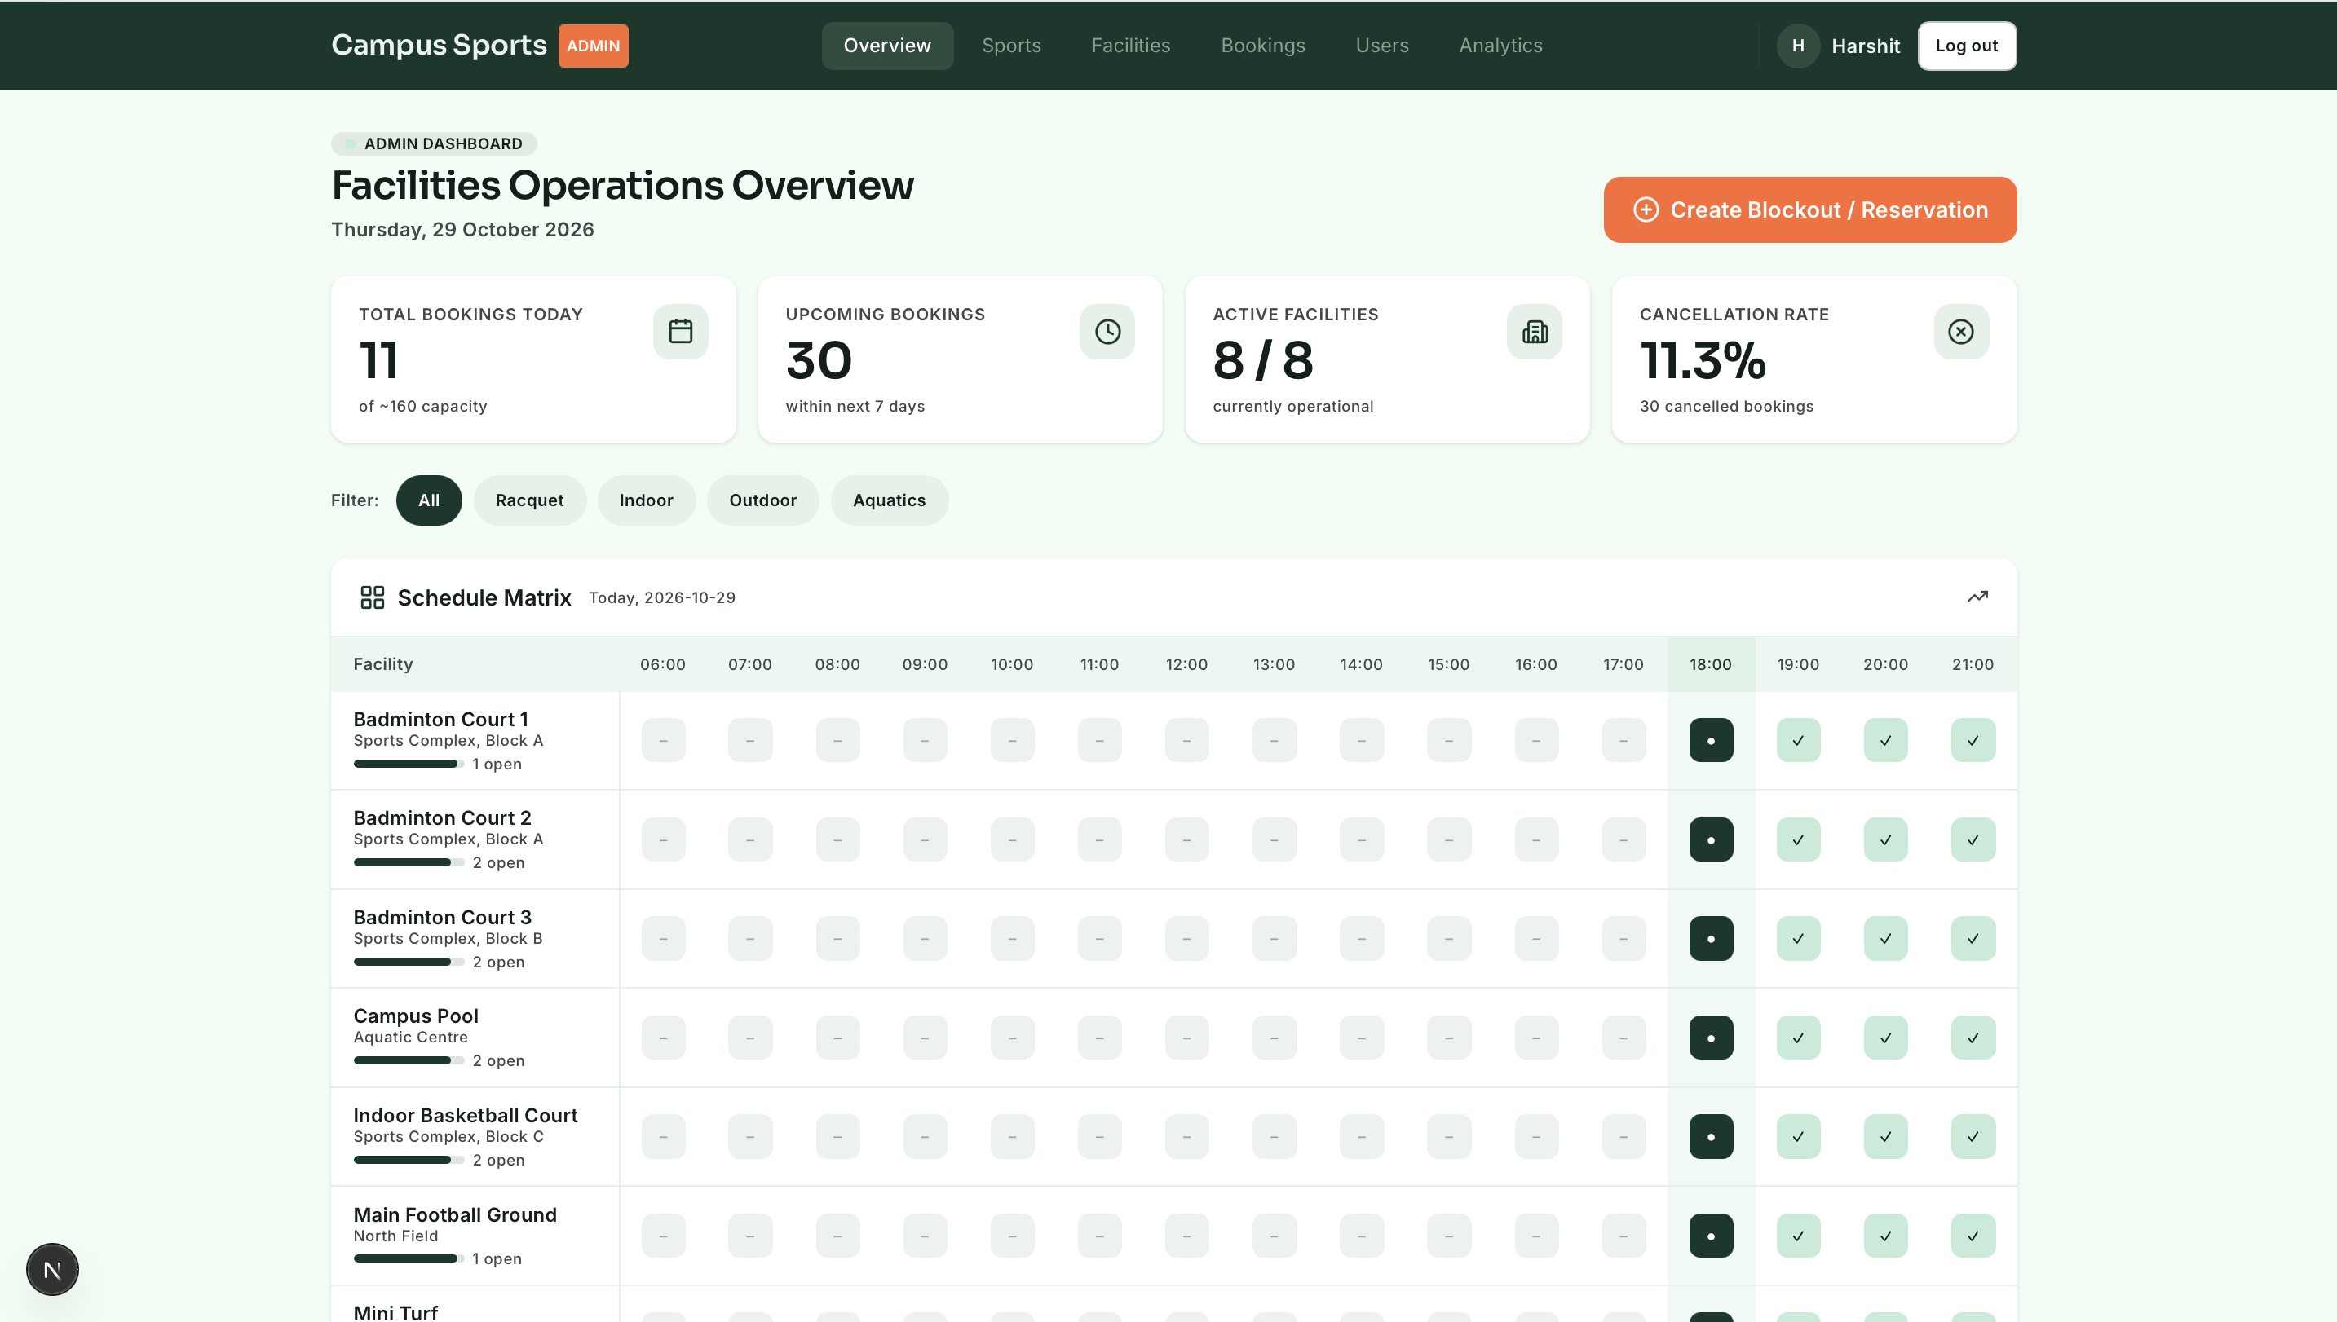

SCREEN 8: Administrator Bookings Roster & Attendance Control Deck
- Route: /admin/bookings
- Purpose: Live high-density administrative table for monitoring turnstile entry, searching student reservations, executing administrative cancellations, and issuing walk-in reassignments.
- Key UI Components:
- Header: Central Athletic Complex Roster label, Sora title, Accent Orange + Manual Booking / Admin Override CTA.
- Filter & Search Console: Student name/ID search bar, Date selector, Sport discipline dropdown, and status segmented pills (All Statuses, Checked In, Confirmed, Cancelled, No-show).
- Primary Roster Split Layout:
- Main Roster Table: Student avatar initials, name, roll number, department, facility/court assignment, formatted 24h time slot, gate access token, status pill, and administrative action buttons (instant cancellation with student notification dispatch).
- Walk-in Quick Station: Dedicated quick-assignment card allowing staff to issue unclaimed/no-show slots to walk-in students on the spot.
- 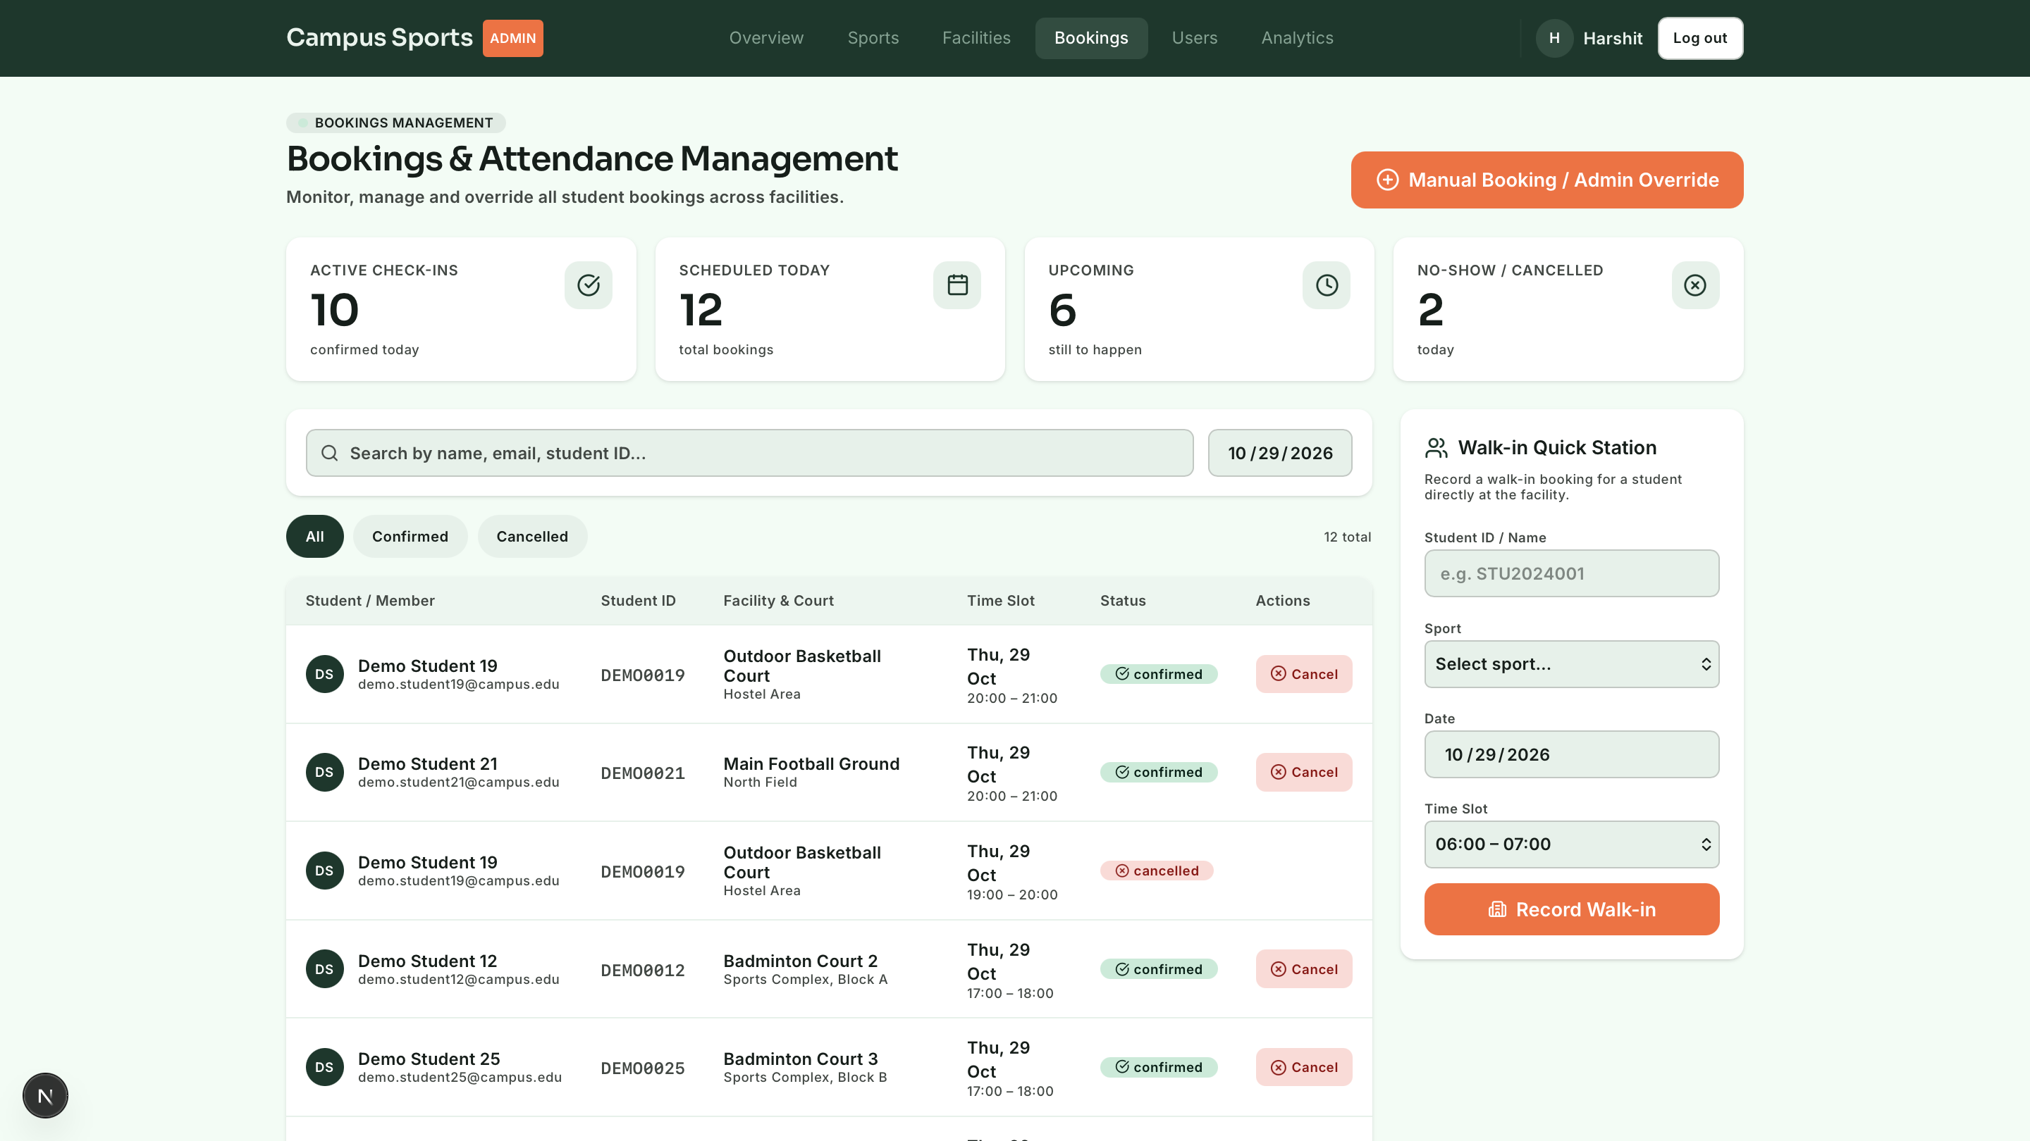

SCREEN 9: Administrator Sports & Parametric Attribute Schema Editor
- Route: /admin/sports
- Purpose: Administrative catalog control for defining sports disciplines and managing their dynamic attribute schemas.
- Key UI Components:
- Header with section badge and Accent Orange + Add Sport button.
- Search filter and 3-column responsive card grid.
- Cards displaying category badges, description, and configured dynamic attribute keys (surface, lighting, air_conditioning).
- Action buttons: Edit Sport schema (pencil) and Delete Sport (trash, with foreign-key constraint protection).
- Create/Edit Modal: Form with dynamic attribute builder (allowing addition/removal of typed attribute definitions with type, label, and required flags).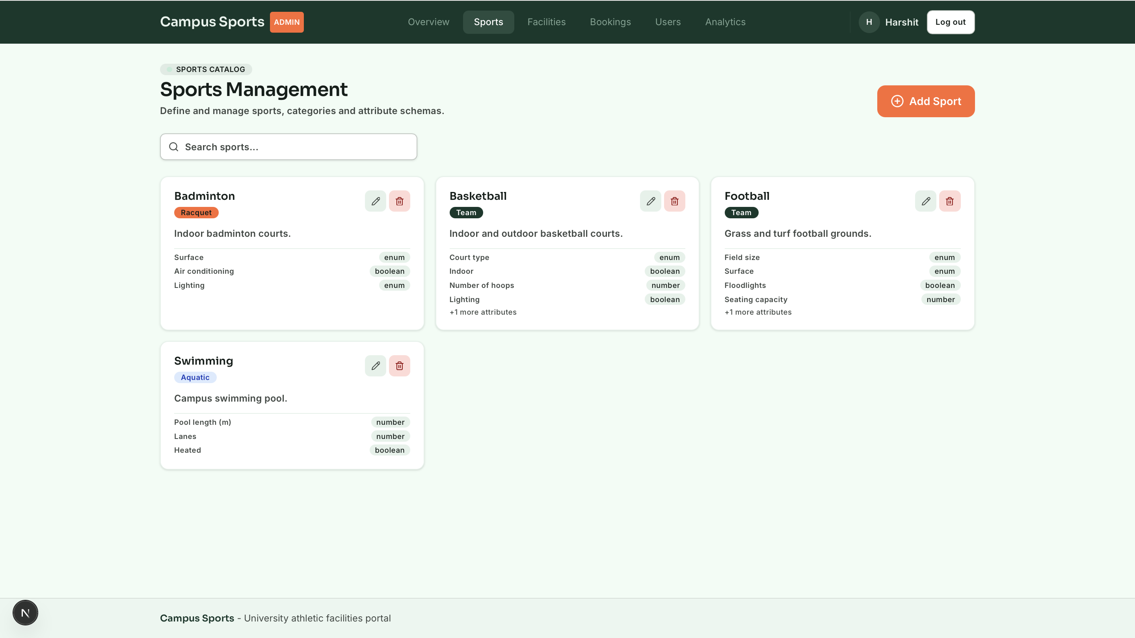

SCREEN 10: Administrator Facilities & Operational Hours Manager
- Route: /admin/facilities
- Purpose: Venue infrastructure manager for creating facilities, setting slot durations, configuring weekly opening/closing windows, and toggling maintenance status.
- Key UI Components:
- Header with Accent Orange + Add Facility button.
- Multi-parameter filter bar (Search, Sport dropdown, Status pills: Active, Maintenance, Inactive).
- Facility cards grid with operational progress bars (showing today's slot occupancy ratio), next free window, and status tags.
- Facility Editor Modal: Facility name, sport selection, campus location, slot duration selector (30, 45, 60, 90, 120 mins), operational status dropdown, and weekly opening/closing window template inputs.
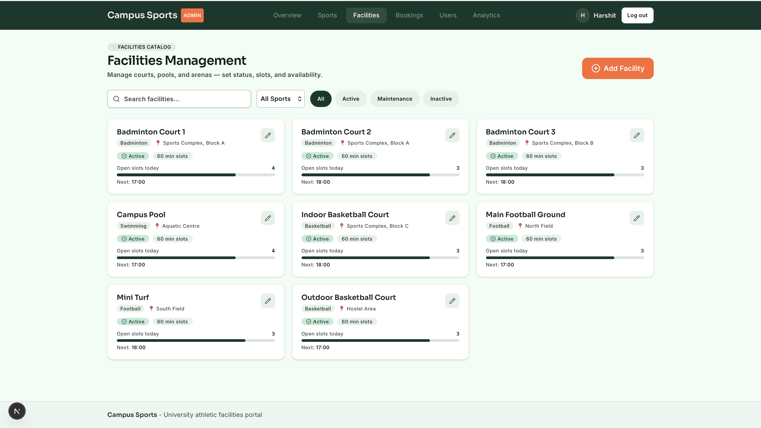

SCREEN 11: Administrator User Governance & Session Directory
- Route: /admin/users
- Purpose: University student and staff account directory allowing administrators to inspect registration numbers, adjust roles, toggle active status, and invalidate sessions.
- Key UI Components:
- Search bar, role filter pills (All Users, Students, Admins), and active status toggle.
- Comprehensive user data table: Avatar initials, full name, institutional email, Student ID / Roll number, Role pill (Student / Admin), Status dot (Active Green / Disabled Grey), Joined date.
- Action Controls: Toggle Active State (instantly revoking access and optionally cancelling upcoming reservations) and Promote/Demote Role with double-confirmation modal protections.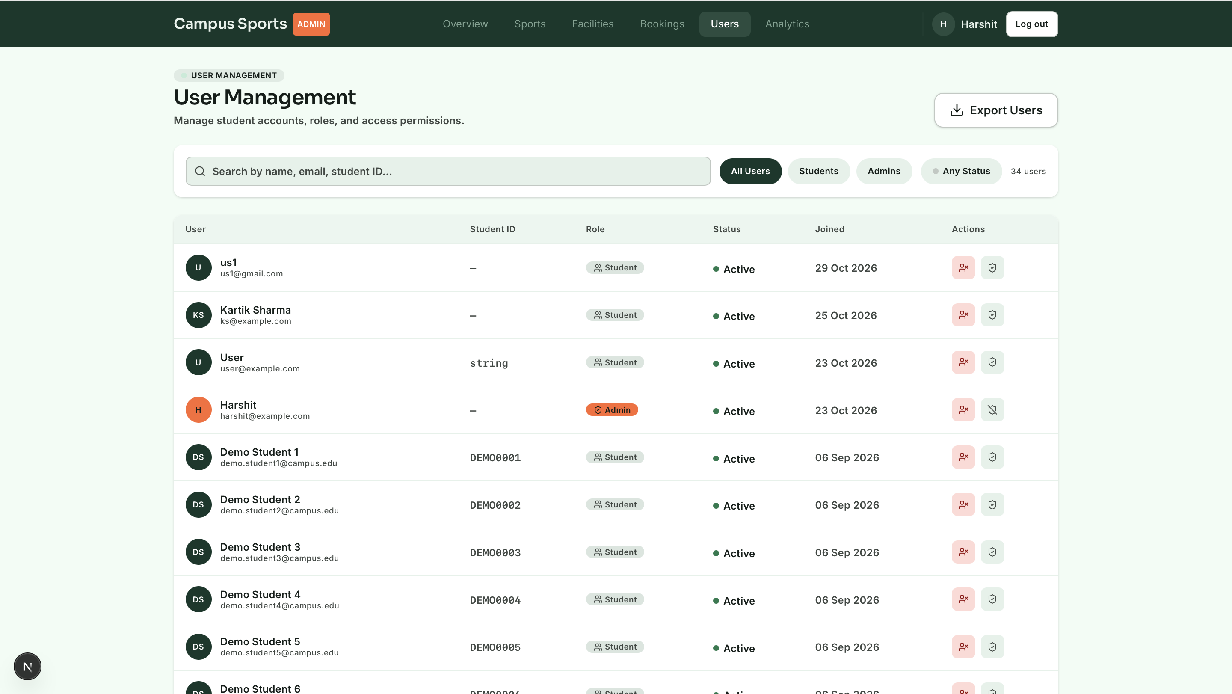

SCREEN 12: Administrator Analytical Intelligence & Utilization Dashboards
- Route: /admin/analytics
- Purpose: Server-side aggregation dashboard providing facility directors with quantitative utilization, peak load hours, cancellation behavior, and sport popularity metrics.
- Key UI Components:
- Date range selector presets (Last 7 Days, Last 30 Days, Last 90 Days) with live refresh trigger.
- Summary KPI Strip: Total Bookings, Cancellation Rate, Unique Students, Active Facilities.
- Popular Sports Distribution: Horizontal relative bar chart displaying booking share percentages across disciplines.
- Peak Load Hourly Histogram: Vertical bar chart visualizing booking density across hours 06:00 to 22:00, highlighting peak operational windows in Accent Orange.
- Busiest Facilities Ranked Table: Capacity vs booked slot utilization meters derived from operating hours templates.
- Cancellation Behavioral Analysis: Circular meter and comparative metric cards contrasting student self-cancellations against administrative weather/maintenance overrides.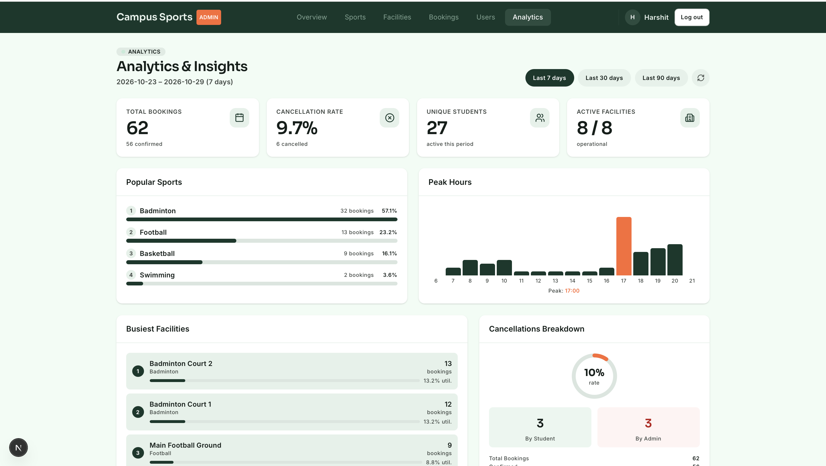

3.1.2 Hardware Interfaces
Campus Sports is architected to operate seamlessly across standard client hardware and university physical infrastructure:
- Client Handheld Devices: Capacitive touchscreen smartphones (iOS Safari, Android Chrome) with screen resolutions ranging from 375x667 px to 430x932 px.
- Client Desktop/Laptop Computers: High-resolution displays (1080p, 1440p, 4K) running modern web browsers with pointer and keyboard navigation.

3.1.3 Software Interfaces
- Database Management System: MongoDB 6.0+ Community/Enterprise Server connected via asynchronous PyMongo driver (AsyncMongoClient).
- Server Runtime Environment: Python 3.12+ ASGI execution runtime running on Uvicorn with Gunicorn process management.
- Frontend Runtime: Node.js 20+ runtime serving Next.js 15 Server-Side Rendered (SSR) and Client-Side Rendered (CSR) components.
- Operating Systems: Linux (Ubuntu 22.04 LTS / Debian 12) for production hosting; macOS (Darwin) and Windows 11 for local development.

3.1.4 Communications Interfaces
- Application Layer Protocol: HTTPS (Hypertext Transfer Protocol Secure) utilizing Transport Layer Security (TLS 1.3) across all client-to-server and server-to-database communication channels.
- Data Serialization Format: Standard UTF-8 encoded JavaScript Object Notation (JSON) conforming to RESTful schema specifications.
- Authentication Header: Standard HTTP Authorization: Bearer <JWT> header utilizing HS256 cryptographic signatures.
- Cross-Origin Resource Sharing (CORS): Strict CORS policies restricting API access exclusively to verified university frontend domains.

3.2 Functional Requirements

3.2.1 User Authentication, Registration & Session Invalidation
- Introduction: Governs student account creation, credential authentication, role assignment, and immediate session termination upon administrative status changes.
- Inputs: Student full name, institutional email (@campus.edu), plaintext password (&ge; 8 characters), optional student registration roll number.
- Processing:
- Lowercase and sanitize email string.
- Verify email uniqueness against MongoDB unique index users_email_unique.
- Hash password using Argon2id with memory-hard parameters via a background thread worker.
- Assign default role student (public registration is restricted from assigning admin).
- Upon login via OAuth2 password form (username = email), authenticate credentials in constant time to prevent timing attacks.
- Generate signed JWT containing sub (User ID), role, and expiration timestamp.
- On every incoming request, re-read user's is_active flag and role directly from database to guarantee immediate revocation if disabled by an administrator.
- Outputs: JWT Bearer access token, serialized User object (omitting password hash).
- Error Handling: HTTP 400 for duplicate email (EMAIL_TAKEN), HTTP 401 for invalid credentials, HTTP 403 for disabled accounts (USER_DISABLED).

3.2.2 Real-time Slot Availability & Dynamic Grid Computation
- Introduction: Computes live open, booked, and past time slots for any facility and date on-the-fly without maintaining redundant pre-generated slot documents.
- Inputs: Facility ID, target calendar date (YYYY-MM-DD in campus-local timezone).
- Processing:
- Retrieve facility record including slot_minutes and weekly operating_hours.
- Identify day of the week; return empty slot array if venue is closed.
- Divide operating windows into discrete non-overlapping time slots of slot_minutes duration.
- Convert computed local slot boundaries to UTC ISO-8601 timestamps.
- Query bookings collection for confirmed bookings matching facility_id and the date's temporal range utilizing the partial unique index.
- Map each slot to its respective state: available, booked, past (if slot end &le; current time), or booked_by_me (if authenticated user matches booking user_id).
- If facility status is maintenance, flag all slots as unavailable.
- Outputs: Serialized SlotsResponse containing timezone, slot duration, facility status, and array of discrete Slot objects.
- Error Handling: HTTP 404 if facility not found; HTTP 422 if date format is invalid.

3.2.3 Atomic Conflict-Free Reservation Engine
- Introduction: Executes instantaneous, collision-free slot bookings while enforcing university fair-play quotas and double-booking invariants.
- Inputs: Authenticated Student User, Facility ID, Slot Start Timestamp (UTC ISO-8601).
- Processing:
- Verify facility is active (status: "active").
- Validate student active booking count against university cap (maximum 5 active bookings).
- Validate requested start time falls within the 14-day advance booking window.
- Ensure student holds no overlapping confirmed reservation at the identical timestamp across other campus facilities.
- Re-compute facility slot grid to ensure requested start time aligns precisely with an authentic slot boundary.
- Perform atomic insert into bookings collection, capturing a denormalized snapshot of sport_id.
- Enforce concurrency via MongoDB partial unique index bookings_facility_start_confirmed_unique. If a competing request commits first, the database raises a DuplicateKeyError.
- Upon successful insert, trigger asynchronous in-app notification dispatch.
- Outputs: Serialized confirmed Booking document with unique booking ID and timestamps.
- Error Handling: HTTP 409 Conflict (SLOT_TAKEN) if slot is already reserved; HTTP 403 Forbidden (MAX_BOOKINGS_REACHED) if student quota is exceeded; HTTP 400 Bad Request if booking window or slot boundary is violated.

3.2.4 Policy-Aware Booking Cancellation System
- Introduction: Enables students and administrators to cancel confirmed bookings while strictly enforcing the 60-minute cancellation grace cutoff for students.
- Inputs: Booking ID, Authenticated User Context, Optional Cancellation Reason string.
- Processing:
- Retrieve booking document by ID.
- Verify booking status is currently confirmed.
- If caller is a student: verify caller is the booking owner; calculate difference between slot start and current server time; verify difference exceeds cancellation_cutoff_minutes (60 minutes).
- If caller is an administrator: permit cancellation at any timestamp prior to slot conclusion.
- Execute single atomic conditional update: set status: "cancelled", cancelled_at: utc_now, cancelled_by: "student" | "admin", and cancel_reason.
- Because the uniqueness index is partial (partialFilterExpression: {status: "confirmed"}), flipping status to cancelled immediately frees the slot for other students without document deletion.
- If cancelled by an administrator, dispatch urgent notification to the affected student.
- Outputs: Updated Booking document reflecting cancellation metadata.
- Error Handling: HTTP 403 Forbidden (CANCELLATION_CLOSED) if student attempts cancellation within 60 minutes of start; HTTP 404 if booking not found; HTTP 400 if booking is already cancelled or in the past.

3.2.5 Sports Taxonomy & Dynamic Parametric Metadata Schema
- Introduction: Manages sporting disciplines and defines typed parametric attribute definitions that dynamically configure facility filtering.
- Inputs: Sport Name, Category enum (team, racquet, aquatic, fitness, individual, other), Description, Array of AttributeDef objects (key, label, type: string/number/boolean/enum, required, options).
- Processing:
- Validate sport name uniqueness via case-insensitive collation index.
- Validate attribute definitions to ensure valid types and non-empty option lists for enum types.
- Store sport document.
- When facilities are registered or edited under this sport, validate their embedded metadata key-value pairs strictly against these attribute definitions.
- Reject deletion of any sport currently referenced by active facilities.
- Outputs: Created/Updated Sport entity with serialized attribute schemas.
- Error Handling: HTTP 400 for duplicate sport name; HTTP 409 Conflict if attempting to delete a sport with referencing facilities.

3.2.6 Facilities Operations & Parametric Catalog Management
- Introduction: Governs campus facility creation, weekly operating hours templates, dynamic metadata validation, and status transitions.
- Inputs: Facility Name, Sport ID, Campus Location, Slot Minutes (30, 45, 60, 90, 120), Weekly Operating Hours object (mon–sun array of {open: "HH:MM", close: "HH:MM"}), Status (active, maintenance, inactive), Metadata key-value dictionary.
- Processing:
- Validate referenced sport_id exists.
- Validate facility name uniqueness within the specific sport.
- Validate operating hours windows: ensure times are ordered, non-overlapping, and span at least one full slot duration.
- Validate metadata dictionary against the sport's configured attribute definitions.
- Store facility document.
- Support parametric catalog filtering: query facilities by sport, keyword regex search on name/location, and nested wildcard attribute queries (meta.<key>).
- Outputs: Serialized Facility document including computed availability summaries when requested.
- Error Handling: HTTP 422 for malformed operating windows; HTTP 400 for invalid metadata keys/values.

3.2.7 In-App Notification Dispatch & TTL Expiry
- Introduction: Dispatches contextual notifications for reservation confirmations and administrative overrides, automatically expiring aged records.
- Inputs: Target User ID, Notification Type (booking_confirmed, booking_cancelled_by_admin), Title, Message, Referenced Booking ID.
- Processing:
- Construct notification document with UTC creation timestamp and read: false.
- Execute asynchronous insert into notifications collection.
- Log delivery as best-effort: failure to dispatch notification does not abort primary database transaction.
- Enforce automated cleanup via MongoDB TTL index notifications_ttl: documents automatically purged 60 days following creation.
- Provide endpoints to list unread notifications, fetch unread counts, and execute batch mark-as-read updates.
- Outputs: Serialized notification list, unread count integer.
- Error Handling: Non-blocking error logging on insert failures; HTTP 404 for non-existent notification IDs.

3.2.8 Administrative Central Dispatch Operations & Schedule Matrix
- Introduction: Provides facility directors with an integrated schedule timetable matrix and manual blockout override mechanics across all campus sectors.
- Inputs: Target Date, Sport category filter, Manual Blockout Form (Facility, Date, Start Time, Duration, Justification, Cancellation Alert toggle).
- Processing:
- Aggregate all active campus facilities across selected categories.
- Compute 16 discrete hourly windows from 06:00 to 22:00 for the target date.
- Correlate all confirmed student bookings, varsity blockouts, and maintenance windows.
- For manual blockouts: execute administrative override bookings. If "Send instant cancellation alerts" is toggled, identify displaced student bookings, execute administrative cancellations with justification reason, and dispatch high-priority notifications.
- Outputs: Comprehensive multi-court schedule matrix dataset, override confirmation.
- Error Handling: HTTP 409 Conflict if manual blockout attempts to overwrite an already-closed past window.

3.2.9 High-Density Administrative Bookings Roster Management
- Introduction: Powers the live turnstile operations deck, providing searchable student roll logs, attendance verification, and walk-in reissuance.
- Inputs: Pagination parameters (limit, skip), search query string q (student name, roll number, court, token), status filter, date range bounds.
- Processing:
- Construct MongoDB query combining search filters, date ranges, and status predicates.
- Execute $lookup joins to enrich booking records with student roll numbers, facility names, and sport categories in a single database round-trip.
- Sort results by slot start descending.
- Support walk-in reissuance: allow staff to cancel unclaimed no-show bookings past the 15-minute grace threshold and reassign the slot to a waiting student.
- Outputs: Paginated Page<AdminBooking> object containing item records, total match count, limit, and skip parameters.
- Error Handling: HTTP 422 for invalid pagination limits (&gt; 100).

3.2.10 Server-Side Analytical Intelligence & Aggregation Pipelines
- Introduction: Computes institutional utilization, hourly load distributions, sport popularity ratios, and cancellation statistics via MongoDB server-side aggregation pipelines.
- Inputs: Inclusive campus-local date range (date_from, date_to, default: last 30 days ending today).
- Processing:
- Validate date bounds (maximum span 366 days); convert local dates to UTC temporal bounds.
- Execute specialized aggregation pipelines:
- Popular Sports: $match confirmed bookings in range -> $group by sport_id -> $sort by count -> $lookup sport name -> compute percentage share.
- Peak Hours: $match confirmed bookings -> extract $hour in campus timezone (Asia/Kolkata) -> $group by hour -> sort 0 to 23.
- Busiest Facilities: $match -> $group by facility_id -> join facility metadata -> return top ranked venues.
- Cancellations Breakdown: $match all bookings in range -> $group by status and cancelled_by -> compute student vs admin cancellation ratios.
- Summary Dashboard: Utilize $facet to execute two sub-pipelines in a single database pass, computing overall totals and unique student counts simultaneously.
- Facility Utilization: Hybrid computation combining booked slot aggregations against potential theoretical capacity derived from weekly operating hours templates.
- Outputs: Serialized Ranged<T> analytical datasets formatted for direct UI chart binding.
- Error Handling: HTTP 422 if date_from exceeds date_to or range exceeds 366 days.

3.2.11 User Directory, Active State Governance & Session Invalidation
- Introduction: Enables administrators to manage student/staff roles, inspect enrollment data, and immediately deactivate accounts.
- Inputs: User ID, Patch parameters (is_active, role, cancel_upcoming_bookings boolean).
- Processing:
- Prevent self-demotion or self-deactivation: verify targeted user ID does not match the authenticated administrator.
- Update user record in database.
- If cancel_upcoming_bookings: true is supplied upon deactivating a user: query all upcoming confirmed reservations for the user and cancel them in bulk, immediately returning the freed slots to the public pool.
- Because user active status is verified on every API invocation, deactivation takes immediate effect, blocking subsequent token usage.
- Outputs: Serialized updated UserAdminOut entity including count of cancelled reservations.
- Error Handling: HTTP 400 if administrator attempts to modify their own account status; HTTP 404 if user not found.

3.5 Non-Functional Requirements

3.5.1 Performance
- API Response Latencies: 95% of read queries (facility directory, sports taxonomy, notification feeds) shall return in under 50 milliseconds under a concurrent load of 500 requests per second.
- Reservation Transaction Throughput: The booking reservation engine shall process atomic insertions in under 120 milliseconds, including slot grid re-computation, double-booking validation, and partial index verification.
- Frontend Initial Load Time: First Contentful Paint (FCP) of the web application shall occur in under 1.2 seconds, and Largest Contentful Paint (LCP) in under 1.8 seconds on standard 4G mobile connections.

3.5.2 Reliability
- Mean Time Between Failures (MTBF): System MTBF shall exceed 720 hours (30 days) of continuous production operation.
- Zero Inconsistent States: The system shall strictly prevent orphan bookings or phantom slot holds; slot states must deterministically reflect the presence or absence of confirmed documents under the partial unique index.
- Data Durability: All write operations shall execute with MongoDB write concern w: "majority", ensuring committed bookings survive sudden node restarts.

3.5.3 Availability
- Operational Uptime: The system shall maintain an operational uptime of 99.9% during active campus operational hours (06:00 to 23:00 daily).
- Graceful Degradation: In the event of notification service degradation, the core booking engine shall continue operating without interruption, logging notification delivery failures asynchronously.

3.5.4 Security
- Cryptographic Storage: User passwords shall be hashed utilizing Argon2id with memory-cost &ge; 65,536 KiB, time-cost &ge; 3 iterations, and parallelism &ge; 4 threads. Plaintext passwords shall never be logged or persisted.
- Token Integrity: Authentication tokens shall utilize JSON Web Tokens signed via HMAC-SHA256 (HS256) with a cryptographically random secret key of at least 256 bits (32 bytes).
- Protection Against Timing Attacks: Credential verification routines shall execute dummy hash verifications when non-existent emails are queried, eliminating timing-based account enumeration vulnerabilities.
- Input Sanitization & Injection Prevention: All API inputs shall be strictly parsed and validated against Pydantic v2 type schemas; database queries shall utilize structured BSON objects, precluding NoSQL injection vulnerabilities.
- Cross-Site Scripting (XSS) Mitigation: React output escaping shall be enforced across all UI components, strictly disallowing unescaped dangerouslySetInnerHTML directives.

3.5.5 Maintainability
- Clean Monorepo Decoupling: Complete separation of concerns between backend domain logic (backend/app/services/), database models (backend/app/models/), API routers (backend/app/routers/), and frontend UI components.
- Codebase Typing Rigor: 100% type coverage across both TypeScript (tsc --noEmit clean) and Python (PEP 484 type annotations checked via mypy).
- Automated Test Coverage: Unit and integration test suites executed against a live test database instance, covering concurrent booking conflicts, cancellation cutoffs, and slot boundary calculations.

3.7 Design Constraints
- No External Charting Libraries: In accordance with project architectural guidelines, analytical data visualizations (horizontal sport bars, peak hour histograms, utilization meters) must be rendered utilizing pure CSS/HTML and SVG rather than external runtime charting packages (e.g., Chart.js, Recharts).
- Stateless Backend Architecture: The FastAPI backend must remain completely stateless, persisting no in-memory session tokens; authentication state must be verified purely via cryptographically signed JWTs and instantaneous database queries, facilitating horizontal scaling.
- Local Database Clock Dependency: Business rules depending on the passage of time must accept an injectable clock abstraction to permit deterministic unit and integration testing.4. ANALYSIS MODELS

4.1 Data Flow Diagrams (DFD)

4.1.1 Context Level (Level 0) DFD
The Level 0 Context Diagram establishes the boundary of the Campus Sports system, detailing the fundamental information flows between external entities (Students, Facility Administrators, and Turnstile Gate IoT Hardware) and the central platform.
+---------------------------------------------------------------------------------------------------------+
| LEVEL 0 CONTEXT DIAGRAM |
+---------------------------------------------------------------------------------------------------------+
[ Student User ]
/ ^
/ \
Credentials, Booking / \ Turnstile Pass (QR/Token),
Requests, Cancellations/ \ Notifications, Availability Matrix
/ \
v \
+--------------------------------------+
| |
| |
| 0.0 CAMPUS |
| SPORTS SYSTEM |
| |
| |
+--------------------------------------+
^ /
/ \
Admin Overrides, / \ Real-time Schedule Matrix,
Catalog Definitions/ \ Operational Analytics,
User Governance / \ Attendance Rosters
/ \
v v
[ Facility Administrator ] [ Turnstile Gate IoT Hardware ]
^
| Token Query & Validation Response
v

4.1.2 Level 1 DFD (Decomposed System Architecture)
The Level 1 Diagram decomposes the system into its primary operational subsystems: Authentication, Availability Computation, Booking Management, Notification Dispatch, Administration, and Analytical Intelligence.
+---------------------------------------------------------------------------------------------------------+
| LEVEL 1 DATA FLOW DIAGRAM |
+---------------------------------------------------------------------------------------------------------+
[ Student ] -------- Credentials --------> ( 1.0 Auth & Session ) <=====> [ D1: Users Store ]
|
Valid JWT
|
v
[ Student ] ------ Browse / Date --------> ( 2.0 Slot Availability ) <===> [ D3: Facilities Store ]
| ^
Computed Grid |
| |
v v
[ Student ] ------ Reserve Slot ---------> ( 3.0 Reservation Engine ) <=> [ D4: Bookings Store ]
| (Partial Unique Index)
Confirmed Record |
| |
v v
[ Turnstile Gate ] <-- Token Valid ------- ( 4.0 Gate Validation ) ( 5.0 Notifications )
|
Push Notification
|
v
[ Student ]
|
[ Administrator ] -- Blockout / Override -> ( 6.0 Central Dispatch ) =====> [ D4: Bookings Store ]
|
[ Administrator ] -- Query Range --------> ( 7.0 Analytics Engine ) <==== [ D4: Bookings Store ]
|
Aggregated KPIs
|
v
[ Administrator ]

4.1.3 Level 2 DFD (Reservation & Concurrency Lock Subsystem)
The Level 2 Diagram details the exact algorithmic and data validation flow executed when a reservation request is submitted, highlighting the race-safe atomic insertion mechanism.
+---------------------------------------------------------------------------------------------------------+
| LEVEL 2 DFD: RESERVATION PIPELINE |
+---------------------------------------------------------------------------------------------------------+
[ Student Booking Request ]
|
v
( 3.1 Validate Quota & Advance Window )
|
[ Quota OK? ] -- NO --> [ Return HTTP 403: Quota Cap Exceeded ]
|
YES
v
( 3.2 Verify Temporal Overlaps )
|
[ Overlap? ] --- YES -> [ Return HTTP 400: Overlapping Booking ]
|
NO
v
( 3.3 Verify Slot Boundary Alignment )
|
[ Boundary OK? ] - NO -> [ Return HTTP 400: Invalid Slot Boundary ]
|
YES
v
( 3.4 Atomic Insert into MongoDB Bookings Store )
|
[ Duplicate Key on Partial Index? ]
|
/ \
YES / \ NO
/ \
v v
[ Return HTTP 409: ] [ Commit Document to D4: Bookings Store ]
[ Conflict (Taken) ] |
v
( 3.5 Generate Turnstile Token )
|
v
( 3.6 Trigger Best-Effort Notification )
|
v
[ Return HTTP 201: Confirmed Booking + QR Payload ]

4.1.4 Entity-Relationship Diagram (ERD / Collection Relational Model)
+---------------------------------------------------------------------------------------------------------+
| COLLECTION RELATIONAL MODEL |
+---------------------------------------------------------------------------------------------------------+
+---------------------------+ +---------------------------+
| USERS | | SPORTS |
+---------------------------+ +---------------------------+
| _id: ObjectId [PK] | | _id: ObjectId [PK] |
| name: String | | name: String [UNIQUE CI] |
| email: String [UNIQUE] | | category: Enum |
| password_hash: String | | description: String |
| role: Enum (student/admin)| | attributes: Array [Embed] |
| student_id: String (opt) | | created_at: DateTime |
| is_active: Boolean | | updated_at: DateTime |
| created_at: DateTime | +---------------------------+
+---------------------------+ |
| 1 | 1
| |
| | Has Many
| | (Referenced)
| Has Many |
| (Referenced) v
| +---------------------------+
| | FACILITIES |
| +---------------------------+
| | _id: ObjectId [PK] |
| | sport_id: ObjectId [FK] |
| | name: String [UNIQUE CI] |
| | location: String |
| | slot_minutes: Integer |
| | operating_hours: Object |
| | status: Enum |
| | metadata: Object [Embed] |
| | created_at: DateTime |
| | updated_at: DateTime |
| +---------------------------+
| | 1
v v
+---------------------------------------------------------------------------+
| BOOKINGS |
+---------------------------------------------------------------------------+
| _id: ObjectId [PK] |
| user_id: ObjectId [FK -> USERS._id] |
| facility_id: ObjectId [FK -> FACILITIES._id] |
| sport_id: ObjectId [FK -> SPORTS._id] (Denormalized Snapshot) |
| start: DateTime UTC |
| end: DateTime UTC |
| status: Enum (confirmed, cancelled) |
| created_at: DateTime |
| updated_at: DateTime |
| cancelled_at: DateTime (Nullable) |
| cancelled_by: Enum (student, admin, Nullable) |
| cancel_reason: String (Nullable) |
+---------------------------------------------------------------------------+
* INDEX: Unique (facility_id, start) WHERE status == "confirmed"
| 1
|
| 0..* Generates
v
+---------------------------+
| NOTIFICATIONS |
+---------------------------+
| _id: ObjectId [PK] |
| user_id: ObjectId [FK] |
| type: Enum |
| title: String |
| message: String |
| booking_id: ObjectId [FK] |
| read: Boolean |
| created_at: DateTime (TTL)|
+---------------------------+

4.1.5 State Transition Diagram (Booking Lifecycle)
+---------------------------------------------------------------------------------------------------------+
| BOOKING LIFECYCLE STATE TRANSITIONS |
+---------------------------------------------------------------------------------------------------------+
+-----------------------------------+
| OPEN |
| (Computed Virtual Slot) |
+-----------------------------------+
|
| Student Selection & Atomic Insert
| (No Conflicting Document in DB)
v
+-----------------------------------+
| CONFIRMED | <================================+
| (Document Inserted in DB; | |
| Partial Unique Lock Active) | |
+-----------------------------------+ |
/ | \ |
/ | \ |
Student Cancel / | Pass Scanned \ Admin Override |
(> 60m to start)/ | at Turnstile \ (Anytime) |
/ v \ |
/ +--------------------+ \ |
| | CHECKED IN | | |
| | (Turnstile Scanned)| | |
| +--------------------+ | |
| | | |
| | Slot Concludes | |
v v v |
+-----------------------------------+ +-----------------------------------+ |
| CANCELLED | | COMPLETED | |
| (Status Flipped to Cancelled; | | (Slot End Time Elapsed in Past) | |
| Partial Unique Lock Released) | +-----------------------------------+ |
+-----------------------------------+ |
| |
+--------- Slot Returned to Public Availability Matrix ----------+

5. GITHUB LINK
- Repository URL: https://github.com/campus-sports/campus-sports-portal
- Monorepo Structure:
- /backend: FastAPI Python 3.12 Asynchronous REST Service
- /frontend: Next.js 15 App Router Frontend Application
- /design: Google Stitch "Field & Court" Design Assets & Wireframes
- /docs: Technical Specifications, Architecture Decision Records (ADRs) & Data Models
- Branch: main (Production Release)

A. APPENDICES

A.1 Appendix 1: Database Collection Schemas, Indexes & REST API Specifications

Collection 1: users
- Stores registered student and administrative staff identities.
- Fields:
- _id: ObjectId (Primary Key)
- name: String (User full name)
- email: String (Stored lowercased, Unique)
- password_hash: String (Argon2id hash, excluded from serialization)
- role: String Enum ("student", "admin")
- student_id: String / Null (Campus roll identifier)
- is_active: Boolean (Active status flag)
- created_at: DateTime (UTC timestamp)
- Indexes:
- users_email_unique: Unique index on email.

Collection 2: sports
- Defines cataloged athletic disciplines and dynamic attribute definitions.
- Fields:
- _id: ObjectId (Primary Key)
- name: String (Case-insensitive unique name)
- category: String Enum ("team", "racquet", "aquatic", "fitness", "individual", "other")
- description: String / Null
- attributes: Array of Embedded Objects: [{key: String, label: String, type: Enum, required: Boolean, options: Array[String]}]
- created_at: DateTime (UTC)
- updated_at: DateTime (UTC)
- Indexes:
- sports_name_unique_ci: Unique index on name with collation {locale: "en", strength: 2}.

Collection 3: facilities
- Catalogs physical sports venues, operating windows, and parametric metadata.
- Fields:
- _id: ObjectId (Primary Key)
- name: String (Unique within a sport, case-insensitive)
- sport_id: ObjectId (Foreign Key referencing sports._id)
- location: String (Building, sector, ground/level)
- slot_minutes: Integer (30, 45, 60, 90, 120)
- operating_hours: Embedded Document containing weekly templates: {mon: [{open: "HH:MM", close: "HH:MM"}], ..., sun: [...]}
- status: String Enum ("active", "maintenance", "inactive")
- metadata: Embedded Document containing arbitrary attributes validated against sport schema
- created_at: DateTime (UTC)
- updated_at: DateTime (UTC)
- Indexes:
- facilities_sport_name_unique_ci: Unique compound index on (sport_id, name) with collation {locale: "en", strength: 2}.
- facilities_sport_status: Compound index on (sport_id, status).
- facilities_metadata_wildcard: Wildcard index on metadata.$**.

Collection 4: bookings
- Records discrete confirmed and cancelled court reservations.
- Fields:
- _id: ObjectId (Primary Key)
- user_id: ObjectId (Foreign Key referencing users._id)
- facility_id: ObjectId (Foreign Key referencing facilities._id)
- sport_id: ObjectId (Denormalized snapshot of sport at reservation time)
- start: DateTime (UTC instant corresponding to computed slot start)
- end: DateTime (UTC instant corresponding to computed slot end)
- status: String Enum ("confirmed", "cancelled")
- created_at: DateTime (UTC)
- updated_at: DateTime (UTC)
- cancelled_at: DateTime / Null
- cancelled_by: String Enum ("student", "admin", Null)
- cancel_reason: String / Null
- Indexes:
- bookings_facility_start_confirmed_unique: Partial Unique Index on (facility_id, start) with partialFilterExpression: {status: "confirmed"}. Primary double-booking prevention engine.
- bookings_user_start: Compound index on (user_id, start desc) powering "My Bookings".
- bookings_status_start: Compound index on (status, start desc) powering status-filtered admin rosters and analytical pipelines.
- bookings_start: Index on (start desc) powering broad date range scans.

Collection 5: notifications
- Logs system dispatch directives with automated TTL expiration.
- Fields:
- _id: ObjectId (Primary Key)
- user_id: ObjectId (Foreign Key referencing users._id)
- type: String Enum ("booking_confirmed", "booking_cancelled_by_admin")
- title: String
- message: String
- booking_id: ObjectId / Null
- read: Boolean
- created_at: DateTime (UTC)
- Indexes:
- notifications_user_created: Compound index on (user_id, created_at desc).
- notifications_ttl: TTL Index on created_at with expireAfterSeconds: 5184000 (60 Days).

Core REST API Endpoint Reference
HTTP Method | Route Endpoint | Access Control | Functional Purpose
POST | /api/auth/register | Public | Student account registration
POST | /api/auth/login | Public | OAuth2 password authentication & JWT issuance
GET | /api/auth/me | Authenticated | Retrieve authenticated user profile
GET | /api/rules | Public | Return university booking window, quota, and cutoffs
GET | /api/sports | Public | Fetch all sporting disciplines and attribute definitions
GET | /api/facilities | Public / Auth | List facilities with parametric filters (sport_id, q, meta.*, with_availability)
GET | /api/facilities/{id} | Public | Retrieve single facility technical specifications
GET | /api/facilities/{id}/slots | Public / Auth | Compute live slot availability grid for facility on date ?date=YYYY-MM-DD
POST | /api/bookings | Student | Atomically reserve an available court slot
GET | /api/bookings/me | Student | List student's own bookings (?scope=upcoming or ?scope=history)
POST | /api/bookings/{id}/cancel | Student / Admin | Cancel a confirmed booking with policy cutoff validation
GET | /api/notifications/me | Student / Admin | List user notifications feed
GET | /api/notifications/me/unread-count | Student / Admin | Fetch count of unread notifications
POST | /api/notifications/read-all | Student / Admin | Mark all user notifications as read
GET | /api/admin/bookings | Admin Only | High-density administrative booking roster with search & filters
GET | /api/admin/users | Admin Only | Administrative user directory with active state inspection
PATCH | /api/admin/users/{id} | Admin Only | Modify user role, toggle active status, or cancel user bookings
GET | /api/admin/analytics/summary | Admin Only | Fetch overall operational KPIs, occupancy, and cancellation rates
GET | /api/admin/analytics/popular-sports | Admin Only | Aggregation: booking share distribution across sports
GET | /api/admin/analytics/peak-hours | Admin Only | Aggregation: hourly load density distribution (06:00–22:00)
GET | /api/admin/analytics/busiest-facilities | Admin Only | Aggregation: ranked venue utilization counts
GET | /api/admin/analytics/cancellations | Admin Only | Aggregation: student vs admin cancellation behavioral breakdown
GET | /api/admin/analytics/utilization | Admin Only | Hybrid aggregation: booked hours vs capacity utilization meters

