**FRONT-END DEVELOPMENT**

**MINI PROJECT REPORT**

**ON INTERNSHIP**

**BACHELOR OF TECHNOLOGY**

**SUBMITTED TO**



**Dr. A.P.J. ABDUL KALAM TECHNICAL UNIVERSITY**

**LUCKNOW**

SUBMITTED BY

HARSHIT SRIVASTAVA

University Roll No. 220100100163

**UNDER THE SUPERVISION OF**

Mr.Sachin Sonkar



**UNITED COLLEGE OF ENGINEERING & RESEARCH,**

**PRAYAGRAJ, 2024-25**



**DEPARTMENT OF COMPUTER SCIENCE**

**BONAFIDE CERTIFICATE**

This is to certify that this Project Report is the Bonafide work of HARSHIT SRIVASTAVA (2200100100163) and who carried out the project entitled “PORTFOLIO WEBSITE” under our supervision from 01 / 09 / 2024 to 10 / 09 / 2024.

**Head of the Department**

Dr. Vijay Kumar Dwivedi

**ACKNOWLEDGEMENT**

I take this occasion to thank God, almighty for blessing us with his grace and taking our endeavour to a successful culmination.

I extend our sincere and heartfelt thanks to our esteemed guide, **Mr. Sachin Sonkar (Project Coordinator)**, for providing us with the right guidance and advice at the crucial junctures and for showing me the right way.

I also take this opportunity to express a deep sense of gratitude to **Dr. Vijay Kumar Dwivedi, Head of department computer science and** **engineering.**

I would like to thank our friends and family for the support and encouragement they have given us during the course of our work.

**ABSTRACT**

A portfolio website serves as a digital showcase of your work, skills, and accomplishments. It offers a centralized platform for potential employers or clients to explore your expertise and past projects. A well-designed portfolio includes a brief introduction, a comprehensive display of your projects with descriptions, and contact information. Use a clean and user-friendly layout to enhance navigation. Ensure your portfolio is mobile-responsive for accessibility. Regularly update it to reflect your latest work and skills. Include a resume or CV for a holistic overview. Utilize compelling visuals and concise content to leave a lasting impression on visitors. Optimize your portfolio for search engines to increase visibility. Incorporate a personal touch, such as a bio or mission statement, to connect with visitors. Implement a consistent design aesthetic that aligns with your brand. Include testimonials or endorsements to build credibility. Regularly evaluate and refine your portfolio to stay relevant in your field.

TABLE OF CONTENTS

1. Introduction

a. Project Aims and Objectives

b. Operation Environment

2. System Analysis

a. Software Requirement Specification

b. Software Tool Used

3. System Implementation

a. Screenshots

4. Conclusion & Future Scope

5. References

**INTRODUCTION**

**Overview of the Project**

A portfolio website serves as a digital showcase of an individual's or a professional's work, skills, and achievements. It typically includes a collection of projects, resume details, and contact information. Users create and customize these sites to present their expertise in a visually appealing manner. The website often features a clean design and user friendly navigation to highlight key accomplishments. In today's competitive landscape, a well-crafted portfolio website is crucial for job seekers, freelancers, and creative to establish an online presence, attract potential clients or employers, and showcase their capabilities to a global audience. It serves as a dynamic and accessible representation of one's professional identity.

**AIM AND SCOPE OF PRESENT INVESTIGATION**

**Aim of the project**

Image People can get accurate showcasing is the main aim of this website. The important issue faced in our country is presenting/showcasing and that can be resolved by our application “PORTFOLIO WEBSITE”. The goal of weather prediction is to provide information. People and organizations can use to reduce Job related loses and enhanced societal benefits, including protection of life and property, public health and support of economic prosperity and quality of life.

**Scope and Objective**

1. **Career Progression:** Supporting career progression is a fundamental goal, whether through job opportunities, freelance gigs, or entrepreneurial ventures, by creating a platform for continuous growth and development.

2. **Establishing Credibility**: Building trust and credibility is a key objective, achieved by presenting a professional and well-organized portfolio that reflects expertise and competence.

3. **Global Reach**: With the internet's global reach, a portfolio website transcends geographical boundaries, allowing professionals to connect with potential clients, employers, or collaborators worldwide.

4. **Professional Visibility**: A portfolio website expands professional visibility, providing a platform for individuals to showcase their skills, work history, and achievements to a global audience.

**MATERIALS AND METHODS USED**

**System Requirements**

*Hardware Requirements*

The most common set of requirements defined by any operating

system or software application is the physical computer resources, also

known as hardware. The minimum hardware requirements are as follows,

• Hard disk : 40 GB and Above

• RAM : 512 MB and Above

• Processor : Intel I3 and Above

*Software requirements*

Software requirements deals with defining resource requirements

and prerequisites that needs to be installed on a computer to provide

functioning of an application. The minimal software requirements are as

follows,

1. Visual Studio Code

2. Windows / Mac

*Front-End part*

• HTML

• CSS

**IDE : Visual Studio Code**

Visual studio code is a source-code editor that can be used with a variety

of programming languages, including Java, JavaScript, Go, Node.js, Python

and C++. It is based on the Electron framework, which is used to develop

Node.js Web application that run on the Blink layout engine. Visual studio code employs the same editor component used in Azure DevOps.

Instead of a project system, it allows users to open one or more directories,

which can be saved in workspaces for future reuse. This allows it to operate as a language-agnostic code editor for any language. It supports a number of

programming language and a set off features that differs per language.

Unwanted files and folders can be excluded from the project tree via the

settings. Many visual studio code features are not exposed through menus or

the user interface but can be accessed via the command palette.

Visual studio code can be extended via extensions, available through a

central repository. This includes additions to the editor and language support. A notable feature is the ability to create extensions that add support for new

languages, themes and debuggers, perform static code analysis, and add code using the language server protocol.

Out of the box, visual studio code includes basic support for most common

programming languages. This basic support includes syntax highlighting,

bracket matching, code folding, and configuring snippets. Visual studio code

also ships with intelligent sense for Java script, TypeScript, JSON, CSS, and HTML, as well as debugging support for Node.js. support for additional languages can be provided by freely available extensions on the VS code Marketplace.

Visual Studio Code collets usage data and sends it to Microsoft, although

this can be disabled. However, because of the open-source nature of the

application, the telemetry code is accessible to the public, who can see exactly what is collected.

HTML

The Hyper Text Markup Language or HTML is the standard markup

language for documents designed to be displayed in a web browser. It can be

assisted by technologies such as Cascading Style Sheets (CSS) and scripting

languages such as JavaScript.

Web browser receives HTML documents from a web server or from local

storage and render the documents into multimedia web pages. HTML

describes the structure of a web page semantically and original included cues

for the appearance of the documents.

HTML elements are the building blocks of HTML pages. With HTML

constructs, images and other objects such as interactive forms may be

embedded into the rendered page. HTML provides a means to create

structured documents by denoting structural semantics for text such as

heading, paragraphs, lists, links, quotes and other items. HTML elements are

delineated by tags written using angle brackets. Tags such as <img/> and

<input/> directly introduce content into the page. Other tags such as <p>

surround and provide information about document text and may include other

tags as sub-elements. Browsers do not display the HTML tags but use them

to interpret the content of the page.

HTML can embed programs written in a scripting language such as

JavaScript, which affects the behavior and content of web pages. Inclusion of

CSS defines the look and layout of content. The World wide Web consortium

(W3C), former maintainer of the HTML and current maintainer of the CSS

standards, has encouraged the use of CSS over explicit presentational HTML

since 1997.

A form of HTML, known as HTML5, is used to displayed video and audio,

primarily using the <canvas> element, in collaboration with Java script.

Originally, HTML was developed with the intent of defining the structure of

documents like headings, paragraphs, lists, and so forth to facilitate

thesharing of scientific information between researches. Now, HTML is being

widely used to format web pages with the help of different tags availableHTML

language

CSS

Cascading Style Sheets (CSS) is a style sheet language used for

describing the presentation of a document written in a markup

language like HTML. CSS is a cornerstone technology of the

World Wide Web, alongside HTML and JavaScript.CSS is

designed to enable the separation of presentation and content,

including layout, colors, and fonts. This separation can improve

content accessibility, provide more flexibility and control in the

specification of presentation characteristics, enable multiple web

pages to share formatting by specifying the relevant CSS in a

separate .CSS file, and reduce complexity and repetition in the

structural content.

OUTPUT OF OUR PROGRAM

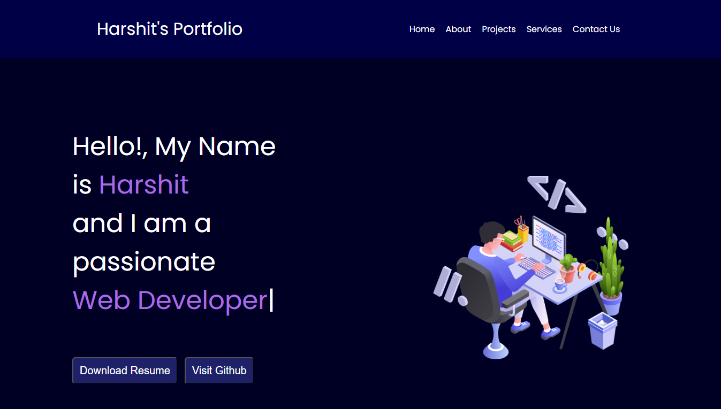

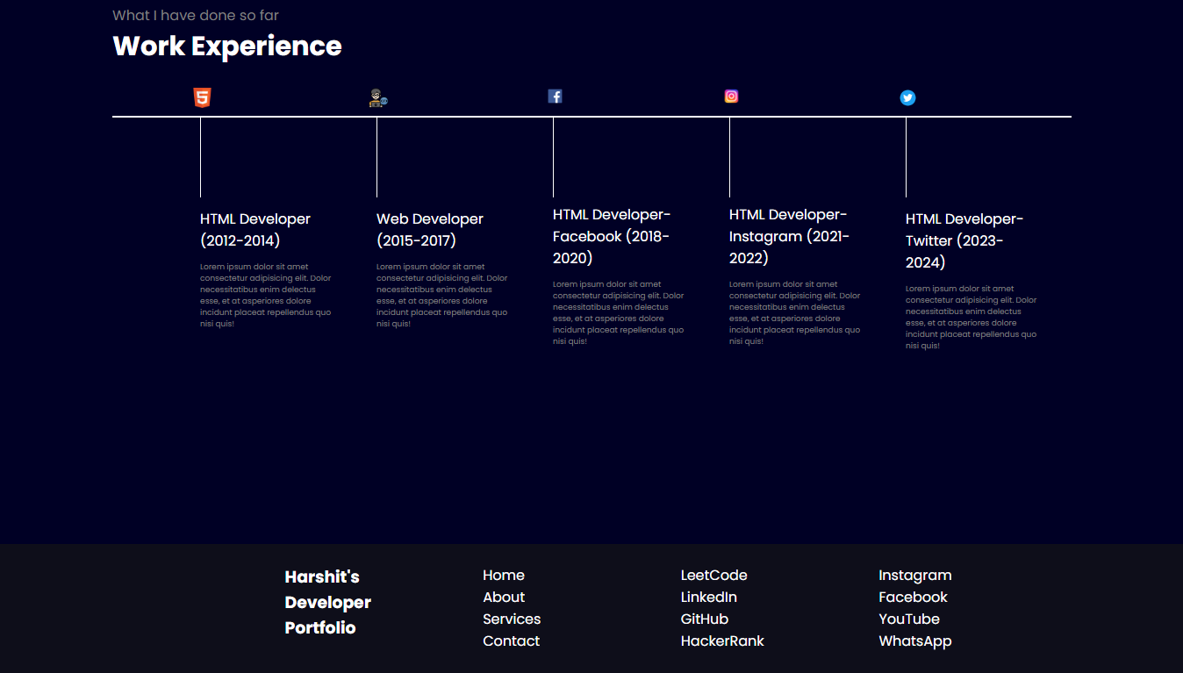

**SOURCE CODE:**

<!DOCTYPE html>

<html lang="en">

<head>

<meta charset="UTF-8" />

<meta name="viewport" content="width=device-width, initial-scale=1.0" />

<title>Portfolio Website</title>

<link rel="preconnect" href="https://fonts.googleapis.com" />

<link rel="preconnect" href="https://fonts.gstatic.com" crossorigin />

<link

href="https://fonts.googleapis.com/css2?family=Poppins:ital,wght@0,100;0,200;0,300;0,400;0,500;0,600;0,700;0,800;0,900;1,100;1,200;1,300;1,400;1,500;1,600;1,700;1,800;1,900&display=swap"

rel="stylesheet"

/>

<style>

* {

margin: 0;

padding: 0;

}

body {

background-color: rgb(0, 0, 37);

color: white;

font-family: "Poppins", sans-serif;

}

nav {

display: flex;

justify-content: space-around;

align-items: center;

padding: 30px;

background-color: rgb(0, 0, 70);

}

nav ul {

display: flex;

justify-content: center;

}

nav ul li {

list-style: none;

margin: 0 10px;

}

nav ul li a {

text-decoration: none;

color: white;

}

nav ul li a:hover {

color: rgb(153, 153, 226);

font-size: 1.04rem;

}

.left {

font-size: 2rem;

}

main hr {

border: 0;

background: #9c97f1;

height: 1.2px;

margin: 60px 84px;

}

.firstSection {

display: flex;

justify-content: space-around;

margin: 130px 0;

align-items: center;

}

.firstSection > div {

width: 30%;

}

.leftSection {

font-size: 3rem;

}

.leftSection .buttons {

padding: 50px 0;

}

.leftSection .btn {

padding: 12px;

background: #1e2167;

color: white;

border-radius: 6px;

font-size: 20px;

cursor: pointer;

}

.rightSection img {

width: 90%;

}

.purple {

color: rgb(170, 107, 228);

}

#element {

color: rgb(170, 107, 228);

}

.secondSection {

max-width: 80vw;

margin: auto;

height: 80vh;

}

.secondSection h1 {

font-size: 1.9rem;

}

.text-grey {

color: grey;

}

.secondSection .box {

background: white;

width: 80vw;

height: 2px;

margin: 56px 0;

display: flex;

}

.secondSection .verticle {

height: 93px;

width: 1px;

background-color: white;

margin: 0 100px;

}

.image-top {

width: 23px;

position: relative;

top: -32px;

left: -9px;

}

.verticle-title {

position: relative;

top: 75px;

width: 150px;

}

.verticle-desc {

position: relative;

top: 86px;

color: grey;

width: 150px;

font-size: 9px;

}

footer {

background-color: #0e0e1a;

}

.footer {

display: flex;

padding: 23px 122px;

justify-content: space-evenly;

}

.footer ul {

list-style: none;

}

.footer > div {

width: 23px;

}

footer .footer-rights {

text-align: center;

color: grey;

padding: 12px 0;

}

</style>

</head>

<body>

<header>

<nav>

<div class="left">Harshit's Portfolio</div>

<div class="right">

<ul>

<li><a href="/">Home</a></li>

<li>

<a

href="https://www.linkedin.com/in/harshit-srivastava-14a41a30a/"

target="_blank"

>About</a

>

</li>

<li>

<a

href="https://github.com/Harshit-17-04/Harshit-projext"

target="_blank"

>Projects</a

>

</li>

<li><a href="/">Services</a></li>

<li><a href="form.html" target="_blank">Contact Us</a></li>

</ul>

</div>

</nav>

</header>

<main>

<section class="firstSection">

<div class="leftSection">

Hello!, My Name is <span class="purple">Harshit</span>

<div>and I am a passionate</div>

<span id="element"></span>

<div class="buttons">

<a href="resume.pdf" target="_blank"

><button class="btn">Download Resume</button></a

>

<a href="https://github.com/Harshit-17-04" target="_blank"

><button class="btn">Visit Github</button></a

>

</div>

</div>

<div class="rightSection">

<img src="bg.png" alt="" />

</div>

</section>

<hr />

<section class="secondSection">

<span class="text-grey">What I have done so far</span>

<h1>Work Experience</h1>

<div class="box">

<div class="verticle">

<img class="image-top" src="html.png" alt="" />

<div class="verticle-title">HTML Developer (2012-2014)</div>

<div class="verticle-desc">

Lorem ipsum dolor sit amet consectetur adipisicing elit. Dolor

necessitatibus enim delectus esse, et at asperiores dolore

incidunt placeat repellendus quo nisi quis!

</div>

</div>

<div class="verticle">

<img class="image-top" src="developer.png" alt="" />

<div class="verticle-title">Web Developer (2015-2017)</div>

<div class="verticle-desc">

Lorem ipsum dolor sit amet consectetur adipisicing elit. Dolor

necessitatibus enim delectus esse, et at asperiores dolore

incidunt placeat repellendus quo nisi quis!

</div>

</div>

<div class="verticle">

<img class="image-top" src="fb.png" alt="" />

<div class="verticle-title">

HTML Developer- Facebook (2018-2020)

</div>

<div class="verticle-desc">

Lorem ipsum dolor sit amet consectetur adipisicing elit. Dolor

necessitatibus enim delectus esse, et at asperiores dolore

incidunt placeat repellendus quo nisi quis!

</div>

</div>

<div class="verticle">

<img class="image-top" src="Instagram.png" alt="" />

<div class="verticle-title">

HTML Developer- Instagram (2021-2022)

</div>

<div class="verticle-desc">

Lorem ipsum dolor sit amet consectetur adipisicing elit. Dolor

necessitatibus enim delectus esse, et at asperiores dolore

incidunt placeat repellendus quo nisi quis!

</div>

</div>

<div class="verticle">

<img class="image-top" src="twitter.png" alt="" />

<div class="verticle-title">

HTML Developer- Twitter (2023-2024)

</div>

<div class="verticle-desc">

Lorem ipsum dolor sit amet consectetur adipisicing elit. Dolor

necessitatibus enim delectus esse, et at asperiores dolore

incidunt placeat repellendus quo nisi quis!

</div>

</div>

</div>

</section>

</main>

<footer>

<div class="footer">

<div class="footer-first">

<h3>Harshit's Developer Portfolio</h3>

</div>

<div class="footer-second">

<ul>

<li>Home</li>

<li>About</li>

<li>Services</li>

<li>Contact</li>

</ul>

</div>

<div class="footer-third">

<ul>

<li>LeetCode</li>

<li>LinkedIn</li>

<li>GitHub</li>

<li>HackerRank</li>

</ul>

</div>

<div class="footer-fourth">

<ul>

<li>Instagram</li>

<li>Facebook</li>

<li>YouTube</li>

<li>WhatsApp</li>

</ul>

</div>

</div>

<div class="footer-rights">

Copyright &#169; harshitsportfolio.com | All Rights Reserved

</div>

</footer>

<script src="https://unpkg.com/typed.js@2.1.0/dist/typed.umd.js"></script>

<script>

var typed = new Typed("#element", {

strings: [

"Web Developer",

"Graphics Designer",

"Video Editor",

"Web Developer",

],

typeSpeed: 50,

});

</script>

</body>

</html>

BIBLIOGRAPHY

1. Geeks For Geeks
2. YOUTUBE
3. Code with Harry
4. Google.