Algorithm Efficiency Analysis of Sorting and Fibonacci Algorithms
Complete Lab File

1. Objective
The objective of this laboratory work is to implement and analyze different sorting and Fibonacci algorithms. The algorithms are experimentally tested using different input sizes and input conditions.
The performance of the algorithms is evaluated using the following parameters:
- Execution Time
- Memory Usage
- Best-Case Complexity
- Average-Case Complexity
- Worst-Case Complexity
- Space Complexity
The experimental analysis includes sorted, reverse-sorted, and random input data for sorting algorithms.

2. Software and Tools Used
The following software and tools were used to perform the experiments:
- Python 3.12.9
- Jupyter Notebook
- Pandas
- Matplotlib
- time module
- tracemalloc module
Python was used to implement the algorithms. Jupyter Notebook was used to execute the programs and record the experimental results. Pandas was used for organizing the results into tables, and Matplotlib was used for generating graphs.

3. Performance Measurement Method
The execution time and memory usage of each algorithm were measured experimentally.
Execution time was measured using:
time.perf_counter()
Memory usage was measured using:
tracemalloc
The following performance measurement function was used:
def measure_performance(func, *args):
tracemalloc.start()

start_time = time.perf_counter()

result = func(*args)

end_time = time.perf_counter()

current_memory, peak_memory = tracemalloc.get_traced_memory()

tracemalloc.stop()

execution_time = end_time - start_time
memory_usage_kb = peak_memory / 1024

return result, execution_time, memory_usage_kb

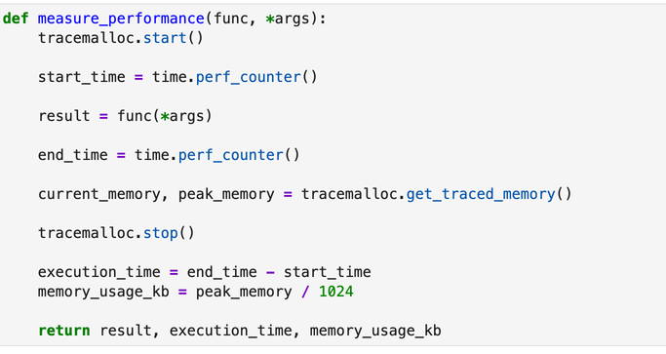

Function Used to Measure Execution Time and Memory Usage
4. Sorting Algorithms
4.1 Bubble Sort
Bubble Sort repeatedly compares adjacent elements and swaps them when they are in the wrong order. The process continues until the array is sorted.
Program
Paste the following code:
def bubble_sort(arr):
arr = arr.copy()
n = len(arr)

for i in range(n):

swapped = False

for j in range(0, n - i - 1):

if arr[j] > arr[j + 1]:

arr[j], arr[j + 1] = arr[j + 1], arr[j]

swapped = True

if not swapped:
break

return arr

4.2 Insertion Sort
Insertion Sort builds the sorted portion of the array one element at a time by inserting each element into its correct position.
Program
def insertion_sort(arr):
arr = arr.copy()

for i in range(1, len(arr)):

key = arr[i]

j = i - 1

while j >= 0 and arr[j] > key:

arr[j + 1] = arr[j]

j -= 1

arr[j + 1] = key

return arr

4.3 Merge Sort
Merge Sort uses the divide-and-conquer technique. The input array is divided into smaller subarrays, which are sorted and then merged.
Program
def merge(left, right):

result = []

i = 0
j = 0

while i < len(left) and j < len(right):

if left[i] <= right[j]:

result.append(left[i])
i += 1

else:

result.append(right[j])
j += 1

result.extend(left[i:])
result.extend(right[j:])

return result

def merge_sort(arr):

if len(arr) <= 1:
return arr

mid = len(arr) // 2

left = merge_sort(arr[:mid])
right = merge_sort(arr[mid:])

return merge(left, right)

4.4 Quick Sort
Quick Sort also uses the divide-and-conquer approach. A pivot element is selected and the remaining elements are partitioned around the pivot.
The experimental implementation uses a middle-element pivot.
Program
def partition(arr, low, high):

mid = (low + high) // 2

arr[mid], arr[high] = arr[high], arr[mid]

pivot = arr[high]

i = low - 1

for j in range(low, high):

if arr[j] <= pivot:

i += 1

arr[i], arr[j] = arr[j], arr[i]

arr[i + 1], arr[high] = arr[high], arr[i + 1]

return i + 1

def quick_sort_recursive(arr, low, high):

if low < high:

pivot_index = partition(arr, low, high)

quick_sort_recursive(arr, low, pivot_index - 1)

quick_sort_recursive(arr, pivot_index + 1, high)

def quick_sort(arr):

arr = arr.copy()

quick_sort_recursive(arr, 0, len(arr) - 1)

return arr

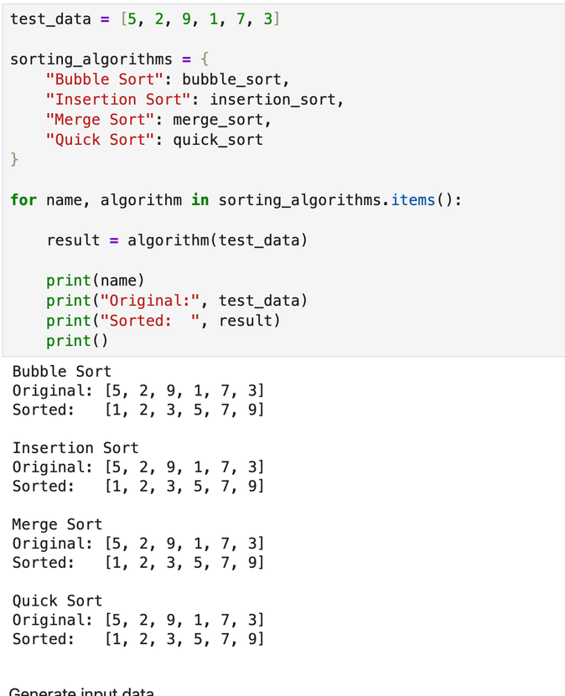

Testing and Verification of Sorting Algorithms
5. Sorting Experimental Analysis
The sorting algorithms were tested using the following input sizes:
100, 300, 500, 1000, 2000
The following input conditions were used:
- Sorted Data
- Reverse-Sorted Data
- Random Data
The following algorithms were tested:
- Bubble Sort
- Insertion Sort
- Merge Sort
- Quick Sort
For each experiment, execution time and peak memory usage were recorded.
Sorted results

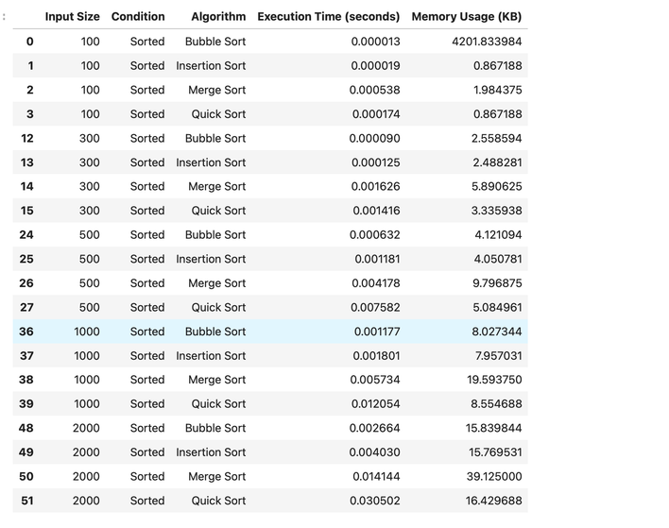

Reverse-sorted results

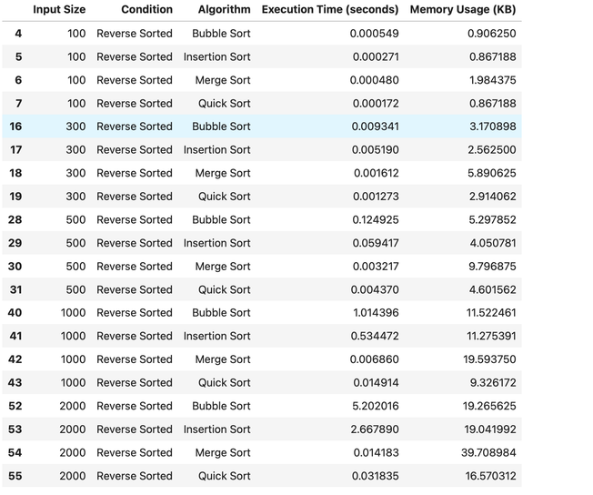

Random result
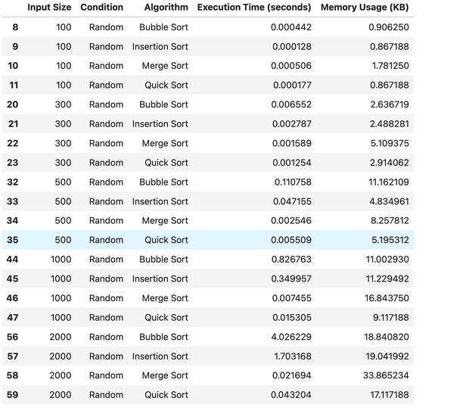

Experimental Results of Sorting Algorithms

6. Fibonacci Algorithms
6.1 Recursive Fibonacci
Recursive Fibonacci calculates Fibonacci numbers by recursively calculating the previous two Fibonacci values.
Program
def fib_recursive(n):
if n <= 1:
return n

return fib_recursive(n - 1) + fib_recursive(n - 2)

6.2 Iterative Fibonacci
The iterative approach calculates Fibonacci numbers using a loop.
Program
def fib_iterative(n):
if n <= 1:
return n

a, b = 0, 1

for _ in range(2, n + 1):
a, b = b, a + b

return b

6.3 Dynamic Programming Fibonacci
Dynamic Programming stores previously calculated values to avoid repeated calculations.
Program
def fib_dp(n, memo=None):

if memo is None:
memo = {}

if n in memo:
return memo[n]

if n <= 1:
return n

memo[n] = fib_dp(n - 1, memo) + fib_dp(n - 2, memo)

return memo[n]

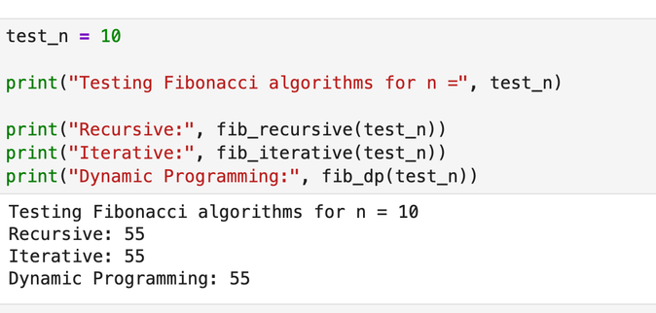

Testing and Verification of Fibonacci Algorithms

7. Fibonacci Experimental Analysis
The Fibonacci algorithms were tested using the following values:
5, 10, 15, 20, 25, 30, 35
The input sizes were selected to clearly demonstrate performance differences while keeping the recursive implementation practical to execute.
For each value of n, execution time and peak memory usage were measured.

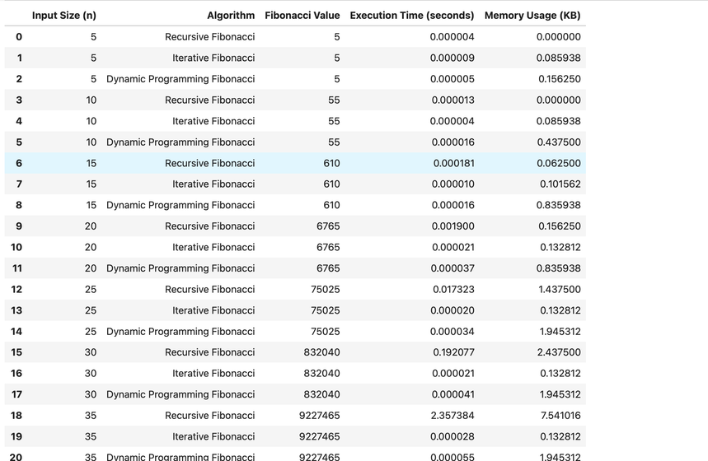

Experimental Results of Fibonacci Algorithms

8. Complexity Comparison
The following table compares the theoretical complexities of all implemented algorithms.
Algorithm | Best Case | Average Case | Worst Case | Space Complexity
Bubble Sort | O(n) | O(n²) | O(n²) | O(1)
Insertion Sort | O(n) | O(n²) | O(n²) | O(1)
Merge Sort | O(n log n) | O(n log n) | O(n log n) | O(n)
Quick Sort | O(n log n) | O(n log n) | O(n²) | O(log n)
Recursive Fibonacci | O(2ⁿ) | O(2ⁿ) | O(2ⁿ) | O(n)
Iterative Fibonacci | O(n) | O(n) | O(n) | O(1)
Dynamic Programming Fibonacci | O(n) | O(n) | O(n) | O(n)

9. Graphical Analysis
9.1 Execution Time Comparison of Sorting Algorithms for Random Input Data

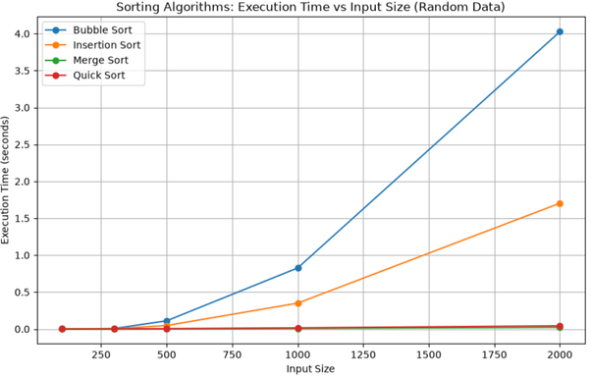

Execution Time Comparison of Sorting Algorithms for Random Input Data

Observation
The graph shows that execution time increases with input size. Bubble Sort and Insertion Sort generally show a greater increase in execution time because of their quadratic time complexity.
Merge Sort and Quick Sort generally scale more efficiently for larger input sizes because of their O(n log n) average-case complexity.

9.2 Memory Usage Comparison of Sorting Algorithms

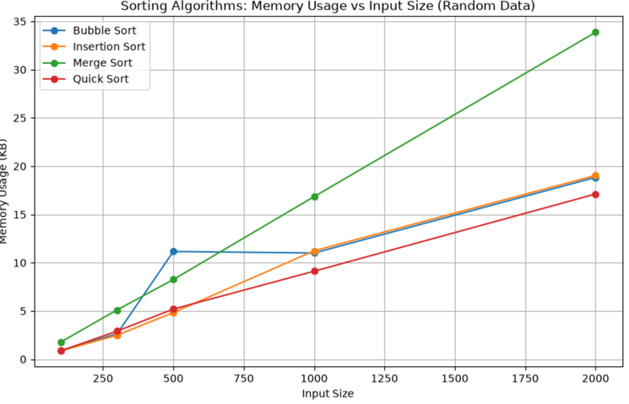

Memory Usage Comparison of Sorting Algorithms
9.3 Sorting Algorithms Under Different Input Conditions
Bubble Sort

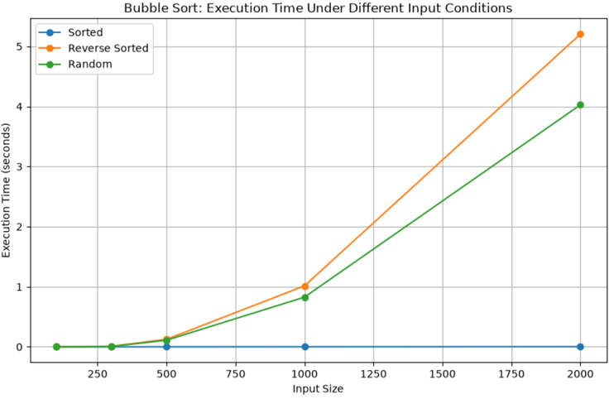

Bubble Sort Performance Under Different Input Conditions

Insertion Sort

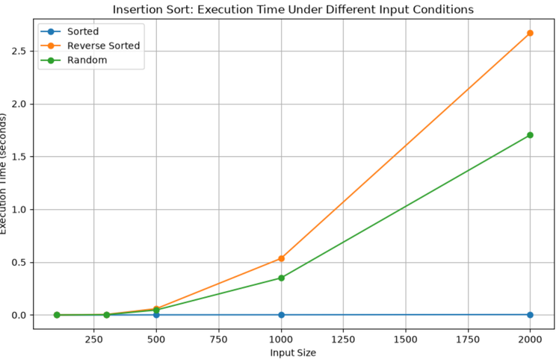

Insertion Sort Performance Under Different Input Conditions

Merge Sort

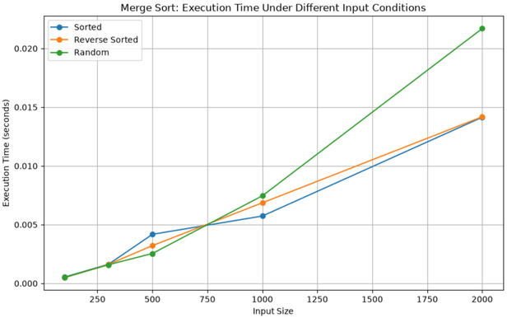

Merge Sort Performance Under Different Input Conditions

Quick Sort

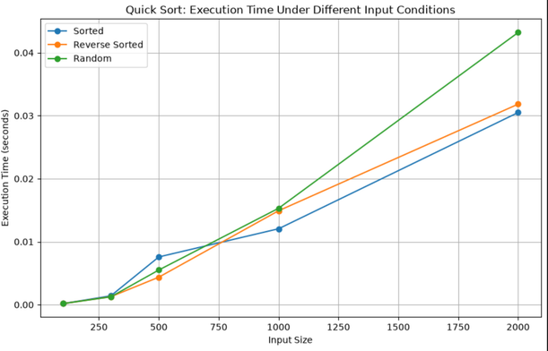

Quick Sort Performance Under Different Input Conditions

9.4 Fibonacci Execution Time Comparison

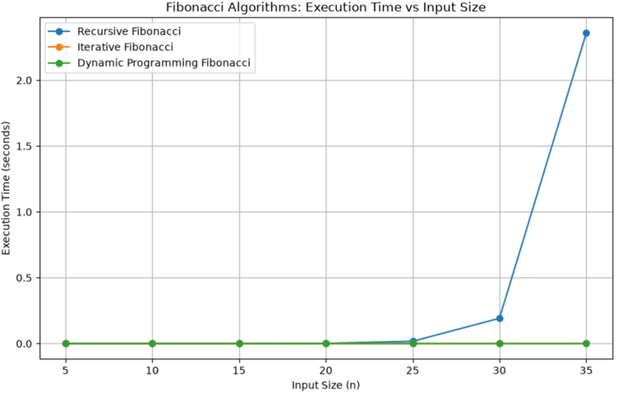

Execution Time Comparison of Fibonacci Algorithms

9.5 Fibonacci Memory Usage Comparison

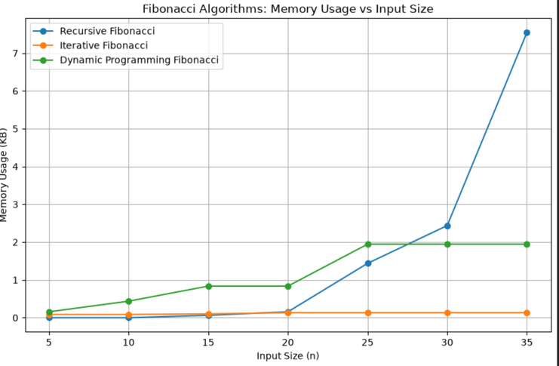

Memory Usage Comparison of Fibonacci Algorithms

10. Observations
Sorting Algorithms
- Bubble Sort and Insertion Sort showed increasing execution time as the input size increased.
- Bubble Sort performed efficiently on already sorted data because the optimized implementation stops when no swaps are required.
- Insertion Sort generally performed well on sorted data because fewer element shifts were required.
- Merge Sort showed more consistent performance across sorted, reverse-sorted, and random input conditions.
- Quick Sort performance depended on pivot selection and input distribution.
- Merge Sort generally required more additional memory because temporary arrays were used during merging.

Fibonacci Algorithms
- Recursive Fibonacci became significantly slower as the value of n increased.
- Recursive Fibonacci repeatedly calculated the same subproblems, resulting in increased execution time.
- Iterative Fibonacci remained efficient as n increased.
- Dynamic Programming Fibonacci avoided repeated calculations by storing previously computed results.
- Iterative Fibonacci generally required less additional memory than recursive and dynamic programming approaches.

11. Conclusion
The laboratory work demonstrated the practical importance of algorithm analysis.
The experimental results showed that execution time and memory usage depend on the algorithm design, input size, and input conditions.
Bubble Sort and Insertion Sort become less efficient as input size increases because of their quadratic time complexity. Merge Sort and Quick Sort generally provide better scalability for larger inputs.
The Fibonacci experiments demonstrated that Recursive Fibonacci becomes inefficient for larger values because of repeated calculations. Iterative and Dynamic Programming approaches provide significantly better performance.
Overall, the experiments confirm that theoretical complexity analysis is important for predicting algorithm performance, while experimental analysis provides practical evidence of how algorithms behave on real systems.
GitHub Repository Link
The complete source code, experimental analysis, complexity comparison, generated graphs, and result files used in this laboratory work are available in the following GitHub repository:
GitHub Repository:
Algorithm Efficiency Analysis Repository
The repository contains the complete Jupyter Notebook implementing Bubble Sort, Insertion Sort, Merge Sort, Quick Sort, Recursive Fibonacci, Iterative Fibonacci, and Dynamic Programming Fibonacci. It also includes the experimental result files, complexity comparison data, and generated graphs used in this laboratory work.

