Experiment-4

Student Name: Harshit Kumawat UID: 24BAI70025
Branch: CSE - AIML Section/Group: 24AIT_KRG G1
Semester: 4 Date of Performance: 04/02/26
Subject Name: DBMS Subject Code: 24CSH-298

Aim
To design and implement PL/SQL programs utilizing conditional control statements such as IF–ELSE, ELSIF, ELSIF ladder, and CASE constructs in order to control the flow of execution based on logical conditions and to analyse decision-making capabilities in PL/SQL blocks.

Software Requirements
- Database Management System:
  - PostgreSQL
- Database Administration Tool:
  - pgAdmin

Objectives
- Implement control structures in PL/SQL (IF-ELSE, ELSE-IF, ELSE-IF LADDER, CASE STATEMENTS in PL-SQL BLOCK).

Problem Statement
Develop and execute PL/SQL programs that demonstrate the use of conditional control statements. The programs should employ IF–ELSE, ELSIF, ELSIF ladder, and CASE statements to evaluate given conditions and control the flow of execution accordingly, thereby illustrating decision-making capabilities in PL/SQL blocks.

- Problem Statement – IF–ELSE Statement
Write a PL/SQL program to check whether a given number is positive or non-positive using the IF–ELSE conditional control statement and display an appropriate message.

- Problem Statement – IF–ELSIF–ELSE Statement
Write a PL/SQL program to evaluate the grade of a student based on the obtained marks using the IF–ELSIF–ELSE statement and display the corresponding grade.

- Problem Statement – ELSIF Ladder
Write a PL/SQL program to determine the performance status of a student based on marks using an ELSIF ladder and display the appropriate result.

- Problem Statement – CASE Statement
Write a PL/SQL program to display the name of the day based on a given day number using the CASE conditional statement.

Practical/Experiment Steps
- Control Blocks:
  - Design and implement distinct PL/SQL program blocks to explore and demonstrate the functionality of each conditional control structure: simple IF-ELSE, the ELSIF Ladder (IF-ELSIF-ELSE), and the CASE statement.
  - Focus on creating diverse conditional logic formats, including simple binary branching and complex multi-path evaluation.
- Apply Logic Branching for Data Categorization:
  - Utilize the IF-ELSE and ELSIF Ladder structures to categorize numerical input data (e.g., student marks) into predefined logical ranges.
  - This enables structured decision-making to automate outcomes such as assigning specific student grades or determining tiered performance statuses.
- Optimize Selection Logic with CASE Statements:
  - Implement the CASE conditional statement as a streamlined and efficient alternative for mapping discrete input values (e.g., integer day numbers 1 through 7) to their corresponding output names (e.g., 'SUNDAY', 'MONDAY').
  - Include a default handler (the ELSE clause) to manage invalid or out-of-range inputs gracefully.
- Integrate Dynamic Messaging for Real-Time Feedback:
  - Incorporate variable-driven output strings using the DBMS_OUTPUT.PUT_LINE procedure within each block.
  - This provides immediate, real-time feedback and clear, descriptive messages to the console based on the logical evaluation of the input conditions.
- Validate Execution Flow and Decision Logic:
  - Perform rigorous testing by initializing and executing the blocks with diverse test values (e.g., negative numbers, boundary case marks, and specific day numbers).
  - Rigorously validate the decision-making capabilities of the PL/SQL engine to ensure that the correct logical branch is activated for every test case and the resulting output is as expected.

Procedure
- Environment Preparation:
  - Enable the output server environment (e.g., using SET SERVEROUTPUT ON in SQL clients) to ensure all procedural results from DBMS_OUTPUT.PUT_LINE are visible in the console window.
- PL/SQL Block Implementation:
  - IF-ELSE: Construct a basic IF-ELSE block to perform a binary check on an input numerical variable, categorizing it as either positive or non-positive.
  - IF-ELSIF-ELSE (Grading): Develop an IF-ELSIF-ELSE structure to map student marks to specific letter grades based on defined percentage thresholds.
  - ELSIF Ladder (Performance): Expand the conditional logic into a comprehensive ELSIF ladder to categorize performance into tiered statuses (e.g., Distinction, First Class, Pass).
  - CASE Statement: Implement a CASE statement block to translate integer inputs into corresponding day names, ensuring a default handler is included for invalid entries.
- Adherence to Structure:
  - Nest all procedural logic within the standard DECLARE, BEGIN, and END; blocks to maintain structured programming principles.
- Testing and Validation:
  - Initialize diverse test values for each block's variable (e.g., negative numbers, boundary case marks, specific day numbers) to verify the logic accuracy across all conditional branches.
  - Execute each individual block sequentially, monitoring the DBMS output console for the expected string concatenations.
- Result Verification:
  - Verify that the output correctly reflects the logic branch associated with the assigned variable values and document the results.
  - Cross-check the console output against manual calculations to ensure the logic and variable handling were correct.

Input/Output Analysis
SQL Input Queries
DECLARE
NUM NUMBER:=-21;

BEGIN
IF NUM>0 THEN
DBMS_OUTPUT.PUT_LINE('IT IS A POSITIVE NUMBER');
ELSE
DBMS_OUTPUT.PUT_LINE('IT IS A NON-POSITIVE NUMBER');
END IF;
END;

Output
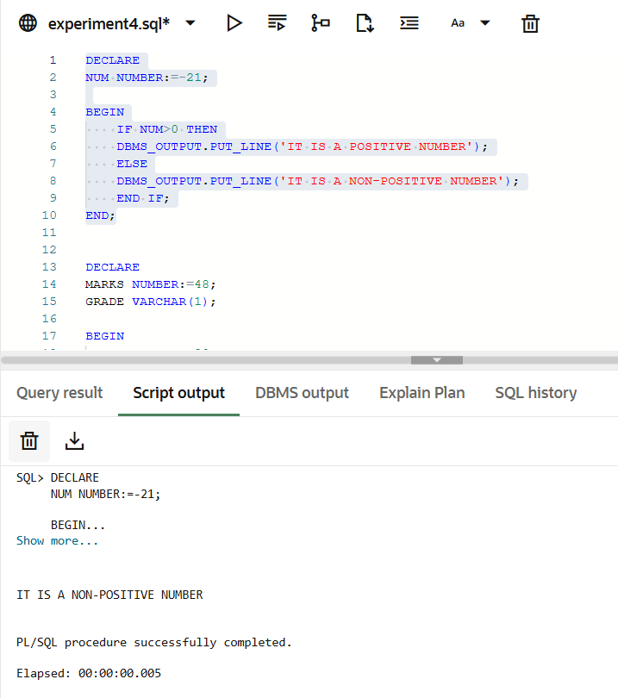
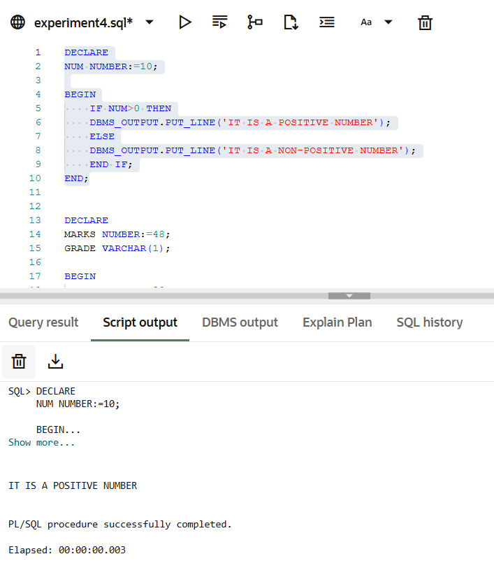

SQL Queries Input
DECLARE
MARKS NUMBER:=68;
GRADE VARCHAR(1);

BEGIN
IF MARKS>=90 THEN
GRADE:='A';
ELSIF MARKS>=80 THEN
GRADE:='B';
ELSIF MARKS>=70 THEN
GRADE:='C';
ELSIF MARKS>=60 THEN
GRADE:='D';
ELSE
GRADE:='F';
END IF;

DBMS_OUTPUT.PUT_LINE('MARKS = '||MARKS||', GRADE = '||GRADE);

END;

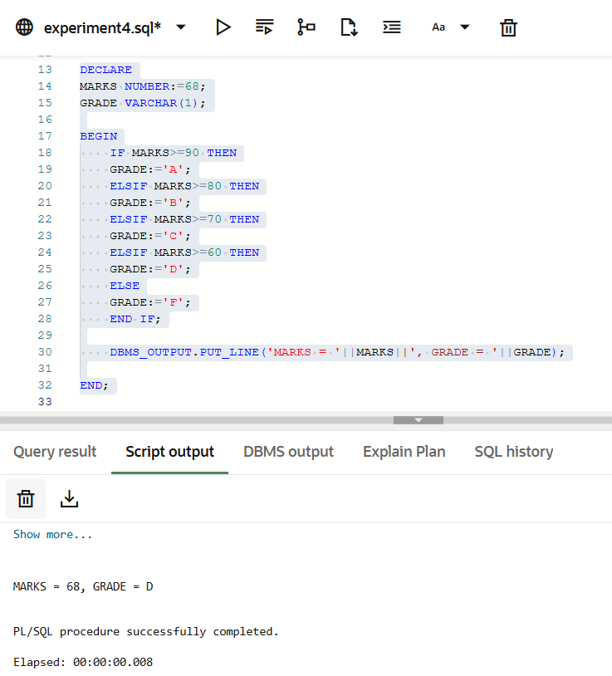
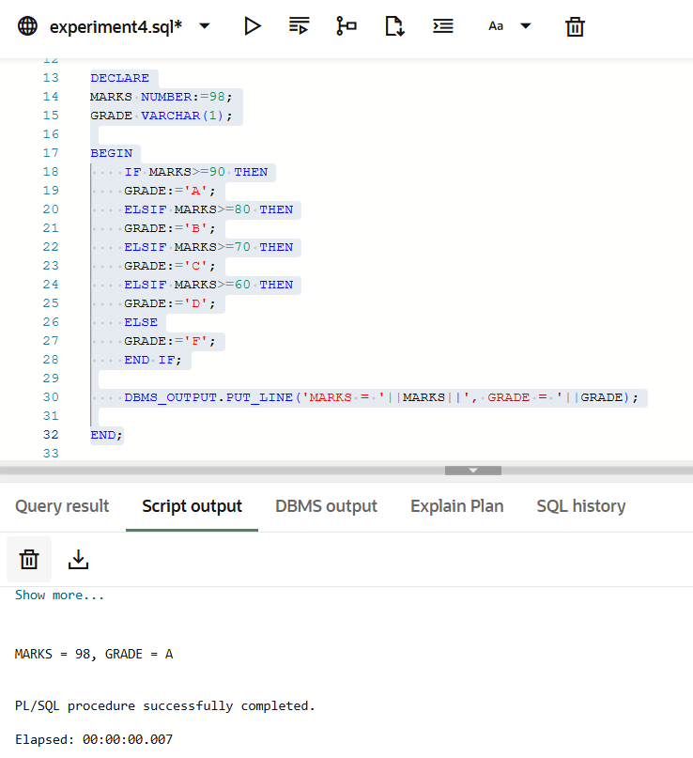
Output

SQL Queries Input
DECLARE
MARKS NUMBER:=58;
PERFORMANCE VARCHAR(20);

BEGIN
IF MARKS>=75 THEN
PERFORMANCE:='DISTINCTION';
ELSIF MARKS>=60 THEN
PERFORMANCE:='FIRST CLASS';
ELSIF MARKS>=50 THEN
PERFORMANCE:='SECOND CLASS';
ELSIF MARKS>=35 THEN
PERFORMANCE:='PASS';
ELSE
PERFORMANCE:='FAIL';
END IF;

DBMS_OUTPUT.PUT_LINE('MARKS = '||MARKS||' AND PERFORMANCE = '||PERFORMANCE);
END;

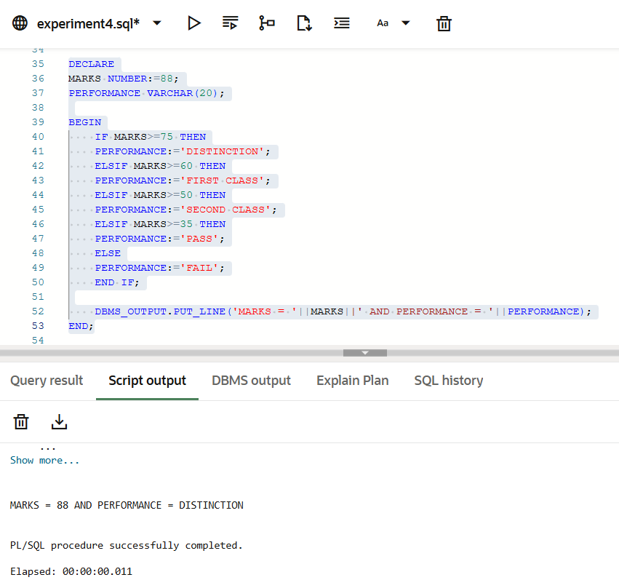
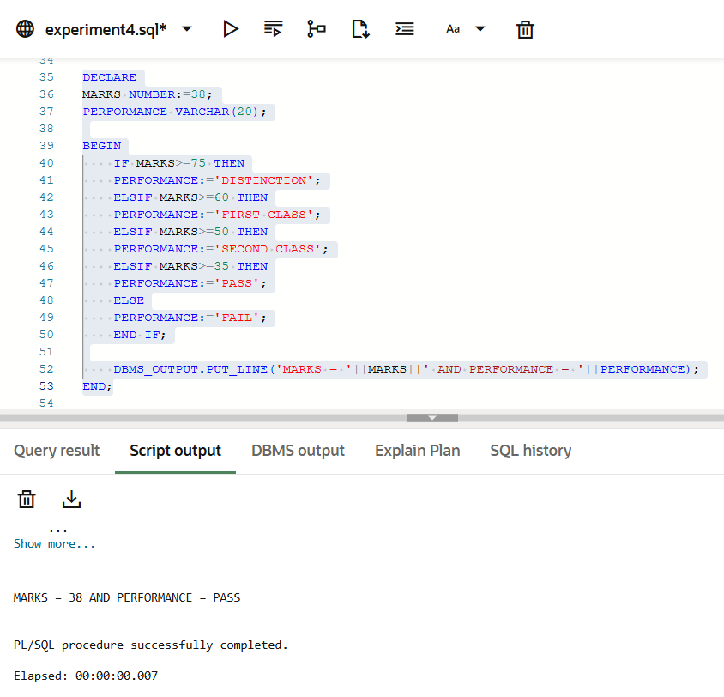
Output

SQL Queries Input
DECLARE
DAYNUM NUMBER:=3;
DAYNAME VARCHAR(20);

BEGIN
DAYNAME:=CASE DAYNUM
WHEN 1 THEN 'SUNDAY'
WHEN 2 THEN 'MONDAY'
WHEN 3 THEN 'TUESDAY'
WHEN 4 THEN 'WEDNESDAY'
WHEN 5 THEN 'THURSDAY'
WHEN 6 THEN 'FRIDAY'
WHEN 7 THEN 'SATURDAY'
ELSE 'INVALID DAY'
END;

DBMS_OUTPUT.PUT_LINE('IT IS '||DAYNAME);
END;

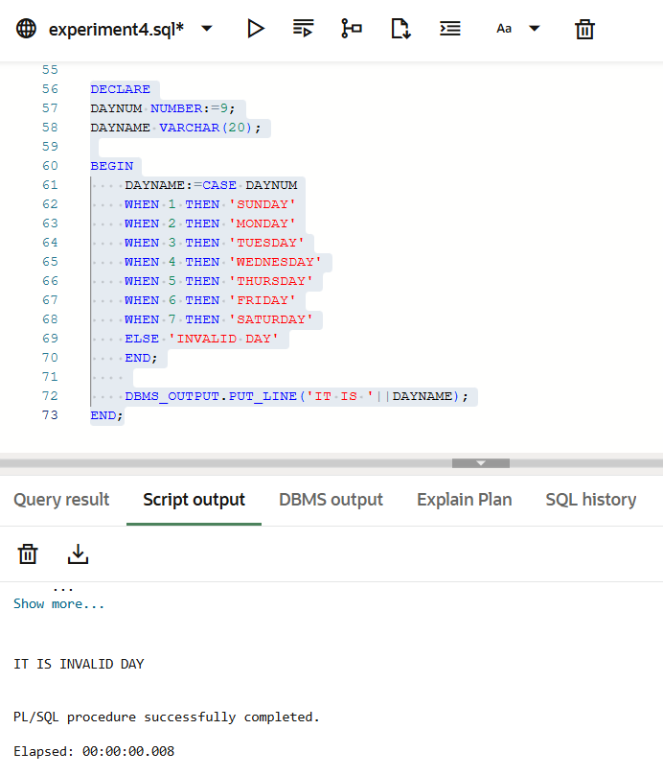
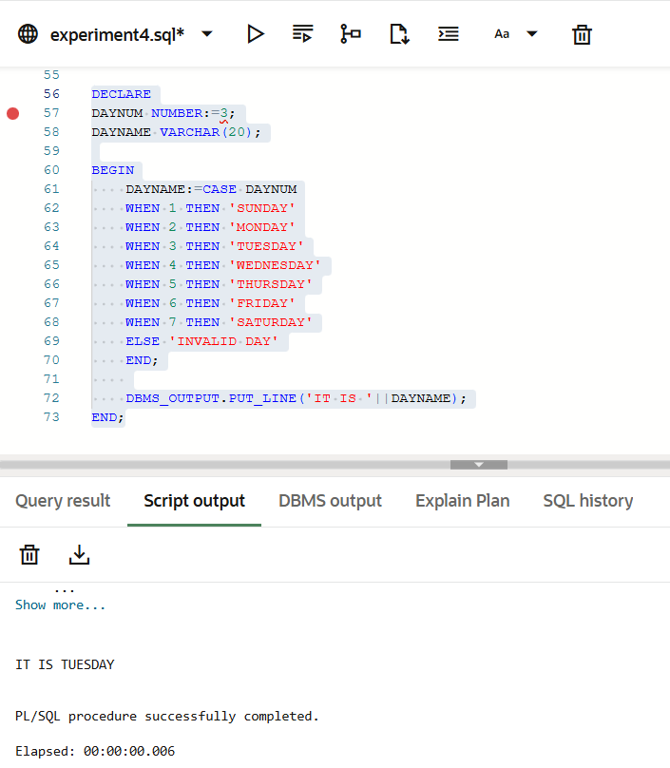
Output

Learning Outcomes
- Gained proficiency in using IF-ELSE, ELSIF ladders, and CASE statements to control program execution flow.
- Evaluated data variables to automate specific outcomes, such as student grading or performance status.
- Using CASE statements as a streamlined method for mapping discrete values like day numbers to names.
- Skills in setting logical thresholds to categorize raw numerical marks into descriptive classifications

