Student Name: Harshit Kumawat UID: 24BAI70025
Branch: B.E CSE(A.l & M.L) Section/Group: 24 AIT-KRG-G1
Semester: 4TH Sem Date of Performance:09/01/2026
Subject Name: DBMS Subject Code:

WORKSHEET 1
AIM: To design and implement a Library Management System using SQL by creating tables with constraints, performing data manipulation operations, and managing user roles and privileges.

S/W Requirement: PostgreSQL (pgAdmin 4)
OBJECTIVES:
To create tables using PRIMARY KEY, FOREIGN KEY, NOT NULL, UNIQUE, and CHECK constraints.
To insert, update, delete, and retrieve records using SQL DML commands.
To maintain referential integrity between tables.
To create a database role and manage access permissions using GRANT and REVOKE.
PROCEDURE:
- Environment Setup
  - Launch the PostgreSQL administration tool (pgAdmin 4).
  - Create a new database instance for the Library Management System.
- Database Design
  - Execute the CREATE TABLEstatements for the books, library_visitors, and book_issue tables.
  - Verify that the following constraints are successfully implemented in the respective tables:
    - Primary Keys: id in books, user_id in library_visitors, and book_issue_idin book_issue.
    - Foreign Keys: book_id and user_id in book_issuereferencing books and library_visitors, respectively.
    - NOT NULL: On essential columns like name, author_name, user_name, age, email, book_id, user_id, and book_issue_date.
    - UNIQUE: On the email column in the library_visitors table.
    - CHECK: On count > 0in books and age >= 18in library_visitors.
- Data Manipulation Operations (DML)
  - Execute the INSERT INTOstatements to add sample records into all three tables (books, library_visitors, book_issue).
  - Run SELECT * FROM [table_name]queries after each insertion to verify the data.
  - Perform an UPDATE operation (e.g., changing the email of a user) and verify the change with a SELECT statement.
  - Perform a DELETE operation (e.g., deleting a book) and ensure that referential integrity is maintained (although no cascading action is explicitly set, the delete should demonstrate the operation).
- Access Control and Security
  - Execute the CREATE ROLE command to set up a new user/role named reporting_user with a password.
  - Use GRANT SELECT statements to give the reporting_user read-only access to the main tables (Departments, Employees, Projects - based on the 'Given' section, assuming these are the required reporting tables).
  - Use REVOKE CREATE to explicitly prevent the user from creating new database objects within the public schema.
  - Use REVOKE INSERT, UPDATE, DELETE to ensure the reporting_user has strictly read-only access on all existing tables in the public schema.
- Database Maintenance
  - Execute the DROP TABLE command to remove a table that is no longer needed (e.g., Projects).

Given:
An organization wants to design a sample database system to manage Departments, Employees, and Projects. The database must ensure data integrity, controlled access, and proper privilege management for different users.

- Database Design
Create multiple tables such as Department, Employee, and Project.
Define appropriate PRIMARY KEY and FOREIGN KEY constraints.
Enforce NOT NULL, UNIQUE, and CHECK constraints where necessary.

Querry:
CREATE TABLE books(
id INT PRIMARY KEY,
name VARCHAR(50) NOT NULL,
author_name VARCHAR(50) NOT NULL,
count INT CHECK(count>0)
)

CREATE TABLE library_visitors(
user_id INT PRIMARY KEY,
user_name VARCHAR(20) NOT NULL,
age INT CHECK(age>=18) NOT NULL,
email VARCHAR(40) UNIQUE NOT NULL
)

CREATE TABLE book_issue(
book_issue_id INT PRIMARY KEY,
book_id INT NOT NULL,
user_id INT NOT NULL,
FOREIGN KEY (book_id) REFERENCES books(id),
FOREIGN KEY (user_id) REFERENCES library_visitors(user_id),
book_issue_date DATE NOT NULL
)

- Data Manipulation
Insert sample records into all tables.
Querry:

INSERT INTO books VALUES(1, 'Harry Potter', 'R. Snape', 1)
INSERT INTO books VALUES(2, 'Avengers', 'Stan Lee', 3)

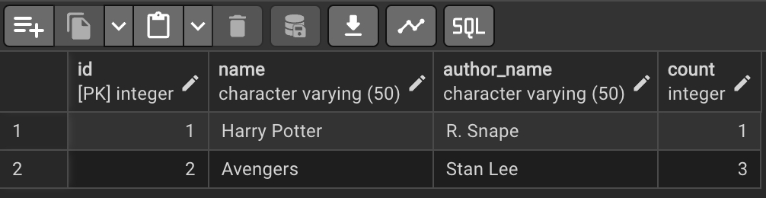

SELECT * FROM books

INSERT INTO library_visitors VALUES(101, 'Robert', 20, 'abc@gmail.com')
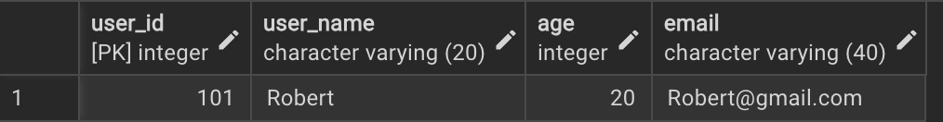

SELECT * FROM library_visitors
INSERT INTO book_issue VALUES(1234,1,101,'2026-01-07')
SELECT * FROM book_issue
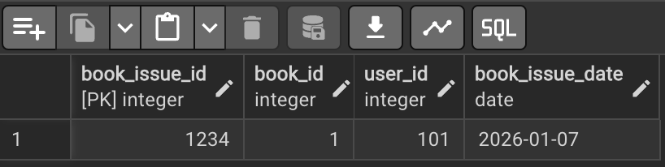
Perform UPDATE operations to modify existing records.
Querry:

Change an employee’s email
UPDATE library_visitors SET email='Robert@gmail.com' WHERE user_id = 101

Perform DELETE operations while maintaining referential integrity.
Querry:
DELETE FROM books WHERE id = 2
SELECT * FROM books

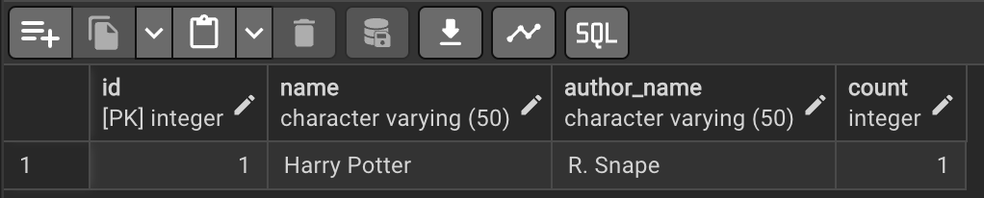

- Access Control & Security
Create a role/user for a reporting staff member.
Querry:
CREATE ROLE reporting_user LOGIN PASSWORD 'report123';


Grant ONLY SELECT privilege on required tables to this role/user.
Querry:
GRANT SELECT ON Departments TO reporting_user;
GRANT SELECT ON Employees TO reporting_user;
GRANT SELECT ON Projects TO reporting_user;

Explicitly REVOKE CREATE privilege so that the user cannot create any database objects.
Querry:
REVOKE CREATE ON SCHEMA public FROM reporting_user;

Ensure the user has read-only access to the database.
Querry:
REVOKE INSERT, UPDATE, DELETE ON ALL TABLES IN SCHEMA public FROM reporting_user;

Drop a table that is no longer required using DROP TABLE.
Querry:
DROP TABLE Projects;
I/O Analysis

This section analyzes the primary inputs provided to the PostgreSQL database system and the corresponding outputs generated, as executed in the Procedure and Querry sections.
Component | Input (The Action/Command) | Output (The Expected Result/Status)
Database Design (DDL) | CREATE TABLE statements with constraints (PRIMARY KEY, FOREIGN KEY, NOT NULL, UNIQUE, CHECK). | Successful creation of the books, library_visitors, and book_issue tables. Verification that all defined constraints are active (e.g., no insertion of a book with count <= 0).
Data Manipulation (DML) | INSERT INTO statements with sample data for all tables. | Successful addition of new records. Data integrity is maintained (e.g., foreign key check ensures only existing user/book IDs can be used in book_issue).
 | SELECT * FROM [table_name] queries. | Display of the newly inserted or modified data sets, confirming the DML operation was successful.
 | UPDATE operation (e.g., changing a user's email). | One or more rows are modified, and the change is committed to the table. SELECT query confirms the new email address.
 | DELETE operation (e.g., deleting a book). | The specified row is removed. If the book ID was used in book_issue, the database prevents the deletion (due to foreign key constraint) unless a cascading action was defined.
Access Control (DCL) | CREATE ROLE command. | Successful creation of a new database role named reporting_user with a specified password.
 | GRANT SELECT statements. | The reporting_user is successfully assigned read-only access to the specified tables (Departments, Employees, Projects).
 | REVOKE statements (CREATE, INSERT, UPDATE, DELETE). | Explicit removal of object creation and data modification privileges, ensuring the reporting_user has strictly read-only access.
Database Maintenance | DROP TABLE command. | Successful removal of the specified table (e.g., Projects) from the database schema.

Learning Outcomes:
- Understood the basics of relational database design using tables, keys, and relationships.
- Learned to apply primary key and foreign key constraints to maintain data integrity.
- Gained hands-on experience with INSERT, UPDATE, and DELETE operations safely.
- Understood how roles and privileges control access to database objects.
- Learned to use GRANT and REVOKE for implementing read-only users.
- Practiced ALTER TABLE and DROP TABLE for managing database changes.

