Experiment 2

Student Name: Harshit Kumawat UID: 24BAI70025
Branch: CSE - AIML Section/Group: 24AIT_KRG G1
Semester: 4 Date of Performance: 16/1/26
Subject Name: DBMS Subject Code: 24CSH-298

Aim
To understand and implement SQL SELECT queries using various clauses such as WHERE, ORDER BY, GROUP BY, and HAVING to retrieve and manipulate data efficiently from relational database tables.

Software Requirements
- Database Management System:
  - PostgreSQL/Oracle
- Database Administration Tool:
  - pgAdmin

Objectives
- To practice writing SQL SELECT statements.
- To apply filtering conditions using the WHERE clause.
- To sort query results using the ORDER BY clause.
- To group records using the GROUP BY clause.
- To filter grouped data using the HAVING clause.
- To analyze data using aggregate functions like COUNT(), SUM(), AVG(), MIN(), and MAX().

Problem Statement
An organization maintains an EMPLOYEE table to store details of its employees.
The structure of the table is as follows:

Column Name | Data Type
emp_id | NUMBER
emp_name | VARCHAR
Department | VARCHAR
Salary | NUMBER
joining_date | DATE

Practical/Experiment Steps
- Schema Definition: Constructed the fundamental EMPLOYEE table structure, defining specific data types for employee IDs, names, departments, salaries, and joining dates.
- Data Population: Seeded the database with sample employee records across various departments (IT, HR, Finance) to create a functional dataset for testing.
- Aggregate Data Analysis: Implemented GROUP BY operations to calculate the average salary for each department using the AVG() aggregate function.
- Conditional Filtering: Applied high-level filtering logic using the HAVING clause to isolate specific records, such as employees with salaries exceeding 20,000.
- Data Sorting & Grouped Constraints: Configured queries to sort department averages in descending order and practiced applying secondary filters to grouped results.

Procedure
- Logged into the pgAdmin administration tool and established a connection to the PostgreSQL database server.
- Initialized a new database environment to house the employee management system.
- Ran the CREATE TABLE command to define the EMPLOYEE schema, ensuring EMP_ID was set as the Primary Key.
- Executed multiple INSERT statements to populate the table with diverse sample books and visitor profiles—in this case, employee records.
- Used SELECT queries paired with GROUP BY to verify that data was correctly stored and consistent across the table.
- Applied HAVING and WHERE clauses to test how the system handles specific data retrieval conditions.
- Utilized the ORDER BY clause to arrange the output in descending order based on average salaries.
- Tested and verified the effectiveness of security or logic policies by ensuring queries returned expected results or empty sets when conditions weren't met.
- Saved the final SQL script and captured screenshots of the execution results for record maintenance.

Input/Output Analysis
SQL Input Queries
CREATE TABLE EMPLOYEE(
EMP_ID NUMERIC PRIMARY KEY,
EMP_NAME VARCHAR(20),
DEPARTMENT VARCHAR(20),
SALARY NUMERIC(10,2),
JOINING_DATE DATE
)

INSERT INTO EMPLOYEE VALUES(1, 'Aman', 'IT', 30000, '2023-05-23');
INSERT INTO EMPLOYEE VALUES(2, 'Sam', 'IT', 25000, '2016-05-23');
INSERT INTO EMPLOYEE VALUES(3, 'Neha', 'HR', 18000, '2025-09-19');
INSERT INTO EMPLOYEE VALUES(4, 'Suman', 'Finance', 20000, '2021-11-06');
INSERT INTO EMPLOYEE VALUES(5, 'Rohan', 'Finance', 24500, '2023-10-23');
INSERT INTO EMPLOYEE VALUES(6, 'Aditi', 'HR', 28000, '2018-04-16');
INSERT INTO EMPLOYEE VALUES(7, 'Aanya', 'IT', 26000, '2022-07-07')

SELECT DEPARTMENT, AVG(SALARY)::NUMERIC(10,2) AS AVG_SAL FROM EMPLOYEE
GROUP BY DEPARTMENT

SELECT EMP_ID, EMP_NAME, SALARY
FROM EMPLOYEE
GROUP BY EMP_ID
HAVING SALARY>20000

SELECT DEPARTMENT, AVG(SALARY)::NUMERIC(10,2) AS AVG_SAL FROM EMPLOYEE
GROUP BY DEPARTMENT
HAVING AVG(SALARY)>30000

SELECT DEPARTMENT, AVG(SALARY)::NUMERIC(10,2) AS AVG_SAL FROM EMPLOYEE
GROUP BY DEPARTMENT
ORDER BY AVG(SALARY) DESC

Output
Table created
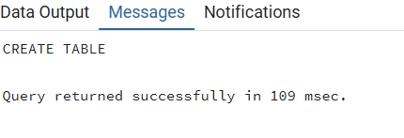

Records inserted

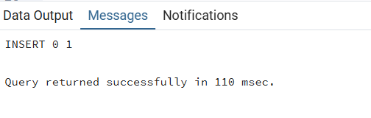

Employees with salaries greater than 20,000
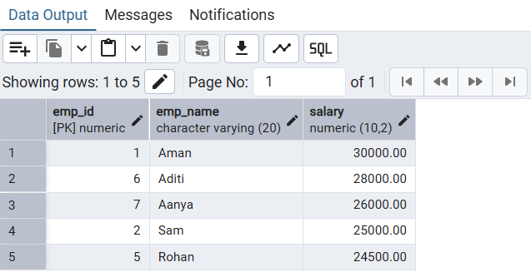

Average salaries of department
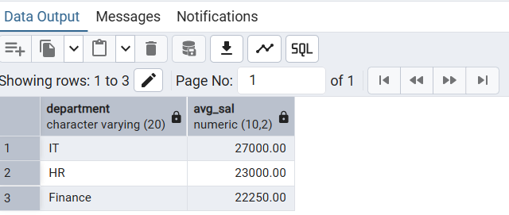

Sorting average salaries in descending order:

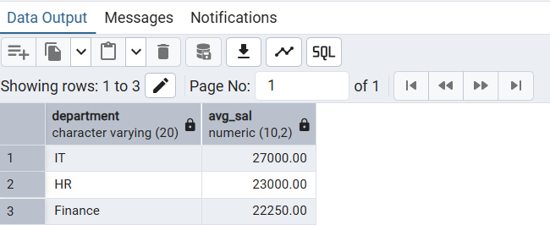

Departments with average salary more than 30,000 (empty because none)
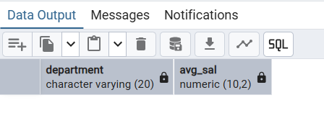

I/O ANALYSIS TABLE
Input (SQL Query) | Output/Purpose
CREATE TABLE EMPLOYEE(...) | Table created.
INSERT INTO EMPLOYEE VALUES(...) (All seven records) | Records inserted.
SELECT DEPARTMENT, AVG(SALARY)::NUMERIC(10,2) AS AVG_SAL FROM EMPLOYEE GROUP BY DEPARTMENT | Displays the average salary for each department.
SELECT EMP_ID, EMP_NAME, SALARY FROM EMPLOYEE GROUP BY EMP_ID HAVING SALARY>20000 | Displays employee IDs, names, and salaries for employees whose salary is greater than 20,000.
SELECT DEPARTMENT, AVG(SALARY)::NUMERIC(10,2) AS AVG_SAL FROM EMPLOYEE GROUP BY DEPARTMENT HAVING AVG(SALARY)>30000 | Attempts to display departments with an average salary greater than 30,000 (Result is empty).
SELECT DEPARTMENT, AVG(SALARY)::NUMERIC(10,2) AS AVG_SAL FROM EMPLOYEE GROUP BY DEPARTMENT ORDER BY AVG(SALARY) DESC | Displays the average salary for each department, sorted in descending order of average salary.

Learning Outcomes
- Learn to filter records using the WHERE clause.
- Group records using GROUP BY.
- Apply conditions on grouped data using HAVING.
- Sort query results using ORDER BY.

