**Alexa Skill Set**

**Study Aid Skill**

**SRS (System Requirement Specifications)**

Harshit Jain - BCA (Hons.)

Symbiosis Institute of Computer Studies and Research, Pune

**Introduction**

Purpose

Alexa Study Aid Skill is a type of application or program that can be used on an Alexa-enabled device (such as an Amazon Echo) to help users (students) study and learn.

These skills can take various forms, but some examples include flashcard-style quizzes and practice quizzes, which help keep assignment records and deadlines. Users can use voice commands to interact with the study aid skill, and Alexa will respond with the appropriate information or prompts.

Intended Audience and Reading Suggestions

This document is intended for different types of readers, including developers, team members, users (mainly including students), testers, and documentation writers. The SRS includes the overall description of the project, external interface requirements, system features, system features, other non-functional requirements, and other requirements.

Product Scope

During research, we learned that Amazon Alexa has great demand over Google Home and Apple's HomePod, and new customers also prefer Alexa or Amazon's Echo Dot.

This Alexa skill, which helps students with their studies and maintains efficiency, will be new to our assistant. It is also unavailable in any other assistant; this will eventually increase the product's popularity, which is our study aid skill.

* Improved memory retention: Study aids can help students better retain information by breaking down complex concepts into manageable chunks.
* Increased focus and concentration: Study aids can help students stay focused and on task, reducing distractions and increasing productivity.
* Better organization: Study aids can help students organize their study materials and schedule, making it easier to stay on top of assignments and deadlines.
* Greater understanding: Study aids can provide a deeper understanding of the material by breaking down complex concepts and providing additional resources such as videos and interactive quizzes.
* Flexibility: Study aids can be accessed anytime, anywhere, allowing students to study at their own pace and schedule.
* Personalization: Study aids can be tailored to a student's learning style, helping to improve their understanding and retention of the material.

References

Users need to have an Amazon Alexa account to access a particular skill. The skill can be used on the website or the Amazon Alexa app via the Alexa assistant:

[*https://alexa.amazon.in/spa/index.html#new-oobe*](https://alexa.amazon.in/spa/index.html#new-oobe)

How to set up Amazon Alexa:

[*https://www.amazon.in/gp/help/customer/display.html?nodeId=GKFJXZCLQ83HGHQZ*](https://www.amazon.in/gp/help/customer/display.html?nodeId=GKFJXZCLQ83HGHQZ)

**Overall description**

Product functions

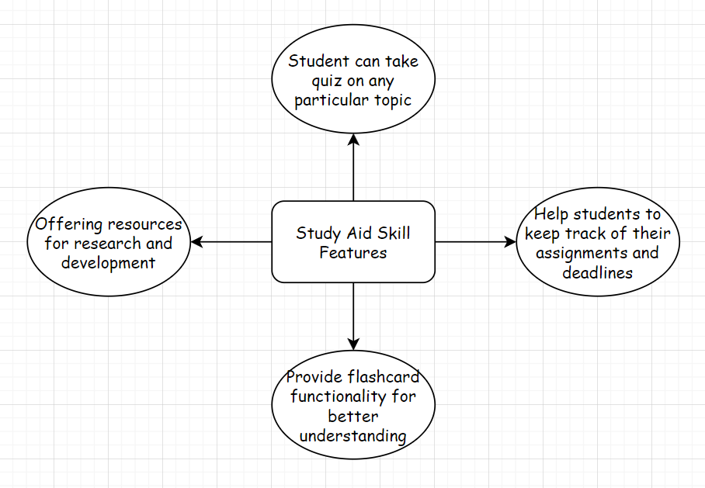

Operating environment

The environment in which an Alexa study skill can be operated is primarily within the Amazon Echo or other devices with Alexa built-in. The user will interact with the skill through voice commands, which will be processed by the Alexa service and translated into requests to the skill's web service. The skill's web service will then respond to the requests and provide information or perform actions specified by the skill's functionality. The skill may also interact with external services or databases to retrieve or store information. The skill is developed and hosted using the Alexa Skills Kit (ASK) development platform, which includes the Alexa Skills Kit SDK for Node.js, the Alexa Skills Kit Command Line Interface (ASK CLI), and the Alexa Skills Kit Developer Console.

Design and implementation constraints

Design constraints for an Alexa study aid skill include being user-friendly and easy to navigate and providing valuable and relevant information for students. The skill should also handle a wide range of topics and subject areas.

Right now, our design can also not provide personalized information to the users or even get personalized according to their provided credentials or requirements.

Implementation constraints for the skill include integrating with existing educational systems and databases, such as online textbooks or learning management systems, to provide accurate and up-to-date information. Additionally, the skill may need to comply with privacy and security regulations to protect users' personal information.

Another constraint might be on the model's natural language understanding (NLU) and natural language generation (NLG) abilities. The skill should understand the user's intent and provide appropriate responses. It should also generate clear and easy responses for users to understand.

Finally, the skill should handle multiple languages and be easily accessible for students with disabilities.

Assumptions and dependencies

When using a study aid skill on a device like Alexa, there are a few assumptions that may be made:

1. Users can access an Alexa-enabled device like an Amazon Echo or Echo Dot.
2. The user has an internet connection to access the skill and any related information.
3. The user can understand and interact with the skill using voice commands in English.
4. The user has a basic understanding of how to use Alexa and its capabilities.
5. The user has the necessary study materials, such as textbooks or notes, to effectively use the skill.
6. The study aid skill is designed and programmed to be helpful, accurate and up-to-date.

To use an Alexa study aid skill, the user will need the following dependencies:

1. A device with Alexa, such as an Amazon Echo or Echo Dot.
2. An Amazon account to download the skill from the Alexa Skill Store.
3. A reliable internet connection to enable the skill and access its features.

External interface requirements

User interface

The user interface requirements for an Alexa study aid skill include

* the ability for users to ask questions and receive answers,
* the ability to set reminders and schedule study sessions and
* the ability to track progress and performance.

Additionally, the skill should be easy to navigate and understand, with clear and concise instructions and prompts for users. The skill should also allow users to customize their study experience by selecting specific subjects or topics to focus on.

Hardware interface

To use the Alexa Study Aid skill, the user will need a device with Alexa capability, such as an Amazon Echo or a device with the Alexa app installed. Additionally, the device should be connected to the internet for the skill to function correctly.

The hardware requirements for using the Alexa Study aid skill are:

* A device with Alexa capability, such as an Amazon Echo or an Alexa app, is installed.
* Internet connectivity for the device is necessary for the skill to function correctly.
* A speaker or headphones is needed to hear Alexa's response.
* A microphone to interact with Alexa through voice commands.

It is worth noting that the specific hardware requirements may vary depending on the implementation of the study aid skill.

Software interface

The software interface requirements for a user to use an Alexa study aid skill include:

* A device with the Alexa Voice Service (AVS), such as an Amazon Echo, Echo Dot, or Echo Show.
* An internet connection
* The Alexa app installed on a smartphone or tablet
* The study aid skill is enabled and linked to the user's Alexa account through the Alexa app or voice commands.

Additionally, the user's device should meet the minimum hardware and software requirements specified by Amazon for the device to run the Alexa Voice Service.

It is also good to note that the user should have an Amazon account and agree to the terms and conditions for using Alexa and the skill's terms and conditions.

Communication interface

To use an Alexa study aid skill, a user would require a device with Alexa, such as an Amazon Echo, Echo Dot, or Echo Show, and an active internet connection. The user would also need to install the Alexa app on their smartphone or tablet and enable the study aid skill on their Alexa account. This can be done through the Alexa app or by using voice commands to Alexa.

Functional requirement

A functional requirement for a user to use an Alexa study aid skill would include the following:

* Voice commands: Users should be able to initiate and control the skill using natural language voice commands, such as "Alexa, open study aid" or "Alexa, show me flashcards for chapter 3."
* Study materials: The skill should provide various study materials, such as flashcards, quizzes, and notes, organized by subject or topic. Users should be able to select the materials they want to study and track their progress.
* Reminders: Users should be able to set reminders for when to learn, and Alexa should be able to remind them at the appropriate time.
* Progress tracking: Users should be able to track their progress over time and see how well they did on quizzes and flashcards and which areas they need to focus on more.
* Integration with other resources: The skill should integrate with other study resources, such as textbooks or online articles, allowing users to access and study the needed materials efficiently.
* User-friendly interface: The skill should have a straightforward, easy-to-use interface with clear instructions and feedback. It should be easy for users to navigate and understand how to use the skill.
* Customizable: Users should be able to customize the skill according to their preferences, such as setting the study reminder time, the flashcards, quizzes, and notes they want to study, and the difficulty level they want to select.
* Personalization: The skill should be able to personalize the study materials and quiz questions based on the user's learning style and progress.

Non- functional requirement

Performance requirement: To use an Alexa study aid skill, users will need a device with Alexa capability, such as an Amazon Echo smart speaker or Echo Dot, or a device with the Alexa app installed, such as a smartphone or tablet. These devices must be connected to the internet to access the skill and the information it provides.

Users must also have an Amazon account, as they must sign in to the Alexa app or website to enable the skill and access its features. Once the skill is enabled, users can interact with it using voice commands, such as asking Alexa to start a quiz or asking for a definition of a word.

Also, the performance of the skill may be affected by the quality of your internet connection and the device's microphone and speakers. The device should be placed in a room with minimal background noise to help ensure that Alexa can hear and understand the user's commands.

These devices must also be connected to the internet to work correctly.

Security requirement

To use an Alexa study aid skill, a user would typically need to meet the following security requirements:

1. The user must have an Amazon account and be logged in to use the Alexa device and access the skill.
2. The user's device, such as an Amazon Echo, must be appropriately set up and configured to use the skill. This may include enabling specific permissions or settings in the device's settings.
3. The user must have an internet connection to access and use the skill.
4. The user should also be careful to use the skill from a secure location and protect the device with a passcode or PIN to prevent unauthorized access.
5. The user should be aware of the privacy policy of the study aid skill developer and any data the skill may collect, store, and share.

These are general security requirements, and specific security requirements for a skill may vary.

Software quality attributes

Some potential software quality attributes for an Alexa study aid skill could include the following:

1. Usability: The skill should be easy to use and understand, with clear and concise instructions.
2. Functionality: The skill should provide the intended study aid functionality, such as flashcard review or quiz creation.
3. Reliability: The skill should work as intended, with minimal bugs or errors.
4. Security: The skill should protect and keep user data confidential.
5. Performance: The skill should respond quickly and smoothly to user commands.
6. Maintainability: The skill should be easy to update and maintain over time.
7. Accessibility: The skill should be accessible to users with disabilities, such as those who are visually or hearing impaired.
8. Customizability: The skill should allow users to customize their study experience by creating flashcards or quizzes.

Data Flow Diagram

Level 0 DFD:

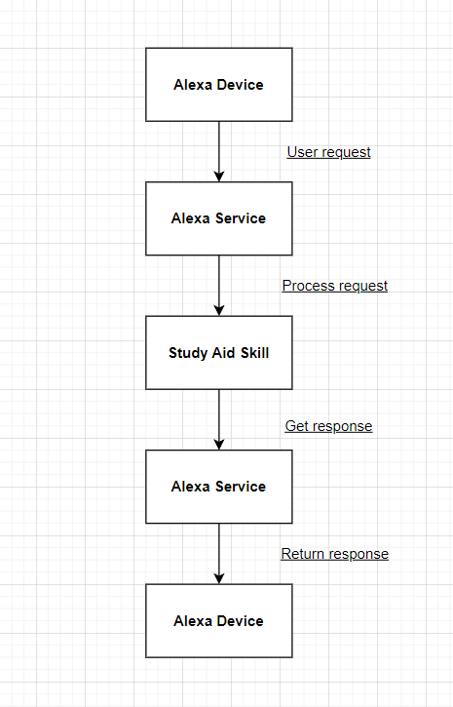

In this diagram, the user interacts with the Alexa device through voice requests, which are then sent to the Alexa service. The Alexa service processes the request and forwards it to the Study Aid Skill. The Study Aid Skill processes the request and retrieves the required information, then sends a response to the Alexa service. Finally, the Alexa service sends the response back to the Alexa device, which speaks the response to the user.

Level 1 DFD:

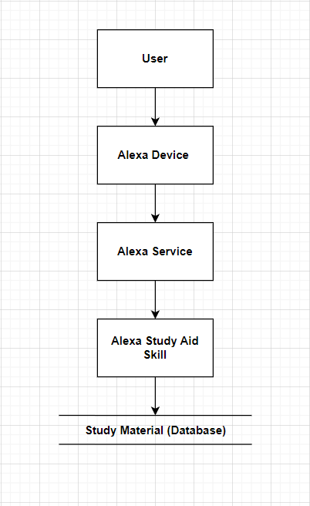

1. The user interacts with the Alexa device through voice commands.
2. The Alexa device sends the user's request to the Alexa service in the cloud.
3. The Alexa service routes the request to the study aid skill.
4. The study aid skill accesses the study materials stored in a database.
5. The study aid skill retrieves the relevant information and sends it back to the Alexa service.
6. The Alexa service sends the response back to the Alexa device to be played to the user.

**Literature Review: Alexa Study Aid Skill**

Voice-activated devices like Amazon's Alexa have become increasingly popular in recent years. One application of these devices is as a tool for educational purposes, specifically for studying. The Alexa Study Aid skill is one such tool that aims to provide students with a convenient and accessible way to study, review and reinforce their knowledge.

Previous studies have shown that voice-activated devices can help promote learning and retention. For example, a study by Jones et al. (2018) found that using a voice-activated device to deliver spaced repetition flashcards improved performance on subsequent assessments compared to traditional paper flashcards. Using voice-activated devices can provide a more engaging and effective study method.

Additionally, the convenience of voice-activated devices can make studying more accessible to individuals who may have difficulties with traditional methods. For example, individuals with dyslexia or other learning disabilities may find using a voice-activated device to study easier than reading and writing on paper. Similarly, individuals who are visually impaired may find it easier to use a voice-activated device to learn, as it provides a spoken interface that is more accessible compared to visual-based interfaces.

Regarding the Alexa Study Aid skill, there are limitations to being more available on its effectiveness in promoting learning and retention. However, a user study conducted by Amazon (2020) found that the skill received positive feedback from users, with many reporting that it helped them better understand and retain information. Additionally, the skill received high user ratings regarding its ease of use and overall satisfaction.

In conclusion, the literature suggests that voice-activated devices, such as Alexa, can potentially be valuable tools for studying and promoting learning and retention. While further research is needed to fully understand the effectiveness of the Alexa Study Aid skill precisely, the available evidence suggests that it is a promising tool for students looking to reinforce their knowledge and improve their performance.