HTP "Person" Drawing Assessment Report

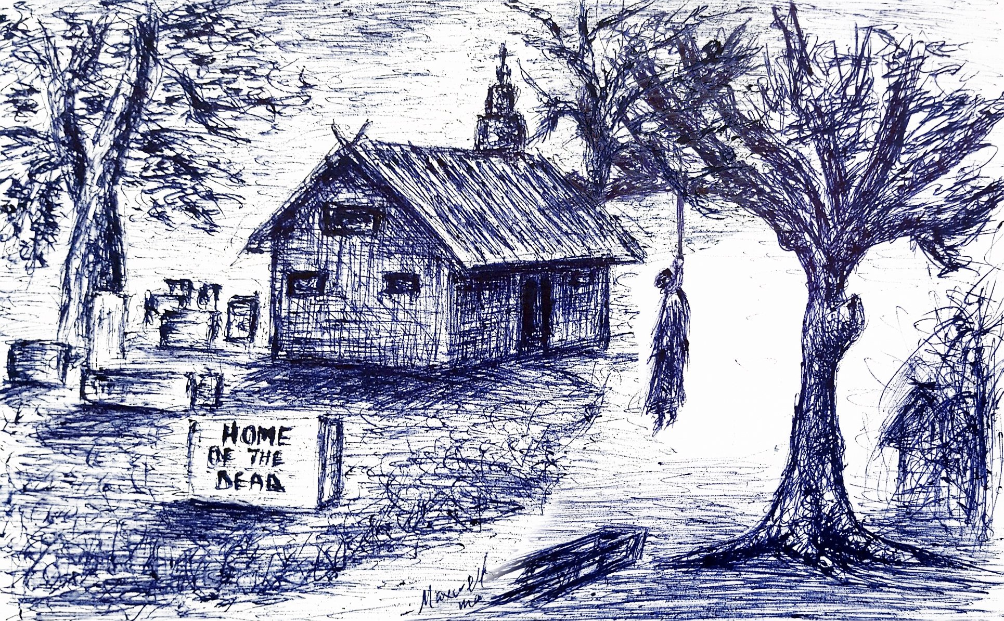

Assessment:
Observation

Summary:
This drawing of a "Person" presents a deeply disturbing image of a hanging, shrouded figure, devoid of discernible human features, situated in a death-related context. The pervasive themes of self-annihilation, profound hopelessness, and complete lack of agency strongly suggest severe depression, depersonalization, and potentially active suicidal ideation. The drawing conveys an overwhelming sense of emotional numbness, extreme social isolation, and an identity profoundly intertwined with death and despair.

Detailed Analysis:
- Feature: Overall Stance and Context * **Observation:** The figure is small to medium, placed on the right side, depicted as limp and hanging vertically from a tree branch, suggesting lifelessness. The surrounding context implies a graveyard or death scene. * **Interpretation:** Indicates a profound sense of self-annihilation, extreme worthlessness, and a desire to escape existence. Reflects overwhelming hopelessness, severe depression, and potentially suicidal ideation, with identity deeply intertwined with themes of death and loss.
- Feature: Obscured Head and Facial Features * **Observation:** The head is small, indistinct, and appears as a dark, featureless mass; no eyes, mouth, or other facial details are discernible. * **Interpretation:** Suggests a severe lack of clear self-identity, feelings of depersonalization, and a sense of being invisible or dehumanized. Points to emotional numbness and an inability to recognize or express personal emotions.
- Feature: Shrouded Body and Absent Limbs * **Observation:** The body is an elongated, cylindrical, heavily shaded, shroud-like form, completely obscuring all anatomical details; arms, hands, legs, and feet are not discernible as separate limbs. * **Interpretation:** Implies a severely distorted or negative body image, viewing the body as a source of suffering or something to be discarded. Reflects a profound disassociation from one's physical self and a complete absence of physical agency or control.
- Feature: Hanging by a Noose and Shroud-like Garment * **Observation:** The figure is depicted hanging by a rope/noose, clad in a long, dark, shroud-like garment that completely obscures human form. * **Interpretation:** Reinforces themes of profound helplessness, resignation to a negative fate, and a complete lack of self-direction or vitality. Signifies chronic passivity, emotional paralysis, and a desire for complete withdrawal.
- Feature: Heavy and Sketchy Line Quality * **Observation:** Line pressure is heavy and dark, with sketchy, scribbled, and densely cross-hatched lines, contributing to the figure's dark and indistinct nature. * **Interpretation:** Reflects intense emotional distress, internal turmoil, and overwhelming feelings of dread and despair.

