HTP "Person" Drawing Assessment Report

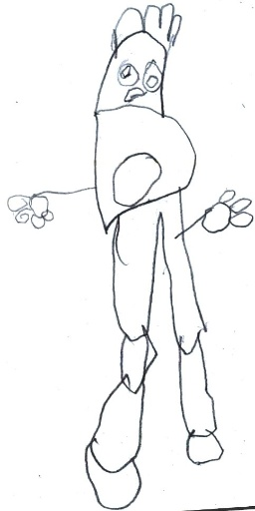

Assessment:
Observation

Summary:
The drawing depicts an individual grappling with significant internal conflict and emotional distress. There is a strong emphasis on intellectualization and self-protection, alongside a pervasive sense of sadness, withdrawal, and difficulty expressing emotions. The figure's unbalanced stance and disproportionate limbs highlight feelings of instability and a struggle for firm footing, while outstretched arms suggest a longing for connection despite feelings of inadequacy.

Detailed Analysis:
- Feature: Figure Stance and Grounding * **Observation:** The figure is large, filling most of the vertical space, with an unbalanced stance. One leg is larger and forward, the other thinner and further back, with disproportionate feet (one large, one small). * **Interpretation:** Suggests an uneven development or internal conflict regarding stability and movement, leading to instability in action or decision-making. There is a desire for grounding and stability, but also a feeling of being unsupported or weighed down, indicating a lack of firm footing in certain areas of life.
- Feature: Head Shape and Neck Omission * **Observation:** The head is proportionally large and elongated, with no distinct neck. * **Interpretation:** Indicates a focus on intellectualization or fantasy as a coping mechanism, potentially feeling "out of touch" with practical realities. The absence of a neck suggests difficulty connecting thoughts and feelings, which may lead to impulsivity or challenges with emotional regulation.
- Feature: Facial Expression (Eyes & Mouth) * **Observation:** Large, round eyes with pupils and eyebrows convey a sad or worried expression. The mouth is a small, downturned line, reinforcing this sadness. * **Interpretation:** Reflects sadness, withdrawal, and an internal focus, possibly indicating feelings of being overwhelmed or difficulty with direct engagement. The small, downturned mouth suggests suppressed communication and difficulty expressing needs or emotions verbally.
- Feature: Spiky Hair * **Observation:** Hair is depicted as several vertical, spiky lines on top of the head. * **Interpretation:** Can signify anxiety, tension, or a desire for power, control, or status. It may also suggest a defensive posture.
- Feature: Trunk with Central Oval * **Observation:** The upper body is elongated and somewhat rectangular, narrowing towards the waist, with a large oval shape drawn on the chest/abdomen. * **Interpretation:** Indicates a focus on basic needs or self-protection. The central oval might represent a vulnerable core, a preoccupation with the self, or a sense of being contained.
- Feature: Arms and Hands * **Observation:** Arms are outstretched horizontally from the sides of the upper body, appearing somewhat disconnected. Hands are depicted as "mittened" or claw-like with distinct finger-like protrusions. * **Interpretation:** Suggests a desire for connection, openness to the environment, or a plea for help and support. However, the claw-like hands imply feelings of inadequacy, difficulty grasping or manipulating the environment effectively, and a limited sense of agency, possibly reflecting anxiety or a desire to withdraw.

