HTP "Person" Drawing Assessment Report

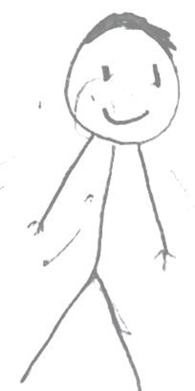

Assessment:
Observation

Summary:
The "Person" drawing depicts a highly simplified, stick-figure representation, suggesting emotional immaturity and a defensive, somewhat fragile self-concept. Despite this underlying vulnerability, the figure's dynamic, walking pose indicates an effort to engage with the world. A prominent head with a conventional smile points to a reliance on intellectualization and a desire to appear agreeable, potentially masking deeper feelings and a limited capacity for genuine social input.

Detailed Analysis:
- Feature: Figure Size, Placement, and Stance * **Observation:** The figure is of average to moderately large size, centered slightly towards the upper half of the page, depicted in a dynamic, walking pose with legs apart and arms slightly outstretched. * **Interpretation:** The dynamic pose suggests an underlying drive or an effort to engage with the world, even if tentatively. The moderately large size, combined with other features, may reflect a desire to be seen or a compensatory effort despite underlying fragility.
- Feature: Stick Figure Representation and Simplification * **Observation:** The figure is drawn as an extremely simplified stick figure, lacking detailed trunk, clothing, or distinct feet. * **Interpretation:** This suggests emotional immaturity, a simplified self-concept, or a defensive avoidance of self-disclosure. It may also indicate feelings of inadequacy, a lack of integrated body image, and a weak or underdeveloped sense of self-worth.
- Feature: Head and Facial Features * **Observation:** The head is large and prominent relative to the stick-figure body. Facial features include two small dot eyes, a simple upward curve for a smile, and scribbled hair, but no nose or ears. * **Interpretation:** The large head suggests an emphasis on intellectualization, fantasy, or preoccupation with mental activity, possibly indicating a desire for intellectual control. The simple, smiling facial features imply superficial social engagement and a conscious effort to appear pleasant, potentially masking true feelings. The absence of a nose and ears suggests reduced interest in social input or a defensive posture against criticism.
- Feature: Body and Limbs * **Observation:** The trunk is a single vertical line. Arms are single lines extending diagonally downwards with simple "rake" or "stick" fingers. Legs are single lines spread in a "V" shape, ending in points without distinct feet. * **Interpretation:** The thin, stick-like trunk and limbs suggest feelings of vulnerability, fragility, and a lack of emotional substance or body image. The absence of a neck implies difficulty connecting thoughts and feelings. The simple hands indicate a primitive or somewhat aggressive mode of interaction, or feelings of inadequacy in manipulating the environment. The pointed, ungrounded legs suggest a lack of grounding, instability, and tentative contact with reality, reflecting a fragile sense of support and agency.

