SkillSphere Learning & Workforce Management:
Item | Detail
Project | SkillSphere Learning & Workforce Management— Full Stack Java
Frontend | React.js
Backend | Java (Spring Boot)
Database | MySQL
Milestone | Milestone 2 — Dashboard, Course Listing, Course Detail (REST + MySQL)  Milestone 1- Landing Page, Login/Signup Page

Milestone 2—Document:

1. Overview
Milestone 2 adds three learner-facing screens on top of the existing landing and login pages: a personalized Dashboard, a searchable/filterable Course Listing page, and a Course Detail page. All three are backed by real REST endpoints and a MySQL database — no mock/static data.
This document covers, for each page: the frontend approach, the backend approach, the API contract, and the exact MySQL tables and columns needed. It closes with a mapping back to the Milestone 2 “Definition of Done” checklist.

2. Architecture
Layered, standard Spring Boot architecture — keeps controllers thin and DB entities hidden from the client:
React (pages/components, Axios)
→ Controller (REST endpoints, request/response only)
→ Service (business logic, aggregation, mapping to DTO)
→ Repository (Spring Data JPA)
→ MySQL

- Entities (JPA @Entity) never go directly to the client — always mapped to a DTO in the Service layer.
- A single @RestControllerAdvice handles exceptions globally (404 for missing course, 401/403 for auth, 400 for bad query params) and returns a consistent JSON error shape.
- CORS is configured once in a WebMvcConfigurer / SecurityConfig bean for the React dev origin (and later, the deployed frontend origin).
- JWT (issued at login) is sent as a Bearer token; Dashboard and Enroll endpoints require it, Course Listing/Detail work for guests too (so browsing doesn't require login).

3. Dashboard Page
Route: /dashboard • Access: logged-in users only (protected route)

3.1 What it shows
- Welcome header with the learner's name
- Summary cards: courses enrolled, courses completed, in-progress, overall progress %
- “Continue Learning” list — enrolled courses with a progress bar and last-accessed date
- Optional: recommended courses strip (reuses the course card component from Course Listing)

3.2 Frontend approach (React)
- Page component Dashboard.jsx calls the API once in useEffect on mount using the JWT from auth context/localStorage.
- Three UI states are handled explicitly: loading (skeleton cards), error (retry banner), success (render data).
- Summary cards and the enrolled-course list are separate child components (SummaryCard, EnrolledCourseCard) so they can be reused/tested independently.
- Route is wrapped in a ProtectedRoute component that checks auth state and redirects to /login if absent.

3.3 Backend approach (Spring Boot)
- DashboardController exposes GET /api/dashboard, resolves the current user from the JWT (SecurityContext), and delegates to DashboardService.
- DashboardService pulls the learner's enrollments (joined with course basics) in a single query — a JPQL projection or JOIN FETCH — to avoid N+1 queries against courses for every enrollment row.
- Aggregates (counts, overall %) are computed in the service layer, not fetched as separate round-trips.
- Result is mapped into DashboardSummaryDTO before returning — raw Enrollment/Course entities are never serialized.

3.4 API
Method | Endpoint | Auth | Returns
GET | /api/dashboard | Required (JWT) | DashboardSummaryDTO

DashboardSummaryDTO

{

"userName": "Aditi Sharma",

"totalEnrolled": 5,

"completedCount": 2,

"inProgressCount": 3,

"overallProgressPercent": 62,

"enrolledCourses": [

{ "courseId": 12, "title": "React.js Essentials", "thumbnailUrl": "...",

"progressPercent": 80, "lastAccessedAt": "2026-07-10T18:22:00" }

]

}

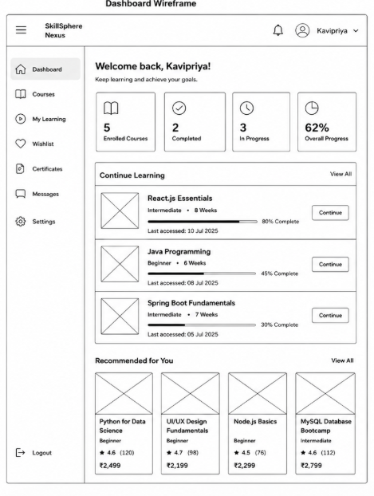

4. Course Listing Page
Route: /courses • Access: public (login optional)

4.1 What it shows
- Search bar (title/keyword), category filter, level filter, pagination
- Grid of course cards: thumbnail, badge (Bestseller/Popular/Trending/New), title, level, duration, rating, price

4.2 Frontend approach (React)
- CourseListing.jsx keeps search/filter/page state in the URL query string (e.g. ?search=react&category=dev&page=2) so results are shareable/bookmarkable and survive a refresh.
- The search input is debounced (~400ms) before triggering a new API call, to avoid firing a request per keystroke.
- Category options are fetched once from GET /api/courses/categories and cached in state for the filter dropdown.
- Loading state renders skeleton cards in place of real cards; empty state renders a “no courses match your filters” message; error state renders a retry banner.

4.3 Backend approach (Spring Boot)
- CourseController exposes GET /api/courses accepting optional query params: search, category, level, page, size, sort.
- CourseService builds the query using Spring Data JPA Specifications (or a JPQL query with optional conditions) combined with a Pageable — MySQL does the filtering, sorting and pagination, not the application layer.
- Response is a Page<CourseDTO> (content + totalElements + totalPages + pageNumber) so the frontend can render pagination controls without a second count call.

4.4 API
Method | Endpoint | Auth | Returns
GET | /api/courses?search=&category=&level=&page=&size=&sort= | Optional | Page<CourseDTO>
GET | /api/courses/categories | Optional | List<CategoryDTO>

CourseDTO (list item shape)

{

"id": 21, "title": "Java Programming", "shortDescription": "...",

"thumbnailUrl": "...", "badge": "TRENDING", "category": "Development",

"level": "Intermediate", "durationWeeks": 8, "price": 3499.00,

"ratingAvg": 4.6, "ratingCount": 1100, "instructorName": "..."

]

5. Course Detail Page
Route: /courses/:id • Access: public (login optional; enroll button requires login)

5.1 What it shows
- Header: thumbnail, title, badge, rating, price, level, duration
- Full description
- Curriculum / module list (what the learner will study, in order)
- Instructor block: name, photo, short bio
- Review summary (average rating + count; optionally a few recent reviews)
- Enroll / Continue Learning button — label depends on whether the current user is already enrolled

5.2 Frontend approach (React)
- CourseDetail.jsx reads the id via useParams() and fetches GET /api/courses/{id} on mount (and again if id changes, e.g. navigating between related courses).
- If a JWT is present, the same request (or a lightweight follow-up call) also returns the caller's enrollment status so the button can read “Enroll Now” vs “Continue Learning”.
- A missing/invalid id returns 404 from the API, which the page renders as a “course not found” state rather than a blank screen.

5.3 Backend approach (Spring Boot)
- CourseController exposes GET /api/courses/{id}.
- CourseService fetches the course with its category, instructor and modules (JOIN FETCH to avoid N+1 on modules), computes/reads the rating aggregate, and — if a JWT is present — looks up the caller's enrollment row for isEnrolled/progressPercent.
- Unknown id throws a custom CourseNotFoundException, caught by the global exception handler and turned into a 404 with a clean JSON body.

5.4 API
Method | Endpoint | Auth | Returns
GET | /api/courses/{id} | Optional | CourseDetailDTO

CourseDetailDTO (extends CourseDTO)

{

...all CourseDTO fields,

"fullDescription": "...",

"modules": [ { "title": "Intro to Hooks", "order": 1, "durationMinutes": 45 } ],

"instructor": { "name": "John Doe", "photoUrl": "...", "bio": "..." },

"isEnrolled": false,

"progressPercent": 0

}

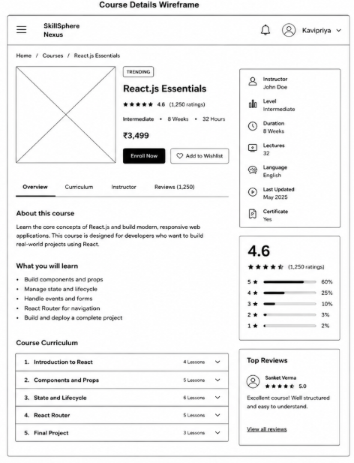

6. Database Schema (MySQL)
Seven tables cover Dashboard, Course Listing and Course Detail. Login/Signup already uses the users table; the rest are new for Milestone 2.

6.1 Entity-relationship summary
- users (1) ──< enrollments >── (1) courses — a learner enrolls in many courses
- categories (1) ──< courses — a course belongs to one category
- instructors (1) ──< courses — a course has one instructor
- courses (1) ──< course_modules — a course has many curriculum modules
- courses (1) ──< reviews >── (1) users — a review links a user to a course

6.2 users
(created in Milestone 1 for login/signup — listed here because Dashboard and Reviews reference it)
Column | Type | Constraints
id | BIGINT | PK, AUTO_INCREMENT
name | VARCHAR(150) | NOT NULL
email | VARCHAR(150) | NOT NULL, UNIQUE
password_hash | VARCHAR(255) | NOT NULL
role | ENUM('LEARNER','INSTRUCTOR','ADMIN') | NOT NULL, DEFAULT 'LEARNER'
created_at | TIMESTAMP | DEFAULT CURRENT_TIMESTAMP

6.3 categories
Powers the category filter dropdown on Course Listing.
Column | Type | Constraints
id | BIGINT | PK, AUTO_INCREMENT
name | VARCHAR(100) | NOT NULL, UNIQUE
icon_url | VARCHAR(255) | NULL

6.4 instructors
Column | Type | Constraints
id | BIGINT | PK, AUTO_INCREMENT
name | VARCHAR(150) | NOT NULL
title | VARCHAR(150) | NULL — e.g. ‘Senior Developer’
bio | TEXT | NULL
photo_url | VARCHAR(255) | NULL

6.5 courses
Backs both Course Listing (subset of columns) and Course Detail (all columns).
Column | Type | Constraints
id | BIGINT | PK, AUTO_INCREMENT
title | VARCHAR(200) | NOT NULL
short_description | VARCHAR(500) | NOT NULL — used on listing cards
full_description | TEXT | NULL — used on detail page
category_id | BIGINT | FK → categories.id, NOT NULL
instructor_id | BIGINT | FK → instructors.id, NOT NULL
level | ENUM('Beginner','Intermediate','Advanced') | NOT NULL
duration_weeks | INT | NOT NULL
price | DECIMAL(10,2) | NOT NULL, DEFAULT 0.00
thumbnail_url | VARCHAR(255) | NULL
badge | VARCHAR(30) | NULL — Bestseller / Popular / Trending / New
rating_avg | DECIMAL(3,2) | DEFAULT 0.00 — denormalized for fast listing
rating_count | INT | DEFAULT 0
created_at | TIMESTAMP | DEFAULT CURRENT_TIMESTAMP

rating_avg / rating_count are denormalized (kept in sync via a trigger or a service-layer update whenever a review is added) so the listing page can sort/display rating without aggregating the reviews table on every request.

6.6 course_modules
Curriculum shown on Course Detail page only.
Column | Type | Constraints
id | BIGINT | PK, AUTO_INCREMENT
course_id | BIGINT | FK → courses.id, NOT NULL
title | VARCHAR(200) | NOT NULL
sequence_order | INT | NOT NULL
duration_minutes | INT | NULL

6.7 enrollments
Core table for the Dashboard page; also used by Course Detail to know isEnrolled / progressPercent.
Column | Type | Constraints
id | BIGINT | PK, AUTO_INCREMENT
user_id | BIGINT | FK → users.id, NOT NULL
course_id | BIGINT | FK → courses.id, NOT NULL
enrolled_at | TIMESTAMP | DEFAULT CURRENT_TIMESTAMP
progress_percent | INT | DEFAULT 0, CHECK (0-100)
status | ENUM('IN_PROGRESS','COMPLETED') | DEFAULT 'IN_PROGRESS'
last_accessed_at | TIMESTAMP | NULL

UNIQUE constraint on (user_id, course_id) — a learner can only have one enrollment row per course.

6.8 reviews
Feeds the rating shown on Course Listing and Course Detail (not required to build the review UI itself in Milestone 2, but the table unblocks rating_avg/rating_count).
Column | Type | Constraints
id | BIGINT | PK, AUTO_INCREMENT
course_id | BIGINT | FK → courses.id, NOT NULL
user_id | BIGINT | FK → users.id, NOT NULL
rating | TINYINT | NOT NULL, CHECK (1-5)
comment | TEXT | NULL
created_at | TIMESTAMP | DEFAULT CURRENT_TIMESTAMP

7. Backend Package Structure

controller → DashboardController, CourseController

service → DashboardService, CourseService

repository → UserRepository, CourseRepository, EnrollmentRepository, ReviewRepository

entity → User, Course, Category, Instructor, CourseModule, Enrollment, Review

dto → CourseDTO, CourseDetailDTO, DashboardSummaryDTO, CategoryDTO

exception → CourseNotFoundException, GlobalExceptionHandler

config → CorsConfig, SecurityConfig

