

Smart Attendance Management

Software Requirements Specifications

# Introduction

## Problem Definition

The Smart Attendance Management system (SAM) takes input as student’s detail, number of lectures attended, number of lectures conducted etc. Student can mark their attendance hassle-free. Teachers can view attendance and if short can take mandatory actions

## Purpose

The following document describes the functional and non-functional requirements for the SAM release version 1.0. The contents are intended to be utilized by the Engineering class as guidelines for implementation and testing. This Software Requirements Specification document only covers the main system and does not describe the implementation of the database in which the main system interacts. All the requirements stated in this document are slated for implementation in version 1.0, unless otherwise specified.

## Product Scope

The Smart Attendance Management system (SAM) will allow the teacher In-charge to maintain a record of attendance of students in their respective classes from a PC or a mobile. Also, the system will permit the teacher In-charge to maintain all the essential details regarding a particular student. Furthermore, the program provides students a way to mark their attendance hassle-free and avoid proxies.

## Overview

SAM will be used by students to only mark or view their attendance by subject, by semester or by date. Teachers use SAM for Management of attendance, manage class schedule and most importantly host a device. Teacher hosts a device during starting of class. The location of student marking attendance will be monitored. Student in a specified radius will be allowed to mark present only after facial recognition.

Use Case Diagram:

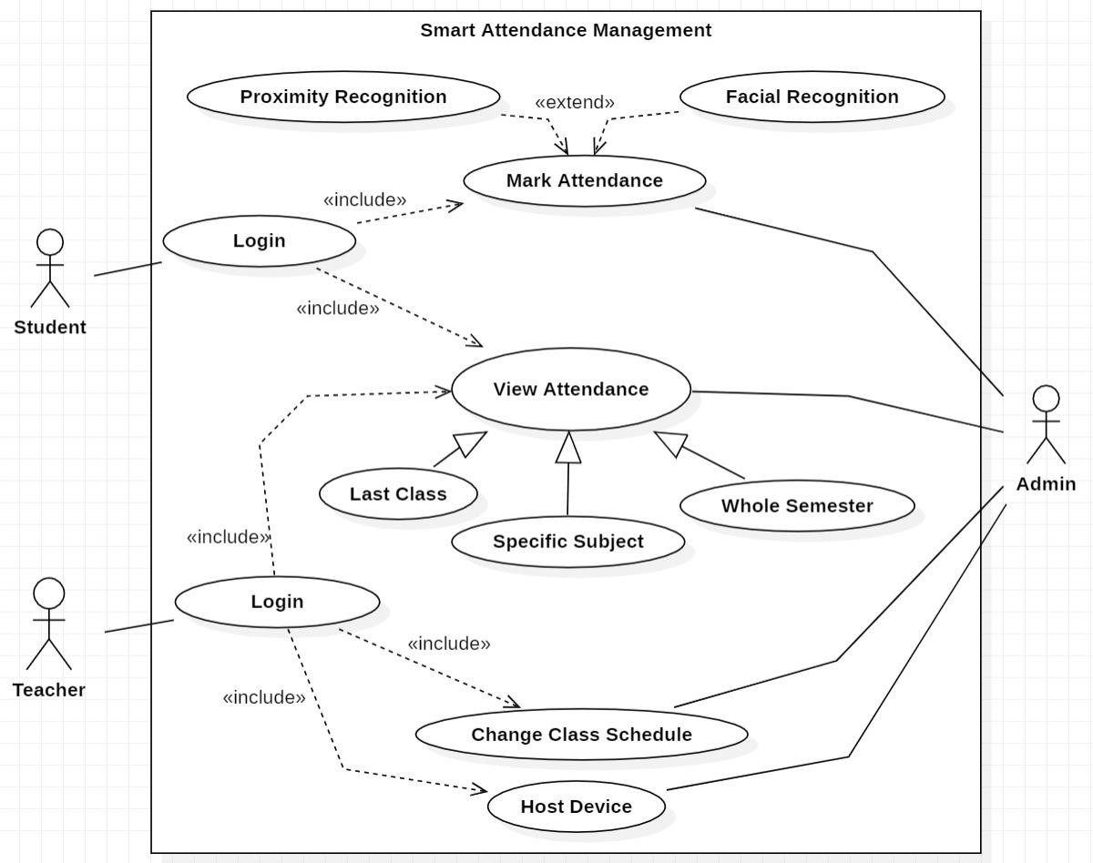

# General description

## Product Perspective

The Smart Attendance Management System is intended to replace the manual model of attendance record keeping by means of roll call and paper records. The roll call and paper records are replaced with a single interaction between the Student and the Attendance Management System. Professors will be able to view details regarding attendance of individual students and quickly maintain attendance records. The features expressed in this Software Requirements Specification document are intended to be fully implemented in version 1.0.

## Product Functions

The main feature of the Attendance Management System is that it keeps a record of all essentials details of each individual student. Attendance Percentage of each student in every subject would be displayed. Also, the system allows the professor to view student’s attendance record for the specified class. Finally, another feature of Attendance Management System is its flexibility and ease of use.

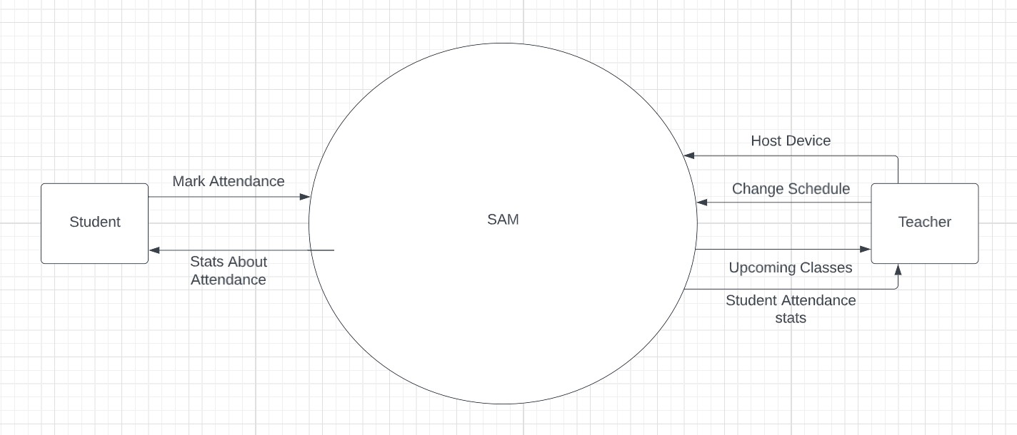

# Design and Implementation Constraints

CO-1: The time allotted for this project will be limited to the end of this semester.

CO-2: The language for the project will be HTML, JavaScript, CSS, Node.js and MongoDB. CO-3: All the HTML code for the user manual will conform to the HTML 5.0 standard.

CO-4: Programming is done in JavaScript, CSS, HTML, Node.js and MongoDB.

# External Interface Requirements

## User Interfaces

UI-1: The Attendance Management System shall provide details of students in the class to aid in taking attendance.

UI-2: These details can be clicked with a mouse in order to view a particular student’s attendance

record.

UI-3: All modifications to the database will be done through a keyboard.

UI-4: Application will be accessed through a Browser Interface. The interface would be viewed best using 1920 x 1080 pixels resolution setting.

UI-5: The program will provide a page that produces current statistics on class attendance.

* 1. **Hardware Interfaces (recommended**)

### Server Side:

H1: Windows Server 2016 or Windows 8, or later versions of either.

H2: Processor: Intel i5 9th gen or higher H3. Processors that support AVX2

H4: RAM: 4 Gb or more

H5: Hard Drive: 100 GB or more

Client side:

H6: Operating System: Windows 7 or above, Mac or UNIX.

H7: Processor: Intel i3 10th gen or higher H8. Processors that support AVX2

H9: RAM: 4 Gb or more

1. Operating Environment

OE-1: The Smart Attendance Management System shall function on the browser like Chrome (version60 and above), Firefox (version 60 and above) and Safari (version 12 and above).

OE-2: The Smart Attendance Management System shall interface between Windows CE designated to store the attendance records. The Web Server and Database Software have not been established at this point.

OE-3: The Attendance Management System will record all the essentials details of each particular student.

OE-4: Intel i3 10th gen or higher, RAM must be 4 Gb or more and Hard Drive 10 GB or more (on user side).

# Other Nonfunctional Requirements

## Performance Requirements

PE-1: The program must be able to be run concurrently by multiple professors. During peak times of usage (9:00 AM to 5:00 PM).

PE-2: Transmission of roll data shall occur in under 5 seconds.

PE-3: Acknowledgement of roll received (confirmation) shall be returned within 8 seconds. PE-4: Queries upon the database shall be performed in less than 5 seconds.

PE-5: Upon start of the roll program, roll information shall be displayed on the instructor’ s Pocket PC

within 10 seconds.

PE-6: Email messages to absent students shall be sent within one hour of the conclusion of a class.

PE-7: The program shall support taking roll for class sizes of up to 100 students. With a maximum class size, performance must still conform to all the specified requirement

## Safety Requirements

System would be protected by a password. As it is connected via LAN and MAN an antivirus has been installed on system for its safety purpose

* 1. **Security Requirements**

SE-1: An instructor shall be permitted to view and edit absence information in the database for only his/her classes.

SE-2: In order to mark attendance or edit database information, the instructor shall be required to enter a password.

SE-3: Passwords shall be stored in a database and verified upon each session of roll or database modification.

SE-4: An instructor shall be allowed to change his/her password only by supplying his/her existing

password. The updated password shall be stored in the instructor database and on the instructor’s PC.

**Appendix A: Glossary**

SRS: Software Requirement Specification HTML: Hyper Text Markup Language RAM: Random Access Memory

OS: operating system DB: Databases

SQL: Structured Query Language HTTP: Hyper Text Transfer Protocol CSS: Cascading Style Sheets