**Problem : 1**->Write a program to print “**Hello World !** ”.

**Program:->**

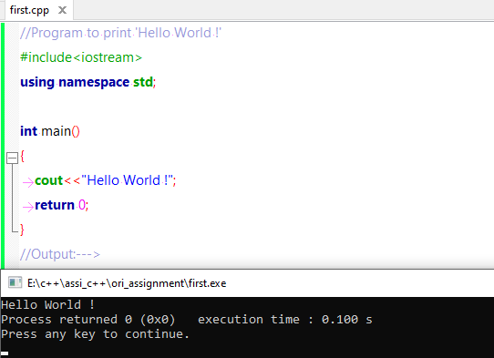

**Problem : 2**-> Write a program to find whether a given number **Even** or **Odd**.

**Program:->**

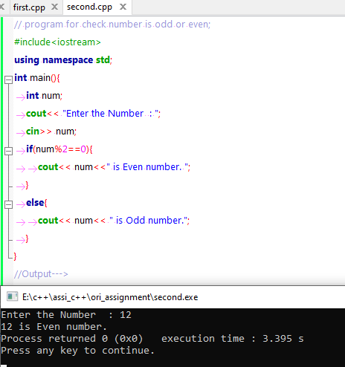

**Problem : 3**-> Write a program to **find the grades according to given marks**.

**Program:->**

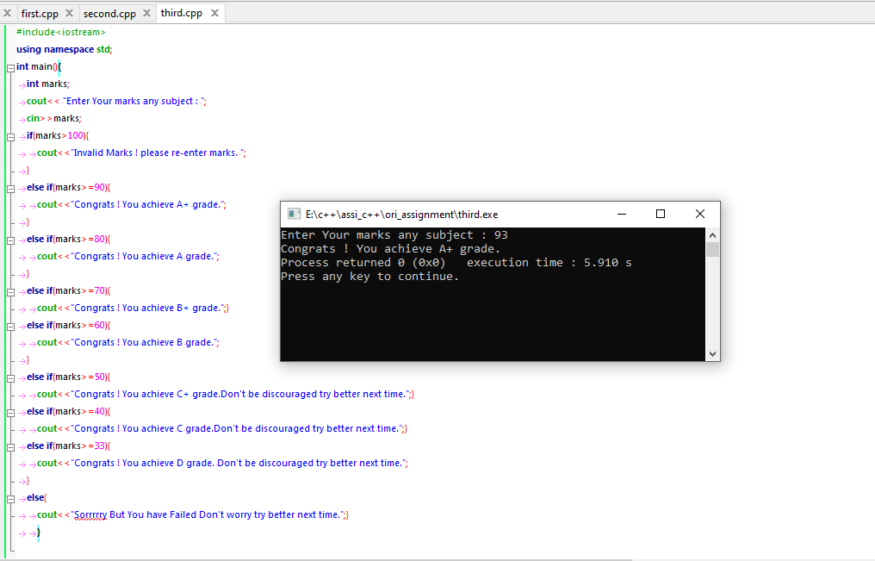

**Problem : 4**-> Write a Program to print number pyramid as-> 1 12 123 1234 12345.

**Program:->**

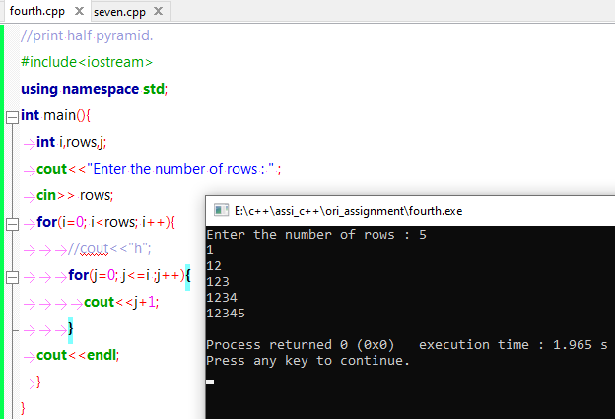

**Problem : 5**-> Write a Program to print number pyramid as-> * ** *** **** *****.

**Program:->**

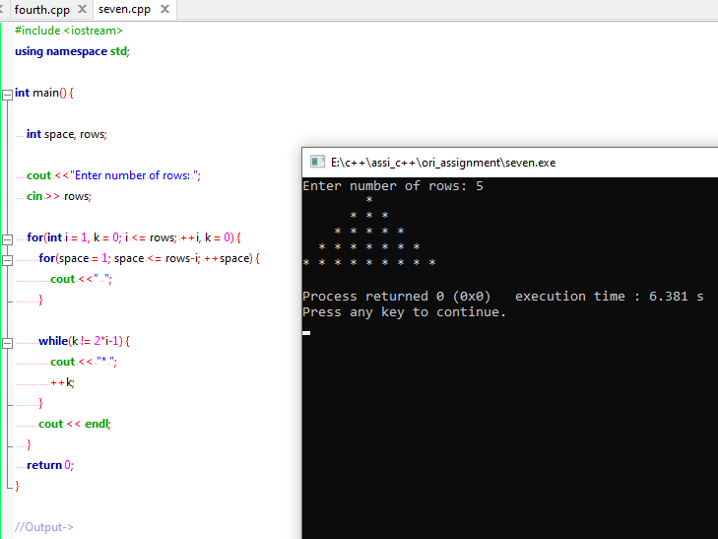

**Problem : 6**-> Write a Program to implement **call by value**.

**Program:->**

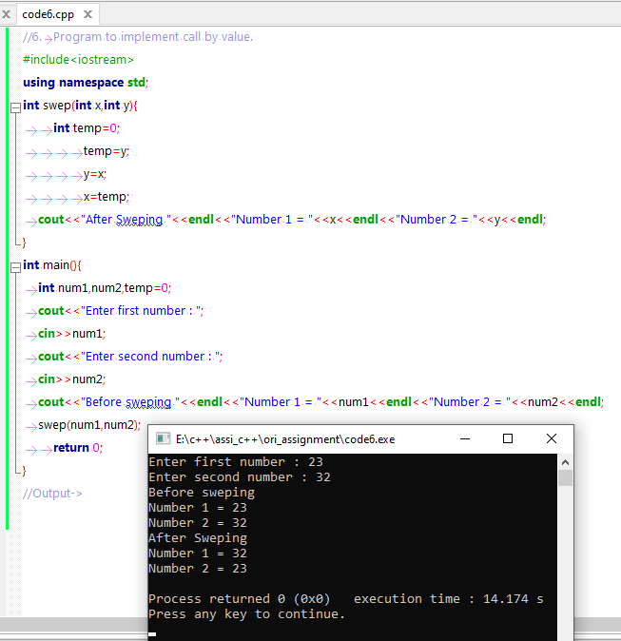

**Problem : 7**-> Write a Program to implement **call by reference**.

**Program:->**

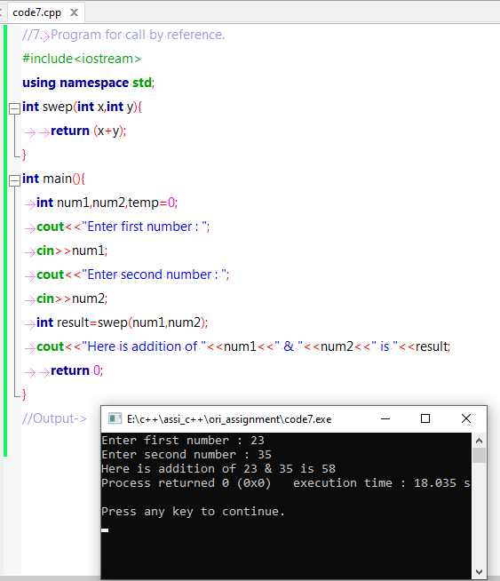

**Problem : 8**-> Write a Program to print **factorial using recursion**.

**Program:->**

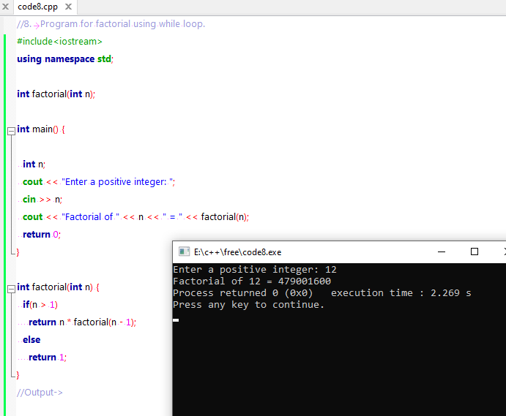

**Problem : 9**-> Write a Program to check alphabet is **vowel or consonant using switch case**.

**Program:->**

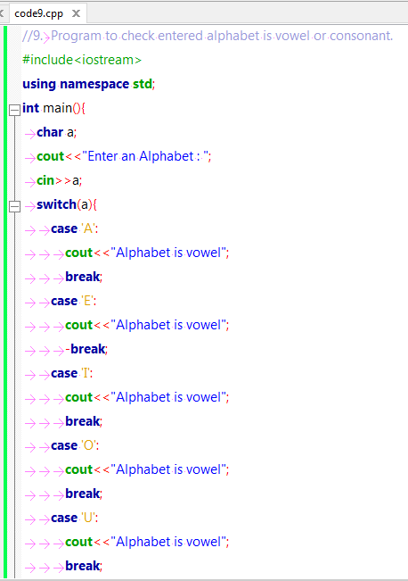

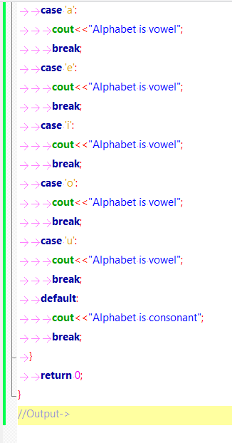

**Output->**

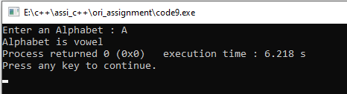

**Problem : 10**-> Write a Program to print **ASCII value of any alphabet**.

**Program:->**

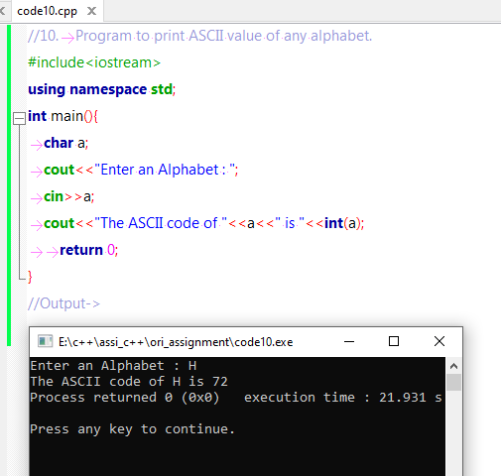

**Problem : 11**-> Write a Program to find **greatest among three number using nested if-els**e.

**Program:->**

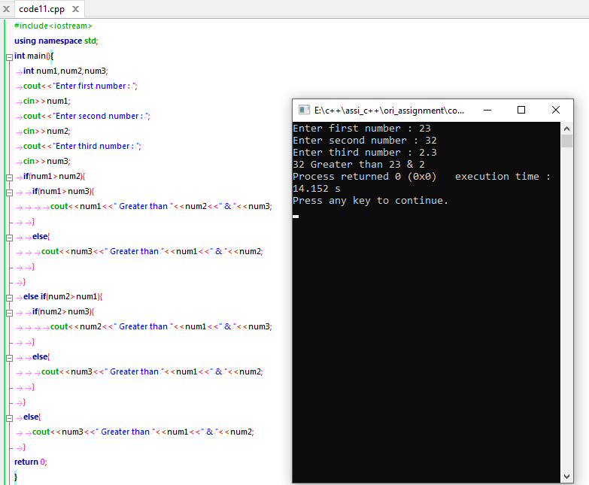

**Problem : 12**-> Write a Program for **factorial using while loop**.

**Program:->**

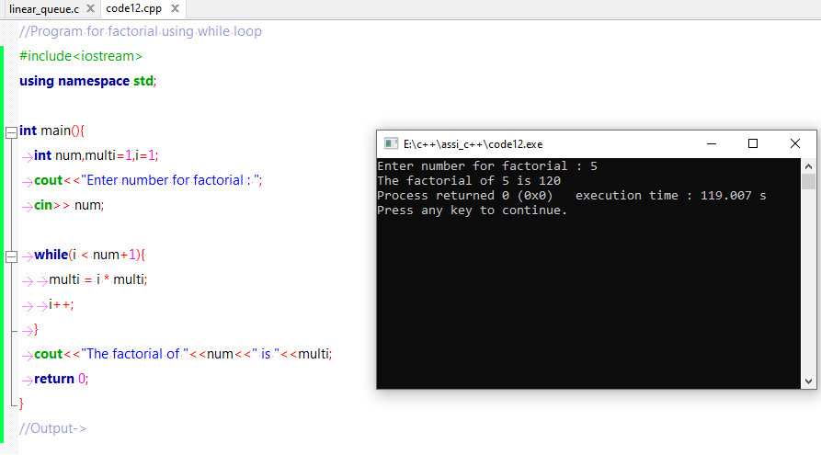

**Problem : 13**-> Write a Program for **reverse number using while loop**.

**Program:->**

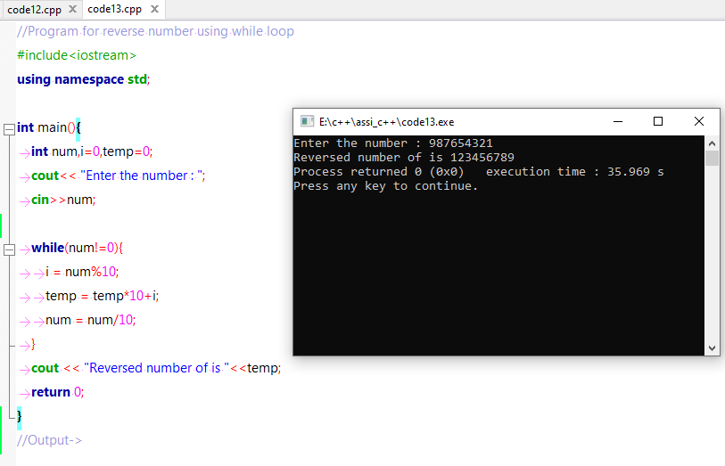

**Problem : 14**-> Write a Program for **Fibonacci Series.**

**Program:->**

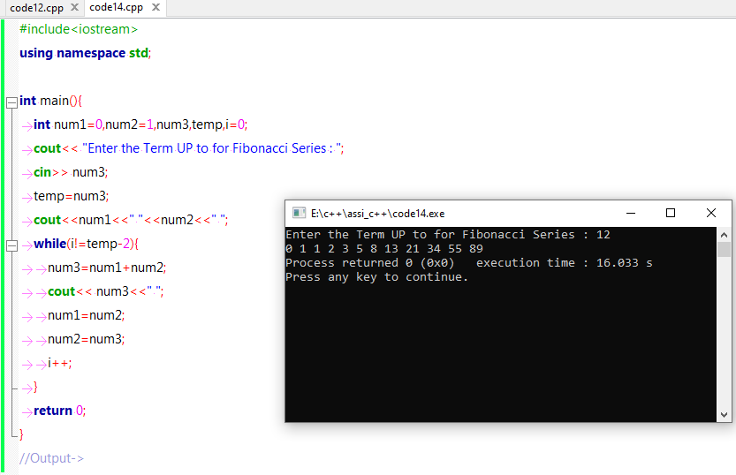

**Problem : 15**-> Write a Program for calculator **using switch case +, -, \***,/**,%,Exponent,.**

**Program:->**

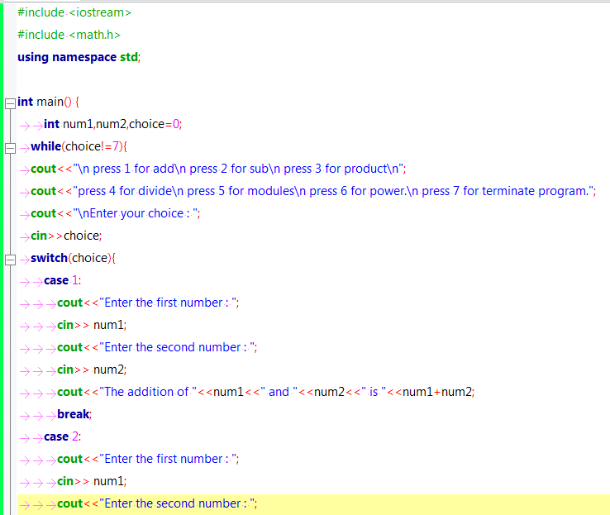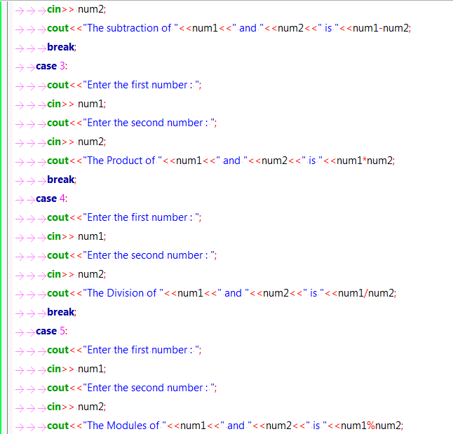

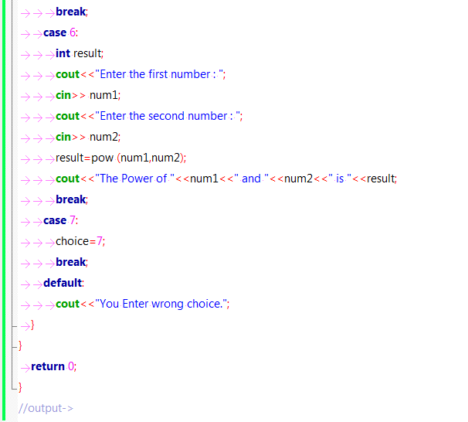

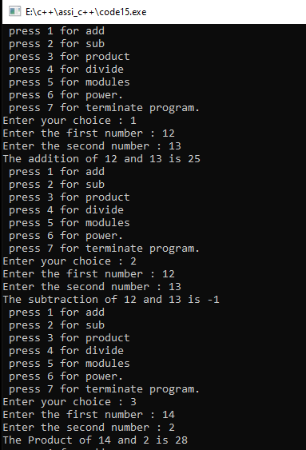

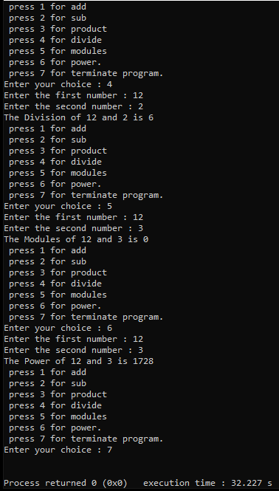

**Problem : 16**-> Write a Program for **Multi Dimensional Array 2D with Multiplication.**

**Program:->**

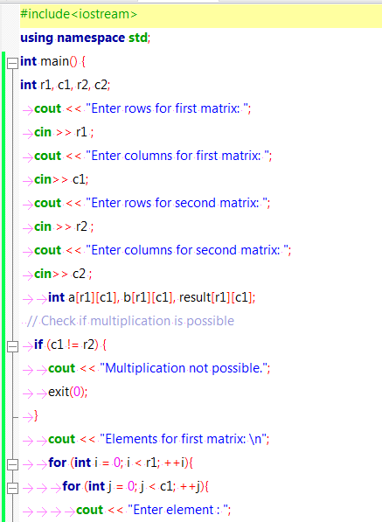

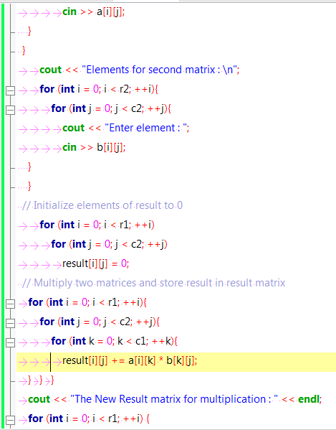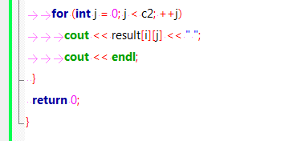

Output->>

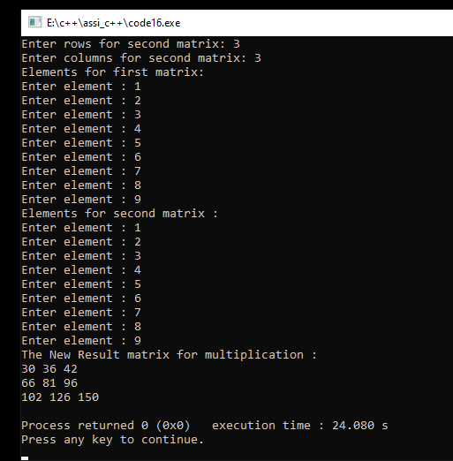

**Problem : 17**-> Write a Program for **Implement array of structure**.**.**

**Program:->**

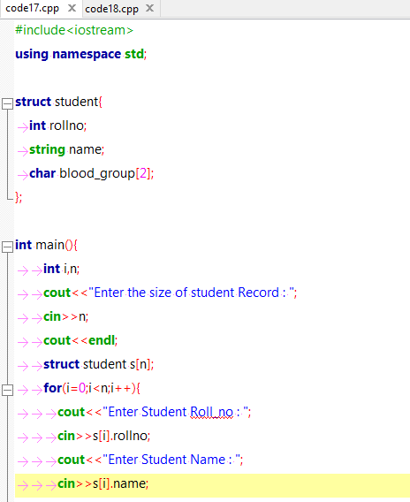

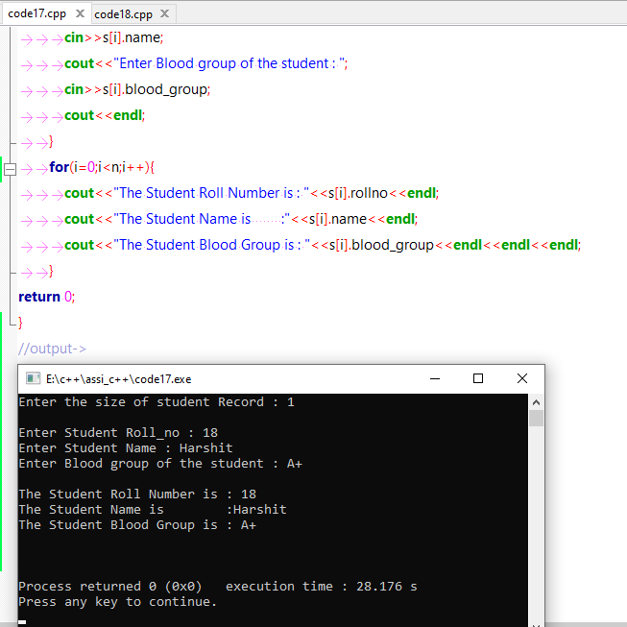

**Problem : 18**-> Write a Program for **Implement a Telephone directory using structure**.**.**

**Program:->**

