# EXPERIMENT NO. 06

**Aim: Add collaborators on GitHub repository**

## LOGIN AND CREATE A REPOSITORY IN GITHUB

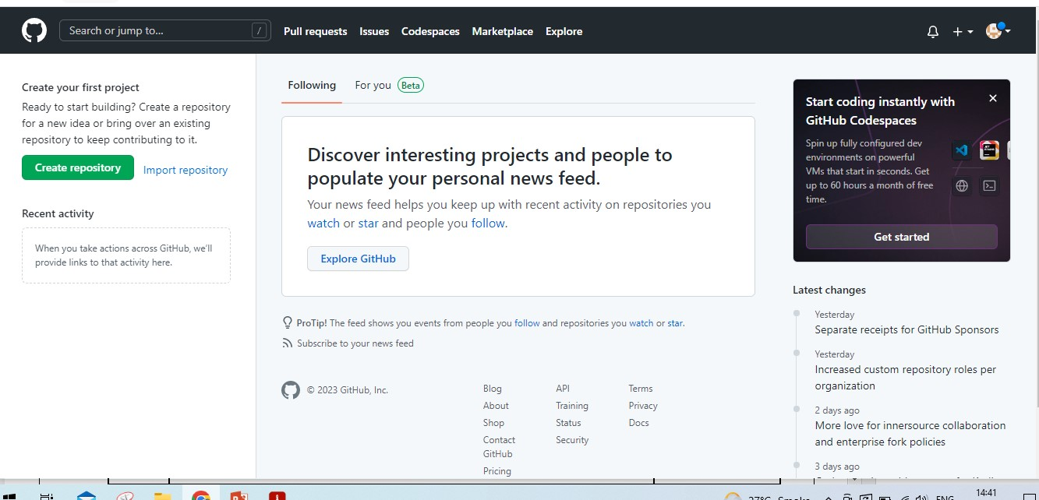

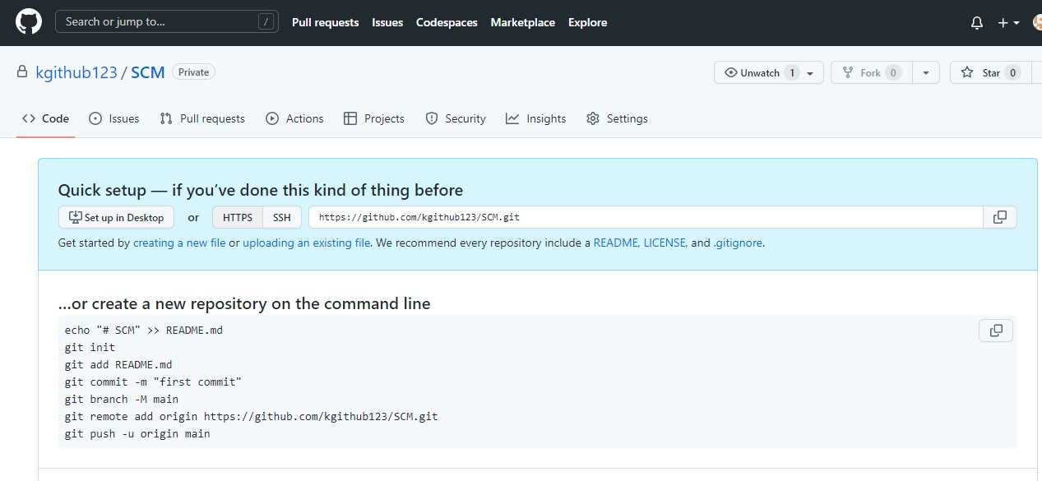

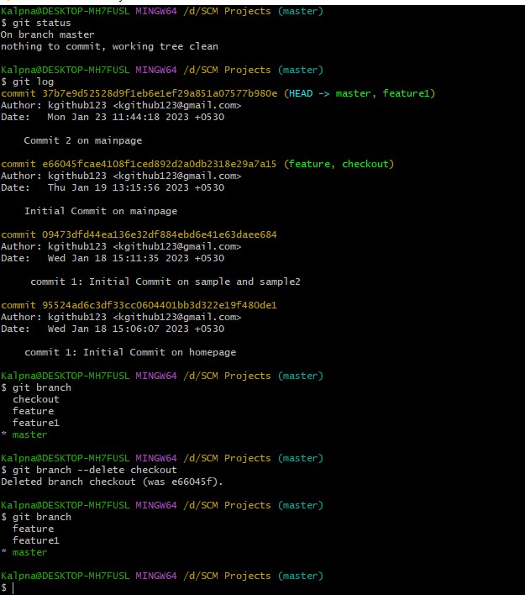

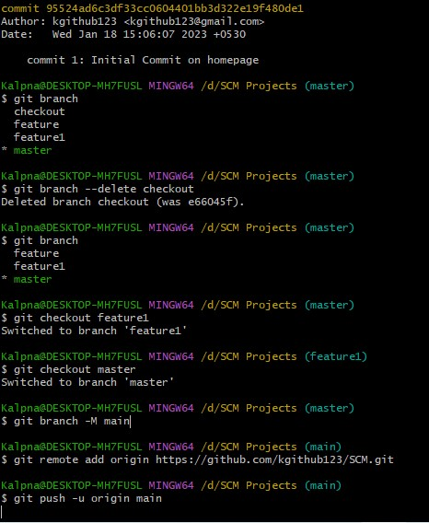

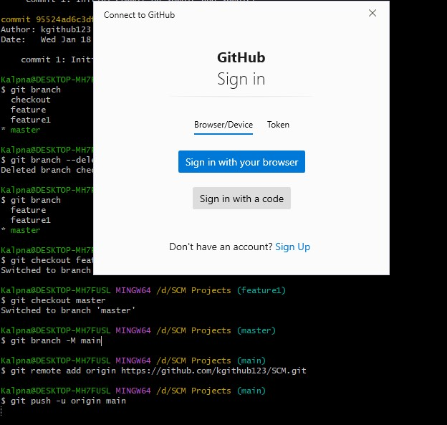

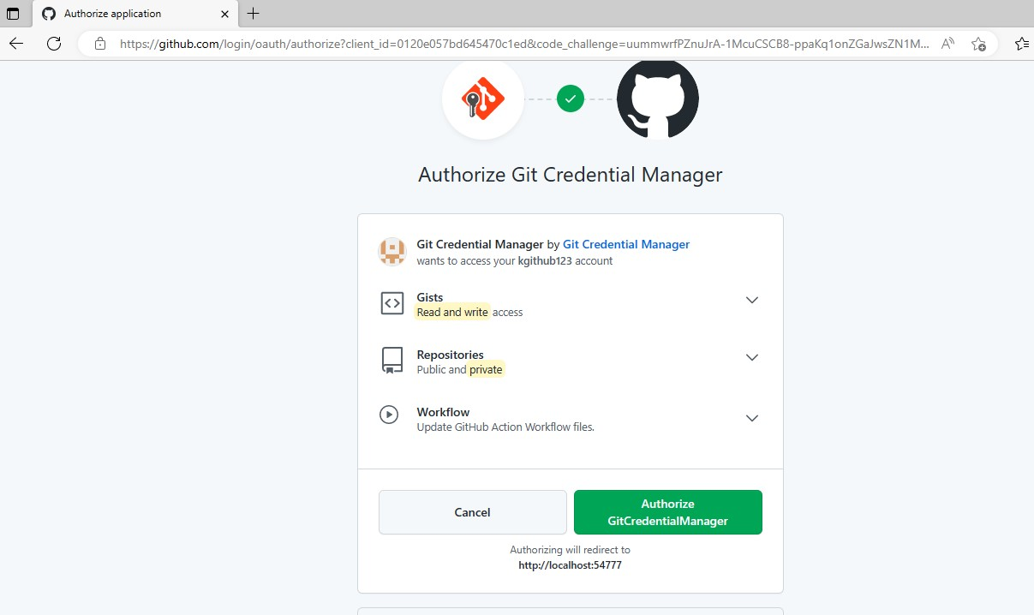

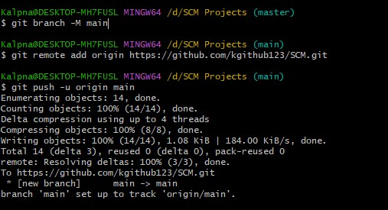

231099

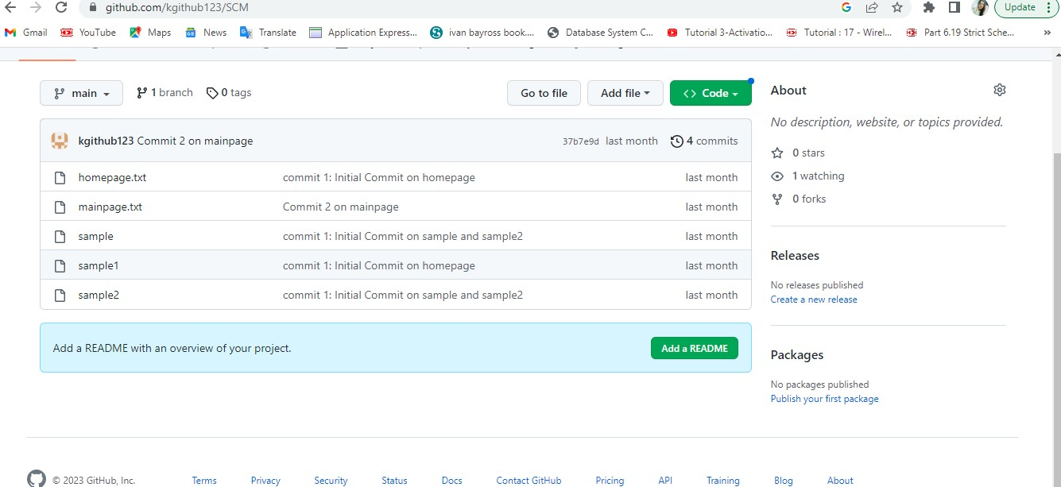

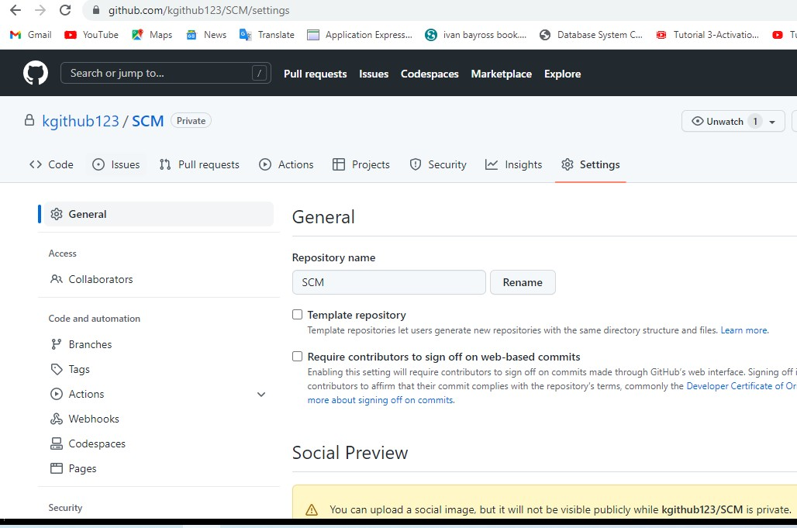

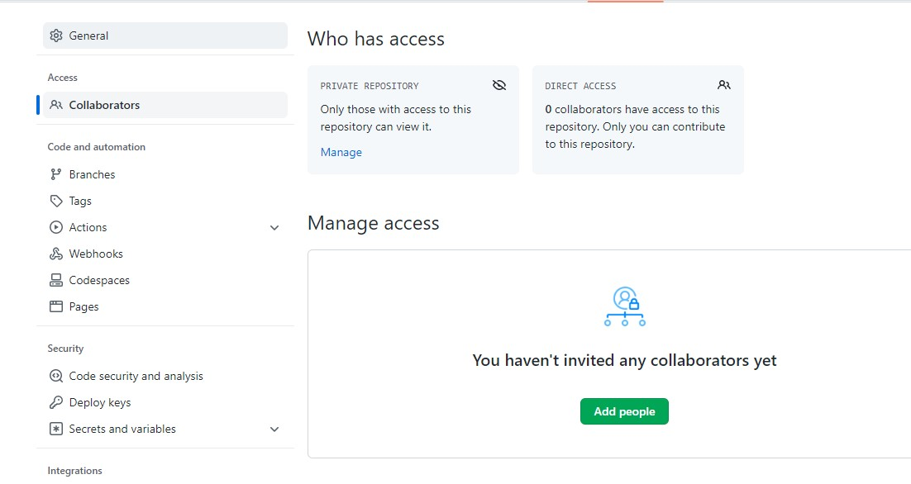

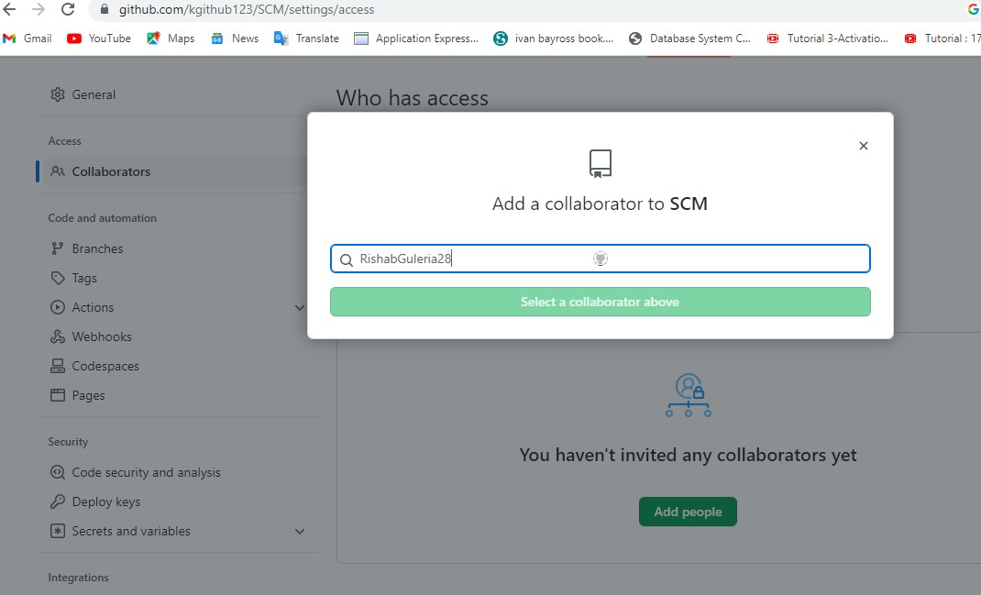

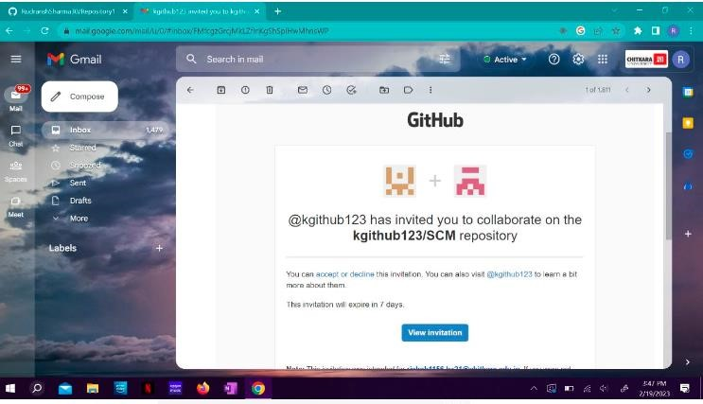

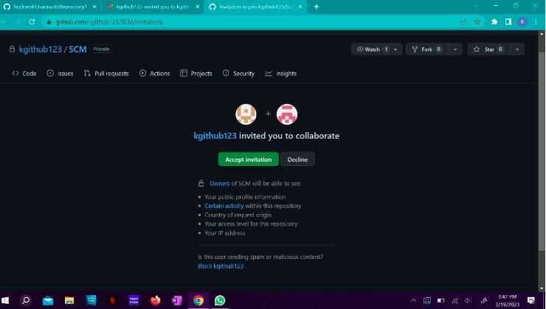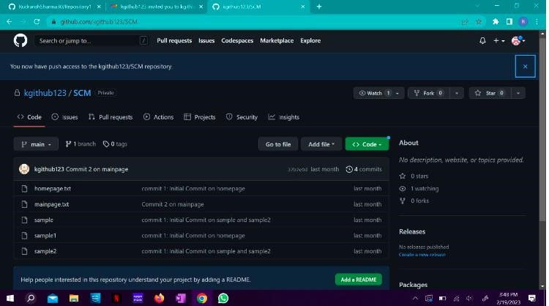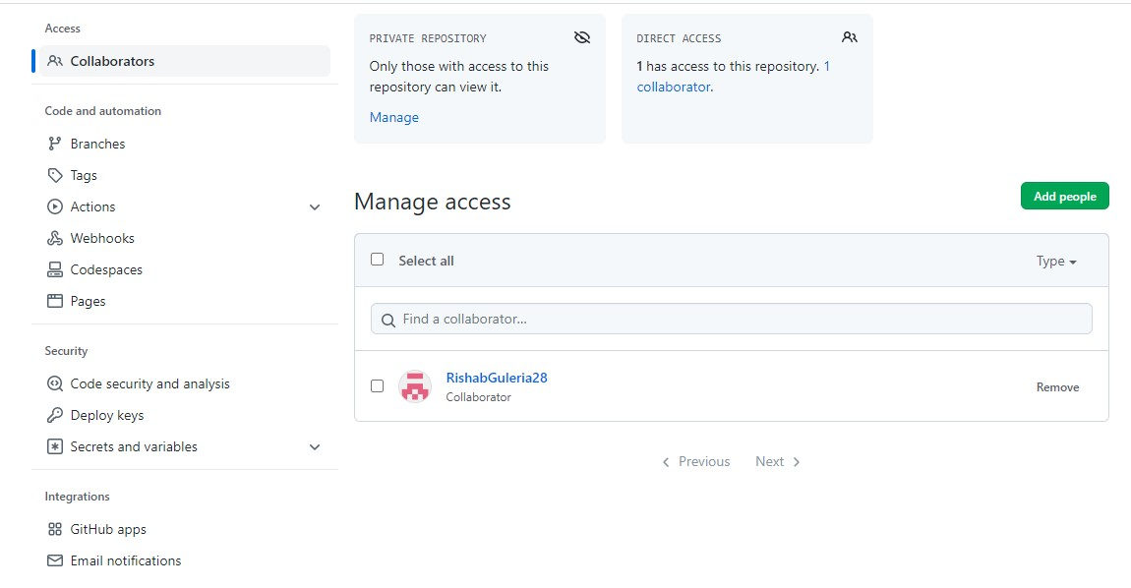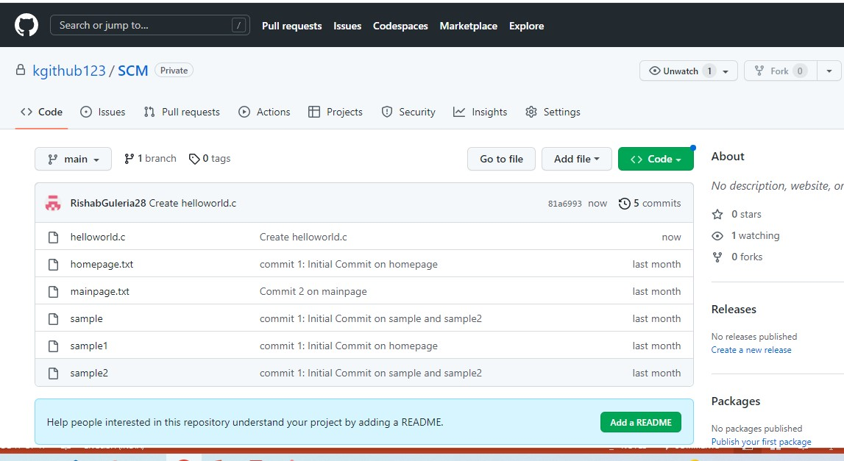

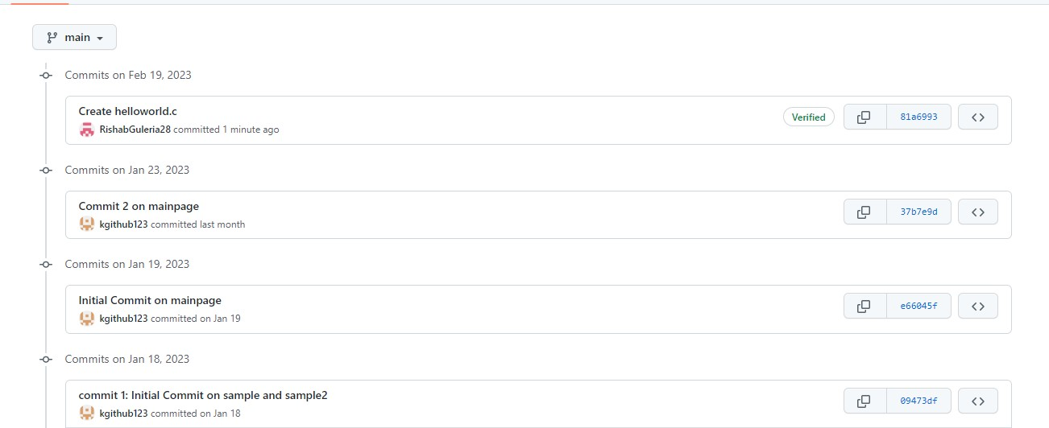

# EXPERIMENT NO. 07

## Aim: Fork and commit

* A fork is a copy of a repository that you manage.
* It allows us to freely experiment with the data.
* After creating a fork, we can make any desired change like adding collaborators, rename files, generate GitHub pages but all these changes won’t be reflected in the original repository

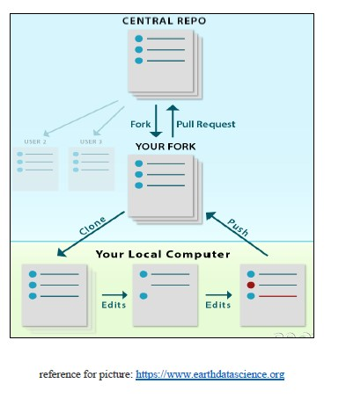

Open a repo and fork

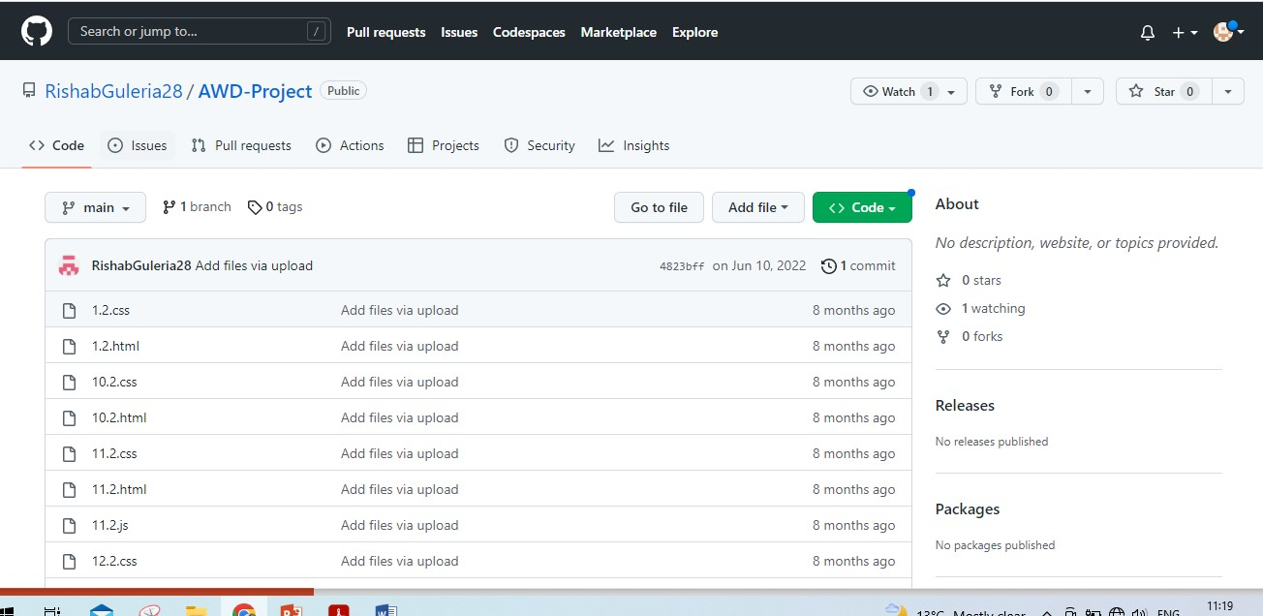

Forked repo in your GitHub account

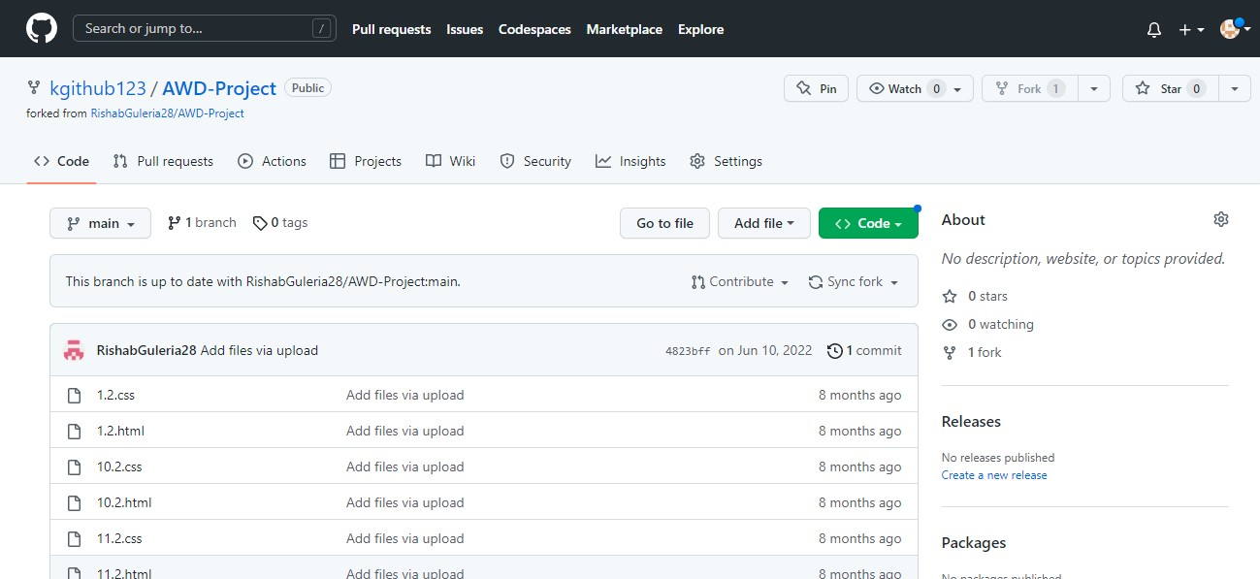

231099

Copy the url of the repo

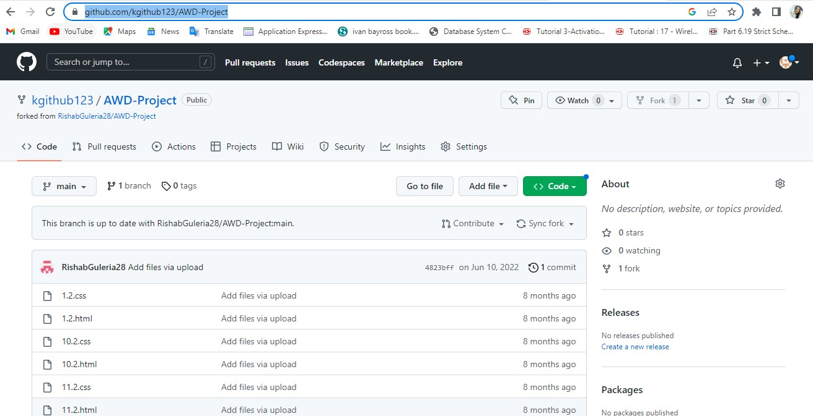

To clone a repo from the Github

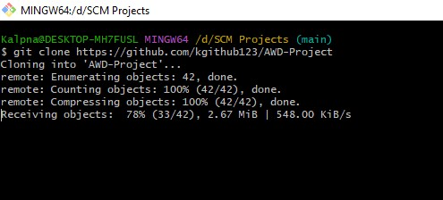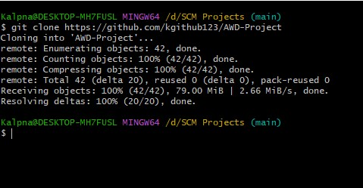

Forked repo in GUI

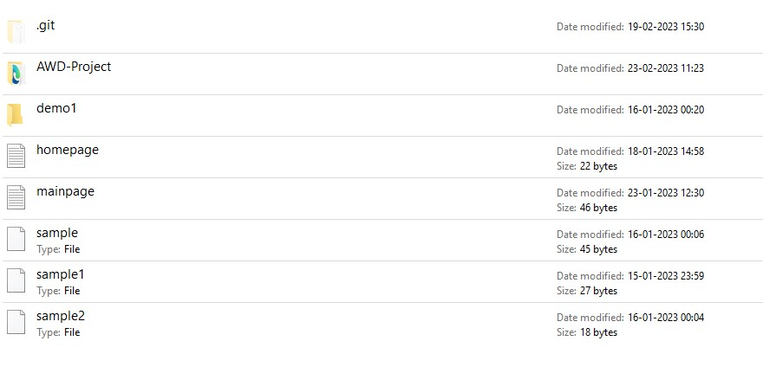

To view files in the forked repo in bash:

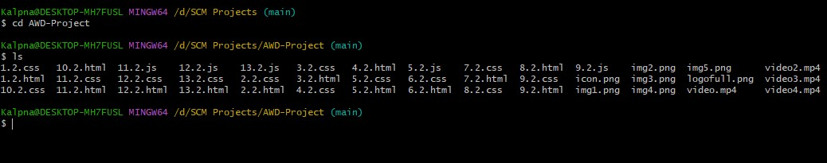

Open a file from the forked repo

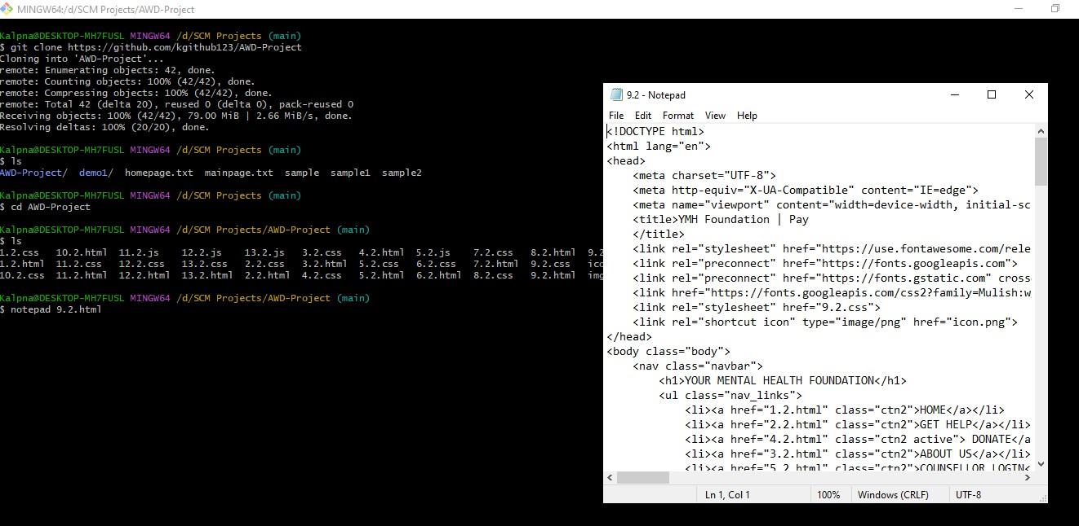

Update a file :

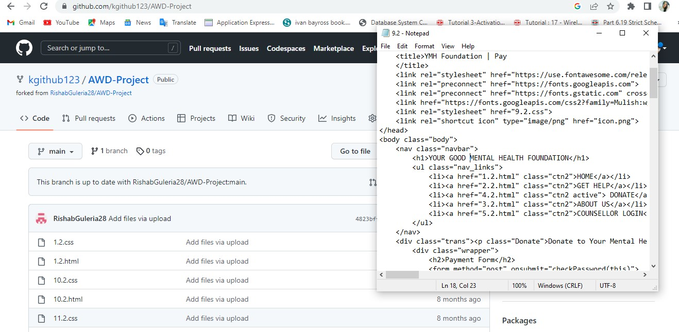

Commit the changes

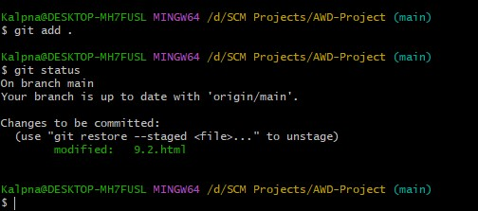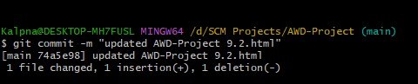

Check the origin created earlier to push the changes to Github

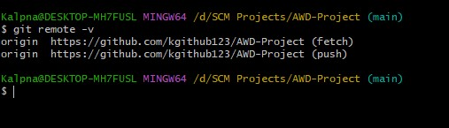

Push the changes to Github

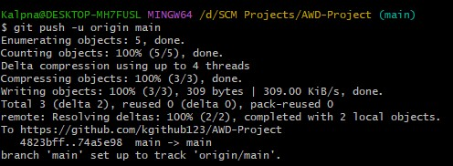

Check the commit on Github

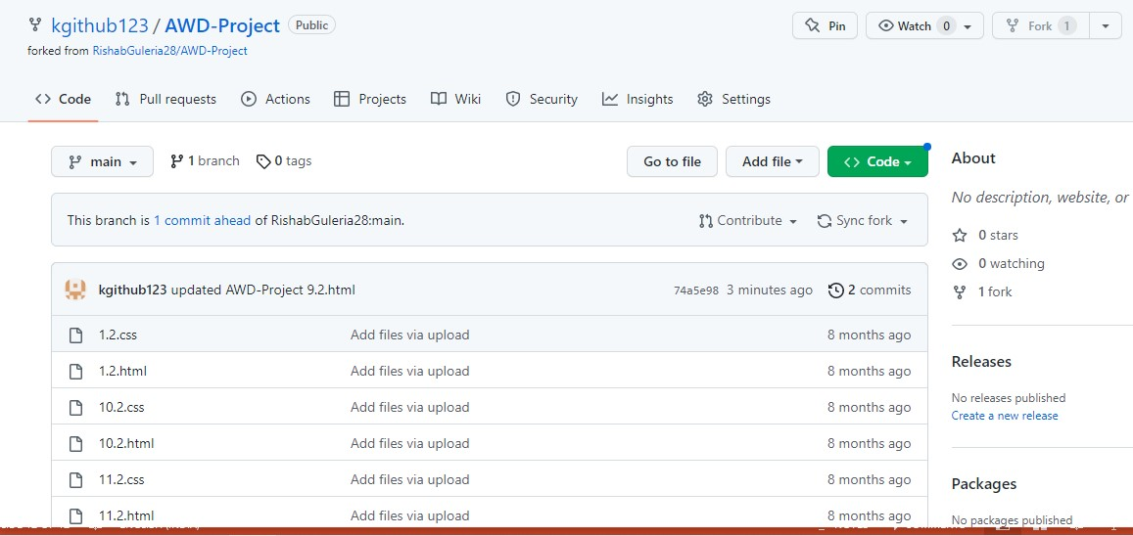

# EXPERIMENT NO. 08

## Aim: Merge and resolve conflicts

Create a file in master branch and commit it.

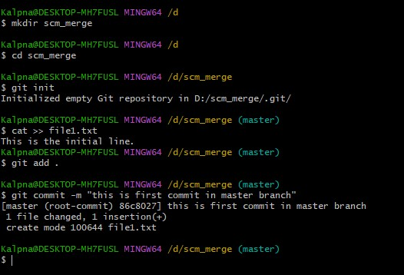

Create a branch and checkout in it

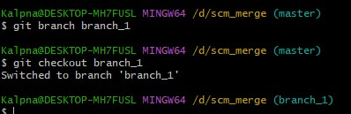

Open vi editor and add a line in the same file

* Open vi editor by command vi filename
* I for insert mode
* Type text you want to add
* Esc:wq to save and exit vi editor.

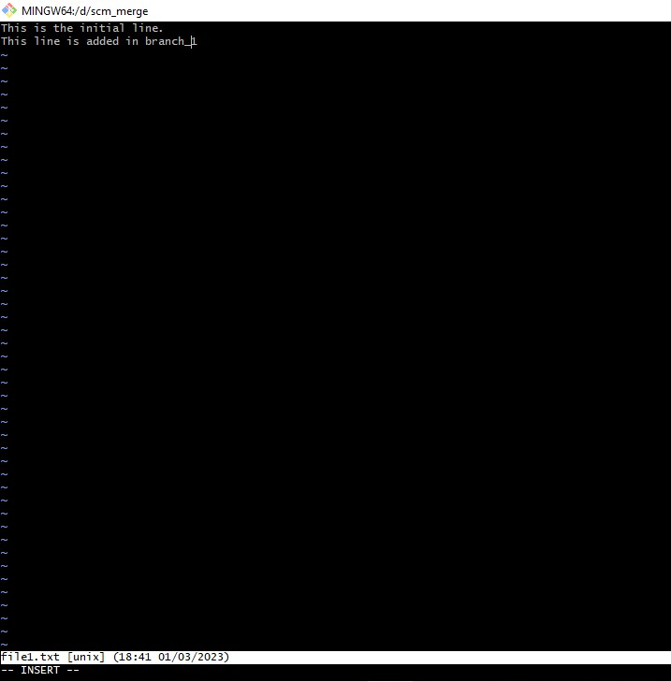

Commit the changes made in branch_1

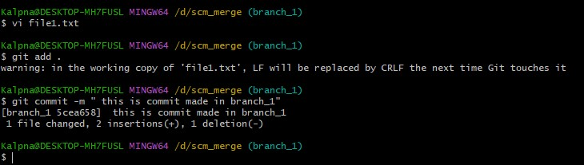

Checkout to master and see the contents of file1 , the changes made in branch 1 are not reflected in master

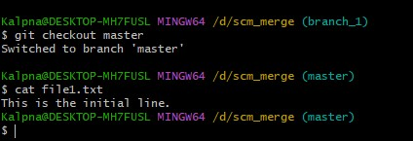

Merge the branch_1 with master and view the changes being reflected in the file

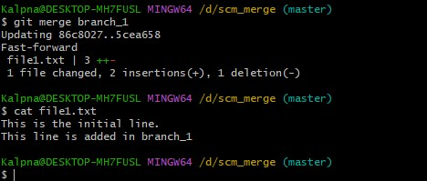

231099

Resolve conflict:

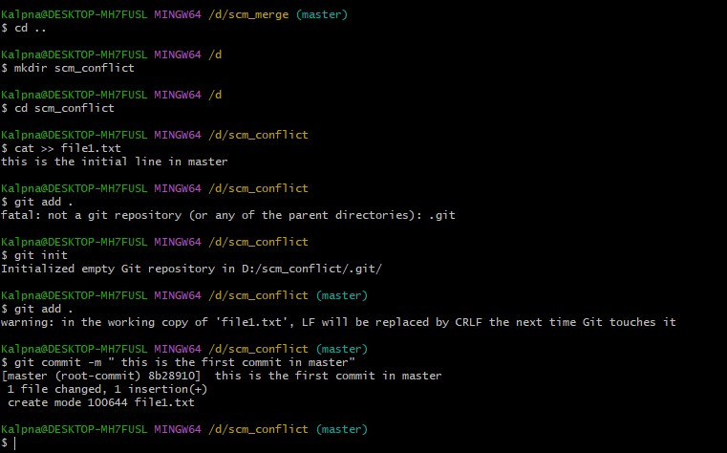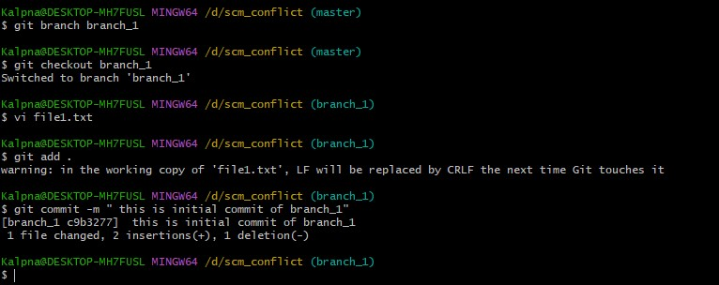

Return to master branch and change the file and commit

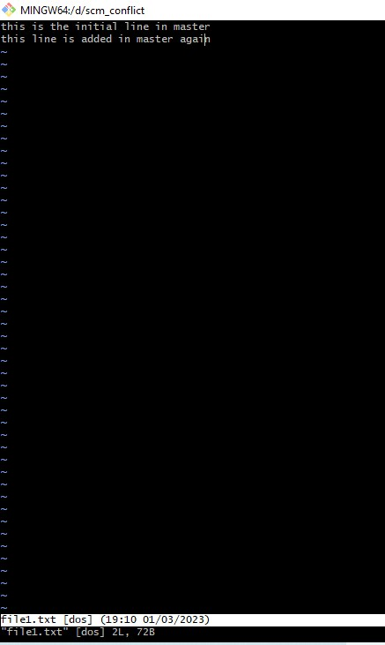

Merge branch_1 with master and view the conflict occurred

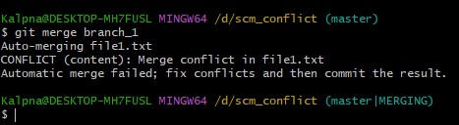

Use merge tool to resolve conflict:

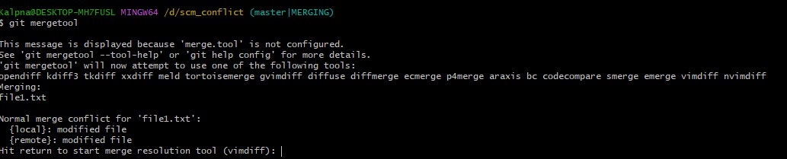

Mergetool opened:

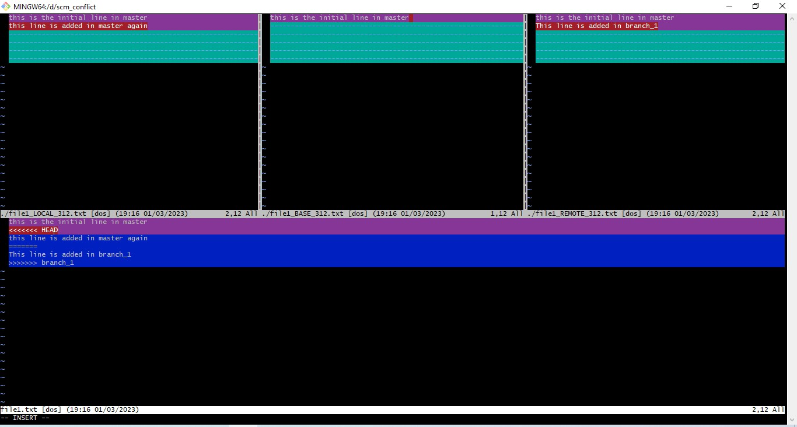

Make the desired changes in the last window

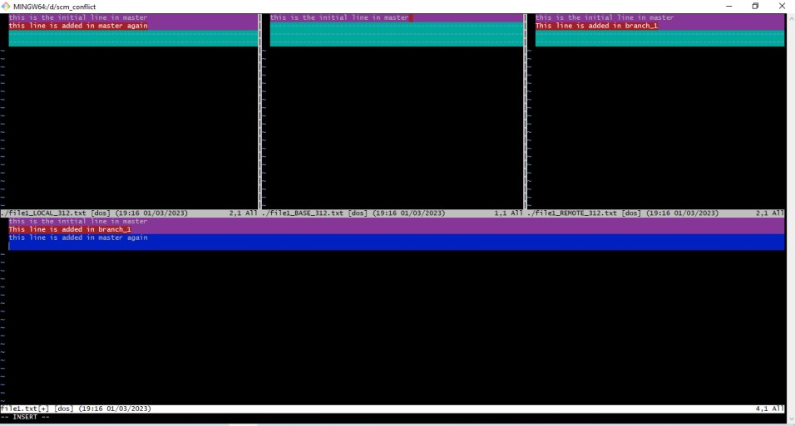

Exit mergetool esc:wq and view the final file in which the conflicts have been resolved:

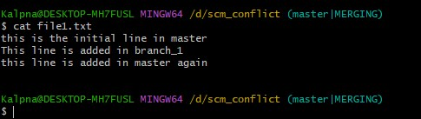

# EXPERIMENT NO. 09

## Aim: Git reset

Gitreset

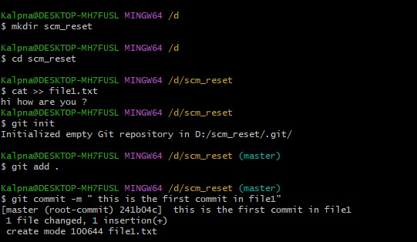

Edit file1 and commit again

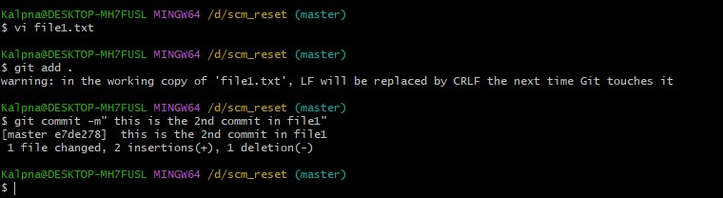

Soft reset done to undo most recent commit , it will bring the committed file back to staging area: you can view by using git status

