DATA ENGINEERING PROJECT
RETAIL_DELTA_PROJECT

FINAL DELIVERABLES
- BRONZE LAYER
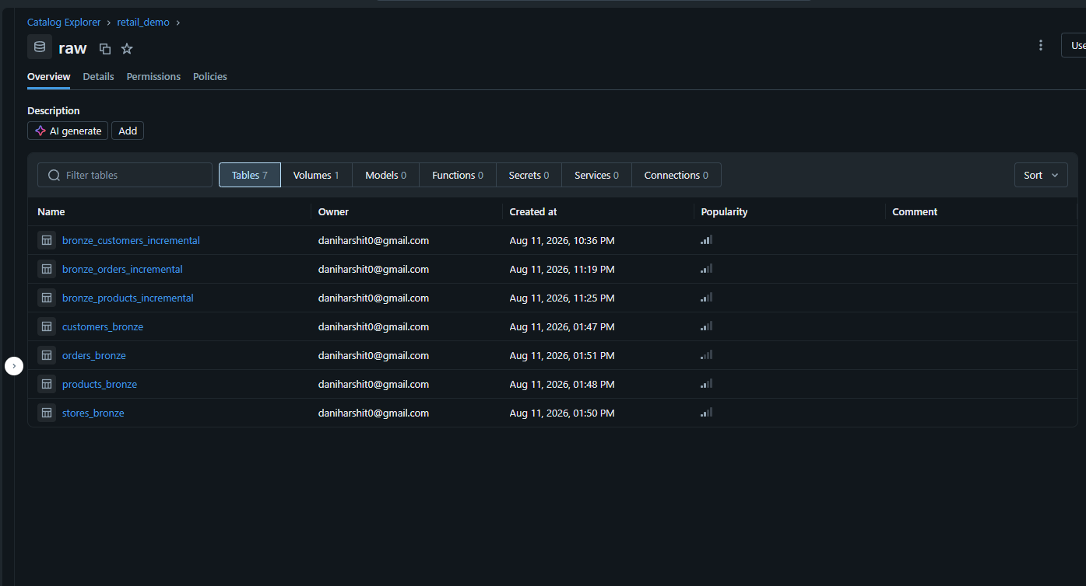

- SILVER LAYER
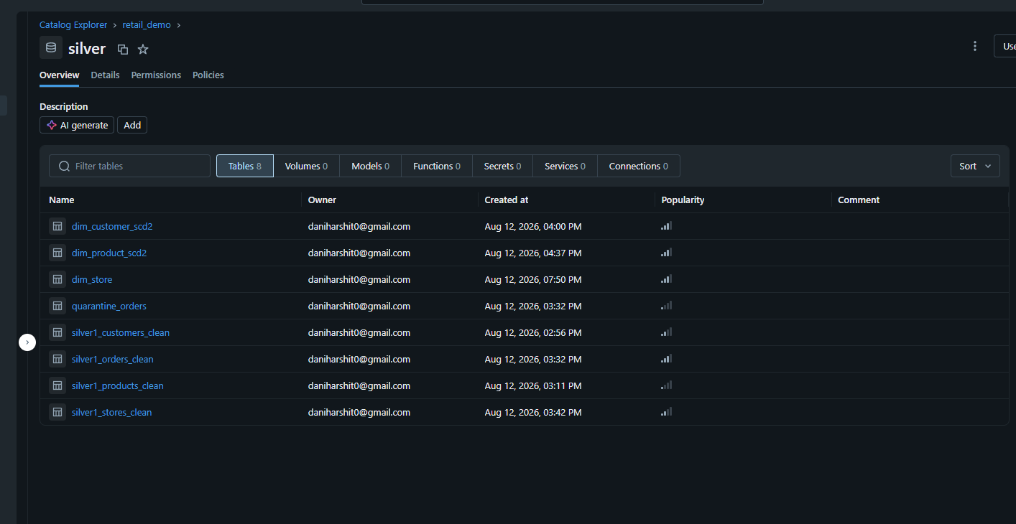
- GOLD LAYER
