DESIGNING AUTOMATA FOR
REAL-TIME VALIDATION APPLICATIONS
AutomataLab: Password, Email and ATM PIN Validation

ACADEMIC DETAILS | INFORMATION
Faculty | Engineering and Technology
Department | Artificial Intelligence and Machine Learning
Programme | B.Tech. Artificial Intelligence and Machine Learning
Semester / Academic Year | V / 2026–2027
Course Code and Title | 21CSC301T – Formal Language and Automata
Assessment | Task 2 – Term Work
Faculty Handling | Dr. C. Gunasundari (AP)
SDG | SDG 9 – Industry, Innovation and Infrastructure
Student Name | Harshit Parmar
Registration Number | RA2411026050026
GitHub Profile | https://github.com/Harshit100306/
Project Repository | [Paste your actual repository URL here]

Submitted in partial fulfilment of the requirements for the course 21CSC301T – Formal Language and Automata.

Abstract
This project presents AutomataLab, an interactive demonstration of finite-state techniques for validating three common input formats: a password under a defined classroom policy, a restricted email-address syntax, and a four-digit ATM PIN. The purpose is to connect formal language concepts with practical software behaviour. Each application is described through its input alphabet, accepted language, state-based recognition logic, and representative positive and negative test strings.
The implementation combines a browser-based interface with Python recognizers and automated tests. The browser interface allows a user to select a validation task, submit a sample string, and inspect the acceptance result. The Python test suite provides repeatable verification of expected outcomes. The report also distinguishes syntactic recognition from semantic checks and security operations that require external services, databases, or cryptographic mechanisms.
The work demonstrates that finite automata are useful for regular-language validation, while also identifying the limits of using a recognizer as a complete authentication system.

1. Introduction
Many digital services receive structured input before performing a more complex operation. Examples include account password creation, email-address entry, and PIN input at an ATM. A first validation stage can reject strings that do not follow the expected format. Finite automata provide a formal model for this stage because they process input symbols and update a finite control state.
AutomataLab applies this idea to three deliberately scoped examples. The password recognizer checks a bounded character policy, the email recognizer checks a restricted lexical structure, and the PIN recognizer accepts exactly four decimal digits. The project is intended as an educational prototype and does not perform real user authentication.

2. Objectives
- Define an alphabet and accepted language for each validation application.
- Design deterministic finite-state recognition logic and explain its state transitions.
- Implement the recognizers in Python and expose them through an interactive browser interface.
- Test each recognizer with accepted and rejected strings, including boundary and malformed cases.
- Compare the applications in terms of state requirements, efficiency, and limitations.
- Explain why format validation must be separated from semantic and security checks.

3. Scope and Assumptions
- The password policy is an illustrative rule selected for this assignment: 8–20 ASCII characters, with at least one lowercase letter, uppercase letter, digit, and one allowed special character from !@#$%^&*.
- The email validator recognizes a restricted common format, not every address permitted by the complete email standards.
- The ATM PIN language contains exactly four ASCII digits. This is an assignment assumption, not a universal banking requirement.
- All three functions inspect a complete input string and return a Boolean acceptance result.
- Only syntax or the explicitly stated local policy is checked; no real password, mailbox, card, account, or PIN is authenticated.

4. Application One: Password Policy Validation

4.1 Alphabet and language
Let the character classes be L = {a,…,z}, U = {A,…,Z}, D = {0,…,9}, and S = {! , @, #, $, %, ^, &, *}. Let X represent every other character, including whitespace and unsupported punctuation. The accepted language is:
L_password = { w ∈ (L ∪ U ∪ D ∪ S)* | 8 ≤ |w| ≤ 20,
w contains at least one symbol from each of L, U, D and S }
The rule is regular. A recognizer only needs to retain a bounded length and whether each of the four required categories has appeared.

4.2 State representation and transitions
The implementation represents a DFA state using a pair (n, mask). The value n records the number of characters consumed, with values above the maximum treated as rejection. The four-bit mask records the presence of lowercase, uppercase, digit, and special-character categories. For each input character, the corresponding bit is set and the length is incremented. Any character outside the four permitted classes leads to rejection. The input is accepted at end-of-string only when the length is between 8 and 20 and all four bits are set.
This compact encoding represents a finite number of states: the length has a fixed upper bound and the mask has only sixteen possible values. A separate dead state handles invalid symbols and over-length input.

4.3 Test cases
Input | Expected result | Explanation
Abcdef1! | Accept | Eight characters; all required classes occur.
StrongPass9@ | Accept | Length and all four character categories are satisfied.
Aa1!bcde | Accept | Meets the minimum length and category requirements.
Zx7#mnopQ | Accept | Contains lowercase, uppercase, digit and special character.
A1!bcdefghijklmnopq | Accept | Within the 20-character upper bound.
abcdef1! | Reject | No uppercase character.
ABCDEFG1! | Reject | No lowercase character.
Abcdefgh! | Reject | No digit.
Abcdefg1 | Reject | No allowed special character.
Ab1!xyz | Reject | Fewer than eight characters.
Abc def1! | Reject | Whitespace is not in the permitted alphabet.

5. Application Two: Email Format Validation

5.1 Restricted grammar
The email recognizer uses a deliberately limited grammar that is straightforward to describe as a finite-state scan. An input must contain exactly one @ separator. The local part must be non-empty and may contain ASCII letters, digits, dot, underscore, percent, plus, and hyphen. It cannot begin or end with a dot and cannot contain two consecutive dots.
The domain must contain at least two non-empty labels separated by dots. A label may contain ASCII letters, digits and hyphens, but a hyphen cannot occur at either edge. The final label must contain at least two ASCII letters. Whitespace is rejected.

5.2 State behaviour
The recognizer moves through conceptual phases: local-part start, local-part scanning, domain start, and domain-label scanning. It records whether the required separator has been encountered and checks local-part dot placement and domain-label boundaries. A malformed separator, empty label, invalid character, or invalid final suffix causes rejection. The Python implementation performs this scan deterministically.
The rule is regular because the recognizer needs only finite control information. It does not need to resolve a domain name or contact a mail server.

5.3 Test cases
Input | Expected result | Explanation
alice@example.com | Accept | One separator and a valid two-label domain.
john.doe@mail.co.uk | Accept | Valid local part and multiple domain labels.
a_b+c@example-domain.org | Accept | Permitted local symbols and internal domain hyphen.
user123@sub.example.in | Accept | Subdomain and valid final suffix.
x@y.ab | Accept | Shortest example under the stated subset.
@example.com | Reject | Local part is empty.
aliceexample.com | Reject | Missing @ separator.
alice@@example.com | Reject | More than one @ separator.
alice..bob@example.com | Reject | Consecutive dots in local part.
.alice@example.com | Reject | Local part begins with a dot.
alice@-example.com | Reject | Domain label begins with a hyphen.
alice@example | Reject | Domain has no dot-separated suffix.
alice@example.c | Reject | Final label is shorter than two letters.

6. Application Three: ATM PIN Format Validation

6.1 Alphabet and language
The PIN alphabet is Σ = {0,1,2,3,4,5,6,7,8,9}. The language is:
L_PIN = { w ∈ Σ* | |w| = 4 }
Leading zeroes are allowed because a PIN is treated as a string of digits rather than as an integer.

6.2 DFA states
State | Meaning | On a digit | Accepting?
q0 | No digits consumed | q1 | No
q1 | One digit consumed | q2 | No
q2 | Two digits consumed | q3 | No
q3 | Three digits consumed | q4 | No
q4 | Exactly four digits consumed | Dead state on another character | Yes
qReject | Invalid symbol or excess length | qReject | No

A non-digit from any progress state moves to the dead state. Any fifth character after q4 also moves to rejection. The only accepting state is q4, and the input must end there.

6.3 Test cases
Input | Expected result | Explanation
1234 | Accept | Exactly four digits.
0000 | Accept | Leading zeroes are permitted.
9071 | Accept | Four decimal digits.
5555 | Accept | Four decimal digits.
0420 | Accept | Leading zero is preserved.
123 | Reject | Only three digits.
12345 | Reject | Five digits.
12a4 | Reject | Contains a non-digit.
12 4 | Reject | Contains whitespace.
(empty string) | Reject | No digits supplied.

7. System Implementation

7.1 Browser interface
The web interface is a standalone HTML, CSS and JavaScript page. It provides a dashboard with three selectable validation modes. A user enters a candidate string and receives an ACCEPTED or REJECTED result. The page also displays the rule summary and illustrative state progression for the selected recognizer. It has no third-party runtime dependency and can be opened locally in a modern browser.

7.2 Python implementation and tests
The Python module contains one validation function per application. The test suite exercises representative accepted and rejected examples. This separation makes the recognizers independently testable and keeps the browser demonstration distinct from the formal validation logic.

7.3 How to run
Open web/index.html in a modern browser
python -m unittest discover -s tests -v
The browser demo can be run without installing packages. Python 3.10 or later is recommended for running the automated test suite.

8. Complexity and Design Comparison
Application | State information | Time | Auxiliary space
Password | Bounded length plus four category flags | O(n) | O(1)
Email | Local/domain phase and finite separator/label flags | O(n) | O(1)
ATM PIN | Count of digits consumed from 0 to 4 | O(n) | O(1)

Each recognizer processes the input in one left-to-right pass, so the running time grows linearly with input length. The PIN DFA is the simplest because it only counts up to four digits. The password DFA needs a bounded counter and four Boolean category flags. The email recognizer has more structural conditions because it must distinguish the local part from the domain and check separator and label placement.

9. Syntax Validation versus Semantic and Business Rules
Application | Finite automaton can check | Additional processing required
Password | Length, permitted characters and category presence | Password breach screening, secure hashing, user/account association, MFA and rate limiting.
Email | Basic lexical structure and separator placement | DNS or MX lookup, mailbox existence and ownership confirmation.
ATM PIN | Exactly four numeric characters | PIN-to-account verification, encrypted processing, attempt limits, card status and fraud controls.

A finite automaton is sufficient when the rule describes a regular language and the required memory can be represented by a finite set of states. It is not a replacement for database access, cryptographic verification, identity checks, external network queries, or security policy enforcement. In a real service, format validation should be one early stage in a larger secure workflow.

10. Limitations and Responsible Use
- The password policy is an assignment-specific example and should not be interpreted as universal password guidance.
- The email grammar intentionally excludes some valid addresses and does not prove that a mailbox exists.
- The four-digit PIN length is a modelling assumption. Actual financial systems may use different policies.
- The prototype must not be connected to real user credentials or banking systems.
- Production authentication requires secure transport, safe storage, privacy controls, rate limiting, monitoring and appropriate account verification.

11. SDG 9 Alignment
The project has a design-level connection to Sustainable Development Goal 9: Industry, Innovation and Infrastructure. Structured input validation is one small but important technique for making software interfaces more predictable. Explicit acceptance rules and repeatable tests can prevent malformed data from reaching later processing stages. The project illustrates this foundational engineering concept; it does not claim to deliver infrastructure-scale outcomes by itself.

12. Conclusion
AutomataLab demonstrates how finite-state recognition can be applied to three familiar input-validation problems. The password example shows how bounded length and category flags can be encoded as finite state. The email example demonstrates a structured lexical recognizer with explicit assumptions. The PIN example provides a direct fixed-length DFA. Testing confirms the stated examples, while the analysis clarifies that syntactic acceptance is not equivalent to authentication or business-rule approval.
The project therefore connects formal language theory with a practical software prototype and highlights both the usefulness and the boundaries of finite automata in real-world systems.

13. Project and Source Code
GitHub profile: https://github.com/Harshit100306/
Project repository: https://github.com/Harshit100306/AutomataLab-Real-Time-Validation
The repository should contain the web demonstration, Python recognizers, automated tests, diagrams, README and this design report.

Academic Integrity and Originality Note
This report has been written specifically around the stated project scope, chosen language rules, implementation structure and test examples. It avoids copying passages from external sources. However, no writer can guarantee a particular similarity or plagiarism-detector percentage: results vary by software, database coverage, matching settings and the inclusion of common technical terminology. Review the report, add your own screenshots and observations, cite any external material you actually use, and follow the institution's submission policy. The requested threshold of below 15% must be verified using the institution-approved similarity checker.

Appendix A — GitHub Repository
The complete project source code, browser demonstration, Python implementation, automated tests and diagrams are available at the following repository:https://github.com/Harshit100306/AutomataLab-Real-Time-Validation
Repository URL: https://github.com/Harshit100306/AutomataLab-Real-Time-Validation

Appendix B — Demonstration Screenshots
Insert screenshots captured from your own execution in the spaces provided below. Add a short caption describing the input and the observed result.
Figure B1. AutomataLab main dashboard
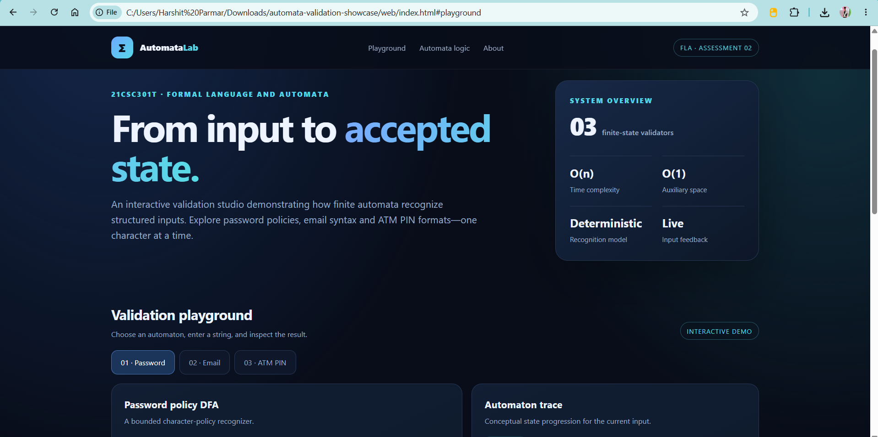
Caption: Main interface showing the three validation applications.
Figure B2. Password and email validation outputs
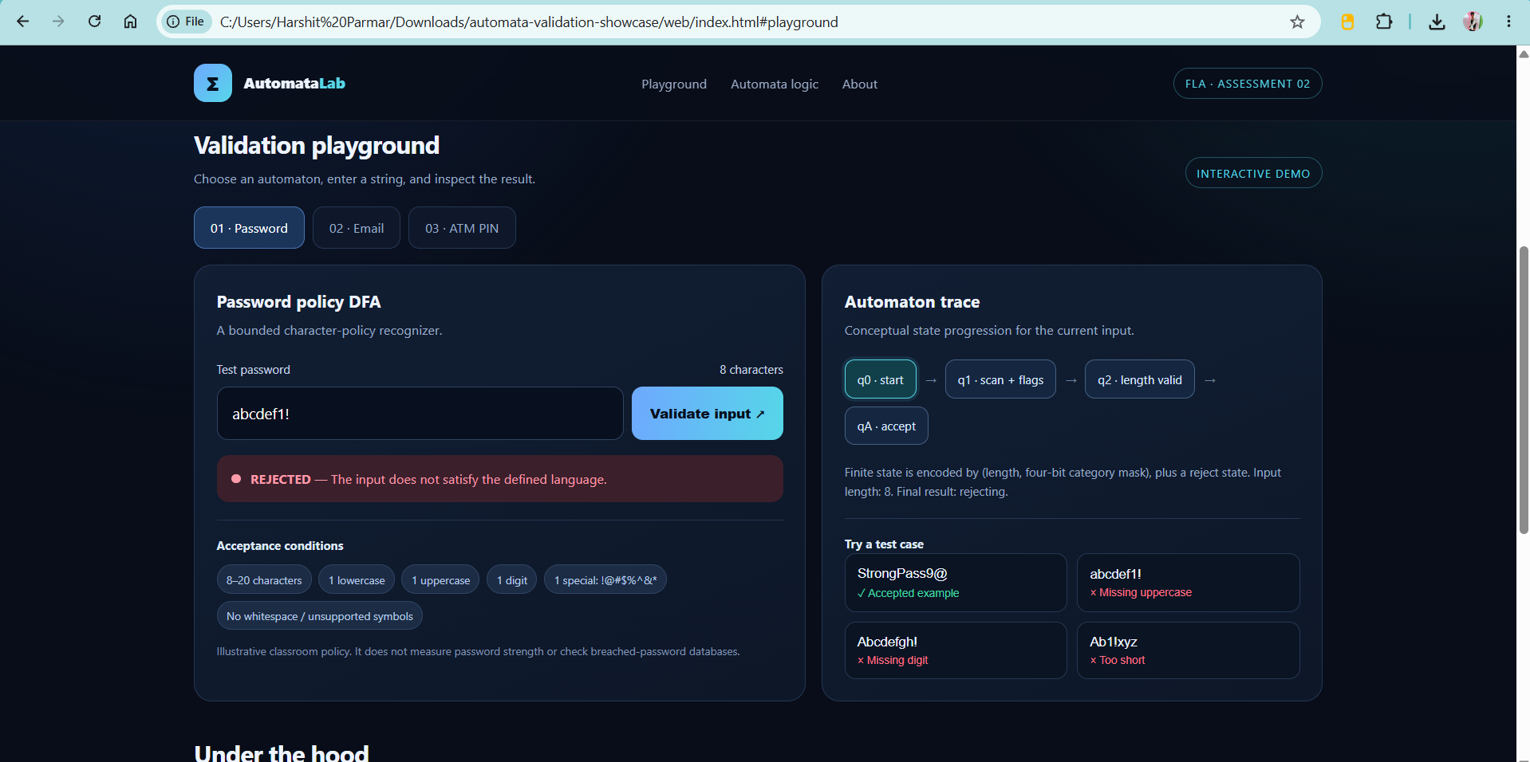
Caption: Insert accepted and rejected password/email examples with visible results.

Figure B3. ATM PIN validation and automated tests
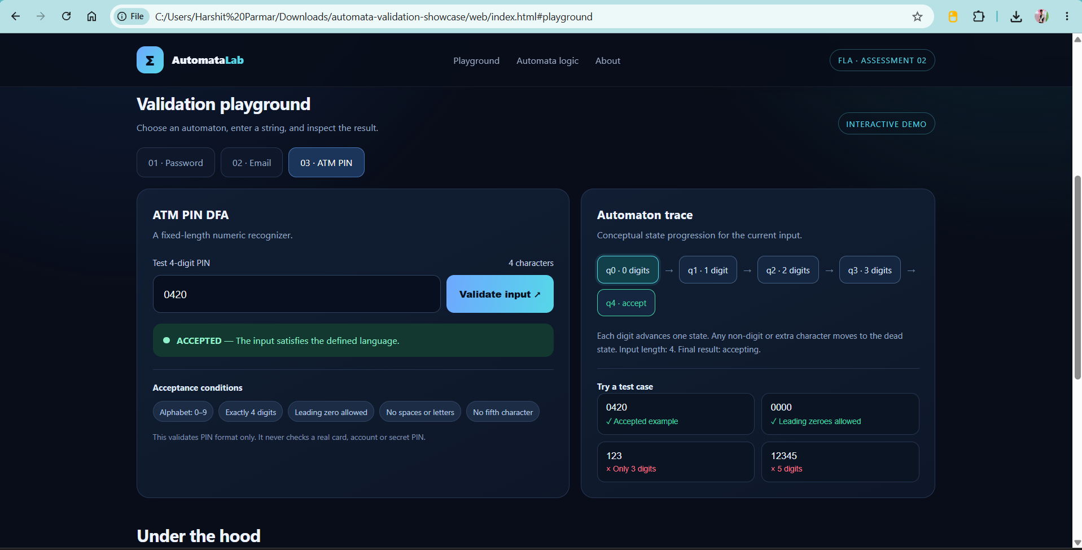
Caption: Insert the PIN validation result and terminal output showing passing unit tests.

